Canopy stratification drives functional niche differentiation and resource use efficiency in cacao agroforestry systems
Francisco Saavedra^{a,}*, Kazuya Naoki^{b}, Maritza Cornejoª, Carlos M. Landivar^{c}, Eduardo Somarriba^{d}, Stéphane Saj^{e}
ª Herbario Nacional de Bolivia, Instituto de Ecología, Universidad Mayor de San Andrés, La Paz, Bolivia
^{b} Instituto de Ecología, Carrera de Biología, Universidad Mayor de San Andrés, La Paz, Bolivia (0000-0002-6656-6950)
^{c} Department of forest growth, Silviculture and Genetics, Austrian Research Centre for Forest, Vienna, Austria (0000-0001-9895-7617)
^{d} Centro Agronómico Tropical de Investigación y Enseñanza (CATIE), Costa Rica (0000-0002-9371-9799)
^{e} Department of International Cooperation, Research Institute of Organic Agriculture (FiBL), Switzerland (0000-0001-5856-5459)

* Corresponding author E-mail address: fsaavedraa@fcpn.edu.bo fsaavedraa@fcpn.edu.bo (F. Saavedra, ORCID 0000-0002-7702-7864).

Supplementary material

Annex 1. 400m drone view of the trial in October 2024. Each plot (squares) is 48m x 48m. Red = dynamic agroforestry (DAF); blue = organic agroforestry (AFO); yellow = conventional agroforestry (AFC).
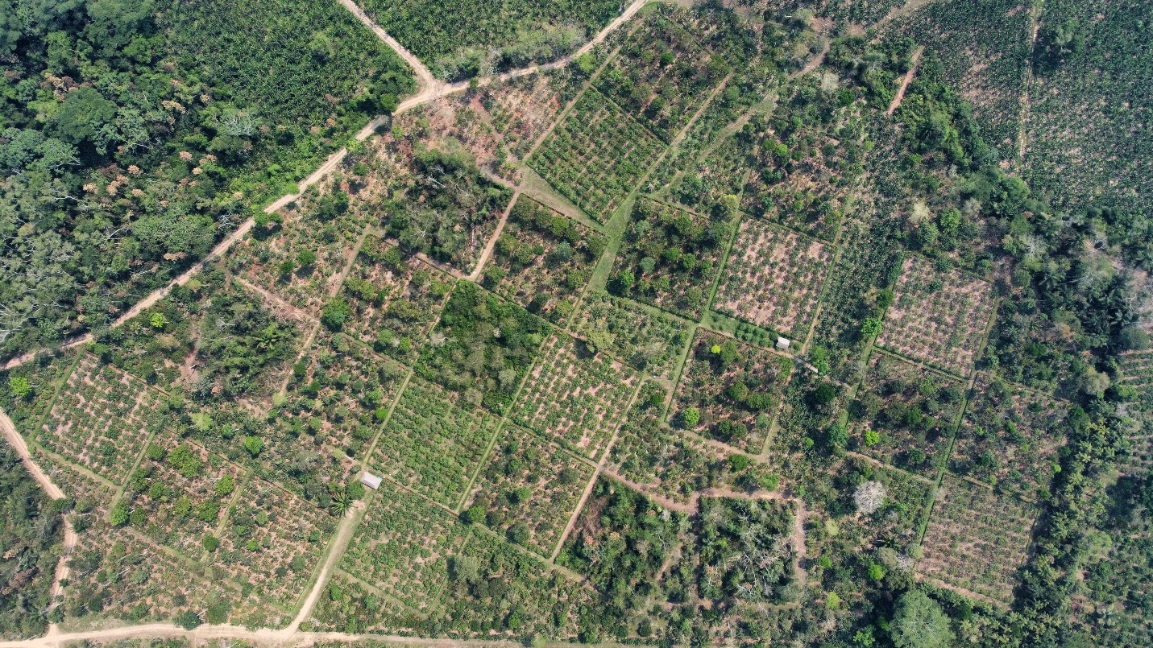

Annex 2. List of studied species. Some species may be in more than one stratum.
N° | Scientific name | Common spanish name | Low  (1.2-4.6m) | Middle  (4.6-7.5m) | High  (7.6-11.5m) | Emergent  (11.5-16m)
1 | Garcinia gardneriana (Planch. & Triana) Zappi | Achachairu | 4 | 27 | 8 | 0
2 | Coffea arabica | Café | 48 | 0 | 0 | 0
3 | Averrhoa carambola L. | Carambola | 0 | 3 | 1 | 0
4 | Cedrela fissilis Vell. | Cedro blanco | 0 | 3 | 0 | 0
5 | Salacia macrantha A.C. Sm. | Chuchuhuasi | 2 | 1 | 0 | 0
6 | Theobroma grandiflorum (Willd. ex Spreng.) K. Schum. | Copoazú | 4 | 29 | 0 | 0
7 | Erythrina fusca Lour. | Ceibo con espina | 0 | 0 | 42 | 7
8 | Centrolobium microchaete (Benth.) H.C.Lima | Huasicucho | 0 | 0 | 2 | 29
9 | Theobroma cacao L. | Cacao ICS1 | 32 | 3 | 0 | 0
10 | Theobroma cacao L. | Cacao IIa22 | 36 | 0 | 0 | 0
11 | Theobroma cacao L. | Cacao III06 | 32 | 2 | 0 | 0
12 | Theobroma cacao L. | Cacao III13 | 33 | 2 | 0 | 0
13 | Theobroma cacao L. | Cacao TSH 565 | 35 | 0 | 0 | 0
14 | Inga ingoides (Rich.) Willd. | Inga | 0 | 0 | 35 | 14
15 | Mangifera indica L. | Mango | 2 | 4 | 4 | 0
16 | Swietenia macrophylla King | Mara | 0 | 6 | 5 | 2
17 | Inga expansa Rusby | Pacay | 0 | 0 | 14 | 2
18 | Hymenaea courbaril L. | Paquio | 6 | 0 | 0 | 0
19 | Myroxylon balsamum (L.) Harms | Quina Quina | 0 | 0 | 0 | 6
20 | Nephelium lappaceum L. | Rambutan | 4 | 20 | 3 | 0
21 | Amburana cearensis (Allemão) A.C. Sm. | Roble | 0 | 8 | 1 | 0
22 | Stryphnodendron purpureum Ducke | Toco colorado | 0 | 0 | 0 | 4
23 | Guarea guidonia (L.) Sleumer | Trompillo | 0 | 0 | 10 | 0
24 | Artocarpus heterophyllus Lam. | Yaca | 0 | 12 | 1 | 0
 |  | Total | 236 | 120 | 126 | 64

Annex 3. Vertical strata clasification into four vertical strata (i.e., low, middle, high, and emergent), differing in the abundance (number of individual trees) and species richness within each stratum. Some species are present in more than one stratum.

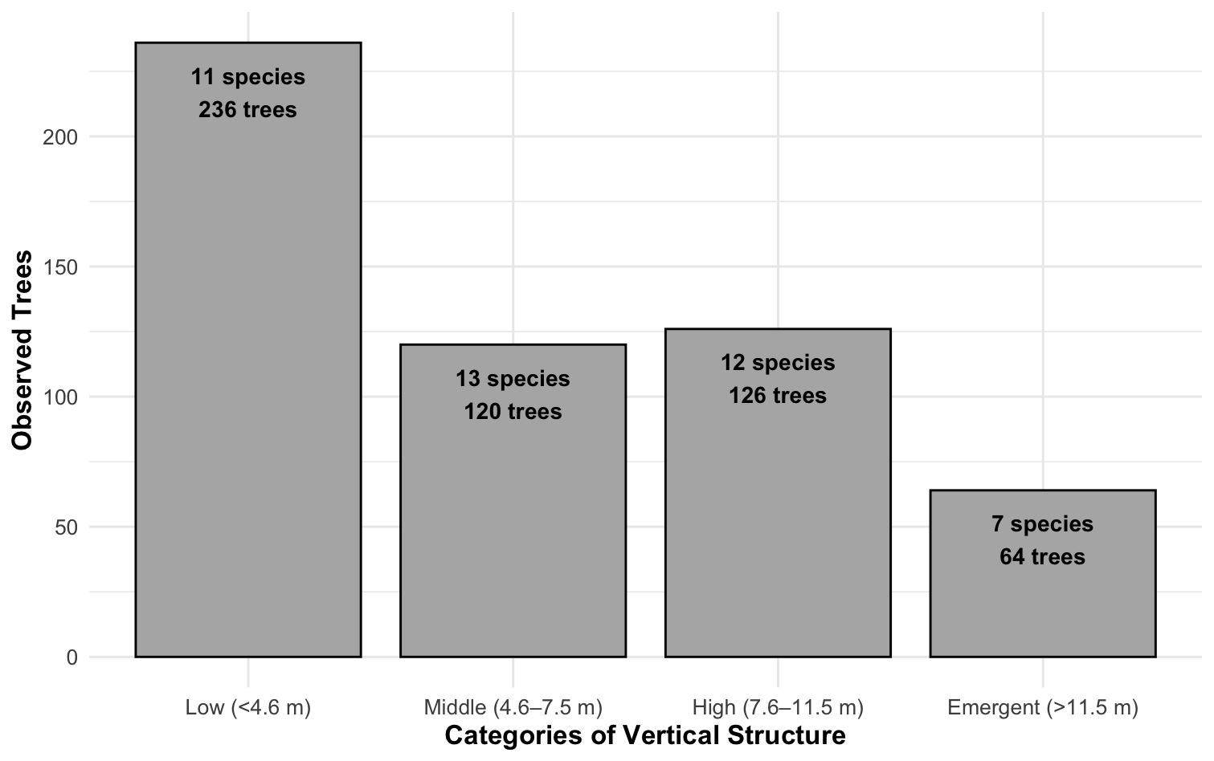

Annex 4. Best model selection results of predictor variables on: instantaneous water-use efficiency (WUE_{inst}) (a-d), CO₂ assimilation rate (A) (e-h), and transpiration rate (E) (i-l).

- WUE_{inst} – Low stratum
Model | k | AICc | ΔAICc | Weight
Hmd + PAR + SLA | 6 | 536.4 | 0.00 | 0.239
LA + Hmd + PAR + SLA | 7 | 537.7 | 1.27 | 0.127
Hmd + SD + PAR + SLA | 7 | 538.2 | 1.77 | 0.099

- WUE_{inst} – Middle stratum
Model | k | AICc | ΔAICc | Weight
LA + RWC + Hmd + PAR + SLA | 7 | 310.2 | 0.00 | 0.066
LA + Hmd + PAR | 6 | 310.4 | 0.21 | 0.060
Hmd + PAR | 5 | 311.0 | 0.78 | 0.045
LA + Hmd + PAR + SLA | 7 | 311.1 | 0.87 | 0.043
LA + PAR + SLA | 5 | 311.2 | 0.94 | 0.041
LA + RWC + Hmd + PAR + SLA | 8 | 311.4 | 1.12 | 0.038
LA + RWC + PAR | 6 | 311.8 | 1.59 | 0.030

- WUE_{inst} – High stratum
Model | k | AICc | ΔAICc | Weight
LA + RWC + Hmd + PAR + SLA + Tmp | 9 | 336.9 | 0.00 | 0.159
LA + Hmd + PAR + SLA + Tmp | 8 | 337.6 | 0.72 | 0.111
LA + RWC + Hmd + PAR +SLA | 8 | 338.3 | 1.44 | 0.077
LA + RWC + PAR + SLA | 7 | 338.4 | 1.49 | 0.075
LA + Hmd + PAR + SLA | 7 | 338.7 | 1.87 | 0.062

- WUE_{inst} – Emergent stratum
Model | k | AICc | ΔAICc | Weight
Hmd + PAR | 5 | 165.2 | 0.00 | 0.044
Hmd + PAR + SLA | 6 | 165.4 | 0.19 | 0.040
Hmd + PAR + SLA + Tmp | 7 | 165.6 | 0.36 | 0.037
PAR | 4 | 165.8 | 0.60 | 0.033
PAR + SLA | 5 | 165.9 | 0.71 | 0.031
Null Model | 3 | 166.0 | 0.80 | 0.029
Hmd | 4 | 166.1 | 0.87 | 0.029
Hmd + PAR + Tmp | 6 | 166.2 | 0.97 | 0.027
RWC + Hmd + PAR + SLA | 7 | 166.7 | 1.49 | 0.021
Hmd + SD + PAR | 6 | 166.7 | 1.50 | 0.021
SLA | 4 | 166.9 | 1.74 | 0.018
LA + Hmd + PAR | 6 | 166.9 | 1.75 | 0.018
Hmd + SD + PAR + SLA | 7 | 167.1 | 1.92 | 0.017
SD + PAR | 5 | 167.1 | 1.93 | 0.017
LA + PAR | 5 | 167.1 | 1.94 | 0.017
Hmd + SLA | 5 | 167.2 | 1.97 | 0.016

- A – Low stratum
Model | k | AICc | ΔAICc | Weight
LA + SD + PAR + SLA | 7 | 412.3 | 0.00 | 0.158
LA + SD + PAR + SLA + Tmp | 6 | 412.9 | 0.64 | 0.115
LA + PAR +SLA | 6 | 141.0 | 1.74 | 0.066
LA + RWC + SD + PAR + SLA | 8 | 414.2 | 1.89 | 0.061
LA + SD + PAR + SLA + Tmp | 8 | 414.2 | 1.90 | 0.061

- A – Middle stratum
Model | k | AICc | ΔAICc | Weight
LA + PAR + SLA + Tmp | 7 | 284.2 | 0.00 | 0.097
LA + Hmd + PAR + SLA | 7 | 285.2 | 1.02 | 0.058
LA + RWC + PAR + SLA + Tmp | 8 | 285.4 | 1.18 | 0.054
LA + SD + PAR + SLA + Tmp | 8 | 285.7 | 1.43 | 0.048
LA + Hmd + SLA | 6 | 285.9 | 1.64 | 0.043
LA + SLA + Tmp | 6 | 286.0 | 1.78 | 0.040
LA + Hmd + PAR + SLA + Tmp | 8 | 286.1 | 1.90 | 0.038
LA + Hmd + SD + PAR + SLA | 8 | 286.2 | 1.98 | 0.036

- A – High stratum
Model | k | AICc | ΔAICc | Weight
LA + SD + PAR + SLA + Tmp | 8 | 301.6 | 0.00 | 0.085
LA + SD + SLA + Tmp | 7 | 301.7 | 0.13 | 0.080
LA + Hmd + SD + PAR + SLA | 8 | 302.5 | 0.87 | 0.055
LA + Hmd + SD + SLA | 7 | 302.6 | 0.98 | 0.052
LA + SD + PAR + SLA | 7 | 303.2 | 1.54 | 0.069
LA + SD + Tmp | 6 | 303.3 | 1.73 | 0.036
LA + SD + PAR + Tmp | 7 | 303.5 | 1.88 | 0.033

- A – Emergent stratum
Model | k | AICc | ΔAICc | Weight
LA | 4 | 167.0 | 0.00 | 0.142
LA + RWC | 5 | 168.6 | 1.54 | 0.066
LA + Hmd | 5 | 168.9 | 1.81 | 0.057
LA + SD | 5 | 169.0 | 1.92 | 0.054

- E – Low stratum
Model | k | AICc | ΔAICc | Weight
LA + Hmd + SD + PAR | 7 | 345.0 | 0.00 | 0.167
LA + Hmd + SD + PAR + Tmp | 8 | 345.3 | 0.38 | 0.137
LA + Hmd + SD + PAR + SLA | 8 | 345.8 | 0.80 | 0.111
LA + Hmd + PAR | 9 | 346.4 | 1.43 | 0.081
LA + Hmd + PAR | 6 | 346.7 | 4.72 | 0.071
LA + RWC + Hmd + SD + PAR | 8 | 346.8 | 1.88 | 0.065

- E – Middle stratum
Model | k | AICc | ΔAICc | Weight
LA + Hmd + SD + SLA | 7 | 291.6 | 0.00 | 0.174
LA + Hmd + SLA | 6 | 282.6 | 0.93 | 0.109
LA + Hmd + SD + SLA + Tmp | 8 | 283.1 | 1.45 | 0.084
LA + Hmd + SLA + Tmp | 7 | 283.6 | 1.96 | 0.065

- E – High stratum
Model | k | AICc | ΔAICc | Weight
LA + Hmd + SD | 6 | 217.9 | 0.00 | 0.153
LA + RWC + Hmd + SD | 7 | 218.7 | 0.79 | 0.103
LA + Hmd | 5 | 219.3 | 1.40 | 0.076
LA + Hmd + SD + Tmp | 7 | 219.7 | 1.73 | 0.064

- E – Emergent stratum
Model | k | AICc | ΔAICc | Weight
LA + SLA | 5 | 129.7 | 0.00 | 0.115
LA | 4 | 129.8 | 0.05 | 0.112
LA + Tmp | 5 | 131.5 | 1.76 | 0.048
LA + PAR + SLA | 6 | 131.6 | 1.92 | 0.044
LA + PAR | 5 | 131.7 | 1.97 | 0.043

