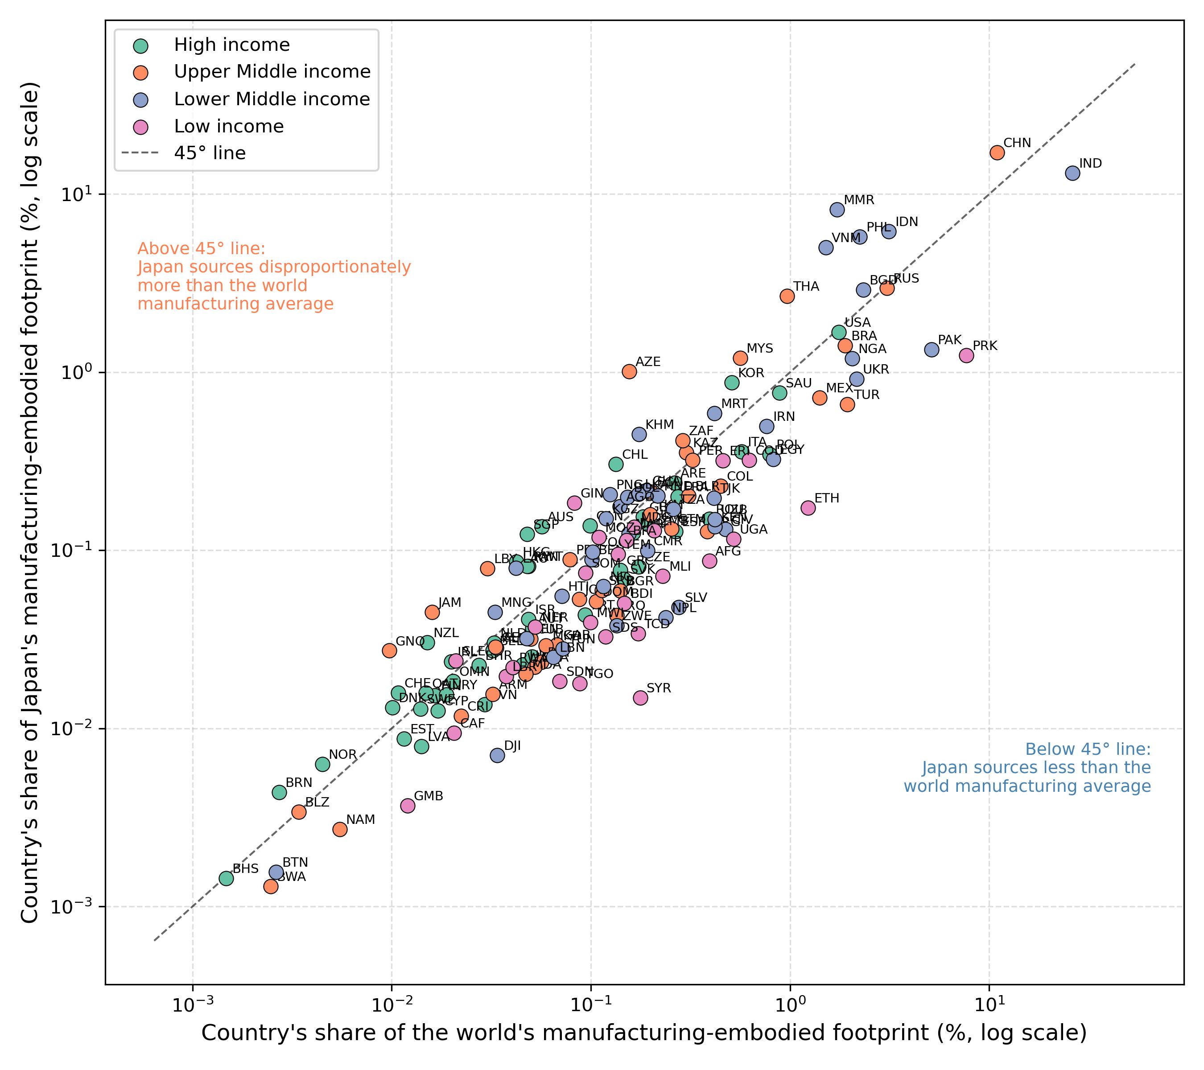
Figure S1. Japan's forced labour footprint concentration relative to the global manufacturing footprint distribution, by country and income group (log-log scale)

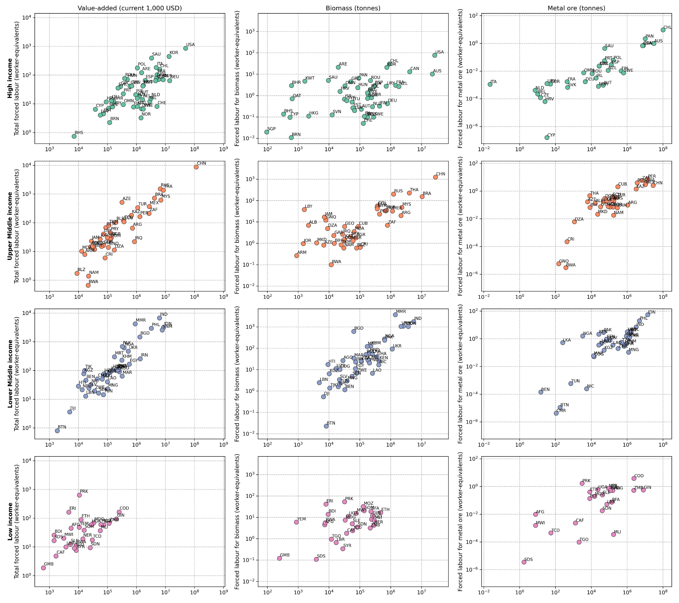
Figure S2. Japan-induced forced labour risk footprint in relation to embodied value-added, biomass extraction, and metal ore extraction, by supplier-country income group (log-log scale)

