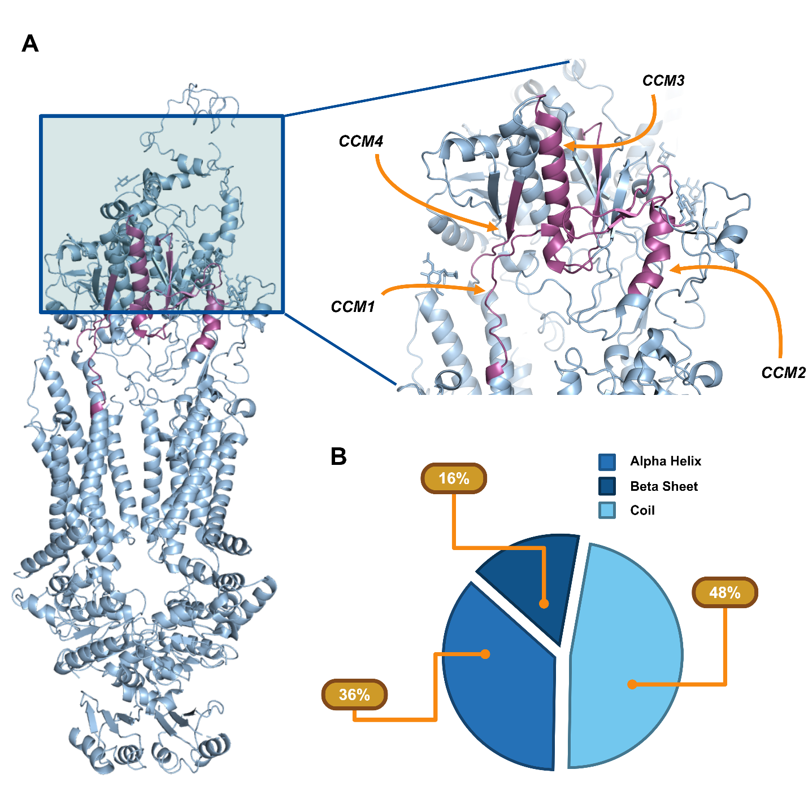

Fig. S1 Secondary structure composition of ECD2 CCM regions. (A) Cartoon representation of the retinoid-bound ABCA4 cryo-EM structure (PDB 7E7O) shown in light blue, with conserved cluster motifs (CCMs) within the ECD2 domain highlighted in magenta. (B) Quantification of secondary-structure elements within ECD2, showing the relative distribution of α-helical, β-strand, and coil segments across CCM regions.

Fig. S2 PAAT variants (pathogenic across all tools) mapped to conserved regions of ECD2 domain. Conserved regions of the ECD2 domain have been defined as critical conserved motifs (CCMs). A total of 4 CCMs were observed (CCM1, CCM2, CCM3, CCM4) and represent areas of higher conservation (dark orange and purple regions). PAAT ECD2 variants which are present in each CCM are labeled. Those PAAT variants which are also VUS are highlighted in blue.

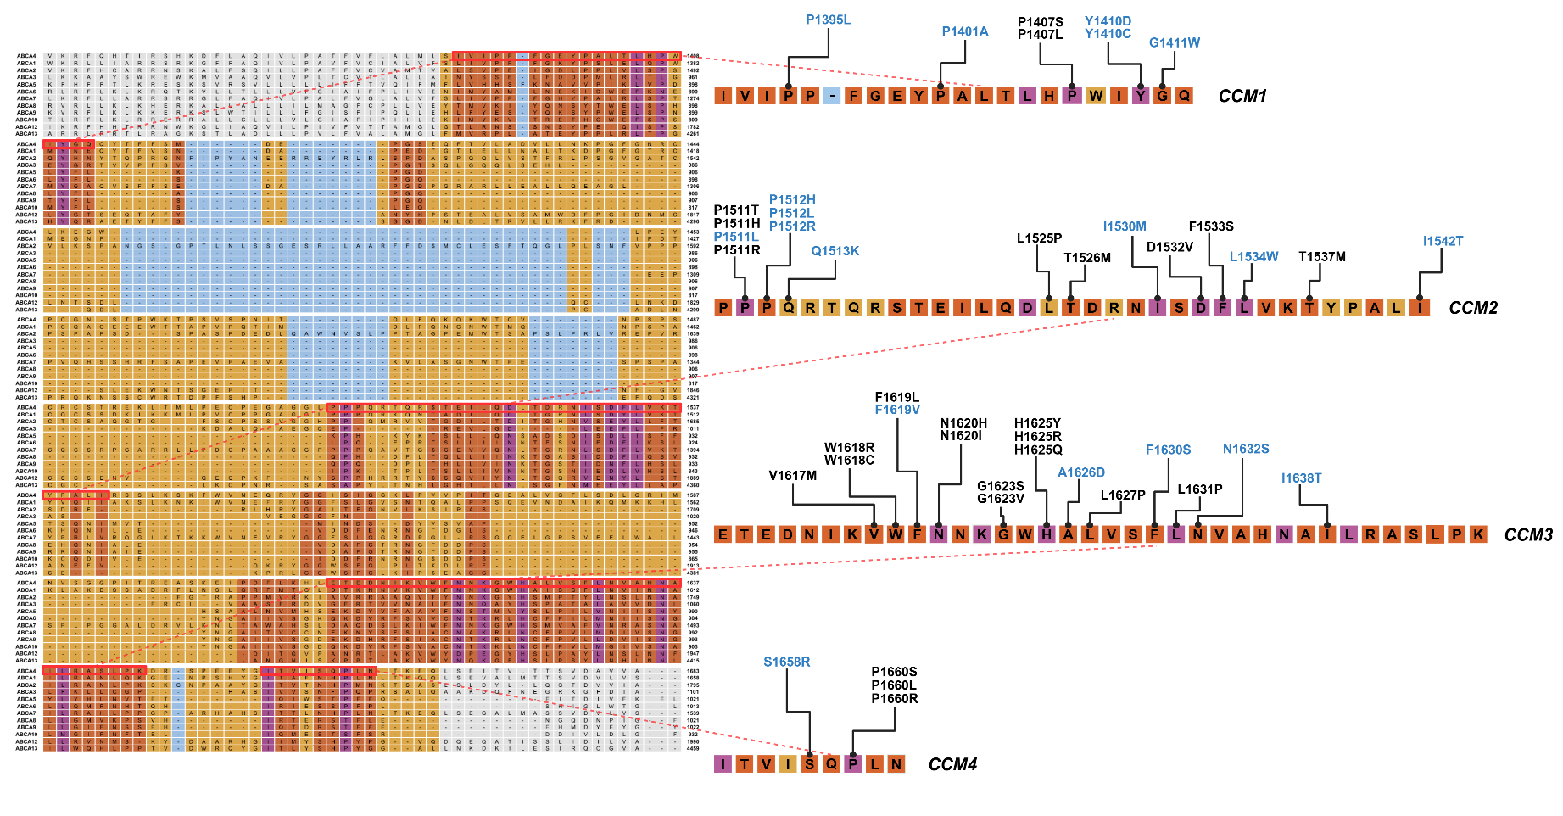

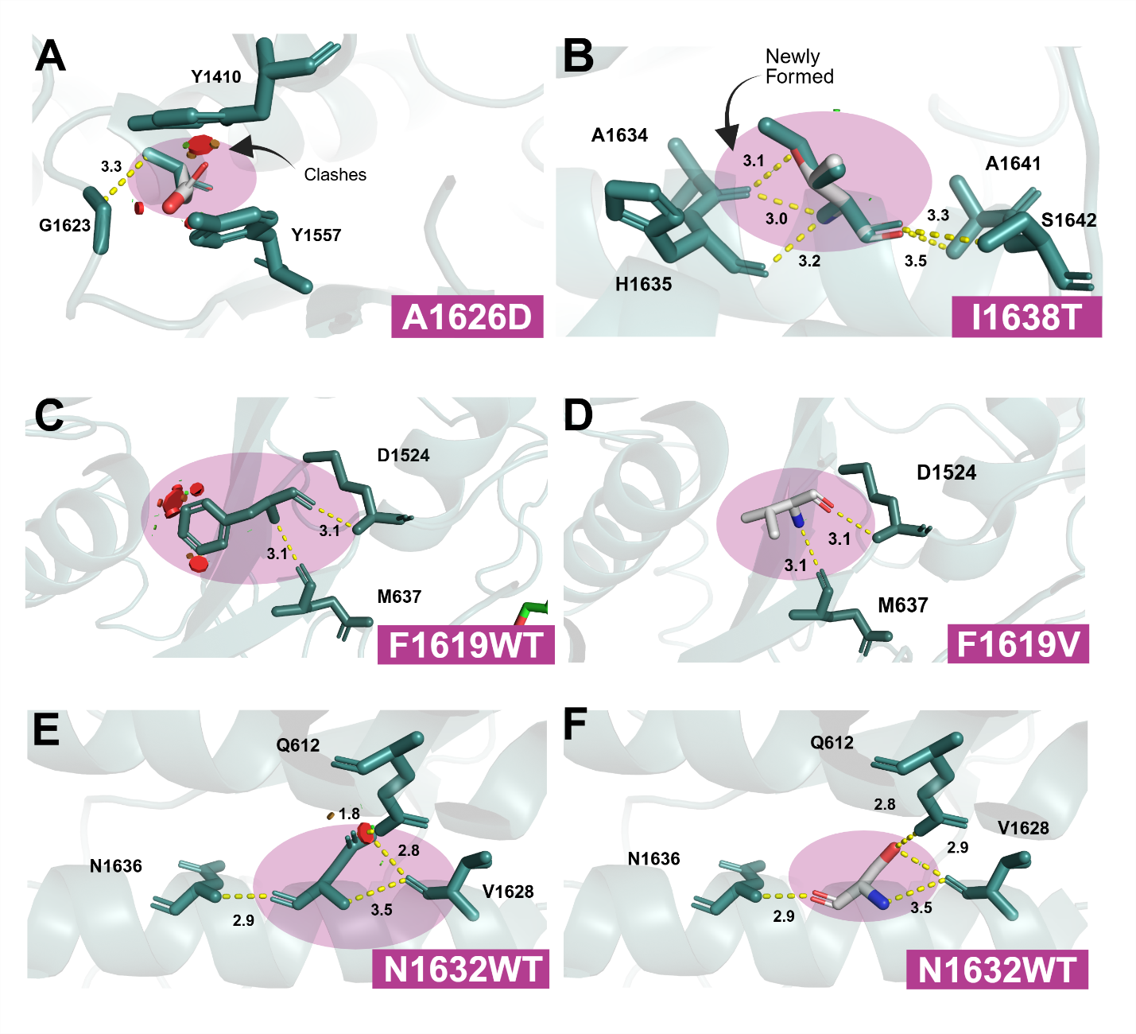
Fig. S3 Structural assessment of PAAT and VUS variants in ECD2 CCM regions. (A) A1626D shows clashing among neighboring ECD2 residues. (B) I1638T, located on an alpha helix, forms a new hydrogen bond along that helix. (C-F) F1619V and N1632 show reduced clashing and minimal overlap relative to their respective wild type residues.

