Supplementary Materials
Contents
Supplementary Materials 1
S1 Protocol 1
Version 1
Objective/Focus 1
Methods 1
Stage 1: Systematic Review 2
Search Strategy: 2
Stage 2: Pilot Survey 3
Stage 3: Consensus Surveys 4
Stage 4: Pilot/Draft of Checklist 4
Stage 5: Guideline Dissemination 4
S2 Participant definitions 5
S3 Round 1 Survey 6
Items and responses 6
Free text items: 11
Participant characteristics: 12
S4 Round 2 Survey 13
Items and responses 13
Free text items: 17
Participant characteristics: 18
S5 Round 3 Survey 20
Items and responses 20
Free text items: 26
Participant characteristics: 26
S6 Round 4 Survey 28
Items and responses 28
Free text items: 36
Participant characteristics: 37
S7 Delphi Consensus Study Round 1 Summary 39
Table 3: Standardisation of DDI classification 41
Table 4: Evidence factors for DDIs 43
Table 5: Importance of factors in evaluating DDIs 44
Table 6: Agreement of statements about DDI classification 45
Table 7: Usefulness of study designs for identifying DDIs 47
Table 8: Statements about animal and in-vitro studies for DDIs 48
Table 9: Usefulness of predictive approaches for DDIs 48
Table 10: Agreement of statements about clinical trials and DDIs 49
Table 11: Agreement of approaches to detecting and managing DDIs 50
S8 Reporting Checklist for Drug-Drug Interactions: Explanatory Document. 52
Title and Abstract 52
Introduction 57
Methods 61
Results 65
Other Information 70

S1 Protocol

Version

Version | Date | Authors | Changes
1.0 | 6th of June 2025 | Brayden Ng Gibson, Jia Wei Koh, Stella Talic | Creation of Protocol
1.1 | 14th of January 2026 | Brayden Ng Gibson, Stella Talic` | Presentation Refinement and updating of scoping review to systematic review

Objective/Focus
The newly proposed STAR-DDI reporting guideline is specifically intended for use in development of DDI checkers or databases for DDIs. These are defined as tools that provide advice to healthcare professionals on prescribing medications to mitigate drug-drug interactions. When conceptualizing the required items within this new checklist, we focused on DDI checkers that are currently available to healthcare professionals and assessed within the literature.

Methods
Our framework/checklist will be developed in accordance with the published guidelines by the EQUATOR Network. Five stages will be undertaken. These stages will consist of, (1) A systematic review of the literature, (2) Pilot survey, (3) Consensus surveys, (4) Pilot/Draft of guidance statement, (5) Implementation and endorsement.

Steering Committee
A steering committee has been established with a collaboration with the University of Liverpool Drug Interactions team, resulting in a team with expertise in DDI checker development, clinical pharmacology, pharmacoepidemiology and clinical practice. This multidisciplinary group will be instrumental in evaluating the survey items, contributing to the writing and refinement of the framework document, and actively participating in its dissemination.

Stage 1: Systematic Review
A systematic review titled, “the identification, reliability and validity of drug-drug interaction checking tools in chronic disease.” was conducted to identify potential items to include within the checklist. This systematic review was registered under PROSPERO (https://www.crd.york.ac.uk/PROSPERO/view/CRD420251065447)

Search Strategy:
The following information sources will be searched:
- MEDLINE (via Ovid)
- Embase (via Ovid)
- Scopus (via Elsevier)
- Web of Science
- Google Scholar (first 100 search results)
- ACM Digital Library
- IEEE Xplore Digital Library
As the databases underpinning DDI checking tools are constantly evolving, a 10 year period was chosen to ensure relevancy to current clinical practice. We have excluded studies not published in English, not conducted in humans and acute presenting diseases. To effectively identify these studies, a senior librarian was consulted. Search terms such as “drug-drug interaction*” or “DDI” was used in a proximity search with terms such as “database”, “knowledge base”, “checker”, “checking platform” and “software”. Articles retrieved were de-duplicated, with Covidence, and screened by two independent reviewers (B.G. and S.C), for title, abstract and full text screening. Conflicts/disagreements were resolved with a third party (H.K).

Data Extraction:
Reporting items will be identified by the steering committee and be guided by the results of the systematic review. Data extraction and risk of bias will be conducted by B.G., S.G and S.C. Information extracted will be study authors, year of publication, study design, drug-drug interaction sample size, drug-drug interaction checkers used, medications used, ATC code of majority of medications, severity scales used, reported agreement (author conclusion), reported agreement value for each severity and overall (Gweit A1 or Cohen Kappa or Fleiss Kappa or Kendall W, etc.), and a narrative synthesis of the clinical recommendation quality as well as the interaction explanation quality. Four data extraction tables will be used, each depicting the category of evaluation of DDI checkers used, descriptive agreement statistics (percentage overlap across all medications and specific severities), analytical agreement statistics (statistical measure such as Cohen Kappa, Fleiss Kappa, etc.) and study specific measures (methodologies differing from other studies using unique evaluation scoring and qualitative measures such as expert consensus).

Stage 2: Pilot Survey
This stage of the project will focus on gathering expert consensus through a structured survey process to refine and validate proposed checklist items. Before commencing any data collection, ethics approval will be obtained, ensuring all research activities adhere to ethical guidelines and protect participant rights (MHREC: 48838). The surveys will be administered using Qualtrics, a secure web-based platform designed for building and managing online surveys and databases, which will ensure data integrity and confidentiality.
The survey process will involve an initial development of survey items by the working group, devised from the results of the systematic review. An internal pilot of the survey will occur via participants from the Pharmacoepidemiology Research Group, Monash University. The first survey will be designed to elicit initial feedback and scoring from participants on the developed checklist items. Participants will be asked to rate each item using a 5-point Likert scale ("Strongly Disagree" to "Strongly Agree", or similar anchors depending on the specific item's phrasing). Crucially, this survey will also include a comment section for each item, providing participants with an opportunity to offer qualitative feedback, elaborate on their ratings, or suggest modifications.

Participant Selection
The study will be conducted internationally, contacting national regulatory bodies, drug information companies and research societies across the world. Individual clinicians and researchers will be identified within the steering committee’s professional networks, resulting in a majority being based in Australia. This study will aim to recruit 60 participants, with an optimal count of 20 to 30 participants, as this exceeds the minimum requirement of 12 participants for content validity in Delphi studies. To allow consistent engagement of regulatory bodies and industry partners, new participants will be permitted to partake in the consensus study at each round. Participants will be retrieved from the following stakeholder groups, with the retrieval methods described below.
Clinical stakeholders: By leveraging connections through professional associations such as Outcome Health, the Royal Australian College of General Practitioners, and the Australian Commission for Safety and Quality in Healthcare, relevant healthcare professionals will be contacted to participate. Invitations will be sent via email, highlighting the clinical relevance and potential impact on patient safety.
Technical stakeholders: Companies and developers of DDI tools will be contacted directly. The DDI tools identified in the systematic review will be used to guide which companies will be approached.
Regulatory bodies: Formal letters outlining the project’s alignment with regulatory goals will be sent to Therapeutic Goods Administration Australia, the European Medicines Agency, and known contacts within the United States Food and Drug Administration, including those with whom prior collaborations have occurred. Prior collaborations or institutional connections will be used to facilitate introductions.
Researchers: University affiliations and research groups will be used to identify experts, and authors of key papers on DDIs will be contacted via email. Engagement will also occur through organisations such as the International Society for Pharmacoepidemiology via its Special Interest Group on DDIs to invite participants.

Stage 3: Consensus Surveys
The delphi consensus survey rounds will build upon the feedback in the pilot survey. For each consecutive round the delphi consensus survey results will be presented as a summary to inform the participants decision making. This summary will include the appropriate descriptive statistics and data visualisations, and a narrative synthesis of the comments received. Based on this comprehensive feedback, participants will be asked to re-score each item in the consecutive round. Consensus on an item will be determined as greater than 75% of participants agree/disagree with the items required in the checklist.

Stage 4: Pilot/Draft of Checklist
Following the final delphi survey round results, a draft of the framework/checklist along with explanations and examples will be developed and provided to all participants. A key aspect of this draft would include concise wording for the background and rationale for each item to ensure ease for adherence. A further two rounds of rating these items will occur to ensure the participants agree with the proposed checklist. To finalise the checklist devised, a consensus meeting will be held to allow participants to openly discuss and review the draft framework/checklist, explanations, example documentation, and dissemination method of the guidelines. An initial piloting of this draft will occur by providing these to the participants within DDI development, and identified members within the working group network. Feedback will be asked upon by these participants to assess usability, accessibility and to further identify important reporting items. A final revision will include the remaining suggestions and feedback. If substantial feedback is obtained, an additional piloting phase may occur.

Stage 5: Guideline Dissemination
As the final objective, the framework/checklist must be disseminated in a manner to maximise acceptance and usage. The dissemination process would be led by the working group, and the advice from the consensus meeting. The framework/guideline would be published with a comprehensive explanation and example documentation. We will cooperate with journal editors and organisations such as International Society for PharmacoEpidemiology (ISPE) to encourage the use of our framework/checklist. We hope to have endorsement from Enhancing the QUAlity and Transparency Of health Research (EQUATOR) Network website. Further dissemination will go towards authors within the field and at relevant conferences.

S2 Participant definitions
Regulatory bodies: Formal letters outlining the project’s alignment with regulatory goals were sent to Therapeutic Goods Administration Australia, the European Medicines Agency, and known contacts within the United States Food and Drug Administration, including those with whom prior collaborations have occurred.
Technical stakeholders: Companies and developers of DDI checkers were contacted directly. The DDI checkers identified in the systematic review were used to guide which companies were approached.
Clinical stakeholders: By leveraging connections through professional associations such as Outcome Health, the Royal Australian College of General Practitioners, and the Australian Commission for Safety and Quality in Healthcare, relevant healthcare professionals were contacted to participate. Invitations were sent via email, highlighting the clinical relevance and potential impact on patient safety.
Researchers: University affiliations and research groups were used to identify experts, and authors of key papers on DDIs were contacted via email. Engagement was sought through the Special Interest Group on DDIs within the International Society for Pharmacoepidemiology to invite participants.

S3 Round 1 Survey

Items and responses

Questions | Agreement (%)* | Disagreement (%) | Unsure (%) | Result
Standardisation of DDI classification
Please rate your agreement to the following severity levels for Drug-Drug Interactions (DDIs) classification…
No Interaction (Green): evidence shows a lack of clinically relevant interactions | 95 | 5 | 0 | Progressed - confirmation
Mild - Manageable (Yellow): Evidence states clinical effects are minor. Manageable upon intervention | 68.4 | 15.8 | 15.8 | Progressed
Moderate - requires intervention (Orange): Clinically relevant, requires monitoring and adjustments | 89.5 | 0 | 10.5 | Progressed - confirmation
Contraindicated (Red): May cause severe harm without professional management | 90 | 5 | 5 | Progressed - confirmation
How important are the following factors when considering whether evidence supports a DDI?
Study Design type | 82.4 | 0 | 17.6 | Progressed - confirmation
Number of supporting studies | 41.2 | 17.6 | 41.2 | Progressed
Case reports (>5 reports) | 25 | 43.8 | 31.2 | Progressed
Bias and quality assessment | 52.9 | 5.9 | 41.2 | Progressed
Other (Preclinical data) | 33.3 | 33.3 | 33.3 | Excluded
How important are the following factors in evaluating DDIs in practice?
Necessity of Medication (condition and patient) | 93.8 | 0 | 6.2 | Progressed - confirmation
Likelihood of clinical DDI (PK / PD, duration of treatments) | 94.1 | 0 | 5.9 | Progressed - confirmation
Severity of DDI | 94.1 | 0 | 5.9 | Progressed - confirmation
Patient Tolerance/Therapeutic Index | 82.4 | 0 | 17.6 | Progressed - confirmation
Ease of management/monitoring | 58.8 | 0 | 41.2 | Progressed
Quality of supporting evidence | 82.4 | 5.9 | 11.8 | Progressed - confirmation
Timing (Start of medication simultaneously or offset) | 47.1 | 11.8 | 41.2 | Progressed
Real-world factors (polypharmacy, multimorbidity, clinical setting) | 52.9 | 11.8 | 35.3 | Progressed
Please indicate your level of agreement with the following statements about DDI classification….
The clinical significance of DDIs is often context-specific (population, comorbidities, setting) | 87.5 | 12.5 | 0 | Progressed - confirmation
DDIs should be expressed by both mechanistic class (e.g., CYP3A4 inhibitors) and therapeutic class (e.g., SSRIs, ACE inhibitors) unless unique | 68.8 | 0 | 31.2 | Progressed
Pharmacogenomics and patient variability should be included in DDI classification. | 56.2 | 18.8 | 25 | Progressed
Please rate the usefulness of the following study designs for identifying DDIs…
Case reports | 26.7 | 40 | 33.3 | Excluded
In vitro studies | 13.3 | 46.7 | 40 | Excluded
In vitro to vivo extrapolation | 31.2 | 37.5 | 31.2 | Excluded
Animal studies | 7.7 | 53.8 | 38.5 | Excluded
Clinical Trials (phase I- III) | 93.8 | 0 | 6.2 | Consensus only
Observational studies (cohort, case-control) | 75 | 0 | 25 | Consensus only
Other (please specify) | 33.3 | 33.3 | 33.3 | Excluded
Evidence source: Animal and In vitro Studies
Please indicate your level of agreement with the following statements about animal and in vitro studies for DDIs…
Primate models are more predictive than other animal models | 43.8 | 12.5 | 43.8 | Progressed
Negative results in animals provide weak evidence against human DDIs | 50 | 0 | 50 | Progressed
Negative results in in vitro studies provide some evidence against a DDI. | 38.5 | 23.1 | 38.5 | Excluded
PK/PD assessments in animal or in vitro models can inform potential mechanisms but not severity | 38.5 | 15.4 | 46.2 | Progressed
Evidence source: Extrapolation and Modelling
Please rate the usefulness of the following predictive approaches for identifying DDIs…
In vitro extrapolation to humans | 20 | 33.3 | 46.7 | Excluded
PBPK modelling | 37.5 | 31.2 | 31.2 | Excluded
Genomics-informed prediction models | 25 | 31.2 | 43.8 | Excluded
Evidence source: Clinical Trials
Please indicate your agreement with the following statements about clinical trials and DDIs….
Most clinically significant DDIs should ideally be identified in Phase I | 31.2 | 31.2 | 37.5 | Progressed
Varying onset studies (precipitant vs victim drug timing) provide the strongest DDI evidence | 50 | 6.2 | 43.8 | Progressed
Potential DDIs in Phase II may be confounded by disease state | 62.5 | 18.8 | 18.8 | Progressed
Evidence source: Observational Studies and Post Market Surveillance
Please indicate your agreement with the following approaches for detecting or managing DDIs in real-world practice….
Mandatory clinician adverse event reporting is necessary | 50 | 18.8 | 31.2 | Progressed
Patient-reported outcomes (e.g., symptom diaries, structured scales) are useful in detecting DDIs | 68.8 | 18.8 | 12.5 | Progressed
Social media monitoring can be a supplementary source of safety signals | 26.7 | 40 | 33.3 | Progressed
Patient education is an effective strategy for mitigating DDI-related harms | 68.8 | 12.5 | 18.8 | Progressed
*Agreement was defined as the proportion of the 5-point Likert scale questions that were 4 or 5, and disagreement was defined as the proportion of the 5-point Likert scale questions that were 1 or 2.
Statements that exceeded the threshold of 75% agreement or disagreement are depicted with a green colour.
Result labels: Included = at least 75% agreement in two consecutive mapped Delphi rounds; Included - revised = included with wording changed; Progressed = advanced to the next Delphi round but did not meet the two-round inclusion rule; Consensus only = at least 75% agreement in one round only; Final consensus = final checklist item reached at least 75% agreement in Round 4.
Abbreviations: ACE, angiotensin converting enzyme; CYP3A4, cytochrome P450 3A4; DDI, drug drug interaction; PBPK, physiologically based pharmacokinetic; PD, pharmacodynamic; PK, pharmacokinetic; SSRI, selective serotonin reuptake inhibitor

Free text items:
Domain | Feedback | Result
Standardisation of DDI classification | Severity categories overlap and their boundaries are unclear (especially mild vs moderate). | Boundaries clarified for Round 2 using “requires monitoring” and “intervention required” as anchors.
Standardisation of DDI classification | Severity should reflect evidence quality and how manageable the interaction is. | Evidence and management dimensions integrated into the scheme for Round 2.
Standardisation of DDI classification | Preclinical data should count as a supplementary evidence source. | Role of preclinical data made explicit in the refined factor list.
Standardisation of DDI classification | Unclear whether medication necessity and availability of alternatives are evidence factors. | Round 2 asked whether these belong in evidence evaluation or sit separately.
Standardisation of DDI classification | Identifying a DDI should be kept distinct from deciding how to manage it. | Round 2 clarified which elements belong to identification versus management.
Standardisation of DDI classification | “Patient variability” needs a clear definition; pharmacogenomics needs stronger evidence. | Pharmacogenomics separated out; a definition and a ranking exercise added.
Evidence sources | Usefulness depends on study quality and context; some designs are only exploratory. | Wording refined to rate usefulness under set conditions and quality thresholds.
Evidence sources | Animal data have limited clinical relevance. | Round 2 revisited animal data as a low-weight, context-limited source.
Evidence sources | Some terms were undefined (e.g., genomics-informed model) and need examples. | Methods split out individually and a literature example provided.

Participant characteristics:

Professional role (n/N; %) | Geographic region (n/N; %) | Area of expertise (n/N; %)
Clinician (16/29; 55.2%) | Oceania (11/29; 37.9%) | Pharmacology (11/29; 37.9%)
Researcher (6/29; 20.7%) | Europe (8/29; 27.6%) | Infectious Diseases (3/29; 10.3%)
Regulatory Body Expert (1/29; 3.4%) | North America (5/29; 17.2%) | Oncology (3/29; 10.3%)
Guideline Developer (1/29; 3.4%) | Asia (2/29; 6.9%) | Clinical Pharmacology (3/29; 10.3%)
Policy Advisor (1/29; 3.4%) | Middle East (2/29; 6.9%) | Pharmacoepidemiology / Pharmacovigilance (2/29; 6.9%)
University Academic (2/29; 6.9%) | Caribbean (1/29; 3.4%) | Rheumatology (2/29; 6.9%)
DDI Tool Developer (1/29; 3.4%) |  | Geriatrics (2/29; 6.9%)
Drug interaction editor (1/29; 3.4%) |  | Drug Interactions (1/29; 3.4%)
 |  | Neurology (1/29; 3.4%)

S4 Round 2 Survey

Items and responses

Questions | Agreement (%)* | Disagreement (%) | Unsure (%) | Result
Standardisation of DDI classification
Please rate your agreement to the following statements about a standardised severity scheme..
I would define a No Interaction (Green) category as no symptomatic or PK related effects occur due to the presence of the two medications | 94.1 | 5.9 | 0 | Included - revised
I would define a Contraindicated (Red) category as severe harm (organ toxicity, anaphylaxis, etc.) may occur without close monitoring by a healthcare professional | 87.5 | 12.5 | 0 | Included - revised
Please rate your agreement to the following severity levels for Drug-Drug Interactions (DDIs) classification…
No Interaction (Green): evidence shows a lack of clinically relevant interactions | 100 | 0 | 0 | Included - revised
Mild - Manageable (Yellow): Evidence states clinical effects are minor. Manageable upon intervention | 93.3 | 6.7 | 0 | Progressed
Moderate - requires intervention (Orange): Clinically relevant, requires monitoring and adjustments | 100 | 0 | 0 | Included - revised
Contraindicated (Red): May cause severe harm without professional management | 100 | 0 | 0 | Included - revised
How important are the following factors when considering whether evidence supports a DDI?
Study Design type | 75 | 12.5 | 12.5 | Included
Number of supporting studies | 56.2 | 18.8 | 25 | Progressed
Case reports (>5 reports) | 56.2 | 12.5 | 31.2 | Progressed
Bias and quality assessment | 62.5 | 12.5 | 25 | Progressed
Preclinical data | 33.3 | 26.7 | 40 | Progressed
How important are the following factors in evaluating DDIs in practice?
Necessity of Medication (condition and patient) | 87.5 | 6.2 | 6.2 | Included
Likelihood of clinical DDI (PK / PD, duration of treatments) | 87.5 | 0 | 12.5 | Included
Severity of DDI | 100 | 0 | 0 | Included
Patient Tolerance/Therapeutic Index | 87.5 | 0 | 12.5 | Included
Ease of management/monitoring | 75 | 6.2 | 18.8 | Progressed
Quality of supporting evidence | 81.2 | 12.5 | 6.2 | Included
Timing (Start of medication simultaneously or offset) | 68.8 | 6.2 | 25 | Progressed
Real-world factors (polypharmacy, multimorbidity, clinical setting) | 87.5 | 0 | 12.5 | Included
Preclinical data | 25 | 12.5 | 62.5 | Progressed
Observational data | 56.2 | 12.5 | 31.2 | Progressed
Please indicate your level of agreement with the following statements about DDI classification….
The clinical significance of DDIs is often context-specific (population, comorbidities, setting) | 92.9 | 7.1 | 0 | Included
DDIs should be expressed by both mechanistic class (e.g., CYP3A4 inhibitors) and therapeutic class (e.g., SSRIs, ACE inhibitors) unless unique | 92.9 | 0 | 7.1 | Included
Pharmacogenomics should be included in DDI classification | 64.3 | 7.1 | 28.6 | Progressed
Patient characteristics (age, sex, ethnicity, lifestyle factors and comorbidities) are essential in clinically relevant DDI classification | 71.4 | 0 | 28.6 | Progressed
Evidence source: Animal and in vitro studies
Please indicate your level of agreement with the following statements about animal and in vitro studies for DDIs…
Primate models are more predictive than other animal models | 42.9 | 0 | 57.1 | Progressed
Negative results in animals provide weak evidence against human DDIs | 35.7 | 28.6 | 35.7 | Progressed
Positive results in animal studies are moderate evidence for clinically relevant DDIs | 42.9 | 14.3 | 42.9 | Progressed
PK/PD assessments in animal or in vitro models can inform potential mechanisms but not severity | 50 | 14.3 | 35.7 | Progressed
Evidence source: Clinical Trials
Please indicate your agreement with the following statements about clinical trials and DDIs….
Most clinically significant DDIs should ideally be identified in Phase I | 57.1 | 7.1 | 35.7 | Progressed
Varying onset studies (precipitant vs victim drug timing) provide the strongest DDI evidence | 35.7 | 7.1 | 57.1 | Progressed
Potential DDIs in Phase II may be confounded by disease state | 78.6 | 0 | 21.4 | Included
Evidence source: Observational Studies and Post Market Surveillance
Please indicate your agreement with the following approaches for detecting or managing DDIs in real-world practice….
Mandatory clinician adverse event reporting is necessary | 64.3 | 35.7 | 0 | Progressed
Patient-reported outcomes (e.g., symptom diaries, structured scales) are useful in detecting DDIs | 71.4 | 14.3 | 14.3 | Progressed
Social media monitoring can be a supplementary source of safety signals | 57.1 | 21.4 | 21.4 | Progressed
Patient education is an effective strategy for mitigating DDI-related harms | 78.6 | 0 | 21.4 | Progressed
*Agreement was defined as the proportion of the 5-point Likert scale questions that were 4 or 5, and disagreement was defined as the proportion of the 5-point Likert scale questions that were 1 or 2.
Statements that exceeded the threshold of 75% agreement or disagreement are depicted with a green colour.
Result labels: Included = at least 75% agreement in two consecutive mapped Delphi rounds; Included - revised = included with wording changed; Progressed = advanced to the next Delphi round but did not meet the two-round inclusion rule; Consensus only = at least 75% agreement in one round only; Final consensus = final checklist item reached at least 75% agreement in Round 4.
Abbreviations: ACE, angiotensin converting enzyme; CYP3A4, cytochrome P450 3A4; DDI, drug drug interaction; PD, pharmacodynamic; PK, pharmacokinetic; SSRI, selective serotonin reuptake inhibitor.

Free text items:
Domain | Feedback | Result
Standardisation of DDI classification | Management is a distinct concept from severity and should be its own domain. | Separate clinical management/monitoring domain introduced in Round 3.
Standardisation of DDI classification | “Contraindicated” should mean a prohibited combination regardless of management. | Splitting off management let severity stand alone (prohibited vs mitigable combinations).
Standardisation of DDI classification | Mild and moderate categories may overlap; management should not define “mild”. | Broad mild and moderate definitions drafted from respondents’ examples.
Standardisation of DDI classification | A well-conducted clinical study matters more than the sheer number of studies. | New item added to separate quality from quantity of evidence.
Standardisation of DDI classification | PK parameters (and TDM) are central to judging severity. | New statements added on the usefulness of specific PK parameters.
Standardisation of DDI classification | Medication necessity and availability of alternatives are essential factors. | Factors retained; reasons for neutral ratings invited.
Standardisation of DDI classification | Key characteristics are linked and vary with the drugs involved. | New statements on drug-specific characteristics and combining comorbidity/lifestyle.
Evidence sources | Both preclinical and observational study types are relevant. | Preclinical and observational categories defined by study design.
Evidence sources | Animal data useful mainly for mechanism or when modelling is unavailable. | New statements added on the restricted use of animal models.
Evidence sources | PBPK modelling is favoured, but only when high quality and verified. | New statement requiring PBPK verification against individual-drug PK.
Evidence sources | Phase I detects DDIs only with a theoretical basis; probe-cocktail confounding raised. | New Phase I / TDM and DDI-bioassay statements added.

Participant characteristics:

Professional role (n/N; %) | Geographic region (n/N; %) | Area of expertise (n/N; %)
Clinician (12/16; 75%) | Oceania (8/16; 50%) | Pharmacology (4/16; 25%)
Researcher (4/16; 25%) | Europe (5/16; 31.2%) | Drug Interactions (3/16; 18.8%)
Drug Interaction Editor (2/16; 12.5%) | North America (4/16; 25%) | Infectious Diseases (3/16; 18.8%)
Clinical Researcher (1/16; 6.2%) | Middle East (2/16; 12.5%) | Pharmacoepidemiology / Pharmacovigilance (3/16; 18.8%)
Guideline Developer (1/16; 6.2%) | Asia (1/16; 6.2%) | Geriatrics (2/16; 12.5%)
Regulatory Body Expert (1/16; 6.2%) | Africa (1/16; 6.2%) | Oncology (2/16; 12.5%)
 |  | General Practice (1/16; 6.2%)
 |  | Neurology (1/16; 6.2%)
 |  | Rheumatology (1/16; 6.2%)
 |  | Digital Medicines Information (1/16; 6.2%)

S5 Round 3 Survey

Items and responses

Questions | Agreement (%)* | Disagreement (%) | Unsure (%) | Result
Please rate your agreement to the following standardised clinical management/monitoring categories for Drug-Drug Interactions (DDIs) reporting…
No management required: Alterations to dose and timing does not alter severity or presence of DDI | 78.6 | 21.4 | 0 | Consensus only
Personalized Dosing Required / Manageable by Patient: Alteration to dose may mitigate DDI risk. Alternatively, educating the patient on timing may mitigate DDI risk. | 92.3 | 0 | 7.7 | Consensus only
Professional Management Required: Careful dose timing is required to mitigate DDI related harm. | 100 | 0 | 0 | Consensus only
Please rate your agreement to the following statements about a standardised severity scheme…
I would define a No Interaction (Green) category as no symptomatic or PK related effects occur due to the presence of the two medications ** | 100 | 0 | 0 | Included
I would define Mild Interaction Risk (Yellow) category as symptomatic but does not inhibit daily function, and clinical effects may dissipate quickly (within the day) after ceased use. An observable effect is noticed in PK data. ** | 64.3 | 28.6 | 7.1 | Excluded
I would define Moderate Interaction Risk (Orange) category as inhibiting daily function, and clinical effects may linger (multiple days) after ceased use. PK data suggests concentrations exceed toxic thresholds ** | 76.9 | 7.7 | 15.4 | Included - revised
I would define a Contraindicated (Red) category as may cause severe harm (organ toxicity, anaphylaxis, etc.) ** | 92.3 | 0 | 7.7 | Included - revised
Please rate your agreement to the following statements about quality and quantity of evidence for DDI classification…
The quality in the methodological rigor of a study is more important the quantity of studies | 84.6 | 0 | 15.4 | Consensus only
Please rate the importance of the following PK data / parameters to indicate severity of DDIs…
Ratio of AUC | 61.5 | 7.7 | 30.8 | Excluded
Metabolic pathways | 76.9 | 7.7 | 15.4 | Consensus only
Protein bound fraction | 16.7 | 25 | 58.3 | Excluded
Cmin with and without perpetrator drug | 38.5 | 23.1 | 38.5 | Excluded
Change in plasma level of drug/s | 76.9 | 0 | 23.1 | Consensus only
Therapeutic Index | 92.3 | 0 | 7.7 | Included - revised
How important are the following factors when considering whether evidence supports a DDI?
Study Design type ** | 78.6 | 0 | 21.4 | Included
Number of supporting studies | 50 | 7.1 | 42.9 | Excluded
Case reports (>5 reports) | 14.3 | 14.3 | 71.4 | Excluded
Bias and quality assessment | 64.3 | 0 | 35.7 | Excluded
How important are the following factors when considering whether evidence supports a DDI? - Preclinical data (Animal studies, in vitro PK/PD studies, PBPK modelling) | 21.4 | 35.7 | 42.9 | Excluded
How important are the following factors in evaluating DDIs in practice?
Necessity of Medication (condition and patient) ** | 92.9 | 7.1 | 0 | Included
Likelihood of clinical DDI (PK / PD, duration of treatments) ** | 85.7 | 0 | 14.3 | Included
Severity of DDI ** | 92.9 | 0 | 7.1 | Included
Patient Tolerance/Therapeutic Index ** | 92.9 | 0 | 7.1 | Included
Ease of management/monitoring ** | 64.3 | 0 | 35.7 | Excluded
Quality of supporting evidence ** | 57.1 | 7.1 | 35.7 | Excluded
Timing (Start of medication simultaneously or offset) | 50 | 0 | 50 | Excluded
Real-world factors (polypharmacy, multimorbidity, clinical setting) ** | 78.6 | 0 | 21.4 | Included
Preclinical data (Animal studies, in vitro PK/PD studies, PBPK modelling) | 23.1 | 46.2 | 30.8 | Excluded
Observational data (cohort studies, case studies / reports, ecological studies, registry data) | 28.6 | 7.1 | 64.3 | Excluded
Please indicate your level of agreement with the following statements about DDI classification…
DDIs should be expressed by both mechanistic class (e.g., CYP3A4 inhibitors) and therapeutic class (e.g., SSRIs, ACE inhibitors) unless unique ** | 78.6 | 7.1 | 14.3 | Included
Pharmacogenomics should be included in DDI classification | 57.1 | 7.1 | 35.7 | Excluded
Patient characteristics (age, sex, ethnicity, lifestyle factors and comorbidites) are essential in clinically relevant DDI classification. | 50 | 14.3 | 35.7 | Excluded
Please indicate your level of agreement with the following statements about animal and in vitro studies for DDIs…
Primate models are more predictive than other animal models. | 64.3 | 7.1 | 28.6 | Excluded
Negative results in animals provide weak evidence against human DDIs. | 53.8 | 7.7 | 38.5 | Excluded
Positive results in animal studies are moderate evidence for clinically relevant DDIs | 46.2 | 23.1 | 30.8 | Excluded
Animal models should only be used for initial evaluation of a DDI | 66.7 | 8.3 | 25 | Excluded
Animal models are appropriate to use if modelling is unavailable | 46.2 | 15.4 | 38.5 | Excluded
PK/PD assessments in animal or in vitro models can inform potential mechanisms but not severity. | 38.5 | 46.2 | 15.4 | Excluded
DDI bioassays should investigate a range of medications across therapeutic classes to identify DDIs | 53.8 | 23.1 | 23.1 | Excluded
DDI PBPK modelling from in vitro studies requires verification against the individual drug PBPK modelling to be effective | 53.8 | 7.7 | 38.5 | Excluded
Please indicate your agreement with the following statements about clinical trials and DDIs…
Most clinically significant DDIs should ideally be identified in Phase I. | 76.9 | 0 | 23.1 | Consensus only
Varying onset studies (precipitant vs victim drug timing) provide the strongest DDI evidence. | 30.8 | 15.4 | 53.8 | Excluded
Potential DDIs in Phase II may be confounded by disease state. ** | 76.9 | 0 | 23.1 | Included
Phase I trials should undergo Therapeutic Drug Monitoring of at least one medication for each metabolic isoform relevant to the drug's metabolism | 61.5 | 7.7 | 30.8 | Excluded
Phase I trials should undergo Therapeutic Drug Monitoring of common over the counter medications | 25 | 25 | 50 | Excluded
Please indicate your agreement with the following statements regarding Adverse Drug Event Reporting…
The clinician must be confident the interaction is due to the medications before reporting | 46.2 | 46.2 | 7.7 | Excluded
Only severe DDIs should be reported | 16.7 | 75 | 8.3 | Excluded
Current adverse event reporting systems require further infrastructure development to support usage | 61.5 | 0 | 38.5 | Excluded
Please indicate your agreement with the following approaches for detecting or managing DDIs in real-world practice.
Mandatory clinician adverse event reporting is necessary. | 76.9 | 15.4 | 7.7 | Consensus only
Patient-reported outcomes (e.g., symptom diaries, structured scales) are useful in detecting DDIs. | 61.5 | 15.4 | 23.1 | Excluded
Social media monitoring can be a supplementary source of safety signals. | 30.8 | 15.4 | 53.8 | Excluded
Patient education is an effective strategy for mitigating DDI-related harms. ** | 69.2 | 0 | 30.8 | Excluded
*Agreement was defined as the proportion of the 5-point Likert scale questions that were 4 or 5, and disagreement was defined as the proportion of the 5-point Likert scale questions that were 1 or 2.
Statements that exceeded the threshold of 75% agreement or disagreement are depicted with a green colour.
Result labels: Included = at least 75% agreement in two consecutive mapped Delphi rounds; Included - revised = included with wording changed; Progressed = advanced to the next Delphi round but did not meet the two-round inclusion rule; Consensus only = at least 75% agreement in one round only; Final consensus = final checklist item reached at least 75% agreement in Round 4.
Abbreviations: ACE, angiotensin converting enzyme; AUC, area under the plasma concentration time curve; Cmin, minimum plasma concentration; CYP3A4, cytochrome P450 3A4; DDI, drug drug interaction; PBPK, physiologically based pharmacokinetic; PD, pharmacodynamic; PK, pharmacokinetic; SSRI, selective serotonin reuptake inhibitor.

Free text items:
Domain | Feedback | Result
Standardisation of DDI classification | Dose timing may not be the key factor and manageability depends on the patient; “professional management” needs clarifying. | Domain accepted but treated cautiously (clinician-heavy sample); not yet added to the checklist.
Standardisation of DDI classification | The mild (yellow) definition is unclear and the category examples are ambiguous. | Green, moderate and contraindicated reached consensus; yellow did not — definitions/examples to be refined.
Standardisation of DDI classification | PBPK modelling is close to human data and could be its own category. | Noted; among evidence factors only study-design type reached consensus.
Standardisation of DDI classification | Priority varies by DDI; genetics likely matters more than ethnicity. | Comorbidities ranked highest and age top-3; acknowledged to differ by DDI.
Evidence sources | The term “emulated DDI target trials” was unfamiliar. | No new designs suggested; terminology flagged for clarification.
Evidence sources | PBPK should be verified against in vivo data; hesitancy to rely on animal studies. | No statements in this category reached consensus (many neutral responses).

Participant characteristics:

Professional role (n/N; %) | Geographic region (n/N; %) | Area of expertise (n/N; %)
Clinician (12/16; 75%) | Oceania (7/16; 43.8%) | Drug Interactions (4/16; 25%)
Researcher (2/16; 12.5%) | Europe (4/16; 25%) | Infectious Diseases (3/16; 18.8%)
Drug Interactions Editor (1/16; 6.2%) | North America (3/16; 18.8%) | Pharmacology (2/16; 12.5%)
Drug Interaction Website Worker (1/16; 6.2%) | Middle East (1/16; 6.2%) | Neurology (1/16; 6.2%)
 |  | Pharmacoepidemiology / Pharmacovigilance (1/16; 6.2%)
 |  | General Practice (1/16; 6.2%)
 |  | Laboratory Medicine (1/16; 6.2%)
 |  | Geriatrics (1/16; 6.2%)
 |  | Rheumatology (1/16; 6.2%)

S6 Round 4 Survey

Items and responses

Section | Item | Agreement (%)* | Disagreement (%) | Unsure (%) | Result
Title and Abstract
Title | 1. Identifies the article as introducing / confirming / updating a DDI checker/database. States version number of checker/database. Where relevant, the title may also specify the purpose of the document (e.g., technical update, evidence framework, reporting checklist) and any jurisdictional applicability. | 100 | 0 | 0 | Final consensus
Abstract / Executive Summary | 2. Provides a summary of the purpose and scope of the DDI checker/database, the number and type of DDIs included or added, the expertise involved in determining DDIs, and the evidence sources used. It should identify the intended user population, primary drug classes present (if specialised) and provide a concise description of the methodology or algorithm used for creation and/or curation (e.g., expert review, human‑in‑the‑loop, automated or computational approaches). Where relevant, the abstract should also note the type of update, the severity/actionability framework applied, any validation or concordance assessments, and the availability or access model. | 100 | 0 | 0 | Final consensus
Introduction
Background | 3. Provides medical context, rationale, need, and novelty required for a DDI checklist and DDI database | 100 | 0 | 0 | Final consensus
Methods
Evidence Sources for DDIs | 4a. Provides a summary of evidence source and states the minimum criterion used to determine if a study was deemed of high quality and relevancy to the DDI. Whilst reviewing these evidence sources, if experts and medical specialists were consulted, state their specialisation and how conflicts in decisions were handled. A set of recommendations and reporting criteria are provided below to promote standardised reporting. Authors are encouraged to report as many of these elements as possible where such information is available. | 100 | 0 | 0 | Final consensus
Clinical trials | 4b. Provides the following factors that must be considered: Phase of the trial, study design, randomisation method, blinding, PK sampling schedule, PK and/or PD endpoints, laboratory values, general characteristics of the patient population, dosage of medications, washout periods, no effect boundaries, timing of drug administration, route of administration, experienced adverse event/s, loss in efficacy. | 100 | 0 | 0 | Final consensus
Observational studies | 4c. Provides: study design, general characteristics of the patient population, dosage of medications, washout periods, route of administration, experienced adverse event/s.  timing of drug administration (optional) | 92.9 | 0 | 7.1 | Final consensus
Case studies | 4d. Provides general characteristics of the patient/s, dosage of medications, experienced adverse event/s and Naranjo scale and/or Drug Interaction Probability scale result/s.  timing of drug administration (optional) | 100 | 0 | 0 | Final consensus
PBPK modelling | 4e. Provides the relevant factors from the studied population (clinical – refer to 4b and in vitro – refer to 4f), predictive performance, the population, whether parameters were predicted or clinically obtained, objective, model validation methodology and/or assumptions made for the model | 100 | 0 | 0 | Final consensus
In vitro studies | 4f. Identifies and provides the following factors depending on the mechanism of interaction. For a full list of factors, please consult the ICH M12 guidelines on drug interaction studies (REF).  Metabolism mediated interactions: enzyme contribution to total elimination, unbound inhibition constants compared to concentration maxima and therapeutic range, changes in CYP mRNA expression.  Transporter mediated interactions: IC50 cut offs for transporters, alterations to transporter activity, renal and hepatic quantitative clearance.  Metabolite interactions: Ratio of AUC metabolite and AUC parent, inhibition and induction capacity of metabolite compared to parent. | 92.3 | 0 | 7.7 | Final consensus
Emulated DDI trials | 4g. Provides the general characteristics of the patient/s, exclusion and inclusion criteria, PK and PD endpoints, dosage of medications, washout periods, follow up period, experienced adverse event/s.  randomisation method/technique (optional) | 100 | 0 | 0 | Final consensus
Disproportionality analysis | 4h. Identifies the following factors: Deduplication method, temporal relationship definition and time to onset analysis, reporting odds ratio cut off, proportional reporting ratio cut off, information component (Bayesian), bias controls, validation method (if present). | 100 | 0 | 0 | Final consensus
Animal studies | 4i. Identifies the following factors: mechanistic overlap between animal and human, study design, PK and PD endpoints. | 85.7 | 14.3 | 0 | Final consensus
Data curation processes / algorithms | 5. Provides a detailed process of the procedures used to identify DDIs from the evidence base, including the criteria applied, the review and adjudication workflow, and the approach used to assign severity and clinical management recommendations. Indicate whether decision‑making is performed by clinical experts, supported by human‑in‑the‑loop processes, or generated through computational methods such as artificial intelligence, machine learning, or algorithmic modelling. | 92.9 | 0 | 7.1 | Final consensus
Results
Database | 6. Provides how the database / service / guide can be accessed and form of presentation (i.e., online webpage, application, widget or written resource), the number of DDIs, a breakdown of the most common DDIs based on ATC codes, clinical management level, the standardised severity scheme, mechanistic class and therapeutic class. | 100 | 0 | 0 | Final consensus
System modifications and specific features | 7. Provides a description of any additional software changes or feature developments implemented beyond the core DDI functions. Summarise user feedback obtained through testing or routine use, and detail how this feedback has shaped the roadmap for future updates and continued system improvement. | 92.9 | 0 | 7.1 | Final consensus
Summary and future directions
 | 8. Provides a concise summary of the DDIs encompassed within the resource, the methodological frameworks and evidence pathways used in their identification and assessment. And the target user groups or clinical contexts. Outlines the anticipated direction for future development, including planned methodological refinements, expansion of coverage, or enhancements to usability and clinical applicability | 100 | 0 | 0 | Final consensus
Other Information
Supplementary Information | 9. Outlines the availability of supplementary / additional resources, and direct links to the DDI checker / database. | 92.9 | 0 | 7.1 | Final consensus
Funding and Conflicts of Interest | 10. States any sources of funding and/or conflicts of interest that are relative to the development of the DDI checker / database (e.g., author affiliations, sponsors, etc.) | 92.9 | 0 | 7.1 | Final consensus
*Agreement was defined as the proportion of the 5-point Likert scale questions that were 4 or 5, and disagreement was defined as the proportion of the 5-point Likert scale questions that were 1 or 2.
Statements that exceeded the threshold of 75% agreement or disagreement are depicted with a green colour.
Result labels: Included = at least 75% agreement in two consecutive mapped Delphi rounds; Included - revised = included with wording changed; Progressed = advanced to the next Delphi round but did not meet the two-round inclusion rule; Consensus only = at least 75% agreement in one round only; Final consensus = final checklist item reached at least 75% agreement in Round 4.
Abbreviations: ATC, Anatomical Therapeutic Chemical classification; AUC, area under the plasma concentration time curve; CYP, cytochrome P450; DDI, drug drug interaction; IC50, half maximal inhibitory concentration; ICH, International Council for Harmonisation of Technical Requirements for Pharmaceuticals for Human Use; mRNA, messenger ribonucleic acid; PBPK, physiologically based pharmacokinetic; PD, pharmacodynamic; PK, pharmacokinetic.

Free text items:
Feedback | Result
Item 1 (Title): version reporting is best practice rather than always feasible; broaden “introduce/confirm/update”. | Wording softened to best practice and the framing broadened.
Item 2 (Abstract/summary): support for concise update summaries; name the drugs or drug classes involved. | Item retained with wording refined to note the drugs/classes.
Item 4a (Evidence sources): allow lower-quality or supplementary sources; minor editorial fix. | Edit applied and scope acknowledged supplementary sources.
Item 4b (Clinical trials): capture loss of efficacy and PD endpoints; disclose sponsorship; clarify drug vs drug-class. | Factors expanded and terminology made consistent.
Items 4c/4d (Observational & case studies): “adverse event” is too narrow (use “outcome”); add confounding, causality and management detail; timing is required. | “Outcome” adopted; causality/confounding/management fields added and timing made required.
Items 4e/4f (Modelling & in vitro): add in vitro / in silico parameters; mechanistic data only suggest a possible interaction. | Refinements applied; mechanistic evidence framed as supportive.
Items 4h/4i (Disproportionality & animal): time-to-onset is only “good to have” for spontaneous reports; animal relevance questioned. | Reframed as optional and animal-applicability caveats noted.
Items 6, 8–10 (Summary, availability & funding): clarify class references, simplify long text, and capture funding source and conflicts of interest. | Editorial simplification applied and funding items expanded to source type and COI.

Participant characteristics:

Professional role (n/N; %) | Geographic region (n/N; %) | Area of expertise (n/N; %)
Clinician (11/14; 78.6%) | Oceania (5/14; 35.7%) | Drug Interactions (4/14; 28.6%)
Researcher (2/14; 14.3%) | North America (5/14; 35.7%) | Neurology (3/14; 21.4%)
 | Europe (1/14; 7.1%) | Pharmacoepidemiology / Pharmacovigilance (2/14; 14.3%)
 | Australia (1/14; 7.1%) | Pharmacology (2/14; 14.3%)
 | South America (1/14; 7.1%) | Infectious Diseases (1/14; 7.1%)
 |  | Cardiology (1/14; 7.1%)

S7 Delphi Consensus Study Round 1 Summary

Round 1 overview
Eleven items reached the ≥75% consensus threshold in Round 1. The summaries below synthesise ratings and comments by section and outline how items will be refined for the next round. Table 2., displays the general participant characteristics. Box plots and summary statistics (Median and IQR) will accompany each section for reference. “Table x” are clickable links to that section.
Severity classification (Table 3)
Participants noted overlap between mild and moderate and requested clearer operational distinctions. “Manageable” interactions were seen as similar to “requires intervention”, because both imply clinician involvement to mitigate risk. A clearer framing was to distinguish “requires monitoring” from “intervention required”. Across categories, two determinants were repeatedly highlighted: the strength and quality of evidence, and the feasibility of management strategies. Several comments noted that some interactions considered contraindicated may be safe with appropriate measures, for example dosing adjustments or effective washout periods. A generalised scheme should therefore incorporate both evidence appraisal and management requirements, either embedded within each category or as separate domains to support decision making.
Next round: We will clarify category boundaries, especially mild versus moderate, and explicitly integrate evidence and management dimensions, using “requires monitoring” and “intervention required” as candidate anchors.
Evidence factors in support of DDIs (Table 4)
Study design type and evidence quality or risk of bias were rated as the most useful appraisal factors. The number of studies and case reports were viewed as less determinative of credibility. In the “other” category, some participants proposed considering preclinical data as a supplementary source. A few comments were concerned with the place that alternative therapies and if medication necessity fits the factors in determining DDIs. One suggestion stated that alternative therapies need to be considered. Another comment stated that medication necessity is dependent on whether to treat and assumes the knowledge that the DDI is present or not.
Next round: We will present a refined list of appraisal factors, make the role of preclinical data explicit, and ask participants to confirm whether medication necessity and availability of alternatives should be considered within evidence evaluation or treated separately.
Scope of evaluation: identification versus treatment (Table 5)
Comments emphasised distinguishing between identifying a DDI and deciding how to manage it. The necessity of a medication and the availability of alternatives may affect whether intervention is warranted, but these considerations are distinct from determining whether a DDI exists.
Next round: We will ask whether medication use context should be included in DDI evaluation and clarify which elements belong to identification versus management.
Patient variability, pharmacogenomics, and context (Table 6)
Clinical significance of DDIs as context dependent, was rated the highest of these statements. Comments suggested that although, pharmacogenomic can be potentially impactful, substantial evidence is required to establish applicability. “Patient variability” was recommended to have a concise definition, for example age, sex, and ethnicity, and to be defined with specific factors. Recharacterizing DDI classes to reflect mechanistic and therapeutic categories was denoted as neutral and one comment stated that they prefer to assess the individual interactions rather than a mechanistic / therapeutic class.
Next round: We will separate pharmacogenomics from patient variability, provide a candidate definition for patient variability, and include a ranking exercise for specific patient variability factors.
Usefulness of study designs for identifying DDIs (Table 7)
Clinical trials and observational studies were generally regarded as useful for identifying DDIs. Case reports, in vitro studies, PBPK modelling, and animal studies were seen as less directly applicable for clinical decision making, although informative in defined circumstances. Comments noted that animal data have limited clinical translation, computational methods such as PBPK vary in quality, and regulatory agencies tend to rely on high quality studies. In vitro studies produced by pharmaceutical companies were viewed as often methodologically robust. In silico molecular docking and disproportionality analyses were mentioned as exploratory avenues for signal generation.
Next round: We will refine wording to differentiate identification utility from decision utility, and we will ask participants to rate usefulness by design under specified conditions and quality thresholds.
Role of animal studies (Table 8)
Animal studies were consistently rated around neutral with “negative animal findings were considered weak evidence against human DDIs” as rated the highest. It was reiterated that clinical applicability is limited. One comment suggested that chimeric / humanized animal models have some applicability but overall agreed with limited usage of animal studies.
Next round: We will revisit whether and how animal data should contribute to DDI classification and identification, potentially as a low weight or context limited evidence source.
Predictive and modelling approaches (Table 9)
Predictive approaches, including in vitro extrapolation, PBPK modelling, and genomics informed prediction, were judged variably useful. High quality PBPK work was repeatedly emphasised as essential when used. It was noted that the definition of a genomics informed model was not provided and may be required.
Next round: We will break this up into each method and ask participants to state aspects of each method’s utility. An example of a genomics informed model will be provided as found within the literature.
Statements on clinical trials and DDIs (Table 10)
In this section, a majority of ratings were centred around neutral. We strongly encourage detailed comments, suggestions and opinions on the role that clinical trials should play in the DDI identification process, including when trial evidence is most informative and when other evidence sources may be more appropriate.
Statements on real-world detection and management of DDIs (Table 11)
Neutral central tendencies with high variability were observed with responses approximately balanced between agreement and disagreement. We strongly encourage comments and suggestions, together with the reasoning behind ratings, to guide refinement of these items and inform future statements.

Table 2: Participant characteristics
Professional role (number of participants) | Geographic region  (number of participants) | Area of expertise  (number of participants)
Clinician (16/29) | Oceania (11/29) | Pharmacology (11/29)
Researcher (6/29) | Europe (8/29) | Infectious Diseases (3/29)
Regulatory Body Expert (1/29) | North America (5/29) | Oncology (3/29)
Guideline Developer (1/29) | Asia (2/29) | Clinical Pharmacology (3/29)
Policy Advisor (1/29) | Middle East (2/29) | Pharmacoepidemiology / Pharmacovigilance (2/29)
University Academic (2/29) | Caribbean (1/29) | Rheumatology (2/29)
DDI Tool Developer (1/29) |  | Geriatrics (2/29)
Drug interaction editor (1/29) |  | Drug Interactions (1/29)
 |  | Neurology (1/29)

Table 3: Standardisation of DDI classification
Rate usefulness | Minimum | Maximum | Median (IQR) | Count
No Interaction (Green): Evidence shows a lack of clinically relevant interactions | 2.00 | 5.00 | 5 (4–5) | 22
Mild – Manageable / Amber: Evidence states clinical effects are minor. Manageable upon intervention | 2.00 | 5.00 | 4 (3–5) | 21
Moderate – requires intervention (Orange): Clinically relevant, requires monitoring and adjustments | 3.00 | 5.00 | 5 (4–5) | 21
Contraindicated / Red: May cause fatal outcomes or life-threatening harm | 2.00 | 5.00 | 5 (5–5) | 22

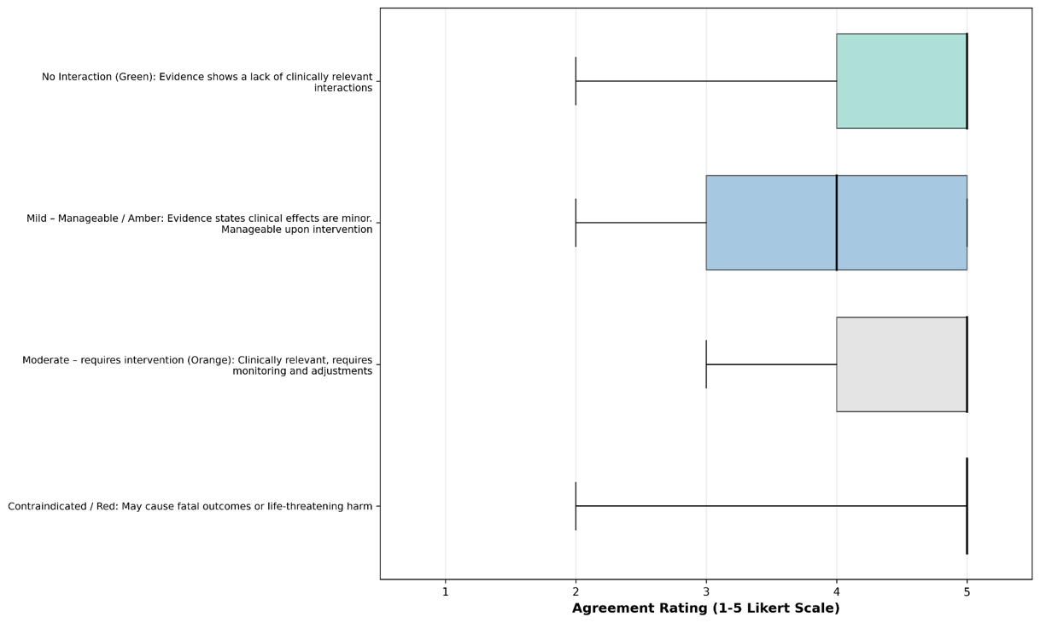
Figure 1: Standardisation of DDI Classification.

Table 4: Evidence factors for DDIs
Rate importance | Minimum | Maximum | Median (IQR) | Count
Study Design type | 3.00 | 5.00 | 4 (4–5) | 19
Number of supporting studies | 2.00 | 5.00 | 3 (3–4) | 19
Case report (>5 reports) | 2.00 | 5.00 | 3 (2–3) | 18
Bias and quality assessment | 2.00 | 5.00 | 4 (3–5) | 19
Other | 1.00 | 5.00 | 3 (2–4) | 3

Other:
Preclinical data (n=1)

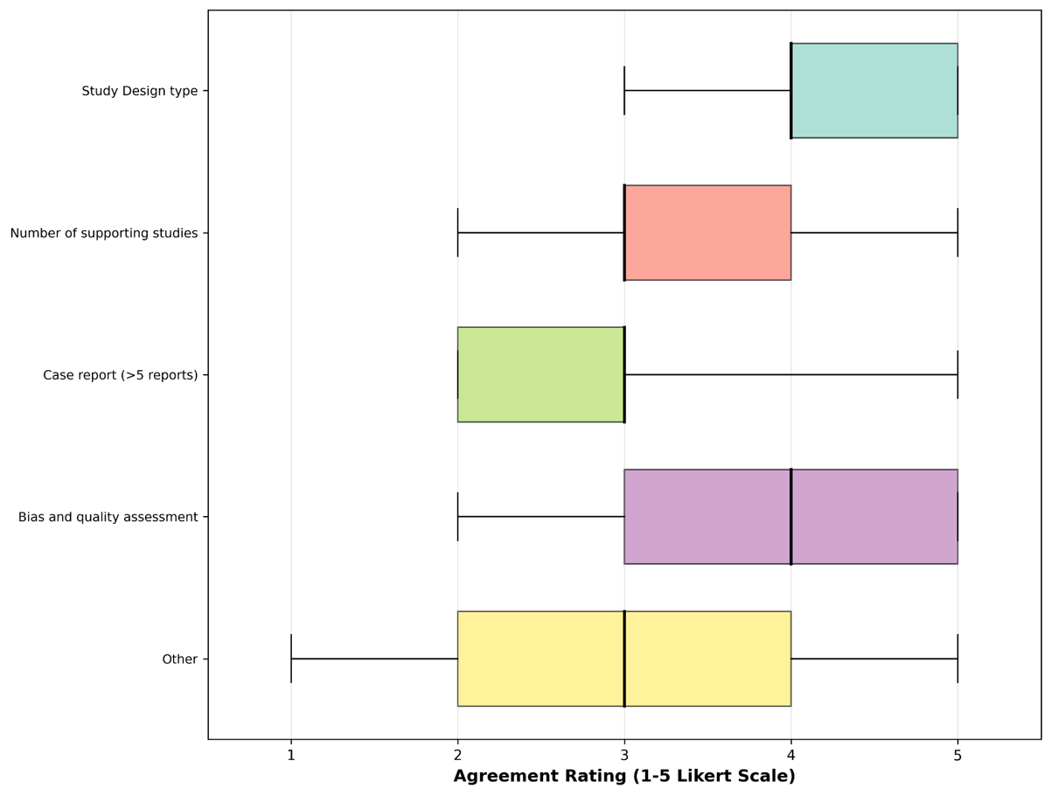
Figure 2: Evidence Factors for DDIs.

Table 5: Importance of factors in evaluating DDIs
Rate importance | Minimum | Maximum | Median (IQR) | Count
Necessity of medication (Condition and patient) | 3.00 | 5.00 | 5 (4–5) | 18
Likelihood of clinical DDI (PK / PD, duration of treatments) | 3.00 | 5.00 | 4 (4–5) | 19
Severity of DDI | 3.00 | 5.00 | 5 (4–5) | 19
Patient Tolerance / Therapeutic Index | 3.00 | 5.00 | 4 (4–5) | 19
Ease of management / monitoring | 3.00 | 5.00 | 4 (3–4) | 19
Quality of supporting evidence | 2.00 | 5.00 | 4 (4–5) | 19
Timing (start of medication simultaneously or offset) | 2.00 | 5.00 | 4 (3–4) | 19
Real-world factors (polypharmacy, multimorbidity, clinical setting) | 2.00 | 5.00 | 4 (3–4) | 19

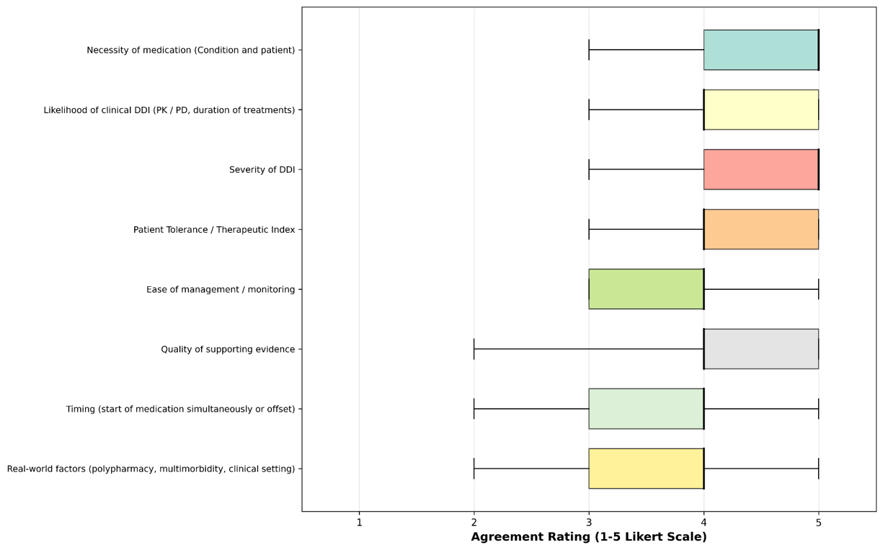
Figure 3: Importance of factors in evaluating DDIs.

Table 6: Agreement of statements about DDI classification
Rate agreement | Minimum | Maximum | Median (IQR) | Count
Clinical significance of DDIs is often context-specific (Population, comorbidities, setting) | 2.00 | 5.00 | 4 (4–5) | 18
DDIs should be expressed both by mechanistic class (CYP3A4 inhibitors) and therapeutic class (SSRIs, Ace inhibitors) unless unique | 3.00 | 5.00 | 4 (3–4) | 18
Pharmacogenomics and patient variability should be included in DDI classification | 2.00 | 5.00 | 4 (3–4) | 18

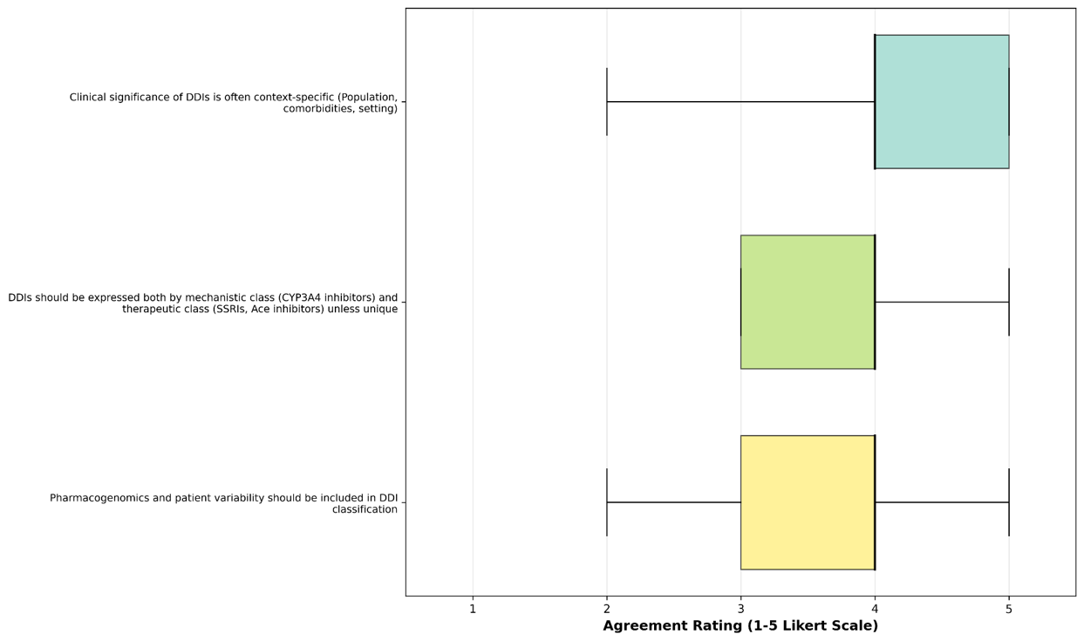
Figure 4: Agreement of statements about DDI classification.

Table 7: Usefulness of study designs for identifying DDIs
Rate usefulness | Minimum | Maximum | Median (IQR) | Count
Case reports | 2.00 | 5.00 | 3 (2–3) | 17
In vitro studies | 2.00 | 4.00 | 3 (2–3) | 17
In vitro to in vivo extrapolation (PBPK modelling) | 2.00 | 4.00 | 3 (2–4) | 18
Animal Studies | 2.00 | 4.00 | 2 (2–3) | 15
Clinical Trials (phase I – III) | 3.00 | 5.00 | 4 (4–5) | 18
Observational studies (cohort, case-control) | 3.00 | 5.00 | 4 (3–5) | 18
Other | 0 | 0 | 0 | 0

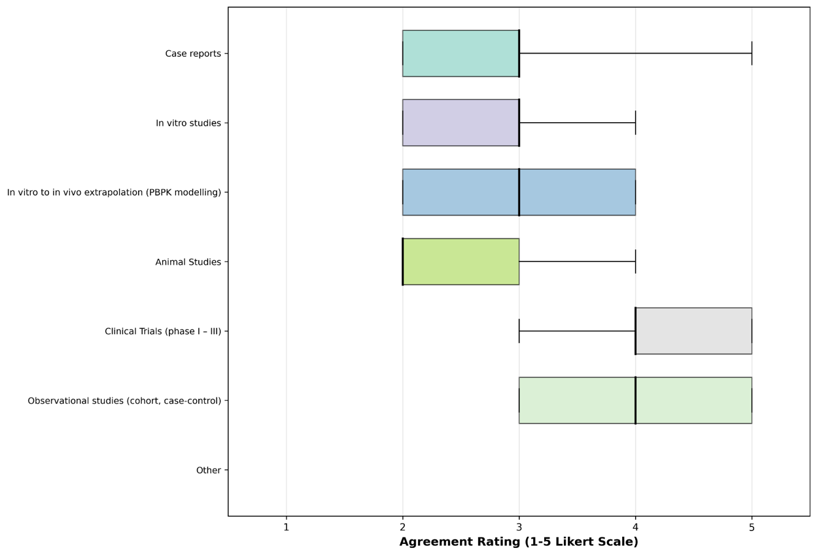
Figure 5: Usefulness of study designs for identifying DDIs.

Table 8: Statements about animal and in-vitro studies for DDIs
Rate agreement | Minimum | Maximum | Median (IQR) | Count
Primate models are more predictive than other animal models | 2.00 | 5.00 | 3 (3–4) | 18
Negative results in animals provide weak evidence against human DDIs | 3.00 | 5.00 | 4 (3–4) | 16
Negative results in in vitro studies provide some evidence against a DDI | 2.00 | 4.00 | 3 (3–4) | 15
PK/PD assessments in animals or in vitro models can inform potential mechanisms but not severity | 2.00 | 5.00 | 3 (3–4) | 15

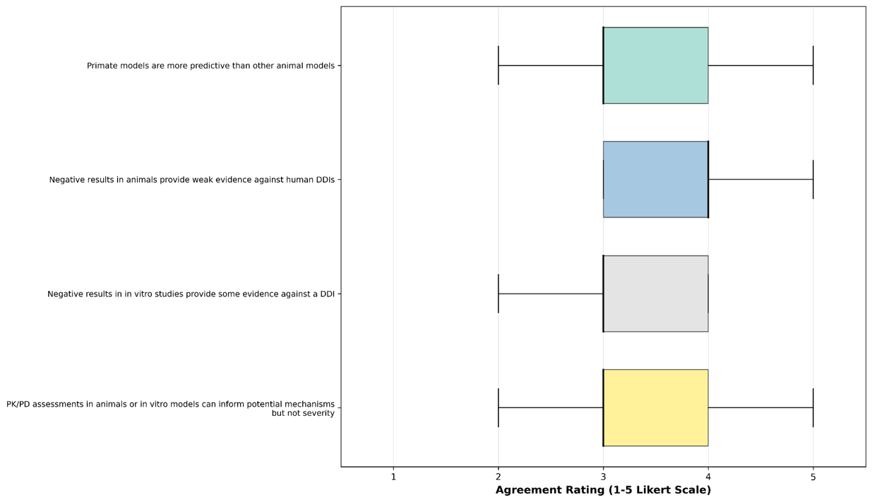
Figure 6: Statements about animal and in-vitro studies for DDIs.

Table 9: Usefulness of predictive approaches for DDIs
Rate usefulness | Minimum | Maximum | Median (IQR) | Count
In vitro extrapolation to humans | 2.00 | 5.00 | 3 (2–3) | 17
PBPK modelling | 2.00 | 4.00 | 3 (2–4) | 18
Genomics-informed prediction models | 2.00 | 5.00 | 3 (2–4) | 18

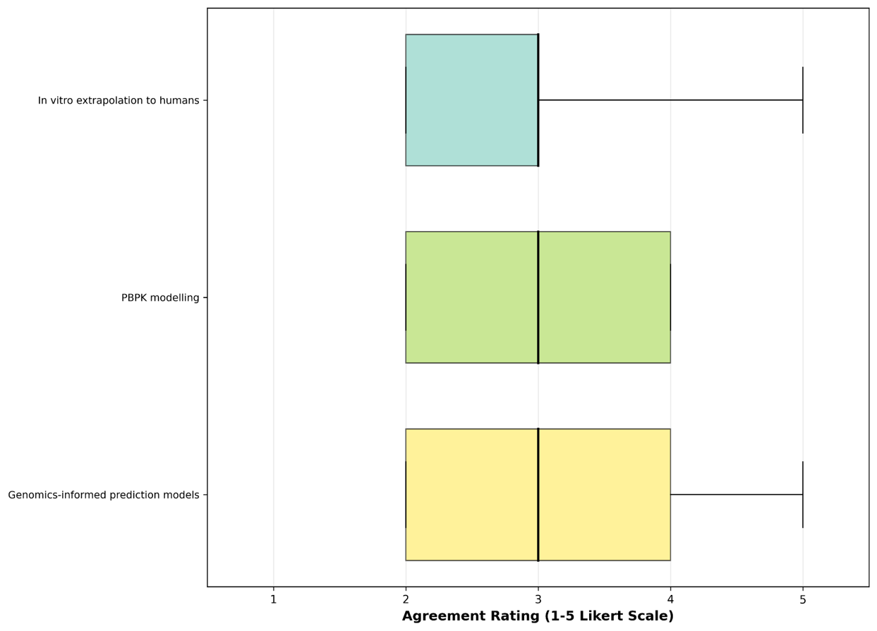
Figure 7: Usefulness of predictive approaches for DDIs.

Table 10: Agreement of statements about clinical trials and DDIs
Rate agreement | Minimum | Maximum | Median (IQR) | Count
Most clinically significant DDIs should ideally be identified in Phase I | 2.00 | 5.00 | 3 (2–4) | 18
Varying onset studies (precipitant vs victim drug timing) provide the strongest DDI evidence | 2.00 | 5.00 | 4 (3–4) | 18
Potential DDIs in Phase II may be confounded by disease state | 2.00 | 5.00 | 4 (3–4) | 18

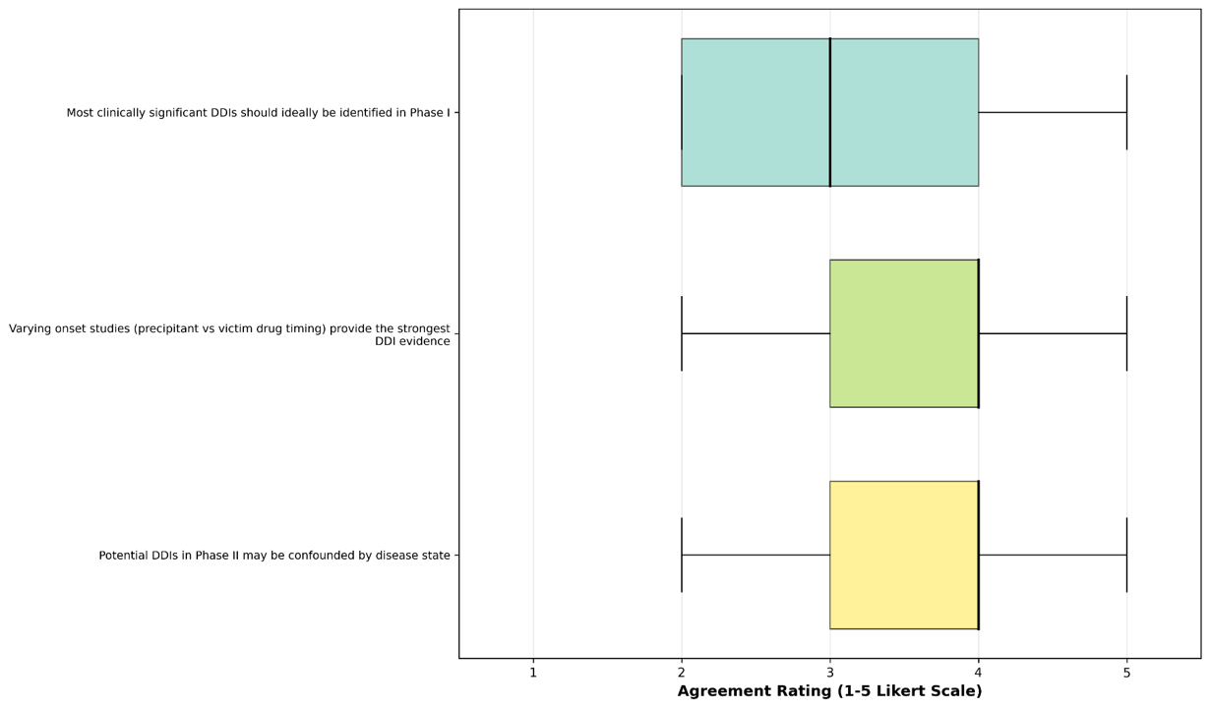
Figure 8: Agreement of statements about clinical trials and DDIs.

Table 11: Agreement of approaches to detecting and managing DDIs
 | Minimum | Maximum | Median (IQR) | Count
Mandatory clinician adverse event reporting is necessary | 1.00 | 5.00 | 4 (3–4) | 18
Patient-reported outcomes (e.g. symptom diaries, structured scales) are useful in identifying DDIs | 1.00 | 5.00 | 4 (3–4) | 18
Social media monitoring can be a supplementary source of safety signals | 1.00 | 5.00 | 3 (2–3) | 17
Patient education is an effective strategy for mitigating DDI-related harms | 2.00 | 5.00 | 4 (3–4) | 18

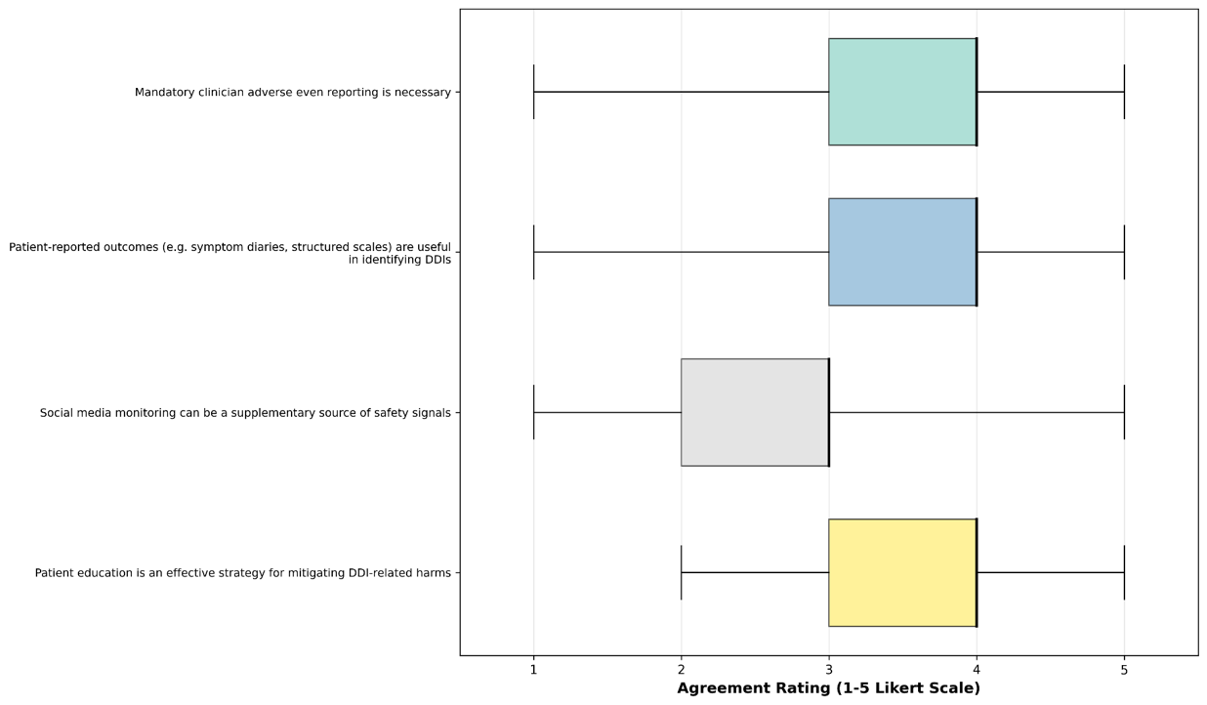
Figure 9: Agreement of approaches to detecting and managing DDIs.

S8 Reporting Checklist for Drug-Drug Interactions: Explanatory Document.
The following items are for the introduction or updating of a Drug-Drug Interaction (DDI) checker or database. These are presented in accordance with the STandArdised consensus-based Reporting checklist foR Drug–Drug Interaction checkers and databases (STAR-DDI) should be addressed appropriately and in accordance with the relevant fields. Many DDI checkers and databases are owned by private organisations and thus may not publish their introductions in a journal format. Although the items have been designed to be presented with the following sequence, resembling a journal article, no structured format is required and allowance to present more similarly to a newsletter is acceptable. For each item from the reporting checklist, an example/s and explanation will be provided. Please note that many of the examples provided are fabricated examples made to illustrate the important elements and features that are to address each item.

Title and Abstract

Title: Item 1; Identifies the article as introducing / updating a DDI checker / database. States version of checker / database.

Example of introducing a DDI database: RefDDI v1.0: A standardised reference dataset developed from natural language processing of drug-drug interaction literature.
Example of introducing a DDI checker: RefDDI v1.0: An open-source drug-drug interaction checker.
Example of updating a DDI database: RefDDI v2.0: an enhanced reference dataset with [X] new additions.
Example of updating a DDI checker: RefDDI v2.0: integrating a precision tool for personalised drug interaction risk assessment.

Explanation:
A standardised title was deemed necessary to allow potential readers or systematic reviewers of DDI checkers / databases to retrieve the relevant articles. Three essential aspects are required in the title:
Checker / Database name.
Checker / Database version.
One sentence summary of addition / novelty.
An additional optional feature would be to state the population this is intended for. For example, “RefDDI v1.0: A cardiometabolic drug-drug interaction checker.”. This is not a necessary characteristic as many DDI checkers are intended for general use, and thus a DDI checker that is specific could be seen as the unique / novel characteristic.

Abstract/Executive Summary: Item 2; Provides a summary of the number of DDIs present/added, expertise used to determine DDIs, evidence sources, intended user population, algorithm/methodology for curation.

Example for Introducing a DDI Checker:
Intended users: General practice clinicians, patients, and specialist clinicians.
Methodology: A multi-disciplinary team of toxicologists, pharmacologists, pharmacists and medical practitioners retrieved relevant evidence sources from clinical trials, observational studies, case reports and pharmacokinetic studies. A selection criterion for each study design is outlined within the text, with the specific aim of maximising translatability to the general population. These were thoroughly discussed and graded to remain high quality studies that comprise the DDI checker presented. Anonymous voting was used taking the majority vote (≥75% agreement).
Results: RefDDI contains 1100 DDIs, carefully curated by a multi-disciplinary team, with a majority (30%) of interactions being relevant to cardiometabolic medications. The lowest proportion of interactions were identified within immunosuppressant therapies. Overall, 36% of DDIs were deemed to be severe / contraindicated, 22% were identified to be of a moderate severity, the remaining 42% were deemed to have no interaction.
Future Direction: To further expand the current DDI checker’s breadth, with a strong emphasis on immunosuppressant medications. Currently, there are developments to incorporate human in the loop data curation methods, utilising natural language processing to identify potentially relevant articles, and an expert from the multi-disciplinary team confirming relevancy for evaluation.

Example for updating a DDI Checker:
Intended users: General practice clinicians, patients, and specialist clinicians.
Methodology: Building upon the original multi-disciplinary expert curation framework, RefDDI v2.0 now integrates an AI-assisted, human-in-the-loop validation pipeline. Natural language processing algorithms continuously screen PubMed, clinical trial registries, and pharmacovigilance databases for emerging interaction evidence, pre-ranking articles by relevance for review by the expert panel (toxicologists, pharmacologists, pharmacists, and medical practitioners). This hybrid approach combines computational efficiency with expert adjudication to maintain high-quality, evidence-based standards while reducing curation time by 60% and enabling quarterly database updates.
Results: RefDDI v2.0 has expanded to encompass 1,850 curated DDIs, representing a 68% increase in coverage. The previously underrepresented immunosuppressant category has been substantially enhanced, now comprising 18% of total interactions (up from 4%) through targeted oncology-pharmacy collaboration, and rheumatic-pharmacy collaboration. Cardiometabolic medications remain well-represented (28% of total). The severity distribution reflects refined clinical judgment: 41% contraindicated, 27% moderate, and 32% no interaction, with improved granularity through the addition of "conditional" risk flags (e.g., dose-dependent, duration-specific) for 35% of entries.
Future Direction: To transition toward precision medication safety, the DDI checker will incorporate pharmacogenomic variant data (CPIC guidelines) and patient-specific risk factors (organ function, age, pregnancy status) to provide individualized interaction risk stratification rather than population-level binary alerts. Development is underway to implement real-time surveillance of adverse event reporting systems (FAERS) to proactively detect novel interaction signals for expert validation, ensuring the tool anticipates emerging risks before they reach critical prevalence in clinical practice.

Example for introducing a DDI Database:
Intended users: Biomedical researchers, pharmacoepidemiologists, and developers of clinical decision support systems.
Methodology: A retrospective analysis of the FDA Adverse Event Reporting System (FAERS) and WHO VigiBase (2015-2024) utilizing disproportionality analysis (ROR-1.96SE ≥ 2, PRR ≥ 2) to detect potential signals, subsequently validated against electronic health record (EHR) data from three academic medical centres. Signals were filtered through a pharmacological plausibility framework assessing mechanism consistency, temporal relationships, and concordance with current data / literature. Drug nomenclature was standardized to UNII and ATC codes, with interaction frequencies stratified by patient demographics and comorbidity indices.
Results: RefDDI captures 1,850 clinically observed interactions among 520 drugs, with prevalence data derived from 45,000+ de-identified patient records. CNS-active medications (psychotropics, opioids) showed the highest co-occurrence rates (34%), while antimicrobial interactions demonstrated the strongest signal-to-noise ratios. Real-world severity differed from theoretical predictions: 18% resulted in hospitalization (vs. 41% predicted contraindicated), suggesting substantial "clinical noise" in traditional severity classifications.
Future Direction: Implementation of federated learning across hospital networks to enable privacy-preserving signal detection in underrepresented populations (paediatric, geriatric, pregnant patients). Development of patient-specific interaction risk scores incorporating pharmacogenomic variants (CPIC guidelines) and organ function biomarkers to transition from binary interaction alerts to probabilistic risk stratification.

Example for updating a DDI Database:
Intended users: Biomedical researchers, pharmacoepidemiologists, and developers of clinical decision support systems.
Methodology: RefDDI 2.0 expands version 1.0 with updated FAERS/VigiBase data through 2025 and longitudinal EHR records from 12 academic centres across four countries (increased from three). Enhanced disproportionality analysis employs BCPNN and MGPS algorithms alongside traditional ROR/PRR metrics, supplemented by temporal validation assessing onset latency and resolution upon drug withdrawal. Molecular mechanisms are cross-referenced against DrugBank kinetics data. The database now utilises the OMOP Common Data Model with standardised nomenclature (UNII, ATC, RxNorm, MedDRA, SNOMED CT) for seamless interoperability.
Results: The database catalogues 3,400 validated interactions among 890 pharmaceutical agents, representing a 166% increase in patient records and 84% expansion in drug coverage. Temporal analysis indicates 44% of adverse DDIs manifest within 48 hours of co-administration. While CNS-active medications remain most frequent (31%, down from 34%), oncology-immunology combinations demonstrated 210% growth. Real-world severity alignment improved substantially: hospitalisation rates now closely match predictions (26% observed versus 28% predicted), addressing previous clinical noise. Pharmacogenomic phenotype frequencies (CYP2D6, CYP2C19, SLCO1B1) are included for 38% of metabolic pathways with renal/hepatic impairment adjustments.
Future Direction: Implementation of federated learning across 50+ healthcare networks for privacy-preserving signal detection in underrepresented populations (paediatric, geriatric, pregnancy, rare diseases). Integration of multi-omics biomarkers will clarify idiosyncratic mechanisms, complemented by open-source in silico prediction modules enabling pre-clinical DDI liability screening for pharmaceutical developers.

Explanation:
Abstracts and Executive summaries provide the reader an understanding of the methodologies used and relevancy of a DDI checker / database briefly. With this in mind, stating the intended users first allows the variety of interested parties to choose if the following full text will be relevant for them. We recommend the additional sections to include the methodology for data curation / determining DDIs, a results section, and finally the future direction / plans to expand the database (if there are any intentions).
To ensure applicability, the methodology section needs to provide a thorough description of how data curation occurred and how DDIs were determined. Clearly stating a specific criterion was used (as per the methods section Evidence Sources for DDIs) and intended purpose is sufficient. Furthermore, if experts and medical specialists were consulted, briefly state their specialisation and how conflicts in decisions were handled. If statistical analysis or models were utilised, a sufficient description of the cut off values / relevant statistical variables must be present. Any changes to the methodology compared to the prior version of the database should be described. The results section outlines the number of DDIs introduced / added and stratifies the interactions based upon ATC codes. If statistical analysis methods or models were used, a general description of results and performance metrics should be provided. Future directions is a broad section to state any intentions in maintaining or addressing deficits within the checker / database. This could directly address increasing the coverage of DDIs within an ATC code or the usage of an accompanying methodology to increase breadth, coverage or quality of DDI selection. If no further additions or support is to be provided for a checker / database, using the following statement is sufficient; “There is no further intention to continue [development and / or maintenance] of [checker / database].”
Applicability of each section is likely to vary and will be subject to the author’s discretion to implement this criterion.

Introduction

Background: Item 3; Provide medical context, rationale and novelty of DDI checker / database.

Example DDI checker:
Drug–drug interactions (DDIs) contribute up to 30% of all adverse drug events and are a preventable cause of medication related harm. They occur when the effect or toxicity of one medicine is altered by another medicine. In clinical practice, DDIs are especially relevant for people using multiple medicines, including older adults, and patients with multimorbidity. As prescribing becomes more complex across primary care, specialist care and hospital settings, it is unreasonable for clinicians to know all potential interactions. Thus, actionable, comprehensive and transparent interaction information is a necessity in providing optimal care.
DDI checkers are commonly used to support prescribing, dispensing, medication reconciliation and medicines review. These clinical decision support tools can help clinicians identify potentially harmful medicine combinations and select appropriate management strategies, such as avoiding the combination, changing dose, separating administration times, monitoring laboratory parameters or counselling patients about symptoms of toxicity. However, current drug interaction resources differ substantially in their interaction coverage, severity classification, evidence grading, mechanism descriptions and clinical recommendations. The same medicine pair may be classified as contraindicated in one resource, moderate in another and absent in a third. This inconsistency can make it difficult for clinicians to determine whether an alert is clinically significant, leading to alert fatigue, and distrust within these digital health technologies. Whilst these systems can be integral to ensuring patient safety, current means to evaluate these tools is limited due to lack of transparency in how these systems are reported, various means to present clinical studies / mechanistic descriptions for the interaction and differing criterion for clinical management and severity classification.
To address this need, we developed RefDDI, a curated transparent reference database of clinically relevant DDIs. RefDDI was designed to provide structured, evidence-linked and clinically interpretable interaction records for use by clinicians, pharmacists, researchers and developers of clinical decision support systems. Each RefDDI record includes the interacting medicines, interaction mechanism, expected clinical consequence, severity rating, evidence category, evidence summary, patient specific risk modifiers and recommended management strategy. Where available, records also include pharmacokinetic parameters, affected metabolic enzymes or transporters, relevant therapeutic classes, onset of interaction, monitoring recommendations and links to supporting references.
The novelty of RefDDI is its explicit separation of interaction existence, clinical seriousness, evidence strength and management action. Rather than presenting a single overall warning level, RefDDI allows users to see whether an interaction is mechanistically plausible, clinically observed, supported by high quality evidence and actionable in routine care. This structure is intended to reduce inappropriate equivalence between theoretical, minor and clinically serious interactions. RefDDI also incorporates patient context fields, including age related vulnerability, renal impairment, hepatic impairment, pregnancy relevance, pharmacogenomic considerations and use of narrow therapeutic index medicines, allowing interaction records to be interpreted in relation to the patients most likely to experience harm.
RefDDI further differs from existing resources by providing transparent evidence provenance and reproducible curation rules. All interaction records are mapped to standardised medicine identifiers and assigned to predefined mechanism, outcome, severity, evidence and management categories. Each record is accompanied by a concise rationale explaining why the interaction was included and how its classification was determined. This design supports consistent interpretation, enables external evaluation of database content and provides a reference standard for comparing DDI checkers. Each of these features are constantly critiqued and evaluated by practising clinicians, pharmacologists and toxicologists to ensure clinical relevancy.
By combining clinical context, transparent evidence summaries and structured management recommendations, RefDDI aims to improve the reliability and usability of drug interaction information. The database is intended to support safer prescribing, reduce preventable medication related harm and provide a reproducible foundation for research, benchmarking and development of future drug interaction decision support tools. Here, we describe the design, data sources, curation process, database structure and potential applications of RefDDI.
Example DDI database:
Drug–drug interactions (DDIs) account for up to 30% of adverse drug events and are a preventable source of medication related harm. They occur when one medicine alters the therapeutic effect or toxicity of another, with particular relevance for people using multiple medicines, including older adults and patients with multimorbidity. Often, DDIs are described as instigating negative effects but can broadly include beneficial effects, coined as combinatorial treatment in pharmacodynamics and pharmacoenhancement in pharmacokinetics. As prescribing becomes increasingly complex across primary, specialist and hospital care, clinicians require actionable, comprehensive and transparent interaction information to support safe prescribing.
Curated DDIs databases are widely used in biomedical informatics, computational pharmacology and computer science as structured sources of known positive interaction pairs. These resources support drug–drug interaction prediction, relation extraction, literature mining, knowledge graph construction and clinical decision support development. In this context, database quality, completeness and transparency directly affect downstream model training, benchmarking and interpretation.
Existing DDI databases vary substantially in scope, terminology, evidence sources, interaction definitions and mechanistic annotation. Some prioritise clinically actionable interactions, whereas others include experimentally observed, pharmacokinetic, pharmacodynamic, predicted or literature derived interactions. As a result, the same drug pair may be inconsistently represented across resources, making it difficult to integrate databases, compare models or determine whether a positive interaction label reflects clinical evidence, mechanistic plausibility, text co occurrence, experimental observation or expert curation. Furthermore, there is a distinct separation of drug synergism interactions and adverse DDIs, hindering the full clinical context.
For computational applications, transparent curation of training data is especially important because complex machine learning and artificial intelligence methods can otherwise amplify poorly defined or weakly supported labels. Mechanistic and evidence based annotation provides a biological basis for plausibility, supports reproducibility and reduces the risk of incorrectly attributing adverse outcomes to non causal drug pairs.
To address these limitations, we developed RefDDI, a curated drug–drug interaction database designed as a transparent reference resource for biomedical and computational research. RefDDI focuses on drug–drug interaction pairs and their supporting evidence. Each record includes the interacting drugs, standardised drug identifiers, interaction mechanism, interaction type, expected effect, evidence category, source reference and curation rationale. Where available, records also include associated enzymes, transporters, targets, pathways and phenotypic outcomes.
The novelty of RefDDI is its explicit separation of interaction label, evidence source, mechanistic basis and biomedical consequence. Rather than treating all positive interaction pairs as equivalent, RefDDI distinguishes interactions supported by clinical reports, pharmacokinetic studies, pharmacodynamic evidence, experimental data, regulatory documents, curated literature or computational inference. This allows users to select subsets appropriate for specific tasks, such as training models on high confidence interactions, evaluating literature mining systems against text supported interactions or constructing mechanism enriched knowledge graphs.
RefDDI further supports computational reuse through reproducible curation rules and standardised data fields. Drug names are mapped to RxNorm, interaction descriptions are normalised into predefined categories and adverse events are standardised using MedDRA. These features allow users to trace interaction labels to their source, compare evidence types across drug pairs and integrate RefDDI with external biomedical resources, including drug target databases, pathway databases, adverse event resources and electronic health data.
By combining curated positive drug–drug interaction labels with evidence provenance and mechanistic annotation, RefDDI aims to improve the reliability and interpretability of drug–drug interaction data used in biomedical informatics. Here, we describe the design, data sources, curation process, database structure and potential applications of RefDDI.

Explanation:
DDI checkers and databases serve a direct purpose, to provide a corpus of known DDIs to warn users or for further predictions of additional DDIs. Thus, the background section does not necessarily require an extensive description. To be thorough the above section has covered a broad criteria of information that could be presented when introducing a checker or database. Within this section, it is recommended to describe broadly the epidemiology of DDIs briefly and what they are, the novelty of the DDI checker / database and the relevancy to the current medical literature or clinical practice. This section can also be used to describe the past versions of the DDI checker / DDI database as context for the additions and changes.

Methods

Evidence Sources for DDIs: Item 4a-4j; Provide a summary of evidence source and state a minimum criterion used to determine if a study was deemed of high quality and relevancy to the DDI. If experts and medical specialists were consulted, state their specialisation and how conflicts in decisions were handled. A list of suggestions and criteria is presented below to assist in reporting.

Example
A multi-disciplinary team of toxicologists, pharmacologists, pharmacists and medical practitioners retrieved relevant evidence sources from clinical trials, observational studies, case reports and pharmacokinetic studies. A selection criterion for each study design is outlined within Table 1, with the specific aim of maximising translatability to the general population. These were thoroughly discussed and graded to remain high quality studies that comprise the DDI checker presented. Anonymous voting was used taking the majority vote (≥75% agreement).

Table 1. Minimum criteria stratified by study design.
Study Design | Selection Criteria
Clinical trials | Phase of the trial: I or II trials only  Study design: Crossover design mandatory (parallel only if half-life >28 days, unethical to stop treatment, prolonged pharmacodynamics)  Randomisation method: Computer-generated with allocation concealment  Blinding: Double-blind mandatory (single-blind with justification)  PK sampling schedule: ≥12 timepoints covering 3× terminal half-life  Pharmacokinetic endpoints: AUC and Cmax as primary with 90% CIs  General characteristics of the patient population: Healthy volunteers or homogeneous disease population (CV<30%)  Dosage of medications: Highest therapeutic dose or maximum tolerated dose  Washout periods: ≥5× elimination half-life or minimum 2 weeks  No effect boundaries: 80-125% for standard drugs; 90-111% for narrow therapeutic index  Timing of drug administration: Sequence and interval between the two drugs specified (concurrent vs. staggered)  Route of administration: Oral bioavailable formulation specified  Experienced adverse event/s: CTCAE v5.0 grading with >90% completion rate
Observational studies | Study design: Prospective cohort or nested case-control only  General characteristics of the patient population: Age ≥18, stratified by renal/hepatic function  Dosage of medications: Therapeutic dose for ≥7 days (chronic) or single dose (acute)  Washout periods: 12-month drug-free lookback for incident users  Route of administration: Oral only (or IV separately specified)  Timing of drug administration: Concurrent exposure (index date ±30 days)  Experienced adverse event/s: Laboratory-confirmed toxicity or therapeutic failure  Population PK modelling - describe TDM cohort/s used
Case studies | General characteristics of the patient/s: Complete demographics (age, sex, weight, BMI, genotype if CYP substrate)  Dosage of medications: Weight-based dosing or standard therapeutic dose  Timing of drug administration: Dechallenge positive of precipitant drug (AE resolution upon discontinuation)  Experienced adverse event/s: WHO-UMC "probable/likely"; Grade ≥3 per CTCAE
PBPK modelling | The predictive performance: AUC fold-error <2.0 (observed/predicted ratio 0.5-2.0)  The population: Virtual n≥100 with realistic variability (CV 20-40%)  Whether parameters were predicted or clinically obtained: ≥50% parameters from clinical studies  Objective: Prospective prediction (blinded to validation data)  Accordance with EMA/CHMP guidelines: Full reporting template compliance  Assumptions made for modelling: Sensitivity analysis on ≥3 key parameters
In vitro studies | Metabolism mediated interactions: fmCYP >0.5 for major pathways; [I]max,u/Ki >0.1 or Ki <10× [I]max,u; ≥2-fold CYP mRNA induction at clinical concentrations  Transporter mediated interactions: [I]/IC50 >0.1 for uptake transporters, >0.02 for efflux transporters; Quantitative contribution to total clearance >25%  Metabolite interactions: AUCmetabolite/AUCparent >0.25 with inhibition potency within 10× of parent compound  Methodology per ICH M12 guidelines mandatory
Emulated DDI trials | General characteristics of the patient/s: EHR with linked pharmacy and laboratory data (not claims-only)  Exclusion and inclusion criteria: Propensity score matching (caliper 0.2 SD) for ≥5 confounders  Dosage of medications: Pharmacy fill dates with ≥80% proportion of days covered (PDC)  Washout periods: 180-day pre-index drug-free interval  Experienced adverse event/s: WHO-UMC "probable/likely"; Grade ≥3 per CTCAE
Disproportionality analysis | Deduplication method: FDA deduplication algorithm or WHO VigiBase method  Temporal relationship definition and time to onset analysis: Median TTO ≤30 days with IQR analysis  Reporting odds ratio cut off: ROR ≥2 with lower 95% CI >1  Proportional reporting ratio cut off: PRR ≥2 with χ² ≥4  Bias controls: Competition bias adjusted and stimulated reporting excluded  Validation method (if presented): Comparison with Lareb or WHO reference DDI set
Molecular docking / computer simulated structure modelling | Accuracy in depicting structure of drug/ligands/proteins involved in pathway: Crystal resolution <2.5Å or AlphaFold pLDDT >90  Definition of true and false positive/negatives: ROC-AUC >0.7 vs validated DDI set  Predictive performance: Enrichment factor >10 at 1% database screening; Redocking RMSD <2.0Å
*The selection criteria provided has omitted some of the recommended factors to illustrate the allowance for flexibility in the reported selection criteria. It is highly recommended that the suggested factors listed in the checklist were considered in the individual grading of the evidence.

Explanation:
Reporting the minimum criterion for justifying the presence of a DDI is a crucial aspect of this reporting checklist and ensuring the DDI checker / database is of a high quality. A variety of study designs are outlined to allow the most up to date available evidence to be appraised with the list of factors identified through the Delphi consensus study. Not all of these study designs will be relevant to report within the manuscript and only the included should be reported. Additionally, ideal information may not be present for some DDIs and thus the ‘best’ information or most fitting information should be reported with an indicator that this may differ from the exacted evidence standards stated. Within each of the study designs presented, dosage descriptions include the route of administration, formulation, and amount of active ingredient.

Data curation processes / algorithms: Item 5; Describes the process for selecting DDIs from the evidence sources and determining severity and clinical management (whether it is by experts, human in the loop, artificial intelligence, machine learning, computational).

Example:
DDIs were selected through dual independent review of evidence sources, with inclusion requiring consensus between two clinical pharmacologists. Severity classification (Contraindicated/ Moderate/No Interaction) and clinical management recommendations (Professional Management Required, Personalised Dosing Required, or No Management Required) were determined by a multidisciplinary expert panel (clinical pharmacologists, toxicologist and a pharmacology researcher) and adverse event severity. Disagreements were resolved by a third reviewer (toxicologist); no automated classification tools were employed.

Explanation:
To complement the section on the Evidence Sources for DDIs criteria, it is important to understand the methodology for DDI selection, classification and conflict resolution. A critical component of reporting data curation is incorporating the standardised severity scheme and clinical management recommendation schemes (Table 2a/b), developed from the Delphi consensus study conducted. To allow trust in the processes / algorithms used, it is highly recommended to utilise this severity scheme and clinical management recommendation criteria.

Table 2a.
Severity Classification | Description
Contraindicated (Red) | May cause severe harm or loss of efficacy, such as organ toxicity
Moderate (Orange) | Inhibits daily function, and clinical effects may linger for multiple days after ceased use. Pharmacokinetic data suggest concentrations exceed toxic thresholds.
No Interaction / Mild Interaction (Green) | no symptomatic or minimal hindrance with limited PK related effects due to the presence of the two medications

Table 2b.
Clinical Management Recommendation | Description
Professional Management Required | Careful dose timing is required to mitigate DDI related harm.
Personalised Dosing Required / Manageable by Patient | Alteration to dose may mitigate DDI risk. Alternatively, educating the patient on timing may mitigate DDI risk.
No Management Required | Alterations to dose and timing does not alter severity or presence of DDI

Results

Database: Item 6; Describes the number of DDIs, a breakdown of the most common DDIs based on ATC codes, clinical management level, the standardised severity scheme, mechanistic class and therapeutic class.

Example
The final database comprised 1,247 unique DDIs involving 412 distinct drugs. As shown in Table 3, interactions were distributed across first-level anatomical groups, with the highest concentrations observed in Anti-infectives for systemic use (ATC J, n=312, 25.0%), driven predominantly by potent CYP3A4 inhibitors (e.g., azole antifungals, macrolides) and P-glycoprotein substrates. The Cardiovascular system (ATC C, n=249, 20.0%) reflected narrow therapeutic index drugs such as digoxin, statins, and anticoagulants, while the Nervous system (ATC N, n=224, 18.0%) showed frequent psychotropic polypharmacy involving CYP2D6 and CYP3A4 metabolic pathways. The Alimentary tract and metabolism (ATC A, n=150, 12.0%) contributed substantially through acid-suppressing agents affecting drug absorption, and Antineoplastic and immunomodulating agents (ATC L, n=125, 10.0%) presented complex metabolic profiles involving tyrosine kinase inhibitors. Remaining anatomical main groups (Musculo-skeletal [M], Blood and blood forming organs [B], Respiratory [R], Genito-urinary [G], Systemic hormonal preparations [H], Dermatologicals [D], Antiparasitic [P], Sensory organs [S], and Various [V]) collectively accounted for 15.0% of documented interactions.
Table 3.
Anatomical Main Group | Number of DDIs | % of Total
Anti-infectives for systemic use | 312 | 25
Cardiovascular system | 249 | 20
Nervous system | 224 | 18
Alimentary tract and metabolism | 150 | 12
Antineoplastic and immunomodulating agents | 125 | 10
Musculo-skeletal system | 50 | 4
Blood and blood forming organs | 25 | 2
Respiratory system | 25 | 2
Genito-urinary system and sex hormones | 30 | 2.4
Systemic hormonal preparations, excluding sex hormones | 20 | 1.6
Dermatologicals | 15 | 1.2
Antiparasitic products, insecticides and repellents | 12 | 1.0
Sensory organs | 10 | 0.8
Various | 10 | 0.8
Total | 1,247 | 100

Table 4 presents the cross-classification of severity and clinical management recommendations, revealing nuanced risk stratification beyond categorical silos. While Contraindicated (Red) interactions predominantly required Professional Management (n=112, 83.6%), mandating avoidance or complex clinical oversight, a subset (n=22, 16.4%) permitted Personalised Dosing strategies. These represented scenarios where drastic dose reduction of the victim drug (e.g., 75-90% reduction) could theoretically mitigate toxicity when absolute discontinuation was clinically untenable. Moderate (Orange) interactions exhibited the most heterogeneous management profiles: 44.0% (n=333) necessitated professional oversight for intricate timing protocols or therapeutic drug monitoring; 50.0% (n=378) were manageable through standard dose adjustments or patient education on administration timing; and notably, 6.0% (n=45) required No Management despite measurable PK changes. These latter cases reflected scenarios where exposure alterations lacked clinical consequence, such as non-critical endpoints with wide safety margins. No Interaction [Green] classifications primarily fell into lower management tiers, with 52.4% (n=187) retaining precautionary personalised dosing recommendations (minimal monitoring) and 47.6% (n=170) warranting no specific clinical action.

Table 4.
 |  | Clinical Management
 |  | Professional Management Required | Personalised Dosing Required / Managed by Patient | No Management Required | Column Total
Severity | Contraindicated | 112 (9.0%) | 22 (1.7%) | 0 | 134 (10.7%)
Severity | Moderate | 333 (26.7%) | 378 (30.3%) | 45 (3.6%) | 756 (60.6%)
Severity | No Interaction | 0 | 187 (15.0%) | 170 (13.6%) | 357 (28.6%)
Severity | Column Total | 445 (35.7%) | 587 (47.1%) | 215 (17.2%) | 1,247 (100%)

Explanation:
To maximise applicability and usage of a DDI checker / database, it is imperative that the coverage of DDIs is mapped and easy to understand for researchers, clinicians and laymen alike. The above example showcases a DDI checker specifically made towards researchers and clinicians, hence only presenting an ATC code breakdown and severity / clinical management table. DDI checkers / databases designed for patients should prioritise accessibility and add additional laymen terms that follow the disease group that the medication is most often prescribed for. The readers and potential users will benefit from structured tables to show therapeutic diversity (as seen in Table 3), and the actionable interactions and coverage through the cross tabulated severity and clinical management (Table 4).
The DDI checker / database should also clearly indicate whether the reported DDI refers to an interaction between specific drugs or a broader drug class interaction. Information on specific drug pairs should be provided where available, as the severity, mechanism and suggested clinical management may differ between individual medications within the same class. Where the evidence or recommendation applies to an entire drug class, this should be clearly stated (e.g., SSRI class + anticoagulant class), rather than presented as though it applies equally to every individual drug pair.
It can be useful as well to present tables highlighting the mechanistic and therapeutic class pairs that are most prevalent as DDIs. However, this is not a requirement and rather these standardised classifications for presenting DDIs should be on the DDI checker / database platform. These definitions are the following:
Mechanistic class refers to the inhibitory / inducing / interaction that occurs (pharmacokinetic or pharmacodynamic) between the precipitant and object drug (e.g., CYP3A4 inhibition, P glycoprotein transport, OATP1B1 inhibition).
Therapeutic class refers to the common therapeutic use of the medications involved (e.g., SSRI + anticoagulant, statin + macrolide). The combination of the two classifications allows clinicians and researchers a short form to gain a general understanding of the interaction / required management.
Where available, suggested clinical management should relate to the interaction between the medications involved, rather than the routine management of the individual medications (e.g., avoid the combination, adjust the dose, separate administration times, use an alternative medication, or undertake additional clinical or laboratory monitoring). Suggested clinical management should be provided for the specific drug pair where possible. Where management is based on a broader drug class interaction, this should be clearly identified.
For DDI databases, a severity and clinical management classification may not be applicable or necessary and thus can be omitted. However, the database should still specify whether the DDI relates to specific drugs or broader drug classes. Furthermore, if the DDI checker / database is specialised towards a specific indication or type of medication, it is suggested to have a breakdown by ATC codes of the corresponding medications.

Additional Changes and Features: Item 7; Outlines any additional changes to software or features. Describes user feedback and planned direction for future updates.

Example:
RefDDI Version 1.0 launched with 1,247 DDIs derived exclusively from Phase I/II clinical trials and PBPK modelling, covering 412 drugs predominantly within cardiovascular, anti-infective, and nervous system therapeutic classes (ATC C, J, and N). User feedback from 45 clinical pharmacists indicated critical gaps in oncology and immunology portfolios, plus requests for real world evidence to supplement controlled trial data.Within the clinical decision support tool, a large language model is present to provide catered prescribing advice based upon the patient’s details.
Version 1.5 (scheduled Q3 2026) expands the evidence base through integration of pharmacovigilance data (FAERS and VigiBase) and high quality observational studies, adding an estimated 800 DDIs involving antineoplastic agents (ATC L) and immunomodulators (ATC L04). We will incorporate in vitro transporter data (OATP1B1, BCRP, MATE1) to address previously underrepresented mechanisms, increasing mechanistic coverage by 40%. We also plan to add 250 DDIs involving narrow therapeutic index drugs extracted from case series and therapeutic drug monitoring databases to enhance clinical validity in high risk populations.
Version 2.0 (planned Q2 2027) represents a methodological paradigm shift. We will implement machine learning algorithms trained on the existing dataset to predict interaction severity for unstudied drug pairs, expanding coverage to an estimated 5,000 predicted DDIs with confidence intervals. We will integrate molecular docking data for CYP3A4 and CYP2D6 inhibition potential to prioritise interactions requiring empirical validation. Finally, we will establish an open submission portal allowing clinicians to report emerging DDIs for expert review, creating a living database that evolves with clinical practice.

Explanation:
In choosing and using a DDI checker, an important factor for a clinician or patient is the additional features for accessibility or utility and the future direction of the software. This section is up to the author’s digression for use and can be omitted. For authors of a DDI database, the authors can detail plans for future expansion or state the absence of continual support.

Summary and Future Direction: Item 8; Provides an overall summary of the DDIs present, methodologies used and intended population. States direction for future development.

Example:
RefDDI Version 1.0 delivers 1,247 curated interactions across 412 drugs, integrating evidence from clinical trials, PBPK modeling, and in vitro mechanistic studies. Designed for clinical pharmacists and physicians managing adult polypharmacy, the database prioritizes high risk therapeutic classes including cardiovascular and anti infective agents.
Future development will deploy machine learning algorithms to predict interaction risks for unstudied drug pairs, supported by a clinician reporting portal that enables users to submit novel interactions for rapid expert assessment and database integration.

Explanation:
A concise conclusion can be used to highlight the overall features of the database or DDI checker. Details of the novelty, who it is designed for and the future direction should be presented here in a succinct manner.

Other Information

Supplementary Information: Item 9; Outlines the availability of supplementary resources, direct links to the DDI checker / database and relevant additional information.

Example:
The RefDDI database and interactive query interface are publicly accessible at https://www.refddi.org. Application Programming Interface (API) documentation and endpoints for institutional integration are available at https://www.refddi.org/api. Source code for the DDI checker platform is provided via GitHub (https://github.com/refddi/core) under the MIT license.
Explanation:
Authors should clearly state where supplementary resources related to the DDI checker or database can be accessed. This should include direct links to the database, web interface, downloadable datasets, API documentation, or other supporting materials, where applicable. The purpose of this item is to ensure that readers, clinicians, researchers and developers can locate, evaluate and reuse the resource without ambiguity.
When access is restricted, authors should describe the conditions of access, such as registration, institutional licence, data use agreement, subscription or request based access. Authors should also specify relevant version information, update dates, licensing terms and repository links to support transparency, reproducibility and long term accessibility.

Funding and Conflicts of Interest: Item 10; States any sources of funding and/or conflicts of interest that are relative to the development of the DDI checker / database (e.g., author affiliations, sponsors, etc.)

Example:
This work was supported by the XXXXX (grant XXXXX) and the XXXXX (grant XXXXX). The funders had no role in development of the database, data collection and analysis, decision to publish, or preparation of the manuscript.
Explanation:
Authors should disclose all funding sources and conflicts of interest relevant to the development, maintenance, evaluation or publication of the DDI checker or database. This includes research grants, institutional funding, industry sponsorship, commercial partnerships, in kind support, paid consultancy, advisory roles, employment relationships, intellectual property, licensing arrangements, equity ownership or any other financial or non financial interests that could influence, or be perceived to influence, the resource.
Authors should also state the role of funders, sponsors or affiliated organisations in the design, data collection, curation, algorithm development, validation, interpretation, manuscript preparation and decision to publish. If funders or sponsors had no role in these activities, this should be explicitly stated. Transparent reporting of funding and competing interests allows readers to assess potential sources of bias, commercial influence and independence of the DDI checker or database.

