Author Contributions
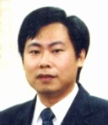
Jia-Chuan Lin received the B.S., M.S., and Ph.D. degrees in electrical engineering from National Cheng Kung University, Taiwan, in 1990, 1992, and 1996, respectively. He is a Distinguished Professor in the Department of Electrical Engineering, National Taipei University, Taiwan. Previously, he has been the Vice President of National Taipei University and the Vice President of St. John’s University in Taiwan. His current research interests include very-large-scale integration circuit, solid state physics, semiconductor devices, and nanotechnology. He received the Excellent Research Award from the International Electronics Devices and Materials Association in Taiwan. Also, he is a subject of biographical record in Who’s Who in the World in 2008.
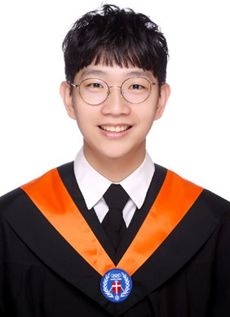
Jun-Hao Chen received the B.S. degree in Electrical Engineering from Chung Yuan Christian University, Taoyuan, Taiwan, in 2023. He is currently pursuing the M.S. degree in Electrical Engineering at National Taipei University, New Taipei City, Taiwan. His research interests include gas sensors, silicon wafer etching, polymer lithium-ion batteries.

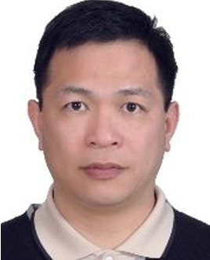
Hsu-Nan Yen received the B.S. degree in electrical engineering from Chung Yuan University, Taoyuan, Taiwan, in 1985, the M.S. degree in electrical engineering from National Tsing Hua University, Hsinchu, Taiwan, in 1987, and the Ph.D. degree in industrial engineering and management from Yuan Ze University, Taoyuan, Taiwan, in 2004. He is an Associate Professor of Electrical Engineering at National Taipei University, New Taipei, Taiwan. His research interests include semiconductor manufacturing and testing, machine vision inspection, photoelectric inspection.
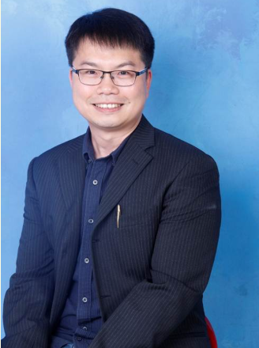
Chien-Hung Wu received the B.S. and M.S. degrees in electrical engineering from Chung Hua University, Hsinchu, Taiwan, in 2001 and 2003, respectively, and the Ph.D. degree in microelectronics and electrical engineering from National Cheng Kung University, Tainan, Taiwan, in 2007. During his academic training, he worked as an engineer in the Reliability Department at Taiwan Semiconductor Manufacturing Company (TSMC). After receiving his Ph.D., he joined TSMC as a chief engineer in the Process Integration Department, where he contributed to the development of 32 nm CMOS high-k/metal gate technology. His doctoral research focused on high-work-function metal gate stacks with excellent thermal stability for advanced CMOS applications. Dr. Wu’s research interests include CMOS process integration, semiconductor devices, flexible electronics, and CMOS compatible sensors. He has published more than 85 peer-reviewed journal articles and 45 conference papers, including five at the IEEE International Electron Devices Meeting (IEDM).

Kalpana Settu obtained PhD from National Central University (Zhongli, Taiwan), System and Biomedical Engineering Group, Department of Electrical Engineering, in July 2016. She was a post-doctoral fellow in the Department of Electrical Engineering at National Central University from September 2016 to January 2017. Her research interests are broadly in Biosensors and Biomedical Electronics. She was a assistant professor (Feb. 2017~Jan. 2022) and a assiciate professor (Feb. 2022) in National Taipei University. She is with Indian Institute of Information Technology, Design and Manufacturing, Kancheepuram: Chennai, Tamilnadu, IN since June 2022.

