Figures, tables and additional files
Supplementary Figure 1
Supplementary Figure 1. Identity-by-descent (IBD) analysis used to identify cryptic relatedness among the genotyped individuals. Each point represents a pairwise comparison between two individuals based on the probabilities of sharing zero (K0) and one (K1) allele identical by descent. The dashed red line indicates the expected relationship trajectory in the K0–K1 space. Sample pairs with an estimated kinship coefficient ≥ 0.125, consistent with first-degree relationships or closer, were identified, and one individual from each related pair was excluded during quality control to ensure statistical independence for downstream genome-wide association analyses.

Supplementary Figure 2
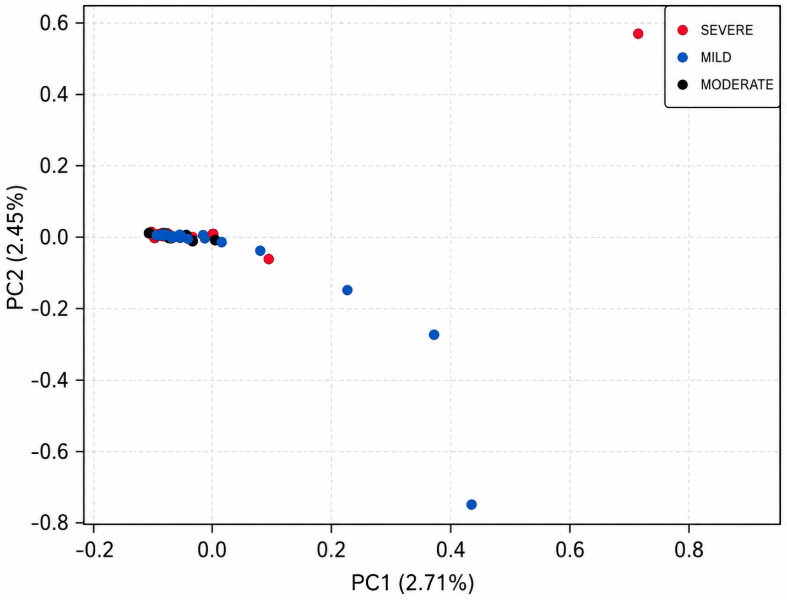
Supplementary Figure 2. Principal component analysis (PCA) of the study cohort stratified by COVID-19 clinical severity. Two-dimensional scatter plot showing the distribution of the 78 genotyped individuals according to the first two principal components (PC1 and PC2), which explained 2.71% and 2.45% of the total genetic variance, respectively. Each point represents one individual and is color-coded according to clinical severity: mild (blue), moderate (black), and severe (red). No distinct clustering was observed among the clinical severity groups, suggesting that population structure was unlikely to substantially influence the observed genetic associations.

Supplementary Figure 3
Supplementary Figure 3. Global ancestry composition of the Brazilian COVID-19 cohort. Stacked bar plot showing the estimated genomic ancestry proportions of the 73 high-quality individuals retained after quality control. Each vertical bar represents one individual and is partitioned into the estimated proportions of European (blue), Native American (green), and African (orange) ancestry. Individuals are grouped according to COVID-19 clinical severity (severe, moderate, and mild). The study population exhibited the expected admixed genetic background of the Brazilian population, with a predominant European ancestry (77.6%), followed by African (11.9%) and Native American (10.5%) contributions among the 73 unrelated individuals included in the final association analyses. Global ancestry estimates were inferred using supervised ADMIXTURE v1.3.0 with individuals from the Human Genome Diversity Project (HGDP) and the Simons Genome Diversity Project (SGDP) as reference populations.

