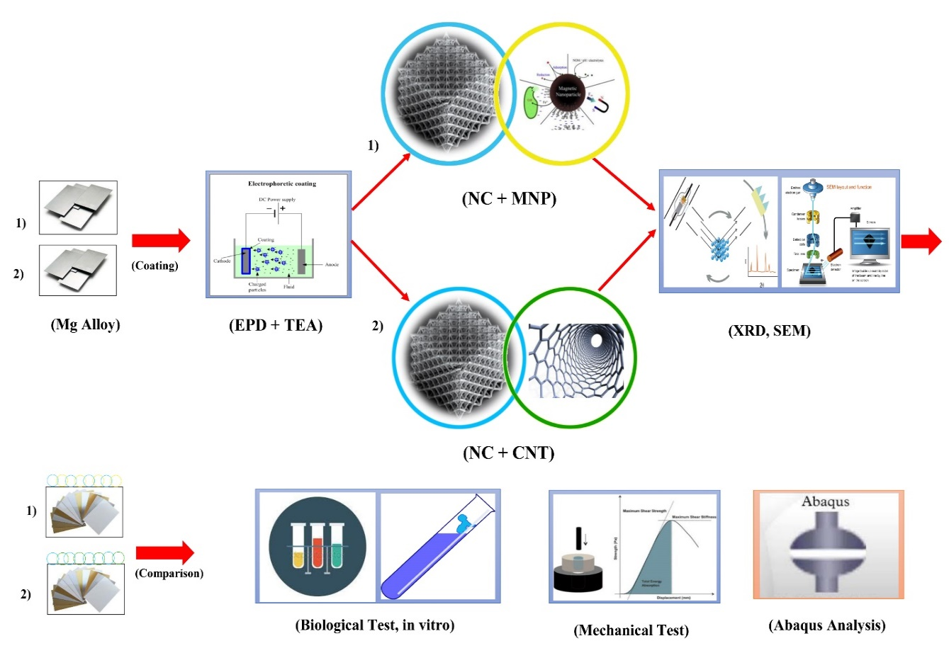
Figure 1: Schematic of the process for fabrication of ceramic-magnetic and ceramic-single walled carbon nanotube bio-nanocomposite coated with EPD technique on AZ91 substrate

