Appendix A
Map 1. Thermal Satellite Imagery of the 2023 Lahaina Wildfire.
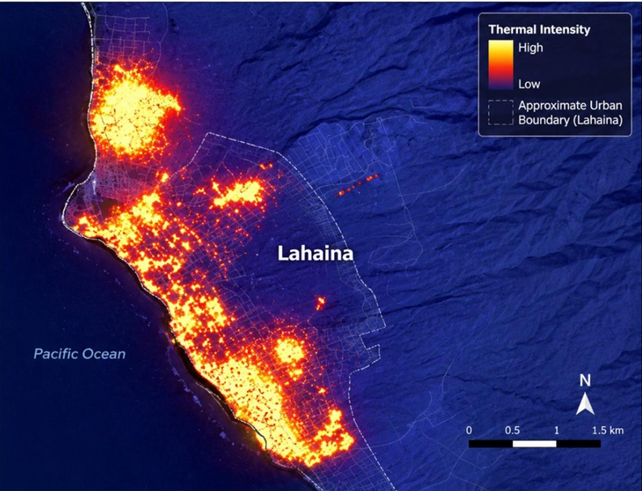
This thermal satellite imagery, captured during the peak of the August 8, 2023, Lahaina wildfire, provides a spatial representation of the wildfire's extent and relative thermal intensity across the affected urban–coastal corridor.
High-intensity thermal signatures (yellow to bright red) identify areas of active combustion and were used in this study to support the spatial analysis of wildfire progression, identify zones of concentrated fire activity, and evaluate the interaction between rapidly advancing fire fronts, urban development, and evacuation infrastructure.

Within the research methodology, NASA FIRMS thermal imagery was integrated with GIS-based roadway mapping, building damage assessments, survivor interviews, official investigations, and field observations to reconstruct wildfire progression and examine its influence on evacuation performance, accessibility, and emergency response.

The spatial distribution of heat signatures provided independent geospatial evidence supporting the study's conceptual–semi-empirical analysis of fire behavior, infrastructure constraints, and evacuation-system degradation. The concentration of intense thermal activity along Lahaina's densely developed coastal corridor is consistent with documented patterns of rapid structure-to-structure fire spread, transportation bottlenecks, and disproportionate impacts on vulnerable populations identified throughout this research.

Thermal data were obtained from NASA's Fire Information for Resource Management System (FIRMS) using MODIS and VIIRS satellite sensors. The approximate urban boundary of Lahaina is delineated for spatial reference.

**Source:** NASA FIRMS (Fire Information for Resource Management System). [https://firms.modaps.eosdis.nasa.gov/](https://firms.modaps.eosdis.nasa.gov/) (Accessed August 2023).

Appendix B
Map 2. Spatial Distribution of Building Damage Following the 2023 Lahaina Wildfire.
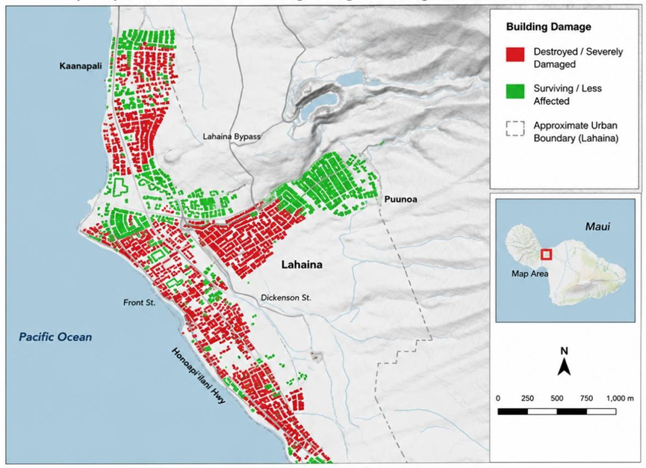
This map illustrates the spatial distribution of structural damage following August 8, 2023, Lahaina wildfire and served as a key GIS dataset in evaluating the relationship between wildfire progression, urban development patterns, evacuation infrastructure, and community vulnerability. Buildings shown in red represent structures that were destroyed or sustained severe fire damage, while green indicates buildings that survived or experienced limited damage. The spatial damage assessment was integrated with roadway networks, thermal satellite imagery, field observations, survivor interviews, and official investigations to identify areas where fire intensity, infrastructure limitations, and evacuation constraints converged.

The damage distribution reveals concentrated structural losses along Lahaina's densely developed coastal corridor, particularly within the historic downtown district, Front Street, and surrounding residential neighborhoods. In contrast, higher-elevation areas and neighborhoods with greater building separation, reduced fuel continuity, and improved roadway access exhibited comparatively lower damage levels. This spatial variability supports the study's findings that wildfire impacts were influenced not only by fire behavior but also by urban density, building configuration, accessibility, roadway connectivity, emergency response capability, and evacuation-system performance.

Within the conceptual–semi-empirical analytical framework developed in this research, the damage assessment map provides spatial evidence supporting the identification of compound-risk factors affecting vulnerable populations. When combined with GIS-based evacuation analysis, thermal imagery, and official post-disaster investigations, the map demonstrates how deficiencies in land-use planning, infrastructure resilience, accessibility, and emergency preparedness contributed to the unequal distribution of wildfire impacts and evacuation outcomes throughout Lahaina.

Damage data were compiled from Maui County GIS layers and post-disaster damage assessment records, including aerial imagery interpretation, field verification, and building inspection reports.

Source: Maui County GIS / Damage Assessment Maps (2023).
https://www.mauicounty.gov/DocumentCenter/View/106094 (Accessed August 2023).
Appendix C
Map 3. Wildfire Progression and Evacuation Corridor Constraints in Lahaina

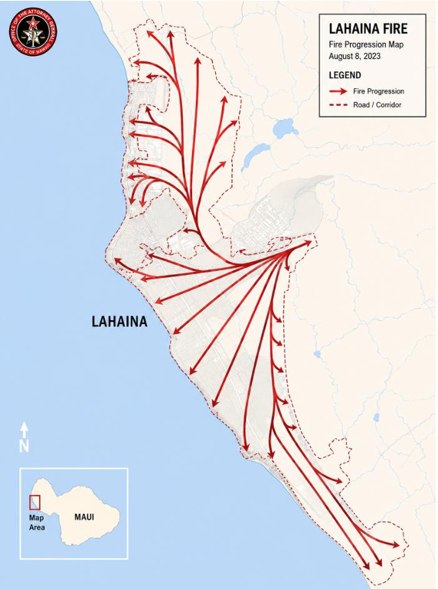
This fire progression map served as a key spatial dataset within the study's GIS-supported analytical framework, illustrating the relationship between wildfire spread, evacuation corridor availability, and transportation network performance during the 2023 Lahaina wildfire. The mapped directional fire progression was integrated with thermal satellite imagery, building damage assessments, roadway networks, survivor interviews, official investigations, and field observations to reconstruct the temporal and spatial interaction between advancing fire fronts and the community's evacuation infrastructure.

The map demonstrates that the wildfire progressed rapidly from the inland Wildland–Urban Interface (WUI) toward Lahaina's densely developed coastal corridor under extreme wind conditions generated by Hurricane Dora. As the fire advanced, it progressively intersected the community's primary north–south transportation network, particularly Honoapiʻilani Highway and connecting collector roads, significantly reducing evacuation route redundancy and limiting safe egress opportunities for residents.

Spatial analysis further reveals that Lahaina's dependence on a limited roadway network created a highly vulnerable evacuation system. The convergence of evacuees onto a small number of arterial corridors resulted in severe traffic congestion, route blockages, and restricted emergency vehicle access. Neighborhoods connected by single-access roads or limited roadway alternatives experienced progressively reduced evacuation options as fire spread intensified, contributing to localized transportation bottlenecks and delayed evacuation.

Within the conceptual–semi-empirical analytical framework developed in this research, this map provides spatial evidence supporting the study's findings that wildfire impacts were governed not only by fire behavior, but also by the interaction of roadway connectivity, land-use configuration, infrastructure resilience, accessibility, emergency traffic management, and evacuation planning. When integrated with the study's GIS analyses, official reports, and survivor accounts, the map demonstrates how limited evacuation corridor redundancy, combined with rapid wildfire progression, contributed to evacuation-system degradation and disproportionately affected older adults, people with disabilities, medically dependent individuals, and other vulnerable populations requiring additional evacuation assistance.

Source: Hawaii Attorney General. (2024). Investigation of the 2023 Lahaina Wildfire.

