Supplementary Figures
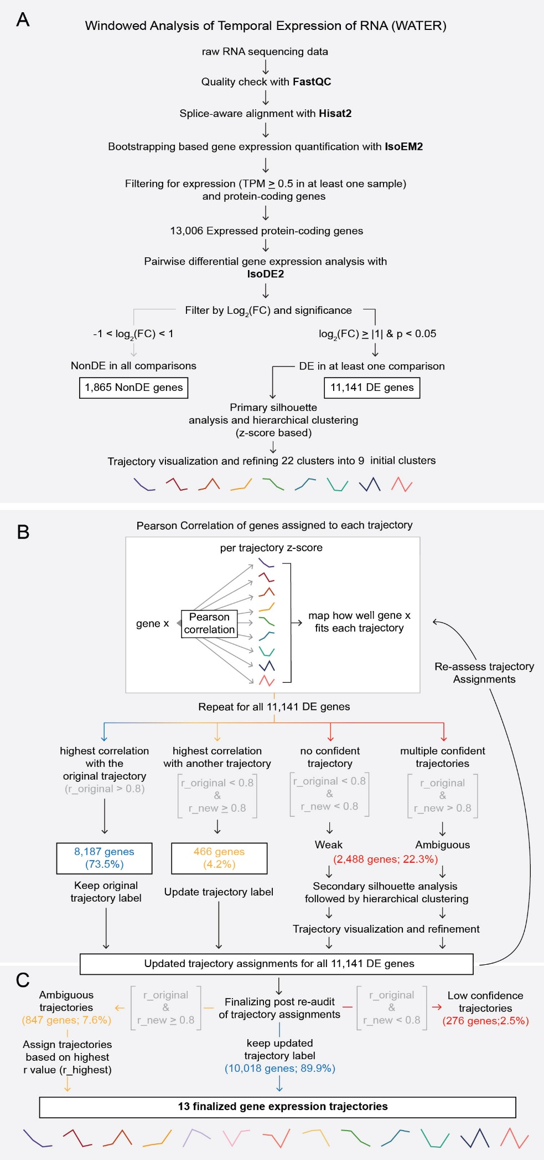
Supplementary Figure 1. Application of WATER to temporal RNA-seq data from WT mouse forelimbs. (A-C) Schematization of the WATER pipeline used to assess temporal gene expression patterns. (A) Following quality control (FastQC), alignment (HISAT2), and gene expression quantification (IsoEM2); 13,006 autosomally encoded protein-coding genes with an average expression > 0.5 TPM in at least one sample were retained for subsequent analysis. Pairwise differential expression analysis (IsoDE2) identified 11,141 differentially expressed (DE) genes and 1,865 non-differentially expressed (NonDE) genes. To characterize temporal expression patterns, z-score-transformed DE genes were subjected to silhouette analysis and hierarchical clustering. Silhouette analysis supported a broad range of robust clustering windows (k = 2-22); selection of k = 22 followed by trajectory consolidation based on shared temporal patterns yielded nine initial expression trajectories (E10.5^{Hi}, E11.5^{Hi}, E12.5^{Hi}, E13.5^{Hi}, Early^{Hi}, Late^{Hi}, E10.5^{Hi} and E13.5^{Hi}, Up-Down-Up, and Down-Up-Down). (B) To validate and refine trajectory assignments, each gene’s expression profile was compared to the mean expression profile of all trajectories using Pearson correlation. Most genes (8,187; 73.5%) showed the strongest correlation with their originally assigned trajectory (Pearson correlation coefficient (r) for the original trajectory ≥ 0.8; panel B, blue). Genes whose expression patterns more strongly matched a different trajectory (r_original < 0.8 & r_new ≥ 0.8; panel B, yellow) were reassigned, whereas genes with weak (r_original < 0.8 and r_new < 0.8) or ambiguous (r_original ≥ 0.8 and r_new ≥ 0.8) correlations were flagged for further evaluation (panel B, red). Genes with weak or ambiguous assignments were reanalyzed using an additional round of silhouette analysis and hierarchical clustering. This revealed four additional trajectories characterized by low expression at a single timepoint (E10.5^{Lo}, E11.5^{Lo}, E12.5^{Lo}, and E13.5^{Lo}). This additional round of clustering produced updated trajectory assignments for all 11,141 DE genes which were subjected to a second correlation-based audit to assess improvement in trajectory fit. (C) After the second audit, 13 high-confidence trajectories were defined (median r = 0.94), encompassing 97.5% (10,865 out of 11,141 genes) of all DE genes. The remaining 276 genes (2.5%) exhibited low similarity to any trajectory and were retained as a low-confidence category for transparency.

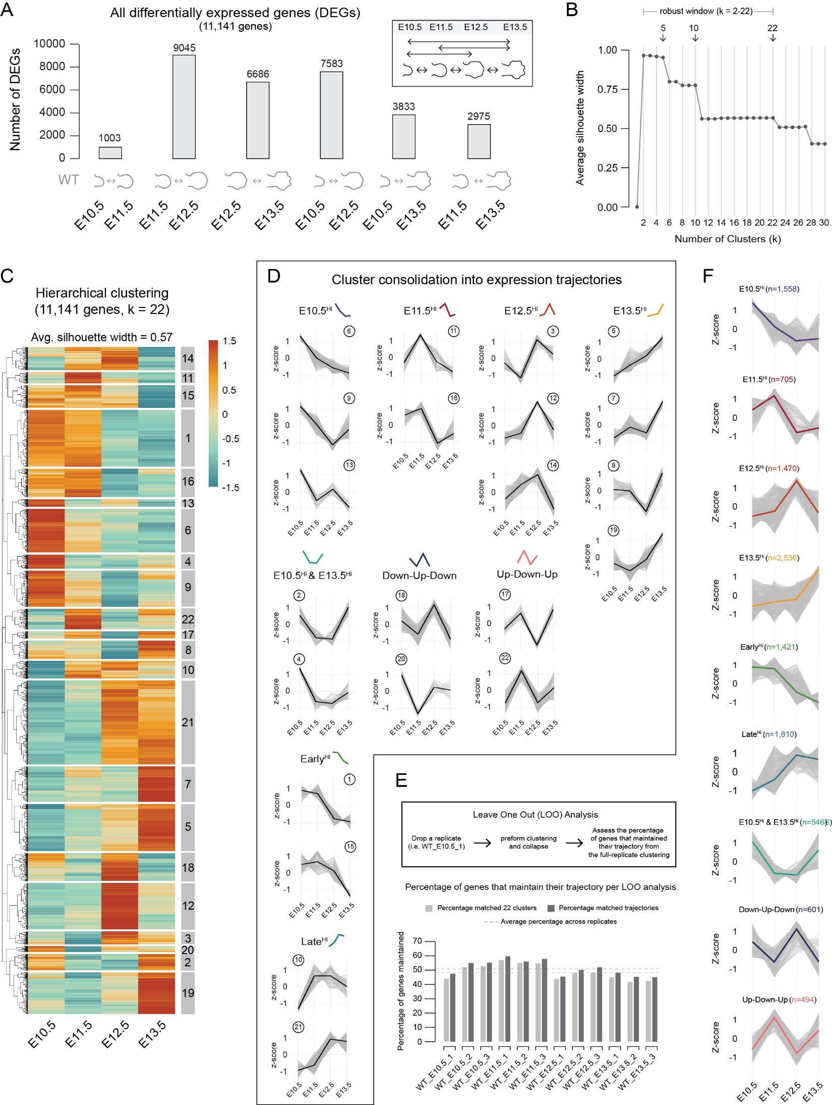
Supplementary Figure 2. Initial differential expression analysis and hierarchical clustering in WT mouse forelimbs. (A) Number of differentially expressed genes (DEGs) identified in each pairwise temporal comparison, including comparisons between non-adjacent timepoints as indicated by schematic icons below each bar. (B) Silhouette analysis across increasing numbers of clusters (k) for all DEGs identified a robust clustering window (k = 2-22) where the average silhouette width was greater than 0.5. These values were used to guide subsequent hierarchical clustering. (C) Hierarchical clustering heatmaps of all WT DEGs (z-scored expression) using k = 22. (D) Individual clusters produced when k = 22 and the strategy used to collapse them into trajectories characterized by high expression at one timepoint (E10.5 High, E11.5 High, E12.5 High, and E13.5 High), high expression at E10.5 and E11.5 (Early High) or E12.5 and E13.5 (Late High), or dynamic expression (E10.5 and E13.5 High, Down-Up-Down, and Up-Down-Up). (E) Assessing internal reproducibility using a Leave-One-Out (LOO) analysis where a single replicate is removed and clustering is repeated. Cluster assignments generated during each LOO iteration were compared to those obtained using the full dataset. The percentage of genes that maintain their original trajectory assignment is reported for both the cluster and trajectory levels. Mean retention values across all LOO iterations are indicated by dashed lines (light grey, mean cluster retention = 44.3%; dark grey, mean trajectory retention = 49.9%). (F) Averaged z-score expression profiles (colored lines) for each collapsed WT trajectory. Individual gene expression profiles are shown in grey. Gene counts per trajectory are indicated above each plot.

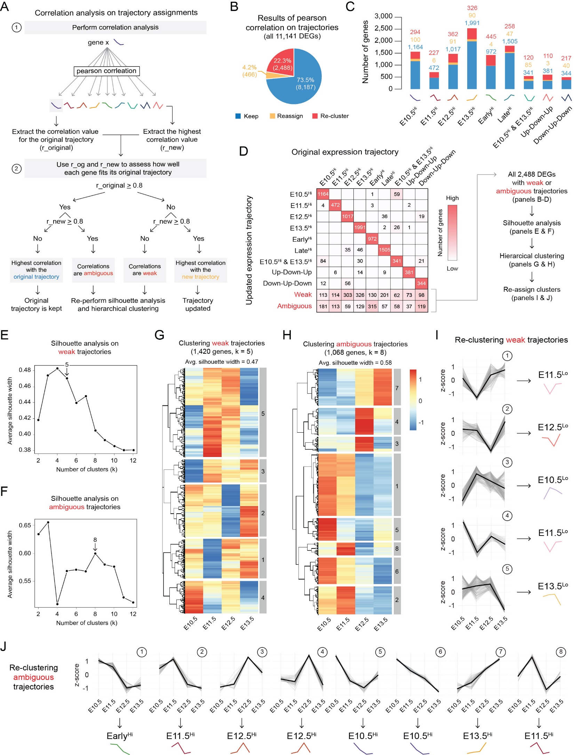
Supplementary Figure 3. Correlation-based reassessment of WT trajectory assignments identifies weak and ambiguous gene expression profiles. (A) Schematic overview of the correlation-based reassignment strategy used to evaluate confidence in trajectory assignments. For each gene, Pearson correlation coefficients (r) were calculated between its z-scored expression profile and each reference trajectory. The correlation with the originally assigned trajectory (r_original) and the highest correlation observed across all trajectories (r_new) were extracted. These values were then evaluated using a decision tree to determine whether a gene best fit its originally assigned trajectory (r_original > 0.8 and r_new < 0.8; original trajectory kept), correlated strongly with multiple trajectories (r_original > 0.8 and r_new > 0.8; ambiguous), lacked strong correlation to any trajectory (r_original < 0.8 and r_new < 0.8; weak), or correlated more strongly with a different trajectory than the one originally assigned (r_original < 0.8 and r_new > 0.8; trajectory updated). (B) Summary of correlation outcomes for all WT DEGs (11,141 genes), showing the proportion of genes that kept their original trajectory (Keep), were reassigned to a different trajectory (Reassign), or were flagged for re-clustering due to weak or ambiguous correlations (Re-cluster). (C) Distribution of genes per trajectory, colored by reassignment outcome from panel B, demonstrating that weak and ambiguous assignments are distributed across multiple trajectories rather than concentrated within a single trajectory. (D) Confusion matrix comparing original and updated trajectory assignments following correlation analysis. Numbers indicate the number of genes per comparison; empty boxes denote no genes in that category. Heatmap coloring is scaled per column (red, many genes; white, no genes). Genes classified as weak or ambiguous are highlighted and carried forward for secondary clustering. (E-F) Silhouette analysis performed separately on weak (E) and ambiguous (F) gene sets to determine an appropriate cluster resolution for re-analysis. (G-H) Hierarchical clustering heatmaps of weak (G; 1,420 genes, k = 5) and ambiguous (H; 1,068 genes, k = 8) gene sets, shown as z-scored expression across time. (I-J) Trajectory plots of re-clustered weak (I) and ambiguous (J) gene sets, revealing four additional low-expression trajectories: E10.5 Low, E11.5 Low, E12.5 Low, and E13.5 Low.

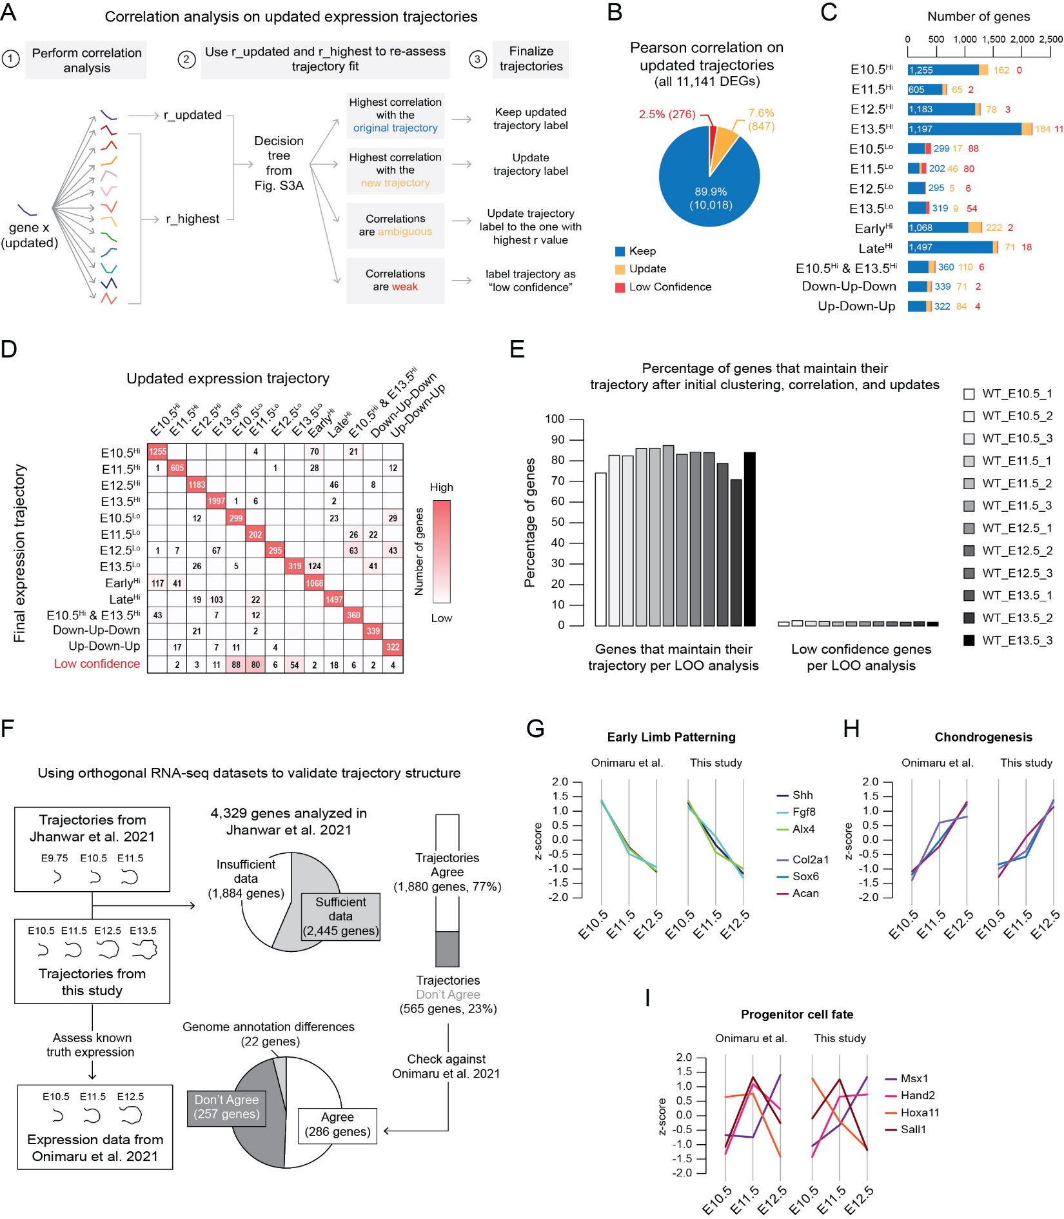
Supplementary Figure 4. Final correlation-based refinement confirms high-confidence gene expression trajectory assignments in WT forelimbs. (A) Schematic overview of the final correlation-based strategy applied to updated expression trajectories. For each gene, Pearson correlation coefficients were calculated between its z-scored expression profile and all updated reference trajectories. The correlation with the currently assigned trajectory (r_updated) and the highest correlation observed across all trajectories (r_highest) were extracted and evaluated using the decision framework established in Figure S3A. Genes either retained their updated trajectory, were reassigned to a different trajectory, or were labeled as low-confidence if correlations remained weak. Ambiguous trajectories were reassigned to the trajectory with the highest correlation value. (B) Summary of correlation outcomes for all WT DEGs (11,141 genes) following final trajectory assignment, showing the percentage of genes that kept their trajectory assignment (Keep), were reassigned (Update), or were designated as low-confidence. (C) Distribution of WT genes per trajectory, colored by reassignment outcome, demonstrating that most genes retained their trajectory assignment following iterative refinement. (D) Confusion matrix comparing the updated and final WT expression trajectory assignments. Numbers indicate the number of genes per comparison; empty boxes denote no genes in that category. Heatmap coloring was scaled per column (red, many genes; white, no genes). Genes classified as low-confidence are highlighted and indicate a small subset (276 genes) that does not robustly fit any defined trajectory. (E) Schematic overview of LOO analysis used to assess reproducibility of final WT trajectory assignments. For each LOO iteration, a single replicate was removed and clustering was repeated. Cluster assignments generated during each LOO iteration were compared to those obtained using the full dataset. The percentage of genes that maintained their final trajectory assignment was calculated per replicate, and the percentage of low-confidence genes generated in each iteration is also reported. (F) Validation of WT trajectory structure using two independent, orthogonal RNA-seq datasets. Trajectories defined in this study were compared with published data from Jhanwar et al. and Onimaru et al. Of the 4,329 genes analyzed in Jhanwar et al., 2,445 had sufficient timepoint overlap for comparison. Among these, 77% showed concordant trajectory structure between studies, while 23% did not. Discordant trajectories were cross-checked against the Onimaru et al. dataset, revealing that approximately half of the genes that disagreed with Jhanwar et al. were concordant with Onimaru et al. (50.6%, 286 genes). Discrepancies in trajectory assignments were consistent with differences in genome annotation, sequencing depth, and timepoint variability between studies^{23,24}. (G-I) Comparison of representative gene expression trajectories associated with known developmental processes between published data (Onimaru et al., 2021) and this study. Early limb patterning genes (G), chondrogenic markers (H), and regulators of progenitor cell fate (I) exhibit highly similar temporal expression profiles across datasets, supporting the reproducibility of the present dataset and the biological relevance of the identified trajectories.

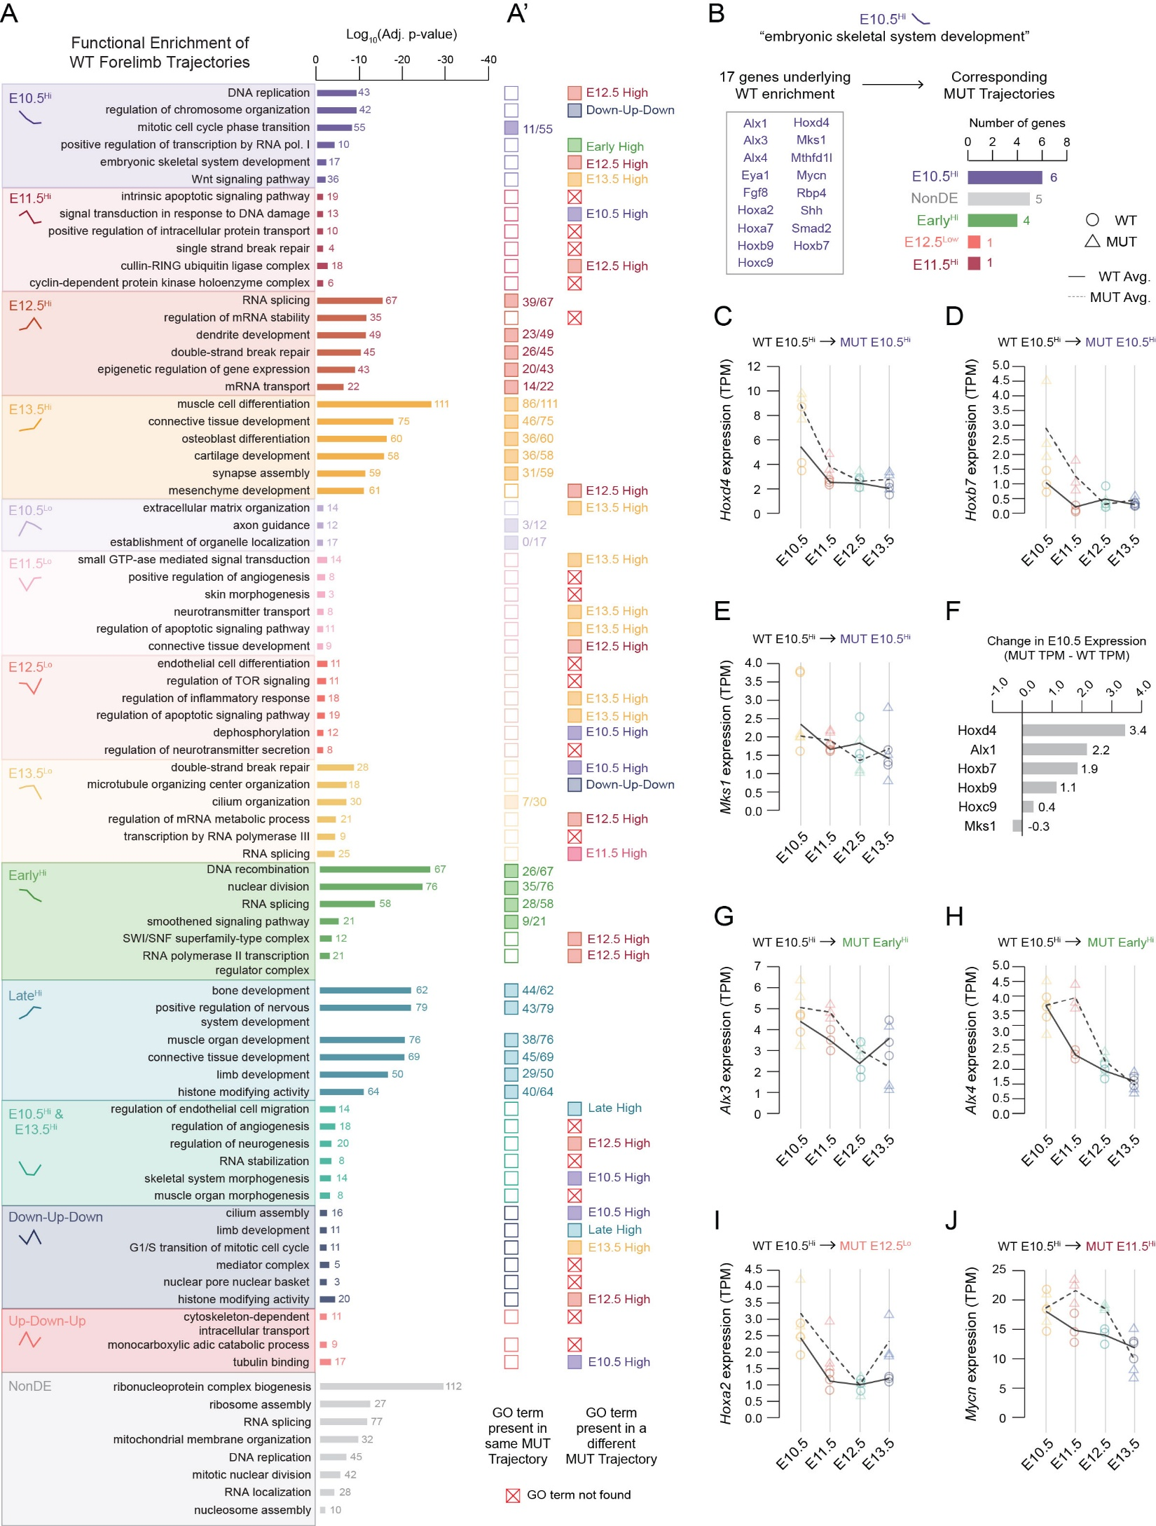
Supplementary Figure 5. Functional enrichment of expression trajectories reveals differences between WT and mutant forelimbs. (A) Gene Ontology (GO; BP, CC, and MF) enrichment analysis for each WT expression trajectory. Bar plots show significantly enriched terms (adjusted p < 0.05), grouped by trajectory and colored to match corresponding WT expression patterns. Bar length indicates log₁₀(adjusted p-value), and the number of genes underlying each enrichment is indicated at the end of the corresponding bar. (A’) Filled squares indicate the same GO term is enriched in the corresponding mutant trajectory, whereas open squares indicate that the term was not enriched in that corresponding mutant trajectory. When a GO term is enriched in the mutant, the number of genes shared between the WT and mutant is shown. If the term is enriched in the mutant but assigned to a different trajectory, the corresponding mutant trajectory is indicated next to the open square to denote redistribution. Red squares marked with an “X” denote GO terms that were not enriched in any mutant trajectory. Together, this panel illustrates redistribution of functional programs across temporal expression trajectories following U11 loss. (B) Genes underlying WT enrichment for the GO term “embryonic skeletal system development” within the WT E10.5 high trajectory (17 genes). Bars indicate the number of these genes assigned to each mutant trajectory, demonstrating partial conservation of early skeletal development programming alongside redistribution to alternative temporal trajectories in the mutant. (C-E) Representative examples of genes that remain assigned to the E10.5 high trajectory in both WT and mutant. Lines show the mean gene expression (TPM) across time (E10.5-E13.5) for WT (solid line, circles) and mutant (dashed line, triangles), with biological replicates overlaid. (F) Change in E10.5 expression (MUT TPM – WT TPM) for genes that maintain an E10.5 high trajectory in both genotypes. Positive values indicate higher expression in the mutant, whereas negative values indicate higher expression in the WT, revealing changes in expression magnitude despite trajectory agreement. (G-J) Examples of skeletal development genes that shift from WT E10.5 high to mutant Early high (G-H), E12.5 Low (I), and E11.5 High (J).

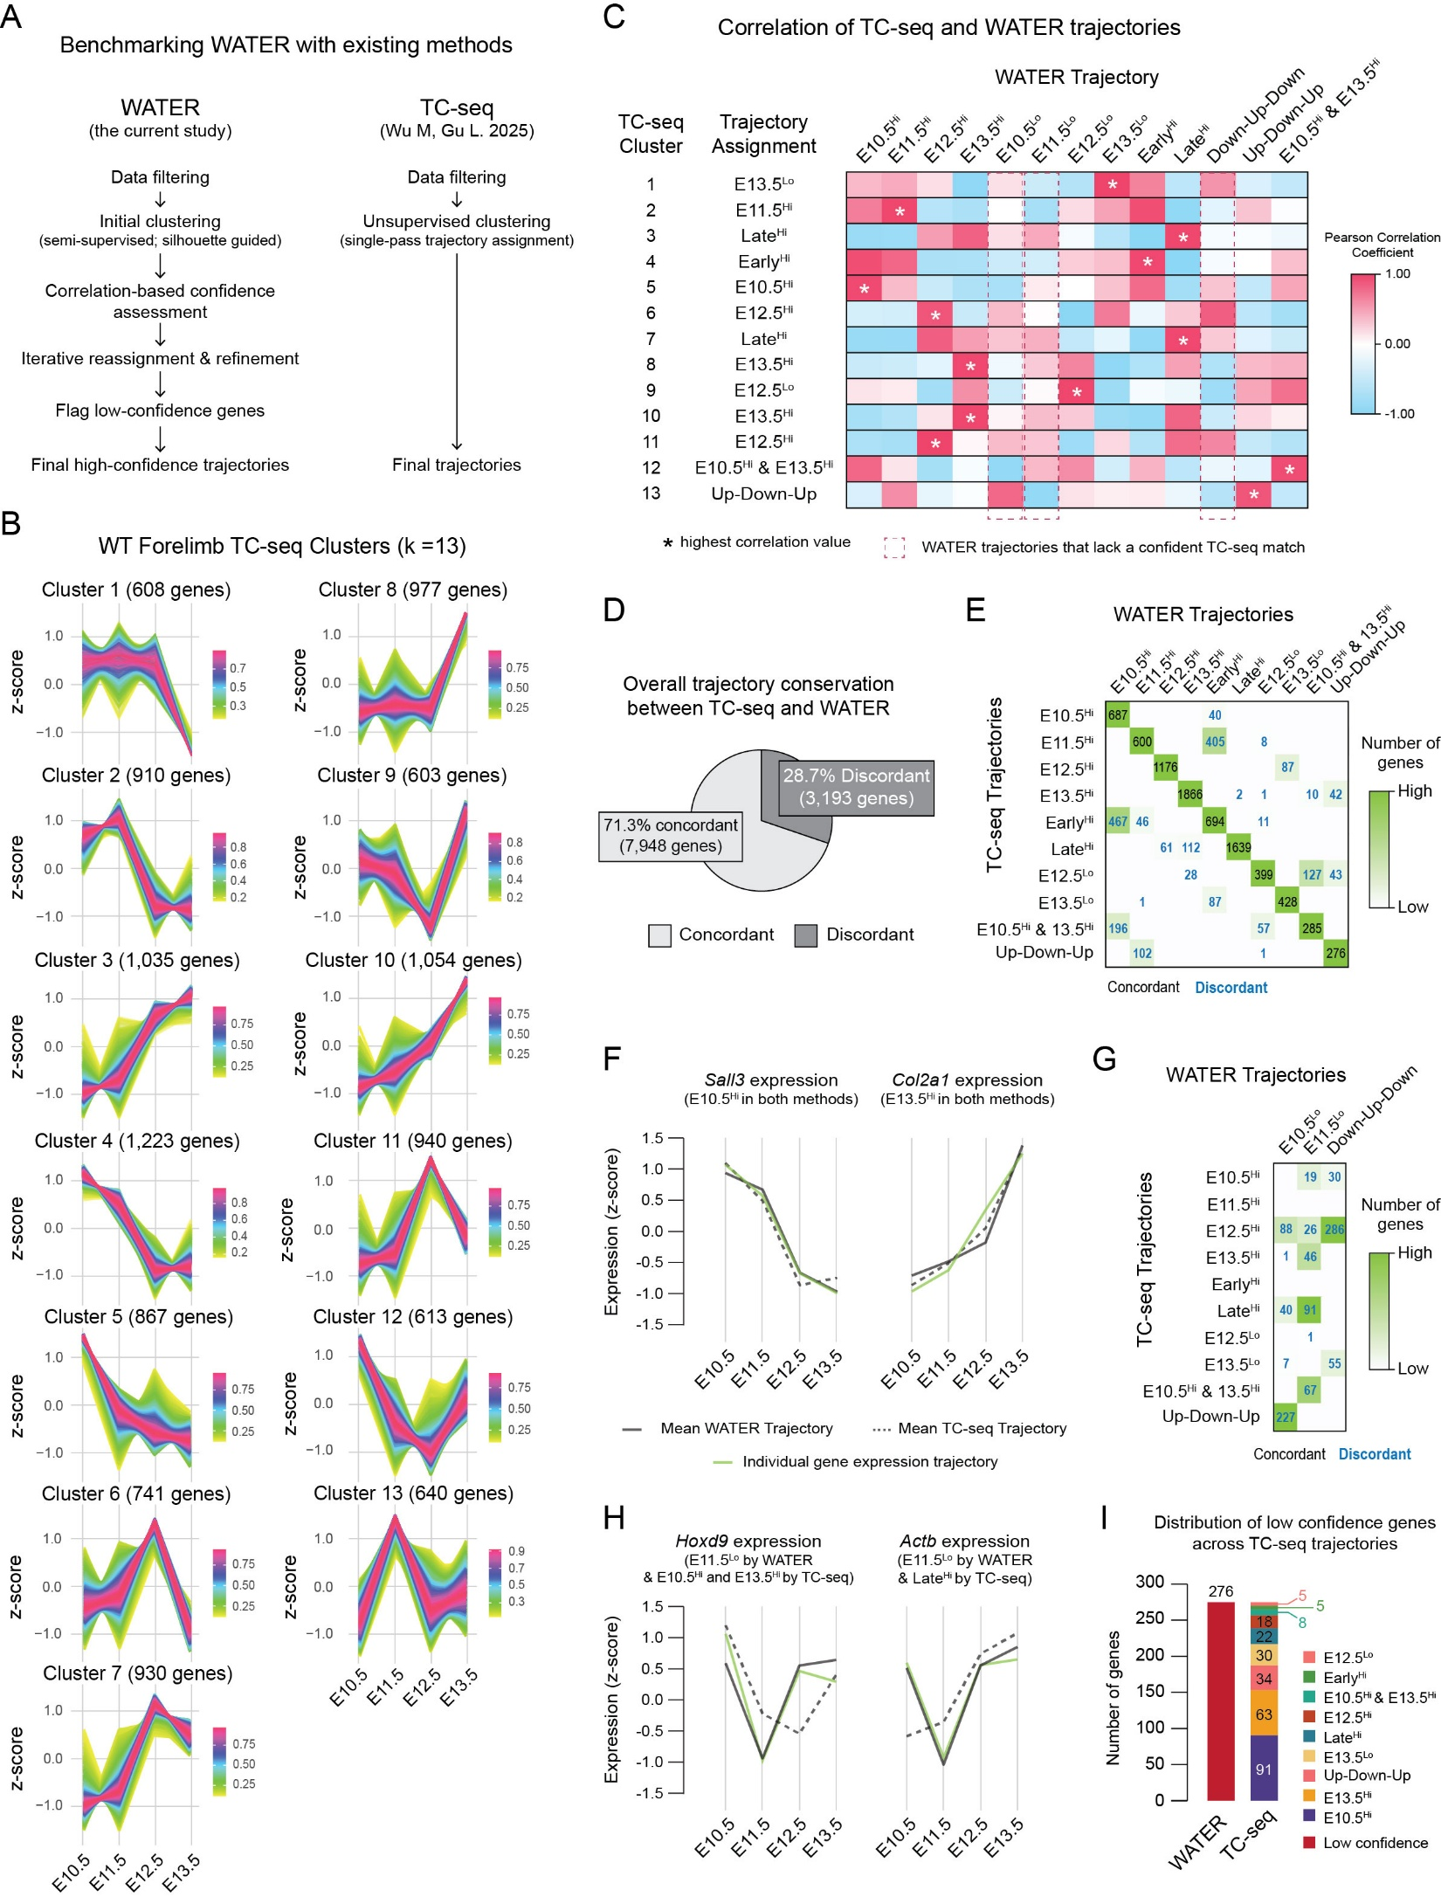
Supplementary Figure 6. Benchmarking WATER against TC-seq for high-confidence temporal trajectory inference. (A) Schematic comparison of WATER and TC-seq workflows. WATER utilizes semi-supervised clustering, correlation-based confidence assessment, iterative refinement, and tagging of low-confidence genes to generate high-confidence temporal trajectories. In contrast, TC-seq applies unsupervised single-pass clustering to assign genes to temporal expression clusters. (B) WT forelimb TC-seq clusters (k = 13). Z-scored gene expression across E10.5 to E13.5 for each TC-seq cluster. Each line represents the expression profile of an individual gene, with colors indicating membership value (i.e., the strength of a gene’s association with a given cluster). Higher membership values denote stronger cluster assignment. (C) Pearson correlation analysis between TC-seq and WATER trajectories. The highest correlation for each TC-seq cluster is indicated by (*). Correlation values were used to match TC-seq and WATER trajectories. Red dashed boxes indicate WATER trajectories that lack a confident TC-seq match. (D) Overall trajectory agreement between TC-seq and WATER shows most genes (7,948 genes; 71.3%) are concordant between the two methods. Conversely, 28.7% (3,193 genes) were discordant between TC-seq and WATER. (E) Confusion matrix showing gene overlap between TC-seq clusters and WATER trajectories. Numbers indicate the number of genes per comparison; empty boxes denote no genes in that category. Heatmap coloring was scaled per column (green, many genes; white, no genes). Gene sets considered discordant between the two methods are colored in blue. (F) Representative expression trajectories for two genes, Sall3 and Col2a1, whose trajectories are concordant between WATER and TC-seq. Plots compare the mean WATER (solid line) and TC-seq (dashed line) trajectory profiles for the cluster assigned to each gene, with the observed gene expression overlaid (green line). (G) Confusion matrix for WATER trajectories lacking a confident TC-seq match, highlighting the distribution of these genes across multiple TC-seq clusters. Numbers indicate the number of genes per comparison; empty boxes denote no genes in that category. Heatmap coloring was scaled per column (green, many genes; white, no genes). Gene sets considered discordant between the two methods are colored in blue. (H) Representative expression trajectories for Hoxd9 and Actb, whose trajectories are discordant between WATER and TC-seq. Plots compare the mean WATER (solid line) and TC-seq (dashed line) trajectory profiles for the cluster assigned to each gene, with the observed gene expression overlaid (green line). (I) Distribution of low-confidence genes across TC-seq trajectories, highlighting the TC-seq clustering of genes flagged as low-confidence by WATER.

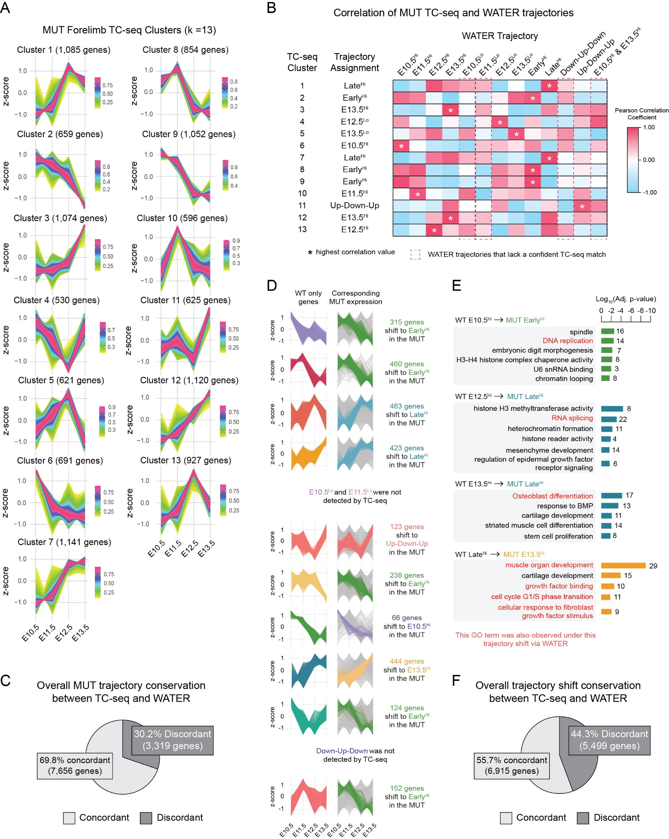
Supplementary Figure 7. TC-seq recovers most mutant forelimb trajectories but incompletely captures WATER-defined trajectory shifts. (A) MUT forelimb TC-seq clusters (k = 13). Z-scored gene expression across E10.5 to E13.5 for each TC-seq cluster. Each line represents the expression profile of an individual gene, with colors indicating membership value (i.e., the strength of a gene’s association with a given cluster). Higher membership values denote stronger cluster assignment. (B) Pearson correlation analysis between TC-seq and WATER trajectories. The highest correlation for each TC-seq cluster is indicated by (*). Correlation values were used to match TC-seq and WATER trajectories. Red dashed boxes indicate WATER trajectories that lack a confident TC-seq match. (C) Overall comparison of mutant trajectory assignments between TC-seq and WATER. Genes were classified as concordant when the TC-seq-derived trajectory assignment matched the WATER trajectory assignment and discordant when the assignments differed. (D) Plotting WT only genes captured by TC-seq and their corresponding mutant expression. Genes undergoing the most common trajectory shift are colored according to their mutant trajectory. Grey lines represent the expression of all other genes in the WT only category that have shifted in the mutant but do not belong to the dominant shift category. Trajectories that were detected by WATER but not by TC-seq have been noted. (E) Gene ontology enrichment analysis of select WT-to-MUT trajectory shifts as detected by TC-seq. Bars represent significantly enriched GO terms (BP, CC, MF; adjusted p < 0.05), with bar length indicating the log10(adjusted p-value) and numbers denoting the number of genes underlying enrichment of each term. Red terms denote GO terms also observed for the same trajectory shift using WATER. (F) Overall agreement of gene-level WT-to-MUT trajectory shifts between TC-seq and WATER.

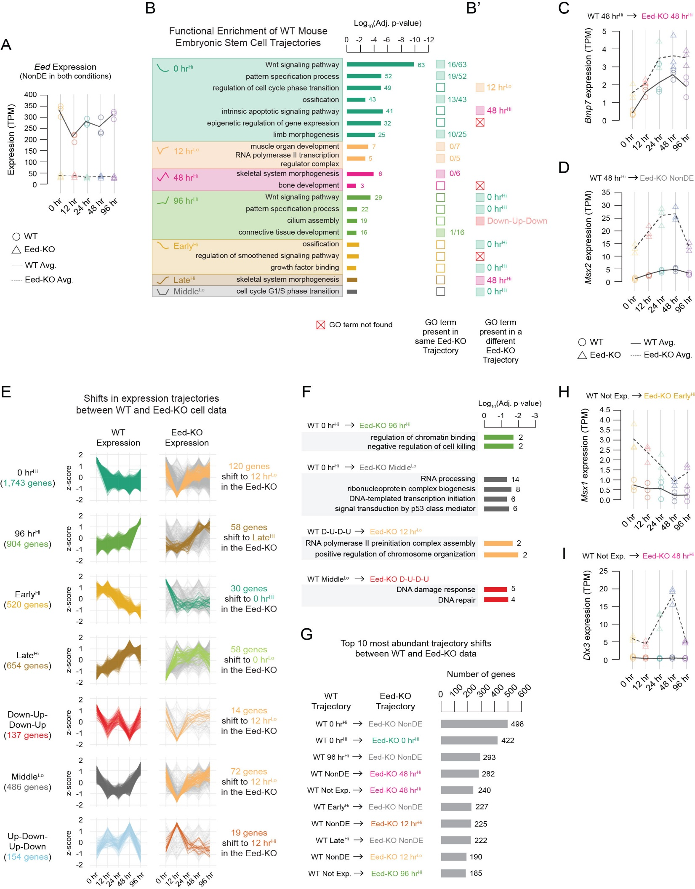
Supplementary Figure 8. Loss of Eed in mouse embryonic stem cells results in shifts in transcriptional trajectories that regulate pluripotency and differentiation. (A) Expression of Eed across time (0, 12, 24, 48, 96 hr) in WT and Eed-KO mouse embryonic stem cells. Points represent individual replicates; lines indicate mean expression (TPM). Eed expression is dramatically reduced in KO cells across all timepoints. (B) GO enrichment analysis of WT trajectories. Terms are grouped by trajectory. Bar length indicates significance (-log10 adjusted p-value), and numbers indicate gene count per term. (B’) Colored boxes indicate whether the same GO term is present in the corresponding Eed-KO trajectories or shifted to different temporal programs. (C-D) Representative expression trajectories illustrate altered temporal dynamics in Eed-KO cells. (C) Bmp7 and (D) Msx2 show shifted expression patterns in the Eed-KO relative to WT cells. (E) For each WT trajectory (left), z-scored expression trajectories are shown in the Eed-KO (right) for the same gene set. The most frequently reassigned Eed-KO trajectory is highlighted in color, with the number of genes undergoing that shift indicated to the right; all other trajectories are shown in grey. Not all trajectories are shown. (F) GO enrichment analysis for subsets of WT genes that shift to alternative trajectories in the Eed-KO. Bars represent significantly enriched GO terms (BP, CC, MF; adjusted p < 0.05), with bar length indicating the log₁₀(adjusted p-value) and numbers denoting the number of genes underlying enrichment of each term. (G) Top trajectory shifts ranked by the number of genes changing between WT and Eed-KO data. (H-I) Examples of genes not expressed in the WT but aberrantly activated in Eed-KO cells at specific timepoints. (H) Msx1 and (I) Dlx3 illustrate activation in KO cells.

Supplementary Tables
Table S1. Primer sequences for RNA probe generation, related to Figure 2.
Gene | Strand | Sequence | Usage | Fig.
Fgf8 | Fwd | CAGGTCCTGGCCAACAAG | In situ probe preparation | 2G
Fgf8 | Rvs | AGCTCCCGCTGGATTCCT | In situ probe preparation | 2G

Supplementary Datasets
Data S1. Replicate expression and log2 fold-change data from WT and U11 mutant forelimbs across time.
Data S2. WATER trajectories for WT and U11 mutant forelimb datasets.
Data S3. Functional enrichment results of all WT gene expression trajectories.
Data S4. Functional enrichment results of all U11 mutant gene expression trajectories.
Data S5. Functional enrichment results for all trajectory shift categories between WT and U11 mutant datasets.
Data S6. WATER trajectories from WT and U11 mutant single-cell RNA-seq data.
Data S7. Hierarchical clustering (Hclust) clusters from WT forelimb bulk RNA-seq data.
Data S8. TC-seq (Mfuzz) fuzzy clusters from WT and U11 mutant forelimb bulk RNA-seq data.
Data S9. TC-seq (k-means) clusters from WT forelimb bulk RNA-seq data.
Data S10. maSigPro results from WT and U11 mutant forelimb bulk RNA-seq data.
Data S11. Trendy results from WT and U11 mutant forelimb bulk RNA-seq data.
Data S12. WATER trajectories for WT mouse forelimb and bat forelimb datasets.
Data S13. WATER trajectories for WT and Eed-KO mouse embryonic stem cell datasets.
Data S14. Functional enrichment results for WT, Eed-KO, and shifts between the two datasets.
Data S15. WATER trajectories for WT and 5xFAD cortex datasets.

