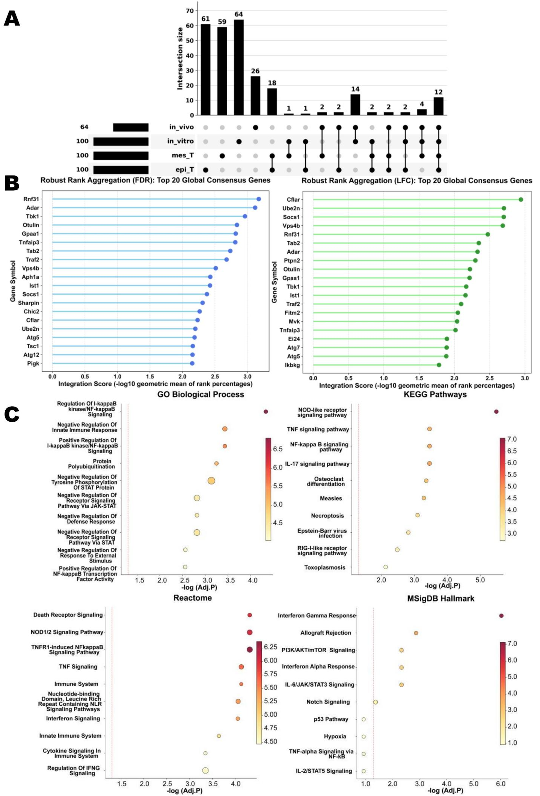
Fig. S1. Cross-context consensus and pathway enrichment of integrated CRISPR genetic screen hits (related to Fig. 1)

- UpSet plot of the top-100 essential genes across the four screen contexts (Epi-Screen 1, Mes-Screen 1, in vitro-Screen 2, in vivo-Screen 2). The bottom matrix indicates the intersection sets; the top bars show the intersection sizes.

- Robust rank aggregation (RRA) of consensus hits. Left, top-20 global consensus genes ranked by FDR (RRA-FDR); right, top-20 global consensus genes ranked by log-fold-change (RRA-LFC). Bars show the integration score, calculated as the –log₁₀ geometric mean of rank percentages. Ist1 ranks among the top consensus genes by both criteria.

(C) Pathway enrichment of the integrated consensus hits across GO Biological Process, KEGG, Reactome, and MSigDB Hallmark gene sets.
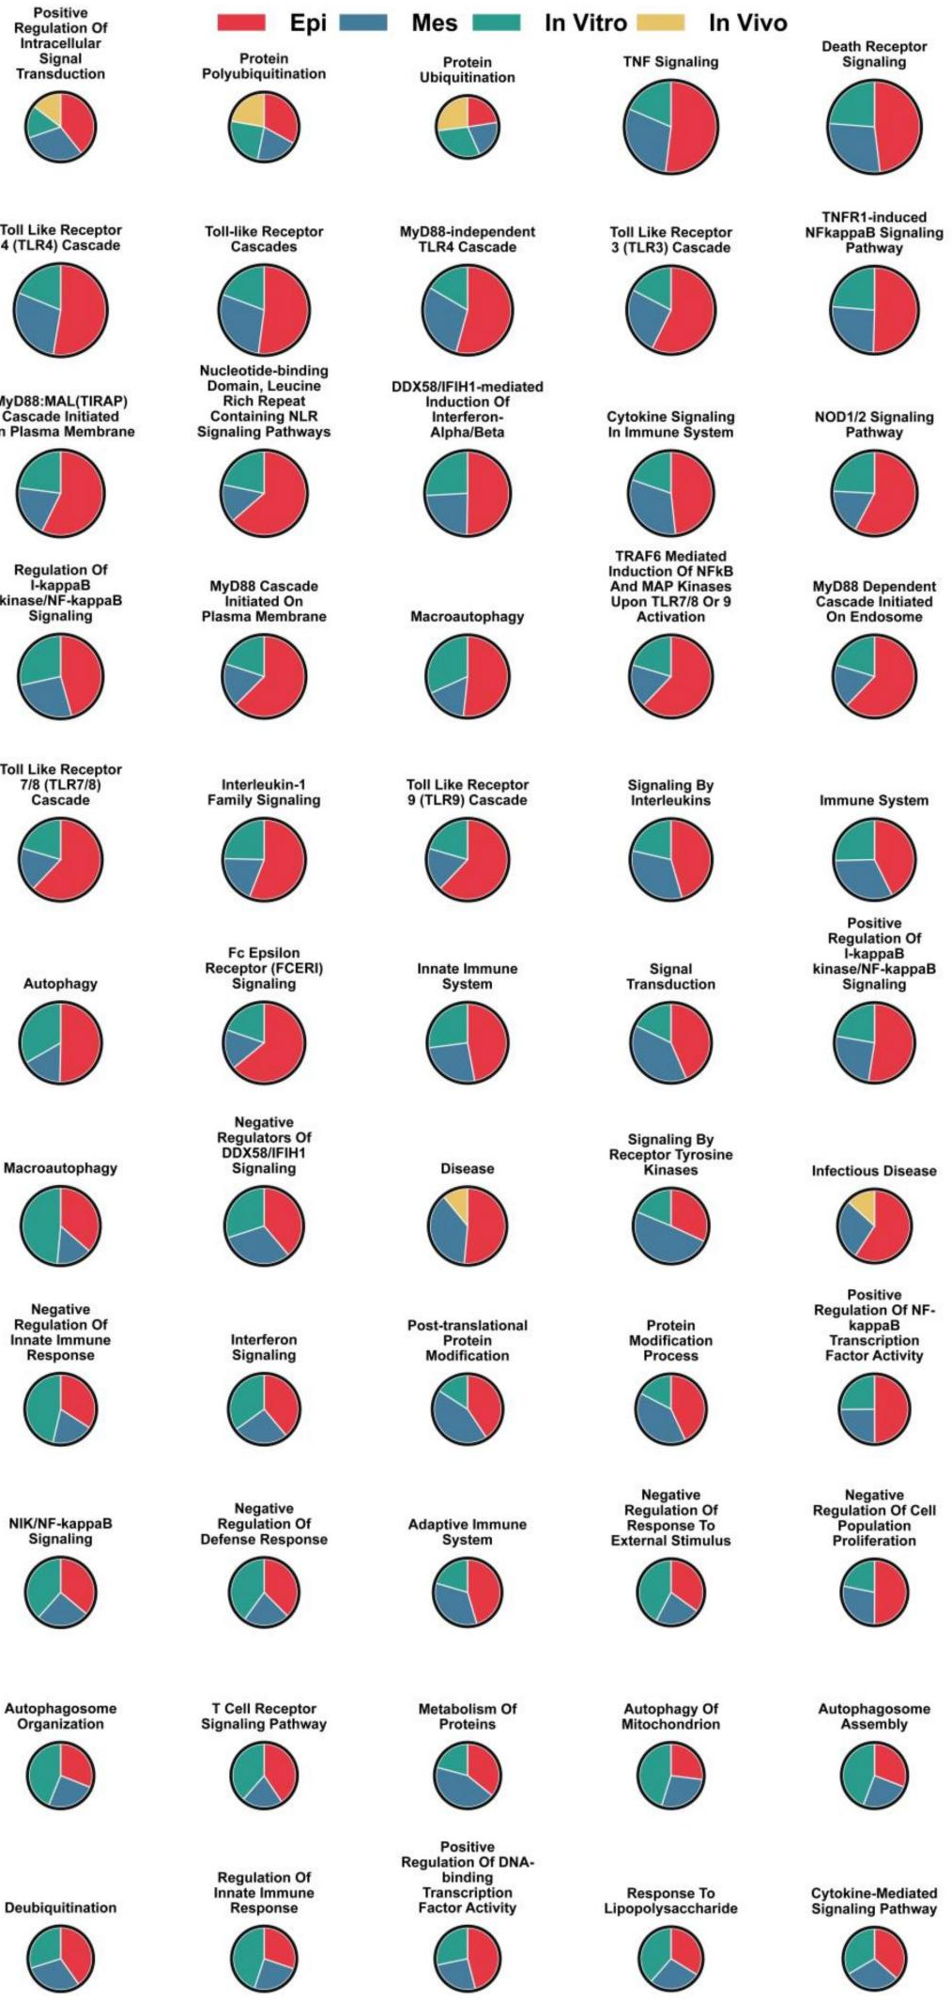
Fig. S2. Per-pathway breakdown of the four-context contribution to immune-resistance regulation (related to Fig. 1).
High-support pathway-modules representing universally conserved immune evasion mechanisms. Pie charts show biological pathways that are significantly enriched in at least three of the four CRISPR screen contexts. Each color slice corresponds to a specific experimental context, with its angular area proportional to the context-specific enrichment significance (-log10 P-value). The overall radius of each pie reflects the mean significance across all contexts.

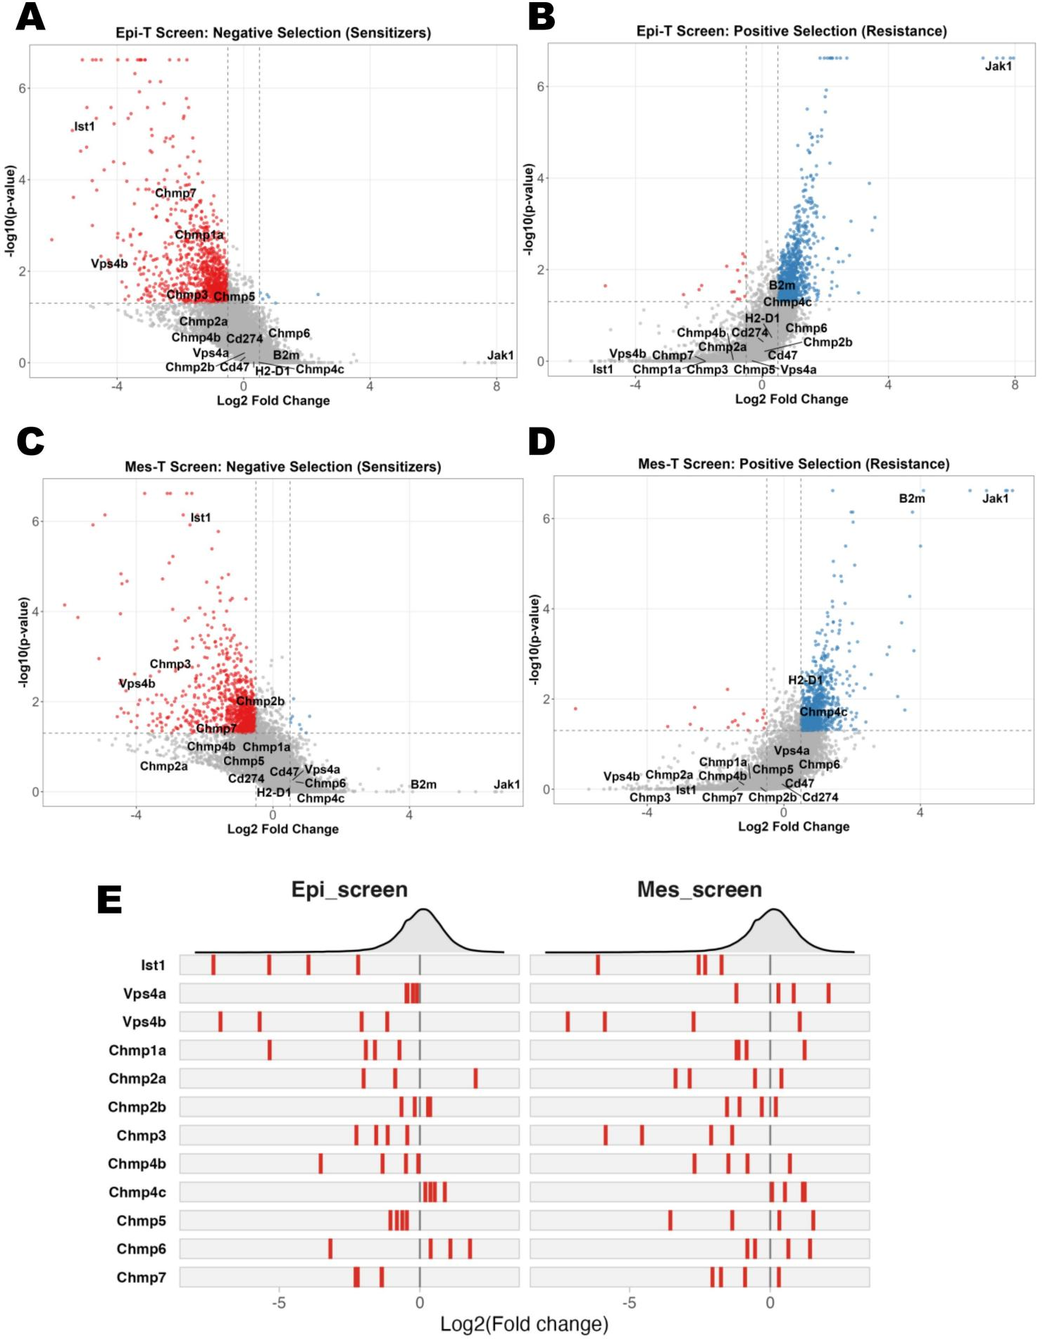

Fig. S3. MAGeCK-based screen-level hit calling in Epi and Mes co-culture CRISPR screens(related to Fig. 1 and Fig. 2).

- Epi-T (epithelial KPC3-OVA-GFP+OT-I) screen, negative-selection sensitizers. Volcano plot of –log₁₀(adjusted p) vs log₂ fold-change. Sensitizer genes (red) are labeled, including Jak1, Vps4b, Chmp4b, Chmp2a, Chmp4a, Chmp6, B2m.

- Epi-T screen, positive-selection resistance hits. Volcano plot as in (A) but with resistance genes (blue) labeled.

(C, D) Mes-T (mesenchymal KPC3-OVA-GFP+OT-I) screen, negative-selection sensitizers (C) and positive-selection resistance hits (D). Genotype-specific behavior of ESCRT-III components is visible across both lineages.

(E) sgRNA-level log2-fold-change distributions for Ist1 and key gene encoding ESCRT-III subunits (Vps4a, Vps4b, Chmp1a, Chmp2a, Chmp2b, Chmp4a, Chmp4b, Chmp4c, Chmp5, Chmp6, Chmp7) in the Epi screen (left) and Mes screen (right). Each red tick = one sgRNA.

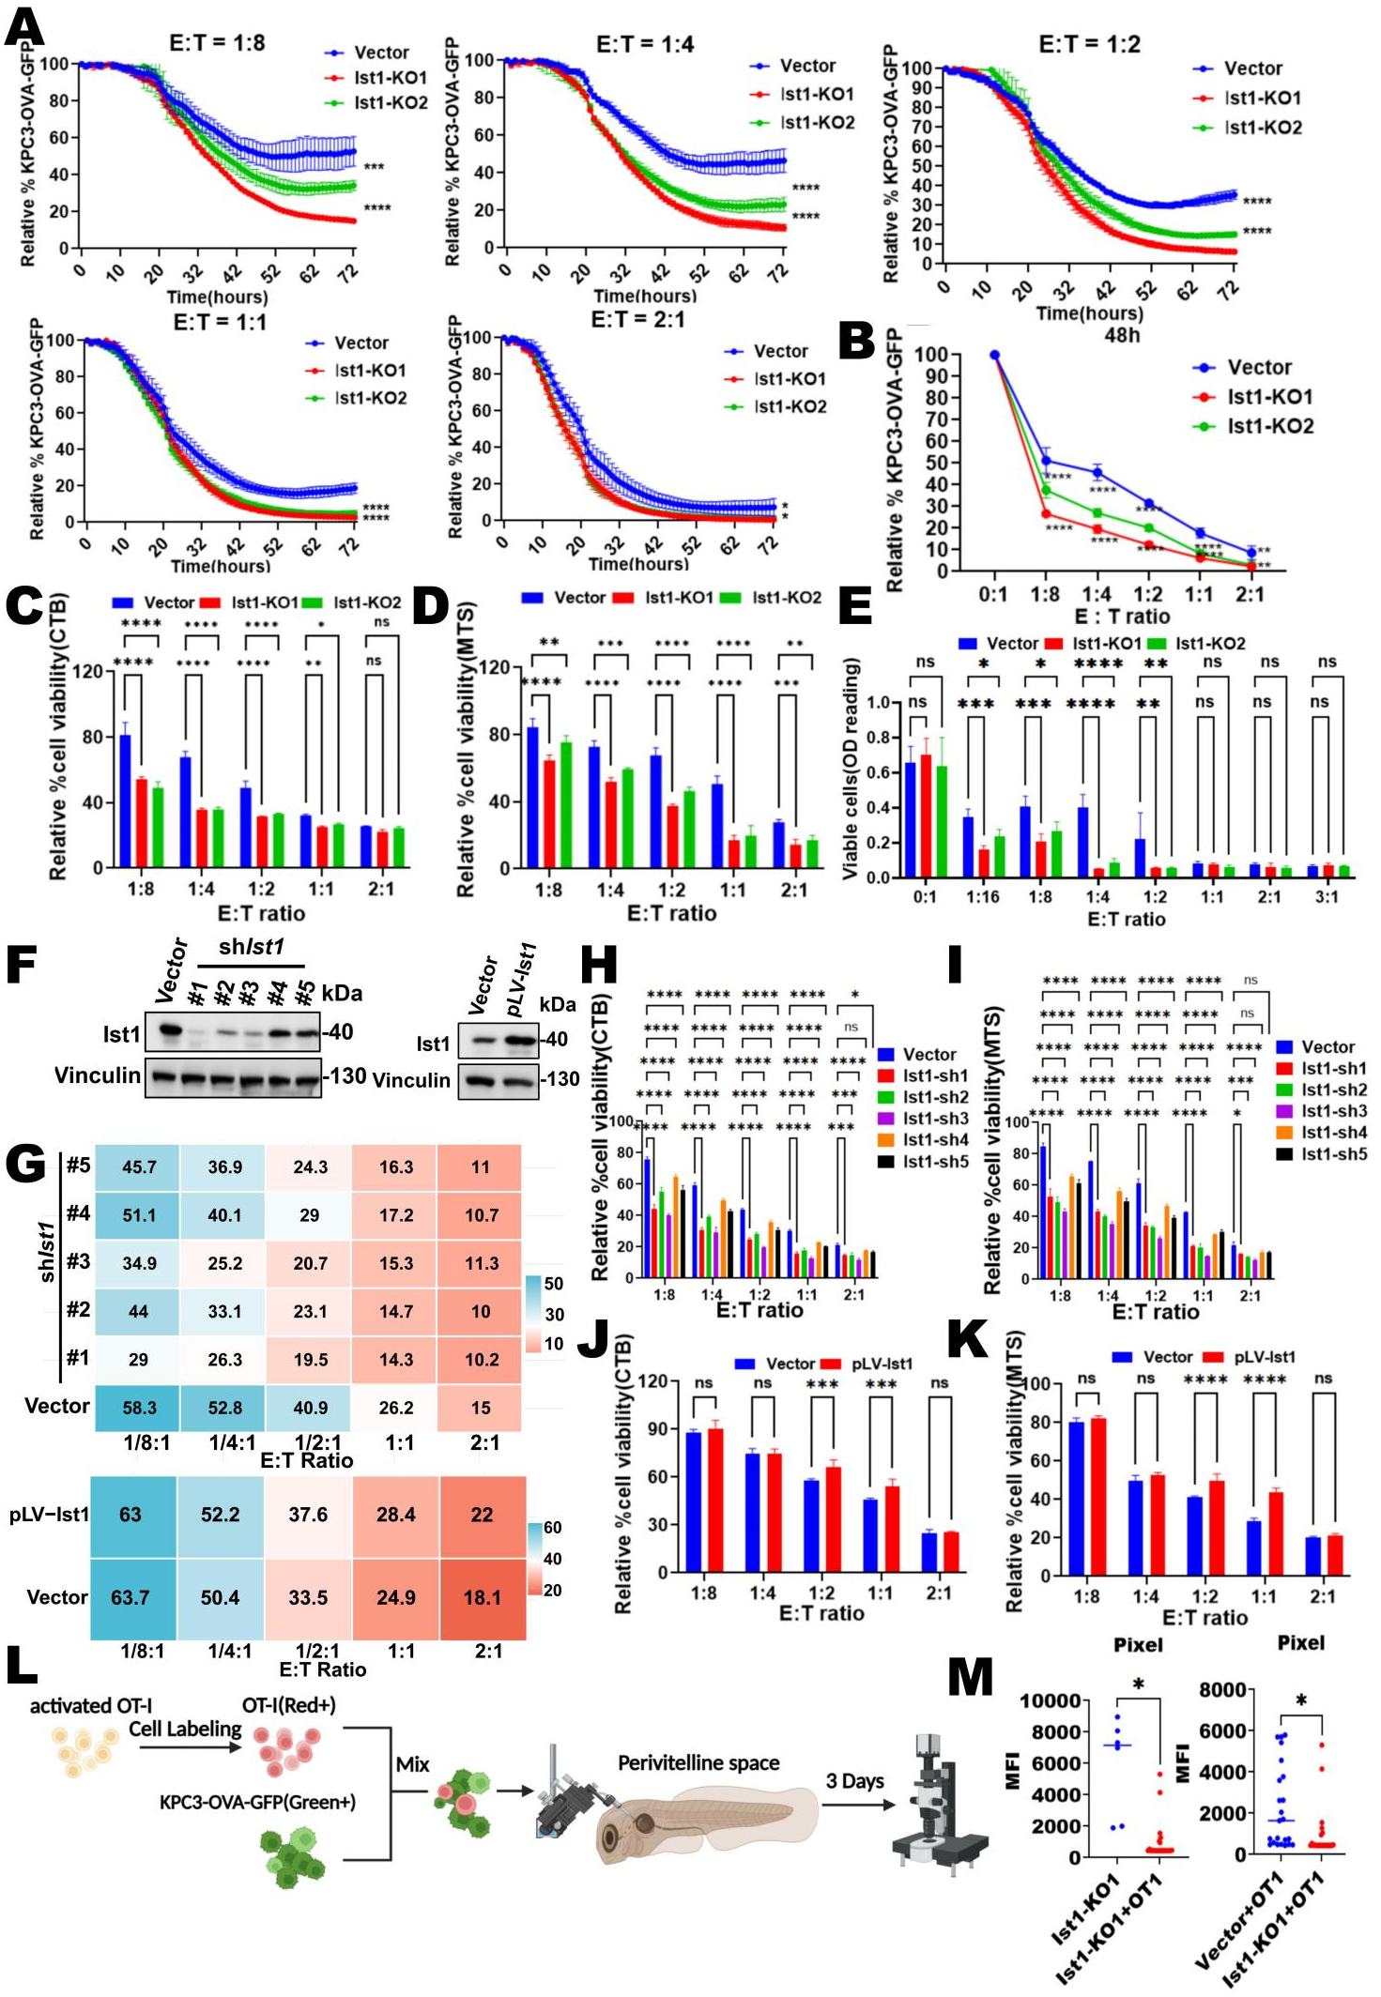
Fig. S4. Extended in-vitro and in-vivo validation of the Ist1 T-cell-killing phenotype, including rescue and orthogonal knockdown.

- Full kinetic curves of the OT-I/KPC3-OVA-GFP co-culture assay across all five tested E:T ratios (1:8, 1:4, 1:2, 1:1, 2:1) for Vector, Ist1-KO1, and Ist1-KO2, complementing Fig 2F. Data are shown as mean ± SD; n=3; *p<0.05, **p<0.01, ***p<0.001, ****p<0.0001 by two-way ANOVA.

- Quantification of relative residual KPC3-OVA-GFP signal (% of t = 0) at the indicated E:T ratios for Vector, Ist1-KO1 and Ist1-KO2(48h), parallel to the 72h analysis in Fig 2F.

(C-E) Cell-viability bar graphs across Vector, Ist1-KO1, and Ist1-KO2 and E:T ratios at endpoint(72h) from independent biological replicates of the killing assay using (C) the Celltiter Blue(CTB) readout, (D) the MTS readout and (E) Crystal Violet staining readout, demonstrating reproducibility across orthogonal viability measurements. Data are shown as mean ± SD; n=3; *p<0.05, **p<0.01, ***p<0.001, ****p<0.0001, ns = not significant by two-way ANOVA.

(F) Western blot validation of the five independent Ist1 shRNAs (shIst1#1-#5) and Ist1 over-expression(pLV-Ist1) used in the orthogonal knockdown or rescue experiments. Vinculin, loading control.

- AUC heatmap across the vector vs shIst1#1-#5(top) or vector vs pLV-Ist1(bottom) and E:T ratios.

(H-I) Endpoint (72h) of co-culture experiment for Vector vs the five shIst1 hairpins read out by (H) the CTB and (I) the MTS assays.

(J-K) Endpoint (72h) of co-culture experiment for Vector vs the overexpression pLV-Ist1 read out by (J) the CTB and (K) the MTS assays.

- Schematic of the zebrafish embryo xenograft model used in Fig 2J-K. Activated OT-I T cells (red) were labeled and mixed with KPC3-OVA-GFP tumour cells (green) in 1:4 (E:T ratio), and co-injected into the perivitelline space, then imaged after 3 days with confocal microscopy.

- Zebrafish-based pixel count of residual tumour burden, confirming the in vivo killing-sensitivity phenotype across genotypes (left, Ist1-KO1 vs Ist1-KO1+OT-I; right, Vector+OT-I vs Ist1-KO1+OT-I). Each dot represents one fish; horizontal bar, median; *p < 0.05 (Mann–Whitney U test).
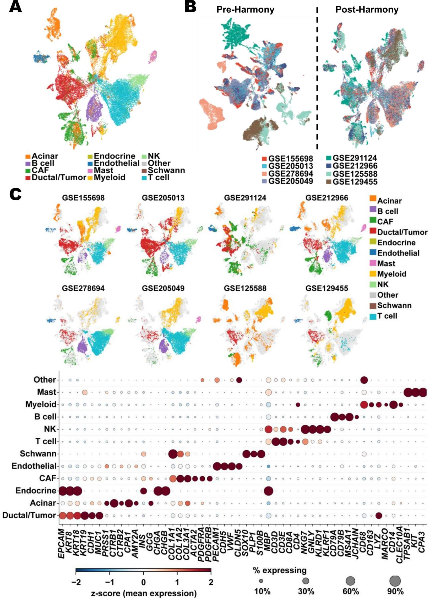
Fig. S5. Cross-cohort scRNA-seq integration of pancreatic cancer microenvironment (related to Fig. 3).

- Harmony-integrated UMAP comprises a total of 40,000 cells single cells from 8 publicly available scRNA-seq cohorts of pancreatic cancer (GSE155698, GSE205013, GSE291124, GSE212966, GSE278694, GSE205049, GSE125588, GSE129455), colored by major cell-type annotation at level 1 (Acinar, B cell, CAF, Ductal/Tumor, Endocrine, Endothelial, Mast, Myeloid, NK, Schwann, T cell, Other).

- Pre- vs post-Harmony UMAPs colored by cohort, showing batch correction by Harmony integration.

(C) Per-cohort UMAPs and a global marker dot-plot. Top: per-cohort UMAPs colored by the same level-1 annotation. Bottom: dot-plot of canonical lineage markers across cell types; dot color = z-score of mean expression, dot size = % of cells expressing.

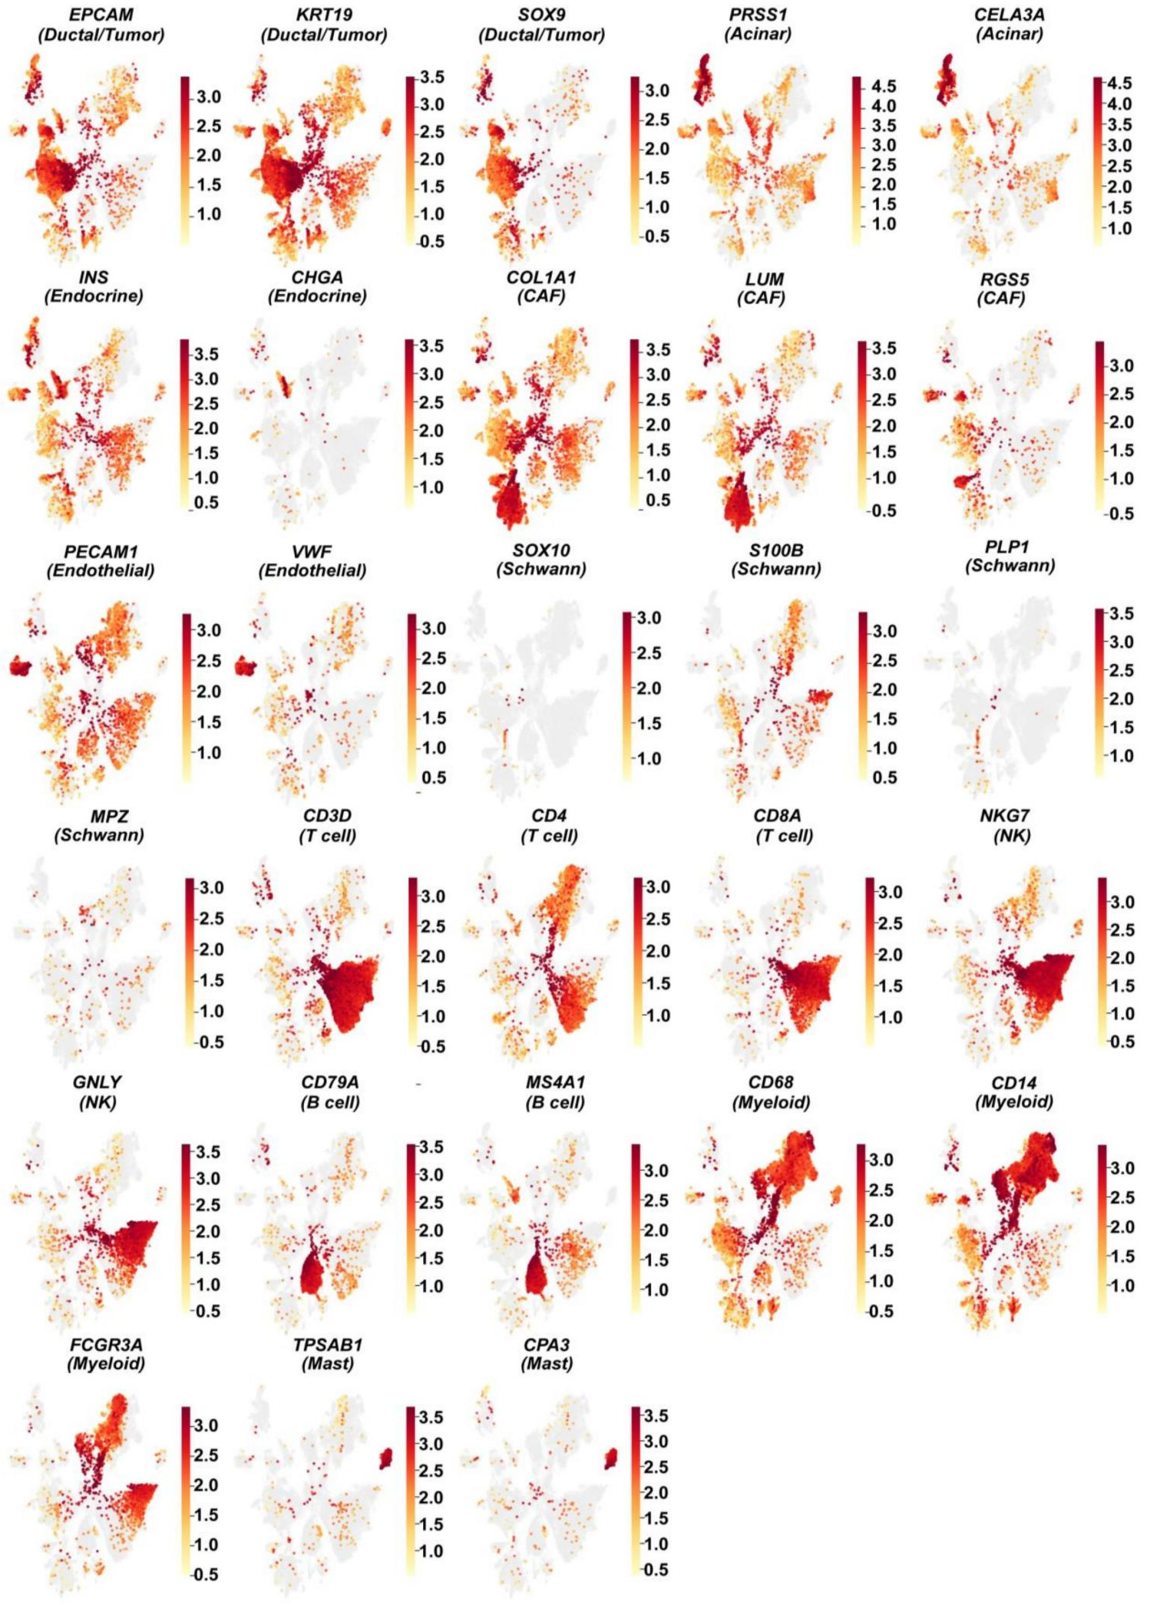
Fig. S6. Canonical lineage marker expression on the integrated pancreas atlas UMAP (related to Fig. S5).

UMAP feature plots of lineage and cell-type marker genes across the integrated atlas: EPCAM, KRT19, SOX9 (Ductal/Tumor); PRSS1, CELA3A (Acinar); INS, CHGA (Endocrine); COL1A1, LUM, RGS5 (CAF); PECAM1, VWF (Endothelial); SOX10, S100B, PLP1, MPZ (Schwann); CD3D, CD4, CD8A (T cell); NKG7, GNLY (NK); CD79A, MS4A1 (B cell); CD68, CD14, FCGR3A (Myeloid); TPSAB1, CPA3 (Mast). Color scale = individually scaled expression.

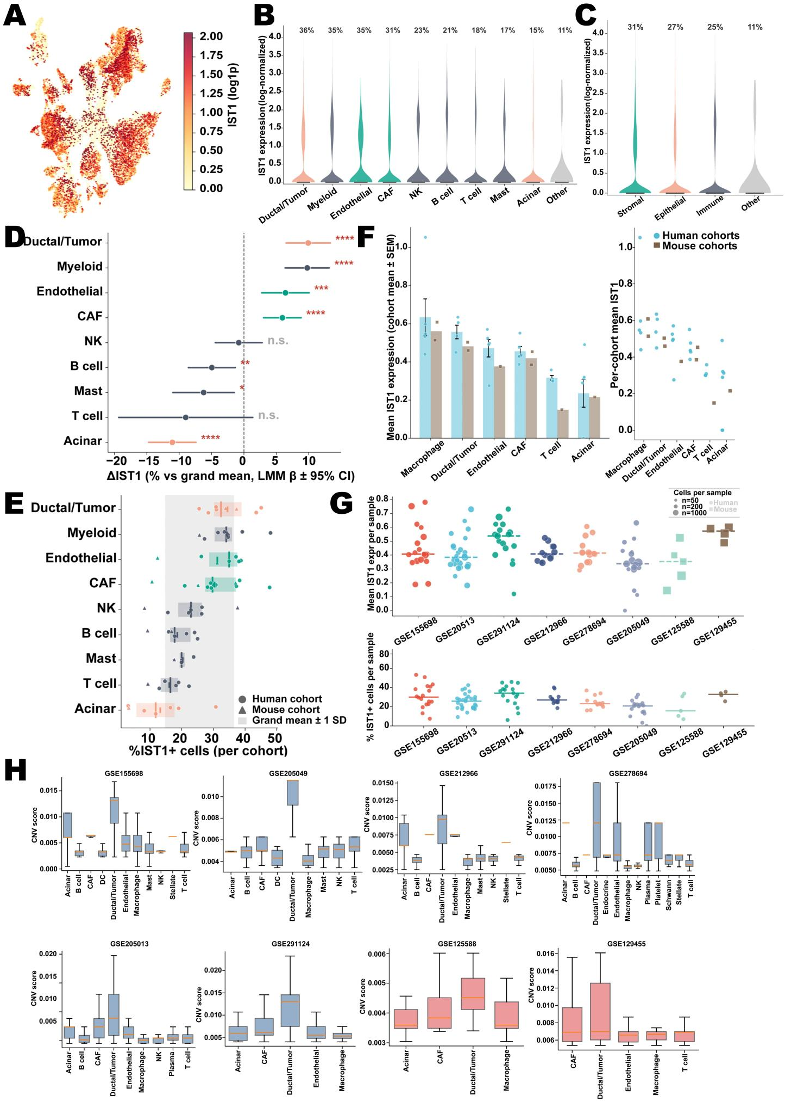

Fig. S7. IST1 expression across cell types and cohorts in the integrated single-cell atlas.

- UMAP feature plot of IST1 expression across the harmonized 8-cohorts integrated atlas.

- Violin plots showing the log-normalized expression levels of IST1 across diverse level-1 cell types (n = 40,000 total cells). The percentage of IST1-positive cells for each group is annotated above the respective violin. Rare populations below the quantification threshold were excluded from the IST1 analyses: Schwann (n = 4 cells) and Endocrine (n = 2 cells) did not meet the inclusion criteria (≥ 10 cells per group for the violins; presence in ≥ 4 cohorts for the linear mixed model), and are therefore shown in the descriptive UMAP (Fig. S5) but not here.

- Violin plot showing the log-normalized expression levels of IST1 across major cellular compartments (Stromal, Epithelial, Immune, and Other). Numbers above the violins indicate the percentage of cells expressing IST1 within each compartment.

- Forest plot detailing the relative enrichment or depletion of IST1+ cells within specific cell types compared to the overall average. Estimates (Δ% IST1+, LMM β ± 95% CI) were calculated using a Linear Mixed Model on sample-level pseudobulk data (8 cohorts, n = ~40,000 cells), with deviation coding for cell types and cohort as a random effect. (* P < 0.05, ** P < 0.01, *** P < 0.001, **** P < 0.0001; n.s., not significant).

- Raw IST1+ cell percentages per cohort. Points denote individual cohorts (circles: human, triangles: mouse). Colored vertical bars indicate the mean for each cell type. The grey shaded background represents the grand mean ± 1 SD across all observations.

- Left: mean IST1 expression across cell types, aggregated at the cohort level (n = 6 human cohorts, light blue; n = 2 mouse cohorts, brown). Bar heights indicate the mean across cohorts, with error bars representing the standard error of the mean (SEM). Individual points denote the mean expression value for each independent cohort(Left). Right: raw cohort-level mean IST1 expression. Individual points represent independent cohorts (circles: human; squares: mouse).

- Inter-cohort heterogeneity of IST1 expression. Top: Mean IST1 expression per sample across 8 cohorts. Points represent individual samples (circles: human, squares: mouse), with point size proportional to the number of cells per sample. Horizontal dashed lines denote cohort means. Bottom: Percentage of IST1+ cells per sample. Horizontal solid lines indicate cohort means. Only samples with ≥20 cells were included in both analyses to maintain statistical robustness.

(H) Validation of malignant-cell identity by inferred copy-number variation (CNV). Per-cohort box plots of single-cell CNV scores across the level-1 cell types present in each of the eight scRNA-seq cohorts (human cohorts, blue; mouse cohorts, red).

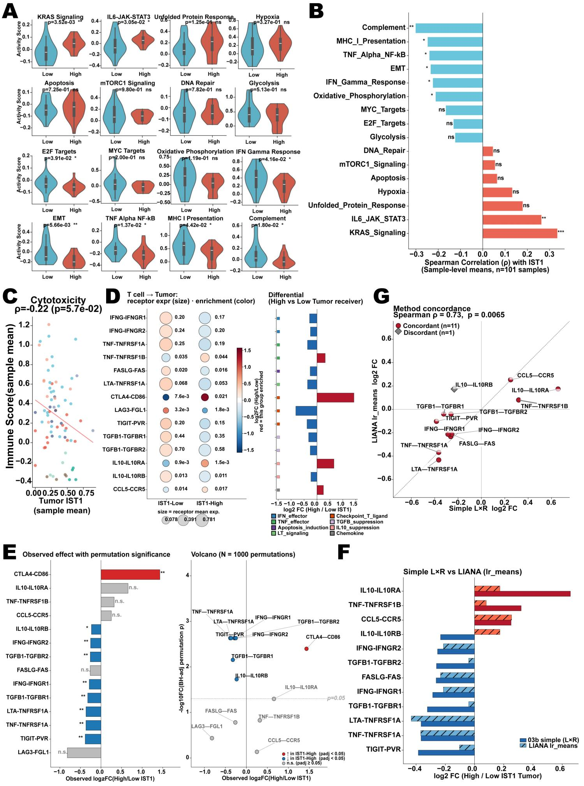

Fig.S8. Pathway and cell-cell interaction programs associated with IST1 expression in the integrated atlas(related to Fig. 3-5).

- Pathway activity in IST1-High vs. IST1-Low tumor cells. Violin plots showing sample-level mean pathway activity scores in Ductal/Tumor cells. To maximize the biological signal-to-noise ratio, the analyzed cohort was stratified by IST1 expression, comparing the top 20% (IST1-High, red) with the bottom 20% (IST1-Low, blue). p values were calculated using a two-sided Wilcoxon rank-sum test (ns, not significant; * p < 0.05, ** p< 0.01).

- Diverging bar chart showing the Spearman rank correlation (ρ) between continuous sample-level IST1 expression and pathway activity scores (n=101 samples). Red bars indicate positive correlations; blue bars indicate negative correlations. Bar length corresponds to the correlation coefficient (ρ) (ns, not significant; * p < 0.05, ** p< 0.01, *** p < 0.001).

- Sample-level Spearman correlation between malignant-cell IST1 expression and an immune-cell cytotoxicity score (PRF1/GZMB/GZMA/IFNG/GNLY/NKG7) across the 8-cohort PDAC atlas (coloured by cohort; ρ=-0.22, two-sided p=0.057; red dashed line, OLS fit).

- Ligand-receptor interaction analysis for T-cell-to-tumour signalling stratified by ductal/tumour cell IST1 expression. Left: Dot plot of 14 L-R pairs; dot area, receptor mean expression in IST1-High or IST1-Low ductal/tumour receivers; colour, log₂FC (High/Low) on a diverging RdBu scale (red, enriched in the indicated group); numeric labels, product interaction score (mean ligand expression in T cells multiplied by mean receptor expression in the tumour subpopulation). Right: log₂fold-change (IST1-High/IST1-Low) per L-R pair; red, enriched in IST1-High; blue, enriched in IST1-Low; coloured squares, functional programme annotation.
- Permutation-based significance of T-cell-to-tumour L-R shifts. Left: Observed log₂FC (IST1-High / IST1-Low) for 14 L-R pairs; BH-adjusted permutation p-values, * p<0.05, **p <0.01, ns = not significant. Right: Volcano plot of observed log₂fold-change versus BH-adjusted permutation p-value (−log₁₀scale); dashed line, significance threshold. Null model: IST1-High/Low labels shuffled 1,000 times within Ductal/Tumour cells (group sizes preserved); two-sided p= fraction of permuted |log₂FC| ≥ observed, floored at 0.001; BH correction across 14 pairs.

- Orthogonal validation of the simple L×R product score against LIANA. Paired bar chart comparing log₂FC (IST1-High / IST1-Low) estimated by the simple mean-product score (Fig S8D) and LIANA lr_means (hatched) for the same 14 curated T-cell-to-tumour L-R pairs(Two pairs (CTLA4-CD86, LAG3-FGL1) were excluded from this panel as they are not annotated in the T-cell-as-sender direction in the LIANA interaction database).

- Concordance scatter of the two log₂FC estimates(related to Fig S8F); dashed line, identity (y=x). Filled circles, directionally concordant pairs (same sign in both methods; n=11); diamonds, discordant (n =1; IL10-IL10RB). Spearman ρ = 0.73, p = 0.0065.
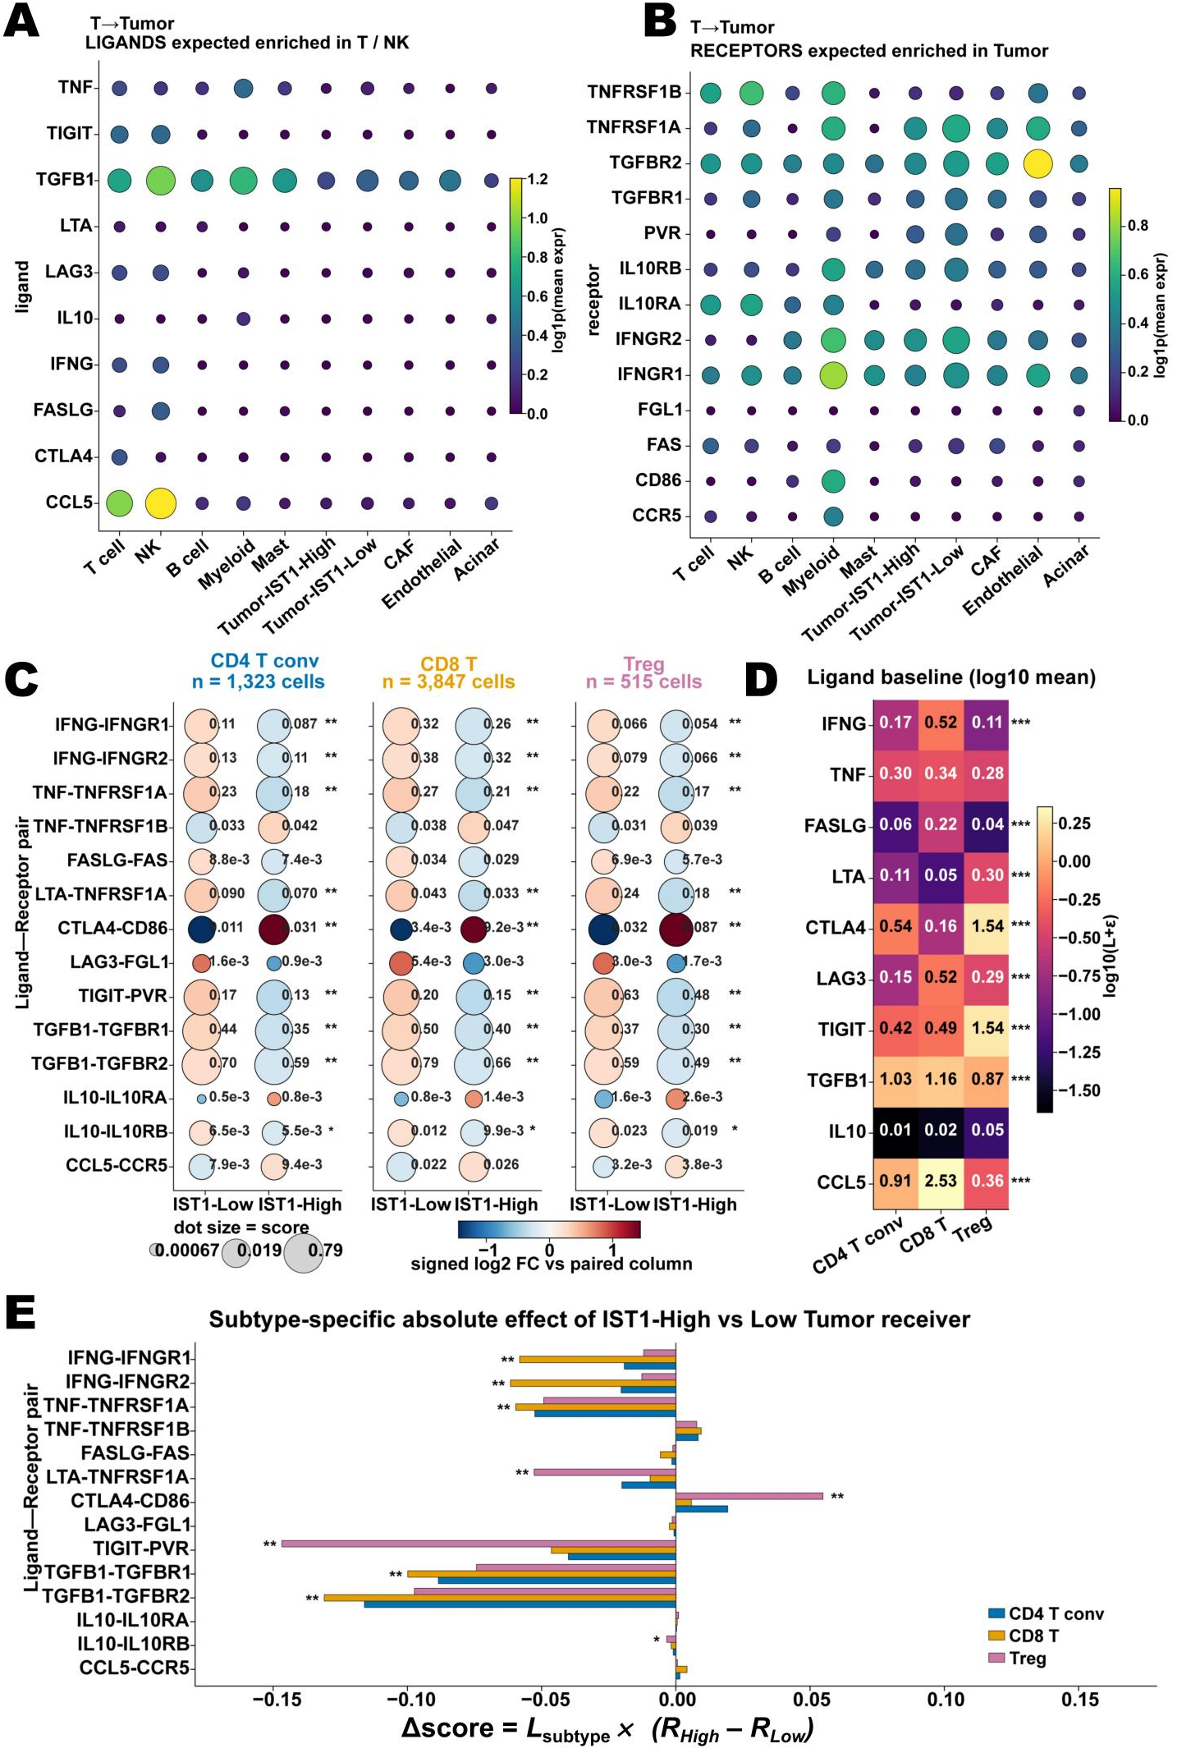
Fig. S9. T-cell-subtype-resolved communication towards IST1-High versus IST1-Low tumour cells in the integrated atlas.

(A, B) Cell-type specificity of the curated T-cell-to-tumour ligand–receptor pairs. Dot plots showing mean log1p-normalized expression (coulor, viridis) and detection rate (dot area, fraction of cells with non-zero expression) across ten major cell groups. (A) Ligands, expected to be enriched in T / NK cells. (B) Receptors, expected to be enriched in tumour cells. IST1-High and IST1-Low expressed- ductal/tumour subgroups are shown as separate columns.

- Per-T-subtype interaction dot plot. T cells were assigned to CD4 T conv (CD4⁺ FOXP3⁻ CD8⁻; n = 1,323), CD8 T (CD8A/B⁺ CD4⁻ FOXP3⁻; n=3,847) and Treg (FOXP3⁺; n=515) using marker gene expression. For each subtype, interaction score: the product of mean ligand expression in the T-cell subtype and mean receptor expression in the tumour subpopulation; dot area, score magnitude; dot colour, signed log₂FC (IST1-High/IST1-Low) on a diverging scale (red, enriched in IST1-High; blue, enriched in IST1-Low), with the complementary sign applied to the paired column so that each row's two dots are mirror images. Numeric labels, exact score values. Significance stars (BH-adjusted *p<0.05, **p<0.01) derive from a receptor-side label-shuffle permutation test (2,000 permutations; IST1-High/Low labels shuffled within the Ductal/Tumour pool).

- Ligand baseline heatmap. Colour, log₁₀(mean ligand expression + ε) per T-cell subtype. Stars denote Kruskal–Wallis test significance for between-subtype heterogeneity in ligand expression, BH-corrected across ligands (BH-adjusted ***p<0.001).

- Subtype-specific absolute effect of IST1-High versus IST1-Low tumour receiver. Bars show Δscore: the subtype-specific ligand mean multiplied by the difference in receptor expression between IST1-High and IST1-Low tumour cells (BH-adjusted *p<0.05, **p<0.01).

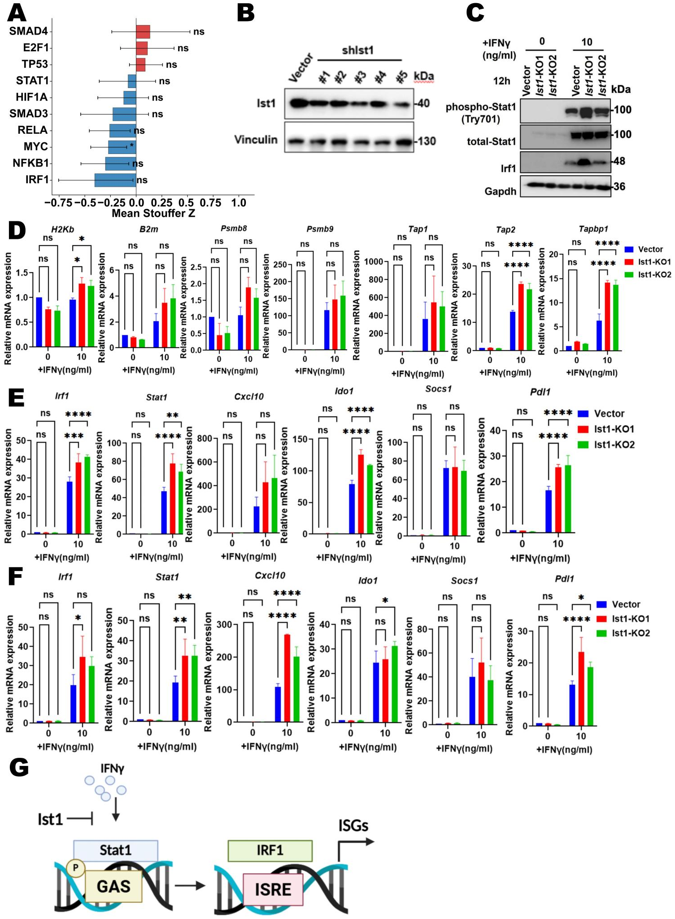

Fig. S10. IFNγ-induced transcriptional response in Ist1-deficient tumor cells (related to Fig. 3).

- CollecTRI orthogonal validation of the TF enrichment analysis in Fig 3A. Direct TF→target edges from CollecTRI (Decoupler v2.1, signed regulatory network) were used for 10 focal TFs (≥ 30 targets each; SMAD3, SMAD4, NFKB1, RELA, TP53, HIF1A, E2F1, STAT1, MYC, IRF1). Same Stouffer Z, global-shift, permutation and bootstrap framework as Fig 3A.

- Western blot validating Ist1 knockdown in stably-transduced Stat1-reporter(pGF-GAS4x) KPC3-OVA-GFP cells using five independent shRNAs (shIst1#1–#5) versus Vector control. Lysates were probed for Ist1 protein and Vinculin loading control.

- Western blot of IFNγ signaling at 12h post-stimulation. Vector, Ist1-KO1 and Ist1-KO2 cells were treated with IFNγ (0 or 10ng/mL); lysates were probed for phospho-Stat1 (Tyr701), total Stat1, Irf1 and Gapdh. Ist1-KO cells show enhanced Stat1 phosphorylation and Irf1 induction.

- qRT-PCR quantification of antigen processing and presentation-related genes at 24h after IFNγ stimulation (0 or 10ng/mL) in Vector, Ist1-KO1, and Ist1-KO2 cells. Data are shown as mean ± SD; n=3; *p<0.05, **p<0.01, ***p<0.001, ****p<0.0001, ns = not significant by two-way ANOVA.

- F) qRT-PCR quantification of the IFNγ/Stat1 target-gene panel at (E)12h, (F)24h after IFNγ stimulation in Vector, Ist1-KO1, and Ist1-KO2 cells. Data are shown as mean ± SD; n=3; *p<0.05, **p<0.01, ***p<0.001, ****p<0.0001, ns = not significant by two-way ANOVA.

(G) Schematic model showing that Ist1 negatively regulates IFNγ-induced Stat1-Irf1 signaling. IFNγ stimulation activates Stat1 phosphorylation, allowing Stat1 to bind GAS elements and induce Irf1 expression. Irf1 subsequently activates ISRE-containing interferon-stimulated genes, including antigen-presentation and inflammatory response genes. Loss of Ist1 enhances IFNγ-induced Stat1 activation and amplifies the downstream Irf1-dependent transcriptional program, thereby promoting expression of immune-related genes in tumor cells.
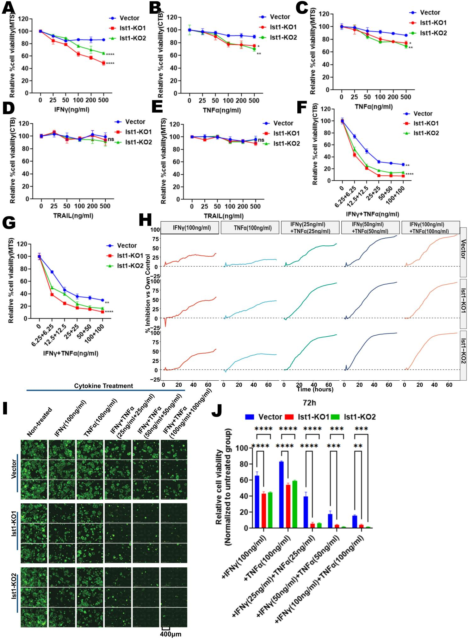

Fig. S11. Cytokine dose-response profiling of Ist1-knockout cells (related to Fig. 3).
(A) CellTiter-Blue (CTB) assays measuring dose-response to IFNγ (0-500ng/mL) in Vector, Ist1-KO1 and Ist1-KO2 KPC3-OVA-GFP cells. Data are shown as mean ± SD; n=3; **p<0.01, ***p<0.001, by two-way ANOVA.

(B-C) CTB or MTS assays measuring dose-response to TNFα (0-500ng/mL) in Vector, Ist1-KO1, and Ist1-KO2 KPC3-OVA-GFP cells. Data are shown as mean ± SD; n=3; *p<0.05, **p<0.01 by two-way ANOVA.

(D-E) CTB and MTS assays measuring dose-response to TRAIL (0-500ng/mL) in Vector, Ist1-KO1, and Ist1-KO2 KPC3-OVA-GFP cells. Data are shown as mean ± SD; n=3; ns = not significant by two-way ANOVA.

(F-G) CTB and MTS assays measuring dose-response to combined IFNγ + TNFα (matched-dose escalation up to 100+100 ng/mL). Data are shown as mean ± SD; n=3; **p<0.01, ****p<0.0001 by two-way ANOVA.

(H) IncuCyte time-course analysis of tumor-cell inhibition for each genotype (Vector, Ist1-KO1, Ist1-KO2) across treatments: IFNγ(100ng/mL), TNFα(100ng/mL), IFNγ+TNFα(25+25ng/mL), IFNγ+TNFα(50+50 ng/mL), IFNγ+TNFα(100+100ng/mL).

(I) Representative IncuCyte fluorescence images at 72 h for Vector, Ist1-KO1, and Ist1-KO2 cells under untreated, IFNγ, TNFα, and combined IFNγ + TNFα treatments.
(J) Quantification of 72h relative cell viability from (I), normalized to the untreated condition within each genotype. Data are shown as mean ± SD; n=3; **p<0.01, ***p<0.001, ****p<0.0001 by two-way ANOVA.
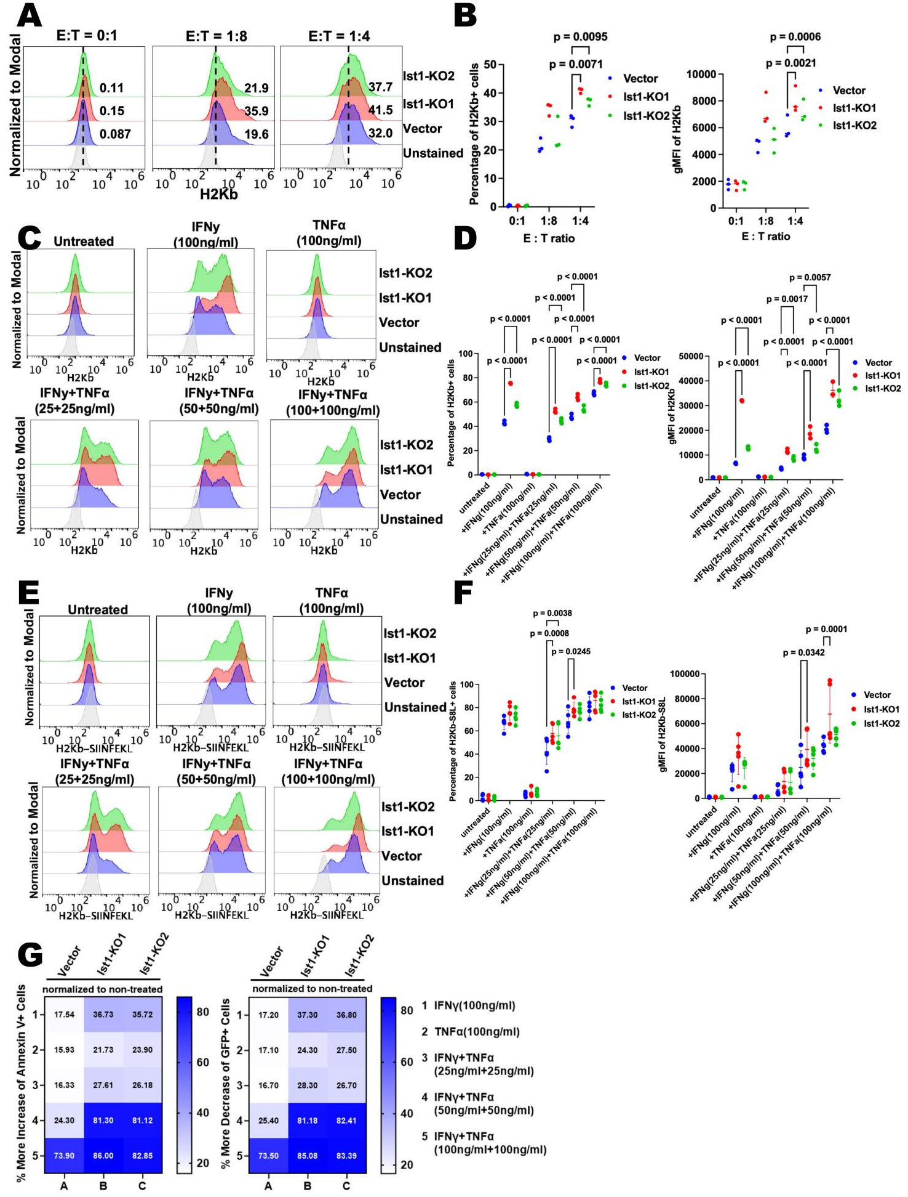

Fig. S12. H-2Kb and H-2Kb-SIINFEKL induction or apoptosis after cytokine/OT-I challenge (related to Fig. 3).
(A) Representative flow-cytometry histograms of H2Kb surface expression in vector-control and Ist1-knockout cells after OT-I co-culture at the indicated E:T ratios. Numbers: percentage of positive cells.
(B) Bar plots of % H2-Kb⁺ cells (left) and gMFI of H2-Kb⁺ cells (right) across E:T ratios for the three genotypes (n=3; p values are output by two-way ANOVA).
- Representative flow-cytometry histograms of H2Kb surface expression in vector-control and Ist1-knockout cells after treatment with the indicated cytokine conditions.

(D) Quantification of Fig S12C for H2Kb-positive cells after cytokine treatments(n=3; p values are output by two-way ANOVA).
(E-F) Representative flow-cytometry histograms of H2Kb-SIINFEKL surface expression in vector-control and Ist1-knockout cells after treated with the indicated cytokine conditions and the quantification of the H2Kb-SIINFEKL-positive cells.

(G) Heatmap visualize the apoptosis of vector-control and Ist1-knockout cells after treatment with the indicated cytokine conditions(normalized to the untreated condition within each genotype).

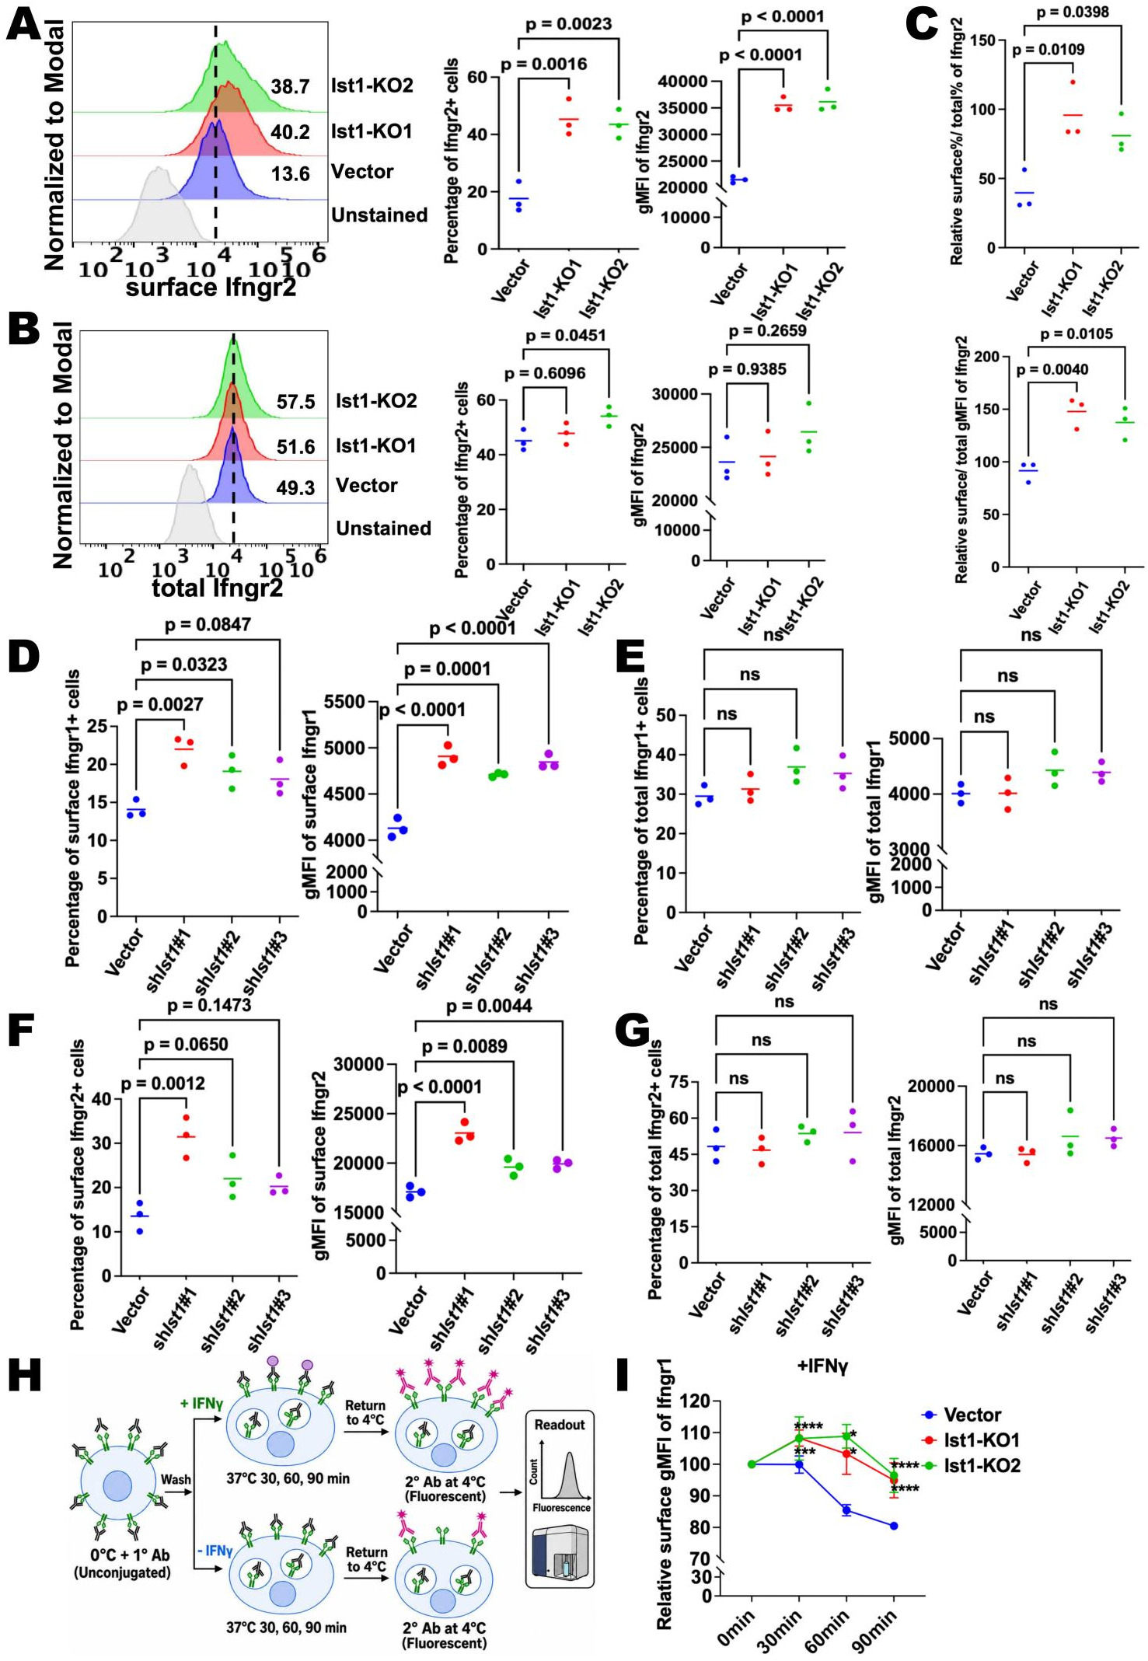
Fig. S13. IFNγ receptors abundance and surface stability in Ist1-deficient tumor cells(related to Fig. 4).

- Representative flow-cytometry histograms of surface Ifngr2 in vector-control and Ist1-knockout cells and quantification of Ifngr2-positive cells.

- Representative flow-cytometry histograms of total Ifngr2 in vector-control and Ist1-knockout cells and quantification of Ifngr2⁺ cells.

- Relative surface to total Ifngr2 levels in vector-control and Ist1-knockout cells. Top: ratio of percentage of surface Ifngr2⁺ cells to total Ifngr2⁺ cells; Bottom: ratio of surface to total Ifngr2 gMFI. Data are shown as mean ± SD; n=3; p values by one-way ANOVA.
- E) Quantification for surface or total Ifngr1-positive cells in vector-control and Ist1 knock-down cells by flow cytometry (n=3; p values are output by two-way ANOVA).
(F-G) Quantification for surface or total Ifngr2-positive cells in vector-control and Ist1 knock-down cells by flow cytometry (n=3; p values are output by two-way ANOVA).

(H) Schematic of the antibody feeding assay. Cells were labeled with primary antibody at 4 degrees and shifted to 37 degrees for the indicated times, and then stained with secondary antibody to quantify remaining surface-accessible receptor.

(I) Antibody feeding assay for tracing surface Ifngr1 internalization and turnover upon IFNγ stimulation. Relative residual surface Ifngr1 gMFI was measured over a time course (30, 60, 90 min after antibody feeding) in Vector, Ist1-KO1, and Ist1-KO2. Data are shown as mean ± SD; n=3; *p<0.05, ***p<0.001, ****p<0.0001 by two-way ANOVA.

Fig. S14. Cytokine-neutralization analysis of OT-I killing in Ist1-knockout cells(related to Fig. 4).
(A) Baseline effects of cytokine isotype control antibodies on tumor cell growth/survival were assessed in Vector control cells and two independent Ist1 knockout clones (Ist1-KO1 and Ist1-KO2) co-cultured with OT-I T cells. Mean area under the curve (AUC) was quantified from longitudinal growth/survival measurements. Isotype antibodies for IFNγ or TNFα did not significantly alter AUC within each genotype.

(B) Quantification of mean AUC in Vector, Ist1-KO1, and Ist1-KO2 cells cultured with OT-I T cells in the presence of IFNγ- or TNFα-neutralizing antibodies, or corresponding isotype controls.

(C) Percent killing at 72h at an effector-to-target ratio of 1:8.
(D) Interaction analysis of cytokine neutralization and tumor cell genotype based on mean AUC at an effector-to-target ratio of 1:4.
(E) Heatmap summary of mean AUC values across tumor-only controls, OT-I co-culture, cytokine isotype controls, and IFNγ or TNFα neutralization conditions for Vector, Ist1-KO1, and Ist1-KO2 cells at an effector-to-target ratio of 1:4.

(F) Bar-plot quantification of the AUC values summarized in panel E at an effector-to-target ratio of 1:4.
(G) Percent killing at 72h at an effector-to-target ratio of 1:4.
(H) Decomposition of the OT-I-dependent killing area into baseline, cytokine-independent killing, and cytokine-preventable killing components at an effector-to-target ratio of 1:4.

Data are shown as mean ± SD; n=3; *p<0.05, **p<0.01, ***p<0.001, ****p<0.0001, ns = not significant by two-way ANOVA.
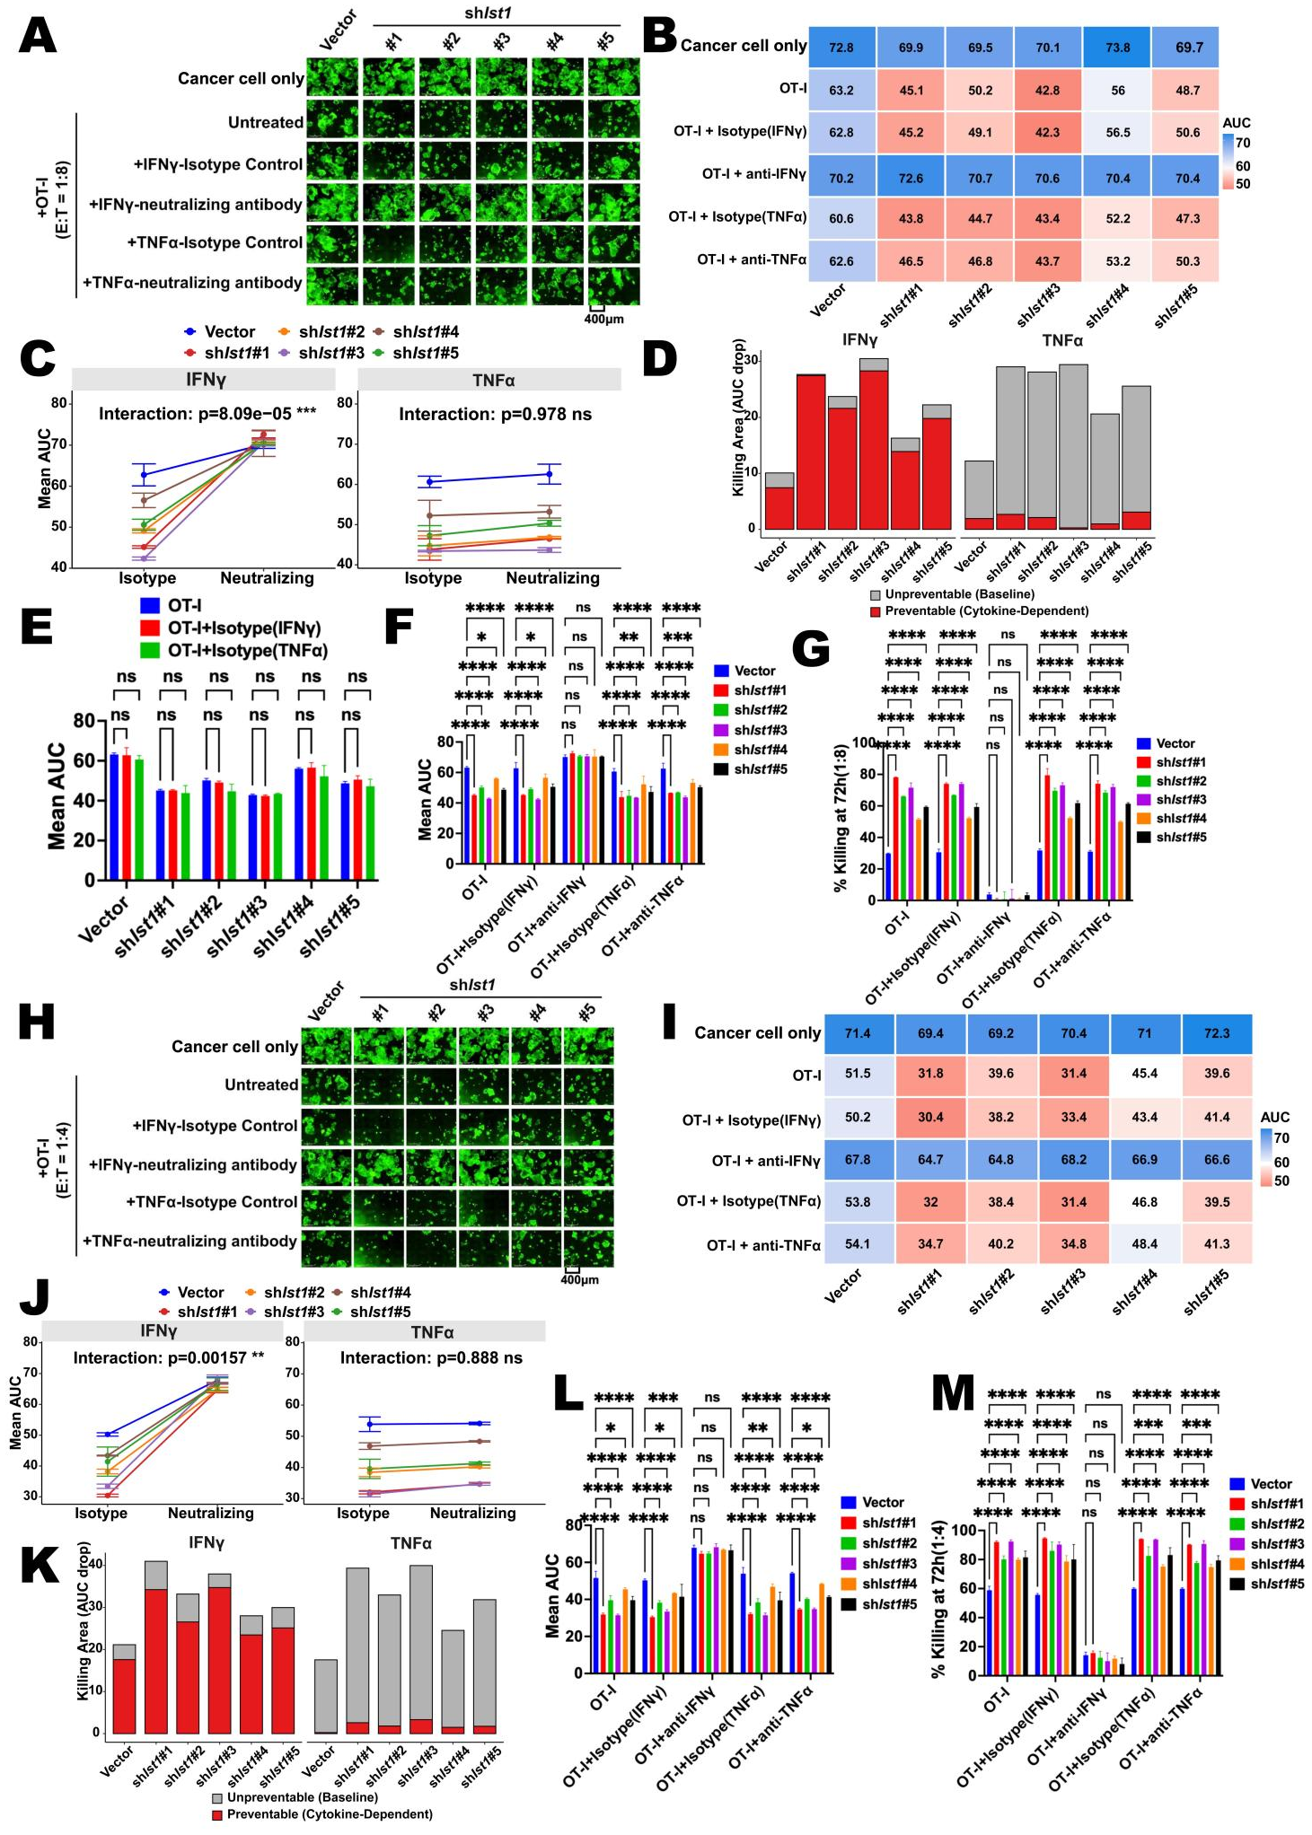

Fig. S15. Cytokine-neutralization analysis of OT-I killing in Ist1-knockdown cells(related to Fig. 4).
(A) Representative live-cell fluorescence images of Vector control and five independent shIst1 tumor cell lines co-cultured with OT-I T cells at an effector-to-target ratio of 1:8. Cells were treated with IFNγ- or TNFα-neutralizing antibodies or the corresponding isotype controls, as indicated. Tumor-only and untreated OT-I co-culture conditions are shown as controls. Scale bar, 400 μm.

(B) Heatmap summary of mean area under the curve (AUC) values derived from longitudinal tumor-cell viability measurements in the 1:8 co-culture condition. Lower AUC values indicate greater OT-I-mediated tumor-cell elimination.
(C) Interaction analysis of cytokine neutralization and tumor-cell genotype based on mean AUC at an E:T ratio of 1:8.
(D) Decomposition of the OT-I-dependent killing area into cytokine-preventable and cytokine-unpreventable components at an E:T ratio of 1:8.
(E) Quantification of mean AUC in Vector and shIst1 tumor cells treated with OT-I alone or with IFNγ or TNFα isotype control antibodies.

(F) Mean AUC quantification for Vector and shIst1 tumor cells co-cultured with OT-I T cells at an E:T ratio of 1:8 in the presence of IFNγ- or TNFα-neutralizing antibodies or the corresponding isotype controls. IFNγ neutralization abrogated the reduced-AUC phenotype caused by Ist1 knockdown, whereas TNFα neutralization did not eliminate the genotype-dependent difference.

(G) Percent killing at 72h in the 1:8 co-culture condition.
(H–M) Validation of the cytokine-dependence phenotype at a higher effector-to-target ratio of 1:4. (H) Representative live-cell fluorescence images. (I) Heatmap summary of mean AUC values. (J) Interaction analysis of IFNγ or TNFα neutralization with tumor-cell genotype. (K) Decomposition of killing area into cytokine-preventable and cytokine-unpreventable fractions. (L) Mean AUC quantification. (M) Percent killing at 72h.
Data are shown as mean ± SD; n=3; *p<0.05, **p<0.01, ***p<0.001, ****p<0.0001, ns = not significant by two-way ANOVA.
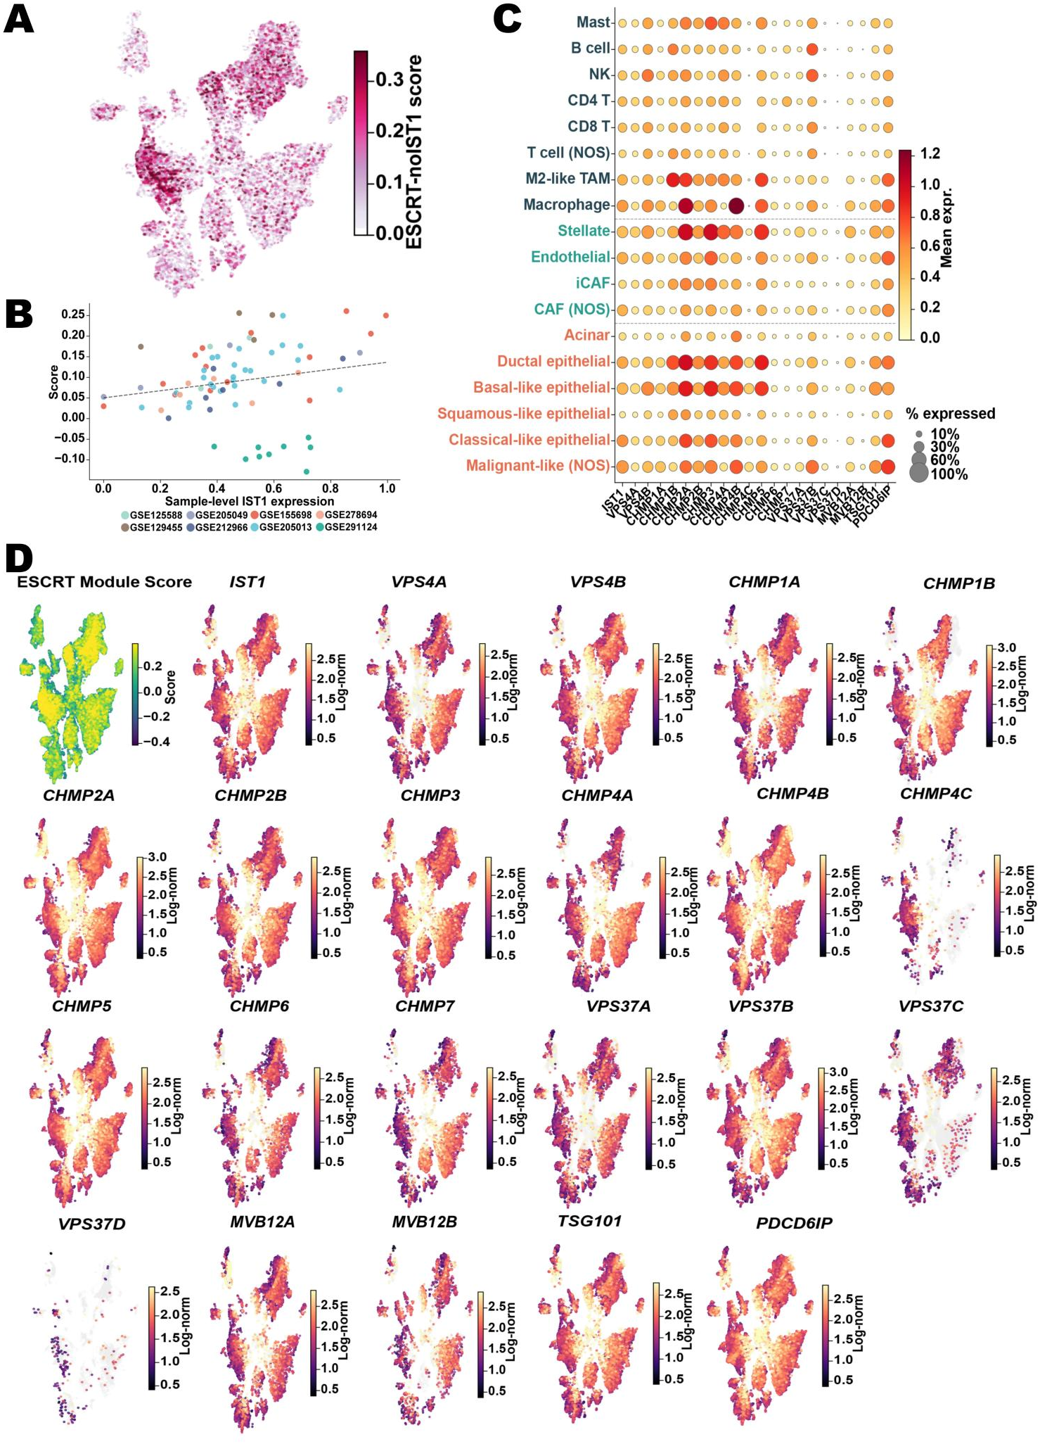
Fig. S16. ESCRT-III module expression in the integrated atlas.

- UMAP of the integrated atlas (same cells as Fig S5A), coloured by the ESCRT-III module score computed after excluding IST1. Scores were derived with Scanpy score_genes (ctrl_size = 50, n_bins = 25), subtracting the mean expression of 50 expression-bin-matched control genes. Excluding IST1 removes its self-contribution to the score; the retained co-localisation with IST1-high regions indicates coordinated ESCRT-III activity rather than an autocorrelation artifact.

- Sample-level (pseudobulk) association between mean IST1 expression (x-axis) and the mean ESCRT module score (y-axis) across ductal/tumor samples. Each point is one sample, coloured by cohort of origin (legend); the dashed line is the ordinary-least-squares fit ρ.and p, two-sided Spearman's rank correlation (ρ= 0.25, p = 0.031).
- Dot plot of IST1 and 21 ESCRT-related genes across major cell populations in the 8-cohort integrated atlas (cell types with≥50 cells shown; y-axis label colour denotes compartment: red/orange, epithelial; teal, stromal; dark, immune). Dot area, detection rate (% cells with non-zero expression); dot colour, mean log-normalised expression.
- UMAP feature plots of the ESCRT-III module score and individual ESCRT-III/ESCRT-related genes (IST1, VPS4A/B, CHMP1A/B, CHMP2A/B, CHMP3, CHMP4A/B/C, CHMP5/6/7, VPS37A/B/C/D, MVB12A/B, TSG101, PDCD6IP) across the integrated atlas; colour, log-normalised expression. ESCRT-III genes co-localise with IST1-high regions.
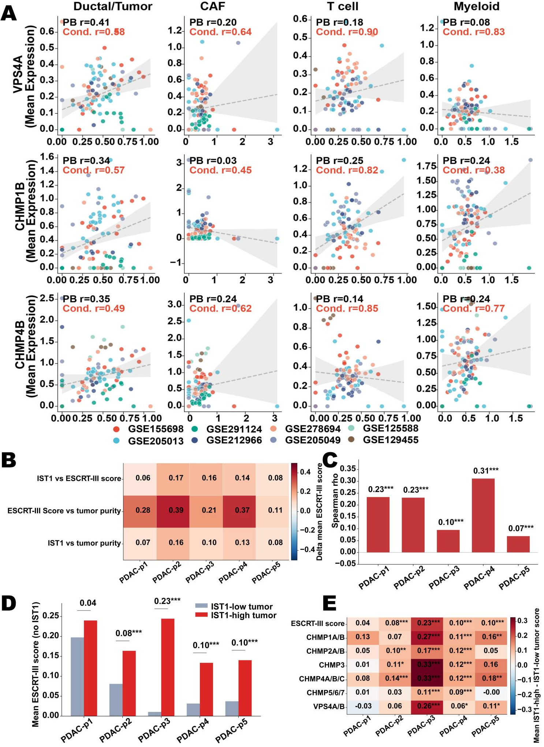

Fig. S17. IST1-ESCRT-III gene co-expression across four major cell populations in the 8-cohort integrated atlas (related to Fig. 5).

- Each scatter plot shows pseudobulk mean IST1 expression (x-axis) versus pseudobulk mean expression of the indicated ESCRT componenrt ecode gene (y-axis) across samples (n, number of samples with ≥ 50 cells of the indicated type; dots coloured by cohort). Two Spearman correlations are reported per panel: PB r, pseudobulk correlation across all samples (each dot=per-sample cell-type mean; black); Cond. r, conditional correlation restricted to cells co-expressing both IST1 and the ESCRT gene (both > 0), computed at the single-cell level to mitigate zero-inflation bias (red). Dashed grey line, OLS regression fit shown for visualisation.
(B)Spot-level Spearman correlation heatmap for three pairwise associations across five PDAC Visium tissue sections (GSE274103, PDAC-p1 to PDAC-p5). All features were robustly normalised per sample (1st–99th percentile min-max clipping) prior to correlation. The ESCRT-III no-IST1 score was computed as the mean z-scored expression of ESCRT-III complex genes excluding IST1. Tumour purity was defined as the malignant epithelial lineage score at each spot. Numbers, Spearman ρ; colour, RdBu diverging scale (-0.5 to +0.5).
(C) ESCRT-III module enrichment in tumour-rich versus stroma/immune-rich spots. Bars show the difference in mean normalised ESCRT-III no-IST1 score between tumour-rich and stroma/immune-rich spot populations in each tissue section. Significance was assessed by two-sided Mann–Whitney U test; p-values were BH-FDR corrected across all features and samples. *** FDR < 0.001; ** FDR < 0.01; * FDR < 0.05.
(D) Mean ESCRT-III activity score (z-scored expression of ESCRT-III genes excluding IST1, averaged per spot) in IST1-low (grey) and IST1-high (red) tumour spots across five PDAC Visium sections (PDAC-p1 to PDAC-p5, GSE274103). Tumour spots were stratified by the spatial IST1-high/low classification. Δ values denote mean_IST1-high−mean_IST1-low. Significance stars derive from two-sided Mann-Whitney U tests with BH-FDR correction across all sections and features. * p_adj < 0.05; ** p_adj < 0.01.
(E) Heatmap of Δ mean score (IST1-high minus IST1-low tumour spots) for seven ESCRT-III submodules across the same five sections. Positive values (red) indicate higher submodule activity in IST1-high regions. Significance overlay as above.

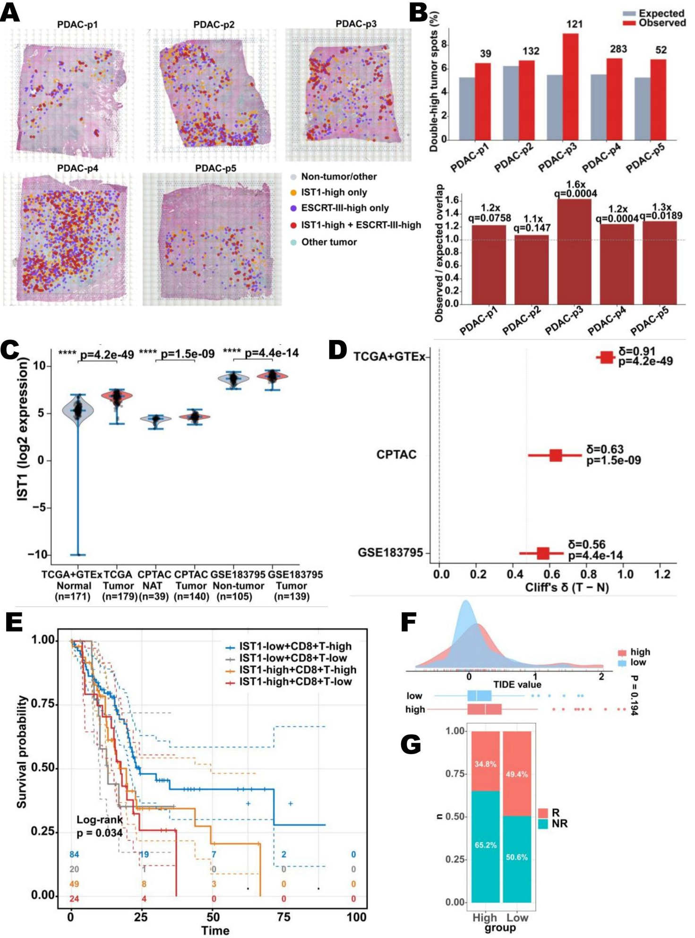

Fig. S18. Spatial co-localization, tumor-vs-normal enrichment and clinical outcome correlates of IST1/ESCRT-III in human PDAC.
(A) H&E overlay of five PDAC Visium sections (PDAC-p1–p5; GSE274103) showing spatial co-distribution of IST1-high and ESCRT-III-high tumour spots. Within each section, five mutually exclusive spot categories are shown: non-tumour/other (grey; spots below the malignant-epithelial purity threshold, encompassing stromal, immune and non-malignant tissue regions), other tumour (teal; tumour-rich spots classified as neither IST1-high nor ESCRT-III-high), IST1-high only (orange; tumour-rich spots with elevated IST1 expression but low ESCRT-III activity), ESCRT-III-high only (purple; tumour-rich spots with elevated ESCRT-III activity but low IST1 expression), and double-high (tumour-rich spots with elevated IST1 expression and ESCRT-III activity).
- Top: Observed (red) versus expected (blue) percentage of double-high tumour spots (IST1-high AND ESCRT-III-high) across five PDAC Visium sections. Expected overlap was computed as the product of marginals under independence: (n_IST1-high × n_ESCRT-III-high) / n_tumour-total. Numbers above red bars indicate observed double-high spot counts. Bottom: Enrichment ratio (observed/expected overlap) per section. Fold-change and BH-FDR-corrected permutation q-values are annotated above each bar; dashed line at 1.0 denotes the null expectation. Permutation p-values were derived from 5,000 random shuffles of ESCRT-III-high spot labels within tumour-rich spots per section; BH-FDR correction applied across all five sections.

- Violin plots of IST1 expression (log2) comparing normal/adjacent tissue with primary PDAC tumors across three independent clinical bulk transcriptomic datasets: TCGA+GTEx , CPTAC washu, and GSE183795. Horizontal lines mark group medians, and overlaid points show individual samples (horizontal jitter). Brackets report exact two-sided Mann–Whitney U test p-values. NAT, normal adjacent tissue.

- Forest plot of the per-cohort IST1 tumor-vs-normal effect size (Cliff's δ, Tumor-Normal) for the same three datasets: TCGA+GTEx δ=0.91 [95% CI 0.86-0.95], CPTAC δ=0.63 [0.49-0.77], GSE183795 δ=0.56 [0.44-0.67]. Squares denote point estimates and horizontal bars the 95% CI from 1,000 bootstrap resamples; the dashed line marks no effect (δ=0) and the dotted line the conventional large-effect threshold (δ=0.474). All three cohorts exceed the large-effect threshold, indicating consistent and substantial IST1 upregulation in tumor.

- Kaplan-Meier overall-survival curves stratifying patients by combined IST1 expression and CD8⁺ T-cell infiltration into four groups: IST1-low+CD8 T-high, IST1-low+CD8 T-low, IST1-high+CD8 T-high, IST1-high+CD8 T-low. Log-rank p=0.034; numbers at risk at each time point are indicated below the curves.

- Density plot of TIDE values stratified by IST1 group (high vs low); stacked bar indicates the proportion of TIDE-high samples per group.

(G) Predicted response (R) vs non-response (NR) to immune checkpoint inhibition by TIDE in IST1-high vs IST1-low groups.

