Supplementary Information
Fear Recognition in Healthy and Clinical Adults: A Systematic Review and Meta-analysis
Martins, A. T.; Carvalho, F. R.; Russo, J.; Campos, C.; Camacho-Ruiz, J. A.; Galvez-Sánchez, C. M.; Rodrigues, J.; & Gomes, A.

Supplementary Methods
Search strategy. Full Boolean queries and per-database record counts.
Supplementary S1 — Search Strategy
Database 1: PubMed/MEDLINE
Date searched (phase 1): 2025 (by coordinating author, A.T.M.)
Temporal filter: 2016/01/01 – 2025/12/31
Boolean query (reconstructed from records retrieved):
```
("fear"[MeSH Terms] OR "fear"[Title/Abstract])
AND
("facial expression"[MeSH Terms] OR "facial expression"[Title/Abstract] OR "facial emotion"[Title/Abstract])
AND
("recognition, psychology"[MeSH Terms] OR "recognition"[Title/Abstract] OR "identification"[Title/Abstract])
AND
("emotion"[MeSH Terms] OR "emotion"[Title/Abstract] OR "emotional"[Title/Abstract])
NOT
("animals"[MeSH:noexp] NOT "humans"[MeSH])
```
Filters applied:
- Article type: Journal Article OR Review (reviews used as theoretical references only)
- Language: English, Portuguese
- Date: 2016–2025
- Age: Adult (18+ years)
Database 2: Scopus
Date searched (phase 1): 2025
Boolean query:
```
TITLE-ABS-KEY(("fear" OR "fearful") AND ("facial expression" OR "facial emotion")
AND ("recognition" OR "identification") AND ("emotion" OR "emotional"))
AND PUBYEAR > 2015 AND PUBYEAR < 2026
AND LANGUAGE("English") OR LANGUAGE("Portuguese")
```
Records identified per database
| Database | Records identified | Notes |
|---|:---:|---|
| PubMed/MEDLINE | 302 | filters: 2016–2025, Humans, Adult 18+, English/Portuguese |
| Scopus | 2,533 | TITLE-ABS-KEY; PUBYEAR 2016–2025; English/Portuguese |
| Total identified | 2,835 | |
| Duplicate records removed | 126 | de-duplication of combined exports |
| Records screened (title/abstract) | 2,709 | |
| Records excluded at title/abstract | 2,663 | screening conducted by coordinating author (phase 1) |
| Records sought for full-text retrieval | 46 | |
Phase 2 — Full-text retrieval (lead author, F.R.C., May 2026)
- 46 records initially identified
- 37 retrieved via institutional access (University of Algarve subscriptions + open access)
- 5 PDFs provided directly by the coordinating author from her personal archive
- 4 records could not be retrieved (Malykhin 2023, Calvo 2016, Tabesh 2025, Manno 2025)
NOT performed (acknowledged limitations)
- Grey literature search (theses, conference proceedings, ResearchGate)
- Hand-searching of reference lists
- Pre-registration in PROSPERO (justified in §2.1)
- Search in PsycINFO, Embase or Cochrane Library (only PubMed + Scopus used)
- Searches in non-English/non-Portuguese languages (potentially missed studies in Mandarin, Japanese, Korean, Spanish)
These omissions are documented as limitations in §4.6 of the manuscript.

Supplementary Tables
Supplementary Table S1. PICO(S) eligibility criteria.

Supplementary Table S2. Hybrid PROBAST/AXIS risk-of-bias tool (14 items × 4 domains).

Supplementary Table S3. Characteristics of the 40 included studies.
Table 1 — Characteristics of Included Studies (n = 40; 2016–2025)
Study (Author, Year) | Country | Sample (HC, clinical) | Stimulus type | Paradigm (response options) | Emotion set | Fear accuracy HC (%) | Pool eligible
Abutalebi et al., 2024 | Italy | HC n=NR (older adults) | Static photo (masked/unmasked) | 7-option FC | 7 basic | 94.3 (unmasked) | ✓
Aho-Ozhan et al., 2016 | Germany | HC n=27; ALS n=39 | Static photo (EFT) | EFT subscore | 6 basic | 55.2 (5.52/10) | ✓
Bell et al., 2017 | New Zealand | HC n=89; PTSD n=28 | Static photo | FERT | 6 basic + neutral | 53.1 | ✓
Bologna et al., 2016 | Italy | HC n=22; PD n=20 | Static photo (EFT) | EFT subscore | 6 basic | — (partial data) | —
Burgund, 2021 | Croatia | HC n=72 | Static photo (KDEF) | 6-option FC | 6 basic | 43 | ✓
Calvo et al., 2018 | Spain | HC n=72 | Dynamic morph (KDEF-dyn) | 6-option FC | 6 basic | 59.8 | ✓
Chen et al., 2025 | China | HC n=62; SCZ n=51 | Dynamic morph (NimStim) | 5-option FC | 5 basic | 77.4 | ✓
Chong et al., 2024 | Australia/HK | HC n=15 raters | Cantonese AV | 7-option FC | 7 basic | 43.9 (AV) | ✓
Chung et al., 2019 | Korea | HC n=NR | Static photo + dynamic (YFace DB) | 7-option FC | 7 basic | ~35 (mean 3 cond.) | ✓
Colonnello et al., 2019 | Italy | HC n=NR | Trustworthiness paradigm | Trust ratings | Various | — (paradigm N/A) | —
Dodich et al., 2022 | Italy | HC n=NR; bvFTD | Static photo (EFT) | EFT subscore | 6 basic | 40 (median) | ✓
Esposito et al., 2016 | Italy | HC n=NR; MDD | AV multimodal | 4-option FC | 4 basic | 75 (audio/video) | ✓
Franca et al., 2023 | Belgium | HC n=NR | Eye-region (SEE-48) | SEE-48 | 6 basic | 67 | ✓
Griffiths et al., 2019 | — | Children 6–16 | — | — | — | EXCLUDED (population) | —
Gu et al., 2023 | China | HC n=60 (avoidant vs secure) | Static photo | 5-option FC + ERP | 5 basic | 69.4 (collapsed) | ✓
Hama et al., 2023 | Japan | HC n=51 | Static photo (Caucasian) | 7-option FC | 7 basic | 19.4 | ✓
Iannaccone et al., 2025 | Italy | HC n=NR; mTLE/rMTLE | Static photo (EFT) | EFT subscore | 6 basic | 76.0 | ✓
Jin et al., 2017 | — | — | — | — | — | EXCLUDED (T/A — no fear) | —
Kim H et al., 2023 | Korea | HC older adults | Production task (FACS) | FACS output | 6 basic | — (production, not recognition) | —
Kim M et al., 2022 | Korea | HC n=NR; KASF stimuli | Static photo (KASF) | 6-option FC | 6 basic | 48.5 (overall) | ✓
Kosonogov & Titova, 2019 | Russia | HC n≈25 | Static photo | 7-option FC | 7 basic | 40.6 | ✓
Lannoy et al., 2019 | Belgium | HC n=NR; AUD | Static photo + ERP | ANOVA/t-tests reported | 6 basic | — (partial) | —
Lee SC et al., 2022 | Korea | HC n=NR; clinical | Static photo | dʹ / accuracy | 6 basic | — (partial PDF) | —
Lomoriello et al., 2023 | Italy | HC n=NR | Static photo | Likert intensity | 6 basic | — (paradigm) | —
Lyons et al., 2021 | UK | HC n=NR | Bodily sensation maps | BSM | Various | — (paradigm) | —
Manno et al., 2025 | Italy | HC n=NR | Static photo (similarity) | — | — | — (no PDF) | —
Martino et al., 2016 | — | BD only | — | — | — | EXCLUDED (clinical-only) | —
Dalkıran et al., 2017 | — | SCZ only | — | — | — | EXCLUDED (clinical-only) | —
Meléndez et al., 2020 | Spain | HC older adults | Static photo (real-life) | 6-option FC | 6 basic | — (partial PDF) | —
Mo et al., 2021 | China | HC n=30; MDD n=28 | Static photo (Ekman) | Pairwise 2-AFC | 6 basic | 88.4 | ✓
Puffet et al., 2025 | Canada | HC n=76 raters | Static photo+body (ECIFBSS) | 7-option FC | 7 basic | 49.46 (raw) | ✓
Richer et al., 2025 | Canada | HC n=NR | Likert intensity | Likert | 7 basic | — (paradigm) | —
Rodger et al., 2018 | UK/HK | HC across age 5–80 | QUEST thresholds | QUEST | 6 basic | — (paradigm) | —
Salvato et al., 2023 | Italy | HC n=50; OC offenders | Static photo (ERT) | Z-scored | 6 basic | — (z-scores) | —
Sarma & Barma, 2021 | India | HC n=NR | EEG-based blinking | BDV | Various | — (psychophysiology) | —
Schönenberg et al., 2016 | Germany | HC n=NR; offenders | Dynamic morph onset | Threshold | 6 basic | — (paradigm) | —
Schönenberg et al., 2019 | Germany | HC n=NR; ADHD | Dynamic morph onset | Threshold | 6 basic | — (paradigm) | —
Schwartz et al., 2018 | Canada | HC n=NR; PD | Dynamic film | Likert + pupillometry | Various | — (paradigm) | —
Suslow et al., 2023 | Germany | HC n=NR | Static photo | Hu unbiased | 6 basic | 34 (Hu) | ✓
Szmulewicz et al., 2020 | Argentina | HC n=NR; MDD/BD | Static photo | Z-scored (meta) | 6 basic | — (z-scores) | —
Tabesh et al., 2025 | Iran | HC n=NR | — | — | — | — (no PDF) | —
Uono et al., 2017 | Japan | HC n=50 | Static photo | 6-option FC | 6 basic | 64.0 | ✓
Xie et al., 2023 | China | HC n=100 | VR video + EEG | SAM rating | 6 basic | — (paradigm) | —
Yamasaki & Miyata, 2025 | Japan | HC n=82 | Static photo (masked) | 7-option FC | 7 basic | 20.3 (no-mask) | ✓
Notes: ✓ = study contributed to the meta-analytic pool (k = 21). — = excluded from pool (paradigm incompatible / partial data / no PDF). EFT = Ekman 60 Faces Test; FERT = Facial Expression Recognition Test; KDEF = Karolinska Directed Emotional Faces; KASF = Korean Adolescent Sensitive Faces; ECIFBSS = Emotional and Cognitive Integrated Face-Body Stimulus Set; AV = audiovisual; BSM = bodily sensation maps; FACS = Facial Action Coding System; QUEST = Bayesian adaptive psychophysics; SAM = Self-Assessment Manikin.

Supplementary Table S4. Studies excluded at full text, with reasons.
Supplementary Table S2 — Studies excluded at retrieval / eligibility / pool stages
Study (Author, Year) | Phase | Reason for exclusion | DOI / Source | Citation
Malykhin et al., 2023 | Not retrieved | Full-text unavailable via institutional or open-access channels | 10.1101 (preprint) | Malykhin, N. V. et al. (2023). Emotional recognition across the adult lifespan. [Full-text not retrieved].
Calvo et al., 2016 | Not retrieved | Full-text unavailable via institutional or open-access channels | — | Calvo, M. G. et al. (2016). Recognition thresholds of static and dynamic faces. [Full-text not retrieved].
Griffiths et al., 2019 | Excluded — Full-text | Inadequate population (children/adolescents 6–16 years) | — | Griffiths, S. et al. (2019). [Children sample; excluded per inclusion criterion].
Martino et al., 2016 | Excluded — Full-text | Exclusively clinical sample (bipolar disorder) without healthy controls | 10.1007/978-3-319-33747-0_42 (vicinity) | Martino, D. J. et al. (2016). [Bipolar disorder sample only; excluded per inclusion criterion].
Dalkıran et al., 2017 | Excluded — Full-text | Exclusively clinical sample (treatment-resistant schizophrenia) without healthy controls | — | Dalkıran, M. et al. (2017). [Treatment-resistant SCZ sample only; excluded per inclusion criterion].
Jin et al., 2017 | Excluded — T/A | Lack of fear assessment | — | Jin, X. et al. (2017). [Fear not specifically assessed; excluded at title/abstract].
Salvato et al., 2023 | Pool excluded | Z-scored accuracy (relative to HC mean) without raw values | 10.1080/02699931.2023.2170333 | Included in review and narrative synthesis (§3.8).
Szmulewicz et al., 2020 | Pool excluded | Meta-analysis of z-scored data | 10.1016/j.jad.2020.01.082 | Included in narrative synthesis (§3.8).
Lomoriello et al., 2023 | Pool excluded | Likert-scale intensity ratings, not categorisation accuracy | 10.1037/emo0001275 | Included in narrative synthesis (§3.8).
Richer et al., 2025 | Pool excluded | Likert-scale intensity ratings | 10.1037/emo0001516 | Included in narrative synthesis (§3.8).
Schwartz et al., 2018 | Pool excluded | Pupillometry + Likert intensity ratings; no categorisation accuracy | 10.1080/13803395.2017.1343802 | Included in narrative synthesis (§3.8).
Schönenberg et al., 2019 | Pool excluded | Dynamic morph onset thresholds rather than accuracy | 10.1177/1087054715577992 | Included in narrative synthesis (§3.8).
Schönenberg et al., 2016 | Pool excluded | Dynamic morph onset thresholds rather than accuracy | 10.1521/pedi.2015.29.217 | Included in narrative synthesis (§3.8).
Rodger et al., 2018 | Pool excluded | QUEST adaptive intensity thresholds rather than accuracy | 10.1016/j.jecp.2018.05.005 | Included in narrative synthesis (§3.8).
Lyons et al., 2021 | Pool excluded | Bodily sensation maps (no facial accuracy) | 10.1007/s10608-020-10195-0 | Included in narrative synthesis (§3.8).
Sarma & Barma, 2021 | Pool excluded | EEG-based blinking duration variability; no behavioural accuracy | 10.1016/j.bspc.2021.102883 | Included in narrative synthesis (§3.8).
Xie et al., 2023 | Pool excluded | EEG/VR study with SAM ratings; no fear-categorisation accuracy | 10.1109/TNSRE.2022.3229389 | Included in narrative synthesis (§3.8).
Kim H et al., 2023 | Pool excluded | FACS-based facial production task (not perception/recognition) | 10.3390/s23167080 | Included in narrative synthesis (§3.8).
Colonnello et al., 2019 | Pool excluded | Trustworthiness/dyadic perception paradigm; auxiliary FER without standard accuracy | 10.3389/fpsyg.2019.00527 | Included in narrative synthesis (§3.8).
Lannoy et al., 2019 | Pool excluded — partial data | Only ANOVA/t-tests reported; no group means or SDs | 10.1111/acer.14152 | Authors to be contacted for raw data.
Bologna et al., 2016 | Pool excluded — partial data | Figure only; no tabular means/SDs in main paper | 10.3389/fneur.2016.00230 | Authors to be contacted for raw data.
Lee SC et al., 2022 | Pool excluded — partial data | Truncated PDF; group means unavailable | 10.1016/j.jad.2022.01.010 | Full PDF to be re-requested.
Meléndez et al., 2020 | Pool excluded — partial data | Truncated PDF; group means unavailable | 10.1016/j.jenvp.2020.101518 | Full PDF to be re-requested.
Tabesh et al., 2025 | Pool excluded — no PDF | Full-text not accessible | — | Authors to be contacted.
Manno et al., 2025 | Pool excluded — no PDF | Full-text not accessible | — | Authors to be contacted.
Total excluded across all stages: 25
Of these: 2 not retrieved + 3 full-text exclusion + 1 T/A exclusion + 13 incompatible paradigm + 4 partial data + 2 no PDF = 25

Supplementary Table S5. PRISMA 2020 checklist (main report).
PRISMA 2020 Checklist — Martins, Gomes & Carvalho (2026). Facial recognition of fear: systematic review and meta-analysis
Section / Topic | # / Item | Checklist item | Location in manuscript / page / section
TITLE | 1 | Identify the report as a systematic review. | Title page; cover
ABSTRACT | 2 | See the PRISMA 2020 for Abstracts checklist (PRISMA-A). | Abstract (unstructured, 200 words)
INTRODUCTION
Rationale | 3 | Describe the rationale for the review in the context of existing knowledge. | §1.1, §1.2, §1.3
Objectives | 4 | Provide an explicit statement of the objective(s) or question(s) the review addresses. | §1.5 (5 objectives) and §1.6 (3 pre-specified hypotheses)
METHODS
Eligibility criteria | 5 | Specify the inclusion and exclusion criteria for the review and how studies were grouped for the syntheses. | §2.2 + Table M1 (PICO(S))
Information sources | 6 | Specify all databases, registers, websites, organisations, reference lists and other sources searched or consulted to identify studies. Specify the date when each source was last searched or consulted. | §2.3
Search strategy | 7 | Present the full search strategies for all databases, registers and websites, including any filters and limits used. | §2.3 (PubMed/Scopus; 2016–2025; boolean: fear AND facial expression AND recognition AND emotion). Full search strings to be included as Supplementary S1.
Selection process | 8 | Specify the methods used to decide whether a study met the inclusion criteria of the review, including how many reviewers screened each record and each report retrieved, whether they worked independently, and if applicable, details of automation tools used. | §2.4 — single-reviewer with coordinator validation of borderline cases.
Data collection process | 9 | Specify the methods used to collect data from reports, including how many reviewers collected data from each report, whether they worked independently, any processes for obtaining or confirming data from study investigators, and if applicable, details of automation tools used. | §2.5 — single reviewer with two targeted audits.
Data items | 10a | List and define all outcomes for which data were sought. Specify whether all results that were compatible with each outcome domain in each study were sought. | §2.5 (85-field template, 9 sections); §2.7.1 (pool inclusion criteria)
 | 10b | List and define all other variables for which data were sought (e.g. participant and intervention characteristics, funding sources). Describe any assumptions made about any missing or unclear information. | §2.5 + §2.7.3 (SD imputation via binomial formula)
Study risk of bias assessment | 11 | Specify the methods used to assess risk of bias in the included studies, including details of the tool(s) used, how many reviewers assessed each study and whether they worked independently, and if applicable, details of automation tools used. | §2.6 + Table M2 (hybrid PROBAST/AXIS, 14 items × 4 domains; single reviewer with coordinator sample supervision)
Effect measures | 12 | Specify for each outcome the effect measure(s) (e.g. risk ratio, mean difference) used in the synthesis or presentation of results. | §2.7.2 — proportion in logit scale; pool reported as %
Synthesis methods | 13a | Describe the processes used to decide which studies were eligible for each synthesis. | §2.7.1 (4 inclusion criteria for pool)
 | 13b | Describe any methods required to prepare the data for presentation or synthesis, such as handling of missing summary statistics, or data conversions. | §2.7.3 (SD imputation via binomial)
 | 13c | Describe any methods used to tabulate or visually display results of individual studies and syntheses. | §3.4 — Forest plot (Fig. 3), Subgroup plot (Fig. 4), Funnel plot (Fig. 5), Confusion patterns (Fig. 6)
 | 13d | Describe any methods used to synthesise results and provide a rationale for the choice(s). If meta-analysis was performed, describe the model(s), method(s) to identify the presence and extent of statistical heterogeneity, and software package(s) used. | §2.7.2 — DerSimonian–Laird random-effects logit; method-of-moments τ²; I² and Cochran's Q (Higgins et al., 2003)
 | 13e | Describe any methods used to explore possible causes of heterogeneity among study results (e.g. subgroup analysis, meta-regression). | §2.8 — subgroups on modality, culture, era, response options
 | 13f | Describe any sensitivity analyses conducted to assess robustness of the synthesised results. | §2.10 — funnel + Egger's. Leave-one-out and QS-restricted pools planned for final version.
Reporting bias assessment | 14 | Describe any methods used to assess risk of bias due to missing results in a synthesis (arising from reporting biases). | §2.10 (Egger's regression)
Certainty assessment | 15 | Describe any methods used to assess certainty (or confidence) in the body of evidence for an outcome. | GRADE assessment not conducted; Quality Score (§2.6) used as a proxy; flagged in §4.6 limitations.
RESULTS
Study selection | 16a | Describe the results of the search and selection process, from the number of records identified in the search to the number of studies included in the review, ideally using a flow diagram. | §3.1 + Figure 1 (PRISMA 2020 flow diagram)
 | 16b | Cite studies that might appear to meet the inclusion criteria, but which were excluded, and explain why they were excluded. | §3.1 (3 excluded: Griffiths 2019, Martino 2016, Dalkıran 2017; 2 not retrieved: Malykhin 2023, Calvo 2016; 1 T/A excluded: Jin 2017)
Study characteristics | 17 | Cite each included study and present its characteristics. | §3.2 + Supplementary Table 1 (40 studies × characteristics)
Risk of bias in studies | 18 | Present assessments of risk of bias for each included study. | §3.3 + Figure 2 (heatmap)
Results of individual studies | 19 | For all outcomes, present, for each study: (a) summary statistics for each group (where appropriate) and (b) an effect estimate and its precision (e.g. confidence/credible interval), ideally using structured tables or plots. | §3.4 + Figure 3 (forest plot k = 21)
Results of syntheses | 20a | For each synthesis, briefly summarise the characteristics and risk of bias among contributing studies. | §3.2, §3.3, §3.4
 | 20b | Present results of all statistical syntheses conducted. If meta-analysis was done, present for each the summary estimate and its precision (e.g. confidence/credible interval) and measures of statistical heterogeneity. If comparing groups, describe the direction of the effect. | §3.4 (pool 54.5% [45.8–62.9], I² = 88%); §3.6 (fear → surprise 32.3% [25.5–39.8], I² = 4%)
 | 20c | Present results of all investigations of possible causes of heterogeneity among study results. | §3.5 + Table 3 + Figure 4
 | 20d | Present results of all sensitivity analyses conducted to assess the robustness of the synthesised results. | §3.7 (Egger's p = 0.196)
Reporting biases | 21 | Present assessments of risk of bias due to missing results (arising from reporting biases) for each synthesis assessed. | §3.7 + Figure 5
Certainty of evidence | 22 | Present assessments of certainty (or confidence) in the body of evidence for each outcome assessed. | §3.3 (Quality Score) + §4.6 limitations
DISCUSSION
Discussion | 23a | Provide a general interpretation of the results in the context of other evidence. | §4.1, §4.2, §4.3
 | 23b | Discuss any limitations of the evidence included in the review. | §4.6
 | 23c | Discuss any limitations of the review processes used. | §4.6 (single-reviewer extraction with audits; no PROSPERO registration; PT/EN screening only)
 | 23d | Discuss implications of the results for practice, policy, and future research. | §4.4, §4.5, §4.7
OTHER INFORMATION
Registration and protocol | 24a | Provide registration information for the review, including register name and registration number, or state that the review was not registered. | §2.1 — not prospectively registered (acknowledged limitation)
 | 24b | Indicate where the review protocol can be accessed, or state that a protocol was not prepared. | §2.1 — a priori plan described but not publicly registered
 | 24c | Describe and explain any amendments to information provided at registration or in the protocol. | No amendments (no formal registration)
Support | 25 | Describe sources of financial or non-financial support for the review, and the role of the funders or sponsors in the review. | Funding section: no specific grant
Competing interests | 26 | Declare any competing interests of review authors. | Declaration of interest section: none to declare
Availability of data, code and other materials | 27 | Report which of the following are publicly available and where they can be found: template data collection forms; data extracted from included studies; data used for all analyses; analytic code; any other materials used in the review. | Data availability statement: will be deposited in OSF/Zenodo prior to publication

Supplementary Table S6. PRISMA 2020 for Abstracts checklist.
PRISMA 2020 for Abstracts (PRISMA-A) — 12-item Checklist
Section | Item | Where addressed in our abstract
TITLE | 1. Title — Identify the report as a systematic review. | Title page: "...a PRISMA 2020 systematic review and meta-analysis..."
BACKGROUND | 2. Objectives — Provide an explicit statement of the main objective(s) or question(s) the review addresses. | Sentence 2: "This PRISMA 2020 systematic review and meta-analysis synthesises 40 studies (2016–2025) on facial recognition of fear..."
METHODS | 3. Eligibility criteria — Specify the inclusion and exclusion criteria for the review. | Implicit in scope: "40 studies (2016–2025) on facial recognition of fear in healthy adults and clinical populations". Full criteria in §2.2.
 | 4. Information sources — Specify the information sources used in the review. | Methods §2.3 (PubMed/MEDLINE + Scopus). Not in abstract due to word limit.
 | 5. Risk of bias — Specify the methods used to assess risk of bias in the included studies. | Sentence 3: "Risk of bias was assessed with a hybrid PROBAST/AXIS tool (14 items × 4 domains)."
 | 6. Synthesis of results — Specify the methods used to present and synthesise results. | Sentence 4: "Pooled fear accuracy ... estimated by a DerSimonian–Laird random-effects logit model in 21 studies (n = 1369)."
RESULTS | 7. Included studies — Give the total number of included studies and participants and summarise relevant characteristics of studies. | 40 studies (2016–2025); 21 in pool with n = 1369 HC.
 | 8. Synthesis of results — Present results for main outcomes, preferably indicating the number of included studies and participants for each. | Pool 54.5% (95% CI 45.8–62.9); fear → surprise pool 32.3% (95% CI 25.5–39.8); subgroup result on response options.
DISCUSSION | 9. Limitations of evidence — Provide a brief summary of the limitations of the evidence included in the review. | "the literature is fragmented by methodological and cultural heterogeneity"; "very large heterogeneity (I² = 87.6%)".
 | 10. Interpretation — Provide a general interpretation of the results and important implications. | Final sentence: "Aggregated estimates of fear accuracy should be interpreted alongside subgroup analyses; the fear-surprise confusion emerges as a candidate clinical marker."
OTHER | 11. Funding — Specify the primary source of funding for the review. | Full disclosure in main text (no funding). Word limit prevents inclusion in abstract.
 | 12. Registration — Provide the register name and registration number. | Not prospectively registered (justified in §2.1). Not included in abstract due to word limit.

Supplementary Figures
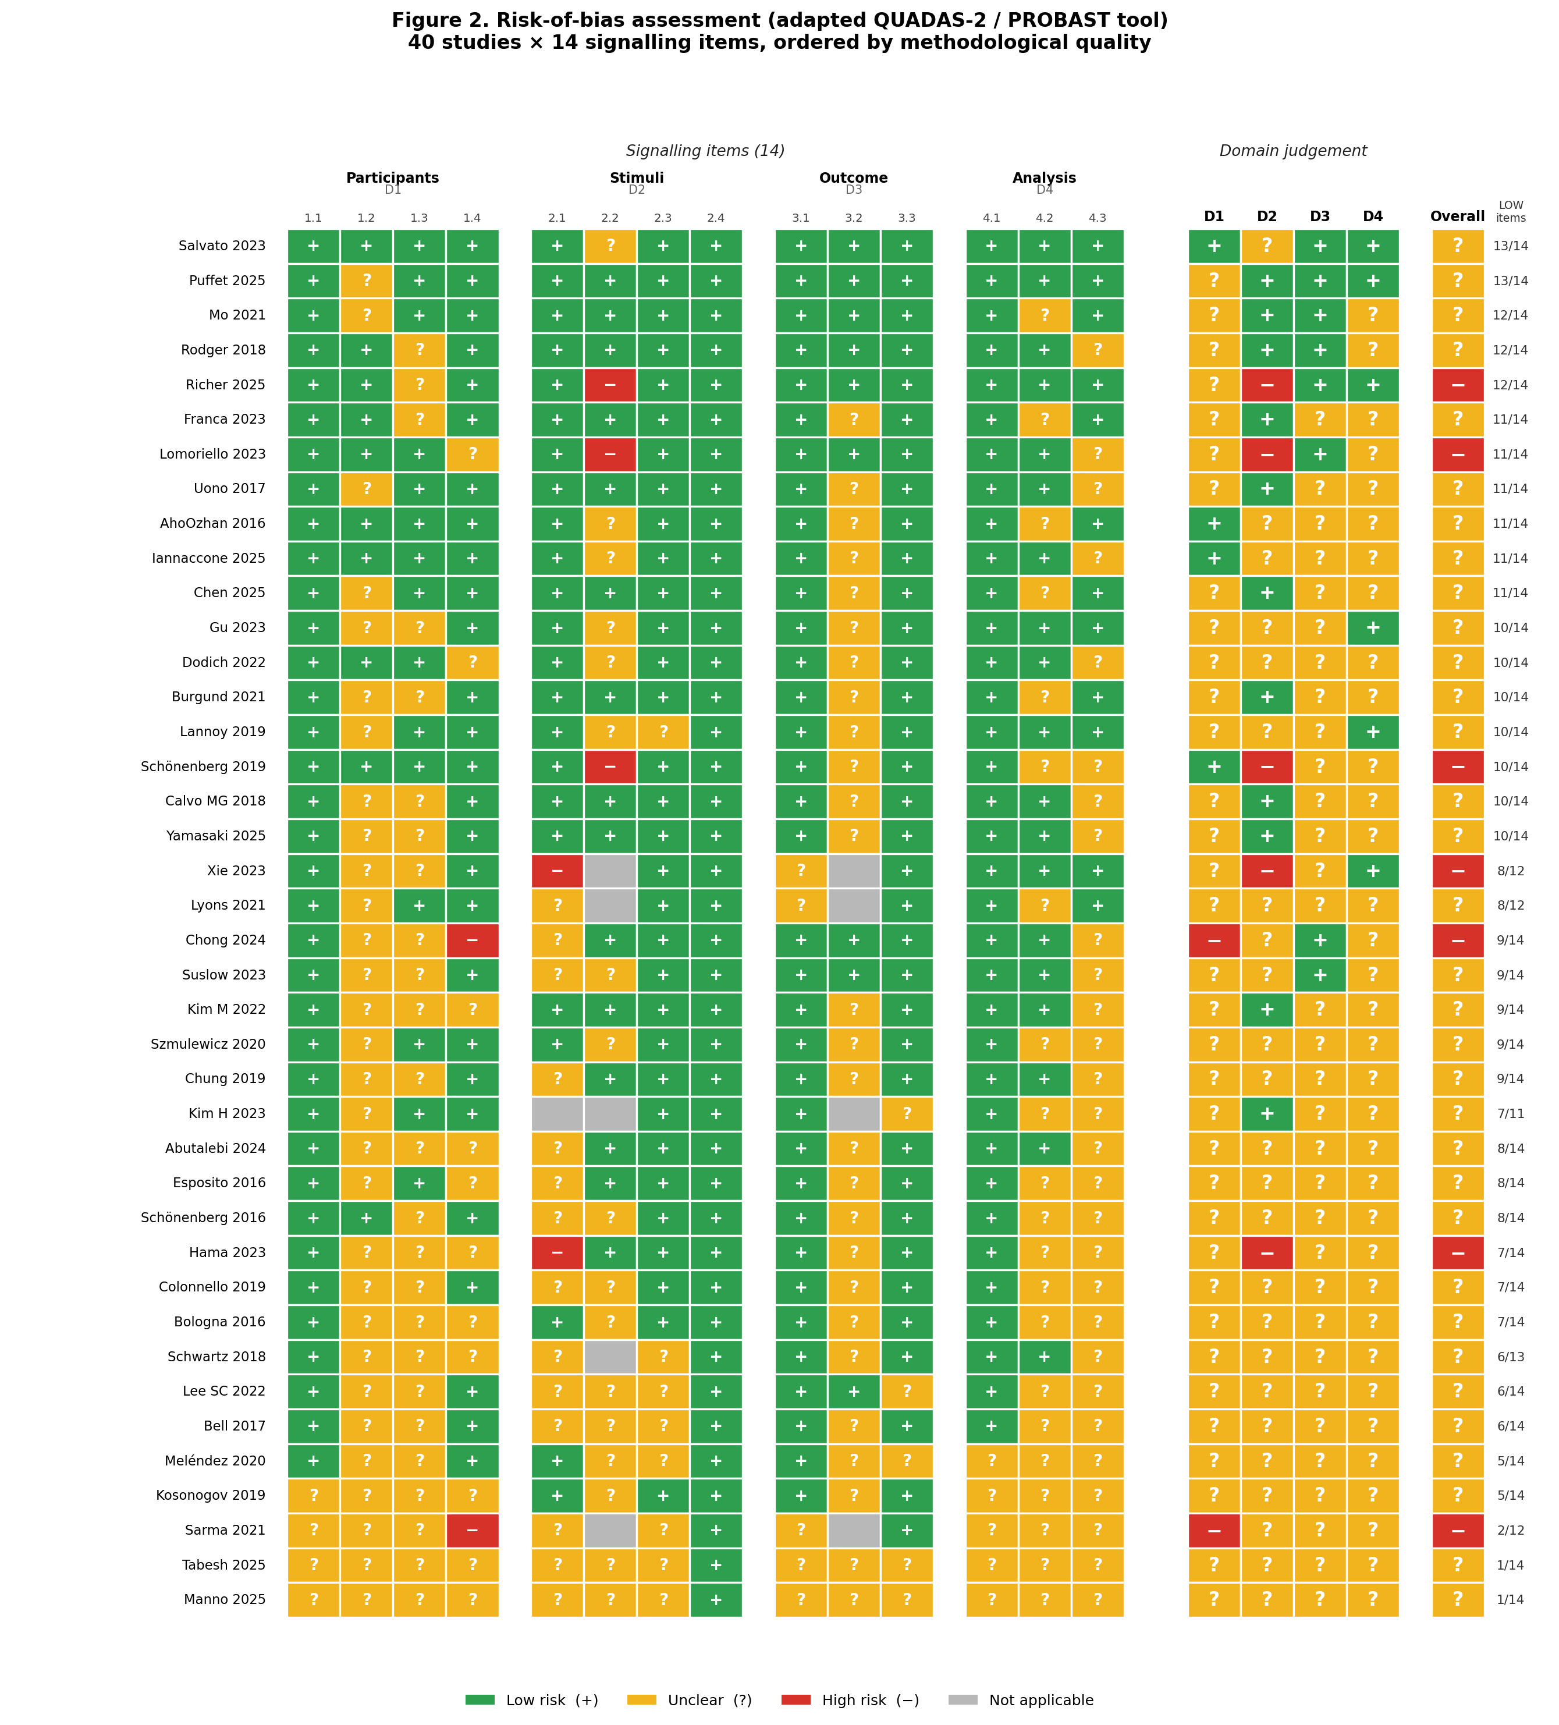
Supplementary Fig. S1. Risk-of-bias heatmap (40 studies × 14 items × 4 domains). Hybrid tool adapted from PROBAST (Wolff et al., 2019) and AXIS (Downes et al., 2016). Studies are ordered by Quality Score.

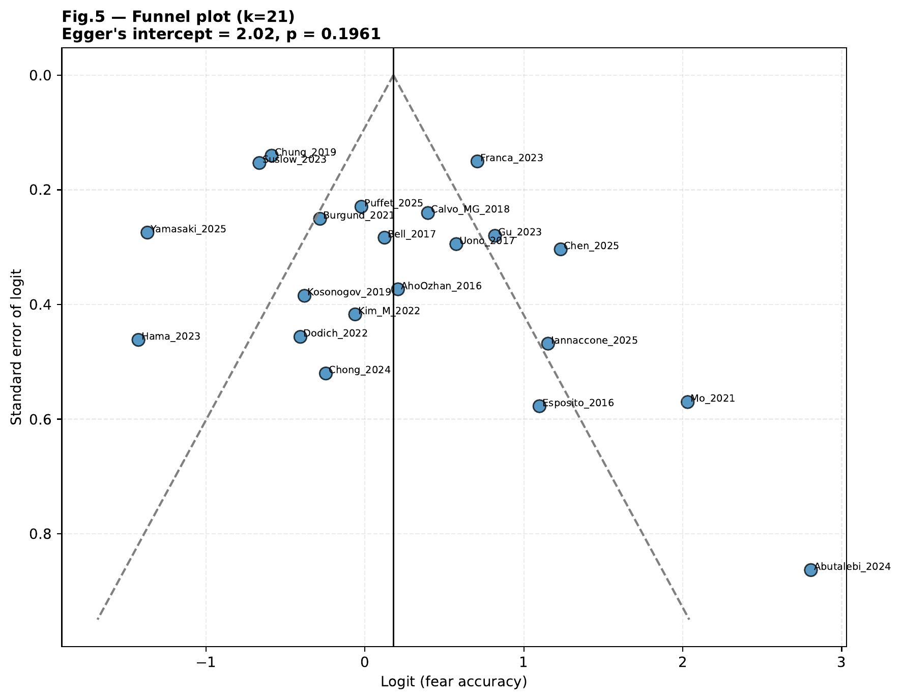
Supplementary Fig. S2. Funnel plot of fear recognition accuracy. Egger's regression: intercept = 2.02; p = 0.196 (not significant; Egger et al., 1997).

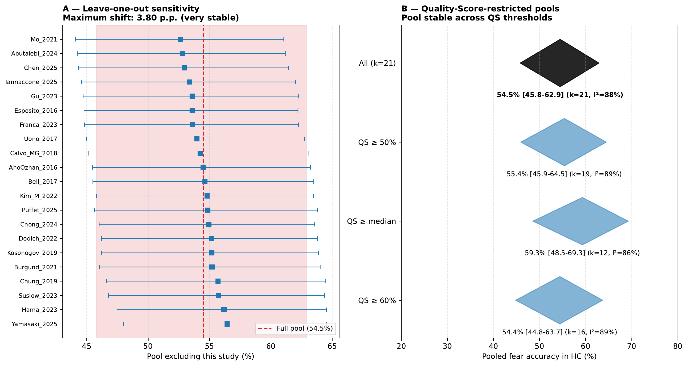
Supplementary Fig. S3. Sensitivity analyses. Panel A: leave-one-out analysis (k = 21; each study sequentially excluded; maximum shift = 3.8 p.p. around full pool of 54.5%). Panel B: Quality-Score-restricted pools (QS ≥ 50%, ≥ median, ≥ 60%); pool estimates remain stable across thresholds.

Criterion | Definition
P (Population) | Adults aged ≥ 18 years — healthy and/or clinical (psychiatric or neurological) populations with comparable assessment.
I (Intervention) | Presentation of facial stimuli (static or dynamic) containing the expression of fear (Ekman & Friesen, 1971), under recognition, discrimination, threshold or subjective evaluation paradigms.
C (Comparator) | Other basic emotions (happiness, sadness, anger, disgust, surprise, neutral) and/or comparison group (healthy controls vs clinical sample).
O (Outcome) | Fear recognition metrics: raw accuracy, Hu unbiased hit rate, signal-detection dʹ, reaction time, detection threshold, or neurophysiological correlates (ERP/EEG, fMRI, eye-tracking).
S (Study design) | Original empirical studies (cross-sectional, longitudinal, experimental, case-control). Systematic reviews and meta-analyses excluded as primary sources.
Domain | Signaling question | Coding rule
Participants | Sample appropriately defined? | LOW if clear inclusion/exclusion criteria reported; HIGH if absent; UNCLEAR if vague.
 | Sample representative? | LOW if random/consecutive sampling; HIGH if convenience sample without justification; UNCLEAR if not described.
 | HC properly screened? | LOW if explicit neuro/psychiatric screening; HIGH if none; UNCLEAR if partial.
 | Sample size justified? | LOW if power calc OR n ≥ 30 per group; HIGH if n < 30 without power; UNCLEAR otherwise.
Stimuli | Stimuli from validated database? | LOW if Ekman/KDEF/NimStim/MSFDE/RaFD/POFA/CFAPS; UNCLEAR if custom unvalidated; HIGH if poorly described.
 | Models gender-balanced? | LOW if explicitly balanced; HIGH if all-male or all-female; UNCLEAR if not reported.
 | Standardised presentation? | LOW if timing/conditions specified; HIGH if untimed and inconsistent; UNCLEAR if vague.
 | Includes fear specifically? | LOW if fear in emotion set; HIGH if fear absent (inclusion criterion check).
Outcome | Outcome clearly defined? | LOW if accuracy operationally defined; HIGH if ambiguous; UNCLEAR if multiple outcomes without specifying primary.
 | Bias-corrected metric? | LOW if Hu unbiased hit rate OR dʹ; UNCLEAR if only raw accuracy; HIGH if no statistical correction.
 | Outcome assessor blind? | LOW if computerized response; UNCLEAR if human rater not described; HIGH if rater knew group.
Analysis | Appropriate statistical methods? | LOW if methods match design; HIGH if mismatch; UNCLEAR if not described.
 | Multiple testing controlled? | LOW if Bonferroni/FDR/Holm; HIGH if many tests without correction; UNCLEAR if not specified.
 | Missing data handled? | LOW if attrition addressed; HIGH if ignored; UNCLEAR if no missing reported.

