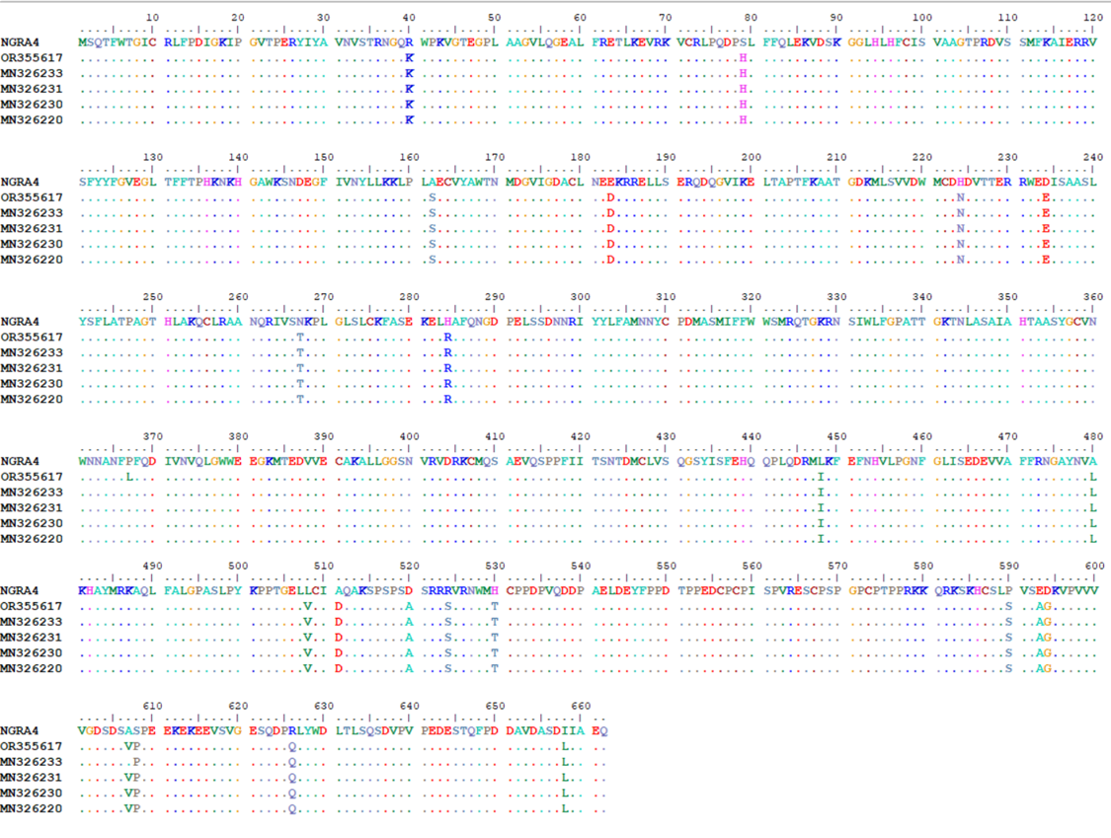
Figure S1. Alignment of the 662-amino-acid ORF1 (NS1) protein encoded by NGRA4 and the five closest BLASTn hits identified using NGRA4 as the query sequence. Conserved amino acid residues are represented by dots, whereas amino acid substitutions are indicated using the corresponding one-letter amino acid codes.

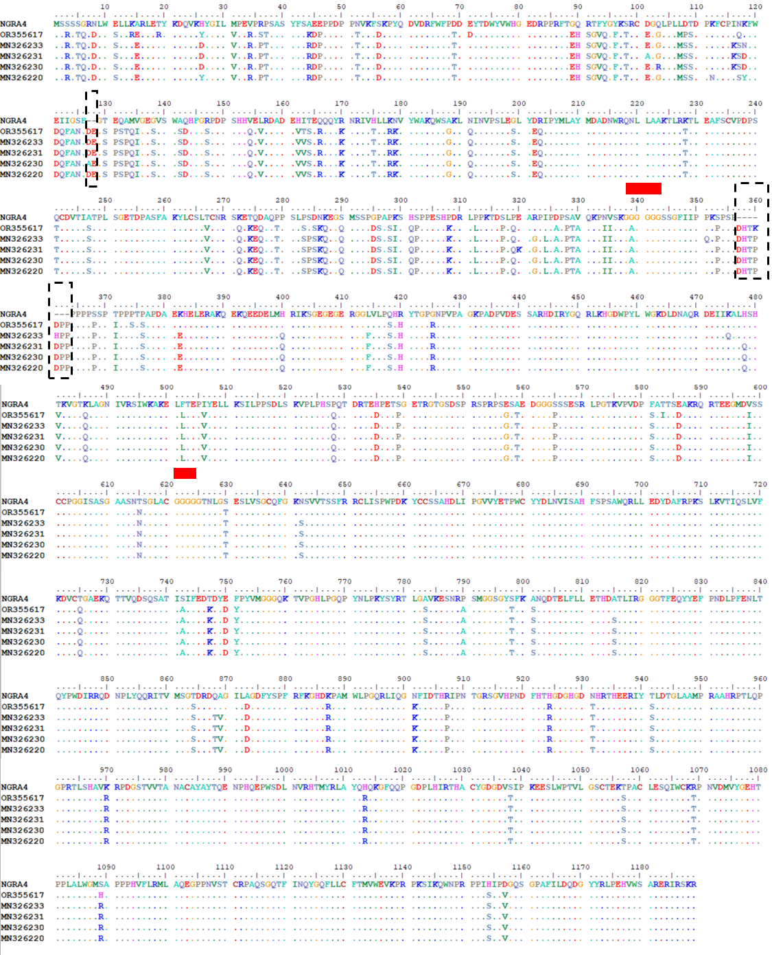
Figure S2. Alignment of the 1,180-amino-acid ORF2 (VP1) protein encoded by NGRA4 and the five closest BLASTn hits identified using NGRA4 as the query sequence. Conserved amino acid residues are represented by dots, whereas amino acid substitutions are indicated using the corresponding one-letter amino acid codes. The two red bars mark the positions of the polyglycine tracts that define the boundaries between VP1 domains. Amino acid deletions unique to NGRA4 are highlighted with black dashed boxes.

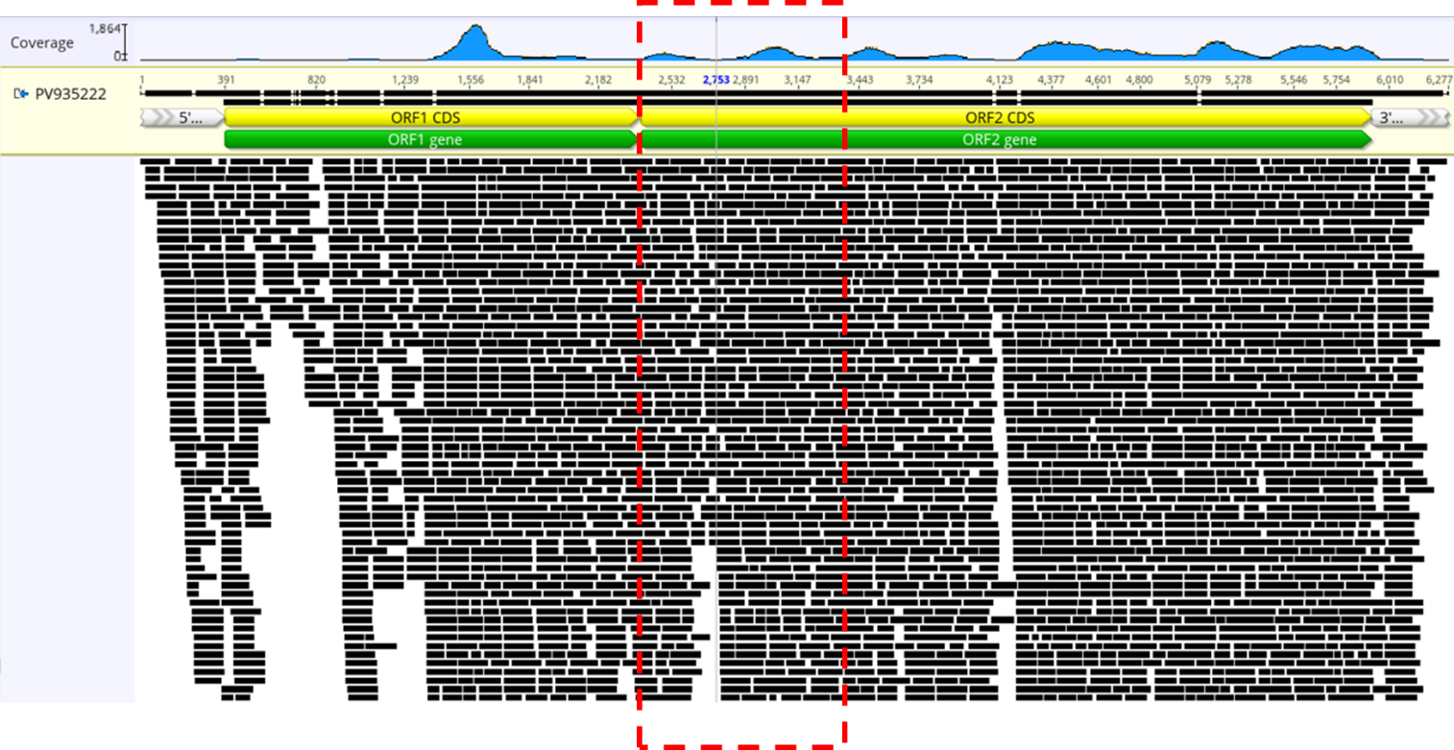
Figure S3. Sequencing reads mapped to the consensus genome of NGRA4-PPV6 (PV935222). The upper panel shows sequencing depth (coverage) across the consensus genome, whereas the lower panel displays representative mapped reads aligned to the consensus sequence. Genome organization is indicated by the annotated ORF1 and ORF2 coding regions. Coverage depth varies across the genome. Domain A (D-A) of ORF2 is highlighted by the red dashed box. Although the upper panel suggests reduced read representation in parts of the D-A region, the mapped-read view indicates sufficient coverage to support a reliable consensus sequence. The image was generated using Geneious Prime.

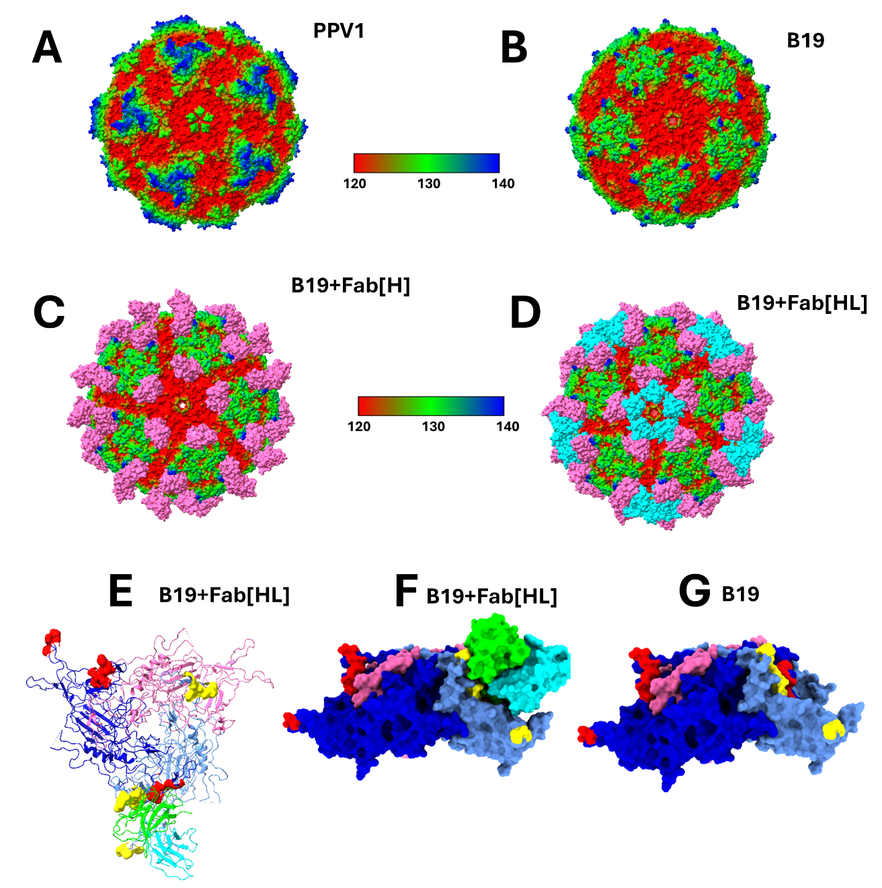
Figure S4. (Panel A) The only experimentally solved structure available in the Protein Data Bank (as of June 1, 2026) for a numbered porcine parvovirus, PPV1 (PDB: 1K3V). (Panels B–G) Experimentally solved structure of parvovirus B19 (PDB: 6NN3) described by Sun et al. (2019). Panel B shows the structure without the heavy (H) and light (L) chains of the neutralizing antibody antigen-binding fragment (Fab). Panel C shows the structure with the heavy chain only, whereas panel D shows the structure with both heavy and light chains present. Panels E–G focus on the threefold axis of symmetry, with Fab-binding footprints annotated on two VP2 proteins. Panel E shows the threefold axis in ribbon representation with Fab bound to one footprint. Residues within the footprint are displayed in surface representation and colored red and yellow. Panel F shows a side view of panel E in surface representation, and panel G shows the same view without the Fab.

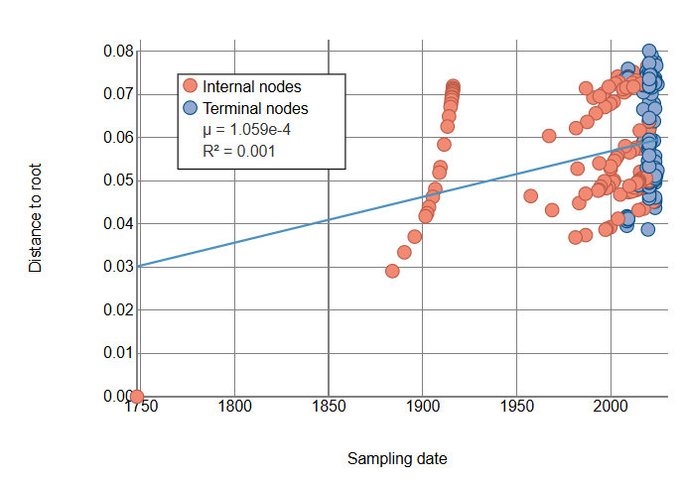
Figure S5. Temporal signal analysis based on the 150 coding-complete sequences included in Figure 6. The analysis yielded an R² value of 0.001, indicating an absence of sufficient temporal structure to support reliable molecular clock inference. Consequently, time-scaled phylogenetic analyses were not pursued.

Table S1. Genera within the subfamilies Parvovirinae and Hamavirinae. Numbered porcine parvoviruses (PPVs) are shown alongside other parvoviruses discussed in this study. Additional information is available at the ICTV taxonomy website (https://ictv.global/taxonomy).
Subfamily | Genus | Numbered PPV types, B19 and CPV
Parvovirinae | Amdoparvovirus
 | Artiparvovirus
 | Aveparvovirus
 | Bocaparvovirus
 | Copiparvovirus | PPV4, PPV5, PPV6
 | Dependoparvovirus
 | Erythoparvovirus | B19
 | Loriparvovirus
 | Protoparvovirus | CPV, PPV1, PPV8
 | Sandeparvovirus
 | Tetraparvovirus | PPV2, PPV3

Hamavirinae
 | Chaphamavirus | PPV7
 | Coluhamavirus
 | Embehamavirus
 | Ichthamavirus

Table S2. GenBank accession numbers of all sequences included in the phylogenetic analysis shown in Figure 6. Sequence PV935222 (S/N 1) corresponds to the NGRA4 variant characterized in this study.
S/N | ID | S/N | ID | S/N | ID | S/N | ID
1 | PV935222 | 41 | NC023860 | 81 | MK378396 | 121 | MN326229
2 | MH447538 | 42 | MH447537 | 82 | MK378372 | 122 | OR435406
3 | MH921906 | 43 | MH921907 | 83 | KF999683 | 123 | OR435407
4 | OR355617 | 44 | MW711841 | 84 | OR435400 | 124 | OM811448
5 | MH447536 | 45 | MH447539 | 85 | KF999684 | 125 | OR435405
6 | MH921909 | 46 | MH921901 | 86 | OR435419 | 126 | MK378405
7 | KR709262 | 47 | MG760726 | 87 | MK378376 | 127 | MK378399
8 | KR709264 | 48 | MH447540 | 88 | MZ846220 | 128 | MK378369
9 | KY094494 | 49 | KR709267 | 89 | MN326224 | 129 | MK378361
10 | MW711840 | 50 | MN326232 | 90 | MW853956 | 130 | MK378388
11 | MH447535 | 51 | MN326242 | 91 | MN326225 | 131 | MK378371
12 | MW711842 | 52 | MZ577040 | 92 | MZ846222 | 132 | MK378365
13 | MT846939 | 53 | MW853954 | 93 | MZ846221 | 133 | PV551205
14 | MT846940 | 54 | MK378351 | 94 | OR435408 | 134 | PQ328186
15 | MH921903 | 55 | MK378381 | 95 | MW853955 | 135 | MN326223
16 | MZ577039 | 56 | MN326240 | 96 | MZ846219 | 136 | MN326220
17 | OR435388 | 57 | OR435399 | 97 | KF999682 | 137 | MN326230
18 | OR435395 | 58 | PV551204 | 98 | MK825573 | 138 | MN326231
19 | OR435409 | 59 | MK092462 | 99 | OM811450 | 139 | MN326241
20 | OR435416 | 60 | OR435387 | 100 | OM811452 | 140 | OR435391
21 | MK378364 | 61 | OR435401 | 101 | MK092463 | 141 | OR435392
22 | MK378392 | 62 | MK378352 | 102 | MK092467 | 142 | OR435394
23 | OR435404 | 63 | MK378355 | 103 | MK092466 | 143 | OR435397
24 | MK378360 | 64 | OR355618 | 104 | MK092464 | 144 | MN326239
25 | OR435413 | 65 | OR355619 | 105 | MK092465 | 145 | MN326233
26 | OR435389 | 66 | KR709265 | 106 | MK378368 | 146 | OR435393
27 | OR435418 | 67 | KR709268 | 107 | OM811449 | 147 | OR435396
28 | OR435402 | 68 | MH447541 | 108 | OM811453 | 148 | MK378377
29 | OR435390 | 69 | MH558679 | 109 | OM811454 | 149 | MN326234
30 | MW853957 | 70 | MH820262 | 110 | OM811455 | 150 | MK378389
31 | OR435412 | 71 | MW051672 | 111 | OM811457 | 151 | PX092311
32 | MK378373 | 72 | MN326238 | 112 | OM811456 | 152 | OR046032_PPV5
33 | PV551203 | 73 | OR046033 | 113 | MN326221 | 153 | MW853953_PPV5
34 | MN326227 | 74 | OR435410 | 114 | MN326226 | 154 | MW051674_PPV5
35 | OR435398 | 75 | OR435417 | 115 | MN326228
36 | OR435415 | 76 | MK378356 | 116 | MN326235
37 | OR435411 | 77 | MK378387 | 117 | MN326236
38 | OR435414 | 78 | MK378386 | 118 | OM811451
39 | KR709263 | 79 | MK378350 | 119 | MK378366
40 | KX273435 | 80 | MK378367 | 120 | MN326222

