Supplementary material
The Microplastic Menace: Polymer-Specific Impacts on Bacterial Communities and Carbon Cycling in Temperate Forest Soils
Supplementary figures
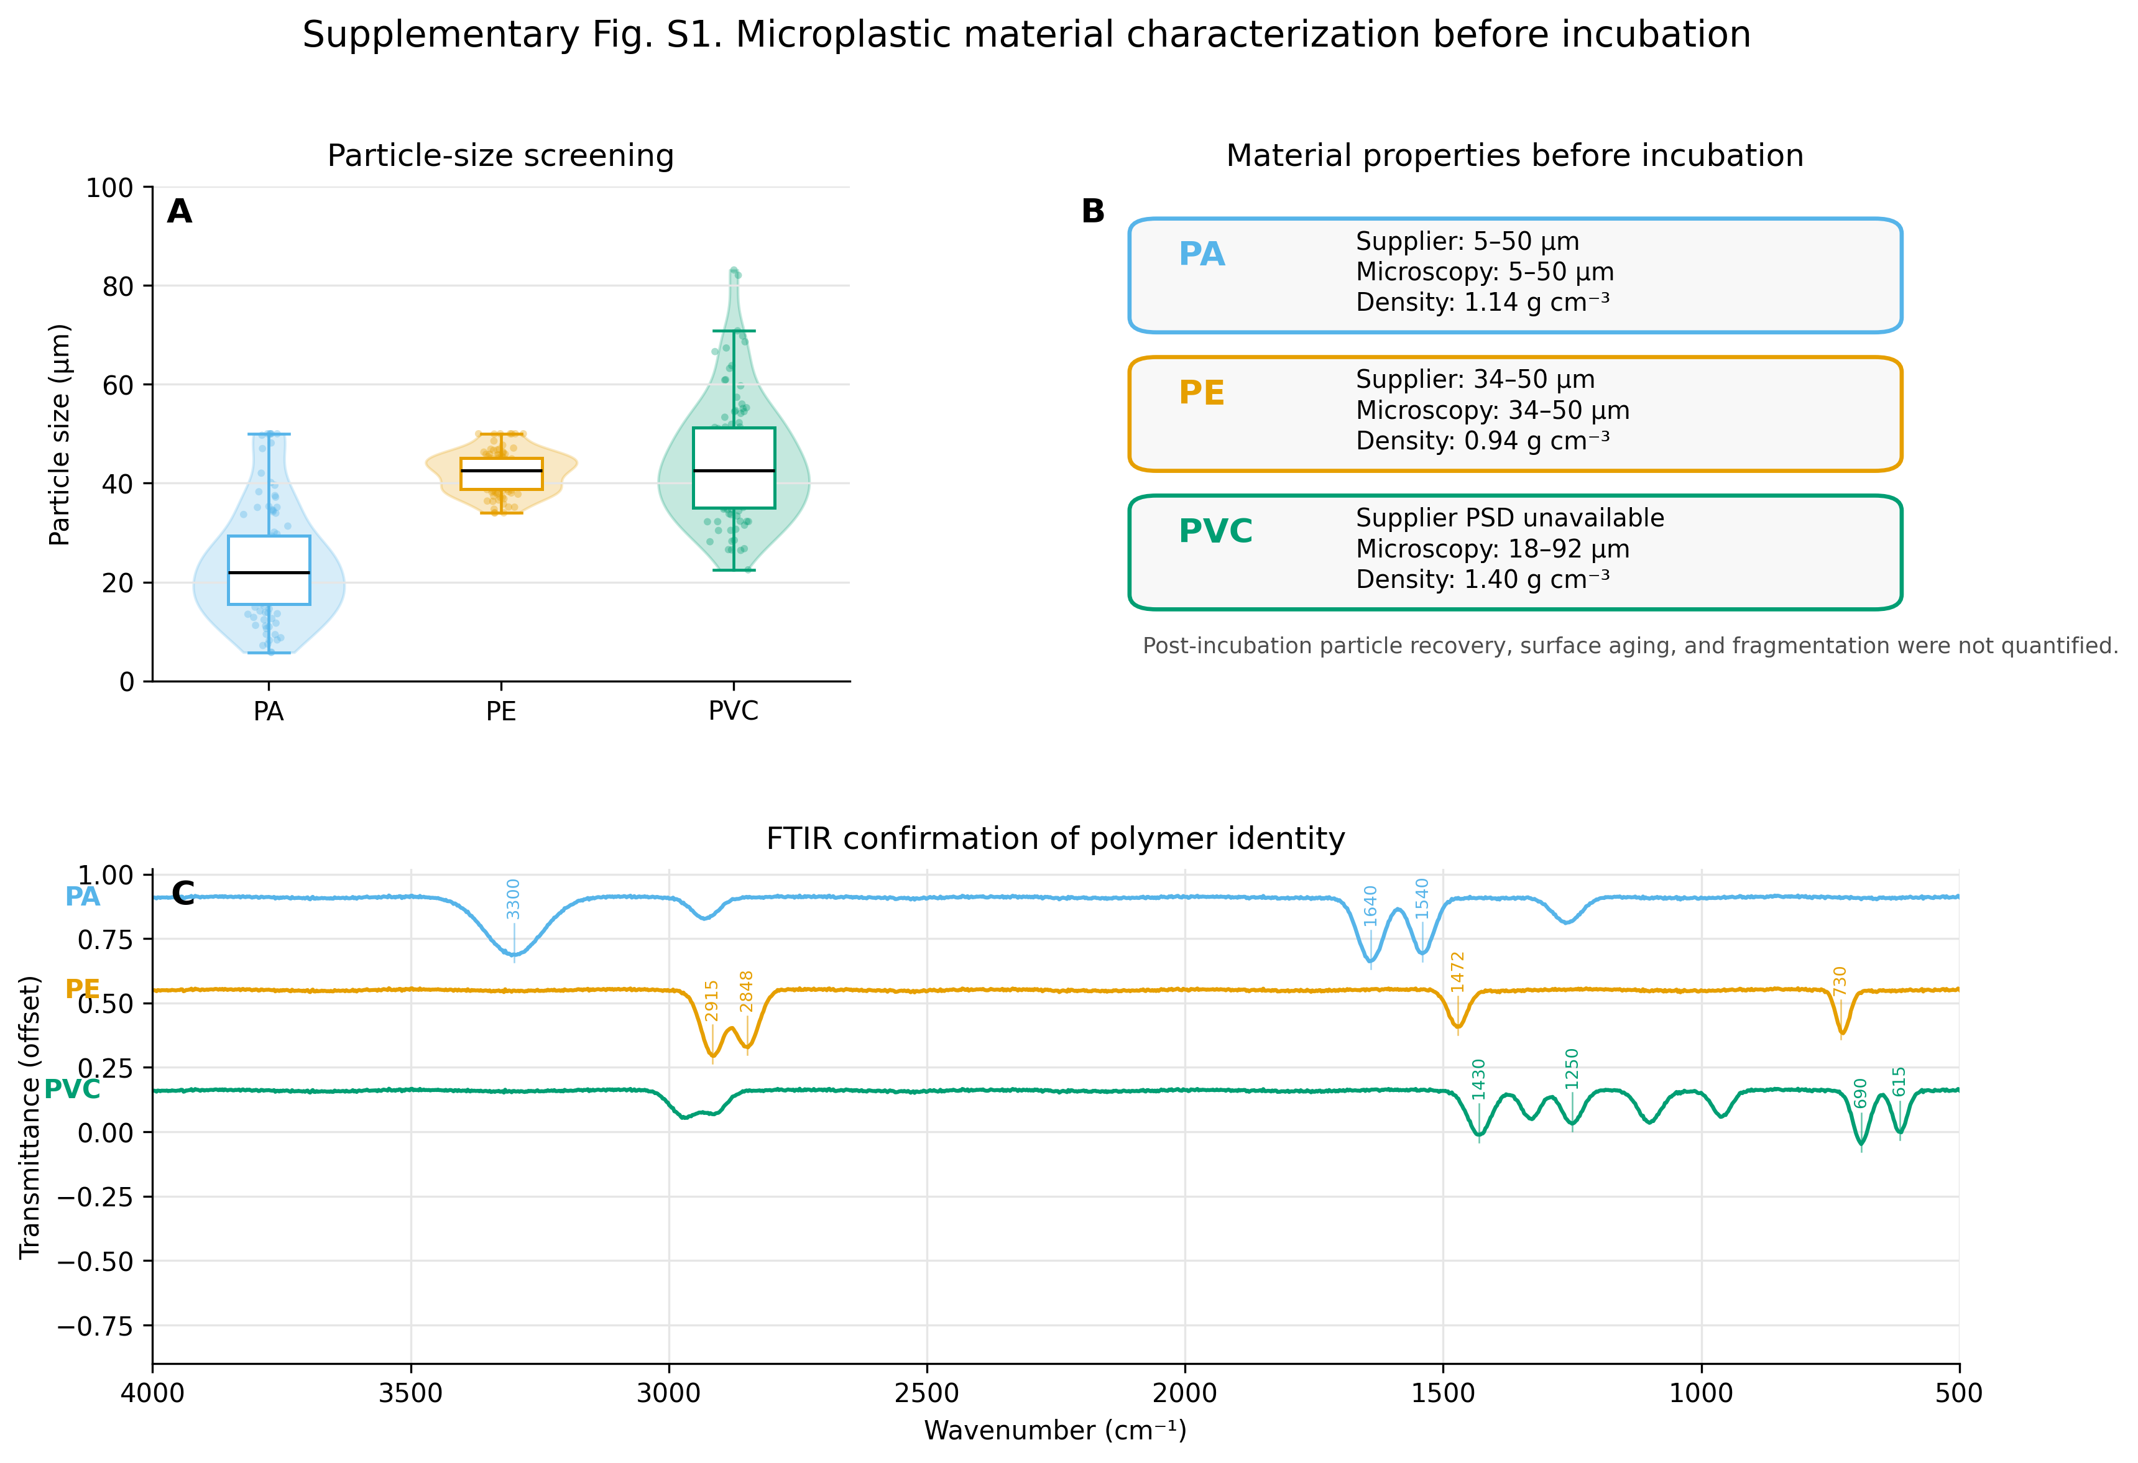
Fig. S1. Microplastic material characterization before incubation. (A) Particle-size screening for PA, PE, and PVC based on working distributions. (B) Polymer density and size-range summary. (C) FTIR spectra used to confirm polymer identity. PVC supplier particle-size distribution was unavailable; therefore, microscope-based screening was used to define a working size range. Post-incubation particle recovery, surface aging, and fragmentation were not quantified.
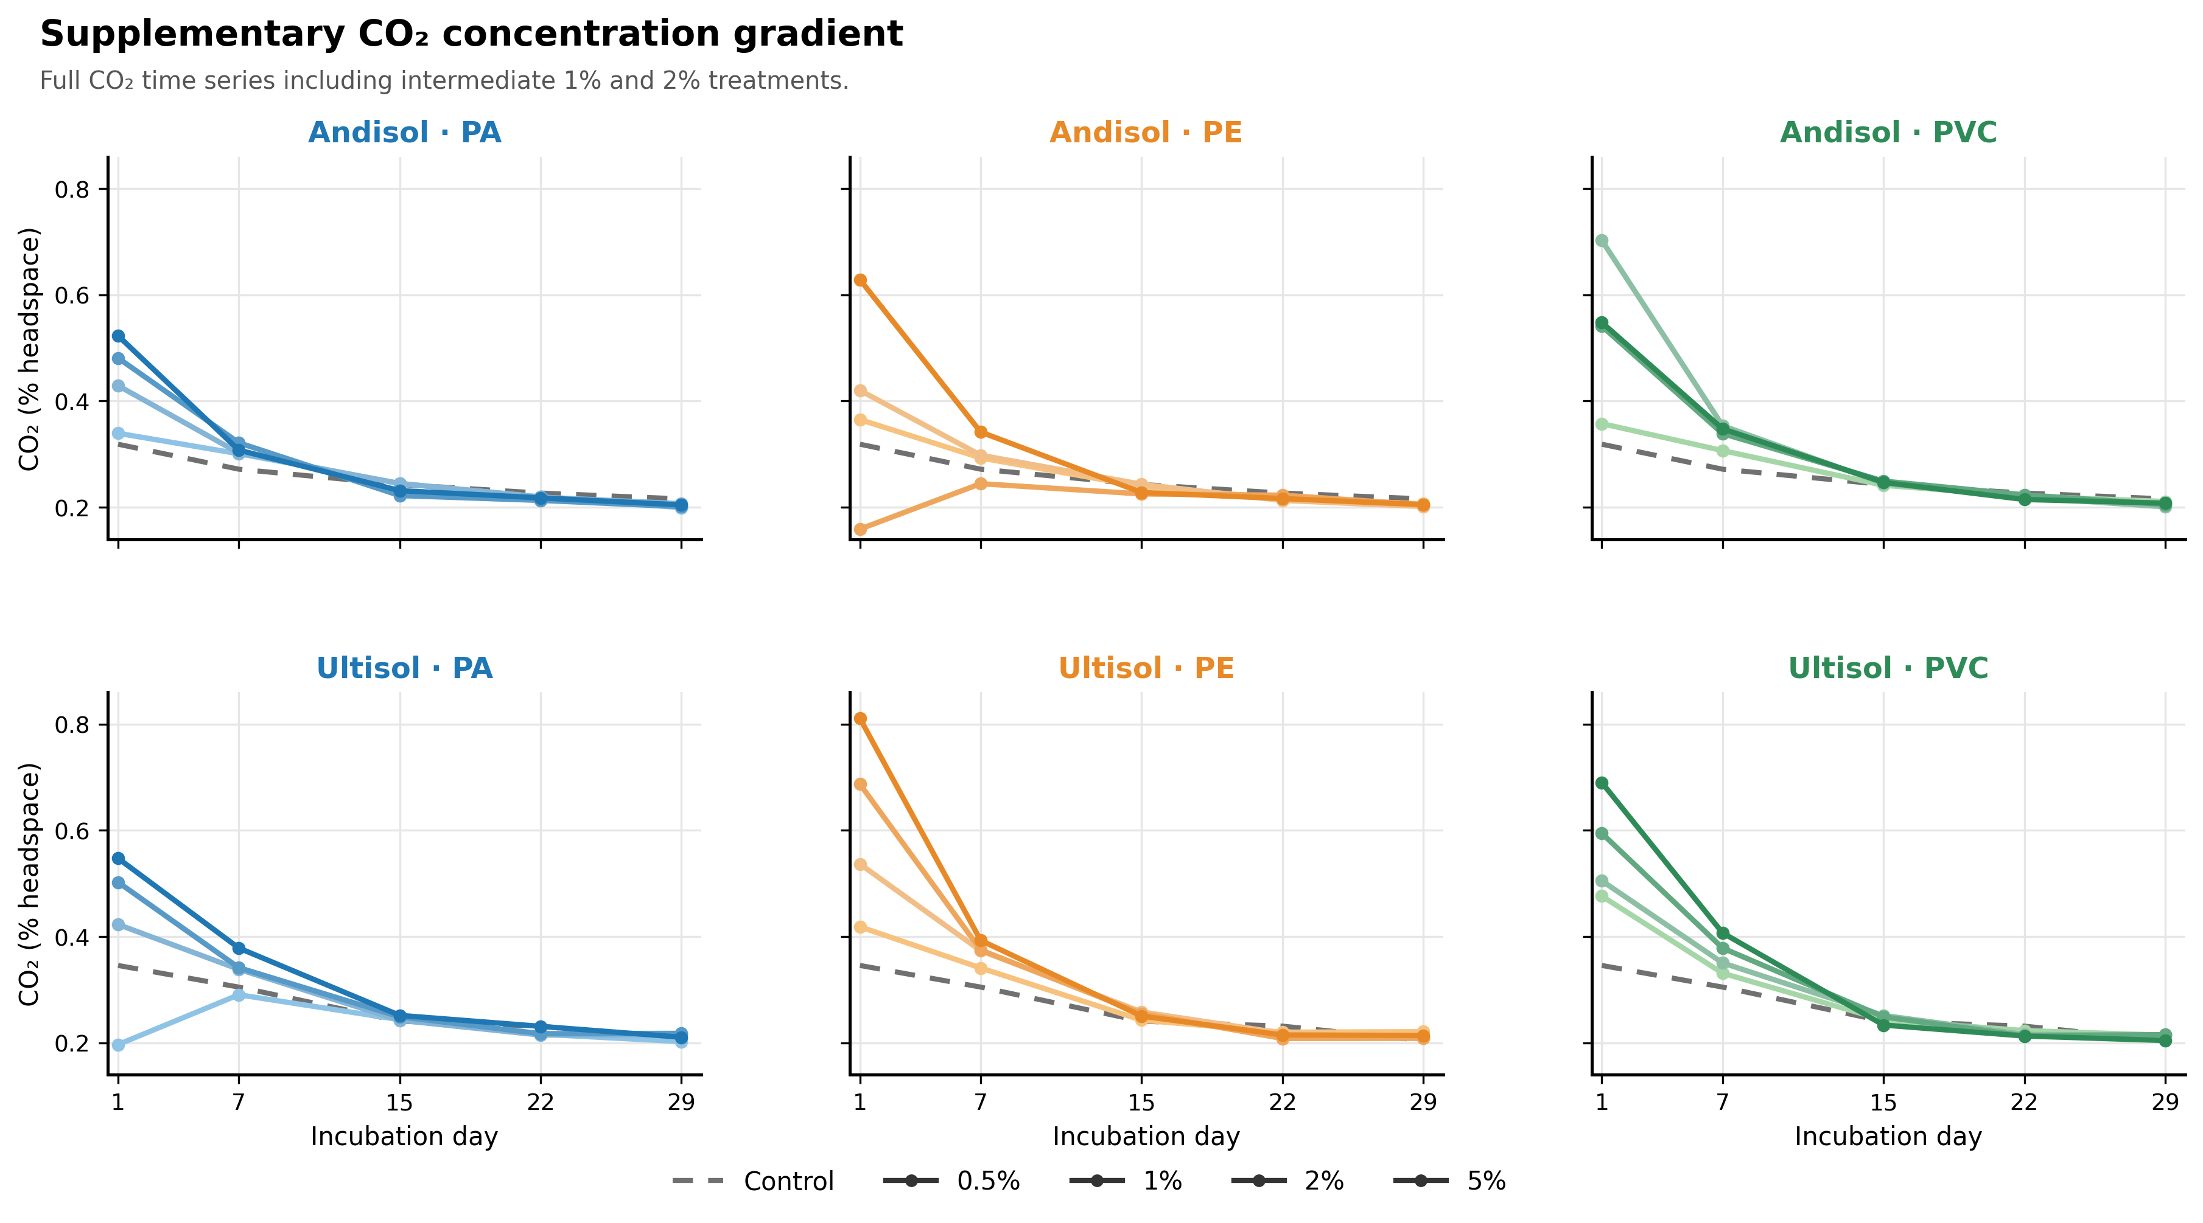
Fig. S2. Full CO₂ dose trajectory for the CO₂-only gradient. The main manuscript presents the common 0.5% and 5% MP contents used across all endpoints. Intermediate 1% and 2% contents were included only for CO₂ production to describe the empirical dose trajectory.

Supplementary tables
Table S1. Two-way ANOVA (MP content × incubation time) for FDA hydrolysis in Andisol and Ultisol soils amended with PA, PE, and PVC microplastics.
Soil | Polymer | Source | df | SS | MS | F | p
Andisol | PA | MP content | 2 | 506 | 253 | 50.6 | <0.001
Andisol | PA | Incubation time | 2 | 939 | 469 | 93.8 | <0.001
Andisol | PA | Content × time | 4 | 61.1 | 15.3 | 3.06 | 0.044
Andisol | PA | Residuals | 18 | 90.0 | 5.00
Andisol | PE | MP content | 2 | 122 | 60.8 | 2.43 | 0.116
Andisol | PE | Incubation time | 2 | 72.2 | 36.1 | 1.44 | 0.262
Andisol | PE | Content × time | 4 | 3.11 | 0.778 | 0.030 | 0.998
Andisol | PE | Residuals | 18 | 450 | 25.0
Andisol | PVC | MP content | 2 | 172 | 86.1 | 23.9 | <0.001
Andisol | PVC | Incubation time | 2 | 2.37e+03 | 1.19e+03 | 331 | <0.001
Andisol | PVC | Content × time | 4 | 44.4 | 11.1 | 3.08 | 0.043
Andisol | PVC | Residuals | 18 | 64.8 | 3.60
Ultisol | PA | MP content | 2 | 267 | 133 | 6.65 | 0.007
Ultisol | PA | Incubation time | 2 | 450 | 225 | 11.2 | <0.001
Ultisol | PA | Content × time | 4 | 33.3 | 8.33 | 0.420 | 0.795
Ultisol | PA | Residuals | 18 | 360 | 20.0
Ultisol | PE | MP content | 2 | 150 | 75.0 | 1.50 | 0.250
Ultisol | PE | Incubation time | 2 | 150 | 75.0 | 1.50 | 0.250
Ultisol | PE | Content × time | 4 | 0.000 | 0.000 | 0.000 | 1.000
Ultisol | PE | Residuals | 18 | 900 | 50.0
Ultisol | PVC | MP content | 2 | 150 | 75.0 | 1.25 | 0.310
Ultisol | PVC | Incubation time | 2 | 50.0 | 25.0 | 0.420 | 0.665
Ultisol | PVC | Content × time | 4 | 0.000 | 0.000 | 0.000 | 1.000
Ultisol | PVC | Residuals | 18 | 1.08e+03 | 60.0
Note: SS and MS correspond to sum of squares and mean square for each factor in the two-way ANOVA fitted separately for each soil × polymer combination. FDA = fluorescein diacetate hydrolysis.

Table S2. Two-way ANOVA summary for extracellular enzyme activities.
Soil | Enzyme | Source | df | SS | MS | F | p
Andisol | β-glucosidase | Incubation day | 2 | 495 | 248 | 13.3 | <0.001
Andisol | β-glucosidase | Residual | 63 | 1.17e+03 | 18.6
Andisol | β-glucosidase | Treatment | 6 | 1.93e+03 | 322 | 17.3 | <0.001
Andisol | β-glucosidase | Treatment × day | 12 | 1.85e+03 | 155 | 8.29 | <0.001
Andisol | Cellobiohydrolase | Incubation day | 2 | 24.8 | 12.4 | 51.8 | <0.001
Andisol | Cellobiohydrolase | Residual | 63 | 15.1 | 0.239
Andisol | Cellobiohydrolase | Treatment | 6 | 55.2 | 9.20 | 38.5 | <0.001
Andisol | Cellobiohydrolase | Treatment × day | 12 | 13.1 | 1.09 | 4.56 | <0.001
Andisol | Peroxidase-like activity | Incubation day | 2 | 2.83e+04 | 1.42e+04 | 152 | <0.001
Andisol | Peroxidase-like activity | Residual | 63 | 5.89e+03 | 93.5
Andisol | Peroxidase-like activity | Treatment | 6 | 2.48e+03 | 414 | 4.43 | <0.001
Andisol | Peroxidase-like activity | Treatment × day | 12 | 4.16e+03 | 347 | 3.71 | <0.001
Ultisol | β-glucosidase | Incubation day | 2 | 595 | 297 | 15.9 | <0.001
Ultisol | β-glucosidase | Residual | 63 | 1.17e+03 | 18.6
Ultisol | β-glucosidase | Treatment | 6 | 806 | 134 | 7.21 | <0.001
Ultisol | β-glucosidase | Treatment × day | 12 | 499 | 41.6 | 2.23 | 0.020
Ultisol | Cellobiohydrolase | Incubation day | 2 | 20.4 | 10.2 | 42.6 | <0.001
Ultisol | Cellobiohydrolase | Residual | 63 | 15.1 | 0.239
Ultisol | Cellobiohydrolase | Treatment | 6 | 13.9 | 2.31 | 9.67 | <0.001
Ultisol | Cellobiohydrolase | Treatment × day | 12 | 9.46 | 0.789 | 3.30 | <0.001
Ultisol | Peroxidase-like activity | Incubation day | 2 | 1.35e+04 | 6.75e+03 | 72.2 | <0.001
Ultisol | Peroxidase-like activity | Residual | 63 | 5.89e+03 | 93.5
Ultisol | Peroxidase-like activity | Treatment | 6 | 370 | 61.7 | 0.660 | 0.682
Ultisol | Peroxidase-like activity | Treatment × day | 12 | 3.31e+03 | 276 | 2.95 | 0.003
Note: Treatment refers to Control, PA 0.5%, PA 5%, PE 0.5%, PE 5%, PVC 0.5%, and PVC 5%.

Table S3. Tukey groupings for extracellular enzyme activities shown in Fig. 4.
Letters compare treatments within each soil × enzyme × day. Treatments sharing letters are not separated by Tukey HSD at p < 0.05.
Table S3a. cellobiohydrolase.
Soil | Day | Treatment | Mean ± SD | n | Letter
Andisol | 15 | Control | 8.40 ± 0.45 | 4 | a
Andisol | 15 | PA 0.5% | 7.20 ± 0.55 | 4 | b
Andisol | 15 | PA 5% | 6.10 ± 0.45 | 4 | b
Andisol | 15 | PE 0.5% | 7.50 ± 0.55 | 4 | a
Andisol | 15 | PE 5% | 5.70 ± 0.45 | 4 | c
Andisol | 15 | PVC 0.5% | 7.00 ± 0.55 | 4 | b
Andisol | 15 | PVC 5% | 4.90 ± 0.40 | 4 | c
Andisol | 29 | Control | 6.20 ± 0.45 | 4 | a
Andisol | 29 | PA 0.5% | 6.20 ± 0.55 | 4 | a
Andisol | 29 | PA 5% | 5.10 ± 0.45 | 4 | ab
Andisol | 29 | PE 0.5% | 5.30 ± 0.55 | 4 | ab
Andisol | 29 | PE 5% | 4.60 ± 0.45 | 4 | b
Andisol | 29 | PVC 0.5% | 6.00 ± 0.55 | 4 | a
Andisol | 29 | PVC 5% | 4.80 ± 0.40 | 4 | b
Ultisol | 15 | Control | 5.30 ± 0.45 | 4 | a
Ultisol | 15 | PA 0.5% | 4.80 ± 0.55 | 4 | a
Ultisol | 15 | PA 5% | 3.60 ± 0.45 | 4 | b
Ultisol | 15 | PE 0.5% | 4.90 ± 0.55 | 4 | a
Ultisol | 15 | PE 5% | 3.20 ± 0.45 | 4 | b
Ultisol | 15 | PVC 0.5% | 4.80 ± 0.55 | 4 | a
Ultisol | 15 | PVC 5% | 3.40 ± 0.40 | 4 | b
Ultisol | 29 | Control | 3.50 ± 0.45 | 4 | a
Ultisol | 29 | PA 0.5% | 3.20 ± 0.55 | 4 | a
Ultisol | 29 | PA 5% | 3.00 ± 0.45 | 4 | a
Ultisol | 29 | PE 0.5% | 3.50 ± 0.55 | 4 | a
Ultisol | 29 | PE 5% | 3.60 ± 0.45 | 4 | a
Ultisol | 29 | PVC 0.5% | 2.80 ± 0.55 | 4 | a
Ultisol | 29 | PVC 5% | 2.80 ± 0.40 | 4 | a

Table S3. Tukey groupings for extracellular enzyme activities shown in Fig. 4. Continued.
Table S3b. Peroxidase-like activity.
Soil | Day | Treatment | Mean ± SD | n | Letter
Andisol | 15 | Control | 105.00 ± 9.00 | 4 | a
Andisol | 15 | PA 0.5% | 98.00 ± 10.00 | 4 | a
Andisol | 15 | PA 5% | 100.00 ± 9.00 | 4 | a
Andisol | 15 | PE 0.5% | 100.00 ± 11.00 | 4 | a
Andisol | 15 | PE 5% | 99.00 ± 9.50 | 4 | a
Andisol | 15 | PVC 0.5% | 95.00 ± 10.00 | 4 | a
Andisol | 15 | PVC 5% | 92.00 ± 9.00 | 4 | a
Andisol | 29 | Control | 120.00 ± 9.00 | 4 | b
Andisol | 29 | PA 0.5% | 128.00 ± 10.00 | 4 | b
Andisol | 29 | PA 5% | 135.00 ± 9.00 | 4 | b
Andisol | 29 | PE 0.5% | 156.00 ± 11.00 | 4 | a
Andisol | 29 | PE 5% | 155.00 ± 9.50 | 4 | a
Andisol | 29 | PVC 0.5% | 158.00 ± 10.00 | 4 | a
Andisol | 29 | PVC 5% | 135.00 ± 9.00 | 4 | b
Ultisol | 15 | Control | 100.00 ± 9.00 | 4 | a
Ultisol | 15 | PA 0.5% | 95.00 ± 10.00 | 4 | a
Ultisol | 15 | PA 5% | 88.00 ± 9.00 | 4 | a
Ultisol | 15 | PE 0.5% | 88.00 ± 11.00 | 4 | a
Ultisol | 15 | PE 5% | 82.00 ± 9.50 | 4 | a
Ultisol | 15 | PVC 0.5% | 100.00 ± 10.00 | 4 | a
Ultisol | 15 | PVC 5% | 95.00 ± 9.00 | 4 | a
Ultisol | 29 | Control | 105.00 ± 9.00 | 4 | b
Ultisol | 29 | PA 0.5% | 122.00 ± 10.00 | 4 | ab
Ultisol | 29 | PA 5% | 128.00 ± 9.00 | 4 | a
Ultisol | 29 | PE 0.5% | 125.00 ± 11.00 | 4 | ab
Ultisol | 29 | PE 5% | 128.00 ± 9.50 | 4 | a
Ultisol | 29 | PVC 0.5% | 112.00 ± 10.00 | 4 | ab
Ultisol | 29 | PVC 5% | 125.00 ± 9.00 | 4 | ab

Table S3. Tukey groupings for extracellular enzyme activities shown in Fig. 4. Continued.
Table S3c. β-glucosidase.
Soil | Day | Treatment | Mean ± SD | n | Letter
Andisol | 15 | Control | 85.00 ± 3.50 | 4 | a
Andisol | 15 | PA 0.5% | 76.00 ± 5.00 | 4 | a
Andisol | 15 | PA 5% | 62.00 ± 4.00 | 4 | b
Andisol | 15 | PE 0.5% | 61.00 ± 5.00 | 4 | b
Andisol | 15 | PE 5% | 58.00 ± 4.00 | 4 | b
Andisol | 15 | PVC 0.5% | 62.00 ± 4.50 | 4 | b
Andisol | 15 | PVC 5% | 54.00 ± 4.00 | 4 | b
Andisol | 29 | Control | 60.00 ± 3.50 | 4 | a
Andisol | 29 | PA 0.5% | 58.00 ± 5.00 | 4 | a
Andisol | 29 | PA 5% | 57.00 ± 4.00 | 4 | a
Andisol | 29 | PE 0.5% | 60.00 ± 5.00 | 4 | a
Andisol | 29 | PE 5% | 58.00 ± 4.00 | 4 | a
Andisol | 29 | PVC 0.5% | 64.00 ± 4.50 | 4 | a
Andisol | 29 | PVC 5% | 61.00 ± 4.00 | 4 | a
Ultisol | 15 | Control | 58.00 ± 3.50 | 4 | a
Ultisol | 15 | PA 0.5% | 55.00 ± 5.00 | 4 | a
Ultisol | 15 | PA 5% | 45.00 ± 4.00 | 4 | b
Ultisol | 15 | PE 0.5% | 49.00 ± 5.00 | 4 | ab
Ultisol | 15 | PE 5% | 42.00 ± 4.00 | 4 | b
Ultisol | 15 | PVC 0.5% | 52.00 ± 4.50 | 4 | a
Ultisol | 15 | PVC 5% | 43.00 ± 4.00 | 4 | b
Ultisol | 29 | Control | 45.00 ± 3.50 | 4 | a
Ultisol | 29 | PA 0.5% | 42.00 ± 5.00 | 4 | a
Ultisol | 29 | PA 5% | 43.00 ± 4.00 | 4 | a
Ultisol | 29 | PE 0.5% | 44.00 ± 5.00 | 4 | a
Ultisol | 29 | PE 5% | 45.00 ± 4.00 | 4 | a
Ultisol | 29 | PVC 0.5% | 40.00 ± 4.50 | 4 | a
Ultisol | 29 | PVC 5% | 40.00 ± 4.00 | 4 | a

Table S4. PCA active-variable loadings and supplementary predicted-vector correlations.
Soil | Vector type | Code | Variable | Group | PC1 | PC2
Andisol | Active variable | R1 | CO₂ pulse D1 | Respiration | 0.979 | 0.433
Andisol | Active variable | R2 | Integrated CO₂ AUC | Respiration | 0.969 | 0.453
Andisol | Active variable | R3 | Respiration decline k | Respiration | 0.969 | 0.450
Andisol | Active variable | E1 | FDA D29 | Activity / enzymes | -0.289 | 0.842
Andisol | Active variable | E2 | β-glucosidase | Activity / enzymes | 0.009 | -0.823
Andisol | Active variable | E3 | Cellobiohydrolase | Activity / enzymes | -0.975 | -0.324
Andisol | Active variable | E4 | L-DOPA oxidation | Activity / enzymes | 0.646 | -0.351
Andisol | Active variable | B1 | Bacterial richness | Bacteria | -0.680 | 0.422
Andisol | Active variable | B2 | Bacterial Shannon | Bacteria | -1.036 | -0.139
Andisol | Active variable | F1 | Fungal richness | Fungi | -0.930 | 0.524
Andisol | Active variable | F2 | Fungal Shannon | Fungi | -0.607 | 0.834
Ultisol | Active variable | R1 | CO₂ pulse D1 | Respiration | 0.531 | -0.924
Ultisol | Active variable | R2 | Integrated CO₂ AUC | Respiration | 0.507 | -0.941
Ultisol | Active variable | R3 | Respiration decline k | Respiration | 0.565 | -0.904
Ultisol | Active variable | E1 | FDA D29 | Activity / enzymes | 0.459 | 0.202
Ultisol | Active variable | E2 | β-glucosidase | Activity / enzymes | -0.830 | -0.613
Ultisol | Active variable | E3 | Cellobiohydrolase | Activity / enzymes | -0.818 | -0.576
Ultisol | Active variable | E4 | L-DOPA oxidation | Activity / enzymes | 0.345 | -0.687
Ultisol | Active variable | B1 | Bacterial richness | Bacteria | 0.871 | 0.465
Ultisol | Active variable | B2 | Bacterial Shannon | Bacteria | 1.058 | 0.177
Ultisol | Active variable | F1 | Fungal richness | Fungi | -0.992 | 0.065
Ultisol | Active variable | F2 | Fungal Shannon | Fungi | -1.061 | -0.108
Andisol | Supplementary predicted vector | P1 | Chemoheterotrophy | Predicted supplementary | -0.174 | 0.331
Andisol | Supplementary predicted vector | P2 | Aromatic hydrocarbon degradation | Predicted supplementary | 0.929 | 0.207
Andisol | Supplementary predicted vector | P3 | Saprotroph guild | Predicted supplementary | 0.060 | 0.413
Andisol | Supplementary predicted vector | P4 | Ectomycorrhizal guild | Predicted supplementary | 0.204 | 0.510
Ultisol | Supplementary predicted vector | P1 | Chemoheterotrophy | Predicted supplementary | -0.484 | -0.723
Ultisol | Supplementary predicted vector | P2 | Aromatic hydrocarbon degradation | Predicted supplementary | 0.533 | -0.810
Ultisol | Supplementary predicted vector | P3 | Saprotroph guild | Predicted supplementary | 0.797 | -0.112
Ultisol | Supplementary predicted vector | P4 | Ectomycorrhizal guild | Predicted supplementary | -0.311 | -0.844
Note: PCA was fitted separately for each soil using standardized deviations from the matched control. Supplementary predicted vectors were projected onto the ordination and were not used to fit the PCA.

Table S5. Endpoint structure, MP contents, and sampling times used in the revised manuscript.
Endpoint | MP contents | Sampling time | Descriptor/unit | Reported in
CO₂ production | 0, 0.5, 1, 2, 5% w/w | Days 1, 7, 15, 22, 29 | Headspace CO₂ (%); AUC (%·day); k (day⁻¹) | Fig. 2; Fig. S2
FDA hydrolysis | 0, 0.5, 5% w/w | 6 h, Day 15, Day 29 | µg fluorescein mL⁻¹ g⁻¹ | Fig. 3; Table S1
Extracellular enzymes | 0, 0.5, 5% w/w | Day 1, Day 15, Day 29 | µmol product g⁻¹ h⁻¹ | Fig. 4; Tables S2–S3
Amplicon sequencing | 0, 0.5, 5% w/w | Day 29 | 16S rRNA and ITS profiles; α-diversity | Figs. 5–7; Table 3
Predicted functional profiles | 0, 0.5, 5% w/w | Day 29 | FAPROTAX and FUNGuild relative abundance | Fig. 8; Table S4
Note: Intermediate 1% and 2% MP contents were included only for CO₂ production and were not used for FDA, enzyme, sequencing, or predicted functional endpoints.

