Supplementary Material
Supplementary Table S1. Random-effect structure comparison for VAS trajectory
model | Model | df | AIC | BIC | logLik | L.Ratio | p-value
Random intercept | 1 | 23 | 2643.195 | 2754.748 | -1298.598
Random intercept + time slope | 2 | 25 | 2645.956 | 2767.209 | -1297.978 | 1.240 | 0.538
Abbreviations: AIC, Akaike Information Criterion; BIC, Bayesian Information Criterion; logLik, log-likelihood; L.Ratio, likelihood-ratio test; VAS, visual analogue scale.

Supplementary Table S2. Observed postoperative VAS by tourniquet use and time point
Group | POD | n | mean | sd | median | Q1 | Q3 | se
No tourniquet | 1 | 100 | 5.004 | 1.137 | 5.100 | 4.100 | 5.725 | 0.114
No tourniquet | 3 | 100 | 5.664 | 1.079 | 5.700 | 4.900 | 6.225 | 0.108
No tourniquet | 5 | 100 | 5.102 | 1.058 | 5.000 | 4.475 | 5.900 | 0.106
No tourniquet | 7 | 100 | 3.889 | 1.075 | 3.900 | 3.100 | 4.900 | 0.108
Tourniquet | 1 | 136 | 6.153 | 1.208 | 6.100 | 5.300 | 6.800 | 0.104
Tourniquet | 3 | 136 | 6.582 | 1.079 | 6.500 | 5.900 | 7.200 | 0.092
Tourniquet | 5 | 136 | 6.241 | 1.157 | 6.100 | 5.475 | 6.925 | 0.099
Tourniquet | 7 | 136 | 5.580 | 0.986 | 5.500 | 4.900 | 6.025 | 0.085
Abbreviations: POD, postoperative day; SD, standard deviation; SE, standard error; VAS, visual analogue scale; Q1, 25th Percentile; Q3, 75th Percentile

Supplementary Table S3. Full adjusted random-intercept LMM for postoperative VAS trajectory
Term | β (95% CI) | P value
Intercept | 3.796 (1.943 to 5.648) | <0.001
Time, centered | -0.148 (-0.223 to -0.073) | <0.001
Tourniquet use | 1.256 (1.037 to 1.476) | <0.001
APAIS anxiety score | 0.151 (0.110 to 0.191) | <0.001
Baseline VAS | -0.024 (-0.166 to 0.119) | 0.744
Age | 0.009 (-0.010 to 0.028) | 0.358
Male sex | 0.205 (-0.060 to 0.471) | 0.129
BMI | -0.014 (-0.041 to 0.014) | 0.330
Smoking | -0.041 (-0.388 to 0.306) | 0.817
Alcohol use | -0.178 (-0.543 to 0.186) | 0.336
Living alone | 0.429 (0.191 to 0.667) | <0.001
Diabetes | 0.207 (-0.114 to 0.529) | 0.205
Hypertension | 0.135 (-0.096 to 0.366) | 0.252
KL grade 3 | -0.091 (-0.363 to 0.180) | 0.507
KL grade 4 | -0.206 (-0.512 to 0.099) | 0.185
ASA grade 3 | -0.066 (-0.402 to 0.270) | 0.698
Operative duration | -0.003 (-0.012 to 0.005) | 0.465
Intraoperative blood loss | 0.001 (-0.002 to 0.005) | 0.480
Pregabalin use | -0.203 (-0.431 to 0.024) | 0.080
Time x tourniquet use | 0.092 (0.044 to 0.139) | <0.001
Time x APAIS | -0.006 (-0.015 to 0.002) | 0.161
Abbreviations: APAIS, Amsterdam Preoperative Anxiety and Information Scale; CI, confidence interval; LMM, linear mixed-effects model; VAS, visual analogue scale; BMI, body mass index; KL, Kellgren-Lawrence; ASA , American Society of Anesthesiologists.

Supplementary Table S4. Full continuous APAIS-by-tourniquet interaction model
Term | β (95% CI) | P value
Intercept | 3.718 (1.852 to 5.584) | <0.001
Time, centered | -0.187 (-0.293 to -0.082) | <0.001
Tourniquet use | 1.482 (0.845 to 2.118) | <0.001
APAIS anxiety score | 0.167 (0.108 to 0.226) | <0.001
Baseline VAS | -0.020 (-0.163 to 0.123) | 0.783
Age | 0.008 (-0.011 to 0.028) | 0.392
Male sex | 0.204 (-0.062 to 0.469) | 0.132
BMI | -0.014 (-0.041 to 0.014) | 0.326
Smoking | -0.039 (-0.387 to 0.308) | 0.824
Alcohol use | -0.181 (-0.546 to 0.184) | 0.331
Living alone | 0.436 (0.197 to 0.675) | <0.001
Diabetes | 0.213 (-0.109 to 0.536) | 0.193
Hypertension | 0.138 (-0.094 to 0.369) | 0.243
KL grade 3 | -0.089 (-0.361 to 0.182) | 0.518
KL grade 4 | -0.204 (-0.510 to 0.102) | 0.190
ASA grade 3 | -0.063 (-0.399 to 0.274) | 0.714
Operative duration | -0.003 (-0.012 to 0.005) | 0.445
Intraoperative blood loss | 0.001 (-0.002 to 0.005) | 0.488
Pregabalin use | -0.213 (-0.442 to 0.016) | 0.069
Time x tourniquet use | 0.163 (0.022 to 0.304) | 0.023
Time x APAIS | -0.001 (-0.014 to 0.012) | 0.874
Tourniquet use x APAIS | -0.030 (-0.109 to 0.049) | 0.459
Time x tourniquet use x APAIS | -0.009 (-0.027 to 0.008) | 0.291
Abbreviations: APAIS, Amsterdam Preoperative Anxiety and Information Scale; CI, confidence interval; LMM, linear mixed-effects model; VAS, visual analogue scale; BMI, body mass index; KL, Kellgren-Lawrence; ASA , American Society of Anesthesiologists.

Supplementary Table S5. Observed postoperative HSS by tourniquet use and follow-up month
Group | Month | n | mean | sd | median | Q1 | Q3 | se
No tourniquet | 1 | 96 | 68.896 | 4.539 | 69.000 | 66.750 | 72.000 | 0.463
No tourniquet | 6 | 92 | 79.587 | 3.057 | 80.000 | 78.000 | 81.000 | 0.319
No tourniquet | 12 | 90 | 84.244 | 2.984 | 84.000 | 82.250 | 87.000 | 0.315
Tourniquet | 1 | 132 | 66.197 | 4.764 | 66.000 | 63.000 | 69.000 | 0.415
Tourniquet | 6 | 127 | 74.386 | 2.997 | 74.000 | 72.000 | 76.000 | 0.266
Tourniquet | 12 | 119 | 81.983 | 3.089 | 82.000 | 80.000 | 84.000 | 0.283
Abbreviations: HSS, Hospital for Special Surgery knee score; SD, standard deviation; SE, standard error; Q1, 25th Percentile; Q3, 75th Percentile

Supplementary Table S6. Full adjusted random-intercept LMM for postoperative HSS trajectory
Term | β (95% CI) | P value
Intercept | 81.371 (75.815 to 86.928) | <0.001
Time, months centered | 1.347 (1.136 to 1.557) | <0.001
Tourniquet use | -3.552 (-4.180 to -2.924) | <0.001
APAIS anxiety score | -0.012 (-0.126 to 0.102) | 0.836
Baseline HSS | -0.006 (-0.055 to 0.044) | 0.821
Age | -0.007 (-0.062 to 0.048) | 0.797
Male sex | 0.204 (-0.545 to 0.952) | 0.592
BMI | 0.008 (-0.071 to 0.088) | 0.839
Smoking | 0.748 (-0.238 to 1.735) | 0.136
Alcohol use | 0.641 (-0.391 to 1.673) | 0.222
Living alone | -0.518 (-1.202 to 0.166) | 0.137
Diabetes | -0.590 (-1.512 to 0.332) | 0.209
Hypertension | -0.136 (-0.788 to 0.516) | 0.682
KL grade 3 | -0.155 (-0.931 to 0.621) | 0.694
KL grade 4 | -0.237 (-1.121 to 0.647) | 0.598
ASA grade 3 | -0.218 (-1.188 to 0.753) | 0.659
Operative duration | -0.019 (-0.044 to 0.005) | 0.127
Intraoperative blood loss | -0.008 (-0.019 to 0.003) | 0.155
Pregabalin use | -0.311 (-0.965 to 0.344) | 0.351
Time x tourniquet use | 0.052 (-0.081 to 0.186) | 0.440
Time x APAIS | 0.005 (-0.020 to 0.029) | 0.706
Abbreviations: APAIS, Amsterdam Preoperative Anxiety and Information Scale; CI, confidence interval; LMM, linear mixed-effects model; HSS, Hospital for Special Surgery knee score; BMI, body mass index; KL, Kellgren-Lawrence; ASA , American Society of Anesthesiologists.

Supplementary Table S7. Propensity score-weighted GEE sensitivity analyses
Model | Term | β (95% CI) | P value
Unweighted GEE in PS-complete sample | Tourniquet use | 1.256 (1.057 to 1.456) | <0.001
Unweighted GEE in PS-complete sample | APAIS anxiety score | 0.151 (0.110 to 0.191) | <0.001
Unweighted GEE in PS-complete sample | Time x tourniquet use | 0.092 (0.048 to 0.136) | <0.001
Unweighted GEE in PS-complete sample | Time x APAIS | -0.006 (-0.014 to 0.002) | 0.123
IPTW-trimmed weighted GEE | Tourniquet use | 1.260 (1.062 to 1.458) | <0.001
IPTW-trimmed weighted GEE | APAIS anxiety score | 0.149 (0.109 to 0.188) | <0.001
IPTW-trimmed weighted GEE | Time x tourniquet use | 0.088 (0.042 to 0.135) | <0.001
IPTW-trimmed weighted GEE | Time x APAIS | -0.007 (-0.015 to 0.001) | 0.108
Overlap-weighted GEE | Tourniquet use | 1.257 (1.059 to 1.455) | <0.001
Overlap-weighted GEE | APAIS anxiety score | 0.150 (0.111 to 0.189) | <0.001
Overlap-weighted GEE | Time x tourniquet use | 0.090 (0.043 to 0.136) | <0.001
Overlap-weighted GEE | Time x APAIS | -0.006 (-0.014 to 0.002) | 0.135
Abbreviations: APAIS, Amsterdam Preoperative Anxiety and Information Scale; CI, confidence interval; GEE, generalized estimating equation; IPTW, inverse probability of treatment weighting;

Supplementary Figures

Abbreviations for Supplementary Figures: RCS, restricted cubic spline; APAIS, Amsterdam Preoperative Anxiety and Information Scale; POD1-7, postoperative day 1 to 7; VAS, visual analogue scale; ROC, receiver operating characteristic; AUC, area under the receiver operating characteristic curve; IPTW, inverse probability of treatment weighting;

Supplementary Figure S1. RCS curve for APAIS and mean VAS in the no-tourniquet group.
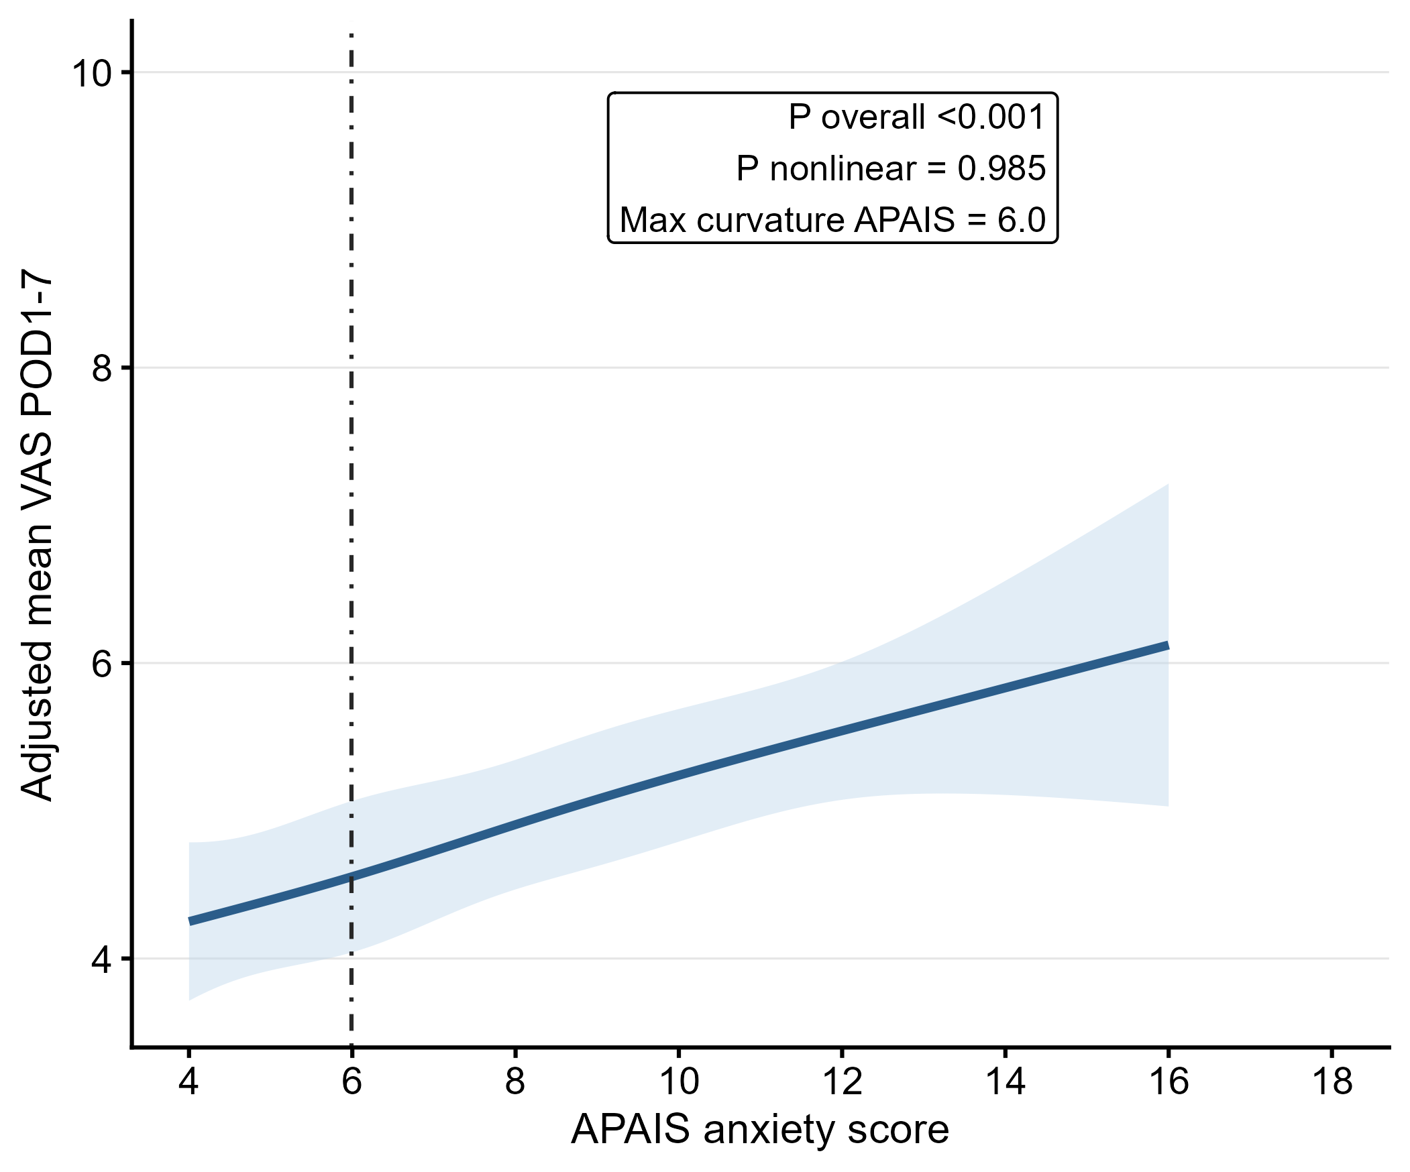

Supplementary Figure S2. RCS curve for APAIS and mean VAS in the tourniquet group. 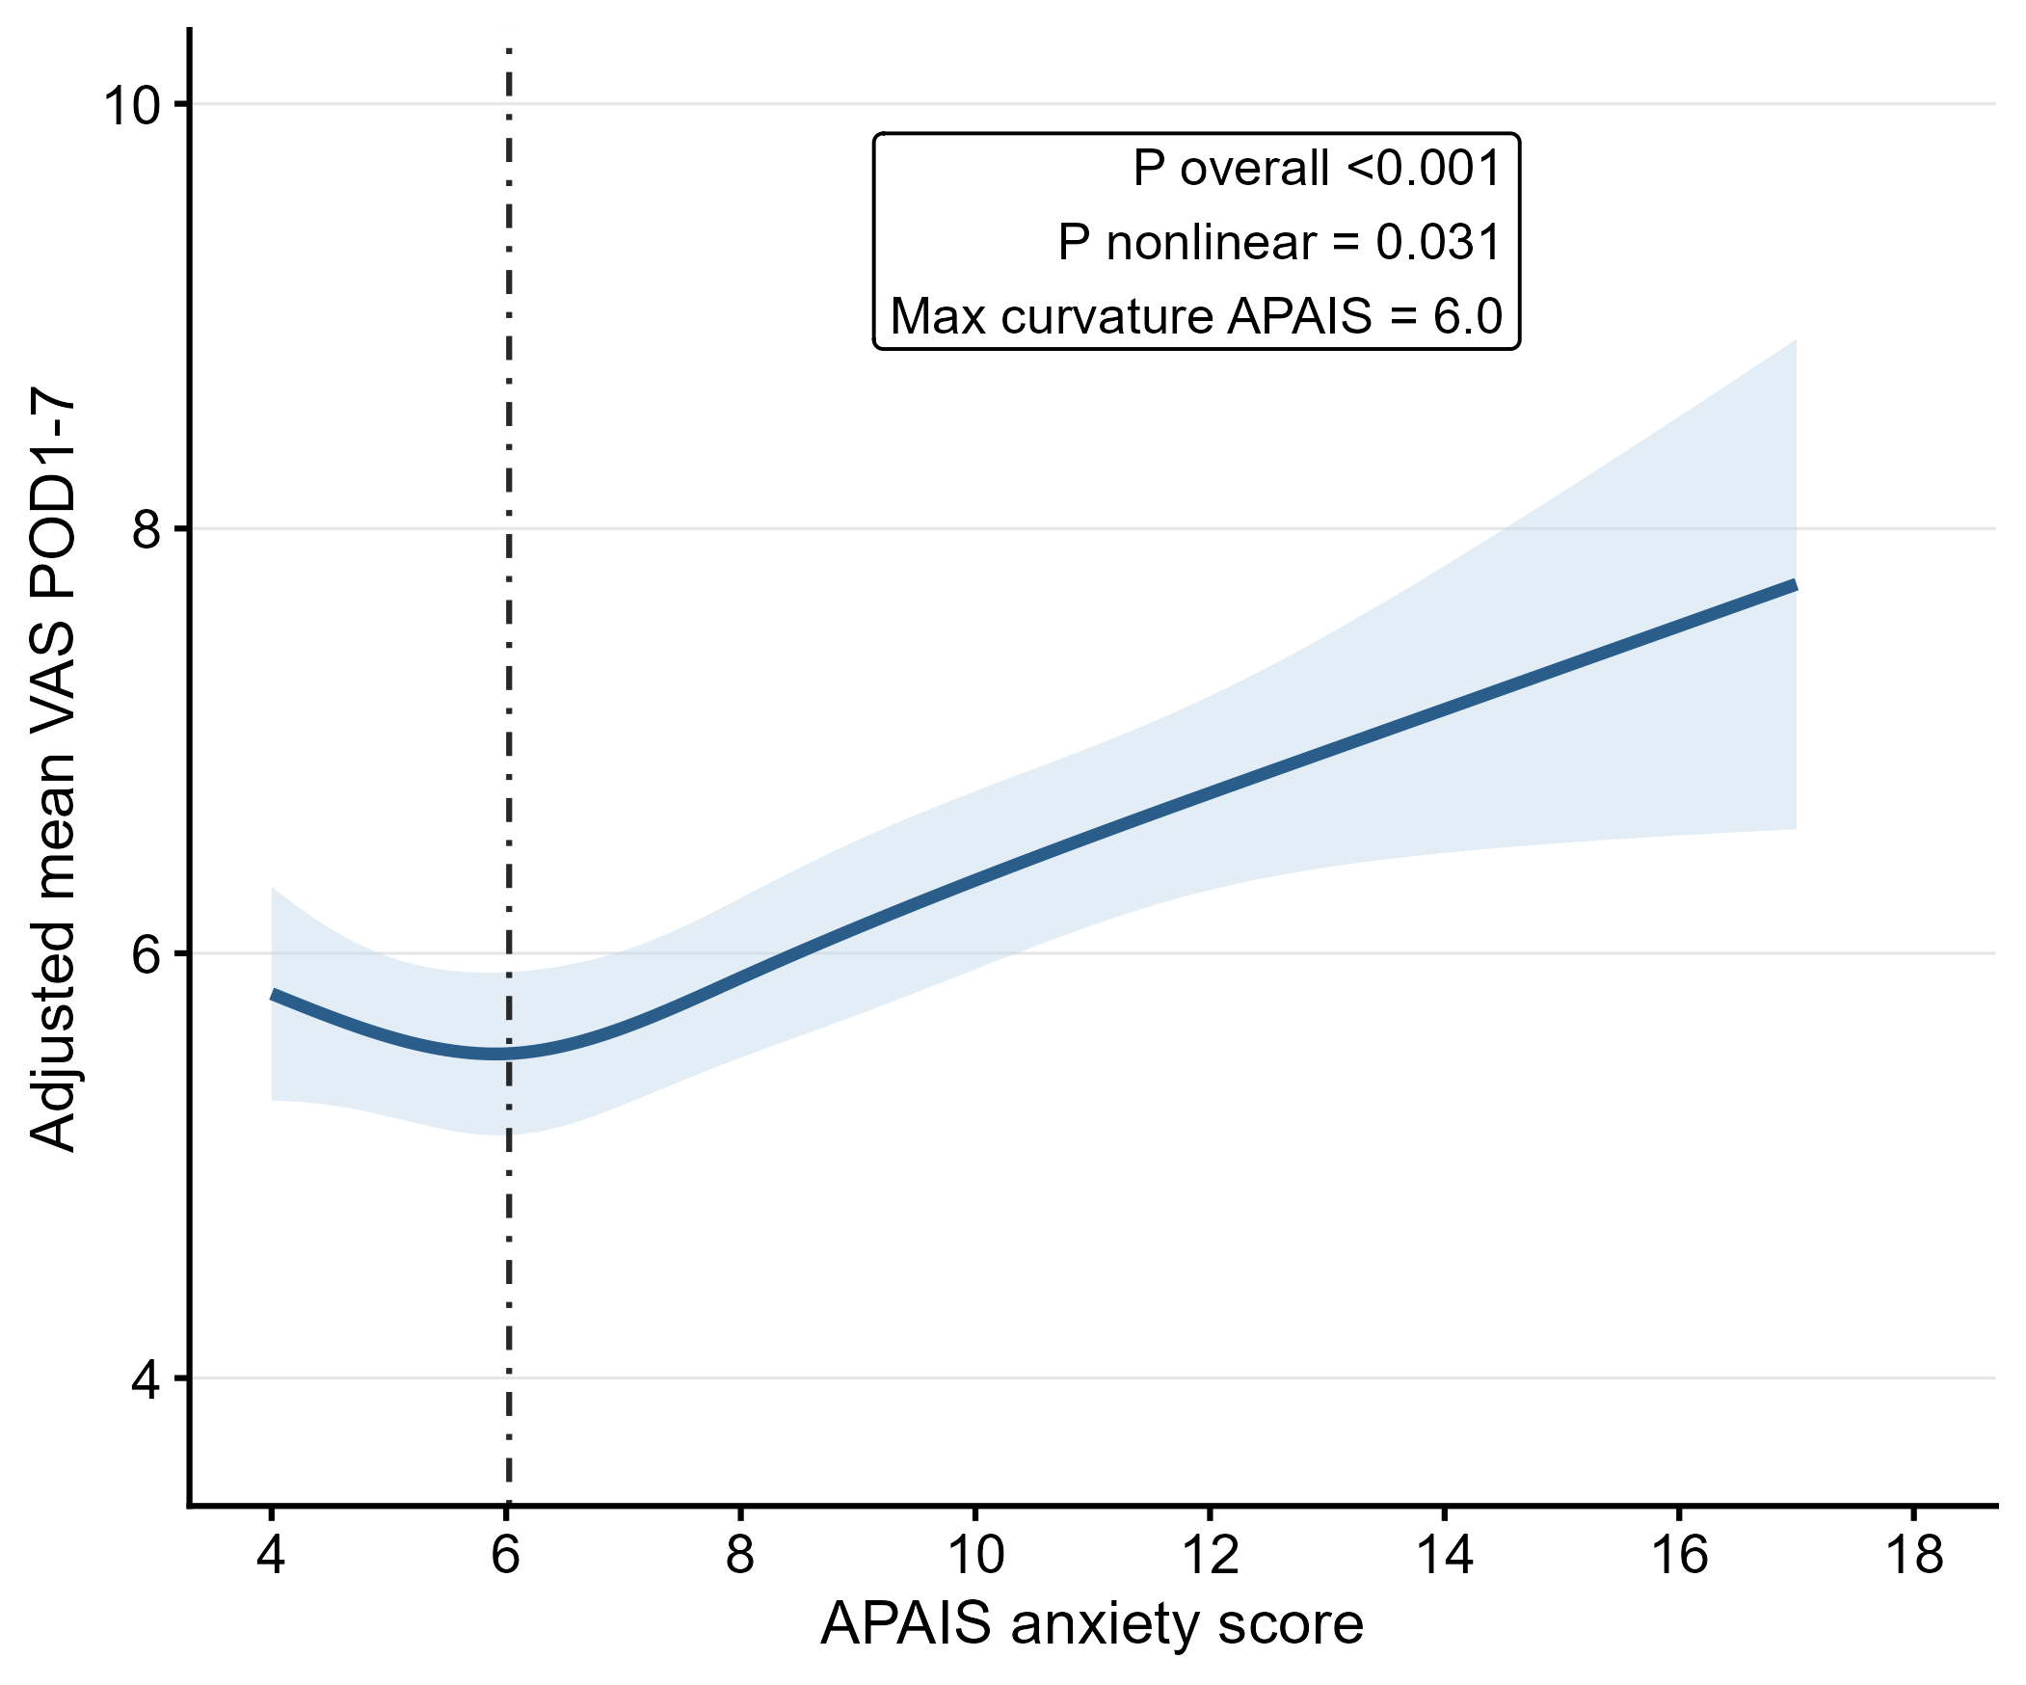Supplementary Figure S3. RCS curve for APAIS and cumulative VAS in the no-tourniquet group. 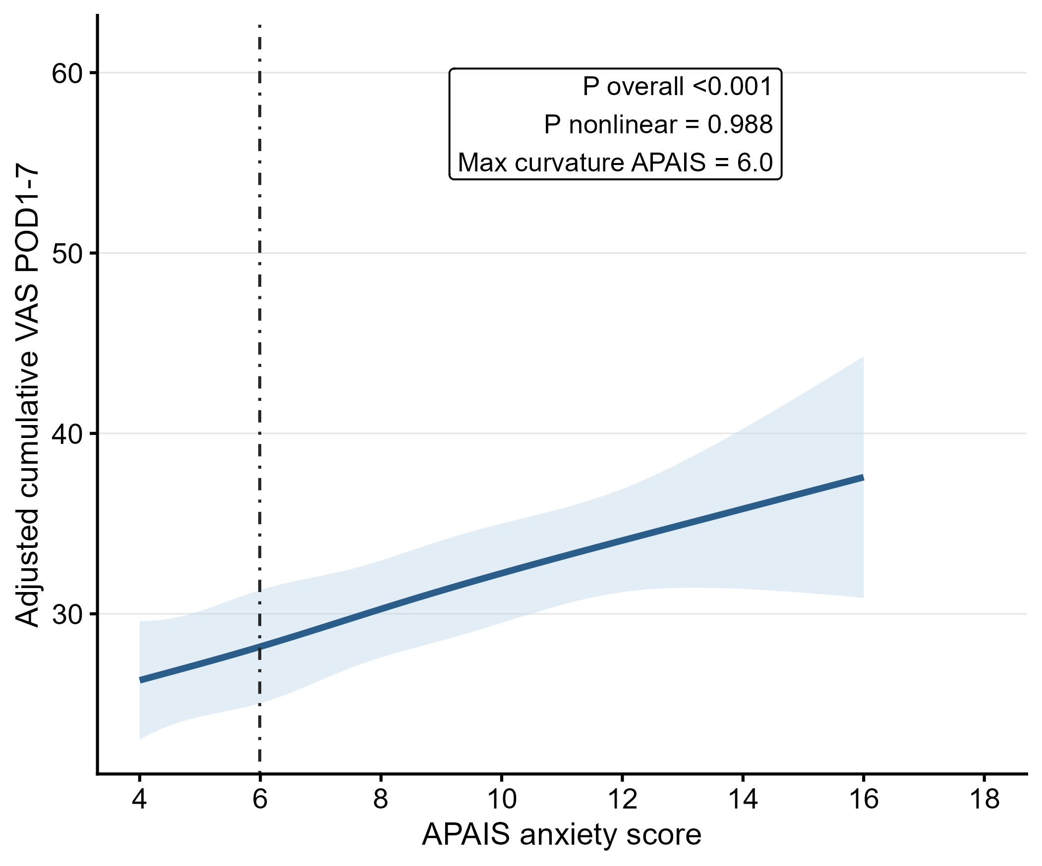

Supplementary Figure S4. RCS curve for APAIS and cumulative VAS in the tourniquet group. 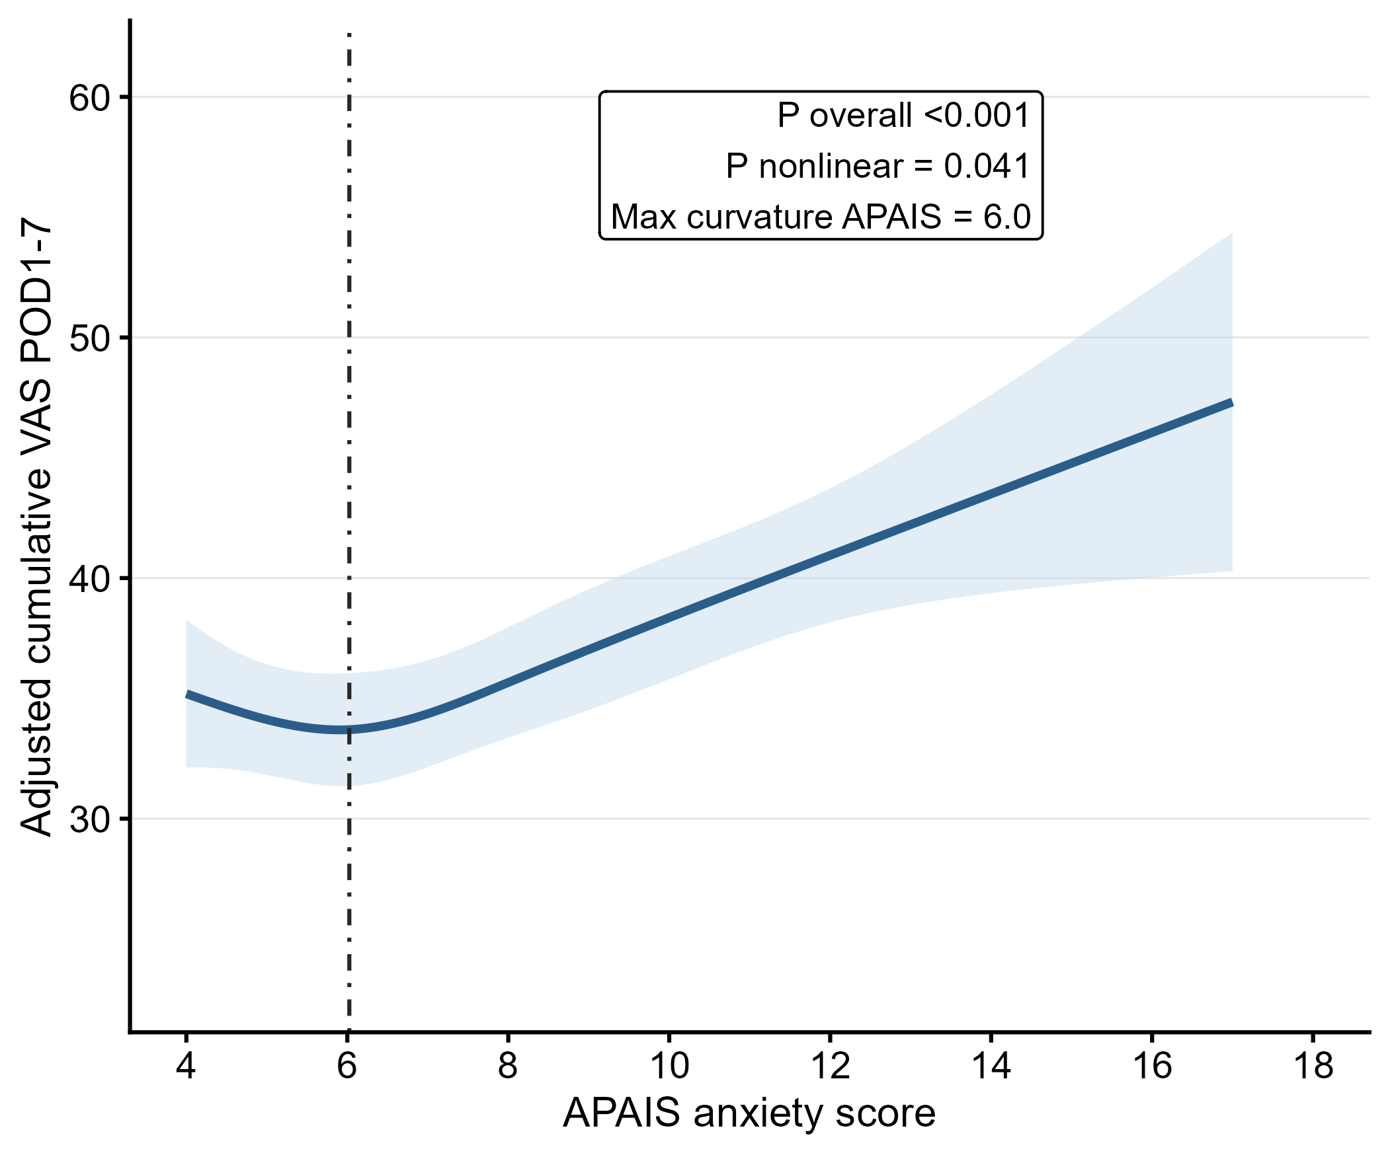
Supplementary Figure S5. Exploratory ROC curves for APAIS discrimination of high cumulative VAS.
Supplementary Figure S5. Covariate balance before and after propensity weighting. 