Supporting Information

Copper-Based Targeted Nanozyme Platform with Sequential Phototherapy-Enzymatic Therapy for Orchestrating Macrophage Homeostasis in Rheumatoid Arthritis
Zeyu Han ^{# a}, Zhan Liu ^{# a}, Shoufu Sun^{# b}, Rui Chao ª, Xinao Fan ª, Xuzhuo Chen ª*, Fan Li ^{cd}* and Shanyong Zhang ª*
ª Department of Oral Surgery, Shanghai Ninth People’s Hospital, Shanghai Jiao Tong University School of Medicine; College of Stomatology, Shanghai Jiao Tong University; National Center for Stomatology; National Clinical Research Center for Oral Diseases; Shanghai Key Laboratory of Stomatology; Shanghai Research Institute of Stomatology, Shanghai, 200011, China.
^{b} Tongren Hospital, Shanghai Jiao Tong University School of Medicine, Shanghai 200336, China.
^{c} Department of Oral Implantology, The Affiliated Hospital of Qingdao University, Qingdao University, Qingdao, 266000, China.
^{d} School of Stomatology, Qingdao University, Qingdao, 266000, China

# These authors contributed equally to this work.
* Corresponding authors:
Xuzhuo Chen, E-mail: 822015@sh9hospital.org.cn
Fan Li, E-mail: lifan911017@qdu.edu.cn
Shanyong Zhang, E-mail: ZHANGSY1787@sh9hospital.org.cn
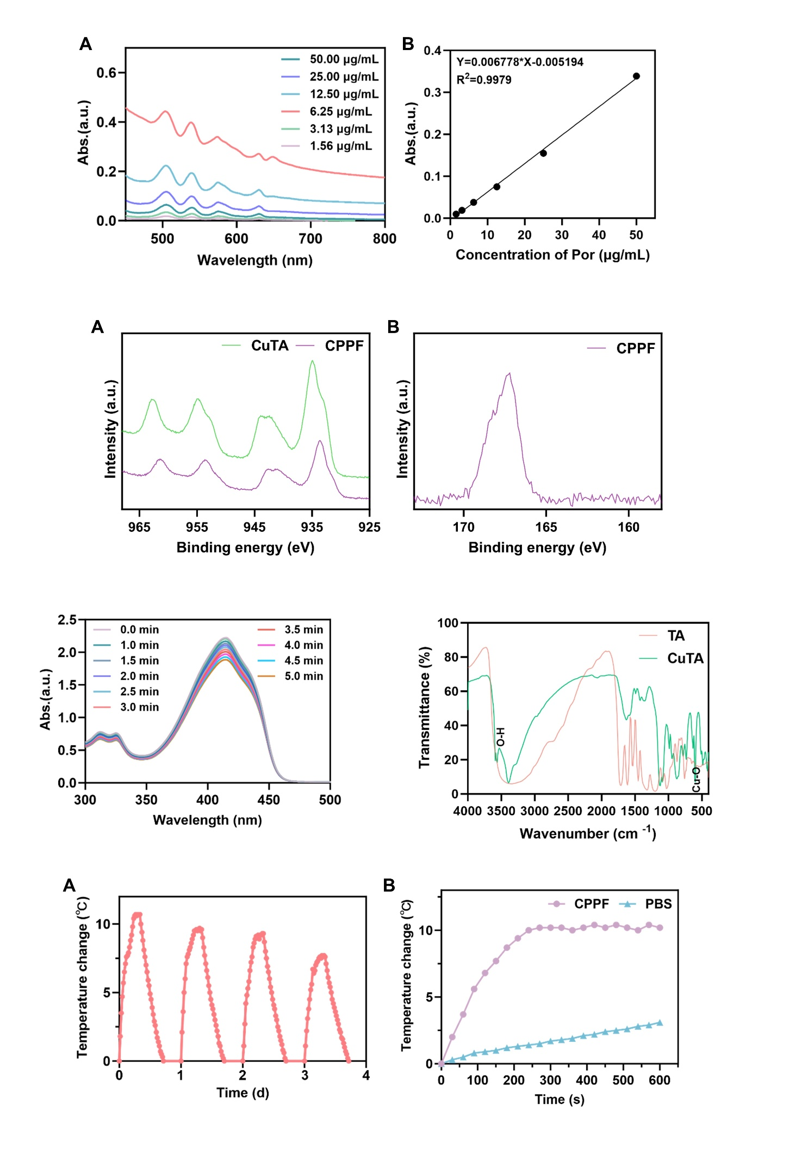
Figure S1. (A) UV-vis absorption spectra of Por at different concentrations and (B) standard curve.
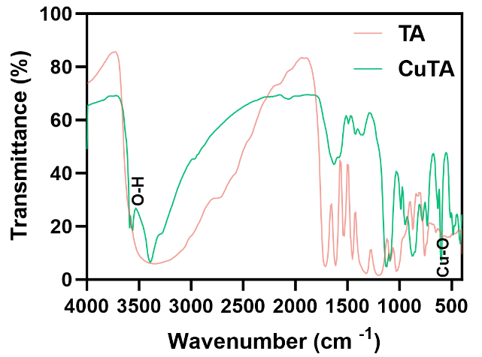
Figure S2. FTIR spectra of TA and CuTA.
Figure S3. XPS spectra of (A) Cu 2p in CuTA and CPPF, and (B) S 2p in CPPF.

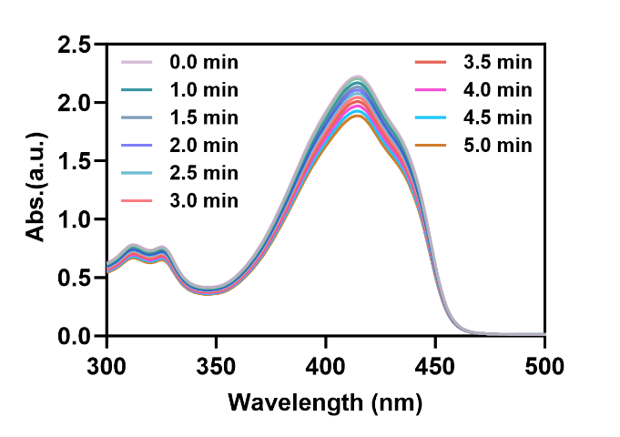
Figure S4. The absorption spectra of DPBF solution showing its natural decay, serving as the control for Figure 1L.
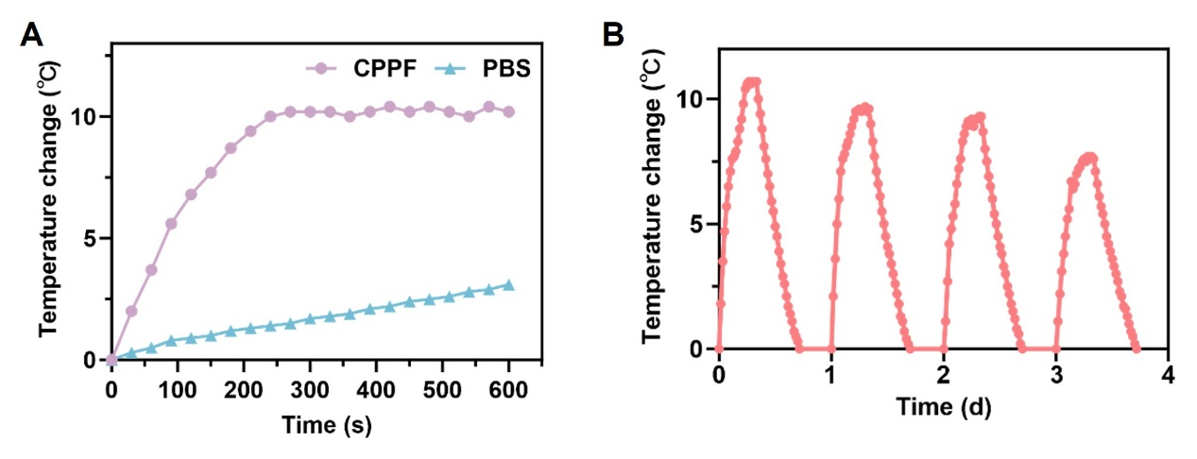Figure S5. (A) Photothermal heating curves of PBS and CPPF solution under 808 nm laser irradiation for 10 min. (B) Long-term photothermal stability of CPPF NPs over four consecutive heating-cooling cycles with 1-day intervals under 808 nm laser irradiation.

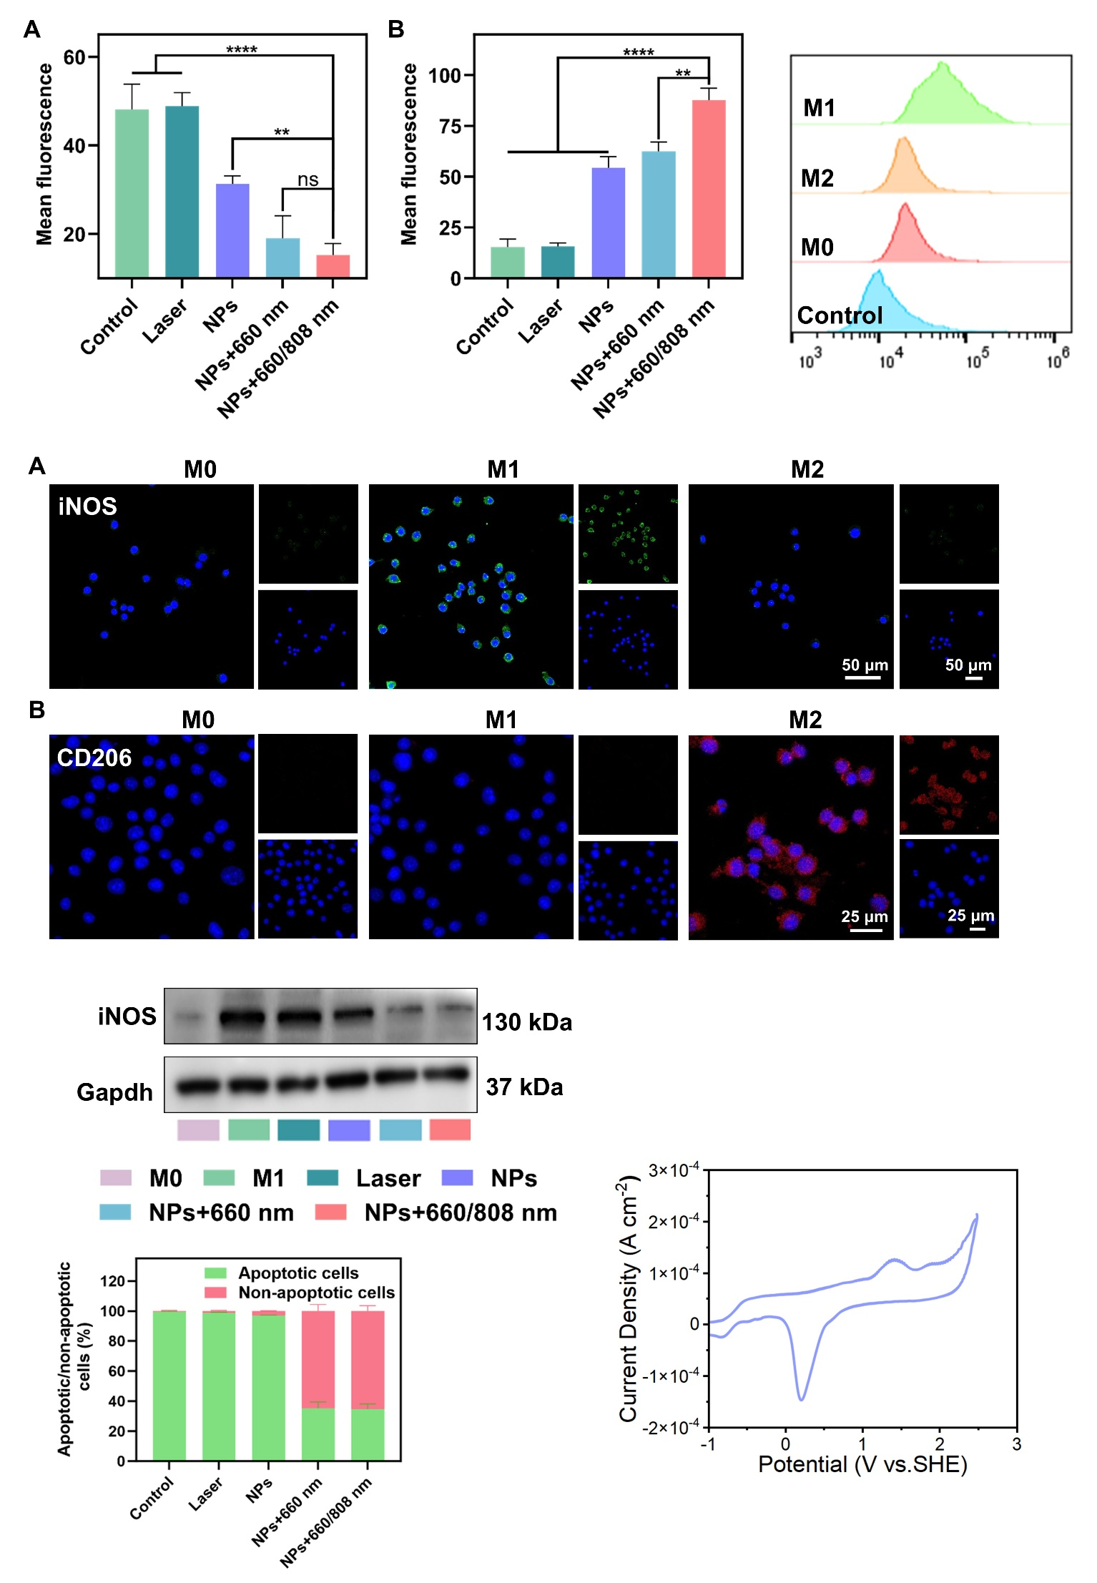
Figure S6. Cyclic voltammetry (CV) curve of CPPF NPs.

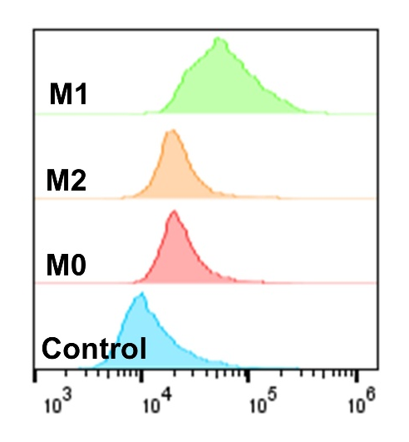
Figure S7. Flow cytometry analysis of CPPF cellular uptake by M0, M1, and M2-polarized RAW 264.7 macrophages after 6 h incubation.
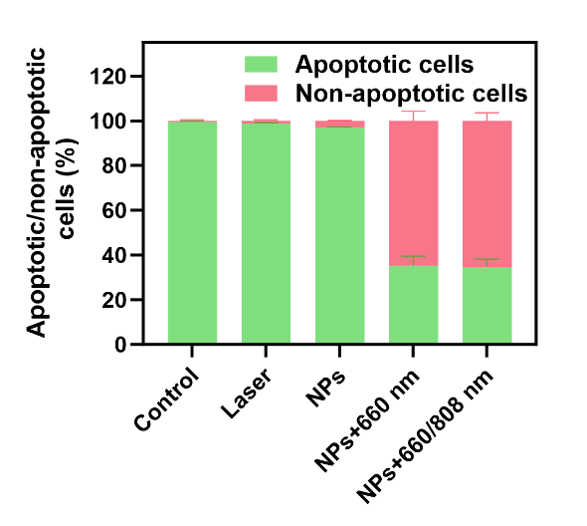
Figure S8. Quantitative analysis of apoptotic rates of M1-polarized macrophages after different treatments, detected by Annexin V-FITC/PI staining flow cytometry.
Figure S9. CLSM images of (A) iNOS and (B) CD206 expression in M0, M1, and M2-polarized RAW 264.7 macrophages.

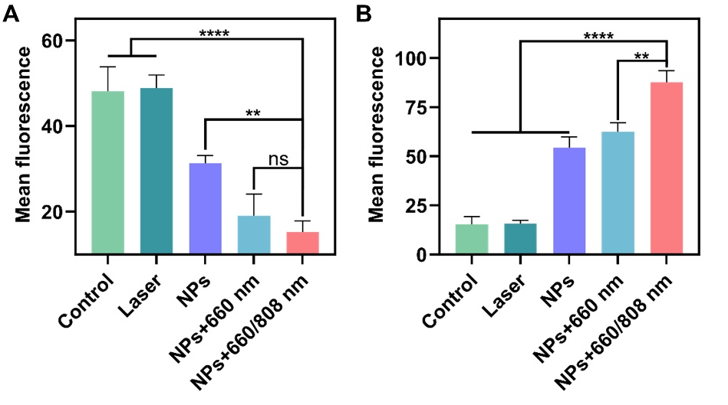
Figure S10. Quantitative analysis of mean fluorescence intensity of (A) iNOS and (B) CD206 in RAW 264.7 macrophages after different treatments.

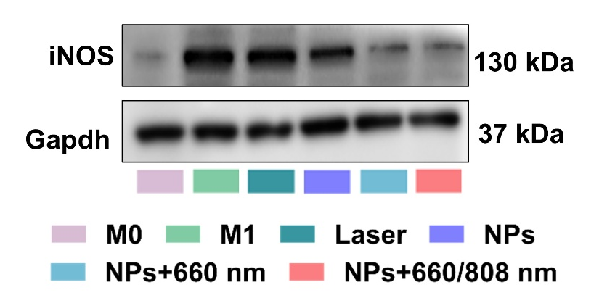
Figure S11. Western blot of iNOS protein expression in RAW 264.7 macrophages after different treatments.
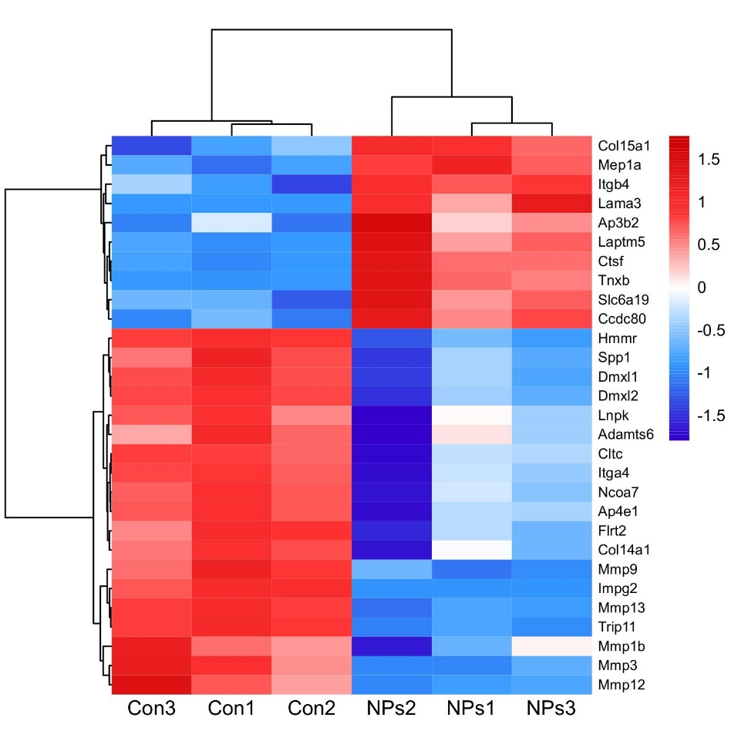
Figure S12. Heatmap of extracellular matrix degradation-related genes in control vs NPs groups.
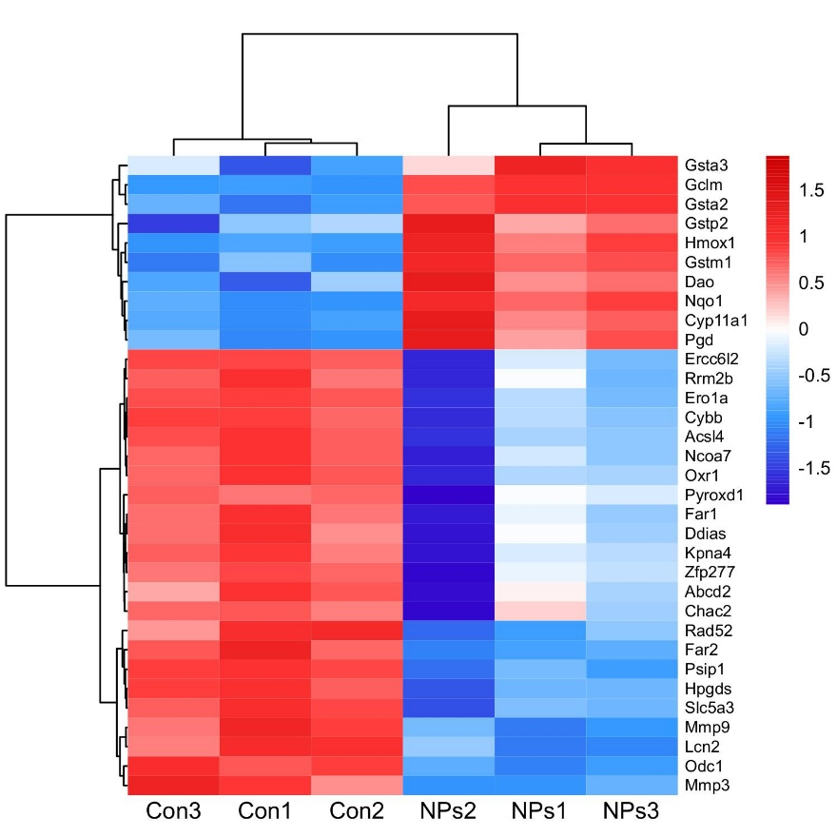
Figure S13. Heatmap of oxidative stress-related genes in control vs NPs groups.
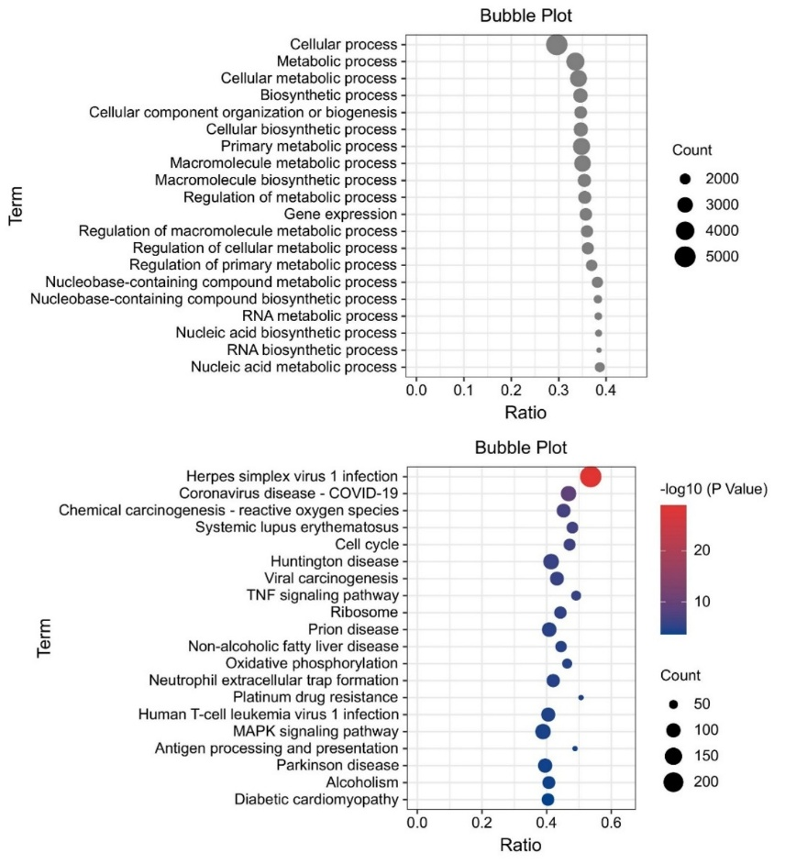
Figure S14. GO enrichment and KEGG pathway enrichment of NPs+L vs Control groups.
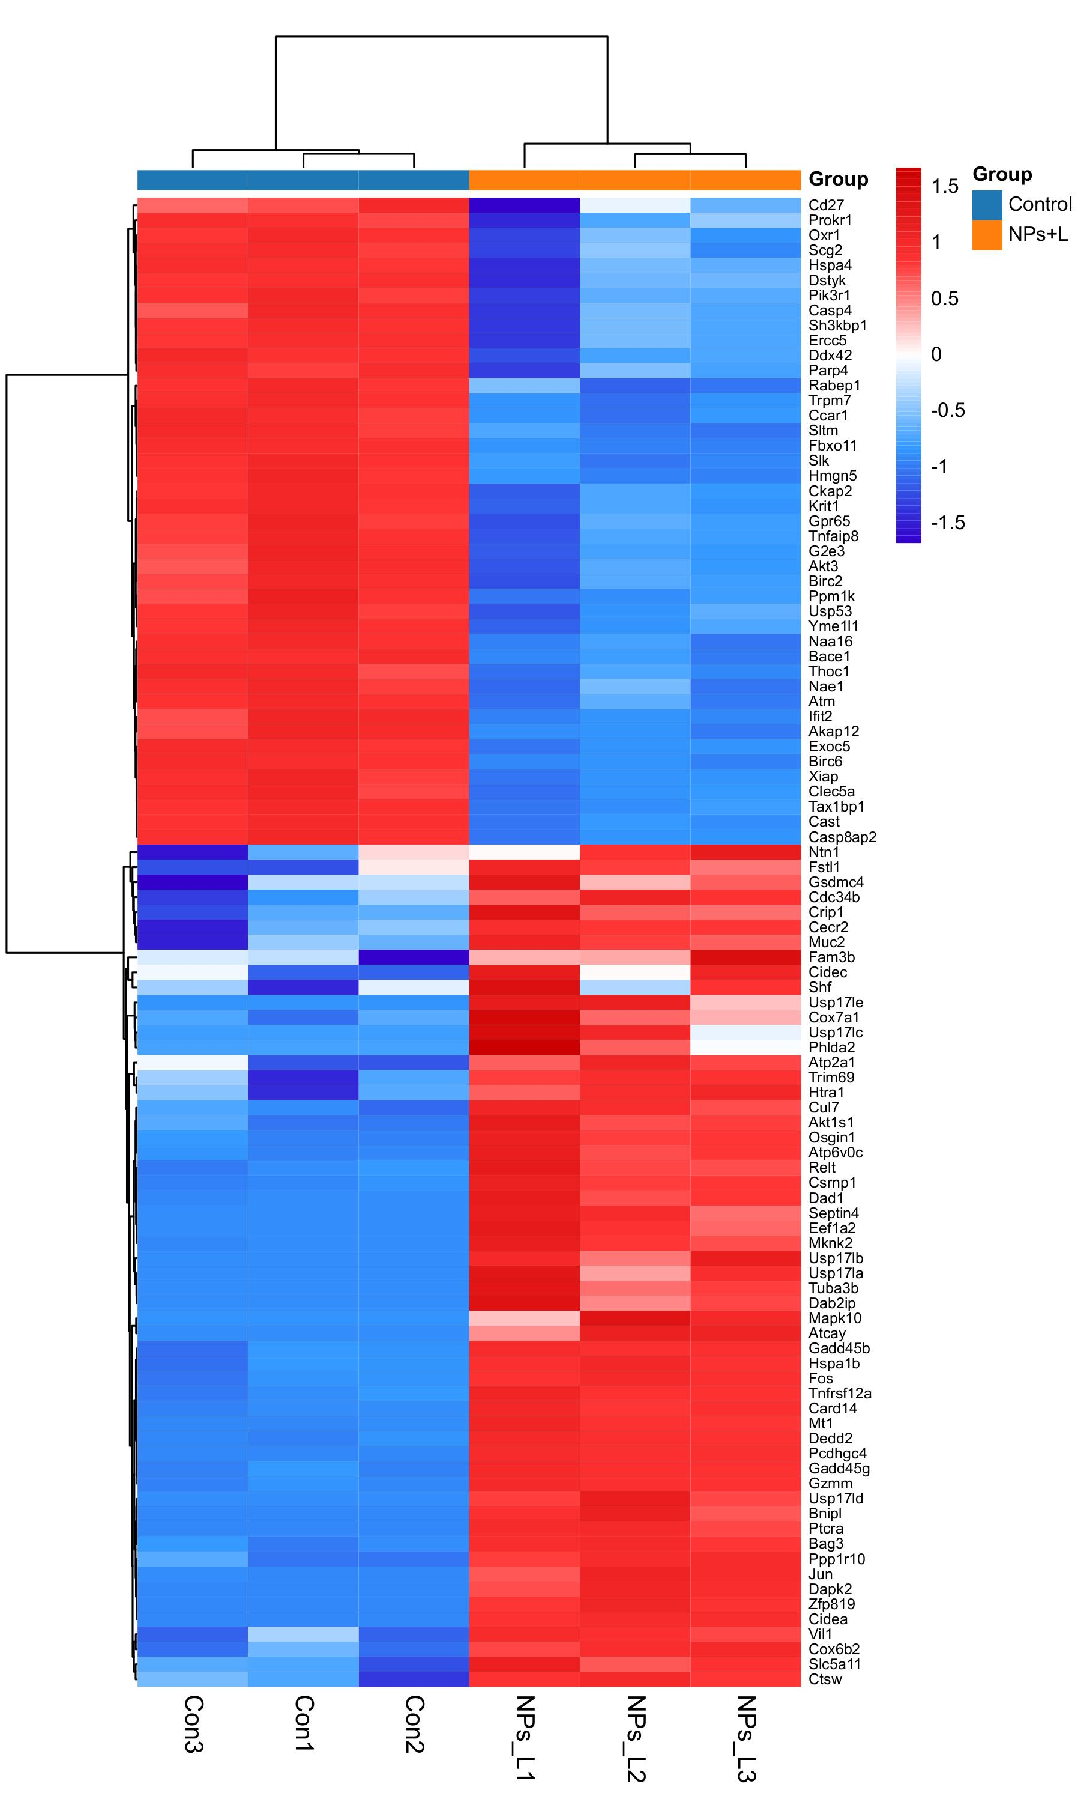
Figure S15. Heatmap of apoptosis-related genes in control and NPs+L groups.

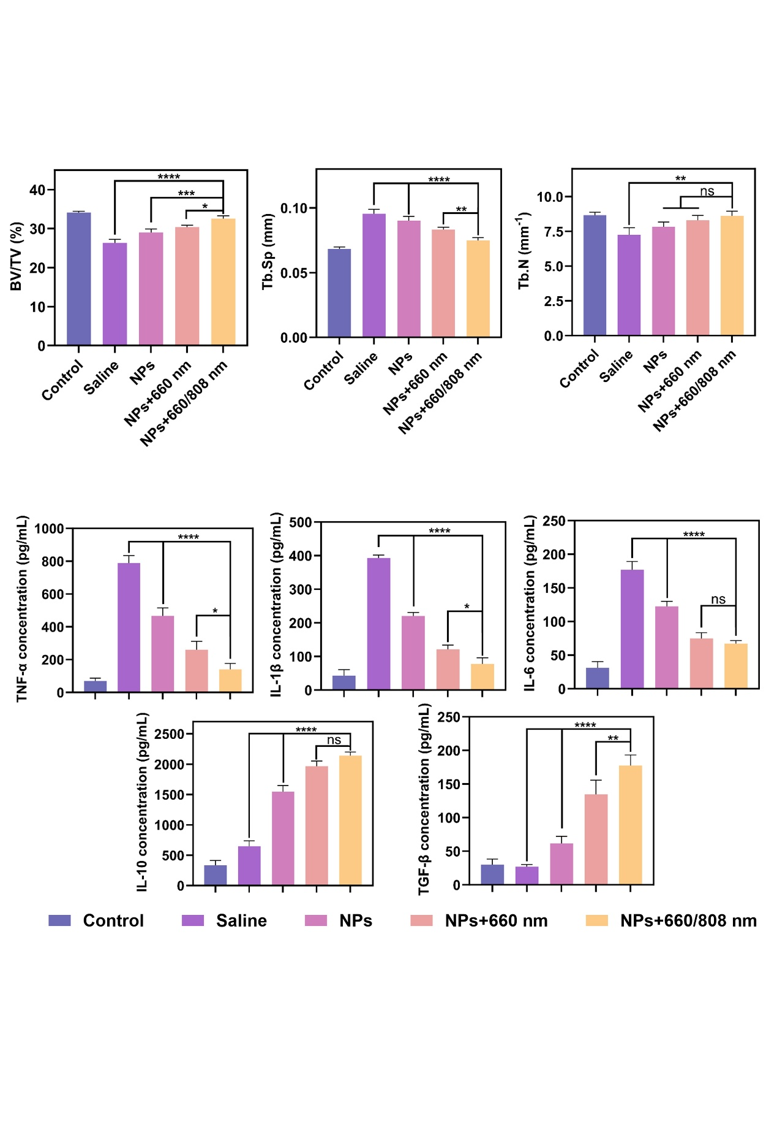
Figure S16. Quantitative Micro-CT analysis of CIA mice in different treatment groups.
Figure S17. ELISA analysis of TNF-α, IL-1β, IL-6, IL-10, and TGF-β concentrations in hind paw tissue homogenates from CIA mice in different treatment groups at the end of treatment.
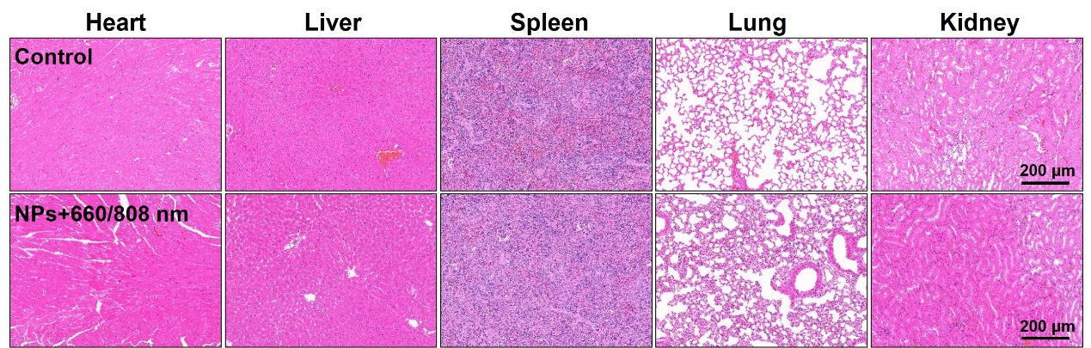 Figure S18. H&E staining of major organs (heart, liver, spleen, lung, kidney) in control and sequential therapy groups at the end of treatment. Scale bar: 200 μm.
Table S1. BET surface area and pore structure parameters of CuTA and CPPF.
 | CuTA CPPF
BET Surface Area (m²/g) | 83.99 56.82
External Surface Area (m²/g) | 83.99 56.82
Internal Surface Area (m²/g) | 0 0
Micropore Volume (cm³/g) | 0.033 0.016
Average Pore Diameter (nm) | 14.36 9.45

Table S2. Routine blood test of mice after different treatment.
 | Normal range | Control | Saline | NPs+660/808 nm
WBC | 0.80-10.60 | 0.91±0.33 | 0.89±0.24 | 0.82±0.16
Neu# | 0.23-3.60 | 0.22±0.08 | 0.23±0.05 | 0.24±0.06
Lym# | 0.60-8.90 | 0.64±0.13 | 0.62±0.15 | 0.55±0.11
Mon# | 0.04-1.40 | 0.05±0.01 | 0.04±0.02 | 0.03±0.01
Eos# | 0.00-0.51 | 0.01±0.01 | 0.01±0.01 | 0.01±0.01
Neu% | 6.5-50.0 | 24.25±4.33 | 25.84±3.46 | 28.77±4.78
Lym% | 40.0-92.0 | 70.33±6.56 | 69.66±6.32 | 67.07±5.96
Mon% | 0.9-18.0 | 5.49±1.45 | 4.49±1.36 | 3.66±1.18
Eos% | 0.0-7.5 | 1.10±0.31 | 1.12±0.22 | 1.22±0.46
RBC | 6.50-11.50 | 7.67±0.42 | 7.54±0.35 | 7.83±0.39
HGB | 110-165 | 112.96±4.67 | 114.26±3.15 | 115.80±2.82
HCT | 35.0-55.0 | 35.52±1.24 | 35.25±1.36 | 36.62±1.29
MCV | 41.0-55.0 | 46.31±1.36 | 46.75±1.29 | 46.77±1.58
MCH | 13.0-18.0 | 14.73±0.83 | 15.15±0.56 | 14.79±0.71
MCHC | 300-360 | 318.02±11.33 | 324.14±10.91 | 316.22±9.74
RDW-CV | 12.0-19.0 | 16.05±2.38 | 16.32±2.46 | 17.24±3.55
RDW-SD | 23.0-39.0 | 35.24±4.53 | 35.68±4.62 | 35.73±5.07
PLT | 400-1600 | 434.71±18.6 | 454.85±24.1 | 463.04±52.3
MPV | 4.0-6.2 | 4.47±0.25 | 4.65±0.34 | 4.46±0.21
PDW | 12.0-17.5 | 14.10±0.26 | 14.68±0.35 | 14.98±0.28
PCT | 0.10-0.78 | 0.19±0.03 | 0.21±0.04 | 0.21±0.03

