TABLE S1 Effect of Sulfuric Acid Concentration (corresponding to Fig. 2)

Analyte | 5% H₂SO₄ | 10% H₂SO₄ | 20% H₂SO₄
Pimelic acid | 78.04 ± 2.13 | 68.51 ± 3.66 | 66.58 ± 1.63
Suberic acid | 87.34 ± 4.76 | 60.00 ± 3.30 | 55.09 ± 1.52
Azelaic acid | 104.51 ± 4.54 | 71.96 ± 3.00 | 63.41 ± 3.02
Sebacic acid | 106.12 ± 5.04 | 76.66 ± 5.12 | 68.59 ± 2.89
Palmitic acid | 114.81 ± 1.28 | 104.18 ± 4.15 | 62.06 ± 2.15
Stearic acid | 100.63 ± 3.58 | 94.45 ± 4.42 | 82.58 ± 2.89

TABLE S2 Effect of number of extractions (corresponding to Fig. 3)

Analyte | 1 | 2 | 3
Pimelic acid | 16.91 ± 0.23 | 78.04 ± 2.13 | 82.22 ± 2.40
Suberic acid | 25.46 ± 1.83 | 87.34 ± 4.76 | 88.37 ± 2.23
Azelaic acid | 41.16 ± 1.92 | 104.51 ± 4.54 | 106.80 ± 5.44
Sebacic acid | 38.21 ± 1.64 | 106.12 ± 5.04 | 105.65 ± 2.79
Palmitic acid | 64.06 ± 0.97 | 114.81 ± 1.28 | 115.25 ± 1.23
Stearic acid | 72.69 ± 2.59 | 100.63 ± 3.58 | 102.29 ± 3.34

TABLE S3 Effect of Water Bath Heating Time (corresponding to Fig. 5)

Analyte | 1h | 2h | 3h | 4h
Pimelic acid | 75.11 ± 0.79 | 73.87 ± 1.57 | 78.28 ± 2.32 | 78.04 ± 2.13
Suberic acid | 66.73 ± 2.92 | 75.30 ± 3.16 | 93.82 ± 1.64 | 87.34 ± 4.76
Azelaic acid | 64.55 ± 2.61 | 64.01 ± 1.15 | 100.68 ± 1.44 | 104.51 ± 4.54
Sebacic acid | 61.30 ± 2.90 | 64.15 ± 2.53 | 88.83 ± 4.44 | 106.12 ± 5.04
Palmitic acid | 71.81 ± 3.87 | 65.61 ± 0.77 | 83.16 ± 3.21 | 114.81 ± 1.28
Stearic acid | 77.84 ± 4.52 | 82.33 ± 1.78 | 96.02 ± 1.32 | 100.63 ± 3.58

TABLE S4 Effect of Solid-Liquid Ratios (corresponding to Fig. 6)

Analyte | 1:2 | 1:3.5 | 1:5 | 1:10 | 1:20
Pimelic acid | 70.22 ± 3.52 | 74.27 ± 2.20 | 78.04 ± 2.13 | 45.30 ± 1.89 | 36.00 ± 1.57
Suberic acid | 50.86 ± 0.34 | 58.35 ± 2.84 | 87.34 ± 4.76 | 47.01 ± 0.42 | 37.30 ± 1.70
Azelaic acid | 56.34 ± 2.83 | 71.17 ± 1.60 | 104.51 ± 4.54 | 57.99 ± 2.70 | 51.63 ± 1.73
Sebacic acid | 54.46 ± 2.82 | 64.29 ± 1.69 | 106.12 ± 5.04 | 80.02 ± 2.64 | 68.53 ± 1.50
Palmitic acid | 55.16 ± 2.45 | 95.13 ± 2.76 | 114.81 ± 1.28 | 86.07 ± 1.25 | 76.48 ± 2.25
Stearic acid | 70.61 ± 1.89 | 95.98 ± 2.98 | 100.63 ± 3.58 | 88.42 ± 2.54 | 79.77 ± 3.56

Supplementary Note S1. Archaeological information of the pottery samples
Two archaeological potsherds from the Liujialiang site, Chifeng City, Inner Mongolia Autonomous Region, Northeast China, were selected for the preliminary application of the optimized acidified methanol protocol. The samples were broadly assigned to the Late Neolithic period based on their archaeological context and ceramic characteristics. Sample LJL-1 was associated with the Hongshan cultural context, whereas Sample LJL-2 belonged to a third category of remains with currently undetermined cultural attribution, tentatively dated to a phase broadly comparable to or later than the late Xiaoheyan cultural horizon. Detailed information on sample type, provenance, chronological context, ceramic characteristics, and sampling position is summarized in Supplementary Table S5, and representative images of the samples and sampling locations are shown in Supplementary Figure S1.

Sample LJL-1, excavated as F5:107, is a rim sherd from a pottery jar made of sandy greyish-brown pottery. It has an everted mouth, folded rim, flat lip, and curved body, with the base only partially preserved. The surface color is uneven, with mottled yellowish-brown, greyish-brown, and blackish-brown patches, and the inner wall is black. A remnant of a vertical bridge-shaped handle is preserved on the body. The wall thickness is 0.3 cm.

Sample LJL-2, excavated as F1:1, is a basal sherd made of sandy greyish-brown pottery. The vessel surface and base are smoothly burnished, and pressing marks related to manufacture are visible on the side of the foot. The sherd preserves a false ring foot, with a base diameter of 5 cm and a preserved height of 2 cm.

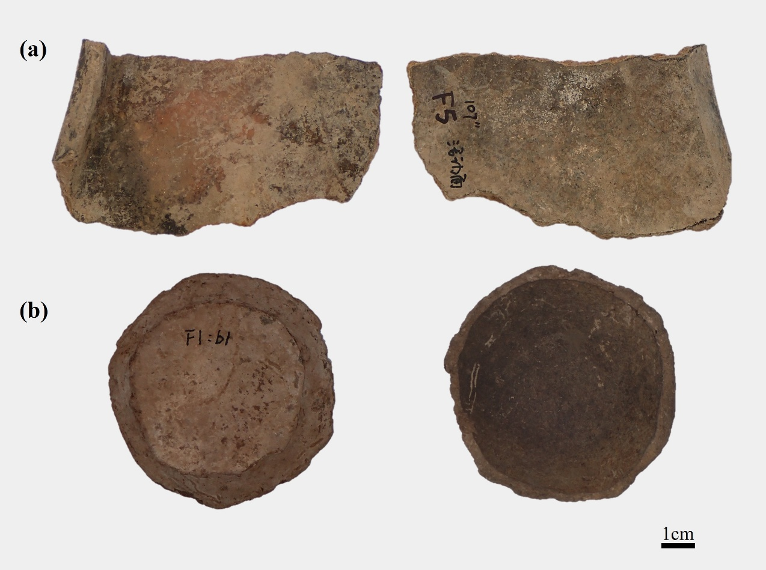
FIGURE S1 Images of the analyzed samples, showing the exterior (left) and interior (right) surfaces: (a) Sample LJL-1; (b)Sample LJL-2

