Supplementary material

SM1. Climatic and environmental variables included in the Urban Heat Stress Index (UHSI), grouped into heat-load and mitigation domains. Variables in the heat-load domain increase the index as values rise, whereas variables in the mitigation domain reduce the index as values rise. All variables were standardized prior to index construction. All of them were standardized in z-score.
Domain | Variable | Operational definition
Heat load | Maximum temperature | Annual mean daily maximum air temperature (°C)
Heat load | Minimum temperature | Annual mean daily minimum air temperature (°C)
Heat load | Extreme heat days | Number of days with daily maximum temperature ≥5°C above the monthly mean
Heat load | Dry days | Number of days without precipitation
Mitigation | Relative humidity | Annual mean relative humidity (%)
Mitigation | Rainfall | Annual accumulated precipitation (mm)
Mitigation | Urban greenness per capita | Municipal urban green cover per inhabitant (m²/person)

SM2. Spearman correlation matrix among climatic and environmental variables used to construct the Urban Heat Stress Index (UHSI): maximum temperature (tmax), minimum temperature (tmin), extreme heat days (heat_days), dry days without precipitation (dry_days), mean relative humidity (rh_mean), annual rainfall (rain), and urban green cover per capita (green_cap). Warmer colors indicate negative correlations and cooler colors indicate positive correlations. Strong positive correlations were observed among thermal load indicators, whereas relative humidity was strongly inversely correlated with temperature-related variables, supporting the domain-based structure of the composite index.
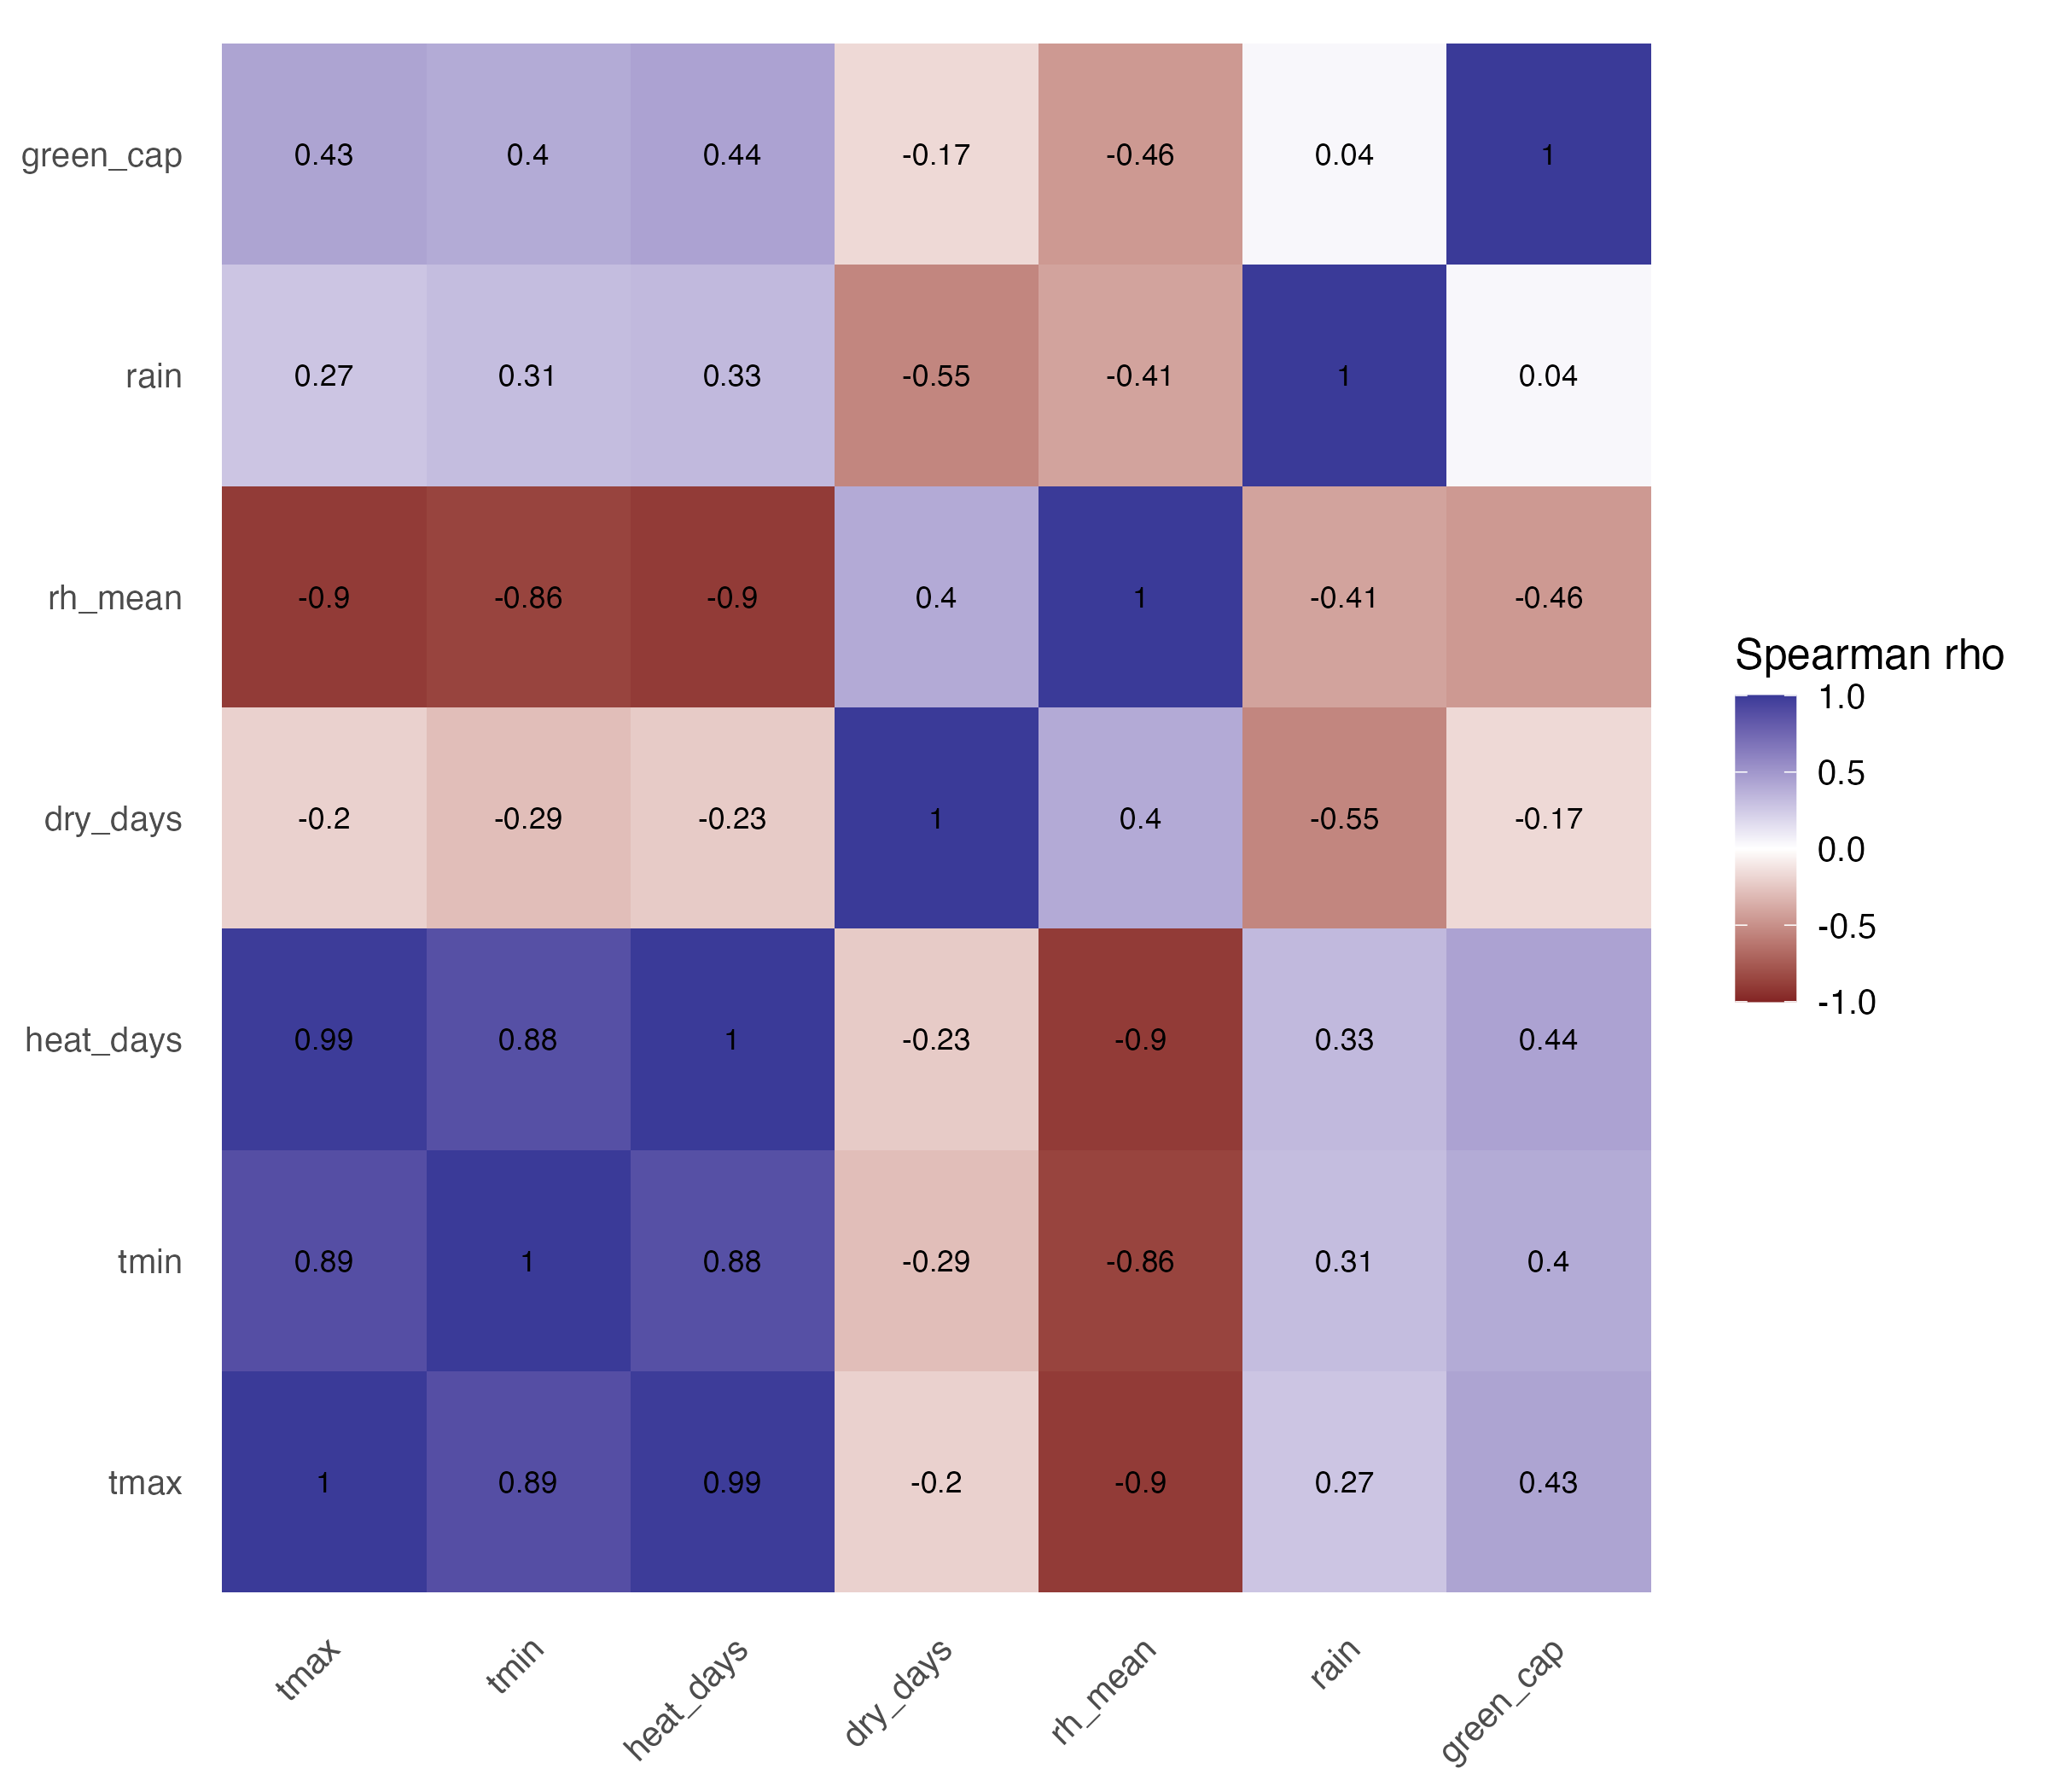
SM3. Heteroskedasticity-robust linear regression models examining associations between the standardized Urban Heat Stress Index (UHSI) and municipal health outcomes in Mato Grosso do Sul, Brazil. Models were adjusted for Human Development Index (HDI), Gini index, and log-transformed population size.
Outcome | Predictor | Beta | Robust SE | 95% CI | p-value
Respiratory mortality | UHSI (per 1 SD) | 10,91 | 4,72 | 1.67 to 20.15 | 0.024
Respiratory mortality | HDI | 49,35 | 96,26 | -139.32 to 238.03 | 0.610
Respiratory mortality | Gini index | -61,16 | 72,14 | -202.55 to 80.23 | 0.399
Respiratory mortality | Log population | 2,1 | 4,09 | -5.92 to 10.12 | 0.609
Circulatory mortality | UHSI (per 1 SD) | 7,77 | 8,32 | -8.54 to 24.09 | 0.353
Circulatory mortality | HDI | 333,73 | 247,59 | -151.54 to 819 | 0.182
Circulatory mortality | Gini index | 109,29 | 172,72 | -229.25 to 447.83 | 0.529
Circulatory mortality | Log population | -13,2 | 8,86 | -30.57 to 4.16 | 0.140
Circulatory hospitalizations | UHSI (per 1 SD) | -20,42 | 22,97 | -65.45 to 24.6 | 0.377
Circulatory hospitalizations | HDI | 719,88 | 614,76 | -485.0 to 1924.8 | 0.245
Circulatory hospitalizations | Gini index | -343,82 | 449,74 | -1225.3 to 537.67 | 0.447
Circulatory hospitalizations | Log population | 25,95 | 23,69 | -20.49 to 72.39 | 0.277
Cancer mortality | UHSI (per 1 SD) | -0,47 | 4,78 | -9.84 to 8.9 | 0.923
Cancer mortality | HDI | 369,04 | 147,58 | 79.78 to 658.31 | 0.015
Cancer mortality | Gini index | 121,98 | 102,5 | -78.91 to 322.88 | 0.238
Cancer mortality | Log population | -10,63 | 7,08 | -24.52 to 3.25 | 0.138

