Supplemental Material

Example Query
Below is the example query utilized to retrieved articles on alcohol, addiction and mental health from January 2020 to June 2020.
("Alcohol Alcohol"[Journal] OR "Addiction"[Journal] OR "Addict Biol"[Journal] OR "Drug Alcohol Depend "[Journal] OR "Alcohol Clin Exp Res (Hoboken)"[Journal] OR "Alcohol Clin Exp Res"[Journal] OR "Subs t Use Addctn J"[Journal] OR "Psychol Addict Behav"[Journal] OR "Addictive Behaviors"[Journal] OR "Dr ug Alcohol Rev"[Journal] OR "Am J Drug Alcohol Abuse"[Journal] OR "J Addict Med"[Journal] OR "J St ud Alcohol Drugs"[Journal] OR "J Subst Use Addict Treat"[Journal] OR "Addict Res Theory"[Journal] OR "Alcohol"[Journal] OR "Eur Addict Res"[Journal] OR "J Addict Dis"[Journal] OR "Drugs (Abingdon Engl )"[Journal] OR "Int J Ment Health Addict"[Journal] OR "Subst Use Misuse"[Journal] OR "J Dual Diagn"[J ournal] OR "Nordisk Alkohol Nark"[Journal] OR "J Addict Nurs"[Journal] OR "J Child Adolesc Subst Abu se"[Journal]) AND (("addiction"[All Fields]) OR ("substance use"[All Fields]) OR ("substance misuse"[All Fi elds]) OR ("substance abuse"[All Fields]) OR ("drug use"[All Fields]) OR ("drug abuse"[All Fields]) OR ("dr ug misuse"[All Fields]) OR ("drug dependence"[All Fields]) OR ("opioid use"[All Fields]) OR ("cannabis us e"[All Fields]) OR ("nicotine dependence"[All Fields]) OR ("prescription drug misuse"[All Fields]) OR ("che mical dependency"[All Fields]) OR ("recreational drug use"[All Fields]) OR ("illicit drug use"[All Fields]) OR ("overdose"[All Fields]) OR ("alcohol use"[All Fields]) OR ("alcohol abuse"[All Fields]) OR ("alcohol misus e"[All Fields]) OR ("alcohol consumption"[All Fields]) OR ("binge drinking"[All Fields]) OR ("heavy drinking "[All Fields]) OR ("problem drinking"[All Fields]) OR ("hazardous drinking"[All Fields]) OR ("alcohol depend ence"[All Fields]) OR ("alcoholism"[All Fields]) OR ("alcohol intoxication"[All Fields]) OR ("alcohol-related harm"[All Fields]) OR ("mental disorder"[All Fields]) OR ("mental health"[All Fields]) OR ("mental illness"[A ll Fields]) OR ("psychological distress"[All Fields]) OR ("psychiatric disorder"[All Fields]) OR ("depression"[ All Fields]) OR ("anxiety"[All Fields]) OR ("mood disorder"[All Fields]) OR ("personality disorder"[All Fields] ) OR ("psychosis"[All Fields]) OR ("post-traumatic stress"[All Fields]) OR ("PTSD"[All Fields]) OR ("emotio nal problems"[All Fields]) OR ("dual diagnosis"[All Fields]) OR ("comorbidity"[All Fields]) OR ("co-occurrin g disorders"[All Fields]) OR ("gambling"[All Fields]) OR ("pathological gambling"[All Fields]) OR ("problem gambling"[All Fields]) OR ("compulsive gambling"[All Fields]) OR ("internet addiction"[All Fields]) OR ("scr een addiction"[All Fields]) OR ("gaming disorder"[All Fields]) OR ("compulsive behavior"[All Fields]) OR (" behavioral addiction"[All Fields])) AND ("2020/01/01"[PDAT] : "2020/06/30"[PDAT])

System Requirements
This research was built on a macOS operating system using an M3 Max CPU with a 16-core CPU, a 40-core GPU, a maximum clock rate of 4.05 GHz, 64 GB of unified RAM, and 2 TB of SSD storage.

Tools and software
The Python programming language was primarily used for interaction. Additionally, the MetaPub package in Python was used to interact with the PubMed database. The lxml package was utilized to parse XML data in order to extract the authors' names and their affiliations. Furthermore, Pandas was employed to read the data and perform deduplication.

Journal Selected
Journals Filtered from PubMed. Below are the 26 journals used to search for alcohol, addiction and mental health related articles.
Supplemental Table 1: This table shows the 26 journals used to search for alcohol, addiction and mental health related articles.
S/N | Journal
1 | Addiction
2 | Addiction Biology
3 | International Journal of Drug Policy
4 | Drug and Alcohol Dependence
5 | Alcoholism: Clinical and Experimental Research
6 | Substance Abuse
7 | Psychology of Addictive Behaviours
8 | Addictive Behaviours
9 | Drug and Alcohol Review
10 | Alcohol and Alcoholism
11 | American Journal of Drug and Alcohol Abuse
12 | Journal of Addiction Medicine
13 | Journal of Studies on Alcohol and Drugs
14 | Journal of Substance Abuse Treatment
15 | Addiction Research & Theory
16 | Alcohol
17 | European Addiction Research
18 | Journal of Addictive Diseases
19 | Drugs: Education, Prevention and Policy
20 | International Journal of Mental Health and Addiction
21 | Substance Use & Misuse
22 | Journal of Dual Diagnosis
23 | Nordic Studies on Alcohol and Drugs
24 | Journal of Substance Use
25 | Journal of Addictions Nursing
26 | Journal of Child & Adolescent Substance Abuse

North of England Institutions
Supplemental Table 2: This table shows the 21 Higher Education Institution in the across the Northern Region of England.
S/N |  | HEI
 | 1 | University of Sheffield
 | 2 | University of York
 | 3 | University of Liverpool
 | 4 | University of Manchester
 | 5 | Liverpool John Moores University
 | 6 | Newcastle University
 | 7 | Manchester Metropolitan University
 | 8 | Edge Hill University
 | 9 | Lancaster University
 | 10 | Northumbria University
 | 11 | University of Leeds
 | 12 | University of Hull
 | 13 | Leeds Trinity University
 | 14 | Teesside University
 | 15 | Durham University
 | 16 | University of Chester
 | 17 | University of Salford
 | 18 | University of Huddersfield
 | 19 | Sheffield Hallam University
 | 20 | Liverpool Hope University
 | 21 | Leeds Beckett University

Network Construction of North West Region
Quantitatively there are 192 nodes (authors) and 676 edges (collaborations) in North West region, the network density was calculated to be 4%, indicating that 4% of all possible collaborations exist. Additionally, the average degree was 7, suggesting that each researcher has collaborated with an average of seven other researchers.
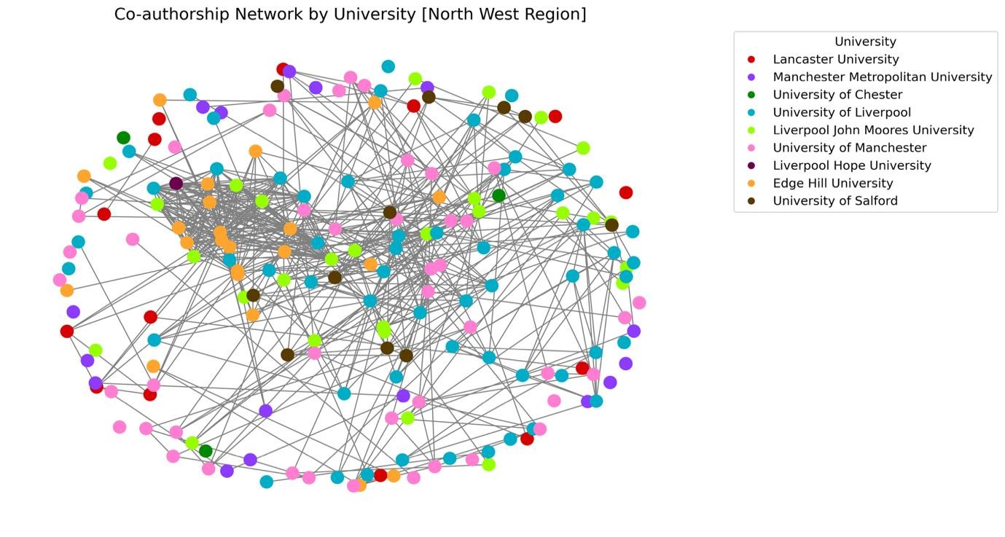 Supplemental Figure 1: Research Network Construction for North West region. The network shows that there is research collaboration network between universities in the North West region.

Network Construction of North East Region
Quantitatively there are 57 nodes (authors) and 230 edges (collaborations) in North West region, the network density was calculated to be 14%, indicating that 14% of all possible collaborations exist. Additionally, the average degree was 8, suggesting that each researcher has collaborated with an average of eight other researchers.
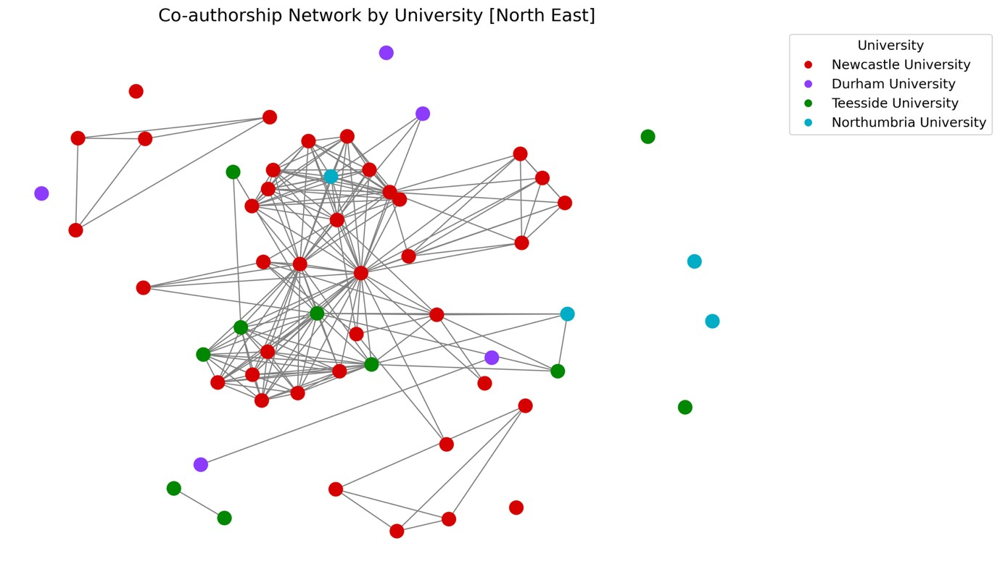
Supplemental Figure 2: Research Network Construction for North East region. The network shows that there is research collaboration network between universities in the North East region.

Network Construction of Northern England
Quantitatively there are 420 nodes (authors) and 1599 edges (collaborations) in Northern England, the network density was calculated to be 18%, indicating that 18% of all possible collaborations exist. Additionally, the average degree was 8, suggesting that each researcher has collaborated with an average of eight other researchers.
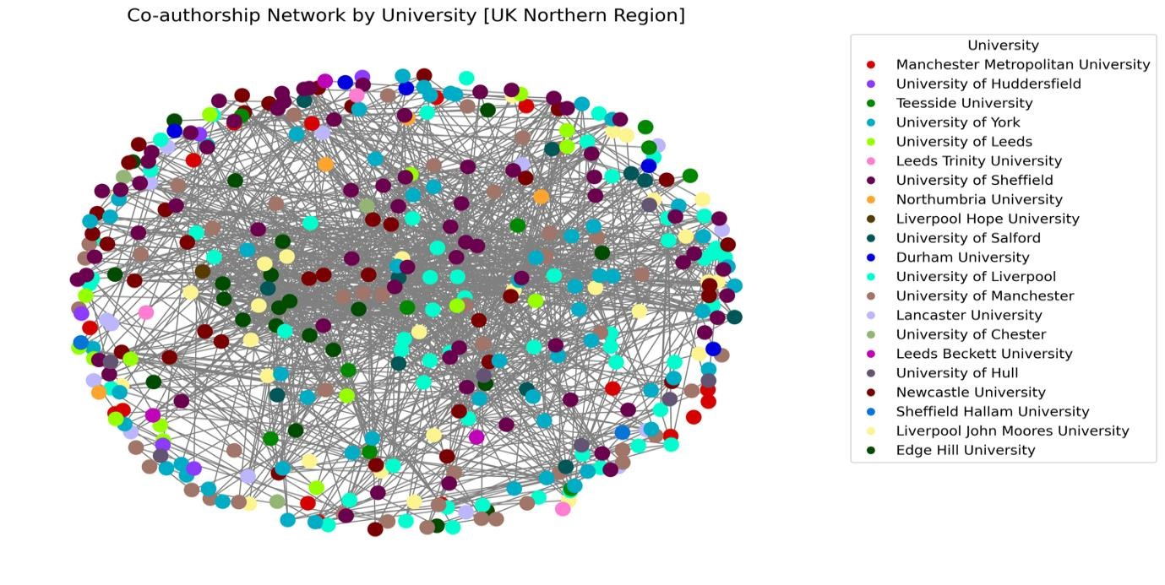
Supplemental Figure 3: Research Network Construction for the three regions combine. This network shows research collaboration network across the 21 universities in the Northern Region of England.

North East Region HEIs Publication
Analyzing universities in the North East showed that Newcastle University has the highest number of publications with 30 articles, Northumbria has 10 publications, Teesside has 8 publications, and Durham University has 7 publications.
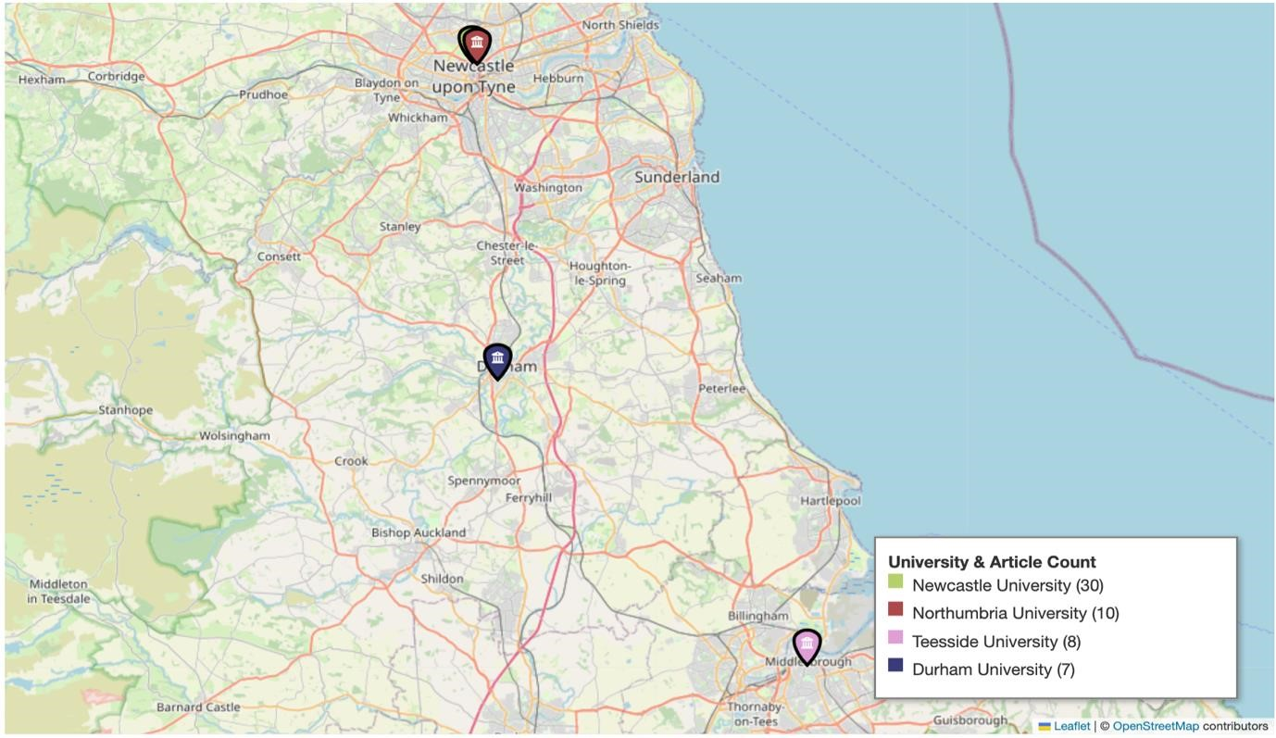 Supplemental Figure 4: This figure illustrates the distribution of research publications among universities in the North East of England, highlighting Newcastle University as the leading contributor with 30 articles, followed by Northumbria University (10), Teesside University (8), and Durham University (7).

NorthWest Region HEIs Publication
In terms of the Northwest Region, the top 3 universities with the highest number of publications are the University of Liverpool with 52 articles, followed by the University of Manchester (33 articles) and Liverpool John Moores University (31 articles).
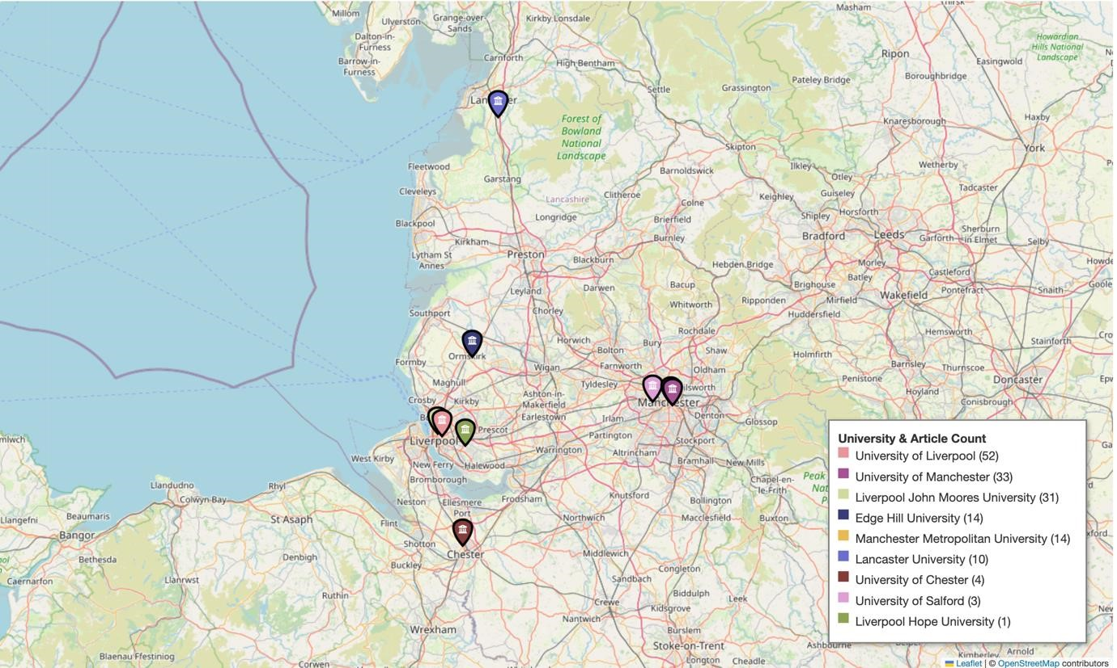 Supplemental Figure 5: This figure presents the leading universities in the North West of England by number of research publications, with the University of Liverpool producing the highest output (52 articles), followed by the University of Manchester (33 articles) and Liverpool John Moores University (31 articles).

Yorkshire and Humber Region HEIs Publication
Analysing the Yorkshire and Humber region showed that the top 3 universities with the highest number of publications are the University of Sheffield with 94 articles, the University of York with 57 articles, and the University of Leeds with 9 articles.
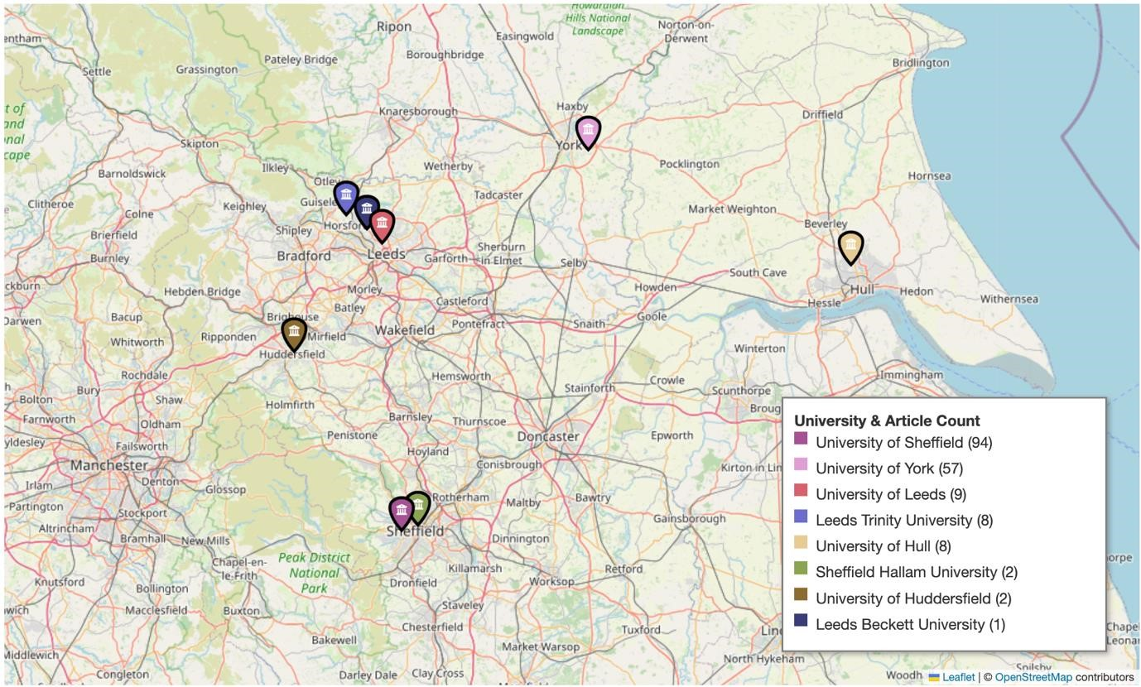
Supplemental Figure 6: This figure illustrates the leading universities in the Yorkshire and Humber region by research publication output, highlighting the University of Sheffield as the dominant contributor with 94 articles, followed by the University of York (57 articles) and the University of Leeds (9 articles).

Northern England HEIs Publication
Overall analyzing the Northern England showed that the top 3 universities with the highest number of publications in the past 5 years are the University of Sheffield (94 articles), the University of York (57 articles), and the University of Liverpool (52 articles).
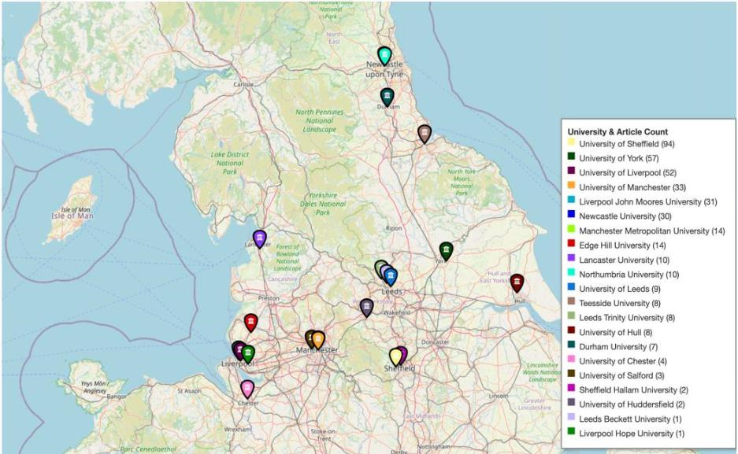
Supplemental Figure 7: This figure summarizes research publication output across Northern England over the past five years, highlighting the University of Sheffield as the leading institution (94 articles), followed by the University of York (57 articles) and the University of Liverpool (52 articles).

