In vitro activation of µ opioid receptor and cardiac voltage-gated potassium channels hERG and K_{V}7.1/KCNE1 of orphine analogs and their detections in forensic casework
Caitlyn Norman^{1,*}, Nina E Ottosson^{2,3}, Jenny Rosengren Holmberg⁴, Maria Norlund⁵, Evert J Homan^{6,7}, Maria Wikström⁵, Robert Kronstrand^{1,5}, Mattias Persson^{1,5,#}, Henrik Green ^{1,5,8,#}
¹Division of Clinical Chemistry and Pharmacology, Department of Biomedical and Clinical Sciences, Linköping University, Linköping, Sweden
²Division of Cell and Neurobiology, Department of Biomedical and Clinical Sciences, Linköping University, Linköping, Sweden
³Chemical Biology Consortium Sweden, Science for Life Laboratory, Linköping University, Linköping, Sweden
⁴Chemistry section, National Forensic Centre, Linköping, Sweden
⁵Department of Forensic Genetics and Forensic Toxicology, National Board of Forensic Medicine, Linköping, Sweden
⁶Department of Medical Biochemistry and Biophysics, Karolinska Institutet, Stockholm, Sweden
⁷Chemical Biology Consortium Sweden, Science for Life Laboratory, Karolinska Institutet, Stockholm, Sweden
⁸Department of Biomedical and Clinical Sciences, Science for Life Laboratory, Linköping University, Linköping, Sweden
*Corresponding author: caitlyn.norman@liu.se
#Contributed equally to the study

Supplementary Information
SECTION 1: Analytical data from first seizure of each orphine
SECTION 2: µ opioid receptor statistical analysis results
SECTION 3: hERG voltage dependence (ΔV₅₀) data for all orphines
SECTION 4: hERG structure-activity relationships statistical analysis results
SECTION 5: In silico hERG molecular docking
SECTION 6: K_{V}7.1/KCNE1 maximal conductance (G_{max}) and voltage dependence (ΔV₅₀) data for all orphines

SECTION 1
Analytical data from first seizure of each orphine

The NMR assignments are according to the numbering in the structures above.

Brorphine (1)
¹H NMR: δ (400 MHz; d₆-DMSO), 10.81 (1H, br s, NH1), 7.53 (2H, d, H20, H22), 7.32 (2H, d, H19, H23), 7.20 (1H, m, H5), 6.98-6.95 (3H, m, H7, H8, H6), 4.06 (1H, m, H10), 3.55 (1H, q, H16), 3.06 (1H, m, H14b), 2.86 (1H, m, H12b), 2.36-2.27 (2H, m, H15b, H11b), 2.06 (1H, m, H14a), 1.98 (1H, m, H12a), 1.65 (1H, m, H15a), 1.59 (1H, m, H11a), 1.31 (3H, d, H17); ¹³C NMR δ (100 MHz; d₆-DMSO), 153.6 (C2), 143.0 (C18), 140.0 (C20, C22), 129.6 (C19, C23), 129.3 (C4), 128.2 (C9), 120.4 (C6), 120.3 (C7), 119.7 (C21), 108.7 (C8), 108.6 (C5), 62.5 (C16), 50.3 (C10), 49.7 (C12), 49.1 (C14), 28.9 (C15), 28.8 (C11), 18.7 (C17); GC-MS: m/z (EI), 399 (M⁺, 2%), 216 (10), 183 (6), 134 (6), 104 (25), 82 (100); HR-LCMS: m/z (HESI), 400.1016, C₂₀H₂₃BrN₃O⁺, calculated 400.1024.

Cychlorphine (2)
¹H NMR: δ (400 MHz; d₆-DMSO), 7.73 (1H, d, H5), 7.70 (2H, d, H19, H23), 7.57 (2H, d, H20, H22), 7.33 (1H, d, H8), 7.07 (2H, quint, H6, H7), 4.56 (2H, m, H10, H16), 4.12 (2H, t, H24), 3.78 (1H, d, H14b), 3.35 (1H, m, H12b), 3.01-2.97 (2H, m, H14a, H15b), 2.94 (3H, m, H25, H12a), 2.80 (1H, m, H11b), 1.88-1.83 (2H, m, H11a, H15a), 1.74 (3H, d, H17); ¹³C NMR δ (100 MHz; d₆-DMSO), 152.5 (C2), 134.2 (C21), 133.7 (C18), 131.4 (C19, C23), 128.9 (C20, C22), 128.5 (C9), 127.4 (C4), 121.1 (C6, C7), 118.6 (C26), 109.6 (C5), 108.5 (C8), 63.9 (C16), 49.9 (C14), 47.7 (C12), 47.2 (C10), 36.4 (C24), 25.3 (C11,C15), 16.5 (C25), 16.4 (C17); GC-MS: m/z (EI), 408 (M⁺, 1%), 393 (3), 269 (11), 139 (11), 103 (16), 82 (100); HR-LCMS: m/z (HESI), 409.1787, C₂₃H₂₆ClN₄O⁺, calculated 409.1795.

Spirochlorphine (3)
¹H NMR: δ (400 MHz; d₆-DMSO), 8.93 (1H br s, NH8), 7.74 (2H, d, H20, H24), 7.54 (2H, d, H21, H23), 7.20 (2H, t, H13, H15), 7.11 (2H, d, H12, H16), 6.77 (1H, t, H14), 4.59-4.58 (3H, m, H9, H17), 3.65 (1H, d, H6b), 3.53-3.42 (2H, m, H2b, H6a), 3.23 (1H, d, H2a), 3.12 (1H, m, H5b), 2.94 (1H, m, H3b), 1.84 (1H, d, H5a), 1.75 (4H, d, H3a, H18); ¹³C NMR δ (100 MHz; d₆-DMSO), 174.6 (C7), 142.7 (C11), 134.2 (C22), 133.9 (C19), 131.4 (C20, C24), 129.0 (C13, C15), 128.8 (C21, C23), 117.9 (C14), 114.3 (C12, C16), 64.1 (C17), 58.7 (C9), 56.6 (C4), 47.2 (C6), 44.7 (C2), 26.0 (C5), 25.9 (C3), 16.6 (C18); GC-MS: m/z (EI), 369 (M⁺, 3%), 354 (13), 230 (40), 175 (100), 139 (46), 125 (26), 103 (40), 77 (23), 56 (43); HR-LCMS: m/z (HESI), 370.1678, C₂₁H₂₅ClN₃O⁺, calculated 370.1686.

SECTION 2
µ opioid receptor statistical analysis results

Table S2.1. Comparison of efficacy and potency between orphines and the reference fentanyl. P values are from Brown-Forsythe and Welch ANOVA tests with fentanyl as a reference.
Comparisons |  | Efficacy (E_{max}) |  |  | Potency (logEC₅₀)
Compound 1 | Compound 2 | Mean Diff | P value | Significant? | Mean Diff | P value | Significant?
Fentanyl | Orphine | -2.404 | 0.2500 | No | -0.7387 | <0.0001 | Yes
Fentanyl | Fluorphine | -1.171 | 0.9700 | No | -0.8889 | <0.0001 | Yes
Fentanyl | Chlorphine | 0.3980 | >0.9999 | No | -0.5614 | <0.0001 | Yes
Fentanyl | Brorphine | -0.7914 | 0.9875 | No | -0.3418 | <0.0001 | Yes
Fentanyl | Iodorphine | -4.604 | 0.0111 | Yes | -0.6299 | <0.0001 | Yes
Fentanyl | Cychlorphine (N-propionitrile chlorphine) | -1.922 | 0.4654 | No | 0.7244 | <0.0001 | Yes
Fentanyl | Spirochlorphine (R6890) | -2.047 | 0.3813 | No | -0.1390 | 0.0370 | Yes
Fentanyl | 5,6-dichloro desmethylchlorphine (SR-17018) | 2.135 | 0.4315 | No | -1.944 | <0.0001 | Yes
Fentanyl | Spirobrorphine | -3.511 | 0.0553 | No | -0.3152 | 0.0002 | Yes
Fentanyl | 5,6-dichloro brorphine | 0.9580 | 0.9695 | No | -0.6610 | <0.0001 | Yes

Table S2.2. Comparison of efficacy and potency between halogen substitutions on the N-benzyl moiety of orphines. P values are from Brown-Forsythe and Welch ANOVA tests with fentanyl as a reference.
Structural comparison | Comparisons |  | Efficacy (E_{max}) |  |  | Potency (EC₅₀)
Structural comparison | Compound 1 | Compound 2 | Mean Diff | P value | Significant? | Mean Diff | P value | Significant?
H vs F | Orphine | Fluorphine | 1.233 | 0.9230 | No | -0.1502 | 0.0403 | Yes
H vs Cl | Orphine | Chlorphine | 2.802 | 0.1309 | No | 0.2342 | 0.0013 | Yes
H vs Br | Orphine | Brorphine | 1.613 | 0.4346 | No | 0.3969 | <0.0001 | Yes
H vs I | Orphine | Iodorphine | -2.200 | 0.1188 | No | 0.1088 | 0.0139 | Yes
F vs Cl | Fluorphine | Chlorphine | 1.569 | 0.8531 | No | 0.3844 | 0.0001 | Yes
F vs Br | Fluorphine | Brorphine | 0.3792 | >0.9999 | No | 0.5471 | <0.0001 | Yes
F vs I | Fluorphine | Iodorphine | -3.434 | 0.1230 | No | 0.2590 | 0.0021 | Yes
Cl vs Br | Chlorphine | Brorphine | -1.189 | 0.8667 | No | 0.1627 | 0.0089 | Yes
Cl vs Br | Spirochlorphine | Spirobrorphine | -1.464 | 0.2669 | No | -0.1762 | 0.0016 | Yes
Cl vs I | Chlorphine | Iodorphine | -5.002 | 0.0057 | Yes | -0.1254 | 0.0422 | Yes
Br vs I | Brorphine | Iodorphine | -3.813 | 0.0029 | Yes | -0.2881 | <0.0001 | Yes

Table S2.3. Comparison of efficacy and potency between the other structural analogs of orphines. P values are from Brown-Forsythe and Welch ANOVA tests with fentanyl as a reference.
Comparisons |  | Efficacy (E_{max}) |  |  | Potency (EC₅₀)
Compound 1 | Compound 2 | Mean Diff | P value | Significant? | Mean Diff | P value | Significant?
Chlorphine | Spirochlorphine | -2.445 | 0.0831 | No | 0.3655 | <0.0001 | Yes
Brorphine | Spirobrorphine | -2.719 | 0.0241 | Yes | 0.02658 | 0.7500 | No
Chlorphine | Cychlorphine | -2.320 | 0.1790 | No | 1.229 | <0.0001 | Yes
Chlorphine | 5,6-dichloro desmethylchlorphine | 1.737 | 0.4813 | No | -1.439 | <0.0001 | Yes
Brorphine | 5,6-dichloro brorphine | 1.749 | 0.1924 | No | -0.3192 | <0.0001 | Yes

SECTION 3
hERG voltage dependence (ΔV₅₀) data for all orphines
The concentration-response relationships for voltage dependence (ΔV₅₀) effect for all 11 orphines tested are provided in Figure S3.1. The ΔV₅₀ was not included for concentrations where the average G_{max} (rel.) was less than 0.2. It can be clearly seen that only iodorphine had ΔV₅₀ that was significantly different (mixed effects model, α = 0.05) from that of the vehicle (0.3% DMSO). The complete statistical data for comparison of the ΔV₅₀ between orphines and run-specific vehicle (0.3% DMSO) controls are provided in Table S3.1.
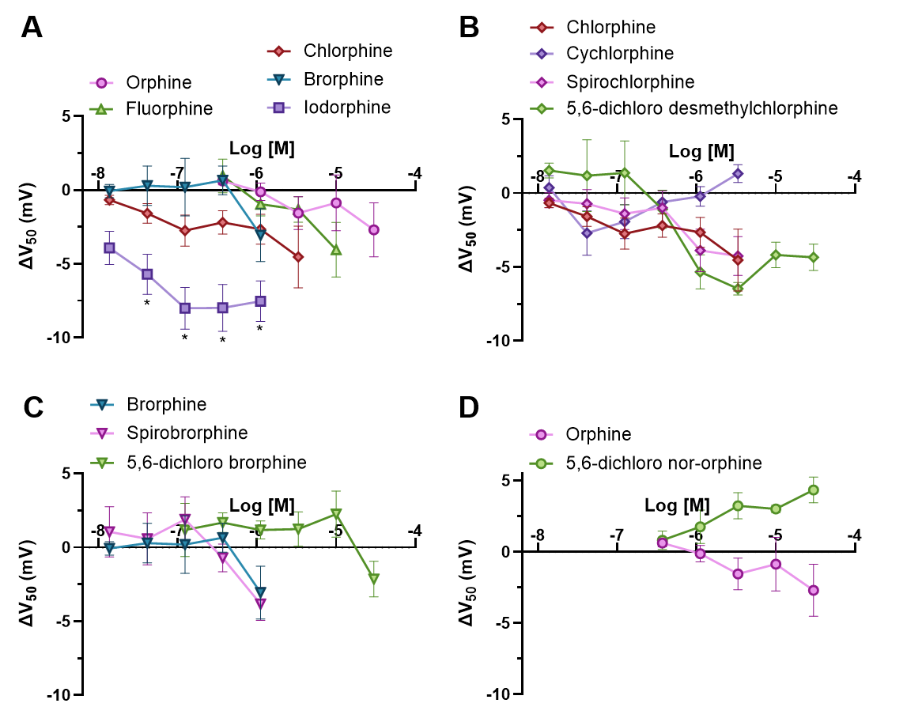
Figure S3.1. Voltage dependence (ΔV₅₀) effect of 11 orphines on hERG channel. Concentration-response relationships for ΔV₅₀ effect for (A) halogen-substituted analogs of orphine; (B) chlorphine analogs; (C) brorphine analogs; and (D) 5,6-dichloro nor-orphine, where n ≥ 5 for all orphines. The ΔV₅₀ was not included for concentrations where the average G_{max} (rel.) was less than 0.2. Error bars indicate SEM. *indicates that the ΔV₅₀ is significantly different (mixed effects model, α = 0.05) from that of the vehicle (0.3% DMSO).

Table S3.1. Comparison of hERG voltage dependence (ΔV₅₀) between orphines and run-specific vehicle (0.3% DMSO) controls. The mean difference (MD) is provided alongside the P values from a mixed effects model (full model fitted; assumed equal variability of differences) followed by Dunnett’s multiple comparisons test (α = 0.05). The ΔV₅₀ was not included for concentrations where the average G_{max} (rel.) was less than 0.2.
Compound | 13.7 nM |  | 41.2 nM |  | 123 nM |  | 370 nM |  | 1.11 µM |  | 3.33 µM |  | 10 µM |  | 30 µM
Compound | MD | P | MD | P | MD | P | MD | P | MD | P | MD | P | MD | P | MD | P
Orphine | - | - | - | - | - | - | -0.62 | >0.99 | 0.12 | >0.99 | 1.6 | >0.99 | 0.87 | >0.99 | - | -
Fluorphine | - | - | - | - | - | - | -1.1 | >0.99 | 0.77 | >0.99 | 1.3 | >0.99 | 4.0 | >0.99 | - | -
Chlorphine | 0.67 | >0.99 | 1.6 | 0.90 | 2.74 | 0.51 | 0.65 | >0.99 | 4.5 | >0.99 | - | - | - | - | - | -
Brorphine | 0.065 | >0.99 | -0.29 | >0.99 | 0.068 | >0.99 | 0.83 | >0.99 | 5.5 | 0.63 | - | - | - | - | - | -
Iodorphine | 3.9 | 0.21 | 5.7 | 0.028 | 8.004 | 0.0007 | 11 | <0.0001 | - | - | - | - | - | - | - | -
5,6-dichloro nor-orphine | - | - | - | - | - | - | -0.97 | >0.99 | -1.9 | >0.99 | -3.2 | >0.99 | -3.0 | >0.99 | -4.3 | >0.99
Cychlorphine | -0.37 | >0.99 | 2.7 | 0.56 | 1.9 | 0.82 | -0.35 | <0.99 | -0.65 | 0.99 | - | - | - | - | - | -
Spirochlorphine | 0.48 | >0.99 | 0.71 | >0.99 | 1.4 | 0.95 | 2.2 | >0.99 | 5.9 | 0.98 | - | - | - | - | - | -
5,6-dichloro desmethylchlorphine | -1.5 | >0.99 | -1.2 | >0.99 | -1.1 | >0.99 | 4.4 | 0.89 | 6.5 | 0.64 | 6.5 | 0.66 | 4.2 | 0.93 | -0.79 | >0.99
Spirobrorphine | -1.1 | >0.99 | -0.58 | >0.99 | -1.6 | >0.99 | 0.12 | >0.99 | - | - | - | - | - | - | - | -
5,6-dichloro brorphine | - | - | - | - | -1.2 | >0.99 | -1.2 | 0.87 | -0.96 | 0.94 | 0.89 | 0.95 | 1.2 | 0.86 | 2.5 | 0.29

SECTION 4
hERG structure-activity relationships statistical analysis results
Table S4.1. Comparison of hERG maximal reduction at 10 µM and potency in channel conductance (G_{max}) between halogen substitutions on the N-benzyl moiety of orphines. P values are from Brown-Forsythe and Welch ANOVA tests.
Structural comparison | Comparisons |  | Max reduction at 10 µM in G_{max} |  |  | Potency (IC₅₀)
Structural comparison | Compound 1 | Compound 2 | Mean Diff | P value | Significant? | Mean Diff | P value | Significant?
H vs F | Orphine | Fluorphine | 0.1100 | 0.1595 | No | 0.2852 | 0.9871 | No
H vs Cl | Orphine | Chlorphine | 0.3150 | 0.0007 | Yes | 0.9545 | 0.0129 | Yes
H vs Br | Orphine | Brorphine | 0.2580 | 0.0005 | Yes | 1.349 | 0.0022 | Yes
H vs I | Orphine | Iodorphine | 0.3180 | 0.0003 | Yes | 1.648 | 0.0006 | Yes
F vs Cl | Fluorphine | Chlorphine | 0.2050 | 0.0065 | Yes | 0.6692 | 0.1968 | No
F vs Br | Fluorphine | Brorphine | 0.1480 | 0.0489 | Yes | 1.064 | 0.0465 | Yes
F vs I | Fluorphine | Iodorphine | 0.2080 | 0.0036 | Yes | 1.363 | 0.0431 | Yes
Cl vs Br | Chlorphine | Brorphine | -0.0570 | 0.6540 | No | 0.3946 | 0.0018 | Yes
Cl vs Br | Spirochlorphine | Spirobrorphine | -0.01500 | 0.0827 | No | 0.2449 | 0.0047 | Yes
Cl vs I | Chlorphine | Iodorphine | 0.0030 | >0.9999 | No | 0.6935 | <0.0001 | Yes
Br vs I | Brorphine | Iodorphine | 0.0600 | 0.6238 | No | 0.2990 | 0.0118 | Yes

Table S4.2. Comparison of hERG maximal reduction at 10 µM and potency in channel conductance (G_{max}) between the other structural analogs of orphines. P values are from Brown-Forsythe and Welch ANOVA tests.
Comparisons |  | Max reduction at 10 µM in G_{max} |  |  | Potency (IC₅₀)
Compound 1 | Compound 2 | Mean Diff | P value | Significant? | Mean Diff | P value | Significant?
Orphine | 5,6-dichloro nor-orphine | -0.5720 | <0.0001 | Yes | - | - | -
Chlorphine | Spirochlorphine | 0.01700 | 0.1361 | No | 0.08663 | 0.8339 | No
Brorphine | Spirobrorphine | 0.05900 | 0.3029 | No | -0.06308 | 0.7513 | No
Chlorphine | Cychlorphine | -0.00800 | 0.8801 | No | -0.06679 | 0.9038 | No
Chlorphine | 5,6-dichloro desmethylchlorphine | -0.2730 | 0.0562 | No | 0.3403 | 0.1110 | No
Brorphine | 5,6-dichloro brorphine | -0.7700 | <0.0001 | Yes | - | - | -

SECTION 5
In silico hERG molecular docking
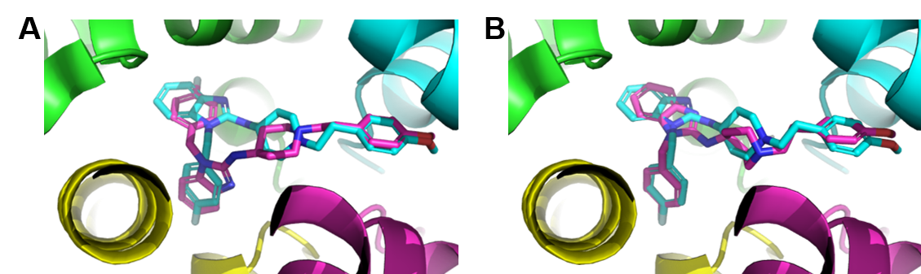
Figure S5.1. Overlays of hERG-bound astemizole as determined by cryo-EM (8ZYO.pdb, magenta sticks) and best-scoring GNINA CNN docking poses (cyan sticks) obtained with (A) astemizole_Model_1 and (B) astemizole_Model_2. hERG protein chains are rendered as cartoons and color-coded as follows: A, green; B, cyan; C, magenta; D, yellow.

Table S5.1. GNINA CNN_VS docking scores obtained for the ligands using astemizole_Model_1 and astemizole_Model_2 for molecular docking. For the chiral molecules (marked *), the values obtained for the individual enantiomers were averaged. hERG pIC₅₀ values were derived from IC₅₀ values reported in Table 2.
Compound | CNN_VS docking score |  | hERG pIC₅₀
Compound | Astemizole_Model_1 | Astemizole_Model_2 | hERG pIC₅₀
Astemizole | 8.43 | 8.32 | ND
Orphine* | 4.11 | 4.35 | 5.26
Fluorphine* | 4.94 | 4.46 | 5.55
Chlorphine* | 4.90 | 4.91 | 6.22
Brorphine* | 5.24 | 5.49 | 6.61
Iodorphine* | 5.43 | 5.52 | 6.91
Spirochlorphine (R6890)* | 6.40 | 6.38 | 6.30
Spirobrorphine* | 6.57 | 6.40 | 6.55
5,6-Dichloro nor-orphine | 5.14 | 5.10 | ND
Cychlorphine (N-propionitrile chlorphine)* | 6.40 | 6.35 | 6.15
5,6-Dichloro brorphine* | 5.93 | 6.03 | ND
5,6-Dichloro desmethylchlorphine (SR-17018) | 6.73 | 6.55 | 7.00
Abbreviations: ND, not determined

Table S5.2. Raw docking scores and post-processing parameters of the GNINA docking poses obtained for the 11 orphines included in this study. Astemizole was included as an internal benchmark. minimizedAffinity: VINA score; CNNscore: GNINA predicted probability that the pose is good (<2 Å from correct); CNNaffinity: GNINA binding affinity prediction in pK units; CNN_VS: CNNaffinity*CNN_score; CNNaffinity_variance: uncertainty or confidence interval associated with the predicted binding affinity; MCS_RMSD: maximum common substructure root means square deviation between docking pose and reference ligand (Å); Shape_Sim: RDKit shape similarity between docking pose and reference ligand; Ref_Sim: RDKit ECFP2 Tanimoto similarity between docking pose and reference ligand; PB_Flags: PoseBusters flags for docking pose; PLIF_Sim: ProLIF protein-ligand interaction fingerprint similarity between docking pose and reference ligand.
Compound | minimizedAffinity | CNNscore | CNNaffinity | CNN_VS | CNNaffinity_variance | MCS_RMSD | Shape_Sim | Ref_Sim | PB_Flags | PLIF_Sim
Astemizole | -12.80 | 0.95 | 8.78 | 8.32 | 0.09 | 1.27 | 0.68 | 1.00 | 0.00 | 0.39
(R)-Orphine | -9.85 | 0.64 | 7.20 | 4.64 | 0.20 | 9.62 | 0.34 | 0.21 | 1.00 | 0.40
(S)-Orphine | -9.27 | 0.56 | 7.18 | 4.05 | 0.46 | 5.51 | 0.35 | 0.21 | 0.00 | 0.35
(R)-Fluorphine | -10.44 | 0.72 | 7.46 | 5.35 | 0.17 | 9.33 | 0.35 | 0.26 | 1.00 | 0.32
(S)-Fluorphine | -10.92 | 0.49 | 7.28 | 3.56 | 0.21 | 5.06 | 0.43 | 0.26 | 0.00 | 0.24
(R)-Chlorphine | 7.42 | 0.66 | 6.99 | 4.62 | 0.64 | 6.93 | 0.29 | 0.20 | 1.00 | 0.28
(S)-Chlorphine | -9.61 | 0.69 | 7.55 | 5.20 | 0.44 | 5.48 | 0.37 | 0.20 | 0.00 | 0.35
(R)-Brorphine | -6.90 | 0.70 | 7.62 | 5.36 | 0.43 | 6.58 | 0.30 | 0.20 | 0.00 | 0.35
(S)-Brorphine | -9.42 | 0.74 | 7.61 | 5.61 | 0.44 | 5.55 | 0.36 | 0.20 | 0.00 | 0.33
(R)-Iodorphine | -9.97 | 0.71 | 7.63 | 5.39 | 0.20 | 7.64 | 0.43 | 0.20 | 0.00 | 0.38
(S)-Iodorphine | -9.13 | 0.74 | 7.64 | 5.65 | 0.35 | 5.62 | 0.37 | 0.20 | 0.00 | 0.33
(R)-Spirobrorphine | -9.75 | 0.89 | 7.77 | 6.94 | 0.13 | 6.07 | 0.38 | 0.14 | 1.00 | 0.28
(S)-Spirobrorphine | -8.94 | 0.79 | 7.45 | 5.86 | 0.08 | 4.80 | 0.37 | 0.14 | 0.00 | 0.19
(R)-Spirochlorphine | -9.75 | 0.89 | 7.73 | 6.86 | 0.12 | 5.98 | 0.38 | 0.14 | 1.00 | 0.24
(S)-Spirochlorphine | -7.14 | 0.78 | 7.59 | 5.91 | 0.24 | 8.48 | 0.29 | 0.14 | 1.00 | 0.21
5,6-Dichloro nor-orphine | -8.71 | 0.75 | 6.78 | 5.10 | 0.27 | 2.66 | 0.30 | 0.13 | 0.00 | 0.25
(R)-Cychlorphine | -9.41 | 0.80 | 8.09 | 6.48 | 0.18 | 6.21 | 0.32 | 0.22 | 0.00 | 0.25
(S)-Cychlorphine | -9.54 | 0.77 | 8.04 | 6.21 | 0.15 | 5.18 | 0.43 | 0.22 | 0.00 | 0.20
(R)-5,6-Dichloro brorphine | -9.84 | 0.72 | 8.05 | 5.82 | 0.08 | 8.28 | 0.39 | 0.17 | 1.00 | 0.40
(S)-5,6-Dichloro brorphine | -11.21 | 0.75 | 8.30 | 6.23 | 0.12 | 8.90 | 0.40 | 0.17 | 1.00 | 0.39
5,6-Dichloro desmethylchlorphine | -11.17 | 0.81 | 8.07 | 6.55 | 0.07 | 9.06 | 0.40 | 0.23 | 1.00 | 0.42

SECTION 6
K_{V}7.1/KCNE1 maximal conductance (G_{max}) and voltage dependence (ΔV₅₀) data for all orphines
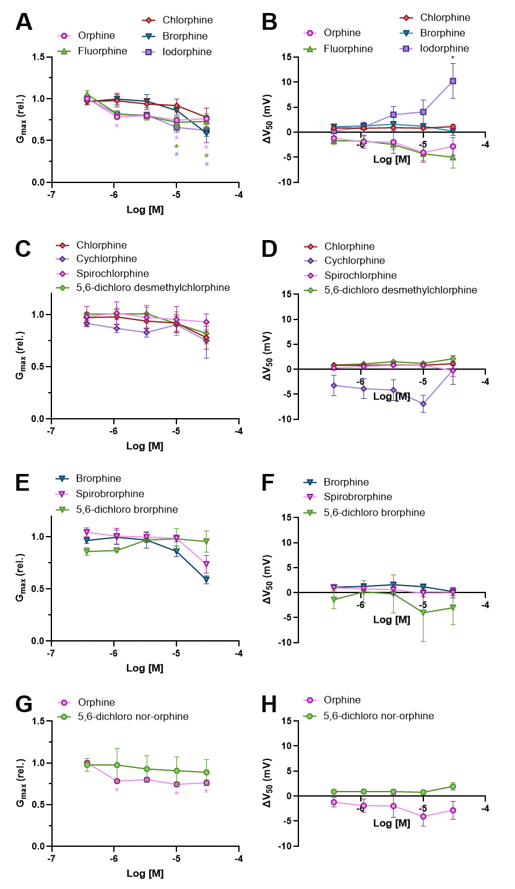
Figure S6.1. Maximal channel conductance (G_{max}) and voltage dependence (ΔV₅₀) of 11 orphines on K_{V}7.1/KCNE1 channel. (A, C, E, G) Concentration-response curves for G_{max} of (A) halogen-substituted analogs of orphine; (C) chlorphine analogs; (E) brorphine analogs; and (G) 5,6-dichloro nor-orphine. Nonlinear regressions could not be calculated for 5,6-dichloro brorphine and 5,6-dichloro nor-orphine as they did not reach saturation, so no curve is shown. *indicates that the G_{max} or ΔV₅₀ is significantly different (mixed effects model, α = 0.05) from that of the vehicle (0.3% DMSO). Error bars indicate standard error to the mean (SEM) and n ≥ 5.
Table S6.1. Comparison of K_{V}7.1/KCNE1 maximal channel conductance (G_{max}) between orphines and run-specific vehicle (0.3% DMSO) controls. The mean difference (MD) is provided alongside the P values from a mixed effects model (full model fitted; assumed equal variability of differences) followed by Dunnett’s multiple comparisons test (α = 0.05).
Compound | 370 nM |  | 1.11 µM |  | 3.33 µM |  | 10 µM |  | 30 µM
Compound | MD | P | MD | P | MD | P | MD | P | MD | P
Orphine | -0.0021 | >0.99 | 0.22 | 0.029 | 0.19 | 0.080 | 0.25 | 0.0077 | 0.24 | 0.015
Fluorphine | -0.053 | 0.89 | 0.18 | 0.096 | 0.20 | 0.062 | 0.28 | 0.0028 | 0.27 | 0.0056
Chlorphine | 0.029 | >0.99 | 0.023 | >0.99 | 0.061 | >0.99 | 0.079 | 0.99 | 0.22 | 0.33
Brorphine | 0.035 | >0.99 | -7.8e-5 | >0.99 | 0.027 | >0.99 | 0.14 | 0.86 | 0.41 | 0.0020
Iodorphine | -0.0040 | >0.99 | 0.19 | 0.057 | 0.18 | 0.088 | 0.34 | <0.0001 | 0.39 | <0.0001
5,6-dichloro nor-orphine | 0.022 | >0.99 | 0.022 | >0.99 | 0.071 | >0.99 | 0.093 | 0.99 | 0.13 | 0.94
Cychlorphine | 0.13 | 0.52 | 0.16 | 0.39 | 0.075 | 0.91 | 0.21 | 0.16 | 0.13 | 0.64
Spirochlorphine | 0.020 | >0.99 | -0.014 | >0.99 | 0.025 | >0.99 | 0.046 | >0.99 | 0.094 | 0.98
5,6-dichloro desmethylchlorphine | -0.0046 | >0.99 | -0.0030 | >0.99 | -0.0033 | >0.99 | 0.090 | 0.98 | 0.18 | 0.54
Spirobrorphine | -0.045 | >0.99 | -0.32 | 0.055 | -0.28 | 0.13 | -0.26 | 0.18 | -0.016 | >0.99
5,6-dichloro brorphine | 0.12 | 0.53 | 0.017 | >0.99 | -0.0017 | >0.99 | 0.037 | >0.99 | 0.058 | 0.98

Table S6.2. Comparison of K_{V}7.1/KCNE1 voltage dependence (ΔV₅₀) between orphines and run-specific vehicle (0.3% DMSO) controls. The mean difference (MD) is provided alongside the P values from a mixed effects model (full model fitted; assumed equal variability of differences) followed by Dunnett’s multiple comparisons test (α = 0.05).
Compound | 370 nM |  | 1.11 µM |  | 3.33 µM |  | 10 µM |  | 30 µM
Compound | MD | P | MD | P | MD | P | MD | P | MD | P
Orphine | 1.4 | 0.93 | 1.9 | 0.84 | 2.0 | 0.82 | 4.1 | 0.26 | 3.0 | 0.56
Fluorphine | 1.9 | 0.83 | 1.7 | 0.87 | 2.4 | 0.69 | 4.3 | 0.22 | 4.9 | 0.15
Chlorphine | 0.24 | >0.99 | 0.19 | >0.99 | 0.099 | >0.99 | 0.17 | >0.99 | -0.14 | >0.99
Brorphine | -0.099 | >0.99 | -0.26 | >0.99 | -0.58 | 0.96 | -0.19 | >0.99 | 0.79 | 0.84
Iodorphine | -0.0057 | >0.99 | -1.0 | 0.97 | -3.2 | 0.43 | -5.1 | 0.22 | -10.3 | 0.0003
5,6-dichloro nor-orphine | 0.097 | >0.99 | 0.015 | >0.99 | 0.092 | >0.99 | 0.23 | >0.99 | -0.92 | 0.83
Cychlorphine | 3.9 | 0.56 | 4.1 | 0.51 | 6.6 | 0.13 | -0.090 | >0.99 | 5.0 | 0.38
Spirochlorphine | 0.71 | 0.86 | 0.43 | 0.99 | 0.17 | >0.99 | 0.18 | >0.99 | 1.2 | 0.38
5,6-dichloro desmethylchlorphine | 0.16 | >0.99 | -0.066 | >0.99 | -0.57 | 0.97 | -0.22 | >0.99 | -1.2 | 0.39
Spirobrorphine | 0.0030 | >0.99 | 0.21 | >0.99 | 0.38 | >0.99 | 1.1 | 0.56 | 1.0 | 0.64
5,6-dichloro brorphine | -0.18 | >0.99 | 0.22 | >0.99 | 3.4 | 0.79 | 3.0 | 0.84 | 1.8 | 0.98

