Supplementary Material
Integrated Optimization of Yellow Lentil Protein Recovery by Alkaline Extraction and Isoelectric Precipitation: Process Efficiency, Nutritional Quality, and Techno-Functional Properties
Food and Bioprocess Technology
Lisa Ziegltrum ^{1,}*, Sara Cutroneo ², Tullia Tedeschi ², Ute Schweiggert-Weisz ^{3,4}, Özlem Özmutlu Karslioglu ¹
¹ Institute of Food Technology, Weihenstephan-Triesdorf University of Applied Sciences, Am Staudengarten 11, 85354 Freising, Germany
² Department of Food and Drug, University of Parma, Parco Area Delle Scienze 17/A, 43124 Parma, Italy
³ Plant Proteins and Nutrition, Technical University of Munich, Weihenstephaner Berg 1, 85354 Freising, Germany
⁴ Fraunhofer Institute for Process Engineering and Packaging (IVV), Giggenhauser Straße 35, 85354 Freising, Germany
* Correspondence: lisa.ziegltrum@hswt.de

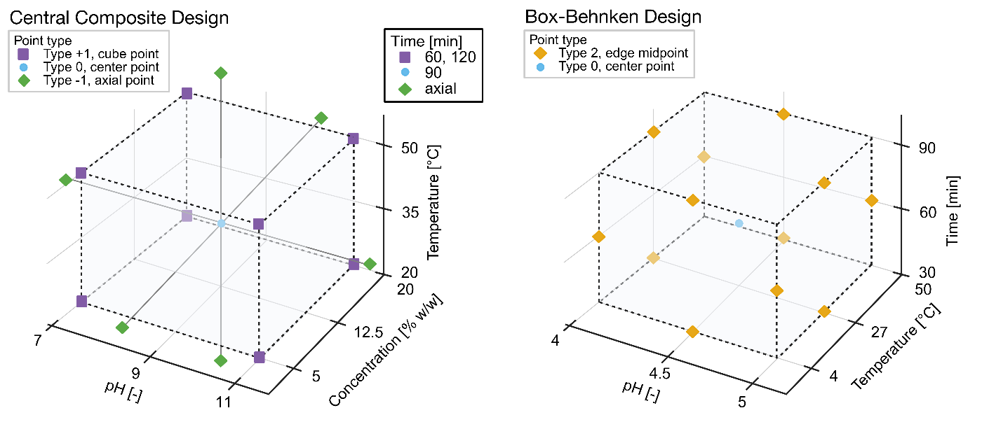
Figure S1 Factor levels (minimum, maximum, center, and axial values) of the central composite design for optimizing alkaline extraction and factor levels (minimum, maximum, and center values) of the Box-Behnken design for optimizing isoelectric precipitation. Created in BioRender. Ziegltrum, L. (2026) https://BioRender.com/kocvr0o

Table S1 Central composite design experimental plan with responses and predicted values for protein yield from alkaline extraction

Runs 29-31 were carried out as additional experiments and incorporated into the final model. In the course of model refinement, however, three star-point runs were excluded because they were marked as unusual observations and produced a significant lack-of-fit (p < 0.05). These points corresponded to the most extreme factor levels (pH 12 and temperatures of 5 °C and 65 °C). As such extreme conditions are not relevant for practical application, their removal was deemed appropriate and did not compromise the validity of the model.
Runs | pH | Concentration | Temperature | Time | Protein yield [%]
 |  | [%w/w] | [°C] | [min] | Experimental | Predicted
1 | 7 | 5 | 20 | 60 | 92.30±0.59 ^{a,b,c,d} | 89.13
2 | 11 | 5 | 20 | 60 | 91.46±0.71 ^{b,c,d,e} | 92.57
3 | 7 | 20 | 20 | 60 | 83.28±2.03 ^{j,k} | 84.33
4 | 11 | 20 | 20 | 60 | 84.66±1.39 ^{h,i,j,k} | 83.86
5 | 7 | 5 | 50 | 60 | 90.16±0.68 ^{b,c,d,e,f} | 91.78
6 | 11 | 5 | 50 | 60 | 96.49±1.79 ª | 95.22
7 | 7 | 20 | 50 | 60 | 84.70±1.17 ^{h,i,j,k} | 83.61
8 | 11 | 20 | 50 | 60 | 84.21±0.66 ^{i,j,k} | 83.14
9 | 7 | 5 | 20 | 120 | 90.48±1.59 ^{b,c,d,e} | 91.38
10 | 11 | 5 | 20 | 120 | 94.85±0.90 ^{a,b} | 94.82
11 | 7 | 20 | 20 | 120 | 85.19±0.99 ^{g,h,i,j,k} | 86.57
12 | 11 | 20 | 20 | 120 | 86.99±0.24 ^{e,f,g,h,i,j} | 86.10
13 | 7 | 5 | 50 | 120 | 89.30±0.55 ^{d,e,f,g,h} | 89.31
14 | 11 | 5 | 50 | 120 | 94.30±0.60 ^{a,b,c} | 92.75
15 | 7 | 20 | 50 | 120 | 81.20±2.56 ^{k,l} | 81.15
16 | 11 | 20 | 50 | 120 | 77.73±1.02 ^{l,m} | 80.67
17 | 5 | 12.5 | 35 | 90 | 19.19±0.58 º | 22.14
18 | 9 | 0.5 | 35 | 90 | 88.75±1.48 ^{d,e,f,g,h,i} | 91.64
19 | 9 | 27.5 | 35 | 90 | 75.34±1.10 ^{m} | 75.34
20 | 9 | 12.5 | 35 | 30 | 88.18±2.93 ^{d,e,f,g,h,i} | 89.72
21 | 9 | 12.5 | 35 | 150 | 91.14±1.29 ^{b,c,d,e} | 89.50
22 | 9 | 12.5 | 35 | 90 | 86.74±2.30 ^{e,f,g,h,i,j} | 86.87
23 | 9 | 12.5 | 35 | 90 | 82.81±1.58 ^{j,k} | 86.87
24 | 9 | 12.5 | 35 | 90 | 85.43±1.78 ^{f,g,h,i,j,k} | 86.87
25 | 9 | 12.5 | 35 | 90 | 84.54±2.08 ^{h,i,j,k} | 86.87
26 | 9 | 12.5 | 35 | 90 | 87.51±2.64 ^{e,f,g,h,i,j} | 86.87
27 | 9 | 12.5 | 35 | 90 | 84.73±1.45 ^{h,i,j,k} | 86.87
28 | 9 | 12.5 | 35 | 90 | 89.65±0.56 ^{c,d,e,f,g} | 86.87
29 | 9 | 5 | 35 | 90 | 94.62±0.63 ^{a,b} | 90.32
30 | 9 | 20 | 35 | 90 | 85.39±0.48 ^{g,h,i,j,k} | 81.87
31 | 6 | 12.5 | 35 | 90 | 55.50±1.80 ^{n} | 50.18

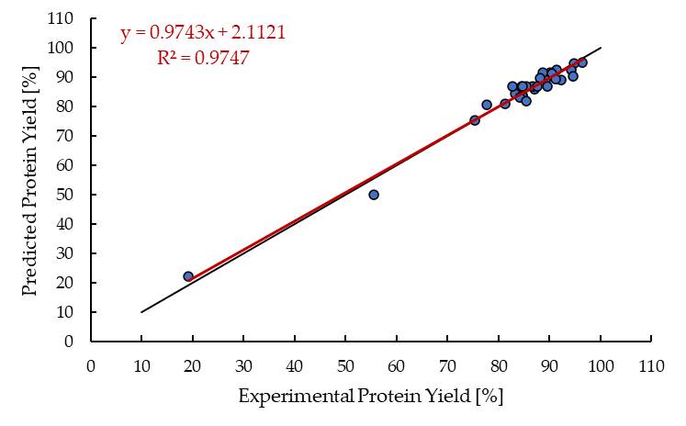
Figure S2 Comparison between predicted and experimental protein yield [%] of alkaline extraction; black: 1:1 line, red: regression line; Mean Absolute Error (MAE) = 2.09%, Root Mean Squared Error (RMSE) = 2.70%, Bias = 0.05%

Table S2 Box-Behnken design experimental plan with responses and predicted values for protein yield from isoelectric precipitation
Runs | pH | Temperature | Time | Protein yield [%]
 |  | [°C] | [min] | Experimental | Predicted
1 | 5 | 4 | 60 | 69.43±1.25 ^{b,c} | 74.53
2 | 4.5 | 50 | 90 | 74.29±2.56 ª | 62.61
3 | 4.5 | 27 | 60 | 70.47±1.34 ^{a,b,c} | 65.16
4 | 4.5 | 27 | 60 | 67.24±0.48 ^{b,c,d,e,f} | 65.16
5 | 5 | 27 | 90 | 68.99±1.15 ^{b,c,d} | 68.74
6 | 5 | 27 | 30 | 71.88±0.94 ^{a,b} | 70.77
7 | 4.5 | 4 | 30 | 68.18±2.83 ^{b,c,d,e} | 66.98
8 | 4 | 27 | 30 | 68.62±1.48 ^{b,c,d} | 69.53
9 | 4.5 | 50 | 30 | 69.13±1.88 ^{b,c} | 68.53
10 | 4 | 50 | 60 | 63.20±1.86 ^{f} | 70.95
11 | 4 | 27 | 90 | 66.06±1.06 ^{c,d,e,f} | 67.49
12 | 4.5 | 27 | 60 | 64.40±0.97 ^{d,e,f} | 65.16
13 | 5 | 50 | 60 | 63.61±0.88 ^{e,f} | 68.15

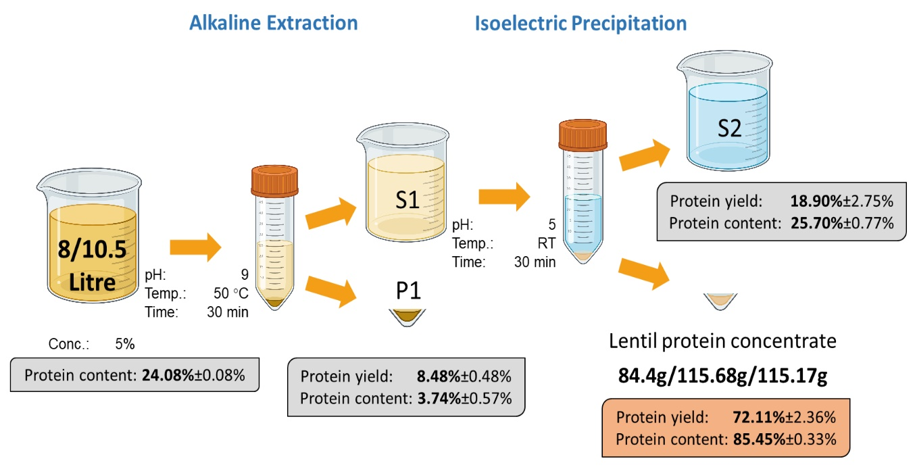
Figure S3 Mass balance across the lentil protein extraction process, including protein contents and protein yield losses during alkaline extraction and isoelectric precipitation. Values are presented as mean ± standard deviation (n = 3). Created in BioRender. Ziegltrum, L. (2026) https://BioRender.com/je1t759
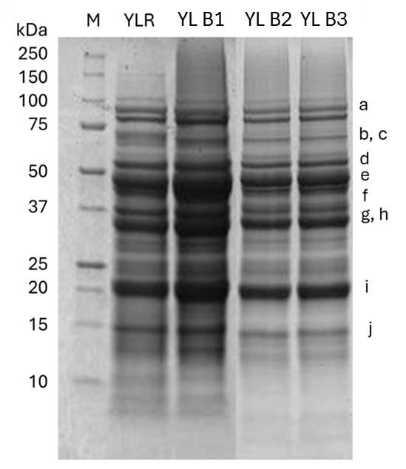 | Band | MW (kDa) | Description
 | a | 95 | Linoleate 9S-lipoxygenase¹
 | b | 66 | Seed-specific biotinylated protein²
 | c | 63 | Convicilin subunit^{1,3,4}
 | d | 50 | Vicilin subunits^{3,4}
 | e | 48 | Vicilin²
 | f | 40 | Legumin-acidic subunit^{1,3}
 | g | 37 | IgE-binding protein²
 | h | 33 | Major vicilin subunit¹
 | i | 20 | Legumin-basic subunit^{1,3}
 | j | 15 | Minor vicilin subunit¹

Table S3 Protein profile of yellow lentil extracts (YL B1-3) compared to the raw sample (YLR). M: molecular marker and Protein putative attribution for comparison with the literature (¹Shrestha et al. (2024), ²Valdelvira et al. (2022), ³Jamirul Ashad Zehadi (2015), ⁴Barbana and Boye (2013), organism: Lens Culinaris)
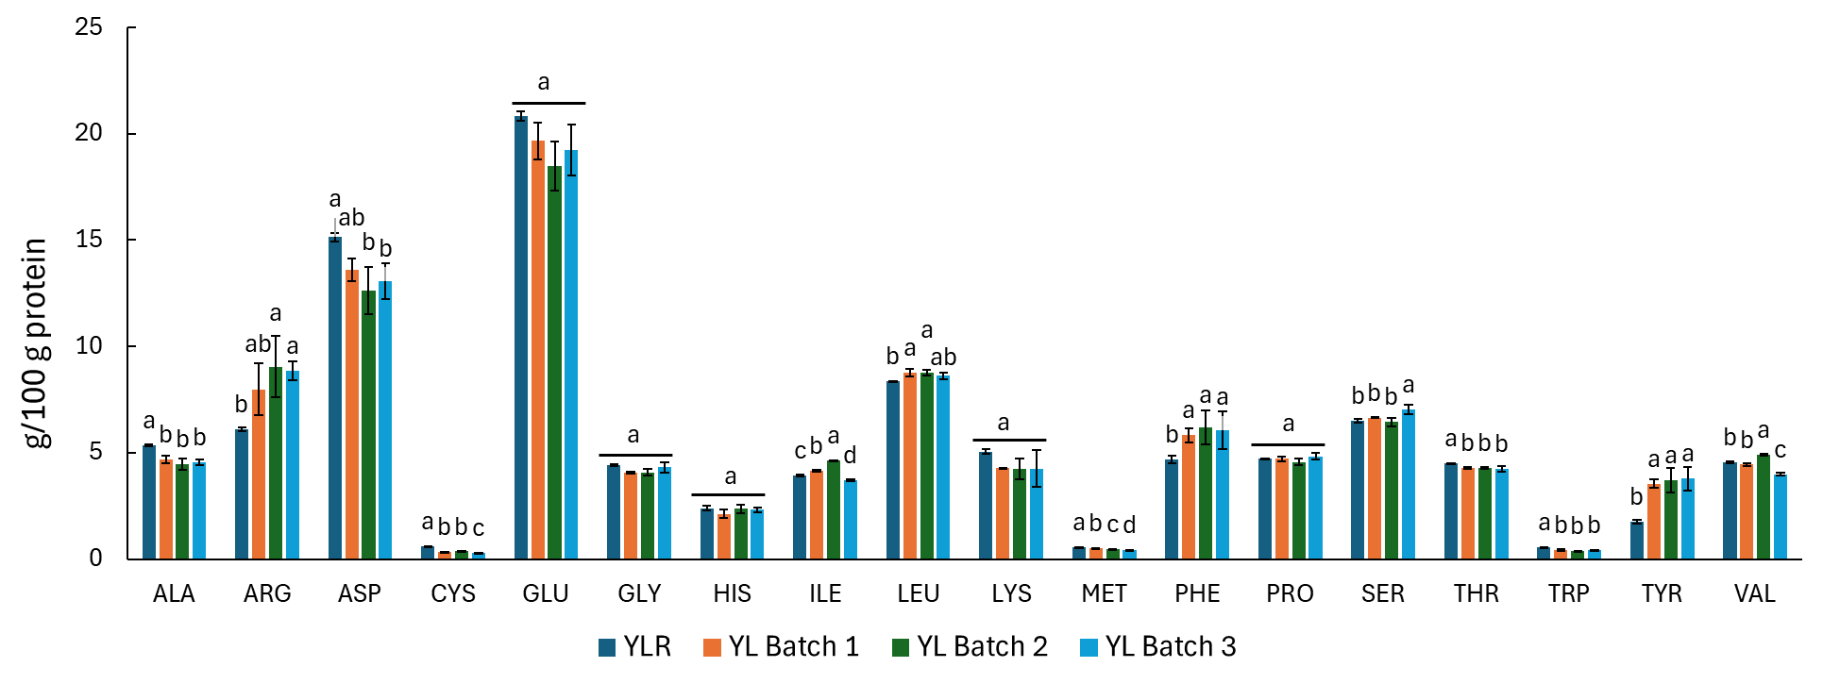
Figure S4 Amino acid profile of samples, expressed as g per 100 g of protein. Letters on bars refer to differences between samples
Table S4 Amino acid score (AAS) calculated according to FAO (2011), indispensable amino acid requirements for children (3-18 years) and adults. Values below 1 are underlined, and the first limiting amino acid is highlighted in bold
Amino acid score
Children (3- 18) | His | Ile | Leu | Lys | SAA | AAA | Thr | Trp | Val
YLR | 1.50 | 1.31 | 1.37 | 1.05 | 0.49 | 1.57 | 1.80 | 0.81 | 1.14
YL Batch 1 | 1.33 | 1.39 | 1.44 | 0.89 | 0.36 | 2.28 | 1.71 | 0.58 | 1.11
YL Batch 2 | 1.48 | 1.54 | 1.44 | 0.89 | 0.35 | 2.41 | 1.71 | 0.52 | 1.23
YL Batch 3 | 1.44 | 1.23 | 1.41 | 0.88 | 0.31 | 2.40 | 1.70 | 0.58 | 1.00
Adults | His | Ile | Leu | Lys | SAA | AAA | Thr | Trp | Val
YLR | 1.60 | 1.31 | 1.42 | 1.12 | 0.51 | 1.69 | 1.96 | 0.94 | 1.17
YL Batch 1 | 1.42 | 1.39 | 1.49 | 0.95 | 0.38 | 2.46 | 1.86 | 0.68 | 1.14
YL Batch 2 | 1.58 | 1.54 | 1.49 | 0.95 | 0.37 | 2.60 | 1.86 | 0.60 | 1.26
YL Batch 3 | 1.54 | 1.23 | 1.46 | 0.94 | 0.32 | 2.59 | 1.85 | 0.68 | 1.02

