Arginine tuning of coiled-coil peptides yields single-domain nanocrystals
Patrick Roth^{+,1,2}, Iain Harley^{+,1,3}, Marco Santucci⁴, Katherine I. Albanese^{5,6}, Zahra Riazimand¹, Ingo Lieberwirth¹, Ute Kolb⁴, David Y. W. Ng^{1,2}, Katharina Landfester^{1*}, Thomas H. Sharp^{7*}, Tanja Weil^{1,2*}, Derek N. Woolfson^{2,5,7,8*}

⁺P. Roth and I. Harley contributed equally to this work.
*Corresponding author
¹Max Planck Institute for Polymer Research, 55128 Mainz, Germany
²Max Planck-Bristol Centre for Minimal Biology, University of Bristol, Bristol, UK
³MRC-University of Glasgow Centre for Virus Research, Glasgow, UK
⁴Institute for Inorganic Chemistry and Analytical Chemistry, Johannes Gutenberg-University, 55128 Mainz, Germany.
⁵ School of Chemistry, University of Bristol, Bristol, UK
⁶Department of Chemistry, Wake Forest University, North Carolina, USA
⁷School of Biochemistry, University of Bristol, Bristol, UK
⁸NNF Center for Protein Design, University of Copenhagen, Copenhagen, DK

1. Materials and Instruments

1.1 Materials

All chemicals were purchased from commercial sources and were used without further purification. Solvents and reagents used for peptide synthesis were obtained in peptide grade. Purification with HPLC was performed with water obtained from a Millipore purification system and HPLC grade acetonitrile.

1.2 Instruments

1.2.1 Microwave Peptide Synthesizer

Peptides were synthesized with a Liberty Blue Automated Microwave Peptide Synthesizer by CEM Corporation.

1.2.2 High-Performance Liquid Chromatography (HPLC)

The synthesized peptides were purified by preparative HPLC using a Shimadzu setup. A YMC-Actus Triart C18 column (150 x 20 mm, 5 µm, 180 Å) with a flowrate of 20 mL/min and a Phenomenex Jupiter C18 column (250 x 10 mm, 5 µm, 300 Å) with a flowrate of 4 mL/min were used for purification.
All purification steps were performed by using gradients of MilliQ water and acetonitrile, each acidified with 0.1% formic acid or 0.1% trifluoracetic acid. The HPLC data were processed with the software LabSolutions by Shimadzu and OriginPro 2019b by OriginLab.

1.2.3 Circular Dichroism Spectroscopy (CD)

CD spectra of the peptides were recorded on a JASCO J-1500 spectrometer in a 0.1 cm High Precision Cell by HellmaAnalytics. The recorded data were processed in Spectra Analysis by JASCO and OriginPro 2019b by OriginLab.

1.2.4 Dynamic Light Scattering (DLS)

Light scattering measurements were performed on an ALV spectrometer consisting of a goniometer and an ALV-5004 multiple-tau full-digital correlator (320 channels) which allows measurements over an angular range from 30° to 150°. A He-Ne Laser (wavelength of 632.8 nm) is used as light source.

1.2.5 Cryogenic electron microscopy

All Cryo-EM experiments were prepared using a Thermo Scientific Vitrobot IV and imaged in a Titan Krios G4. Images were captured on a Gatan K3 direct detector and GIF except for the 3D ED data which was imaged with a Thermo Scientific Ceta detector in the same microscope.

2.1 Peptide Synthesis

The Rink Amide AM resin (0.1 mmol) was swollen in 2 mL DMF at room temperature for 1 h before transferring it into the peptide synthesizer. DMF was removed via a draining process and the resin swollen with 20 mL DMF for 20 s. After draining of the DMF, the Fmoc group was removed with 10 mL 20 % v/v piperidine in DMF and a heating cycle at 70°C for 25 s followed by another cycle at 90°C for 65 s. The solution was drained, and the resin washed with DMF three times. After the last washing step, FmocAA-OH (0.2 M in DMF, 10 mL), DIC solution (0.5 M in DMF, 4 mL) and OxymaPure solution (1.0 M in DMF, 2 mL) was added to the resin and the solution heated to 70°C for 30 s followed by a heating cycle to 90°C for 120 s. The solution was drained, the Fmoc group removed as described before and washed with DMF three times. Fmoc-Arg(Pbf)-OH and all amino acids starting from the asparagine between the third and fourth heptad were coupled twice. After the last amino acid, the Fmoc-group was removed with 10 mL 20 % v/v piperidine in DMF and a heating cycle at 70°C for 25 s followed by another cycle at 90°C for 65 s and the resin washed with DMF three times. The peptide was cleaved from the resin by adding 10 mL of cleavage cocktail (95% TFA, 2.5% TIPS, 2.5% MilliQ water) to the resin and shaking at room temperature for 2 h or 5 h for arginine containing peptides. The cleavage cocktail was drained, and the resin washed with TFA. The TFA containing solutions were combined and precipitated in cold diethyl ether. Next, the dispersion was centrifuged (4000 rpm, 0°C, 15 min) and the diethyl ether removed. The crude peptide was redispersed in cold diethyl ether, centrifuged and the diethyl ether removed. After this, the peptides were dried overnight.
The peptides were purified via HPLC with a YMC-Actus Triart C18 column (flowrate 20 mL/min) and a Phenomenex Jupiter C18 column with a flowrate of 4 mL/min.
The gradient for CCNC-R3 and CCNC-R6 started at 20% ACN and was increased to 40% over 15 min. Then the gradient was increased from 40% to 100% ACN within 2 min. The retention time of CCNC-R3 was 15.4 min and 15.8 min for CCNC-R6. The gradient for CCNC-R0 and CCNC-R8 started at 20% ACN and was increased to 40% over 30 min. Then the gradient was increased from 40% to 100% ACN within 2 min. The retention time of CCNC-R0 was 24 min and 24.9 min for CCNC-R8. After lyophilisation, the products were received as colourless solids. The yields of the peptides are listed below:

CCNC-R0: 18.8 mg, 3.8 µmol, 3.8%
CCNC-R3: 25.0 mg, 5 µmol, 10.0%
CCNC-R6: 29.0 mg, 5.7 µmol, 5.7%
CCNC-R8: 8.5 mg, 1.7 µmol, 1.7%

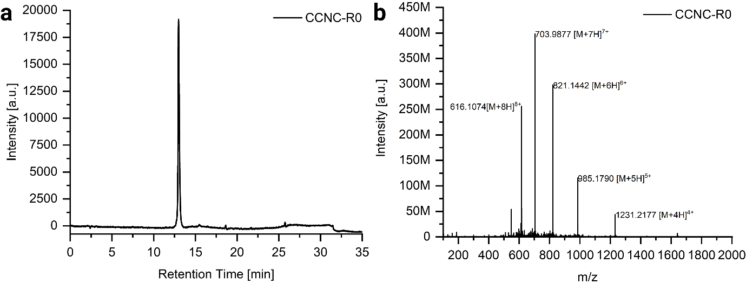
Supplementary Fig. 1: (a) HPLC spectrum of CCNC-R0. (b) HR-ESI MS (positive mode) of CCNC-R0. m/z calculated: [M+4H]⁴⁺ = 1230.4623, [M+5H]⁵⁺ = 985.5713, [M+6H]⁶⁺ = 820.6439, [M+7H]⁷⁺ = 703.5530, [M+8H]⁸⁺ = 615.7300, found: [M+4H]⁴⁺ = 1231.2177, [M+5H]⁵⁺ = 985.1790, [M+6H]⁶⁺ = 821.1442, [M+7H]⁷⁺ = 703.9877, [M+8H]⁸⁺ = 616.1074.

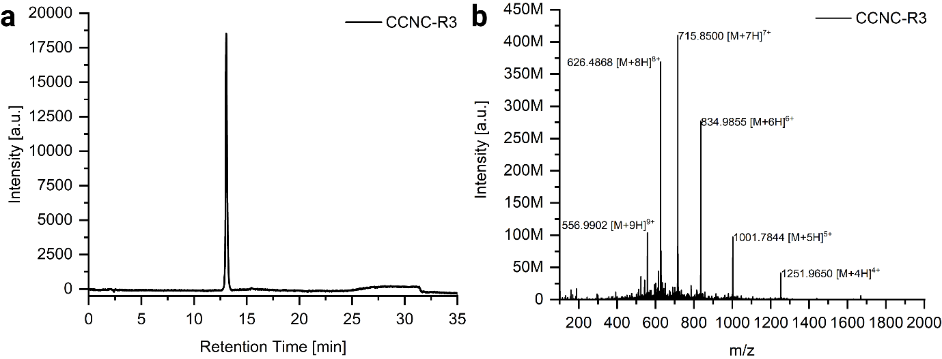
Supplementary Fig. 2: (a) HPLC spectrum of CCNC-R3. (b) HR-ESI MS (positive mode) of CCNC-R3. m/z calculated: [M+4H]⁴⁺ = 1251.4673, [M+5H]⁵⁺ = 1001.3753, [M+6H]⁶⁺ = 834.6473, [M+7H]⁷⁺ = 715.5558, [M+8H]⁸⁺ = 626.2400, [M+9H]⁹⁺ = 556.7700, found: [M+4H]⁴⁺ = 1251.9650, [M+5H]⁵⁺ = 1001.7844, [M+6H]⁶⁺ = 834.9855, [M+7H]⁷⁺ = 715.8500, [M+8H]⁸⁺ = 626.4868, [M+9H]⁹⁺ = 556.9902.

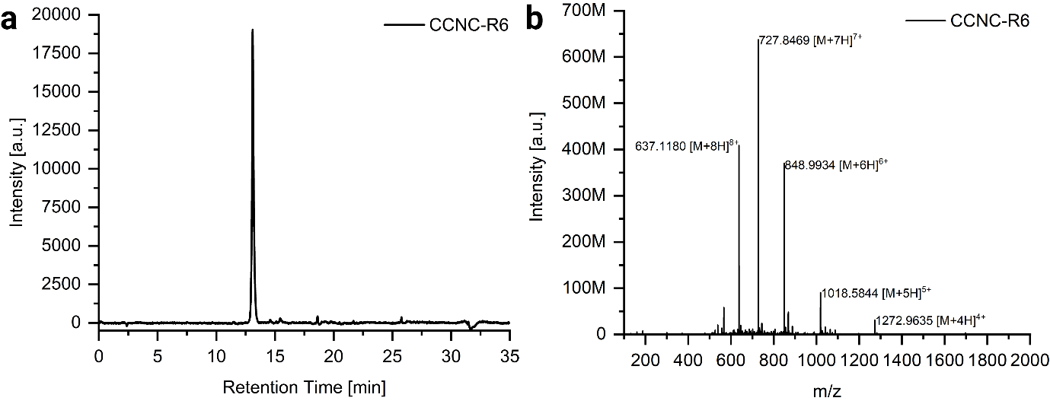
Supplementary Fig. 3: (a) HPLC spectrum of CCNC-R6. (b) HR-ESI MS (positive mode) of CCNC-R6. m/z calculated: [M+4H]⁴⁺ = 1272.4698, [M+5H]⁵⁺ = 1018.1773, [M+6H]⁶⁺ = 848.6489, [M+7H]⁷⁺ = 727.5573, [M+8H]⁸⁺ = 636.7400, found: [M+4H]⁴⁺ = 1272.9635, [M+5H]⁵⁺ = 1018.5844, [M+6H]⁶⁺ = 848.9934, [M+7H]⁷⁺ = 727.8469, [M+8H]⁸⁺ = 637.1180.

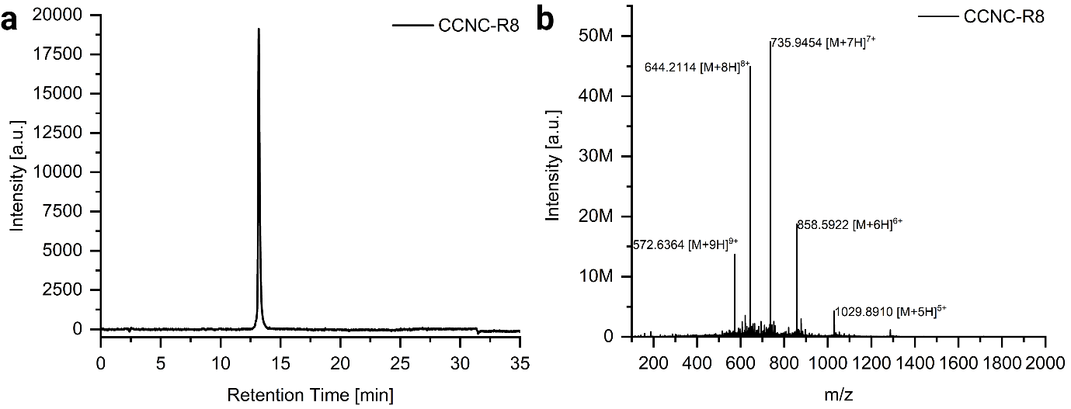

Supplementary Fig. 4: (a) HPLC spectrum of CCNC-R8. (b) HR-ESI MS (positive mode) of CCNC-R8. m/z calculated: [M+5H]⁵⁺ = 1029.3813, [M+6H]⁶⁺ = 857.9856, [M+7H]⁷⁺ = 735.5601, [M+8H]⁸⁺ = 643.7400, [M+9H]⁹⁺ = 572.3300 found: [M+5H]⁵⁺ = 1029.8910, [M+6H]⁶⁺ = 858.5922, [M+7H]⁷⁺ = 735.9454, [M+8H]⁸⁺ = 644.2114, [M+9H]⁹⁺ = 572.6364.

3. Characterization

3.1 CD

3.1.1 CD spectra
Peptides were dissolved in MilliQ water and diluted with DPBS (1x, pH 7.4) in a 1:9 ratio to yield 300 µL of a 25 µM solution. CD spectra were recorded at wavelength from 260 to 180 nm with a bandwidth of 1 nm, data pitch of 0.2 nm and a scanning speed at 20 nm/min at 20 °C or 15 °C.

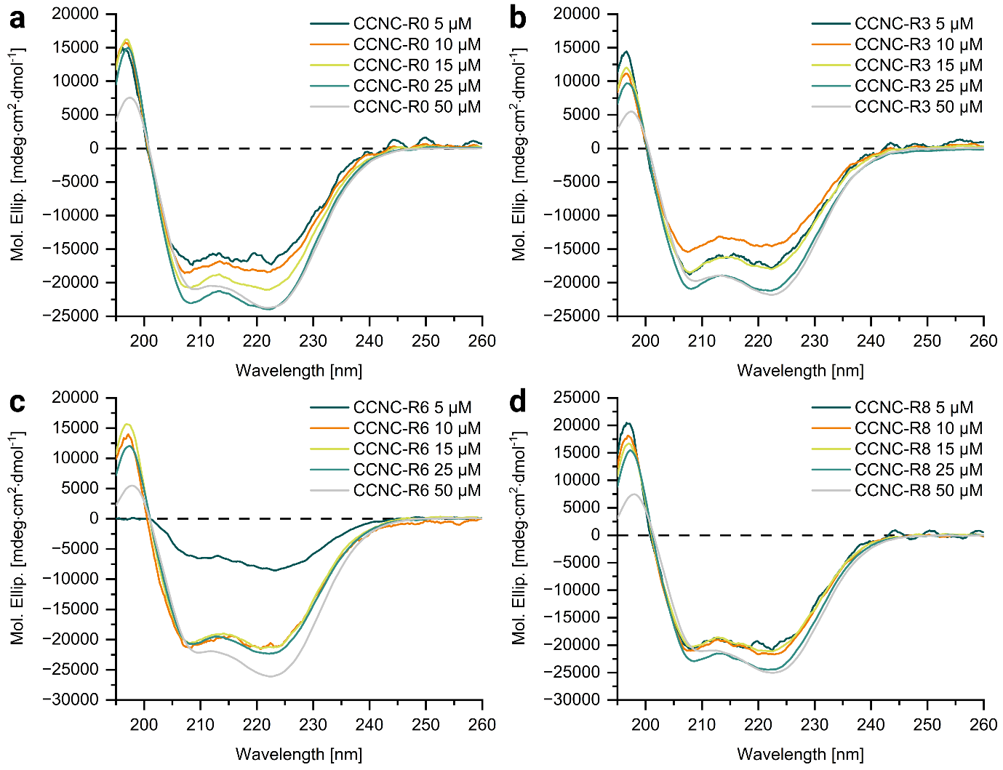
Supplementary Fig. 5: CD spectra of CCNC-R0 (a), CCNC-R3 (b), CCNC-R6 (c) and CCNC-R8 (d) at concentrations of 5, 10, 15, 25 and 50 µM at 15 °C.

3.1.2 Thermal denaturation
Peptides were dissolved in MilliQ water and diluted with DPBS (1x, pH 7.4) in a 1:9 ratio to yield a 25 µM solution. CD spectra were recorded at wavelength of 222 nm with a bandwidth of 1 nm and a data pitch of 0.2 nm at 15-90 °C.

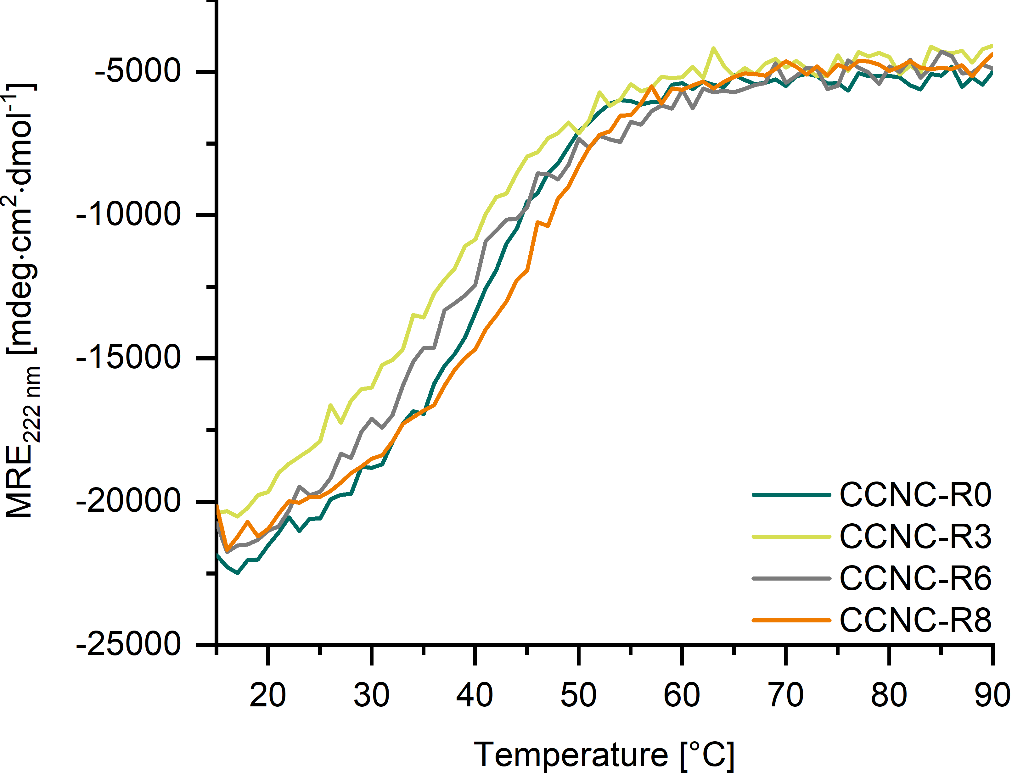
Supplementary Fig. 6: Thermal denaturation curves of CCNC-R0, -R3, -R6 and –R8 at 25 µM.

3.1.3 Assembly Kinetic
Peptides were dissolved in MilliQ water and diluted with DPBS (1x, pH 7.4) in a 1:9 ratio to yield a 25 µM solution. CD spectra were recorded at wavelength from 260 to 180 nm with a bandwidth of 1 nm, data pitch of 0.2 nm and a scanning speed at 20 nm/min at 20 °C over 24 h.

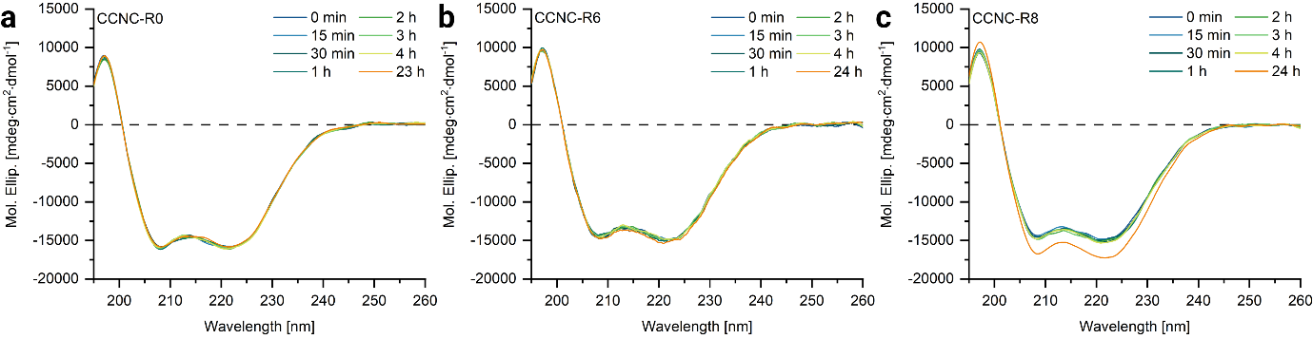
Supplementary Fig. 7: CD assembly kinetics of CCNC-R0 (a), CCNC-R6 (b) and CCNC-R8 (c) at 25 µM over 24 h.

3.2 DLS

3.2.1 Kinetics
Peptides were dissolved in filtered MilliQ water and diluted with filtered DPBS (1x, pH 7.4) in a 1:9 ratio to yield a 10, 25 and 50 µM solution (Millipore Millex-LG Hydrophilic PTFE 0.2 µm). The samples were transferred to a DLS cuvette (Cylinder Cell, Type 540-QS, HP Quartz Glass, WL 200-2500 nm, outer-Ø 10 mm, PTFE Stopper, 3,200 µl) and measured immediately in the DLS setup for 2 h.
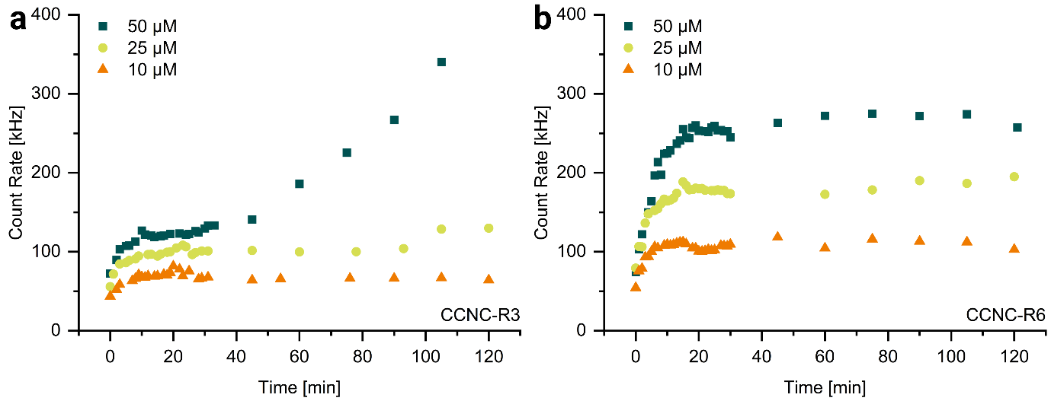
Supplementary Fig. 8: DLS kinetic. Count rates of CCNC-R3 (a) and CCNC-R6 (b) over 2 h.

3.2.2 Critical assembly concentration
Peptides were dissolved in filtered MilliQ water and diluted with filtered DPBS (1x, pH 7.4) in a 1:9 ratio to yield a 50, 25, 15, 10, 5, 1, 0.1 and 0.05 µM solution (Millipore Millex-LG Hydrophilic PTFE 0.2 µm).

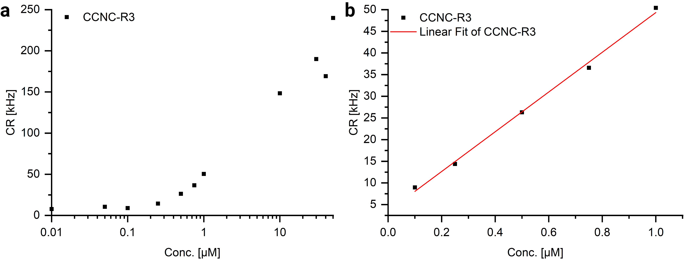
Supplementary Fig. 9: DLS measurements for CAC determination of CCNC-R3. (a) Count rate plotted against the peptide concentration. (b) Linear fit of the concentrations between 0.1 and 1 µM.
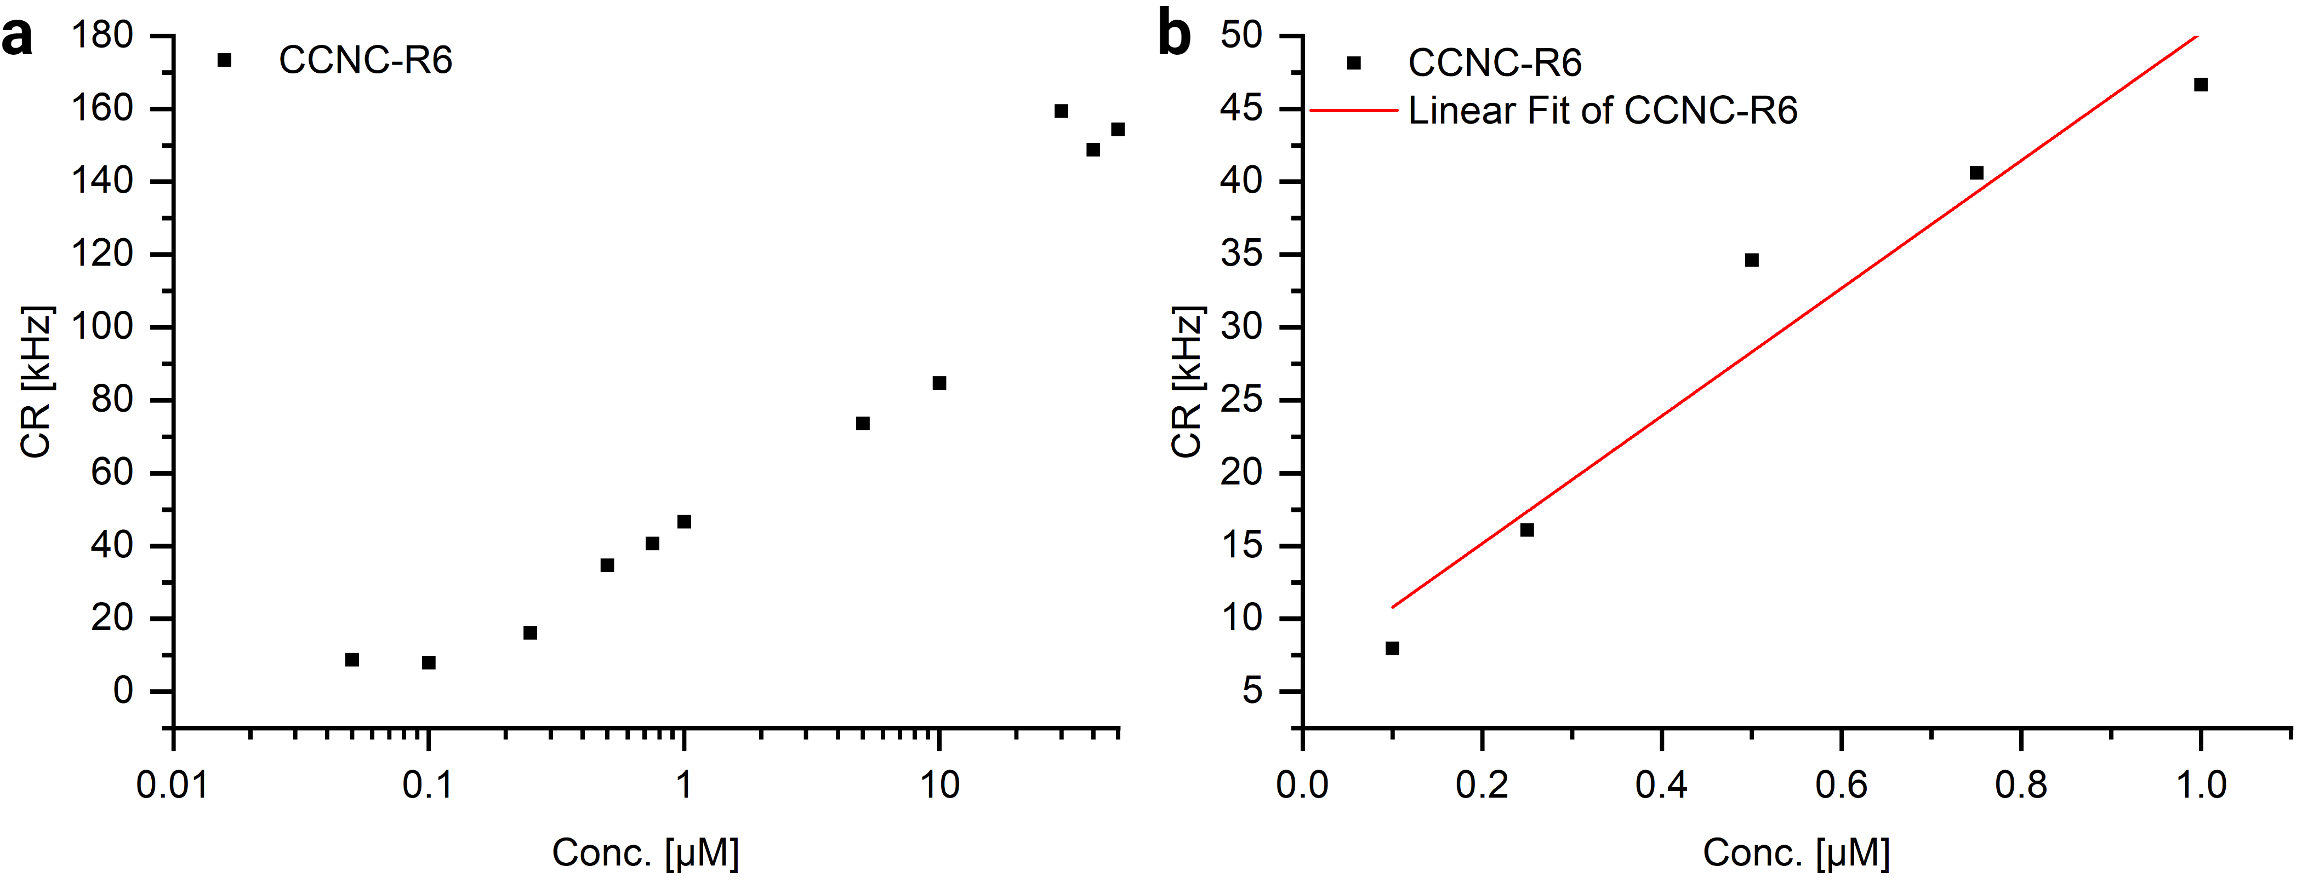
Supplementary Fig. 10: DLS measurements for CAC determination of CCNC-R6. (a) Count rate plotted against the peptide concentration. (b) Linear fit of the concentrations between 0.1 and 1 µM.

3.3 Cryo-EM

3.3.1 CCNC-R0 and CCNC-R8
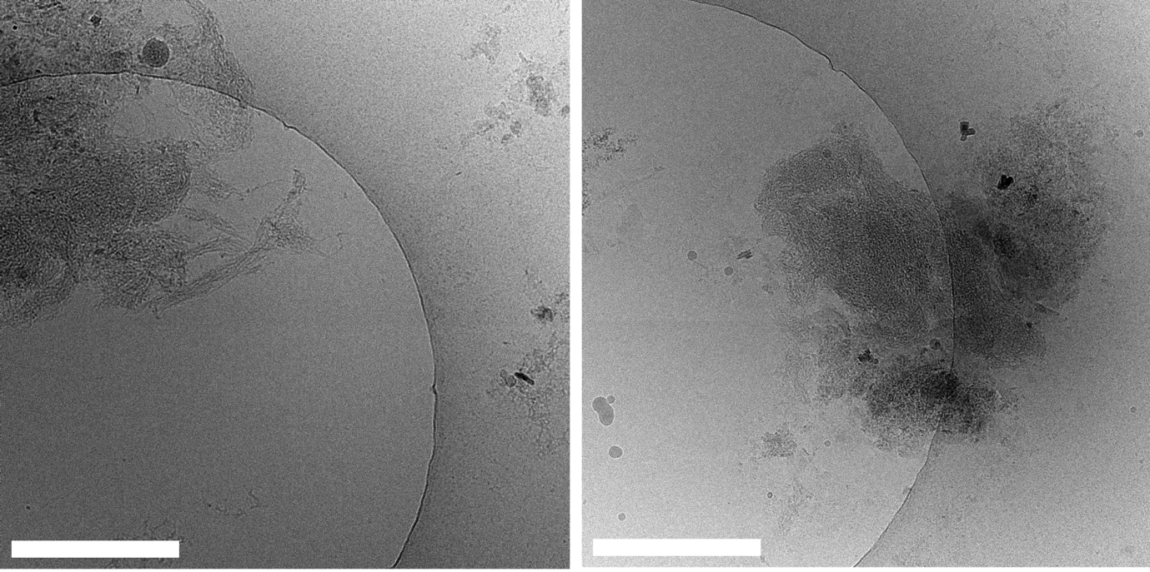
Supplementary Fig. 11: CCNC-R0 at 24 h incubation showing aggregation of peptides with no crystalline formation. Scale bar 500 nm.
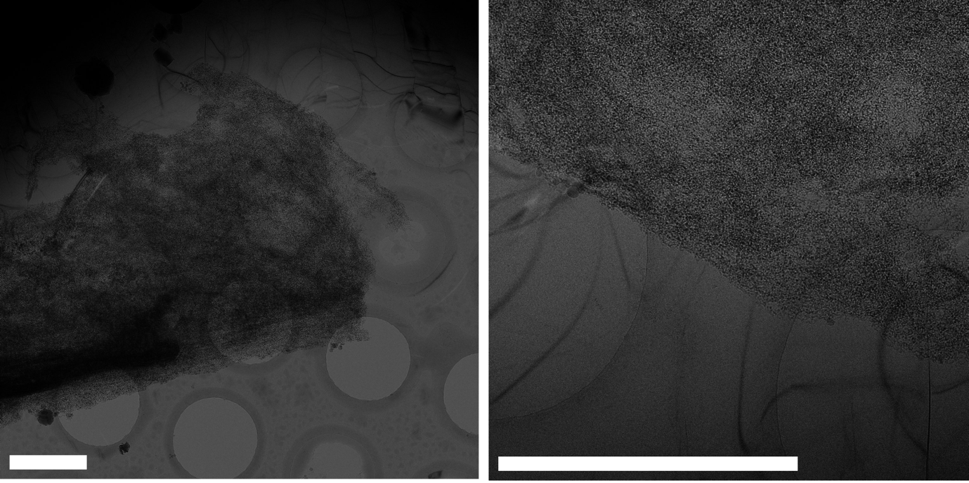
Supplementary Fig. 12: CCNC-R8 at 24 h incubation showing aggregation of peptides with no crystalline formation. Left scale bar 2 µm. Right scale bar 1 µm.

3.3.2 CCNC-R6

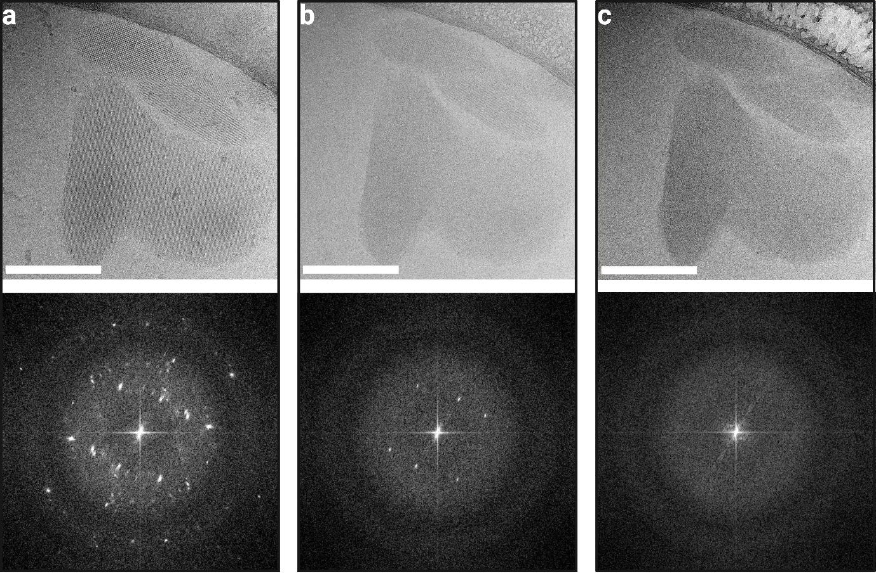
Supplementary Fig. 13: CCNC-R6 beam damage test and associated FFT showing a degrading crystalline signal over increasing electron dose. Scale bar 200 nm. (a) Total dose = 10 e/A² (b) Total dose = 100 e/A² (c) Total dose = 200 e/A².

3.3.3 Morphologies and Tomography

Cryo-ET data was collected using SerialEM with a tilt range of ±60° (120° total) and a total approx. dose 120 e/A². Tomogram reconstruction was performed using IMOD fiducial tracking.

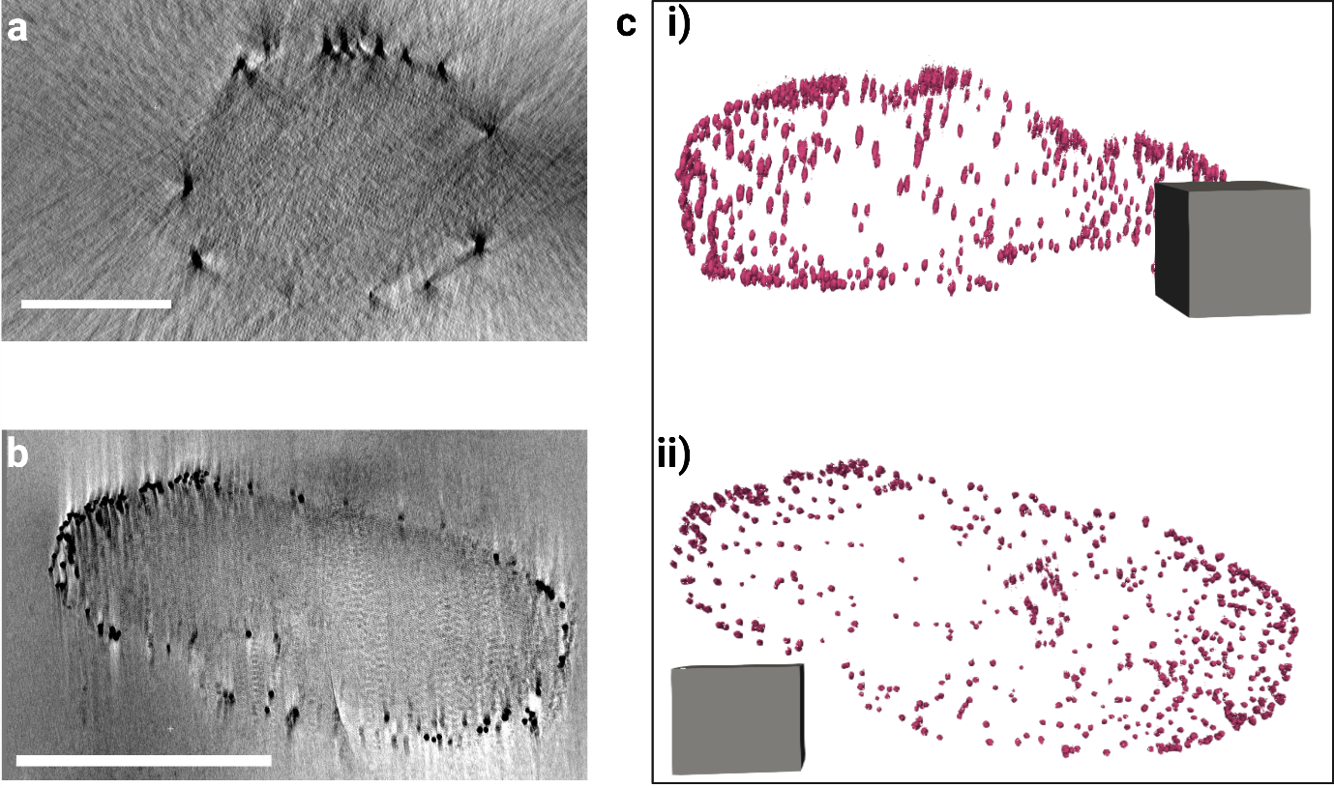
Supplementary Fig. 14: CCNC-R6 tomography. (a) Tomogram reconstruction, section. Scale bar 250 nm. (b) Tomogram reconstruction, section. Scale bar 500 nm. (c) 3D reconstruction using gold fiducial markers as boundary markers. (i) Side view, (ii) top view. Scale cube 250 nm³.

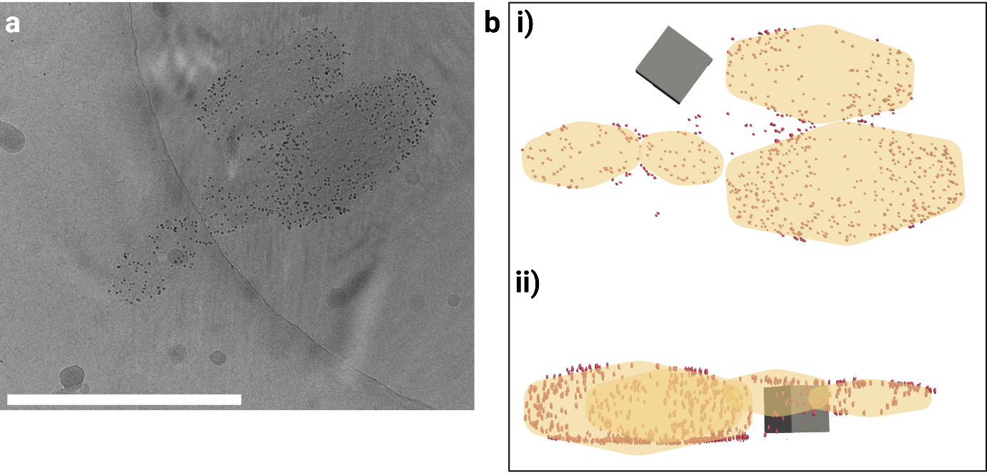
Supplementary Fig. 15: CCNC-R3 tomography (a) Tilt series at 0° tilt, scale bar 500 nm. (b) 3D reconstruction using gold fiducial markers as boundary markers. (i) Top view (ii) side view. Scale cube 200 nm³.

3.3.4 Kinetics

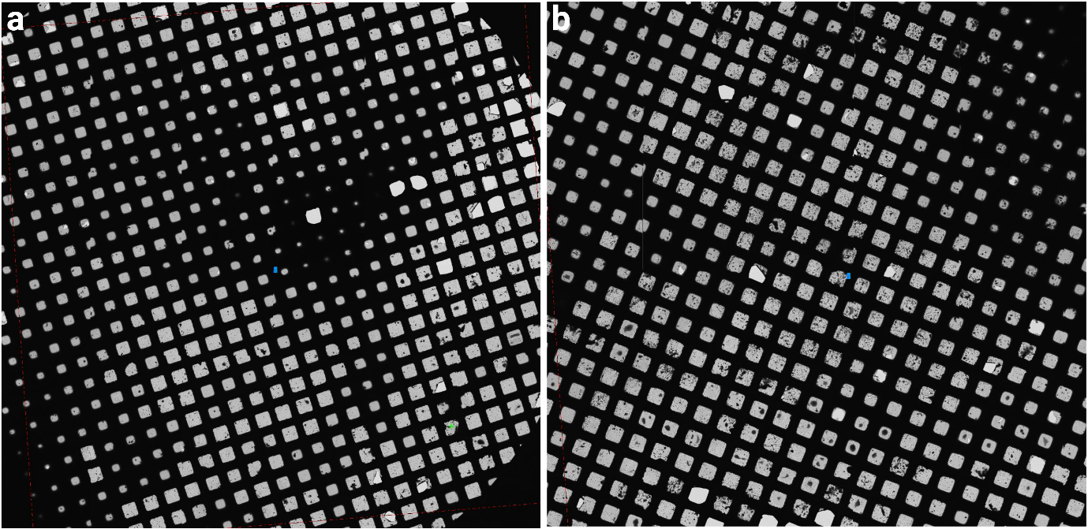
Supplementary Fig. 16: CCNC-R3 low magnification atlas montages of cryo-EM grids (a) 15 min incubation showing crystal aggregates throughout the grid and peptide aggregation b) 4 h incubation showing denser and more abundant aggregates of crystals.
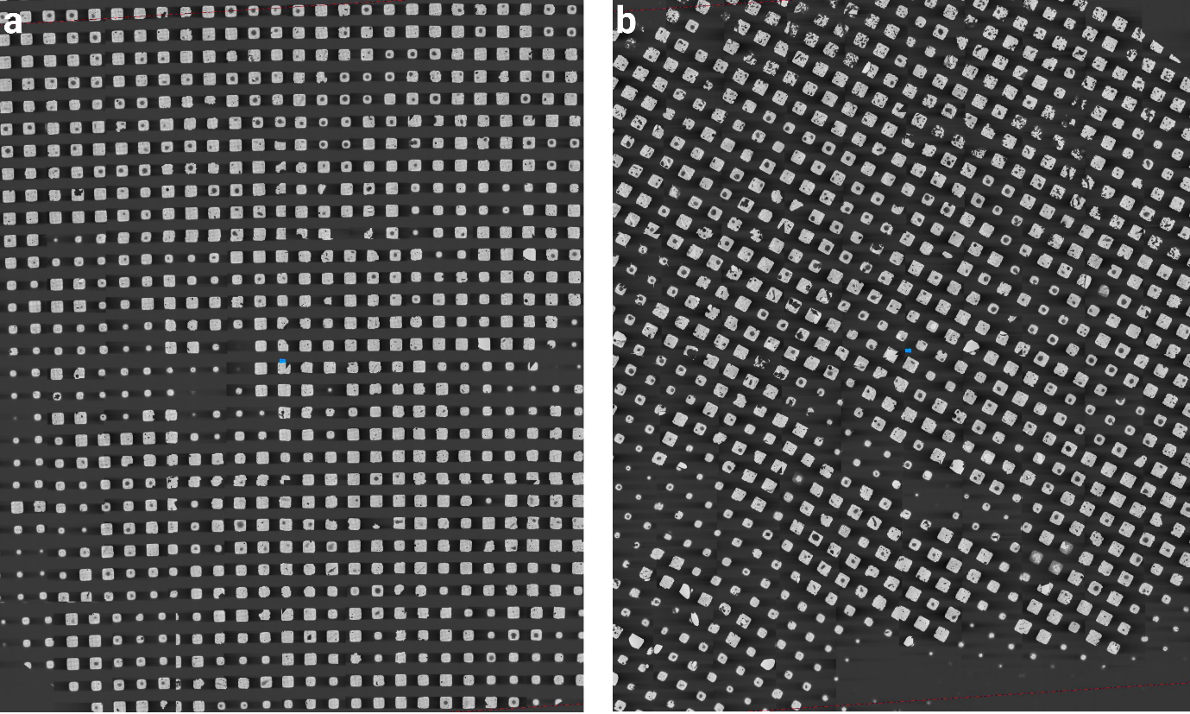
Supplementary Fig. 17: CCNC-R6 low magnification atlas montages of cryo-EM grids (a) 30 min incubation showing a limited number of peptide aggregates throughout (b) 4 h incubation showing dense and more abundant aggregates of crystals throughout the entire grid.
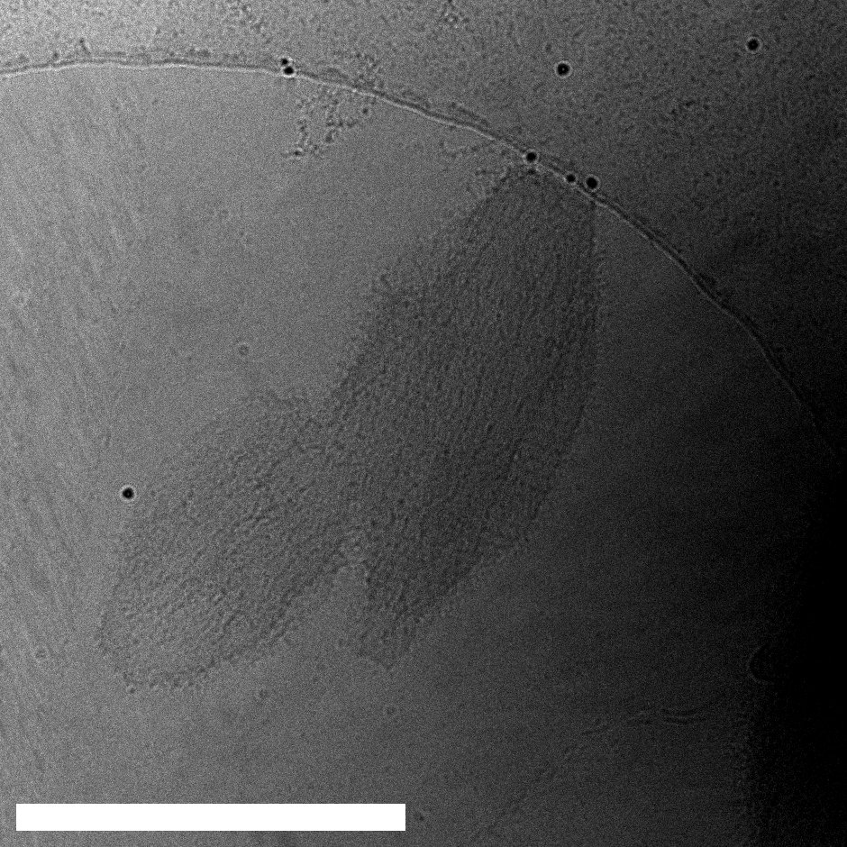
Supplementary Fig. 18: CCNC-R6 4 h incubation showing an intermediate state with striations extending from the crystal boundary. Scale bar 500 nm.

3.3.5 3D ED

Three-dimensional electron diffraction (3D ED) data were collected on a Thermo Fisher Krios operated at 300 kV in nanoprobe TEM mode, with diffraction patterns recorded on a Ceta detector (binning 4, 1024 × 1024 pixels). Individual nanocrystals were isolated using a focused nanobeam (spot size 6). Continuous-rotation tilt series were acquired using pyFAST-ADT¹ over an angular range of ±60° (120° total) at a nominal tilt step of 1°/frame (effective step ≈1.17°/frame) with an exposure of 1 s per frame, at a camera length of 4300 mm. Diffraction tilt series were processed in PETS2².

CCNC-R3. 17 datasets were collected from separate crystals, of which 9 datasets provided adequate unit cell information. By merging the 9 datasets, the coverage of the 3D reciprocal space reached up to 74.4% oC cell and 83.5% hP cell, with a resolution up to 0.08 A⁻¹, in order to minimise the missing cone of information intrinsic in every 3D ED dataset.

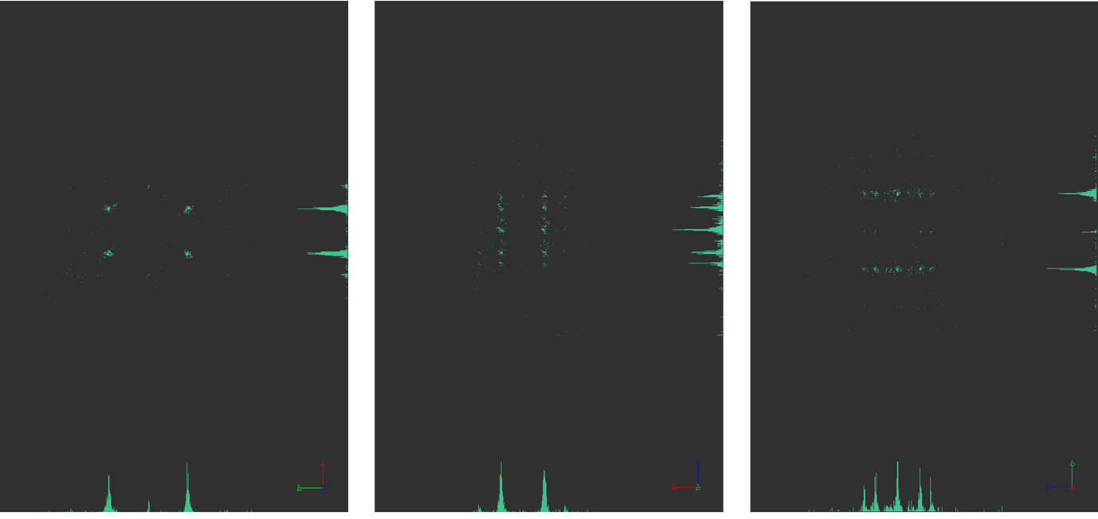
Supplementary Fig. 19: CCNC-R3 - Pets2 Overview of the merged 3D reciprocal space reconstructed from the individual 9 datasets collected.
Supplementary Table 1: Unit Cell. The 2 possible unit cells
Crystal system | a | b | c | α | β | γ | Volume | Indexing %
Hexagonal P | 50.8±0.2 | 50.8±0.2 | 168.7±0.7 | 90 | 90 | 120 | 376452 | 52.59
Orthorhombic C | 88.2±0.4 | 50.1±0.1 | 169.1±0.7 | 90 | 90 | 90 | 747212 | 60.00

CCNC-R6. 10 datasets were collected from separate crystals, of which 6 datasets provided adequate cell information. By merging the 6 datasets, the coverage of the 3D reciprocal space reached up to 81.2% oC cell and 80.2% hP cell, with a resolution up to 0.08 A⁻¹, in order to minimise the missing cone of information intrinsic in every 3D ED dataset.
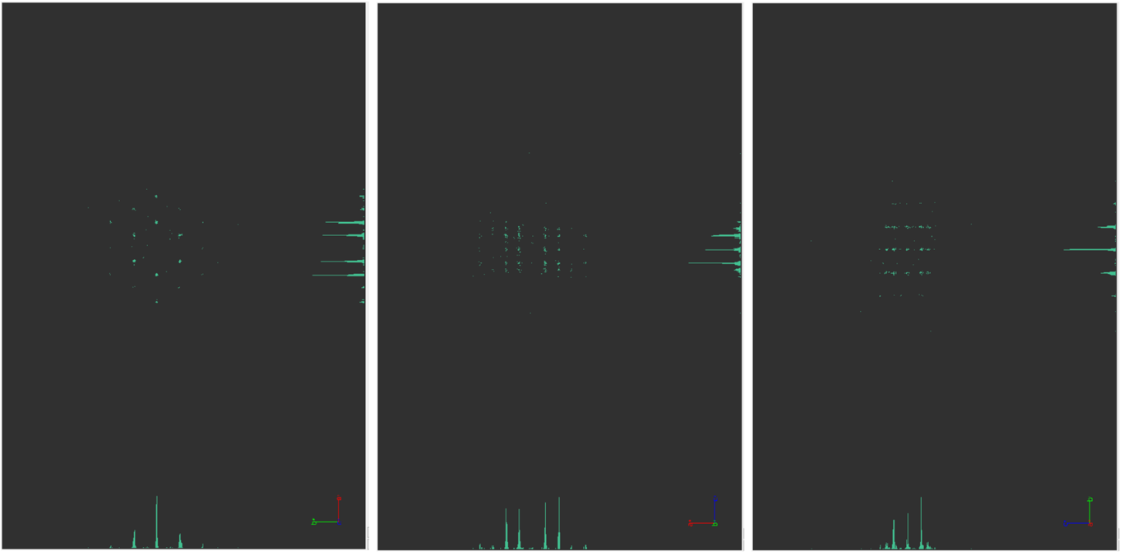
Supplementary Fig. 20: CCNC-R6 - Pets2 Overview of the merged 3D reciprocal space reconstructed from the 6 individual datasets collected.
Supplementary Table 2: Unit Cell. The 2 possible unit cells
Crystal system | a | b | c | α | β | γ | Volume | Indexing %
Hexagonal P | 51.3±0.1 | 51.3±0.1 | 168.0±0.4 | 90 | 90 | 120 | 383539 | 56.32
Orthorhombic C | 88.6±0.1 | 50.5±0.1 | 168.8±0.4 | 90 | 90 | 90 | 755300 | 62.63

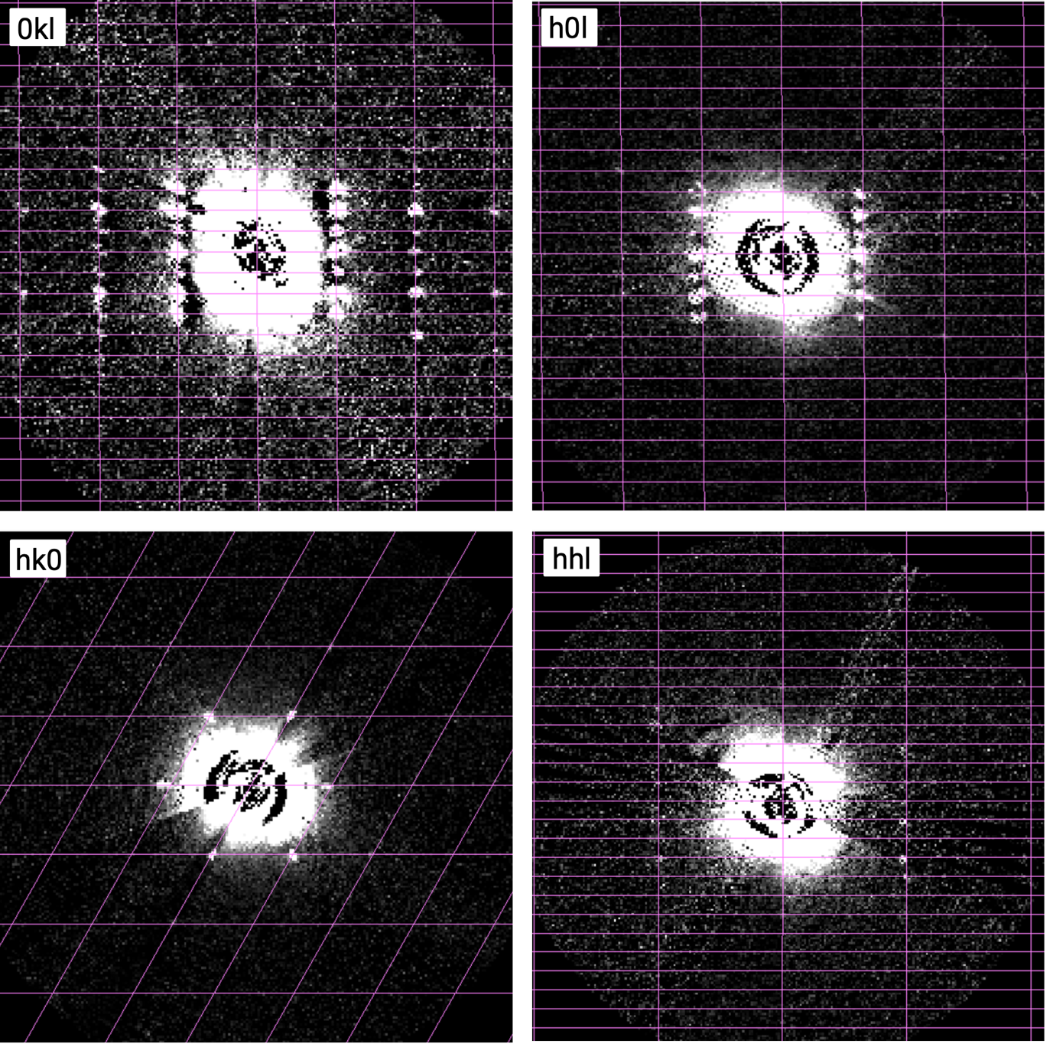
Supplementary Fig. 21: CCNC-R6 - Reciprocal space sections of the 4 main projections in hexagonal settings 0kl, h0l, hk0, hhl.

3.4 Model building and analysis

To construct an atomistic model of the suprahelical coiled coil, a single dimeric coiled coil comprising residues 2-21 and 25-45 was modelled using CCbuilder 2.0³, with the default radius and pitch. These half-peptide units were then placed longituidinally within a synthetic map with pitch and radius of 350 Å and 10.5 Å, respectively, which had been lowpass filtered to 20 Å. Peptide units were then connected with the relevant GN linkers, and C-terminally amidated glycine residues were added. Atoms within the model were then constrained with their existing distances and torsions, and the backbone constrained to α-helical secondary structure parameters using Isolde within ChimeraX⁴. Atoms comprising the termini and GN linkers were not constrained. Finally, the model was relaxed into the map using Isolde, yielding the model shown in Fig. 4a. To construct the larger crystal unit, comprising the 6 × 6 array of suprahelical coiled coils shown in Fig. 4c, the single suprahelical coiled coil described above was placed on a 42 Å × 42 Å lattice using ChimeraX. A projection image of the resulting model was created using e2project.py within EMAN2 ⁵(Fig. 4f), which was compared to the raw image (Fig. 4d) and the Fourier-filtered image (Fig. 4e).

SI References

1. Santucci, M. & Kolb, U. Evaluation of the reproducibility and crystal tracking precision of TEM goniometers in tomography experiments. Ultramicroscopy, 282, 114308 (2026).

2. Palatinus, L. et al. Specifics of the data processing of precession electron diffraction tomography data and their implementation in the program PETS2.0. Acta Crystallogr. Sect. B Struct. Sci. Cryst. Eng. Mater. 75, 512–522 (2019).

3. CCBuilder 2.0: Powerful and accessible coiled‐coil modeling - PMC. https://pmc.ncbi.nlm.nih.gov/articles/PMC5734305/.

4. Croll, T. I. ISOLDE: a physically realistic environment for model building into low-resolution electron-density maps. Acta Crystallogr. Sect. Struct. Biol. 74, 519–530 (2018).

5. Tang, G. et al. EMAN2: an extensible image processing suite for electron microscopy. J. Struct. Biol. 157, 38–46 (2007).

