Supporting Information

Two-sidedness, flexible, durable, highly transparent and haze plastic-paper for green optoelectronics
Wenliang Wang^{1,2}, Xubiao Wang¹, Xingjin Zhao¹, Xiaoxiao Ren¹, Weikun Jiang², Zhao Zhang¹
1. College of Bioresources Chemical and Materials Engineering, Shaanxi University of Science & Technology, Xi’an, Shaanxi Province, 710021, China
2. Key Laboratory of Pulp and Paper Science & Technology of Ministry of Education, Qilu University of Technology (Shandong Academy of Sciences), Ji'nan, Shandong Province, 250353, China

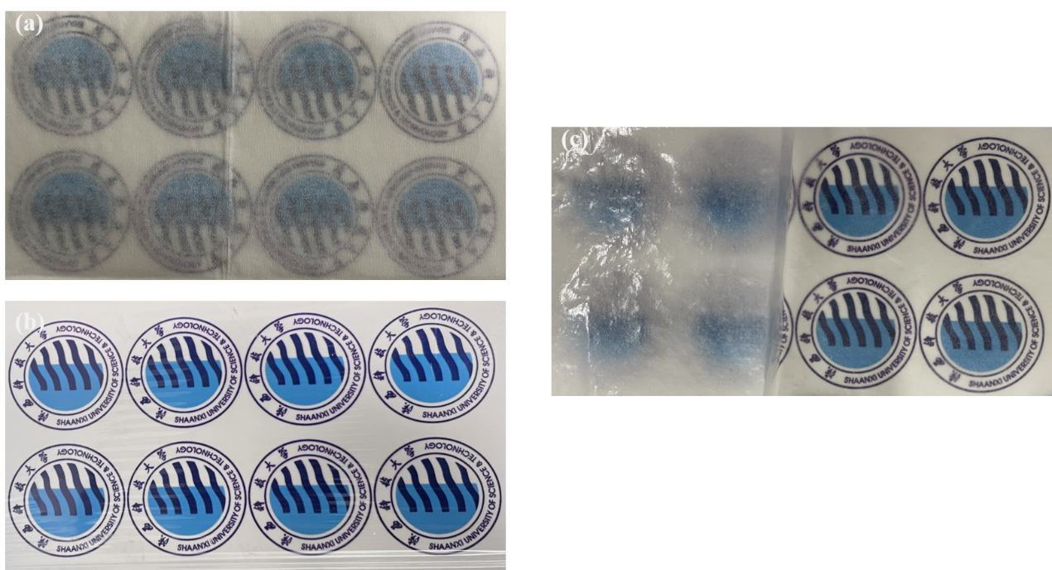
Figure S1. Images of tissue paper (a), polymer (b), and plastic-paper (c).

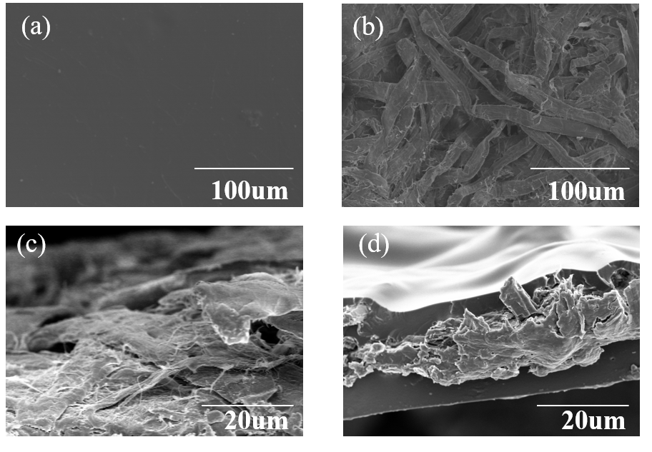
Figure S2. SEM images of PVA/glycerol polymer film (a), top view of tissue paper(b), cross section of tissue paper (c), and cross section of plastic-paper (d).

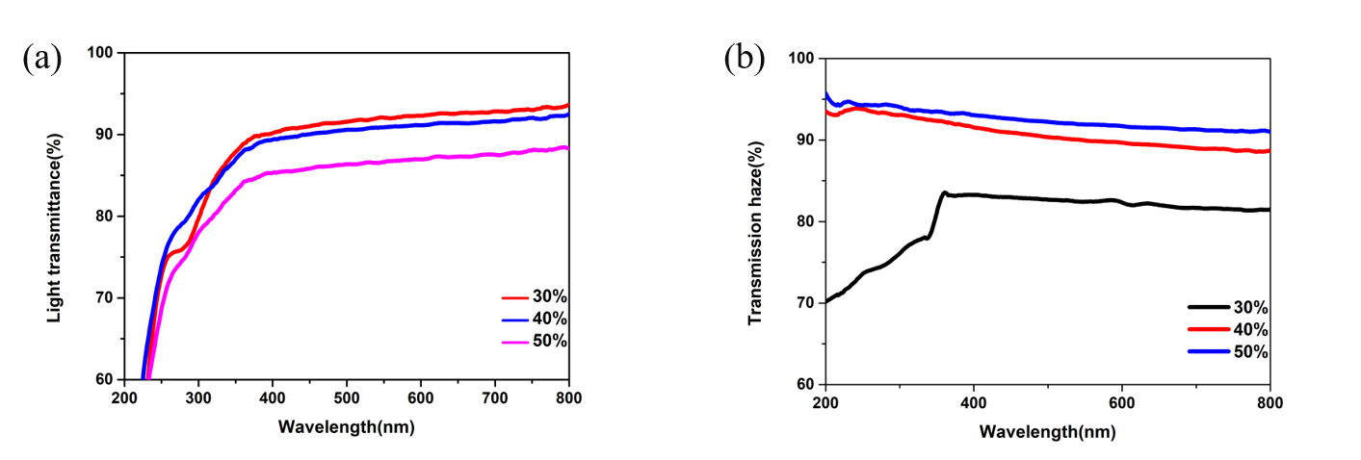
Figure S3. (a) Total transmittance of Plastic paper with different cellulose content measured by an integrated sphere; (b) Optical haze of plastic paper with different cellulose content.

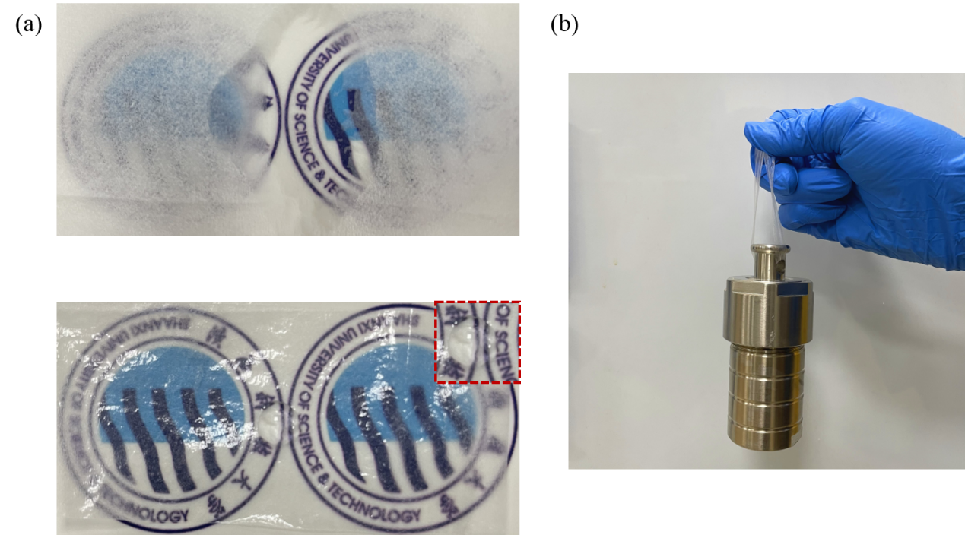
Figure S4. (a) Images of paper and plastic-paper with the water droplet on the surface. (b) Lift 1kg reaction kettle with plastic-paper (20cm×0.5cm).

