Supplementary Information
for
A Quantitative Transformer-Augmented and Virtual-Material-Multiplexed Plasmonic Hydrogen Sensor for Chemically Deactivating Humid Air Environments

Henrik Klein Moberg♣, Athanasios Theodoridis♣, Carl Andersson♣, Joachim Fritzsche, Sara Nilsson, Paul Erhart and Christoph Langhammer*

Department of Physics and Astronomy, Chalmers University of Technology, Göteborg, Sweden

♣Equal contribution
*Corresponding author: clangham@chalmers.se

CAD Design of Experimental Setup
Figure S1. CAD design of the reactor chamber from (a) an angled top view and (b) a side view.

Representative SEM Micrographs from Nanoparticle Arrays
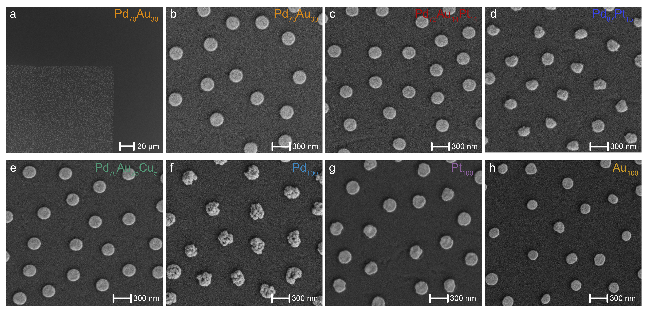
Figure S2. SEM micrographs of the seven material compositions. (a) 1000x magnification showing the edge of the Pd₇₀Au₃₀ array. The scale bar is 20 microm. (b-h) 200,000x magnification of Pd₇₀Au₃₀, Pd₇₂Au₁₄Pt₁₄, Pd₈₇Pt₁₃, Pd₇₀Au₂₅Cu₅, Pd₁₀₀, Pt₁₀₀ and Au₁₀₀ nanostructures. The scale bar is 100 nm. The images were collected with a GeminiSEM 450 (Zeiss) using the InLens detector, an acceleration voltage of 10 kV, a beam current of 200 pA and a working distance of 6 mm.

Non-background corrected EDX spectra
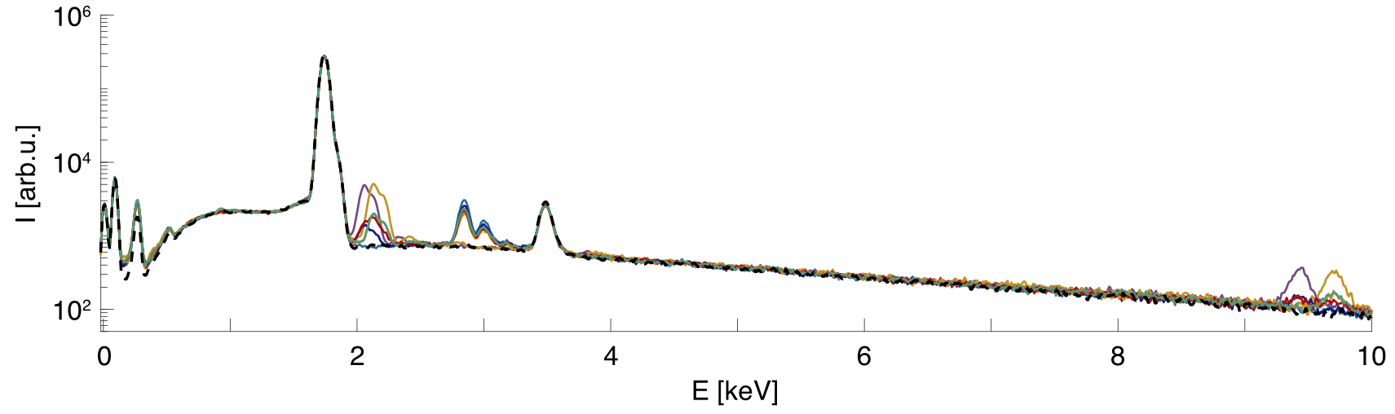
Figure S3. SEM-EDX spectra from one individual nanoparticle each of Pd₇₀Au₃₀, Pd₇₂Au₁₄Pt₁₄, Pd₈₇P_{t13}, Pd₇₀Au₂₅Cu₅, Pd₁₀₀, Pt₁₀₀ and Au₁₀₀. The signal from the substrate is indicated by a dashed line.

Nominal vs Measured EDX Alloy Compositions
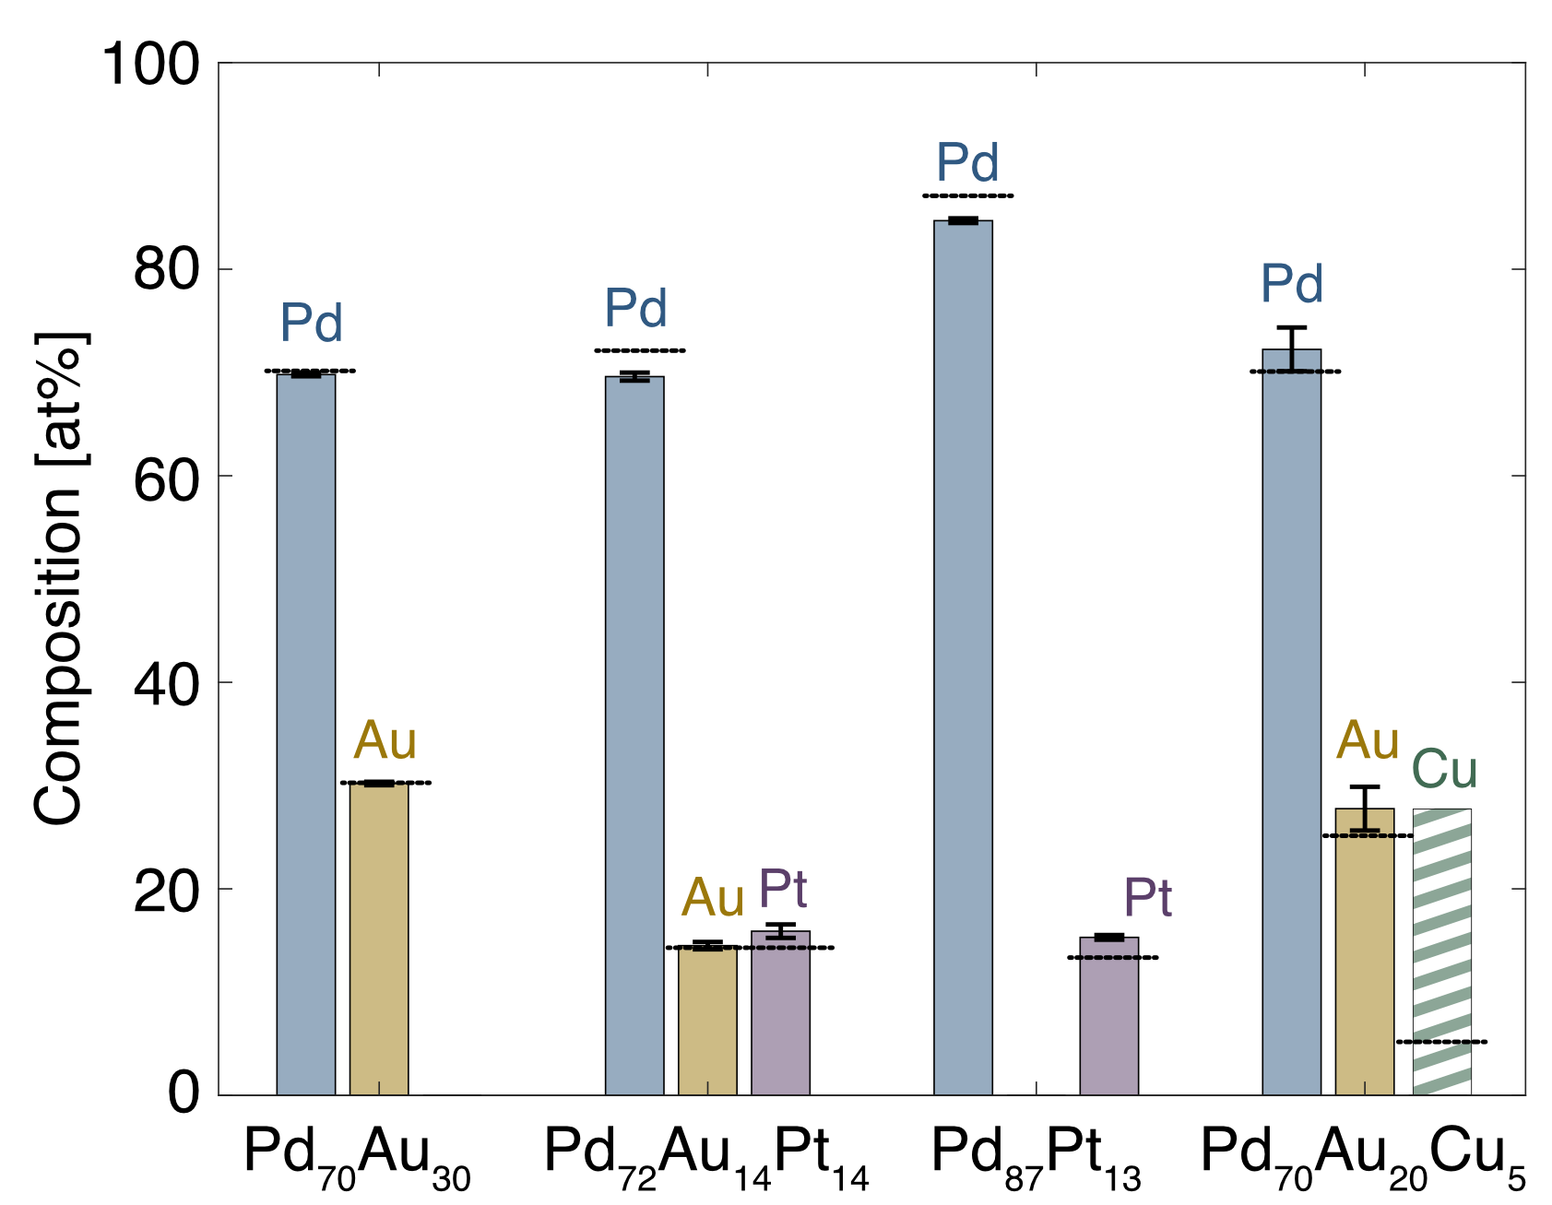
Figure S4. Nominal compositions (dashed black lines) and SEM-EDX measured mean compositions (bars) from three individual nanoparticles each of the Pd₇₀Au₃₀, Pd₇₂Au₁₄Pt₁₄, Pd₈₇P_{t13} and Pd₇₀Au₂₅Cu₅ alloys. Error bars indicate the standard deviation across the three nanoparticles from each alloy. For PdAuCu, the Cu signal was expectedly low (cf. Figure S3 and Figure 1f of the main text), leading the Aztec EDX quantification software to flag the Cu quantification as uncertain (dashed Cu bar). Consequently, the Pd and Au contents for this system were also quantified by fitting only Pd and Au, yielding mean measured compositions (72.2 at% Pd, 27.8 at% Au) close to the nominal values (70 at% Pd, 25 at% Au).

Gas Protocol Used for Training of Deep Learning Model in the Artificial Pulsed Gas-Scheme
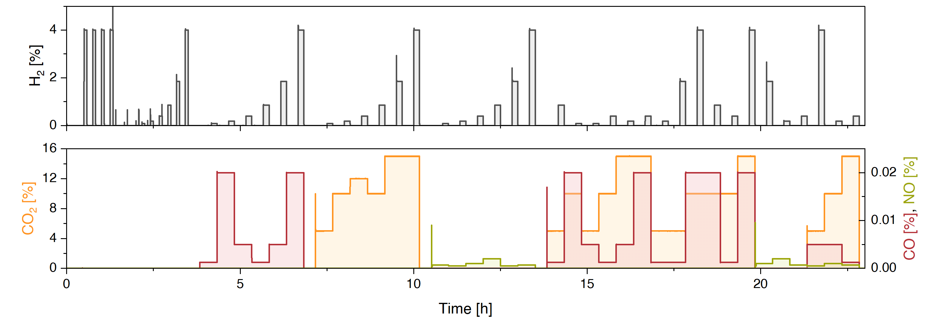
Figure S5. Gas protocol used for training of the transformer model in the dry multigas step-pulse regime of Figure 4 of the main text. Three separate repeat measurements were used for training to capture measurement-to-measurement variance in the optical signal; one representative protocol is shown.

Supplementary Note 1: Transformer sequence representation and virtual-material decoding
The transformer used the complete preprocessed 64-pixel optical readout as input. Each training example was a window S in R^(256 x 64), with 256 consecutive time points and 64 fixed photodiode-pixel channels. The channels were not collapsed to material averages before training; the model therefore received the full optical readout pattern produced by the 7 material regions and their spatial convolution on the photodiode array.
Pixel channels were standardized using means and standard deviations computed from the training measurements only. Each 64-dimensional time-point vector was mapped to a 128-dimensional learned embedding and combined with sinusoidal positional encoding. The encoder contained 4 transformer encoder blocks with 8 self-attention heads per block, feed-forward sublayers, residual connections, layer normalization and dropout p = 0.1.
The encoder output at each time point was passed to gas-specific regression heads for H₂, CO, CO₂ and NO. The model was optimized with a weighted mean-absolute-error loss over the gas target trajectories. The recorded RH(t) trajectory was used to mark dry and humid intervals in figures and downstream summaries; it was not supplied as an additional input channel and was not supervised as an output channel.
Windows were generated in temporal order with length 256 and stride 32 for model fitting and full-sequence inference. Window construction, standardization parameters and hyperparameter selection were computed from training measurements only. For held-out measurements, overlapping window predictions were averaged at each time point to form the full predicted trajectory.
The dry-regime model was trained on the 3 dry step-pulse measurements described in Figure S5 and validated on held-back windows from those training measurements; the held-out humidity-perturbation measurement was used only for testing. The humid-dynamic model was trained on 2 Jakarta day-simulation measurements (Figures S7 and S8), validated on held-back windows from those training measurements and evaluated on the third Jakarta day-simulation measurement. Both regime-specific models used batch size 64, AdamW optimization with learning rate 3 x 10⁻⁴ and weight decay 10⁻², seed 7 and 300 training epochs. With 256-point windows and stride 32, this gave 1066 training windows and 118 validation windows for the dry regime, and 977 training windows and 109 validation windows for the humid dynamic regime. The checkpoint with the lowest validation prediction loss was retained.
The regression objective was applied only to the gas concentration time traces. The recorded RH(t) trajectory was used to mark humidity conditions in figures and downstream summaries, but it was not appended to the 64-pixel optical input and was not treated as an output channel. The pixel- and material-level analysis was performed after training by summarizing model behaviour during inference and by testing the effect of masking defined pixel groups.

Regression Metrics for Training, Validation and Testing of Transformer Model in the Artificial Pulsed Gas-Scheme
Table S1 summarizes the normalized regression metrics for the dry multigas step-pulse regime. These metrics are computed against the prescribed gas-setpoint trajectories on the predefined train/test partitions.

Table S1. Transformer regression metrics by gas species for the dry multigas step-pulse regime of Figure 4 of the main text. Metrics are reported for the training measurements, the held-out test measurement and the combined data. MAE and RMSE are calculated on channel-normalized target trajectories, and Pearson correlation is the correlation between the predicted and target time traces for each gas.
Subset | Gas | MAE | RMSE | Correlation
Train | H₂ | 0.0187 | 0.0581 | 0.977
Train | CO | 0.0144 | 0.0422 | 0.995
Train | CO₂ | 0.0093 | 0.0295 | 0.997
Train | NO | 0.0087 | 0.0274 | 0.996
Test | H₂ | 0.0206 | 0.0592 | 0.974
Test | CO | 0.0326 | 0.0919 | 0.976
Test | CO₂ | 0.0282 | 0.0754 | 0.983
Test | NO | 0.0207 | 0.0550 | 0.984
All | H₂ | 0.0193 | 0.0584 | 0.976
All | CO | 0.0198 | 0.0615 | 0.988
All | CO₂ | 0.0150 | 0.0482 | 0.993
All | NO | 0.0123 | 0.0379 | 0.992

Nominal versus Experimental CO, CO₂ and NO_{x} Concentrations used in the Simulated Urban Environment
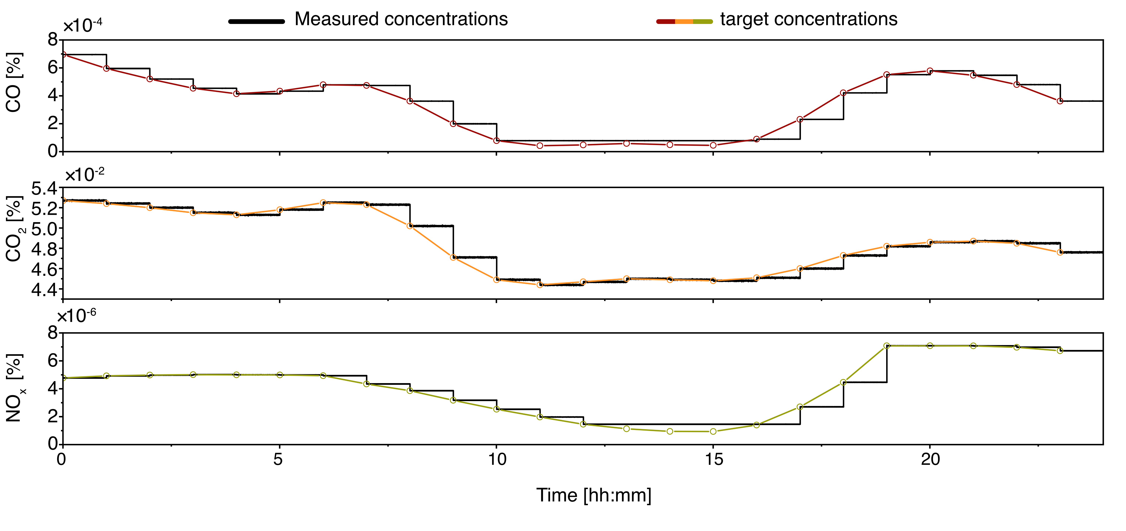
Figure S6. Comparison between the contaminant concentrations used in the simulated urban environment of Figure 5 of the main text (black traces) and the target concentrations from the real-world environmental data^{1,2} (red, orange and green traces for CO, CO₂ and NO_{x}, respectively). In cases where the lowest target concentration was not possible to reach for CO and NO_{x}, the concentration was replaced with the lowest attainable concentration in our experimental setup. The nitrogen-oxide gas used in the experimental setup was NO (see the main text).

Gas Protocol Used for Training of Transformer Model in the Simulated Urban Environment

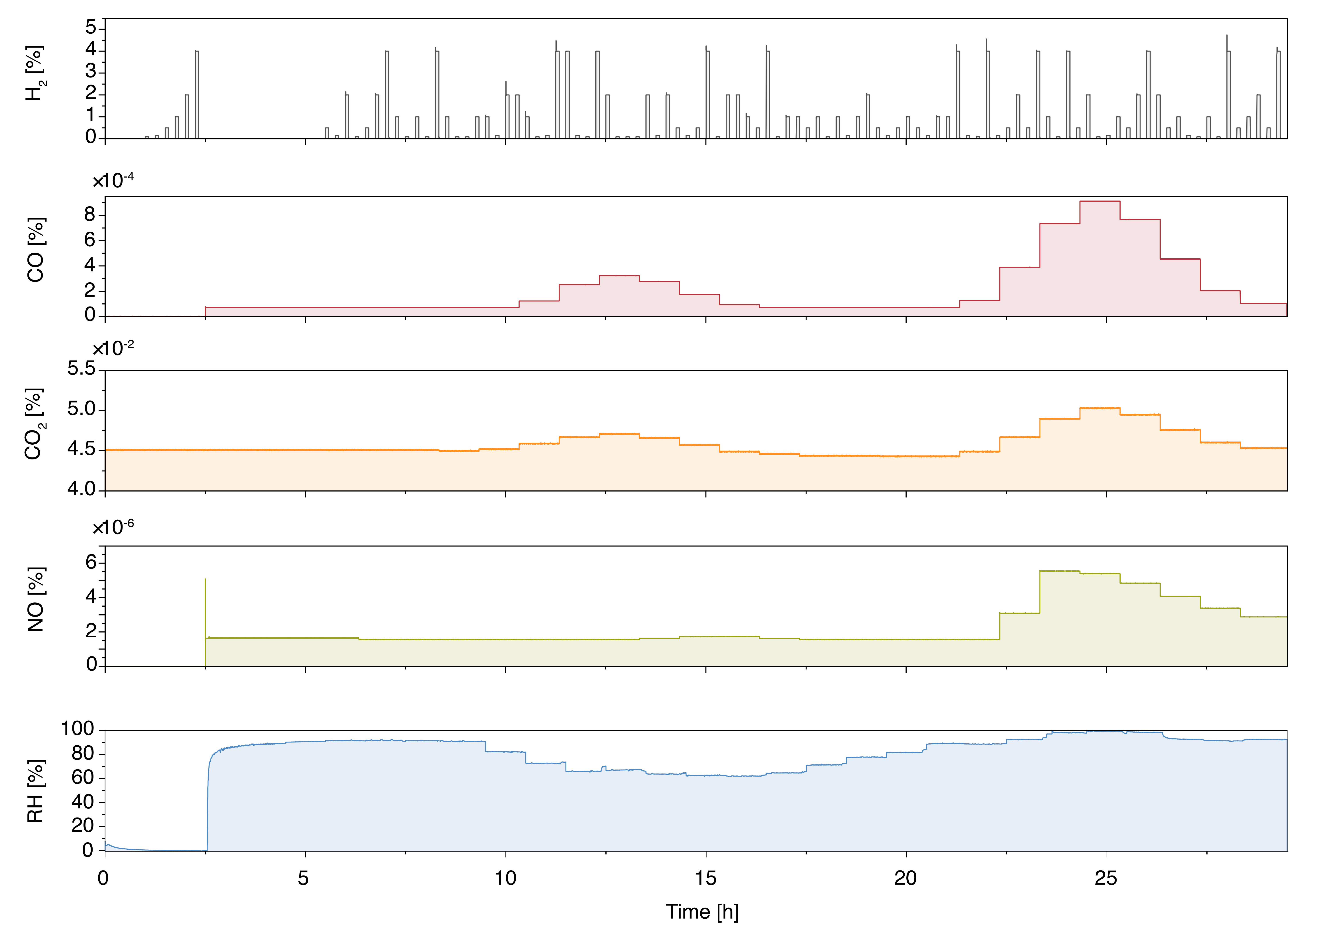
Figure S7. First of the two gas protocols used for training of the transformer model in the simulated urban environment for Figure 5 of the main text. The CO, CO₂, NO and RH data are based on environmental data from Nov. 15, 2025 in Sunda Kelapa, Jakarta, Indonesia^{1,2}. The total sequence is 29.5 h, where the first 5.5 h correspond to an initialization stage, followed by 24 h corresponding to the real environmental data. In cases where the lowest target concentrations were not possible to reach for CO and NO, the concentration was replaced with the lowest attainable concentration in our experimental setup as in Figure S6.

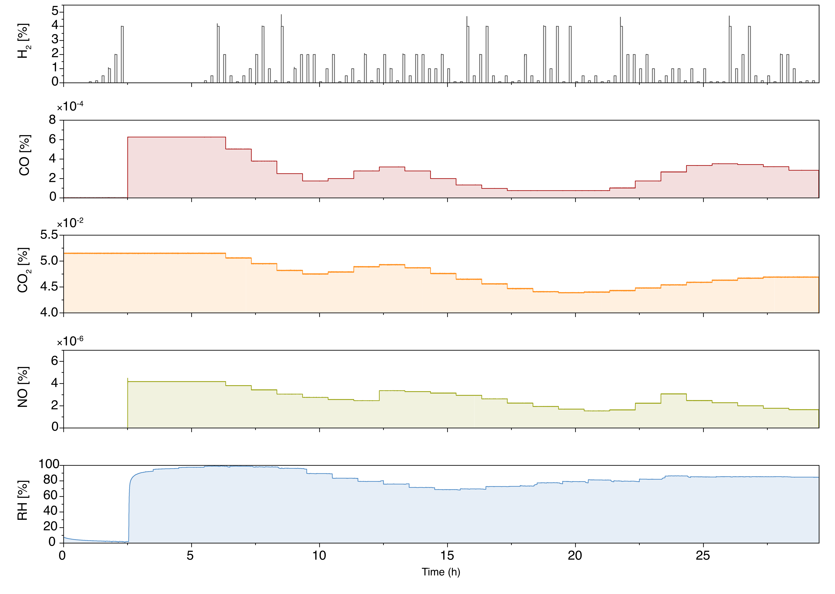
Figure S8. Second of the two gas protocols used for training of the transformer model in the simulated urban environment for Figure 5 of the main text. The CO, CO₂, NO and RH data are based on environmental data from Nov. 23, 2025 in Sunda Kelapa, Jakarta, Indonesia^{1,2}. The total sequence is 29.5 h, where the first 5.5 h correspond to an initialization stage, followed by 24 h corresponding to the real environmental data. In cases where the lowest target concentrations were not possible to reach for CO and NO, the concentration was replaced with the lowest attainable concentration in our experimental setup as in Figure S6.

Regression Metrics for Training, Validation and Testing of Transformer Model in the Simulated Urban Environment
Table S2 summarizes the normalized regression metrics for the simulated urban environment. These metrics are computed against the prescribed gas-setpoint trajectories on the predefined train/test partitions.

Table S2. Transformer regression metrics by gas species for the simulated urban environment of Figure 5 of the main text. Metrics are reported for the training measurements, the held-out test measurement and the combined data. MAE and RMSE are calculated on channel-normalized target trajectories, and Pearson correlation is the correlation between the predicted and target time traces for each gas.
Subset | Gas | MAE | RMSE | Correlation
Train | H₂ | 0.0338 | 0.0795 | 0.960
Train | CO | 0.0184 | 0.0434 | 0.994
Train | CO₂ | 0.0421 | 0.0649 | 0.624
Train | NO₂ | 0.0252 | 0.0501 | 0.989
Test | H₂ | 0.0079 | 0.0174 | 0.997
Test | CO | 0.0344 | 0.0485 | 0.999
Test | CO₂ | 0.0632 | 0.0820 | 0.752
Test | NO₂ | 0.0569 | 0.0759 | 0.995
All | H₂ | 0.0252 | 0.0657 | 0.968
All | CO | 0.0238 | 0.0452 | 0.997
All | CO₂ | 0.0491 | 0.0711 | 0.674
All | NO₂ | 0.0358 | 0.0600 | 0.992

Total Relative Attention Summary
Table S3. Mean relative attention mass for each material-centred pixel group, defined as the centre pixel above each nanoparticle array plus one neighbouring pixel on either side, for the dry multigas step-pulse regime (Figure 4f of the main text) and the simulated urban environment (Figure 5f of the main text). The percentages do not add to 100% because the remaining attention is carried by the inter-strip optical pixels, corresponding to the fully virtual materials discussed in the main text.

Material group | Artificial pulsed gas-scheme (Figure 4) | Simulated urban environment (Figure 5)
PdAu | 17.7% | 5.56%
PdAuPt | 2.78% | 12.2%
PdPt | 2.96% | 10.6%
PdAuCu | 9.79% | 10.4%
Pd | 2.87% | 2.57%
Pt | 2.73% | 3.12%
Au | 2.82% | 2.65%

Virtual Material Ablation Study
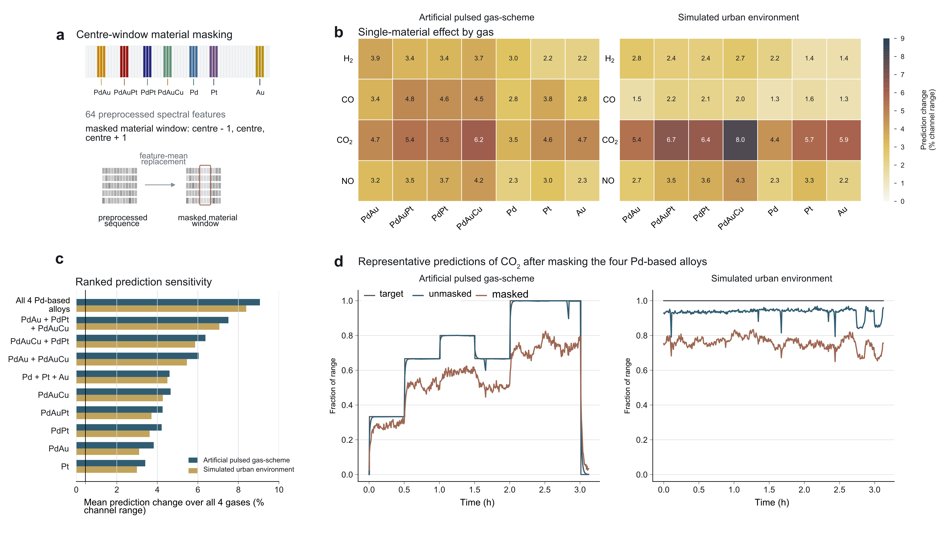
Figure S9. Virtual material ablation study. (a) Ablation strategy in which the material-centered pixel group for a selected material is masked, defined as the center pixel above the nanoparticle array plus one neighboring pixel on either side. (b) Mean change in predicted gas concentration when each material-centered group is masked. Values are normalized to the maximum concentration of the corresponding gas during that sequence. The left table corresponds to the dry multigas step-pulse regime (Figure 4 of the main text), and the right table corresponds to the simulated urban environment (Figure 5 of the main text). (c) Mean prediction change for selected material combinations, averaged over H₂, CO, CO₂ and NO after normalization by the corresponding channel range. The Pd-based alloy group comprises PdAu, PdAuPt, PdPt and PdAuCu; it does not include the pure Pd, Pt or Au regions. (d) Representative CO₂ predictions after masking the Pd-based alloy group for the dry multigas step-pulse regime (left) and the simulated urban environment (right).

Supplementary Note 2: Comparison against static and temporal baselines
Tables S4-S7 compare the main transformer model against three independently fitted baselines: a static ridge regressor, a lagged ridge regressor and a two-layer GRU trained on the same split definitions. All baselines were fitted on the training measurements only and evaluated on the same held-out measurements as the transformer model. The static ridge baseline uses the full preprocessed 64-pixel optical vector at each time point as input, whereas the lagged ridge baseline uses a window of the same 64-pixel vectors to provide linear temporal context. For the temporal baselines, context length was selected over 5, 11, 21 and 41 plotted time steps using only the training measurements, and ridge regularization was swept from 10⁻³ to 10³. GRU results are reported as mean +/- standard deviation across three seeds after context selection. Correlation values are Pearson correlations between the predicted and target time traces for the indicated gas on the evaluated split; they are not correlations between the optical input vector and the gas output. The lagged-ridge model is retained as a linear temporal control rather than as a competitive sequence model, and the GRU is included as a simple recurrent comparator rather than as an exhaustive search over recurrent architectures.

Table S4. Static-ridge comparison for the held-out dry multigas step-pulse regime. The transformer and static ridge regressor were trained on the same dry training measurements and evaluated on the same held-out humidity-perturbation measurement. MAE is reported on channel-normalized gas trajectories; correlation is the Pearson correlation between predicted and target time traces for each gas.
Gas | Transformer MAE | Ridge MAE | Transformer Correlation | Ridge Correlation
H₂ | 0.0206 | 0.1888 | 0.974 | 0.740
CO | 0.0326 | 0.3067 | 0.976 | 0.278
CO₂ | 0.0282 | 0.5641 | 0.983 | 0.366
NO | 0.0207 | 0.3163 | 0.984 | 0.090

Table S5. Static-ridge comparison for the held-out humid dynamic multigas regime. The transformer and static ridge regressor were trained on the same two Jakarta day-simulation measurements and evaluated on the third Jakarta day-simulation measurement. MAE is reported on channel-normalized gas trajectories; correlation is the Pearson correlation between predicted and target time traces for each gas.
Gas | Transformer MAE | Ridge MAE | Transformer Correlation | Ridge Correlation
H₂ | 0.0079 | 1.4003 | 0.997 | 0.553
CO | 0.0344 | 0.1821 | 0.999 | 0.558
CO₂ | 0.0632 | 0.2381 | 0.752 | 0.244
NO₂ | 0.0569 | 0.2506 | 0.995 | 0.651

Table S6. Temporal-baseline comparison for the held-out dry multigas step-pulse regime. The static ridge model uses the instantaneous 64-pixel optical vector, the lagged ridge model uses temporally concatenated 64-pixel vectors, and the GRU is a recurrent neural-network baseline. Values are channel-normalized MAEs on the same held-out humidity-perturbation measurement; GRU values are mean +/- standard deviation across three seeds.
Gas | Transformer MAE | Static Ridge | Lagged Ridge | GRU
H₂ | 0.0206 | 0.1888 | 0.1815 | 0.1141 ± 0.0125
CO | 0.0326 | 0.3067 | 0.2862 | 0.3982 ± 0.0090
CO₂ | 0.0282 | 0.5641 | 0.6587 | 0.3946 ± 0.0152
NO | 0.0207 | 0.3163 | 0.4039 | 0.2532 ± 0.0148

Table S7. Temporal-baseline comparison for the held-out humid dynamic multigas regime. The static ridge model uses the instantaneous 64-pixel optical vector, the lagged ridge model uses temporally concatenated 64-pixel vectors, and the GRU is a recurrent neural-network baseline. Values are channel-normalized MAEs on the third Jakarta day-simulation measurement; GRU values are mean +/- standard deviation across three seeds.
Gas | Transformer MAE | Static Ridge | Lagged Ridge | GRU
H₂ | 0.0079 | 1.4003 | 0.9102 | 0.3213 ± 0.3151
CO | 0.0344 | 0.1821 | 0.2830 | 0.2482 ± 0.0012
CO₂ | 0.0632 | 0.2381 | 0.2702 | 0.2710 ± 0.2021
NO₂ | 0.0569 | 0.2506 | 0.5239 | 0.3247 ± 0.0157

Supplementary Note 3: Physical concentration ranges, low-H₂ thresholds and H₂ plateaus
Table S8 summarizes the full target concentration ranges and held-out mean absolute errors used for the manuscript prediction figures. Tables S9 and S10 report the low-H₂ threshold metrics at 0.5, 1, 2 and 4 vol%, including the fraction of rows with a false-positive H₂ prediction when the target H₂ concentration is 0 vol% and the mean rising-threshold latency. Tables S11 and S12 report plateau-conditioned H₂ errors after excluding +/-60 s around setpoint changes and requiring at least 120 s of stable duration. These physical-unit H₂ summaries complement the normalized regression metrics in the main text and should be read alongside the time-domain plots because the main humid-regime errors are persistent tails and incomplete clearing rather than a uniform loss of correlation across every gas. In that humid split, the relevant transfer question is generalization to a new day-scale humid sequence, not first exposure to humidity.

Table S8. Full target concentration ranges and held-out mean absolute errors for the article prediction figures. The target-range column gives the maximum target concentration read from the corresponding input data and plotted in the figure; the MAE column gives the mean absolute prediction error in the same concentration scale.
Regime | Gas | Full target range | Held-out MAE
Dry | H₂ | 4 | 0.08238
Dry | CO | 0.02 | 0.00065
Dry | CO₂ | 15 | 0.42295
Dry | NO | 0.002 | 4.13566 × 10⁻⁵
Humid | H₂ | 4 | 0.03171
Humid | CO | 0.000695682 | 2.39504 × 10⁻⁵
Humid | CO₂ | 0.0527 | 0.00333
Humid | NO₂ | 7.08354 × 10⁻⁶ | 4.02809 × 10⁻⁷

Table S9. Low-H₂ threshold-detection metrics for the dry held-out humidity-perturbation measurement. Metrics are calculated after thresholding the predicted and target H₂ traces at the listed H₂ concentration. The false-positive fraction at 0% H₂ is the fraction of time points with predicted H₂ above the threshold when the target H₂ concentration is zero; rise lag is the mean delay between target threshold crossing and prediction threshold crossing.
Threshold (vol%) | Sensitivity | Specificity | Precision | F1 | False-positive fraction at 0% H2 | Rise lag (s)
0.5 | 0.781 | 0.948 | 0.797 | 0.789 | 0.055 | 13.6
1 | 0.690 | 0.987 | 0.908 | 0.784 | 0.015 | 0.4
2 | 0.586 | 1.000 | 0.993 | 0.737 | 0.001 | 5.8
4 | 0.006 | 1.000 | 1.000 | 0.011 | 0.000 | 531.0

Table S10. Low-H₂ threshold-detection metrics for the humid dynamic held-out measurement. Metrics are calculated after thresholding the predicted and target H₂ traces at the listed H₂ concentration. The false-positive fraction at 0% H₂ is the fraction of time points with predicted H₂ above the threshold when the target H₂ concentration is zero; rise lag is the mean delay between target threshold crossing and prediction threshold crossing.
Threshold (vol%) | Sensitivity | Specificity | Precision | F1 | False-positive fraction at 0% H2 | Rise lag (s)
0.5 | 0.690 | 0.999 | 0.990 | 0.813 | 0.002 | 94.6
1 | 0.746 | 1.000 | 1.000 | 0.854 | 0.000 | 77.8
2 | 0.343 | 1.000 | 1.000 | 0.510 | 0.000 | 201.2
4 | 0.029 | 1.000 | 1.000 | 0.057 | 0.000 | 297.0

Table S11. Plateau-conditioned H₂ errors for the dry held-out humidity-perturbation measurement. Plateaus are stable H₂ target intervals grouped by median concentration after excluding +/-60 s around setpoint changes and requiring at least 120 s of stable duration. MAE and bias are reported in vol% H₂; positive bias indicates overprediction.

Median level (vol%) | Plateaus | Rows | MAE (vol%) | Bias (vol%)
0.0000 | 59 | 7 316 | 0.06102 | 0.06102
0.0850 | 9 | 439 | 0.01115 | 0.00306
0.1500 | 9 | 441 | 0.03989 | 0.03788
0.5000 | 9 | 439 | 0.02106 | −0.01269
1.0000 | 9 | 440 | 0.05555 | −0.05555
2.0000 | 9 | 441 | 0.04567 | −0.01273
4.0000 | 13 | 516 | 0.15955 | −0.15955

Table S12. Plateau-conditioned H₂ errors for the humid dynamic held-out measurement. Plateaus are stable H₂ target intervals grouped by median concentration after excluding +/-60 s around setpoint changes and requiring at least 120 s of stable duration. MAE and bias are reported in vol% H₂; positive bias indicates overprediction.
Median level (vol%) | Plateaus | Rows | MAE (vol%) | Bias (vol%)
0.0000 | 103 | 6 926 | 0.01792 | 0.01792
0.0850 | 22 | 440 | 0.00774 | 0.00711
0.1500 | 18 | 360 | 0.00395 | 0.00264
0.5000 | 20 | 400 | 0.00699 | −0.00699
1.0000 | 11 | 220 | 0.02337 | −0.02337
2.0000 | 21 | 420 | 0.07454 | −0.07454
4.0000 | 10 | 200 | 0.11250 | −0.11250

Supplementary Note 4: Prior-art comparison
Table S13 places the present submission relative to the closest primary-source precedents in humid-air plasmonic hydrogen sensing, inert-environment transformer decoding and humidity-tolerant catalytic-plasmonic sensing. The comparison is qualitative: the gas panels, humidity protocols and validation designs are not numerically commensurate across the cited studies, so the table is intended to define task structure and evidence scope rather than rank results by a single metric.

Table S13. Prior-art context for humid-air H₂ sensing, multigas interference and sequence-model decoding. The comparison lists whether each study combines humidity, interfering gases, held-out sequence evaluation, machine-learning decoding and material-level interpretability; entries are qualitative because the gas panels and validation designs are not numerically equivalent.
Study | Platform | Mat. | RH | Interf. | Held-out | Model | Link | H₂ range | Limitation
Tomeček et al. 2024³ | Nanoplasmonic H₂ sensor with NN decoding | Single active class | Yes | Humidity only | No held-out dry/humid multigas split | NN spectral model | No | 100 ppm+ humid air | No multiplexed ensemble or confounded held-out multigas decoding
Martvall et al. 2025⁴ | Plasmonic H₂ sensor in inert gas | Single H₂ channel | No | No humid-air multigas panel | Held-out inert-gas sequence decoding | Transformer | No | Inert-gas H₂ regime | No humid-air deployment setting or multiplexed material attribution
Theodoridis et al. 2025⁵ | Catalytic-plasmonic Pt nanoparticle H₂ sensor | Single Pt-based material | Yes | No held-out CO, CO₂ or nitrogen-oxide decoding | No multiplexed held-out sequence-decoding split | No sequence model | No | High-humidity H₂ detection | Humid-tolerant single-material operation rather than ensemble multigas decoding
This work | Lensless waveguide-coupled multiplexed plasmonic strip array | Seven material strips plus 64 optical pixels | Yes | Dry H₂/CO/CO₂/NO and humid H₂/CO/CO₂/NO₂ regimes | Held-out dry split plus held-out humid day-scale split | Encoder-only transformer with attention-based interpretation | Yes | 0–4 vol% H₂ in both held-out regimes | Descriptive rather than perturbation-backed materials interpretation; no product-level qualification
S13: Comparison of the response speed between model prediction and optical signal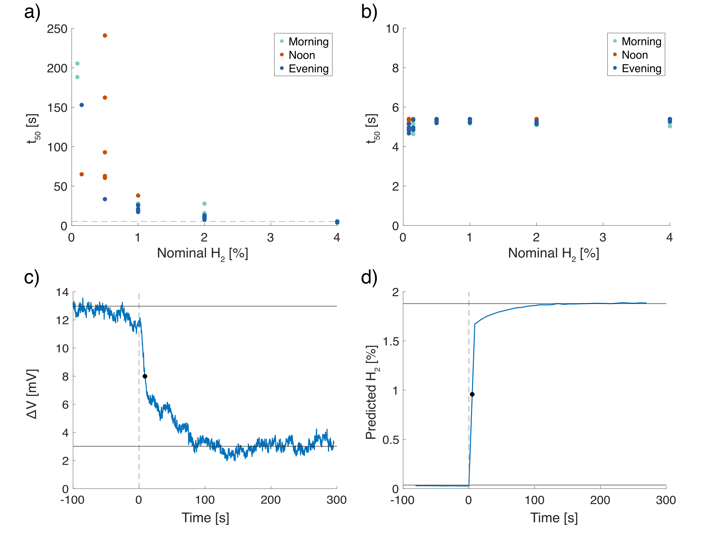
Figure S10. Comparison for the urban environment simulation (Figure 5 in main text) between the t₅₀ derived from a) the optical signal of the PdAuPt nanoparticle array and b) the model prediction, The response times from the model collapse to approximately one prediction time step and become nearly concentration independent. Representative time traces for a 2% H₂ pulse, showing c) the response directly from the optical signal of the PdAuPt nanoparticle array, and d) the predicted H₂ concentration as derived from the model. The black dot refers to the calculated t₅₀.
References
1 Open-Meteo. Historical Weather API, <https://open-meteo.com/en/docs/historical-weather-api> (January 2026).
2 Open-Meteo. Air Quality API, <https://open-meteo.com/en/docs/air-quality-api> (January 2026).
3 Tomeček, D. et al. Neural network enabled nanoplasmonic hydrogen sensors with 100 ppm limit of detection in humid air. Nature Communications, 1-15 (2024).
4 Martvall, V. et al. Accelerating Plasmonic Hydrogen Sensors for Inert Gas Environments by Transformer-Based Deep Learning. ACS Sensors (2025).
5 Theodoridis, A., Andersson, C., Nilsson, S., Fritzsche, J. & Langhammer, C. A Catalytic-Plasmonic Pt Nanoparticle Sensor for Hydrogen Detection in High-Humidity Environments. ACS Sens 10, 8983-8994 (2025).

