Supplementary material

Intrinsic capacity, domain-specific contributions, and longitudinal changes in relation to incident edentulism among middle-aged and older adults: a CHARLS longitudinal cohort study
Chengxi Li^{1†}, Xue Wang^{2†}, Jiasu Li¹,Yan Wang¹ , Weijian Song^{1*}
† Chengxi Li and Xue Wang contributed equally to this work
*Correspondence: Weijian Song, songwj@njmu.deu.cn
¹ Department of Stomatology, the Affiliated Suzhou Hospital of Nanjing Medical University, Suzhou Municipal Hospital, Suzhou 215000,China
² Department of Endodontics, Suzhou Stomatological Hospital, Suzhou 215000,China

Supplementary material Includes the Following:
Supplementary Figures (1-3)
Supplementary Tables (1-3)

Supplementary Table 1 Proportional hazards assumption test

Variable | chisq | df | P_value
ic_w1 | 0.002855339 | 1 | 0.957
gender | 2.515305795 | 1 | 0.113
education | 0.354401607 | 2 | 0.838
marital_status | 0.035370717 | 1 | 0.851
wealth_quartile | 2.864179239 | 4 | 0.581
rural | 1.306312799 | 1 | 0.253
smoke_ever | 0.241660342 | 1 | 0.623
drink_ever | 4.029994684 | 1 | 0.045
hypertension | 0.269085885 | 1 | 0.604
diabetes | 2.051512462 | 1 | 0.152
GLOBAL | 12.367409873 | 14 | 0.577
Schoenfeld residual tests were performed for the fully adjusted Cox model.
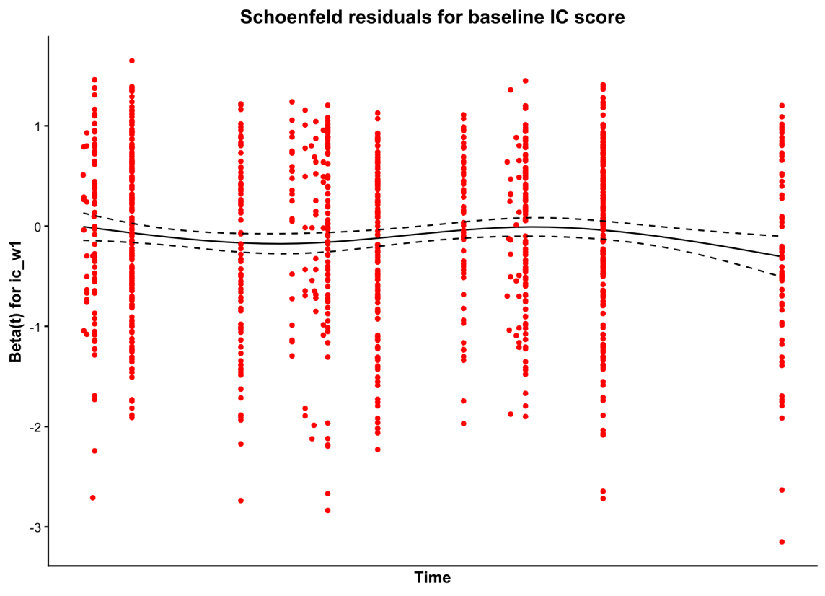
Supplementary Fig. 1 Schoenfeld residuals for baseline IC score

Supplementary Table 2 Sensitivity analyses for the association between baseline IC and incident edentulism

Analysis | N | Events | HR (95% CI) | P value
Main model | 8,282 | 1,064 | 0.913 (0.867-0.961) | <0.001
Age adjusted as continuous variable | 8,282 | 1,064 | 0.921 (0.874-0.971) | 0.002
Age modeled using natural cubic splines | 8,282 | 1,064 | 0.920 (0.873-0.969) | 0.002
Alternative age strata | 8,282 | 1,064 | 0.900 (0.854-0.947) | <0.001
Excluding Wave 2 events | 7,350 | 631 | 0.918 (0.858-0.983) | 0.014
Using reconstructed domain-sum IC | 8,271 | 1,063 | 0.912 (0.865-0.962) | <0.001
Multiple imputation | 8,381 | 1,074 | 0.917 (0.871-0.967) | 0.001
Competing-risk model treating death as competing event | 8,282 | 1,064 | 0.918 (0.872-0.966) | 0.001
The main model used age-stratified Cox regression. The competing-risk model treated death as a competing event using approximate death time based on CHARLS interview status when exact death date was unavailable.

Supplementary Table 3 Subgroup analyses for baseline intrinsic capacity and incident edentulism

Subgroup | Level | N | Events | HR (95% CI) | P value | P interaction
Sex | Male | 4,346 | 545 | 0.918 (0.852-0.990) | 0.026 | 0.867
Sex | Female | 4,035 | 529 | 0.909 (0.846-0.977) | 0.009 | 0.867
Age group | 45-54 | 3,434 | 192 | 1.065 (0.920-1.233) | 0.399 | 0.033
Age group | 55-64 | 3,322 | 480 | 0.851 (0.789-0.918) | <0.001 | 0.033
Age group | 65-74 | 1,345 | 312 | 0.973 (0.885-1.069) | 0.570 | 0.033
Age group | >=75 | 280 | 90 | 0.880 (0.733-1.057) | 0.171 | 0.033
Education | Low | 7,295 | 1,012 | 0.914 (0.867-0.963) | <0.001 | 0.829
Education | Middle/High | 1,086 | 62 | 0.929 (0.700-1.235) | 0.614 | 0.829
Marital status | Married/Partnered | 7,585 | 913 | 0.907 (0.856-0.960) | <0.001 | 0.486
Marital status | Unmarried/Other | 796 | 161 | 0.950 (0.836-1.081) | 0.439 | 0.486
Household wealth quartile | Q1 (Lowest) | 1,422 | 230 | 0.893 (0.805-0.991) | 0.032 | 0.995
Household wealth quartile | Q2 | 1,569 | 211 | 0.925 (0.828-1.033) | 0.166 | 0.995
Household wealth quartile | Q3 | 1,723 | 210 | 0.956 (0.845-1.081) | 0.468 | 0.995
Household wealth quartile | Q4 (Highest) | 1,599 | 169 | 0.943 (0.809-1.098) | 0.449 | 0.995
Household wealth quartile | Missing | 2,068 | 254 | 0.879 (0.786-0.982) | 0.023 | 0.995
Residence | Urban | 3,304 | 347 | 0.919 (0.836-1.010) | 0.080 | 0.949
Residence | Rural | 5,077 | 727 | 0.910 (0.855-0.969) | 0.003 | 0.949
Ever smoking | No | 4,863 | 601 | 0.885 (0.827-0.946) | <0.001 | 0.059
Ever smoking | Yes | 3,518 | 473 | 0.955 (0.881-1.036) | 0.270 | 0.059
Ever drinking | No | 4,863 | 647 | 0.897 (0.840-0.957) | <0.001 | 0.326
Ever drinking | Yes | 3,515 | 427 | 0.946 (0.868-1.032) | 0.214 | 0.326
Hypertension | No | 6,259 | 779 | 0.946 (0.890-1.006) | 0.079 | 0.182
Hypertension | Yes | 2,083 | 289 | 0.829 (0.752-0.914) | <0.001 | 0.182
Diabetes | No | 7,806 | 1,005 | 0.916 (0.868-0.966) | 0.001 | 0.940
Diabetes | Yes | 505 | 62 | 0.890 (0.720-1.099) | 0.279 | 0.940
All subgroup analyses evaluated baseline IC score as a continuous variable. Interaction P values were obtained using likelihood ratio tests comparing models with and without the IC-by-subgroup interaction term.

Supplementary Fig. 2 Subgroup analyses of baseline IC and incident edentulism
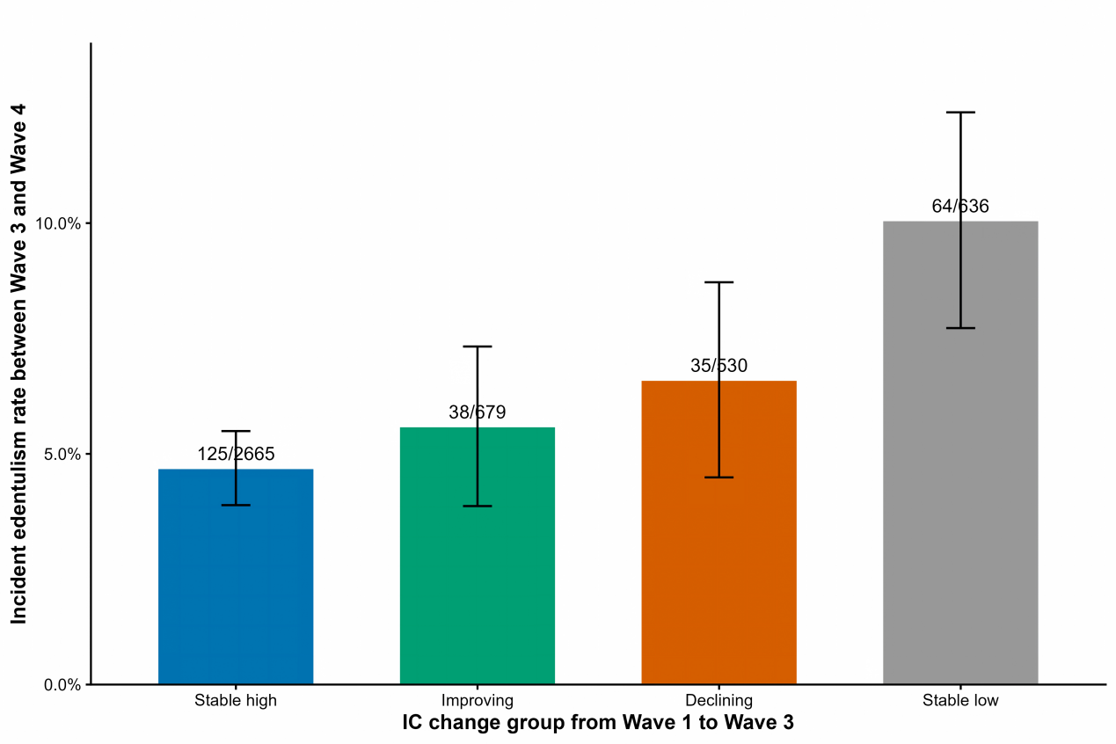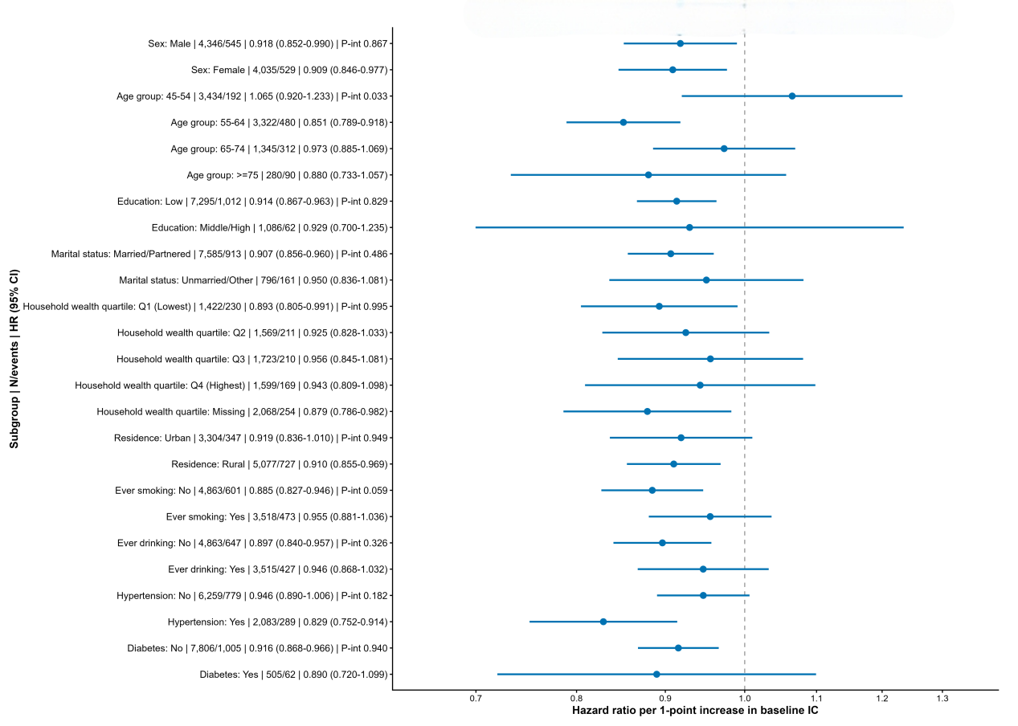

Supplementary Fig. 3 Wave 4 edentulism rate according to IC change group

