Optimized 3d printability and stability of low-methylated pectin-xyloglucan-cellulose nanocrystal composites
Smarak Bandyopadhyay^{† a}, Vadym Chibrikov^{† a}, Katarzyna Grygorczuk-Płaneta ª, Karolina Fila ª, Abitha Puzhakkara Veettil ª, Justyna Cybulska ª, Katarzyna Szewczuk-Karpisz ª, Artur Zdunek * ª
ª Institute of Agrophysics, Polish Academy of Sciences, ul. Doświadczalna 4, Lublin 20-290, Poland
† These authors contributed equally to this work
*corresponding author: Artur Zdunek, Institute of Agrophysics, Polish Academy of Sciences, Doświadczalna 4 Str., 20–290 Lublin, Poland, e-mail: a.zdunek@ipan.lublin.pl; phone: +48 817 445 061; fax: +48 817 445 067

M1. MATERIALS & METHODS
  - Chemical analysis of the commercial PCW materials:

1.1.1. HPLC analysis
1.1.1.1. Uronic acid content
The uronic acid content in pectin was determined using a Continuous Flow Analyser (CFA), SanPlus (Skalar, The Netherlands), according to the colourimetric method used by Blumenkrantz and Asboe-Hansen ¹. The samples were hydrolysed by 18 M sulfuric acid containing 12.5 mM di-sodium tetraborate and then reacted with m-hydroxydiphenyl solution to form a coloured dye, which was analysed at 530 nm. Galacturonic acid solutions were used as standards.
1.1.1.2. Monosaccharide composition
Pectin samples were hydrolysed in 13 M sulfuric acid for 30 min at 25°C and then in 1 M sulfuric acid for 2 h at 100 °C. Further, hydrolysed samples were derivatised to alditol acetates ² and analysed using GC-FID (Brevis GC-2050, Shimadzu) at 250 °C and He as a carrier gas. The SH-2330 capillary column (30 m x 0.25 mm x 0.20 µm, Shimadzu) was maintained at 190 °C for 4 min, increased to 230 °C at a rate of 4 °C/min, and held for 15 min. Inositol was used as an internal standard, and monosaccharide solutions were used as standards.
1.1.1.3. Degree of methylation
To determine the degree of methylation in pectins, the method of Levigne et al. ³ with some modifications by Yu et al. ⁴ was used. Five milligrams of the sample were treated with 0.2 M NaOH at 4 °C for 2 h, then neutralized with 0.2 M H₂SO₄, centrifuged, and filtered through a 0.22 μm syringe filter. The supernatant was analyzed by HPLC (Arc HPLC with 2414 RI detector, Waters, USA) using a C18 column (Lichrospher 100 RP-18e, 5 μm, 4 × 250 mm, Agilent, France) with a 20 µL injection volume, 4 mM H₂SO₄ as the mobile phase at a flow rate of 0.7 mL/min, and a column temperature of 25 °C. Methanol solutions were used as external standards to generate the calibration curve for quantifying samples.

1.1.2. Size-Exclusion Chromatography (SEC)
Samples (4.0 mg) were weighed into plastic centrifuge tubes and dissolved in 2.0 mL Milli-Q water to give a final concentration of 2.0 mg/mL. Each solution was vortexed for 2 min at 3000 rpm and placed on an orbital mixer for 24 h to ensure complete dissolution. Immediately prior to analysis, solutions were filtered through 0.45 µm nylon syringe filters directly into HPLC vials.
SEC measurements were carried out using an HPLC/SEC system equipped with three detectors: a multi-angle laser light scattering (MALLS) (DAWN, Wyatt, USA), a differential viscometer (ViscoStar, Wyatt, USA), and a refractive-index concentration detector (calibration constant 9.766 × 10⁻⁶, 410 mode, 2414 RI, Waters, USA). The mobile phase was 0.10 M acetate buffer containing 0.10 M sodium nitrate and was degassed and filtered before use. The mobile phase was delivered at a flow rate of 0.50 mL·min⁻¹. The column set, connected in series, consisted of an Ultrahydrogel Guard column (6 × 40 mm) followed by Ultrahydrogel 2000 (7.8 × 300 mm), Ultrahydrogel 1000 (7.8 × 300 mm), and Ultrahydrogel 250 (7.8 × 300 mm) (Waters, USA). Sample injections were 100 µL, and chromatographic runs were 150 min in duration.
Light-scattering data were analysed using the first-order Zimm model (fit degree = 1). A refractive-index increment (dn/dc) value of 0.146 mL·g⁻¹ was used for molecular weight and size calculations. Reported molar masses and size parameters were obtained from the combined RI and light-scattering signals according to standard Zimm analysis procedures, using ASTRA 8.2.2.119 software (Wyatt, USA).

References:
1. Blumenkrantz, N. & Asboe-Hansen, G. New method for quantitative determination of uronic acids. Analytical Biochemistry 54, 484–489 (1973).
2. Englyst, H. N. & Cummings, J. H. Improved Method for Measurement of Dietary Fiber as Non-Starch Polysaccharides in Plant Foods. J Assoc Off Anal Chem 71, 808–814 (1988).
3. Levigne, S., Thomas, M., Ralet, M.-C., Quemener, B. & Thibault, J.-F. Determination of the degrees of methylation and acetylation of pectins using a C18 column and internal standards. Food Hydrocolloids 16, 547–550 (2002).
4. Yu, Y. et al. Comparison of Analytical Methods for Determining Methylesterification and Acetylation of Pectin. Applied Sciences 11, 4461 (2021).

Table S1
Characterizations of carbohydrates used for ink formulations. Abbreviation of LMP stands for low methylated pectin; XG for xyloglucan; CNC for cellulose nanocrystals, Number Average Molecular Weight, M_{w}. Weight Average Molecular Weight, PDI. Polydispersity Index, R_{g}. Radius of Gyration, R_{h}. Hydrodynamic Radius, [η]_{n}. Number Average Intrinsic Viscosity, [η]_{w}. Weight Average Intrinsic Viscosity, NA for non-available data. Protocols for the plant cell wall polysaccharide analyses is provided in Chapter M1 of Supplementary Materials.
Parameter | Unit | LMP | XG | CNC
Chemical composition
Arabinose | mol% | 1.03 ± 0.05 | 1.63 ± 0.01 | 0.24 ± 0.01
Fucose | mol% | 0.08 ± 0.00 | 0.03 ± 0.00 | 0.04 ±0.00
Galactose | mol% | 4.19 ± 0.29 | 15.94 ± 0.01 | 0.13 ± 0.10
Glucose | mol% | 1.48 ± 010 | 51.69 ± 0.24 | 95.90 ± 0.03
Mannose | mol% | 0.12 ± 0.02 | 0.07 ± 0.01 | 0.57 ± 0.04
Rhamnose | mol% | 0.47 ± 0.01 | 0.39 ± 0.00 | 0.47 ± 0.03
Uronic acids | mol% | 91.45 ± 0.51 | 0.67 ± 0.13 | 0.67 ± 0.08
Xylose | mol% | 1.19 ± 0.04 | 29.58 ± 0.08 | 1.98 ± 0.04
Degree of methylation | % | 44.64 ± 2.12 | NA | NA
Degree of acetylation | % | 1.20±0.02 | NA | NA
Macromolecular properties
M_{n} | kDa | 55.5 ± 3.5 | 391.7 ± 14.3 | NA
M_{w} | kDa | 138.5 ± 10.9 | 415.7 ± 10.2 | NA
Polydispersity index (M_{n}/M_{w}) | a.u. | 2.4 ± 0.03 | 1.06 ± 0.01 | NA
Radius of gyration | nm | 37.1 ± 0.4 | 18.2 ± 1.9 | NA
Number-average intrinsic viscosity ${[η]}_{n}$ | mL/g | 190.20 ± 13.31 | 94.99 ± 20.19 | NA
Weight-average intrinsic viscosity ${[η]}_{w}$ | mL/g | 361.3 ± 19.95 | 98.12 ± 21.82 | NA
Viscometric hydrodynamic radius $rh{(ν)}_{z}$ | nm | 30.5 ± 1.4 | 19.1 ± 1.5 | NA
Conformation plot slope | a.u. | 0.28 ± 0.03 | 0.58 ± 0.04 | NA

Table S2:
The experimental design
Run | Factor 1: LM % (w/v) | Factor 2: XG % (w/v) | Factor 3: CNC % (w/v) | Response 1:  µ at 1s⁻¹ γ ̇ Pa.s | Response 2:  µ at 100s⁻¹ γ ̇ Pa.s | Response 3:  σy Pa
1 | 5.07 | 1.29 | 1.29 | 734.35 | 15.92 | 551.60
2 | 1.29 | 1.29 | 5.07 | 134.88 | 3.52 | 88.57
3 | 0.00 | 3.18 | 3.18 | 400.45 | 2.99 | 134.59
4 | 1.29 | 1.29 | 1.29 | 101.85 | 1.57 | 76.70
5 | 3.18 | 0.00 | 3.18 | 198.25 | 4.50 | 177.72
6 | 1.29 | 5.07 | 1.29 | 494.87 | 19.14 | 409.33
7 | 3.18 | 3.18 | 3.18 | 531.30 | 15.29 | 430.67
8 | 5.07 | 1.29 | 1.29 | 593.30 | 14.81 | 489.85
9 | 3.18 | 6.36 | 3.18 | 1941.10 | 36.97 | 1500.36
10 | 1.29 | 5.07 | 5.07 | 1173.95 | 27.56 | 1029.86
11 | 1.29 | 5.07 | 1.29 | 338.29 | 15.39 | 302.70
12 | 1.29 | 5.07 | 5.07 | 1072.46 | 25.55 | 937.44
13 | 1.29 | 1.29 | 5.07 | 202.62 | 4.92 | 163.71
14 | 3.18 | 3.18 | 3.18 | 733.22 | 19.54 | 622.25
15 | 5.07 | 1.29 | 5.07 | 1167.33 | 23.16 | 964.46
16 | 5.07 | 1.29 | 1.29 | 690.84 | 16.79 | 640.82
17 | 3.18 | 3.18 | 6.36 | 1169.45 | 27.23 | 1013.50
18 | 5.07 | 5.07 | 1.29 | 2344.03 | 32.09 | 2126.45
19 | 6.36 | 3.18 | 3.18 | 2359.92 | 20.94 | 1853.31
20 | 0.00 | 3.18 | 3.18 | 357.82 | 5.68 | 129.32
21 | 3.18 | 3.18 | 0.00 | 418.75 | 13.68 | 319.13
22 | 3.18 | 3.18 | 3.18 | 625.82 | 16.74 | 551.03
23 | 3.18 | 3.18 | 3.18 | 470.77 | 14.52 | 402.55
24 | 3.18 | 3.18 | 6.36 | 1196.50 | 27.66 | 1091.84
25 | 5.07 | 5.07 | 1.29 | 2126.94 | 31.13 | 1958.87
26 | 0.00 | 3.18 | 3.18 | 429.48 | 4.22 | 272.02
27 | 1.29 | 5.07 | 5.07 | 1055.33 | 23.94 | 987.84
28 | 6.36 | 3.18 | 3.18 | 2293.08 | 21.80 | 1677.87
29 | 5.07 | 1.29 | 5.07 | 954.79 | 18.45 | 748.49
30 | 3.18 | 3.18 | 0.00 | 402.64 | 13.12 | 317.07
31 | 1.29 | 1.29 | 5.07 | 174.62 | 4.26 | 122.11
32 | 1.29 | 1.29 | 1.29 | 155.83 | 2.22 | 98.41
33 | 3.18 | 3.18 | 3.18 | 478.85 | 14.61 | 414.82
34 | 5.07 | 1.29 | 5.07 | 1030.07 | 21.22 | 811.29
35 | 3.18 | 3.18 | 6.36 | 1127.61 | 24.68 | 904.51
36 | 3.18 | 0.00 | 3.18 | 196.86 | 4.25 | 159.48
37 | 3.18 | 0.00 | 3.18 | 230.52 | 4.91 | 174.07
38 | 5.07 | 5.07 | 1.29 | 2239.68 | 19.49 | 1746.38
39 | 3.18 | 6.36 | 3.18 | 1781.83 | 27.17 | 1488.38
40 | 1.29 | 1.29 | 1.29 | 151.50 | 2.04 | 110.44
41 | 5.07 | 5.07 | 5.07 | 2840.43 | 25.26 | 3286.72
42 | 3.18 | 3.18 | 3.18 | 671.68 | 16.96 | 521.48
43 | 5.07 | 5.07 | 5.07 | 3480.76 | 44.79 | 2767.54
44 | 1.29 | 5.07 | 1.29 | 365.55 | 16.10 | 336.56
45 | 3.18 | 3.18 | 0.00 | 414.89 | 14.07 | 338.38
46 | 3.18 | 6.36 | 3.18 | 1878.02 | 40.16 | 1685.40
47 | 5.07 | 5.07 | 5.07 | 3255.92 | 36.47 | 2388.08
48 | 6.36 | 3.18 | 3.18 | 2463.57 | 19.71 | 1918.18

Table S3
Analysis of variance for the quadratic model for ink formulation viscosity at low shear rate (µ at 1s⁻¹ γ ̇), high shear rate (µ at 100s⁻¹ γ ̇) and yield stress (σᵧ). Abbreviation LMP stands for low methylated pectin, XG for xyloglucan, CNC for cellulose nanocrystals, df for degree of freedom.
 | Source | Sum of squares | df | Mean square | F-value | p-value
µ at 1s⁻¹ γ ̇ | Model | 8314.83 | 9 | 923.87 | 226.09 | < 0.0001
 | A-LMP | 3869.42 | 1 | 3869.42 | 946.93 | < 0.0001
 | B-XG | 3280.95 | 1 | 3280.95 | 802.91 | < 0.0001
 | C-CNC | 628.91 | 1 | 628.91 | 153.91 | < 0.0001
 | AB | 108.56 | 1 | 108.56 | 26.57 | < 0.0001
 | AC | 0.3778 | 1 | 0.3778 | 0.0925 | 0.7627
 | BC | 79.32 | 1 | 79.32 | 19.41 | < 0.0001
 | A² | 337.43 | 1 | 337.43 | 82.57 | < 0.0001
 | B² | 66.73 | 1 | 66.73 | 16.33 | 0.0002
 | C² | 26.76 | 1 | 26.76 | 6.55 | 0.0146
 | Residual | 155.28 | 38 | 4.09
 | Lack of fit | 78.01 | 5 | 15.60 | 6.66 | 0.0002
 | Pure error | 77.27 | 33 | 2.34
µ at 100s⁻¹ γ ̇ | Model | 33.89 | 9 | 3.77 | 138.44 | < 0.0001
 | A-LM | 11.35 | 1 | 11.35 | 417.27 | < 0.0001
 | B-XG | 15.54 | 1 | 15.54 | 571.40 | < 0.0001
 | C-CNC | 1.78 | 1 | 1.78 | 65.49 | < 0.0001
 | AB | 3.24 | 1 | 3.24 | 119.24 | < 0.0001
 | AC | 0.1710 | 1 | 0.1710 | 6.29 | 0.0166
 | BC | 0.0550 | 1 | 0.0550 | 2.02 | 0.1634
 | A² | 0.9566 | 1 | 0.9566 | 35.17 | < 0.0001
 | B² | 0.1835 | 1 | 0.1835 | 6.75 | 0.0133
 | C² | 0.1252 | 1 | 0.1252 | 4.60 | 0.0384
 | Residual | 1.03 | 38 | 0.0272
 | Lack of fit | 0.1362 | 5 | 0.0272 | 1.00 | 0.4323
 | Pure error | 0.8975 | 33 | 0.0272
σᵧ | Model | 7575.63 | 9 | 841.74 | 173.98 | < 0.0001
 | A-LM | 3610.79 | 1 | 3610.79 | 746.31 | < 0.0001
 | B-XG | 3056.22 | 1 | 3056.22 | 631.68 | < 0.0001
 | C-CNC | 575.41 | 1 | 575.41 | 118.93 | < 0.0001
 | AB | 86.34 | 1 | 86.34 | 17.85 | 0.0001
 | AC | 0.0064 | 1 | 0.0064 | 0.0013 | 0.9712
 | BC | 83.51 | 1 | 83.51 | 17.26 | 0.0002
 | A² | 144.55 | 1 | 144.55 | 29.88 | < 0.0001
 | B² | 80.87 | 1 | 80.87 | 16.72 | 0.0002
 | C² | 40.30 | 1 | 40.30 | 8.33 | 0.0064
 | Residual | 183.85 | 38 | 4.84
 | Lack of fit | 64.43 | 5 | 12.89 | 3.56 | 0.0110
 | Pure error | 119.42 | 33 | 3.62

Table S4:
Fit Statistics of the Model
 | µ at 1s⁻¹ γ ̇ | µ at 100s⁻¹ γ ̇ | σy
Std. Dev. | 2.02 | 0.1649 | 2.20
Mean | 29.30 | 2.61 | 26.42
C.V. % | 6.90 | 6.32 | 8.33
R² | 0.9817 | 0.9704 | 0.9763
Adjusted R² | 0.9773 | 0.9634 | 0.9707
Predicted R² | 0.9706 | 0.9523 | 0.9619
Adeq Precision | 48.9559 | 37.9437 | 43.3723
Lack of Fit (p-values) | 0.0002 | 0.4323 | 0.0110

Table S5:
Coefficient table showing the coefficient estimate for the coded model term and the p-value for that coefficient
 | Intercept | A | B | C | AB | AC | BC | A² | B² | C²
µ at 1s⁻¹ γ ̇ | 24.1653 | 9.71823 | 8.94877 | 3.91794 | 2.12681 | 0.125467 | 1.81797 | 3.48438 | 1.54955 | 0.981258
p-values |  | < 0.0001 | < 0.0001 | < 0.0001 | < 0.0001 | 0.7627 | < 0.0001 | < 0.0001 | 0.0002 | 0.0146
µ at 100s⁻¹ γ ̇ | 2.77995 | 0.526339 | 0.615926 | 0.208519 | -0.367621 | -0.0844127 | -0.0478528 | -0.185522 | -0.0812509 | 0.0671218
p-values |  | < 0.0001 | < 0.0001 | < 0.0001 | < 0.0001 | 0.0166 | 0.1634 | < 0.0001 | 0.0133 | 0.0384
σy | 21.9903 | 9.38782 | 8.63687 | 3.7476 | 1.89672 | 0.0163136 | 1.86534 | 2.28059 | 1.70583 | 1.20421
p-values |  | < 0.0001 | < 0.0001 | < 0.0001 | 0.0001 | 0.9712 | 0.0002 | < 0.0001 | 0.0002 | 0.0064

Table S6:
Solution based on optimization
Number | LM | XG | CNC | µ at  1s-1 γ ̇ | µ at 100s-1 γ ̇ | σy | Desirability
1 | 5.0737 | 5.0737 | 5.0737 | 3233.88 | 31.3368 | 2784.95 | 0.956 | Selected
2 | 5.07369 | 5.0737 | 5.07369 | 3233.88 | 31.3368 | 2784.95 | 0.956
3 | 5.07369 | 5.07369 | 5.0737 | 3233.86 | 31.3369 | 2784.93 | 0.956
4 | 5.05839 | 5.0737 | 5.07369 | 3216.51 | 31.4118 | 2771.44 | 0.953
5 | 5.0737 | 5.05439 | 5.07367 | 3215.36 | 31.3244 | 2767.96 | 0.952
6 | 5.0737 | 5.07369 | 5.02094 | 3209.21 | 31.1551 | 2761.46 | 0.951
7 | 5.0737 | 5.02767 | 5.07368 | 3189.9 | 31.3064 | 2744.63 | 0.948
8 | 5.03124 | 5.07359 | 5.0737 | 3185.85 | 31.5432 | 2747.57 | 0.947
9 | 5.0737 | 5.04397 | 5.01216 | 3176.91 | 31.1053 | 2731.72 | 0.945
10 | 5.07369 | 5.0737 | 4.9392 | 3171.52 | 30.8819 | 2725.65 | 0.944
11 | 5.07369 | 5.05582 | 4.94377 | 3156.76 | 30.8846 | 2712.2 | 0.942
12 | 5.0737 | 4.95666 | 5.07283 | 3122.67 | 31.2506 | 2683.06 | 0.935
13 | 5.07369 | 5.07369 | 4.82862 | 3121.54 | 30.5283 | 2678.31 | 0.935
14 | 4.96894 | 5.07369 | 5.0737 | 3116.96 | 31.8379 | 2693.81 | 0.934
15 | 5.07369 | 4.93685 | 5.07369 | 3104.62 | 31.2377 | 2666.56 | 0.932
16 | 4.95455 | 5.0737 | 5.07004 | 3099.58 | 31.8912 | 2679.93 | 0.931
17 | 5.0731 | 4.90565 | 5.07369 | 3075.12 | 31.214 | 2639.69 | 0.927
18 | 5.0737 | 4.93115 | 5.01811 | 3074.35 | 31.0389 | 2637.97 | 0.927
19 | 5.0737 | 5.0737 | 4.71785 | 3072.61 | 30.192 | 2632.16 | 0.926
20 | 4.92098 | 5.0737 | 5.07367 | 3064.94 | 32.0577 | 2653.08 | 0.925
21 | 4.90297 | 5.06799 | 5.07369 | 3040.4 | 32.1318 | 2633.1 | 0.920
22 | 5.0737 | 5.07369 | 4.63533 | 3036.89 | 29.9529 | 2598.58 | 0.920
23 | 5.07369 | 5.07271 | 4.60913 | 3024.8 | 29.8782 | 2587.26 | 0.917
24 | 5.07369 | 4.93259 | 4.88868 | 3018.58 | 30.6067 | 2585.06 | 0.916
25 | 4.8501 | 5.07369 | 5.07369 | 2989.77 | 32.3713 | 2593.99 | 0.911
26 | 5.07369 | 4.79478 | 5.07369 | 2975.09 | 31.107 | 2548.29 | 0.908
27 | 5.07369 | 5.07369 | 4.46884 | 2966.71 | 29.499 | 2532.9 | 0.907
28 | 5.0737 | 5.0737 | 4.45503 | 2961.01 | 29.4631 | 2527.59 | 0.905
29 | 4.78874 | 5.07369 | 5.07367 | 2926.28 | 32.6315 | 2543.89 | 0.899
30 | 5.07369 | 5.07368 | 4.20268 | 2859.58 | 28.85 | 2433.46 | 0.886
31 | 5.07369 | 5.0737 | 4.09011 | 2816.12 | 28.6027 | 2393.42 | 0.878
32 | 5.0737 | 5.0737 | 4.0134 | 2787.11 | 28.4431 | 2366.8 | 0.872
33 | 5.0737 | 5.07356 | 3.89778 | 2744.18 | 28.2159 | 2327.56 | 0.864
34 | 5.07369 | 5.07369 | 3.88284 | 2738.84 | 28.1879 | 2322.69 | 0.863
35 | 5.07369 | 4.49849 | 5.06948 | 2718.03 | 30.7302 | 2314.63 | 0.859
36 | 5.0737 | 4.42058 | 5.07369 | 2655.77 | 30.6309 | 2258.38 | 0.847
37 | 5.0737 | 5.07369 | 3.58849 | 2635.11 | 27.6856 | 2228.76 | 0.842
38 | 4.47989 | 5.0737 | 5.06581 | 2625.24 | 33.7395 | 2302.98 | 0.840
39 | 4.42509 | 5.0737 | 5.0737 | 2579.37 | 33.9443 | 2266.44 | 0.831
40 | 5.07369 | 5.0737 | 3.41149 | 2576.02 | 27.4308 | 2175.83 | 0.831
41 | 5.07369 | 5.0737 | 3.39757 | 2571.47 | 27.4122 | 2171.77 | 0.830
42 | 5.0737 | 5.07367 | 3.1346 | 2488.33 | 27.1007 | 2098.15 | 0.813
43 | 4.26544 | 5.0737 | 5.0737 | 2442.02 | 34.388 | 2154.63 | 0.803
44 | 5.0737 | 5.0737 | 2.64404 | 2346.76 | 26.7135 | 1975.28 | 0.783
45 | 5.07369 | 5.0737 | 2.62545 | 2341.72 | 26.7037 | 1970.98 | 0.782
46 | 5.07369 | 5.0737 | 2.60066 | 2335.04 | 26.6911 | 1965.28 | 0.781
47 | 5.07368 | 5.07368 | 2.13631 | 2217.61 | 26.5699 | 1866.67 | 0.756
48 | 3.92576 | 5.07369 | 5.0737 | 2177.65 | 35.0418 | 1935.64 | 0.747
49 | 5.07369 | 5.07369 | 1.93043 | 2170.06 | 26.585 | 1827.75 | 0.745
50 | 5.0737 | 5.0737 | 1.9101 | 2165.51 | 26.5888 | 1824.07 | 0.744
51 | 5.07369 | 5.07369 | 1.80178 | 2141.69 | 26.616 | 1804.86 | 0.739
52 | 5.0737 | 5.07369 | 1.78479 | 2138.02 | 26.6213 | 1801.92 | 0.738
53 | 5.0737 | 5.07368 | 1.6836 | 2116.52 | 26.659 | 1784.79 | 0.733
54 | 5.0737 | 5.0737 | 1.4899 | 2077.12 | 26.76 | 1753.83 | 0.725
55 | 5.07369 | 5.07369 | 1.47148 | 2073.49 | 26.7715 | 1751.01 | 0.724
56 | 5.0737 | 5.07349 | 1.41407 | 2062.18 | 26.8095 | 1742.25 | 0.721
57 | 5.0737 | 5.0737 | 1.32638 | 2045.59 | 26.8749 | 1729.54 | 0.717
58 | 5.0737 | 5.07369 | 1.3099 | 2042.49 | 26.888 | 1727.18 | 0.717
59 | 4.97568 | 5.0737 | 1.28989 | 1953.17 | 27.0697 | 1657.5 | 0.696
60 | 3.58939 | 5.0737 | 5.0737 | 1950.29 | 35.2833 | 1742.44 | 0.696
61 | 2.96162 | 5.0737 | 5.0737 | 1606.38 | 34.6346 | 1438.16 | 0.612
62 | 2.79149 | 5.0737 | 5.07369 | 1529.24 | 34.2192 | 1367.11 | 0.592

Table S7

CIE L*a*b* and whiteness index of the ink formulations. Abbreviation LMP stands for low methylated pectin; XG for xyloglucan; CNC for cellulose nanocrystals; L* for lightness; a* for green-red axis value; b* for blue-yellow axis value; ΔE for total color difference; WI for whiteness index,
Ink formulations | $$L^{*}$$ | $$a^{*}$$ | $$b^{*}$$ | $$∆E$$ | WI
3% (LMP-XG-CNC) | 46.44 | - 0.079 | 5.73 | 21.31 | 46.14
5% (LMP-XG-CNC) | 59.95 | 1.00 | 9.70 | 33.13 | 58.77

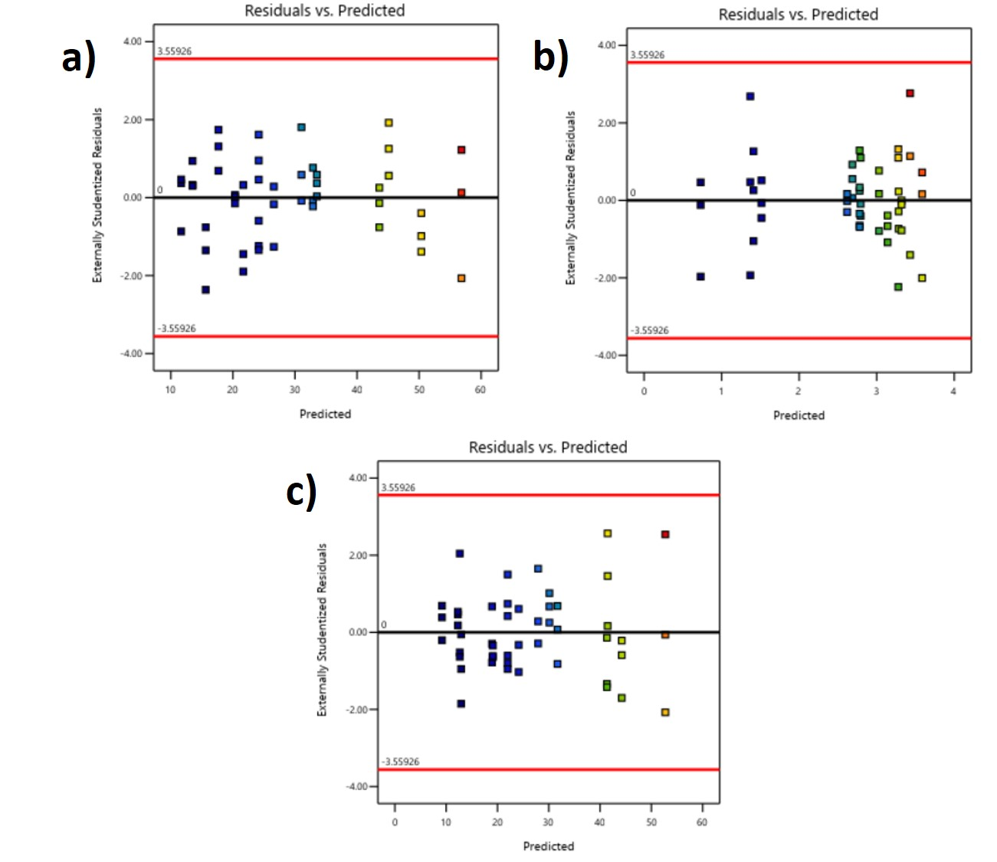
Figure F1: Residuals-versus-predicted plots of the standardized residual for (a) viscosity at low shear rate (µ at 1s⁻¹ γ ̇), (b) high shear rate (µ at 100s⁻¹ γ ̇) and (c) yield stress (σᵧ), generated by Design-Expert

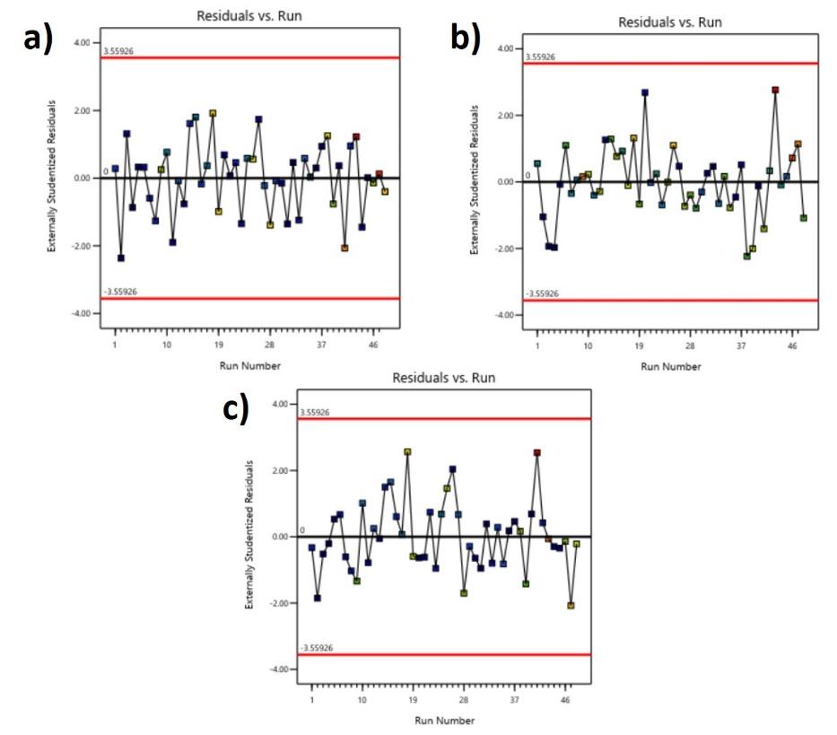
Figure F2: Residuals-verses-run plots of the standardized residual for (a) viscosity at low shear rate (µ at 1s⁻¹ γ ̇), (b) high shear rate (µ at 100s⁻¹ γ ̇) and (c) yield stress (σᵧ), generated by Design-Expert

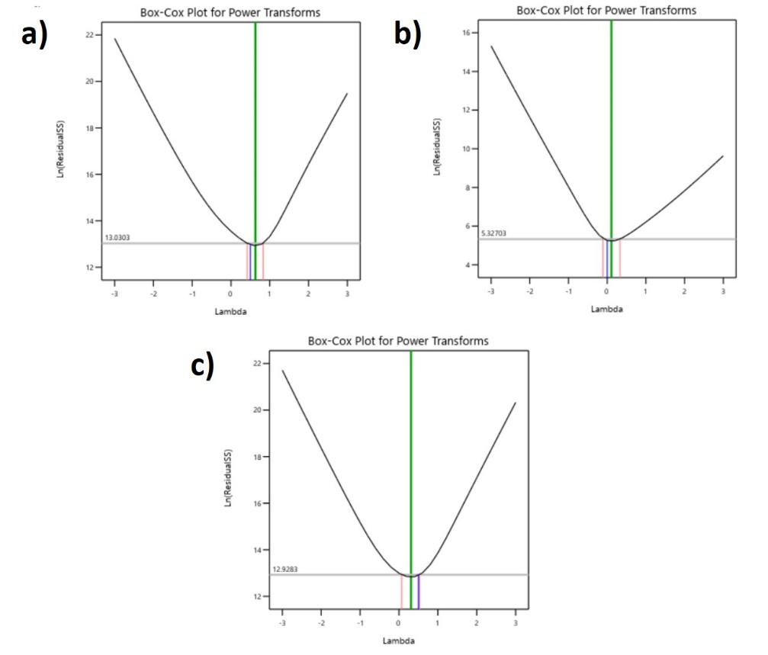
Figure F3: Box-Cox plots of the standardized residual for (a) viscosity at low shear rate (µ at 1s⁻¹ γ ̇), (b) high shear rate (µ at 100s⁻¹ γ ̇) and (c) yield stress (σᵧ), generated by Design-Expert

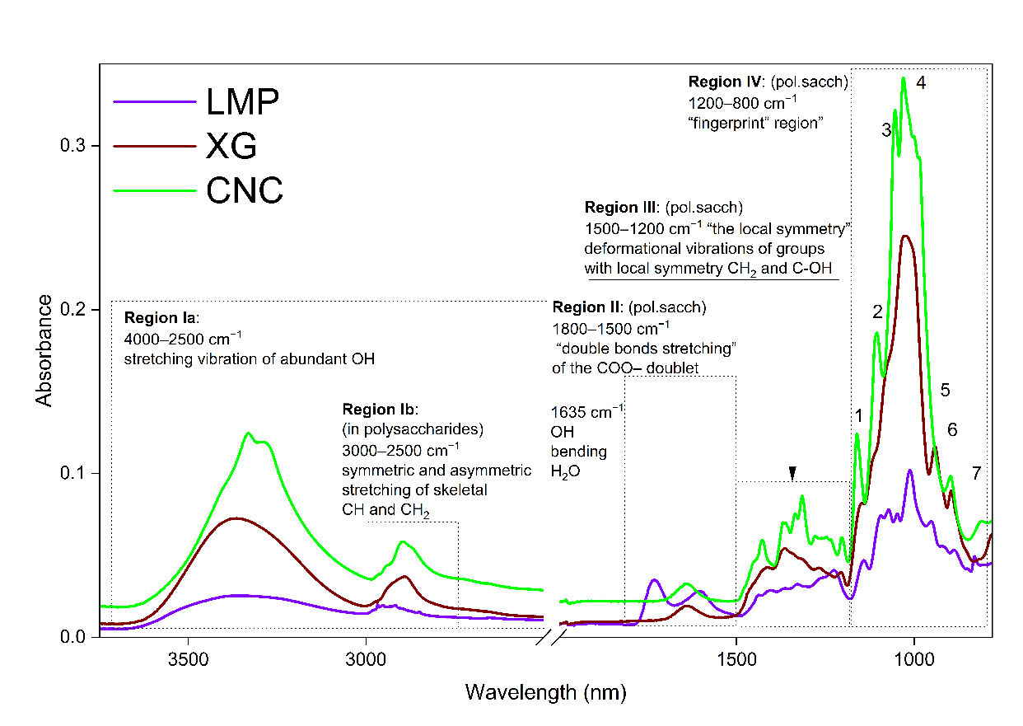
Figure F4: FTIR spectra of raw materials used

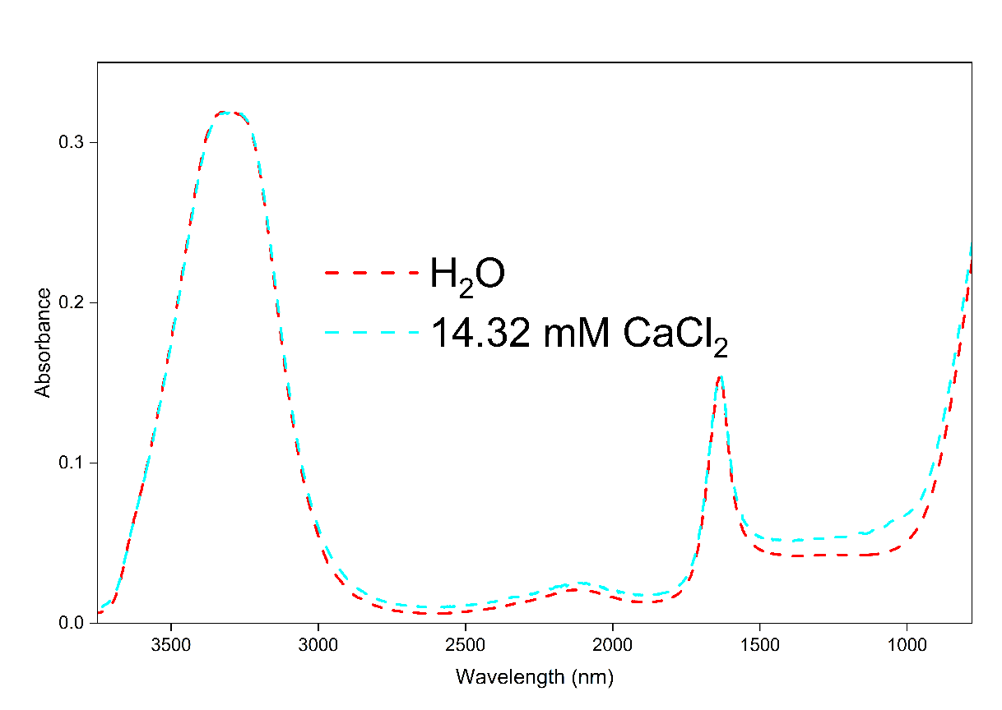
Figure F5: FTIR spectra of the liquid components involved in the study

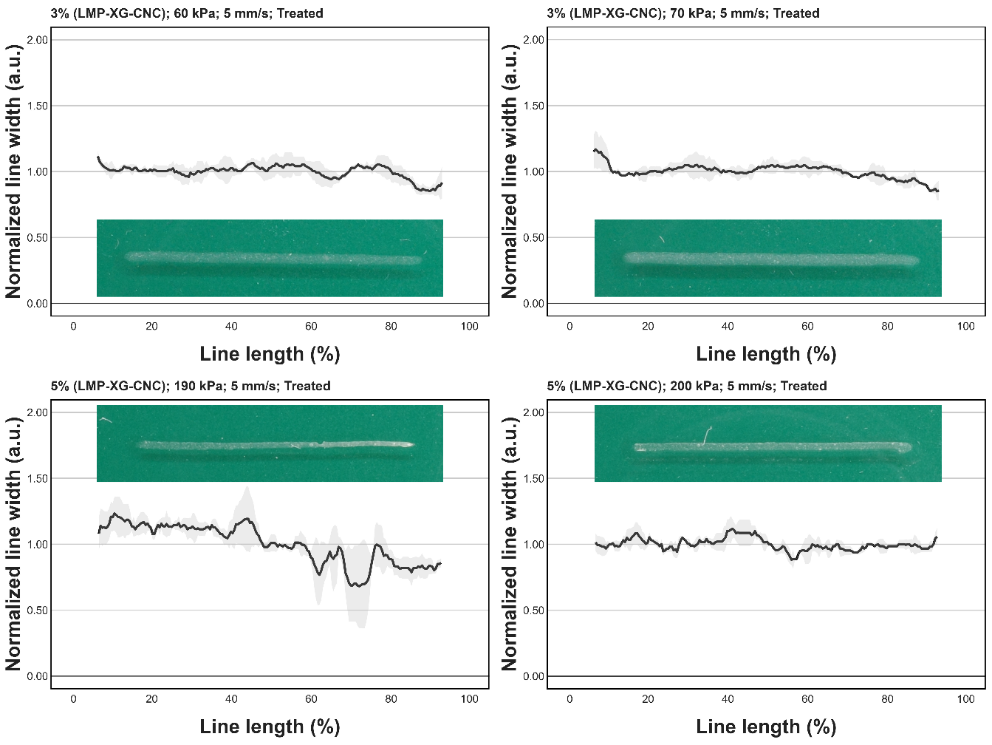
Figure F6 Normalized width of 3D biomaterial printed lines as a function of relative line length. The black line represents the mean normalized width at each relative line length point, while the grey area represents the standard deviation of the distribution. In subsequent subfigures, images represent exemplary printed lines. Abbreviation CNC stands for cellulose nanocrystals; LMP for low-methylated pectin; XG for xyloglucan.

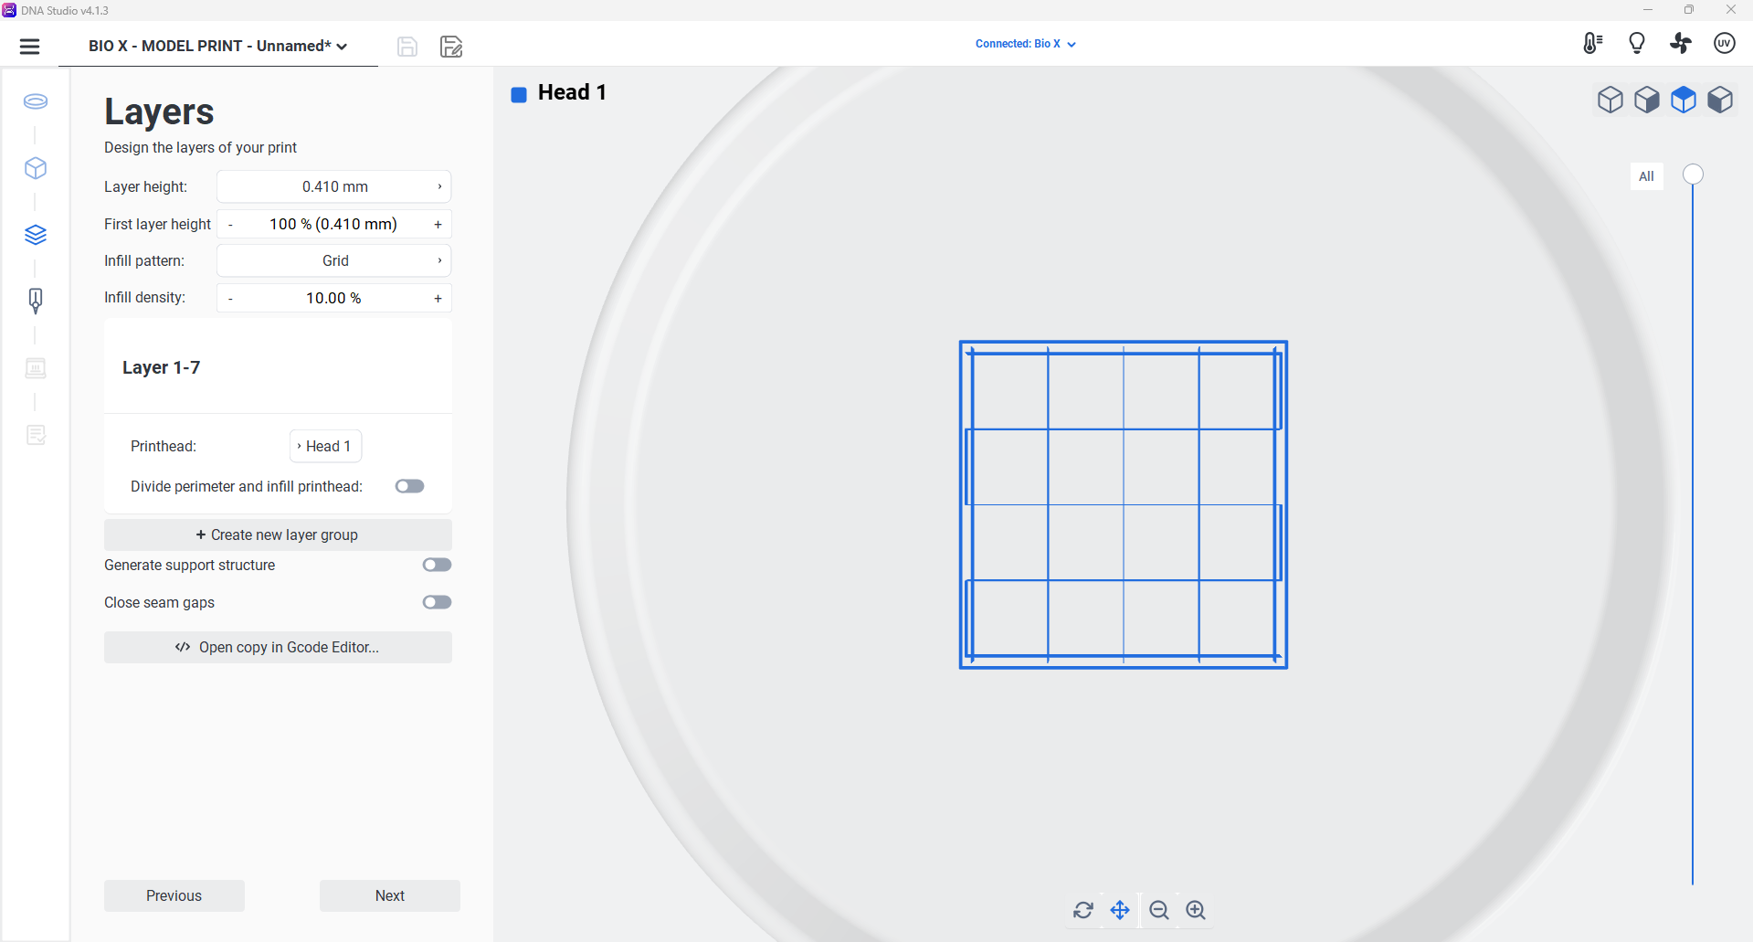
Figure F7 Digital model configuration and layer parameters for the biomaterial printing of a grid. The DNA Studio v4.1.3 interface illustrates the layer-by-layer design with a defined layer height of 0.410 mm, the same, yet adjustable first layer height, and a 10% grid infill density.

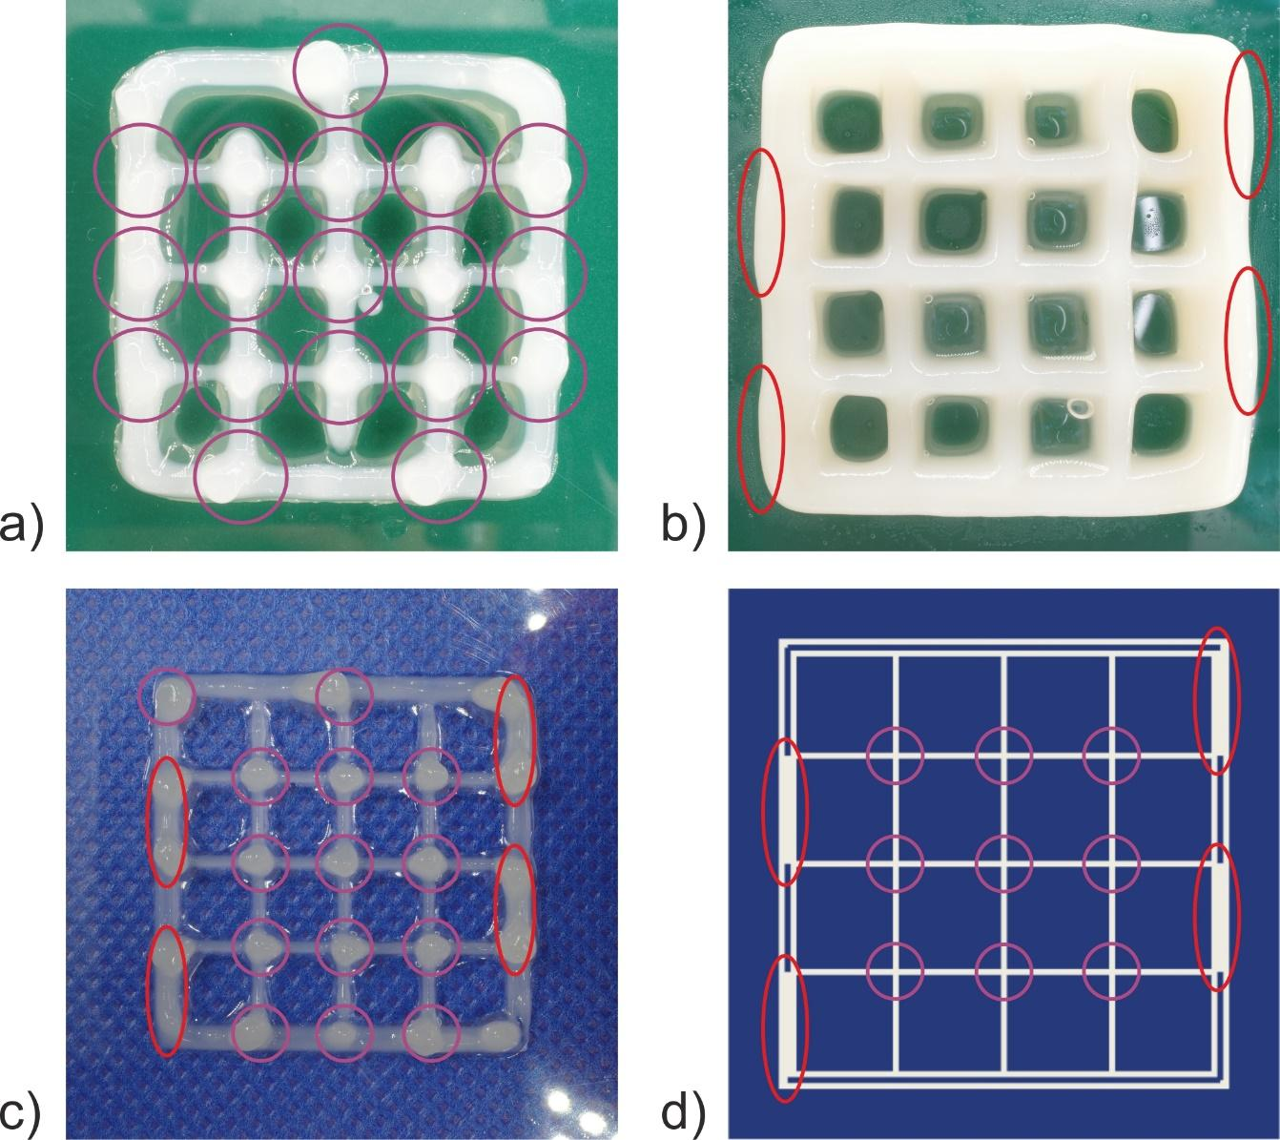
Figure F8 Visual representation of a grid and pore deformation loci: a) grid and pore deformation loci induced by a printing protocol (purple); b) grid and pore deformation loci induced by an overlaying structures (red); c) grid and pore deformation loci induced by a printing protocol (purple), and an overlaying structures (red); d) model structure with aforementioned marked regions.

