Supplementary Information

A quantitative FLIM-FRET framework to measure chromatin compaction with extended dynamic range and functional correlation

Simone Civita,ª Paolo Faraci,^{b} Alberto Leggio,ª Sofia Cristiani,ª Martina Ruglioni,ª Beatrice Polini,ª Benedetta Masciulli,ª Vittoria Carnicelli,ª Matteo Mariangeli,^{c} Francesco Garzella,ª Paolo Bianchini,^{d} Alberto Diaspro,^{d,e} Grazia Chiellini,ª Barbara Storti,^{f,§,}* Ranieri Bizzarri^{a,f,g,§,}*

ªDepartment of Surgical, Medical and Molecular Pathology, and Critical Care Medicine, University of Pisa, Via Roma 65, 56126 Pisa, Italy
^{b}NEST, Scuola Normale Superiore, piazza San Silvestro 12, 56126 Pisa, Italy
^{c}Nanomedicine and Molecular Biology Lab, Dept. of Biology, University of Pisa, S.S. 12 Abetone e Brennero 4, 56127, Pisa, Italy
^{d}Nanoscopy, Istituto Italiano di Tecnologia, Via E. Melen 83, 16152 Genova, Italy
^{e}DIFILAB, Dipartimento di Fisica, Università degli Studi di Genova, Via Dodecaneso 33, 16146 Genova, Italy
^{f}Istituto Nanoscienze – CNR, NEST-SNS, Piazza San Silvestro 12, 56126 Pisa, Italy
^{g}Center for Instrument Sharing of the University of Pisa (CISUP), University of Pisa, Largo Bruno Pontecorvo, 3, 56127 Pisa, Italy

¶ Co-first authorship
§ Co-last authorship
* Corresponding authors: Barbara Storti and Ranieri Bizzarri
Email: barbara.storti@nano.cnr.it, ranieri.bizzarri@unipi.it

1. Inclusion of an explicit sensitized FRET term in the HS-model
As already stated, our treatment generalizes the former HS-FLIM model by including a non-negligible FRET component in the calculus of the A/D concentration ratio, i.e. the term $φ\left[1-τ'(x,y)\right]$ in Eq. (17) of main text. If $A_{0}^{*}$ is the compaction parameter assuming negligible FRET (as, in Pelicci et al. [1]), a little algebra leads to the relative deviation ${eA}_{0}$ from $A_{0}$ (as calculated by Eq. (17), main text):

$$eA_{0}=\left(\frac{A_{0}-A_{0}^{*}}{A_{0}}\right)=\left[\frac{φE}{\left(I_{r}-β\right)\left(1-E\right)}\right]$$ | (S1)

Note that pixel dependency was dropped for simplicity of notation. Figure S1 shows $eA_{0}$ vs. E for $I_{r}$ ranging from 0.4 to 20, using $φ$=0.61 and $β$=0.25, i.e. the typical values found in our setup. $eA_{0}$ becomes significant even for low FRET values unless $I_{r}$ is quite large. Yet, large $I_{r}$ implies a large A/D, which in turn should generate a significant FRET unless the chromatin compaction is low. Narrowing the spectral window of A emission, i.e. reducing both $β$ and $φ$, has no real effect either, since this inevitably leads to a reduction of $I_{r}$ together with a degradation of the S/N ratio of the measurement. We conclude that (17) significantly extends the application range of HS-FLIM with only a modest increase in the complexity of the equation that defines $A_{0}$ and no additional experimental burden.

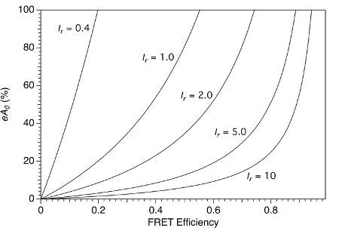
Figure S1. Deviation of the compaction parameter A₀, calculated using the full HS-Lifetime model, from the value obtained by neglecting the sensitized FRET emission in the acceptor channel. Different FRET efficiencies and ratios between the intensities collected in the acceptor and donor channels are explored.

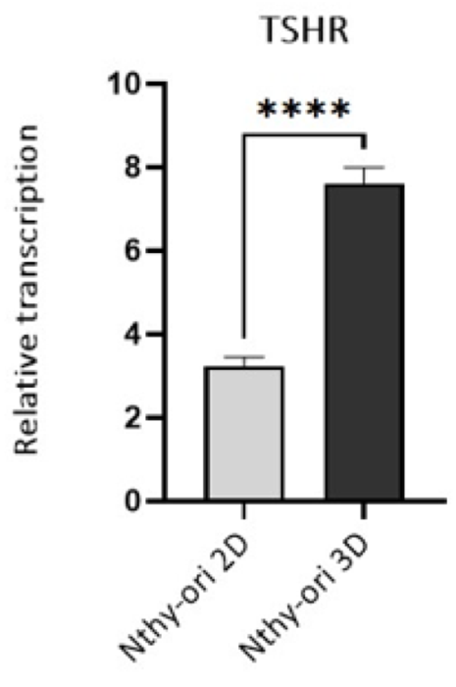
Figure S2. Gene expression of thyroid marker TSHR in 2D and 3D cultures of NTHY by qRT-PCR. 2D and 3D culture sample data were normalized to internal reference control (GAPDH). The results are expressed as mean± SEM, 3 measurements. Statistical analysis was performed through Student’s t-test, with significant p values: p≤0.05 (*), p≤0.01 (**), p≤0.001 (***), p≤0.0001 (****).

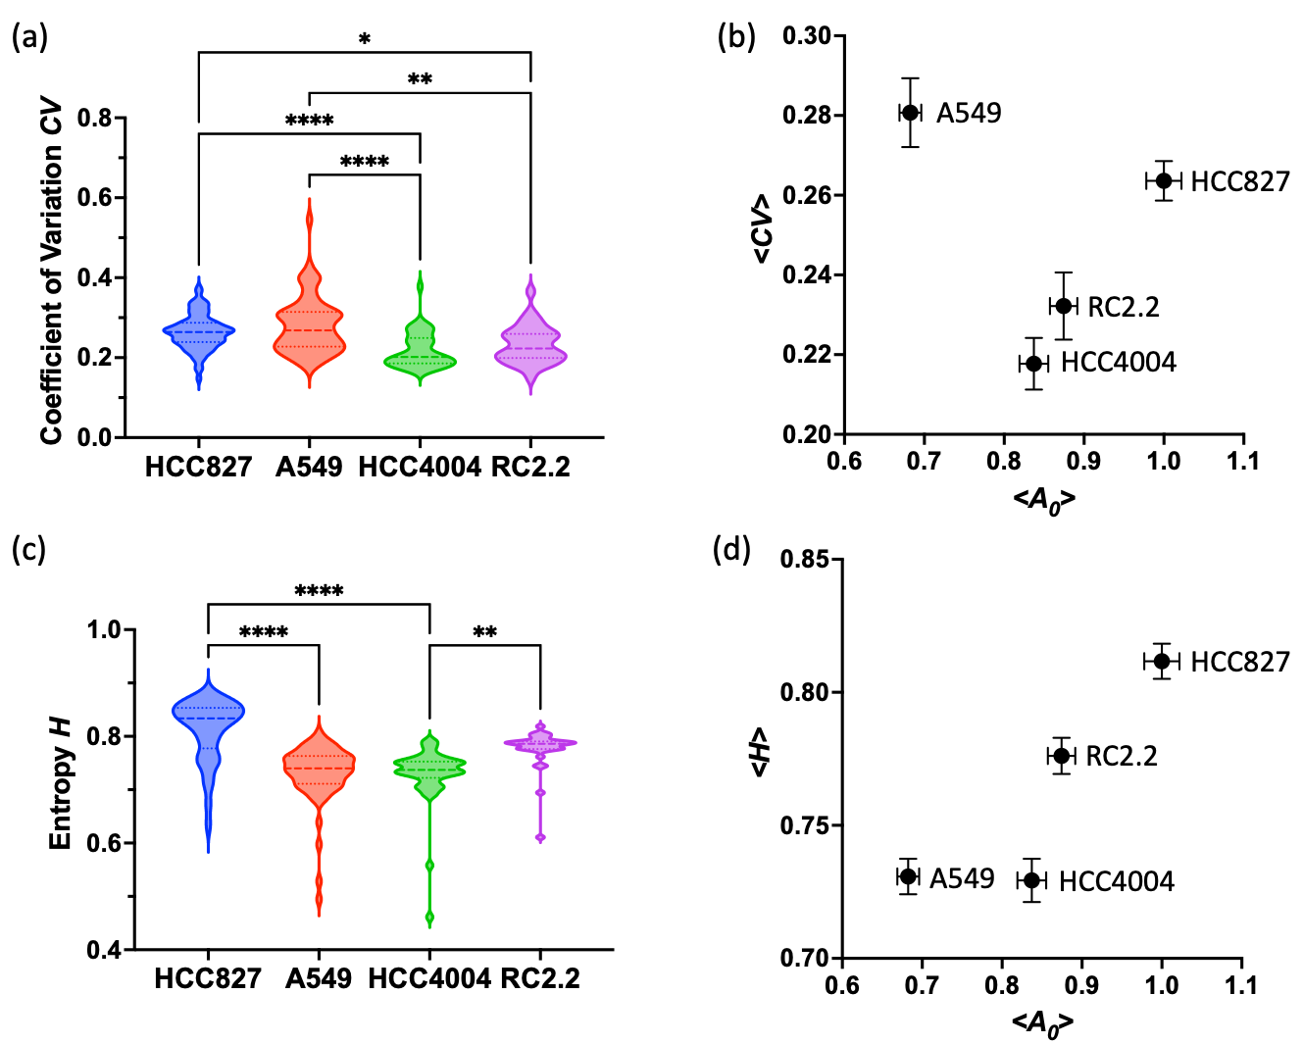

Figure S3. (Relationship between the chromatin compaction parameter A₀ and the descriptors of chromatin organization CV (coefficient of variation) and H (Shannon entropy) in NSCLC cells. (a) Distribution of CV. (b) Plot of cell-averaged <CV> vs. cell-averaged <A₀>; HCC827: <CV> =0.264±0.005, 77 cells; A549: <CV> =0.281±0.009, 65 cells; RCC4004: <CV> =0.218±0.006, 45 cells; RC2.2: <CV> =0.232±0.008, 31 cells; (c) Distribution of H. (d) Plot of cell-averaged <H> vs. cell-averaged <A₀>; HCC827: <H>=0.812±0.007, 77 cells; A549: <H>=0.731±0.007, 65 cells; HCC4004: <H>=0.729±0.008, 45 cells; RC2.2: <H>=0.776±0.007, 31 cells. SEM values are reported as errors and error bars. Statistical analysis was performed through multiple Student’s t-test, with significant p values: p≤0.05 (*), p≤0.01 (**), p≤0.001 (***), p≤0.0001 (****).

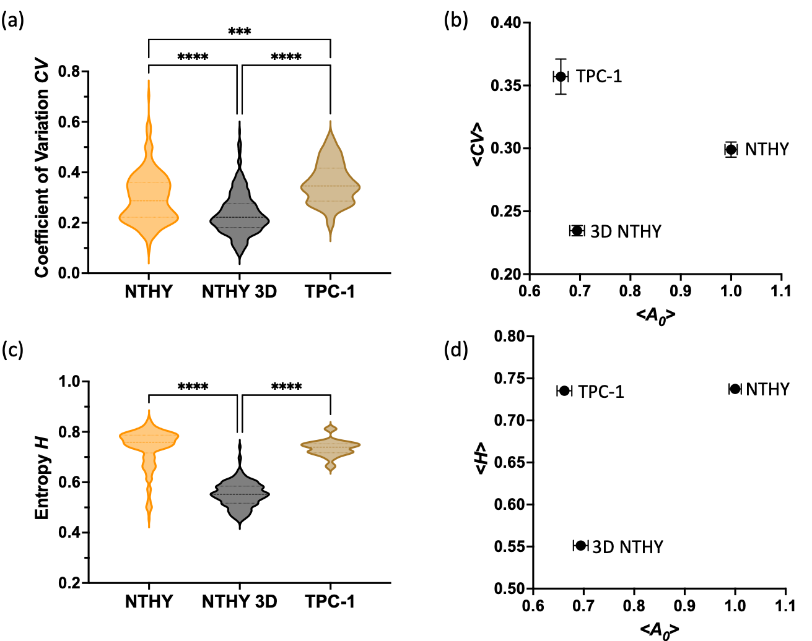

Figure S4. Relationship between the chromatin compaction parameter A₀ and the descriptors of chromatin organization CV (coefficient of variation) and H (Shannon entropy) in Thyroid cells. (a) Distribution of CV.. (b) Plot of cell-averaged <CV> vs. cell-averaged <A₀>; NTHY: <CV> =0.30±0.01, 260 cells; 3D NTHY: <CV> =0.24±0.04, 399 cells; TPC-1: <CV> =0.36±0.04, 32 cells. (c) Distribution of H. (d) Plot of cell-averaged <H> vs. cell-averaged <A₀>; NTHY: <H>=0.737±0.005, 260 cells; 3D NTHY: <H>=0.551±0.002, 399 cells; TPC-1: <H>=0.735±0.006, 32 cells. SEM values are reported as errors and error bars. Statistical analysis was performed through multiple Student’s t-test, with significant p values: p≤0.05 (*), p≤0.01 (**), p≤0.001 (***), p≤0.0001 (****).

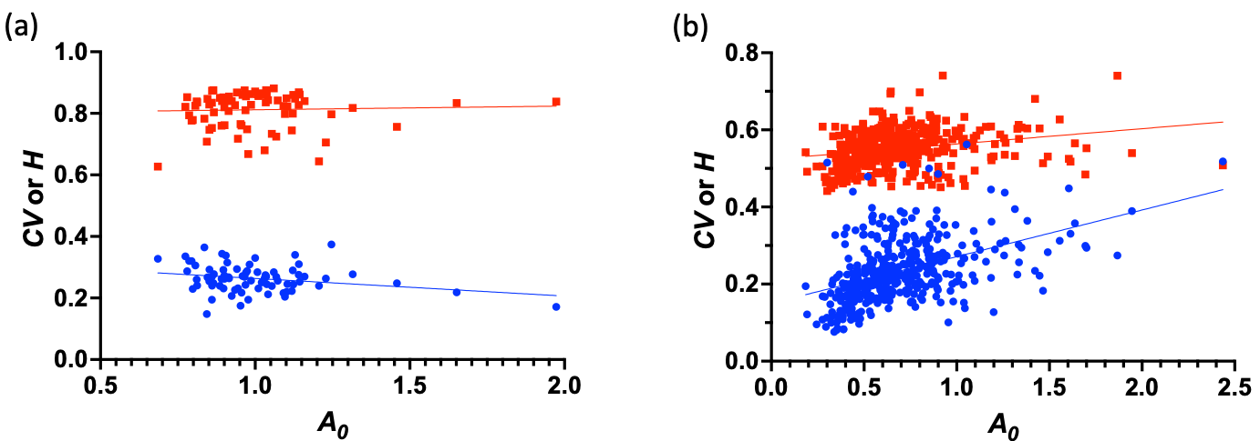

Figure S5. Plot of CV (blue full circles) or H (red full squares) vs. A₀ for HCC827 (a) and 3D NTHY (b). Each value corresponds to a nucleus. Linear regressions of data are added to highlight qualitatively the degree of correlation between data. Actual correlations were analyzed by a nucleus-wise Spearman non-parametric test. CV vs. A₀ : HCC827 S=-0.19, p=0.11; A549 S=-0.27, p=0.03; HCC4004 S=-0.38, p=0.01; RC2.2 S=-0.32, p=0.08; NTHY S=-0.21, p=0.0008; 3D NTHY S=0.47, p<0.0001; TPC-1 S=-0.36, p=0.05. H vs. A₀ : HCC827 S=0.07, p=0.54; A549 S=0.18, p=0.15; HCC4004 S=0.009, p=0.95; RC2.2 S=0.28, p=0.13; NTHY S=-0.008, p=0.19; 3D NTHY S=0.3, p<0.0001; TPC-1 S=0.03, p=0.87.

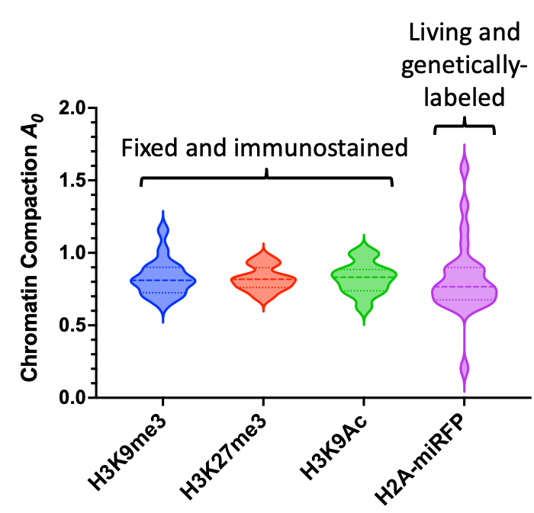

Figure S6. Distribution of average nuclear compaction parameter A₀ in “fixed and immunostained” or “living and genetically-labeled” HCC827 cells. Fixed cells were immunostained against H3K9Me3 (A₀=0.83±0.03, 17 cells), H3K27Me3 (A₀=0.82±0.02, 12 cells), H3K9Ac (A₀=0.83±0.03, 12 cells). Living cells were genetically labelled by H2A-miRFP (A₀=0.82±0.05, 23 cells). A₀ values are expressed as mean±SEM. Statistical analysis was performed through multiple Student’s t-test, but no significant differences were found among the four datasets.

REFERENCES

1 Pelicci, S., Diaspro, A. & Lanzano, L. Chromatin nanoscale compaction in live cells visualized by acceptor-to-donor ratio corrected Forster resonance energy transfer between DNA dyes. Journal of biophotonics, 13, doi:10.1002/jbio.201900164 (2019).

