Supplement Figure
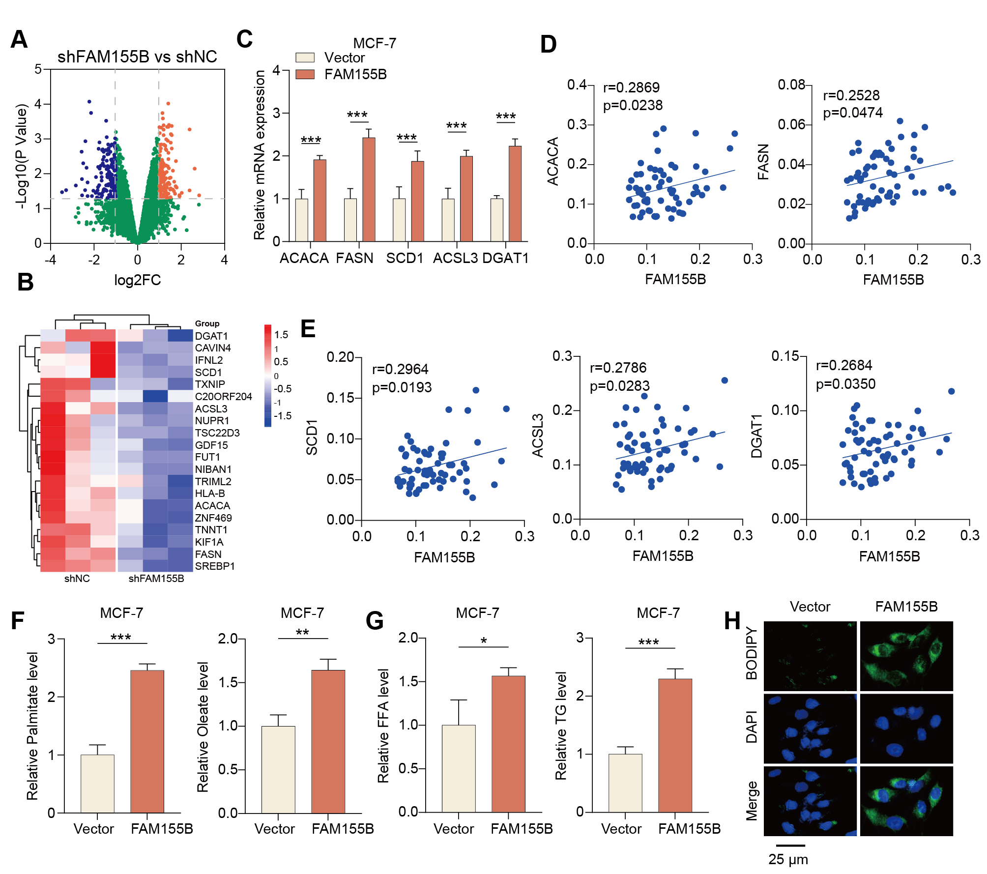
Figure S1. FAM155B regulates the expression of lipid metabolism-associated genes. (A, B) Volcano plot and gene rendering heatmap of the transcriptomic alterations between shNC and shFAM155B groups. (C) Validation of key fatty acid synthesis components' (ACACA, FASN, SCD1, ACSL3, DGAT1) elevation post-FAM155B overexpression. (D, E) Spearman correlation coefficients calculated using the TCGA repository detailing parallel expression between FAM155B and the analyzed lipogenic markers. (F-H) MCF-7 intracellular biochemical indicators depicting elevated palmitate, oleate, FFA, TG, and abundant lipid droplets triggered by overexpressed FAM155B. Data information: Data are shown as Mean ± SD. Statistical differences were mapped by the unpaired Student's t-test. ∗p<0.05, ∗∗p<0.01, ∗∗∗p<0.001.
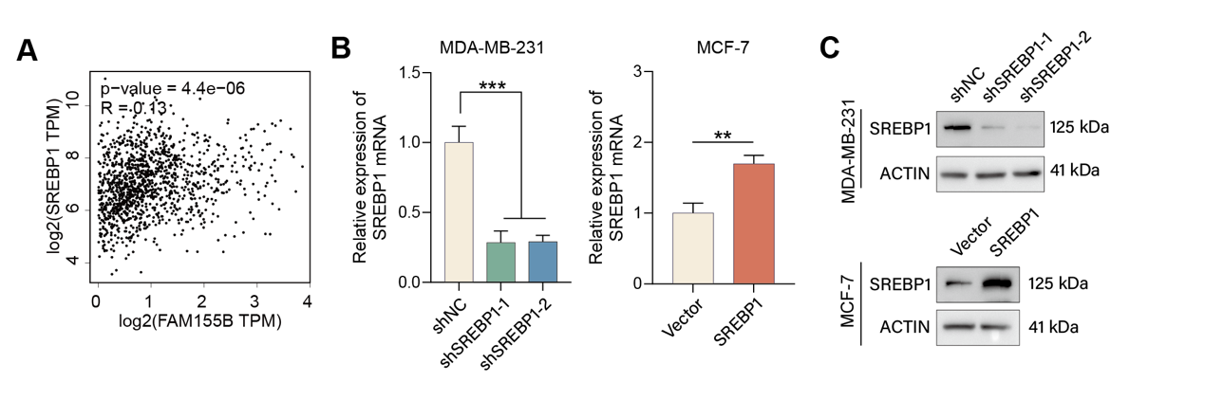
Figure S2. Verification of SREBP1 expression and its clinical correlation to FAM155B. (A) Positive mapping indicating a correlative interplay between FAM155B and SREBF1 within patient tissues derived from standard TCGA archives. (B, C) Confirmation of the shSREBP1 depletion effectiveness and the SREBP1 overexpressing vector delivery evaluated by qPCR and Western blot. Data information: Values are listed as Mean ± SD followed by a standard t-test methodology framework calculation context. ∗p<0.05, ∗∗p<0.01, ∗∗∗p<0.001.
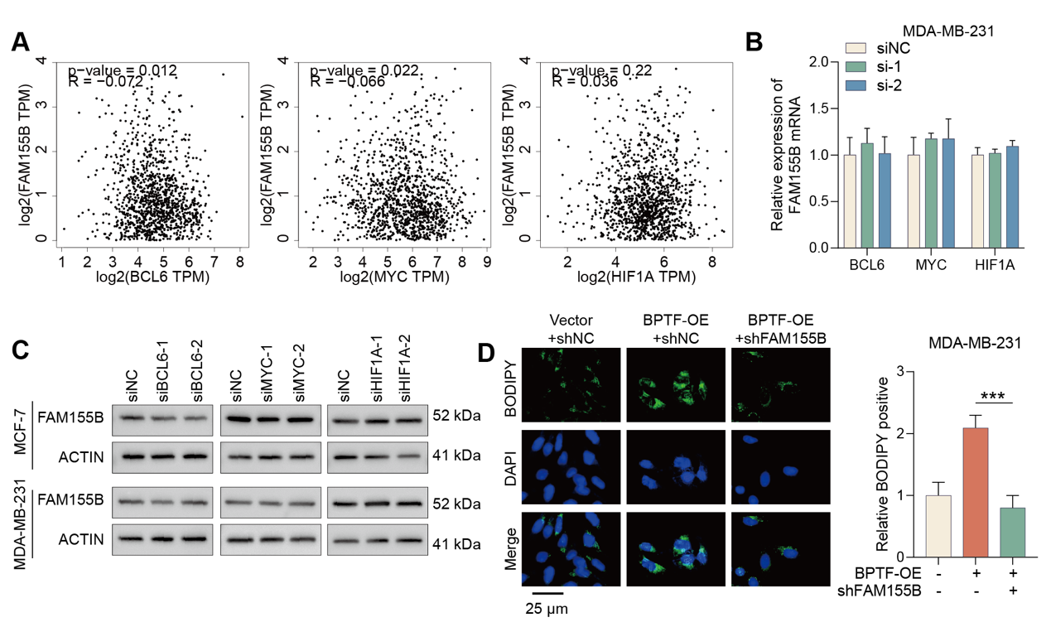
Figure S3. Assessment of alternative transcription factors for FAM155B induction and associated lipogenesis. (A) Minimal descriptive correlative relationships mapping alternative targets (BCL6, MYC, HIF1A) opposite to core candidate evaluation in clinical matrices. (B, C) Genetic loss-of-function tracking of BCL6, MYC, and HIF1A displaying no consequential impacts against FAM155B signature at mRNA and protein dimensions. (D) Internal BODIPY analytics confirm an imperative requirement for FAM155B integrity under elevated BPTF levels necessary to establish potent lipogenesis. Data information: Extricated datasets conform functionally to Mean ± SD parameters via classic t-test and corresponding ANOVA protocols (n = 3). ∗p<0.05, ∗∗p<0.01, ∗∗∗p<0.001.

