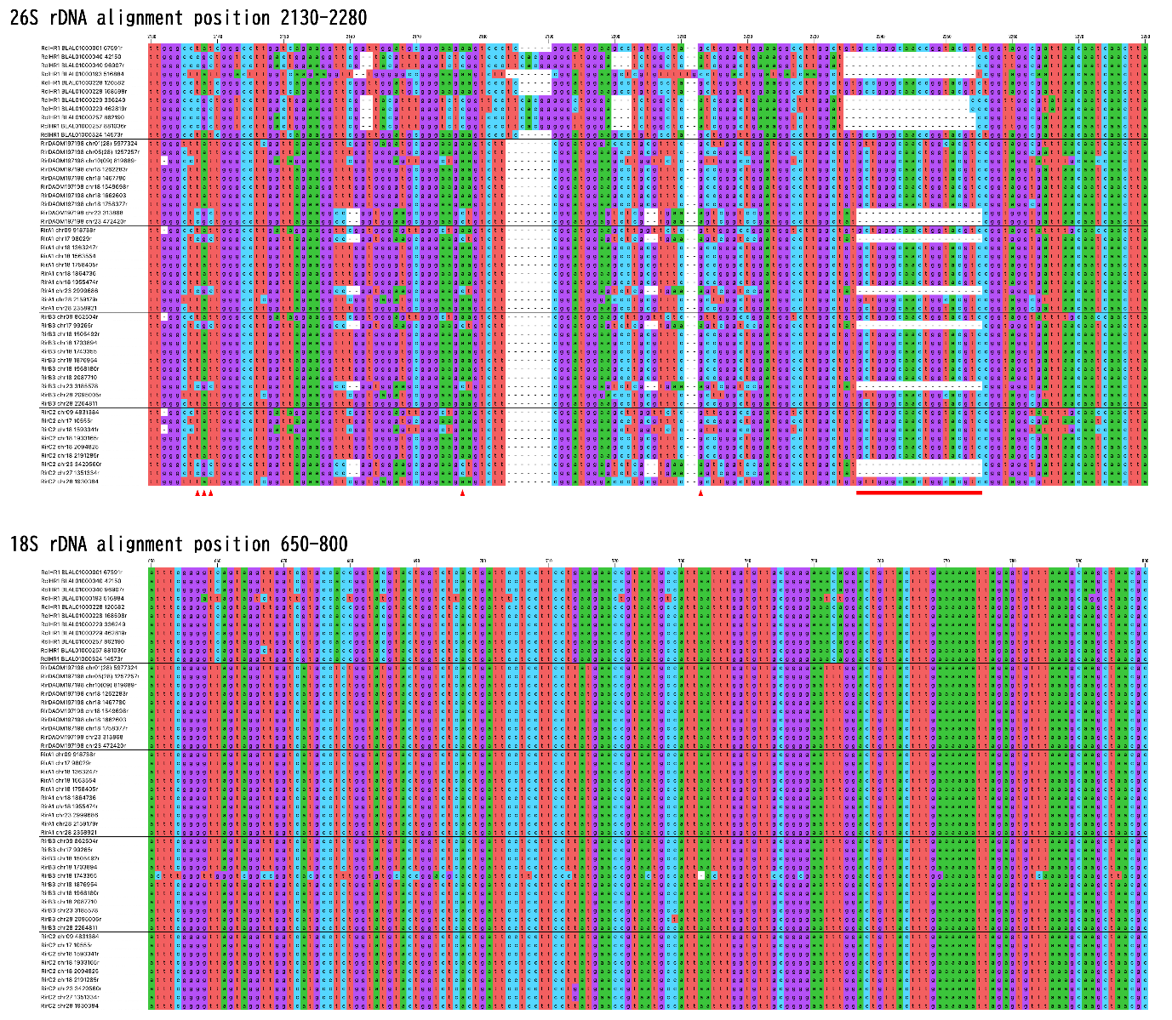Figure S1. Sequence alignments of the D4 region of 26S rDNA and the 18S rDNA from individual copies in R. clarus HR1 and R. irregularis strains. Horizontal lines indicate boundaries between strains.

