A REPORT ON
An Interactive Business Intelligence Framework for Retail Sales Analytics: A Coffee Roasters Case Study

Submitted by:
Gunjan Sahoo

Methodology

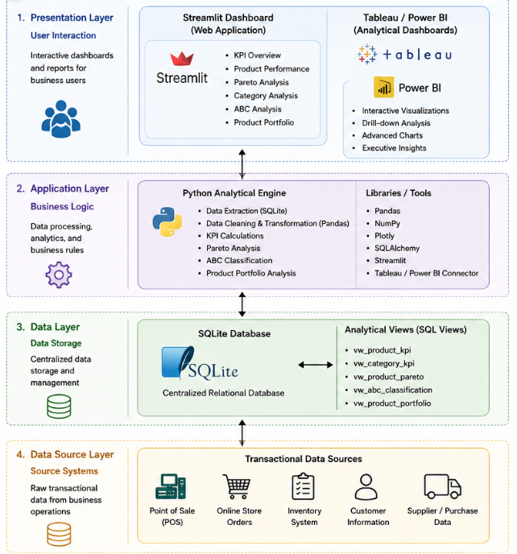
Figure 1. Proposed System Architecture

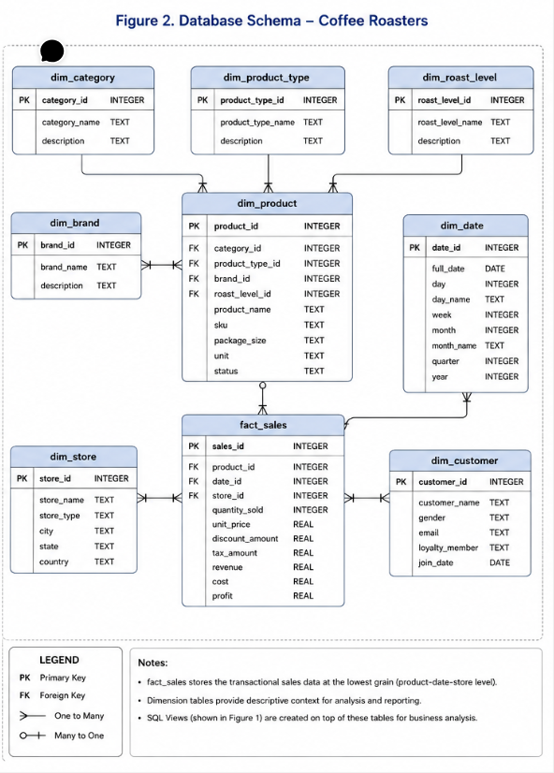
Figure 2. Database Schema

Dashboard Implementation:
The developed Business Intelligence (BI) dashboard integrates a suite of tools - namely Python, Streamlit, SQLite, Plotly, and Tableau to offer a comprehensive analytics environment for monitoring retail sales and aiding decision making. SQLite functioned as the unified repository of transactional sales data, wherein the raw transactional records were aggregated into analytical views to support efficient reporting and query execution. Python, leveraging the Pandas library, acted as the backbone for data cleansing, transformation, aggregation, and the computation of vital business metrics, such as revenue contribution, cumulative percentages, product rankings, and the classification of products into the ABC categories (Sharda, Delen & Turban, 2023).
The Streamlit framework facilitated the construction of a web-based dashboard that allowed end-users to seamlessly monitor crucial performance indicators (KPIs), evaluate product performance, understand category-wise revenue distribution, and conduct a Pareto Analysis with interactive filters and dynamic visualizations.
Plotly was incorporated to render engaging, responsive charts, scatter plots, Pareto curves, treemaps, and portfolio matrices, ensuring that the visual representations of sales data were intuitive and readily interpretable (Few, 2013). In tandem with the web application, Microsoft Power BI was utilized to build executive dashboards replete with advanced analytical and visualization capabilities. The Power BI dashboards highlight revenue trends, product popularity, and category contributions through Sankey diagrams, packed bubble charts, and heatmaps, offering executives robust and interactive insights for strategic business analysis and exploration through drill-down features. In summation, the fusion of Streamlit and Power BI blends operational reporting with executive decision support, enabling managers to identify top-performing products, assess revenue concentration, and make informed, data-driven decisions.
Screenshots representing the built Streamlit and Power BI dashboards are provided below in Figure 3.
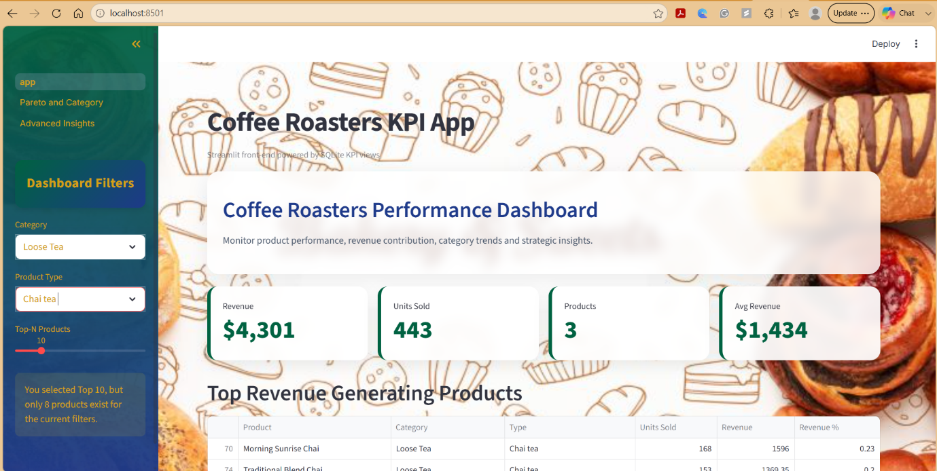
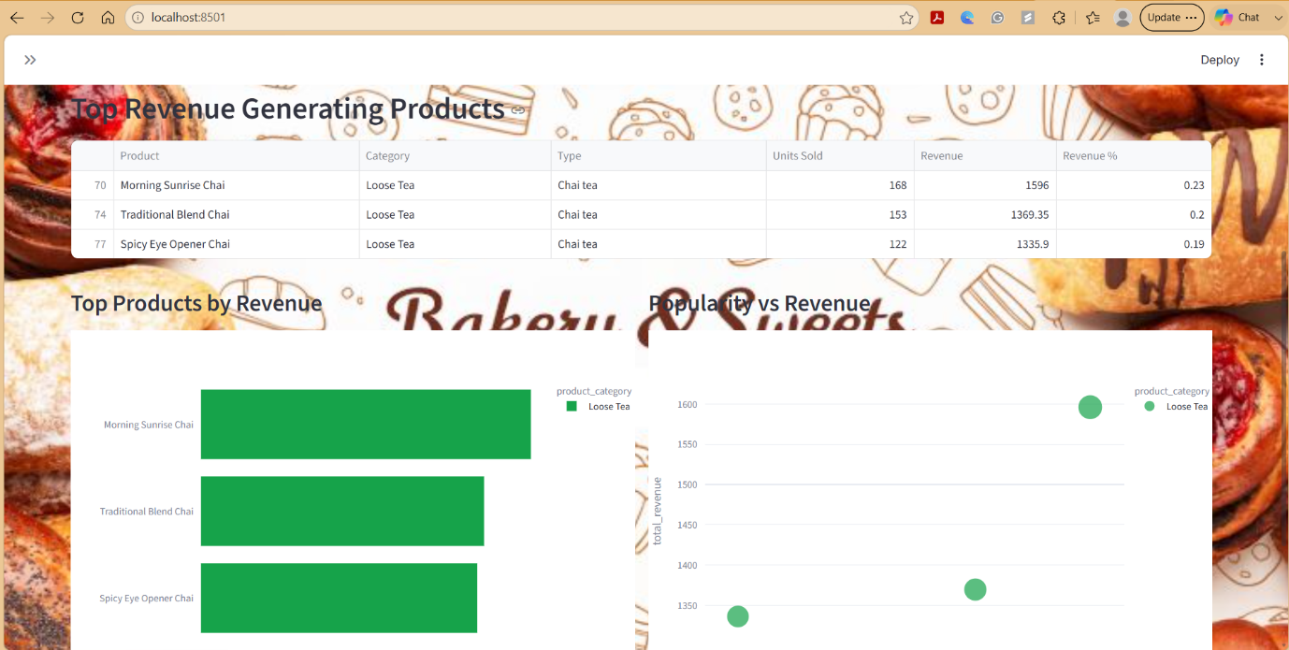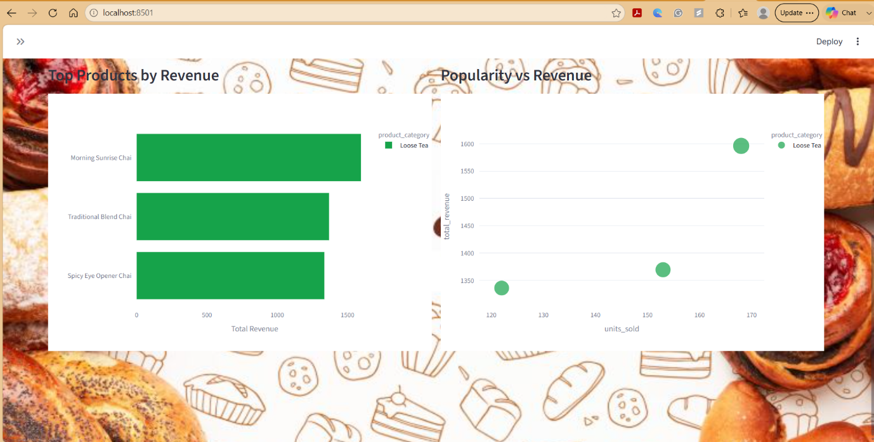
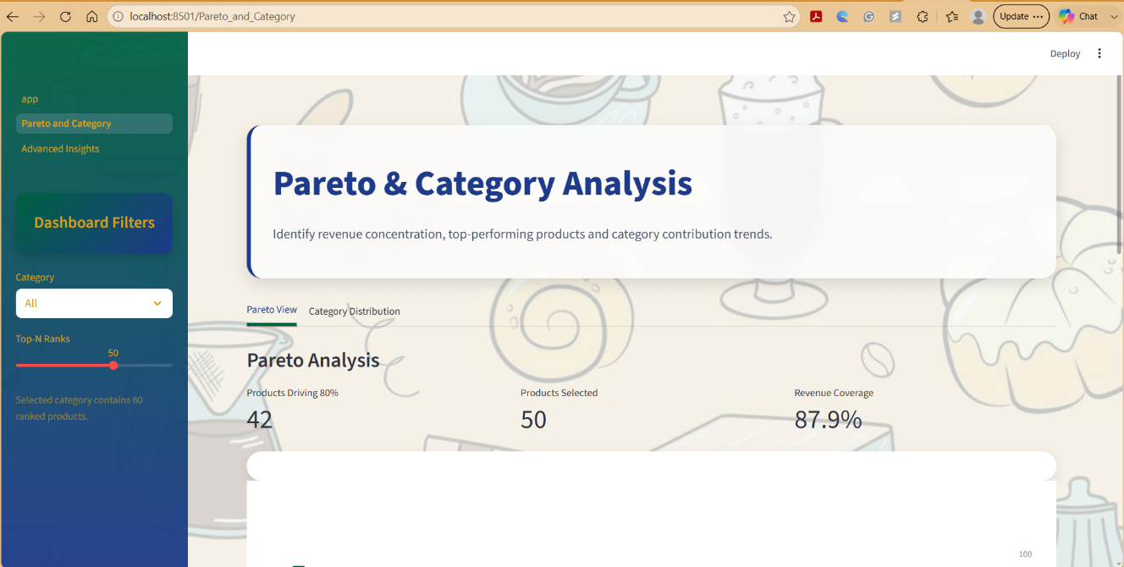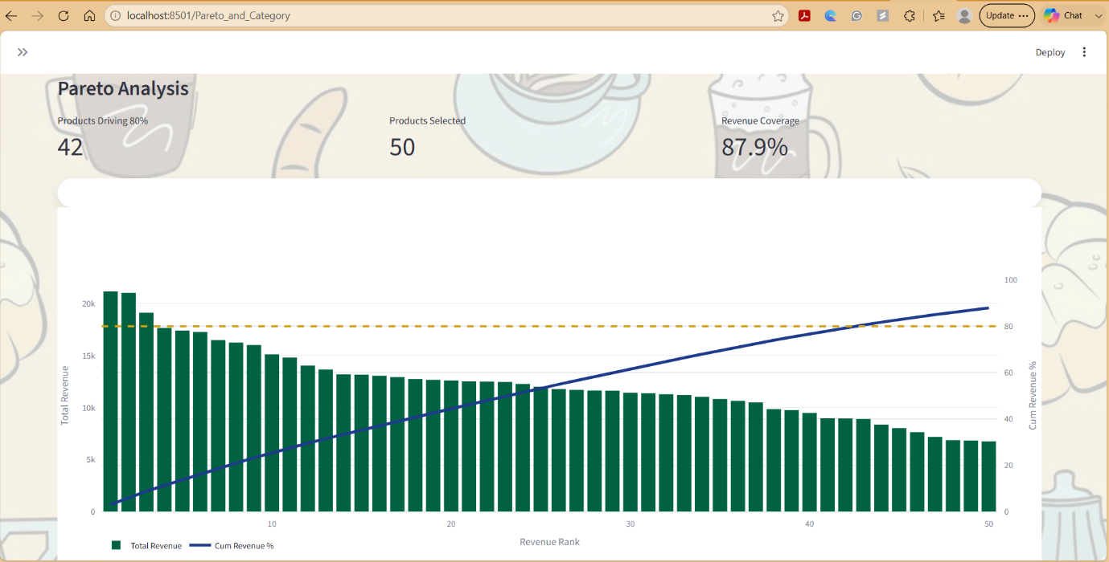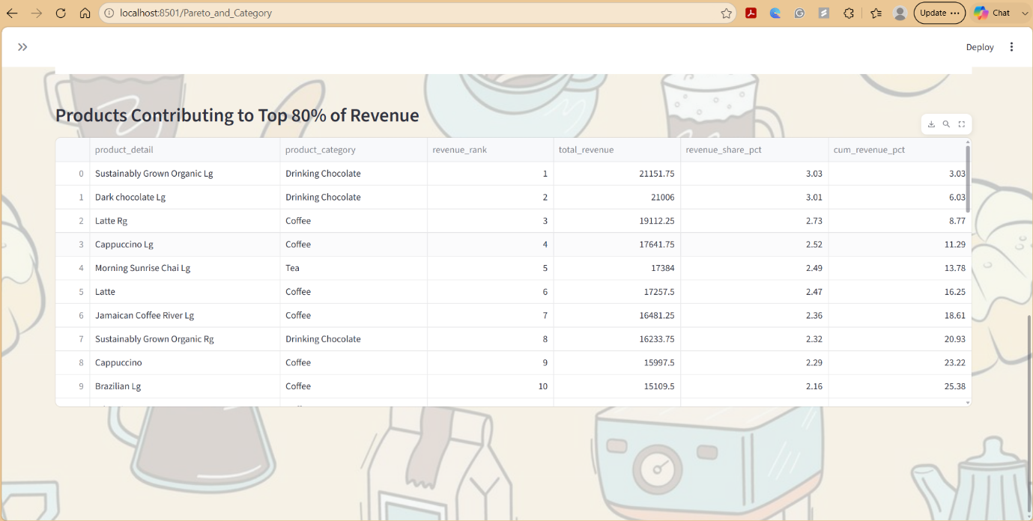
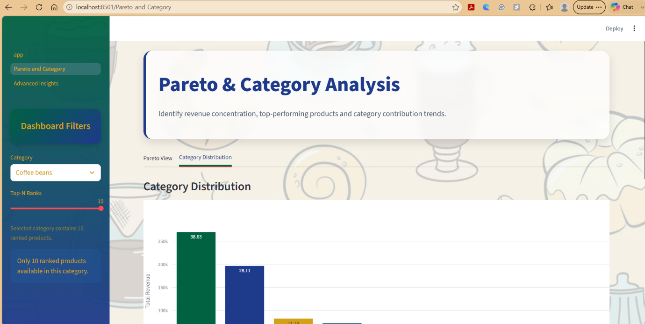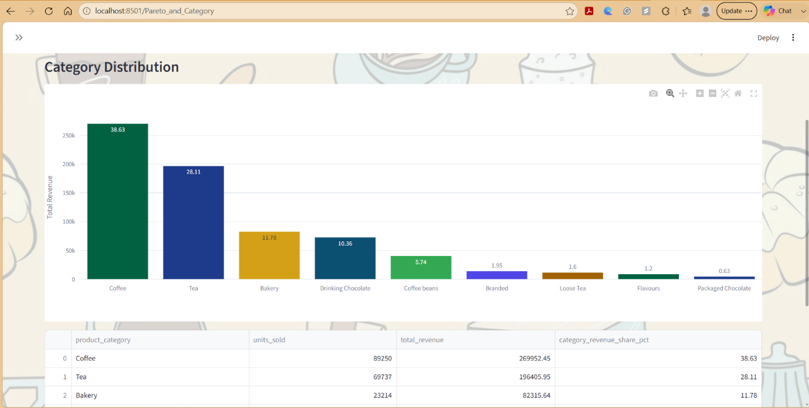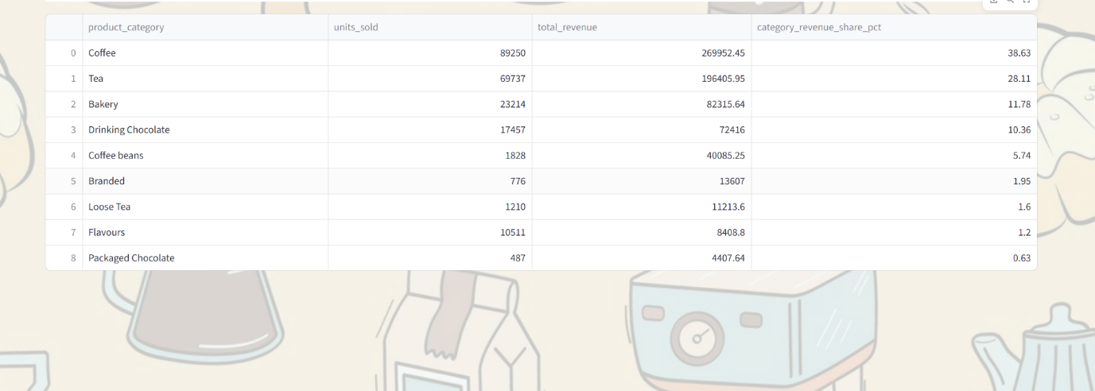

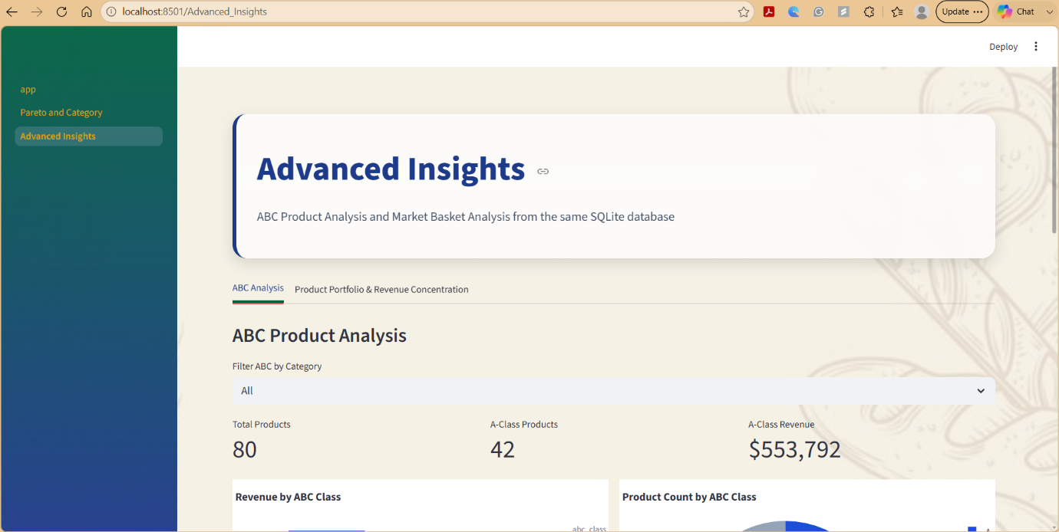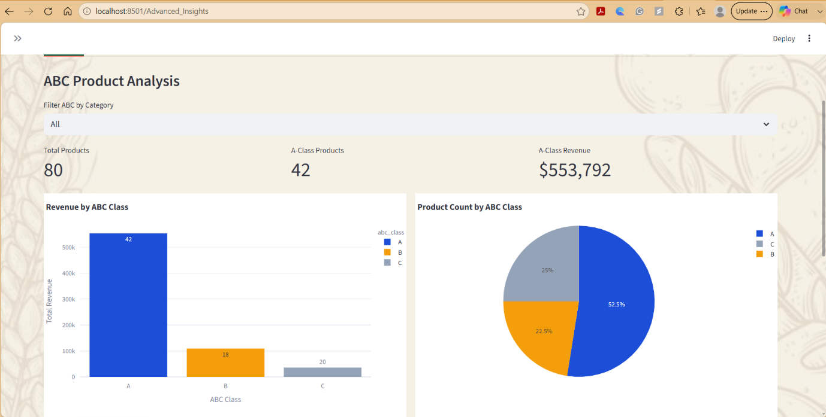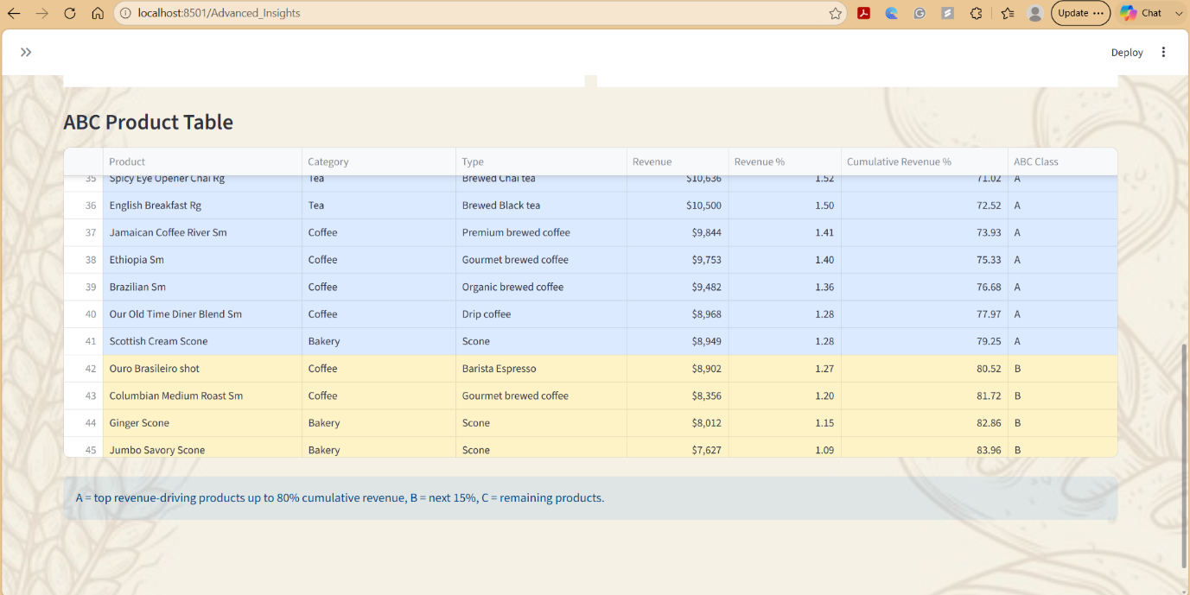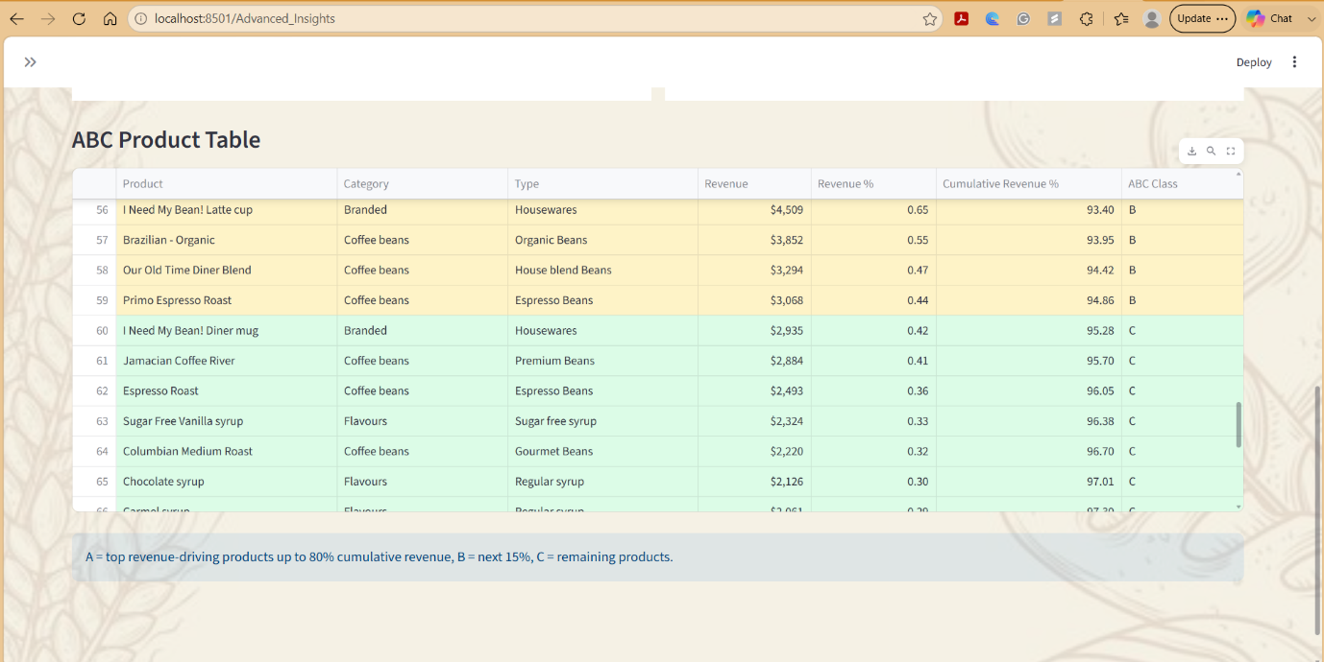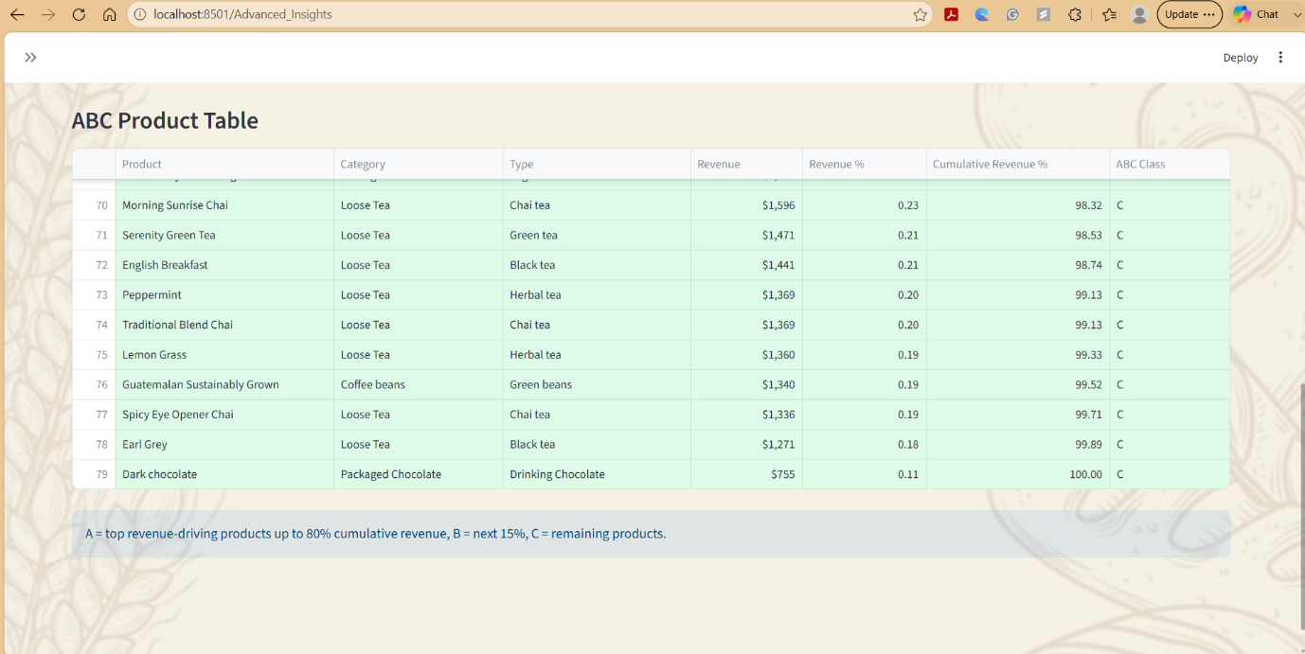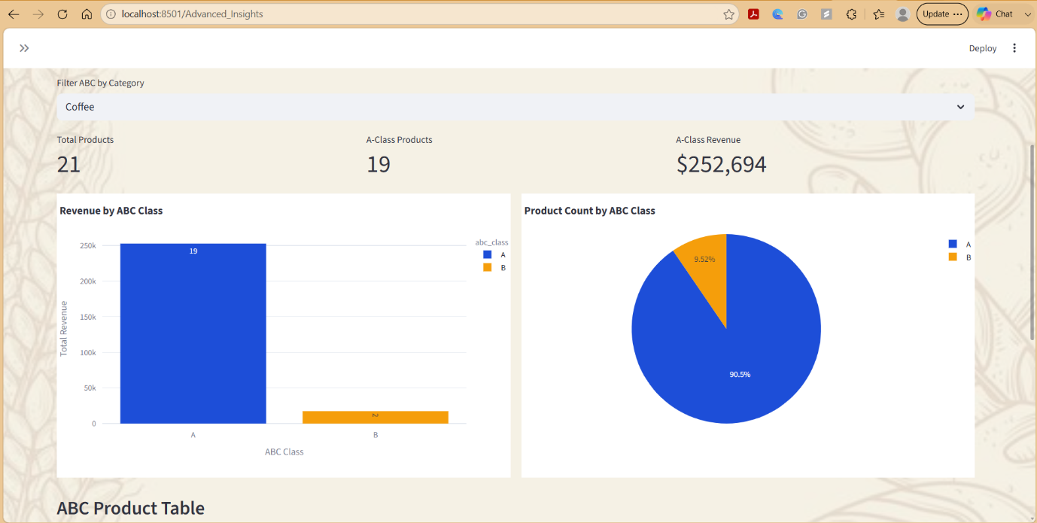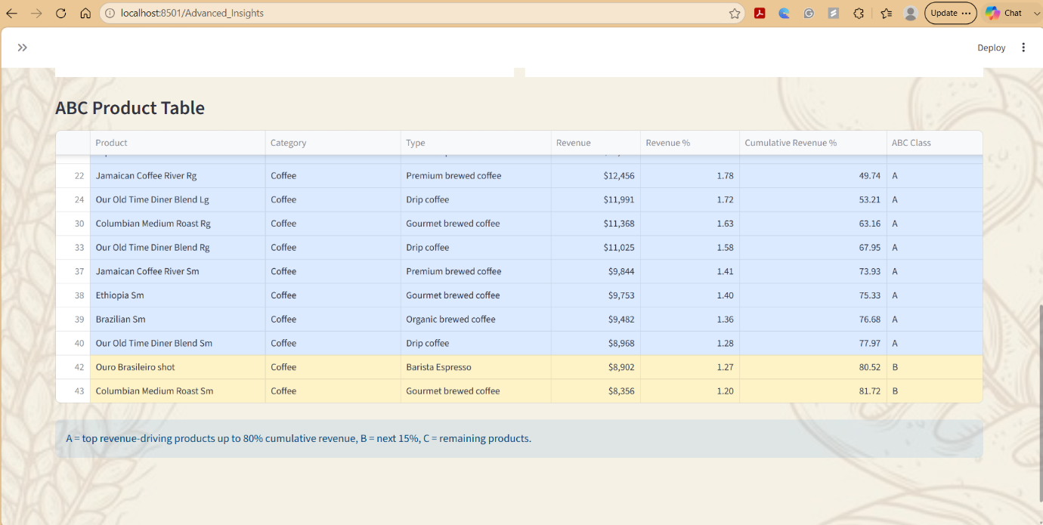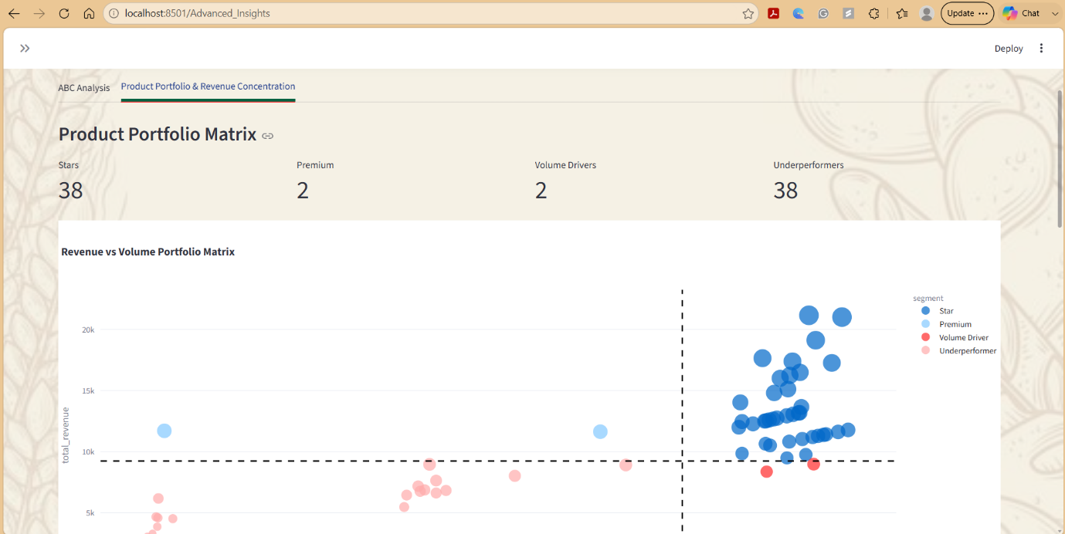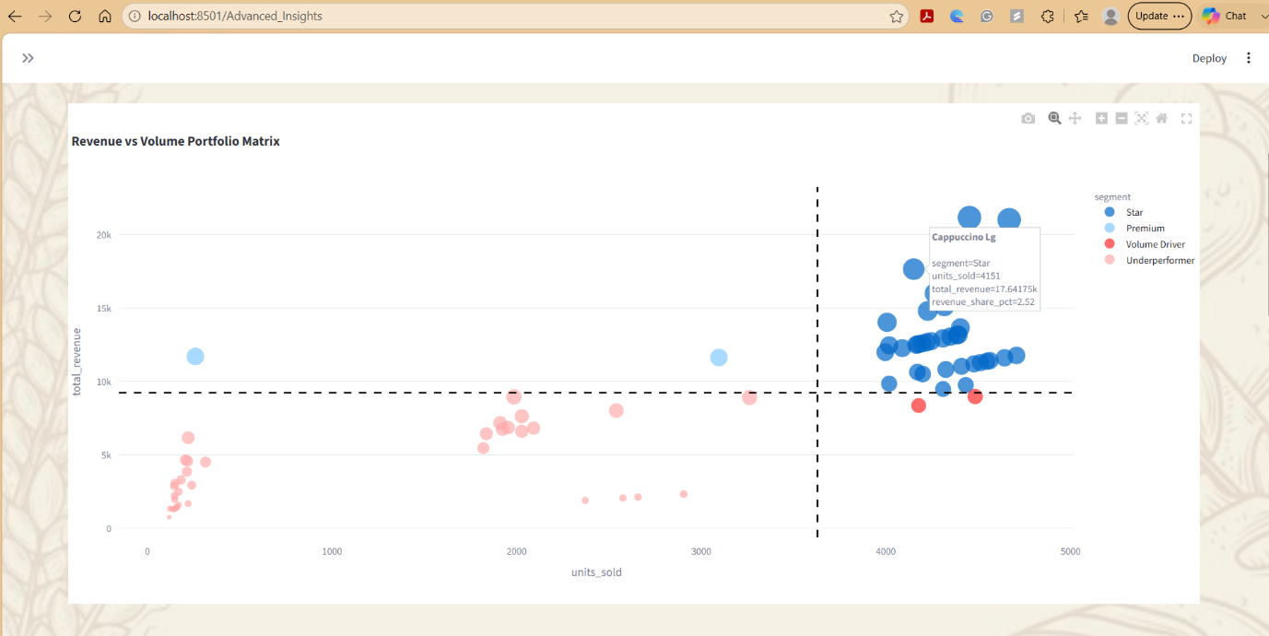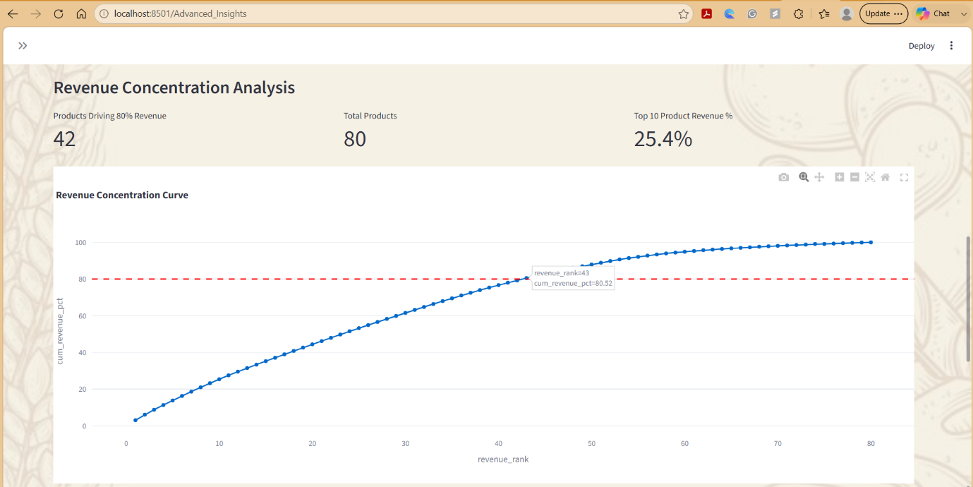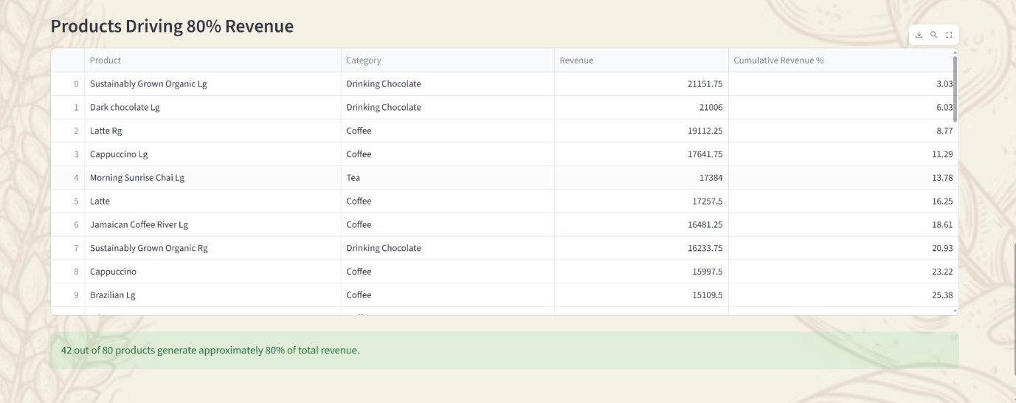
Figure 3. Streamlit Business Intelligence Dashboard for Product Performance and Revenue Analysis

Tableau Analytical Dashboard
In addition to the Streamlit application, Tableau was employed to develop interactive analytical dashboards that provide complementary business intelligence visualizations for retail sales analysis. Tableau's advanced visualization capabilities enabled the presentation of complex sales data through interactive charts, treemaps, Sankey diagrams, packed bubble charts, heatmaps, and Pareto visualizations, facilitating multidimensional exploration of product and category performance.
The Tableau dashboards were designed to analyze revenue contribution, product popularity, category-wise sales distribution, and revenue concentration patterns. Interactive filtering and drill-down capabilities allow users to examine business performance across different product categories and identify high-performing products that contribute significantly to overall revenue. Analytical techniques such as Pareto Analysis and product portfolio evaluation further support inventory prioritization and strategic decision-making.
Representative Tableau dashboard screenshots are presented in Figure 4 to demonstrate the visualization capabilities of the proposed Business Intelligence framework and illustrate how interactive analytics support retail performance monitoring and evidence-based business decisions.

Dashboard 1: Product Performance and Revenue Contribution
This dashboard focuses on identifying high-performing products, understanding revenue concentration, and evaluating the relationship between product popularity and revenue generation.
Popularity vs Revenue Scatter Plot
The scatter plot compares Units Sold against Total Revenue for individual products across different product categories.
Key observations:
- Coffee products occupy the upper-right section of the chart, indicating both high sales volume and high revenue generation.
- Products such as Barista Espresso, Gourmet Brewed Coffee, and Premium Brewed Coffee demonstrate strong business performance.
- Bakery and packaged products generally generate lower revenue and sales volumes compared to coffee and tea products.
- The visualization helps identify products that are highly profitable despite lower sales volume and products that rely heavily on sales volume for revenue generation.
Pareto Analysis: Revenue Concentration by Product Rank
The Pareto chart ranks products based on revenue contribution and displays cumulative revenue percentage.
Key findings:
- A relatively small group of products contributes the majority of overall revenue.
- The cumulative revenue curve crosses the 80% threshold after a limited number of products, confirming the Pareto Principle (80/20 Rule).
- Revenue declines gradually as product rank increases, indicating that top-performing products play a significant role in business profitability.
- Management can use this insight to prioritize inventory, promotions, and pricing strategies for the highest-contributing products.
Top Products by Units Sold
The treemap visual highlights products with the highest sales volumes.
Key findings:
- Coffee and Tea products dominate sales volume across the business.
- Gourmet Brewed Coffee, Barista Espresso, and Brewed Chai Tea are among the highest-selling products.
- Larger rectangles represent products with higher units sold, while color intensity reflects sales magnitude.
- The visualization helps identify customer preferences and products driving transaction volume.
Interactive Filtering
The dashboard allows users to filter by product category.
For example:
- Selecting Bakery isolates bakery products and reveals that items such as Scones and Pastries contribute the majority of bakery revenue.
- Selecting Coffee highlights the strong revenue concentration among premium coffee products.
- Dynamic filtering enables detailed category-level analysis and performance comparison.

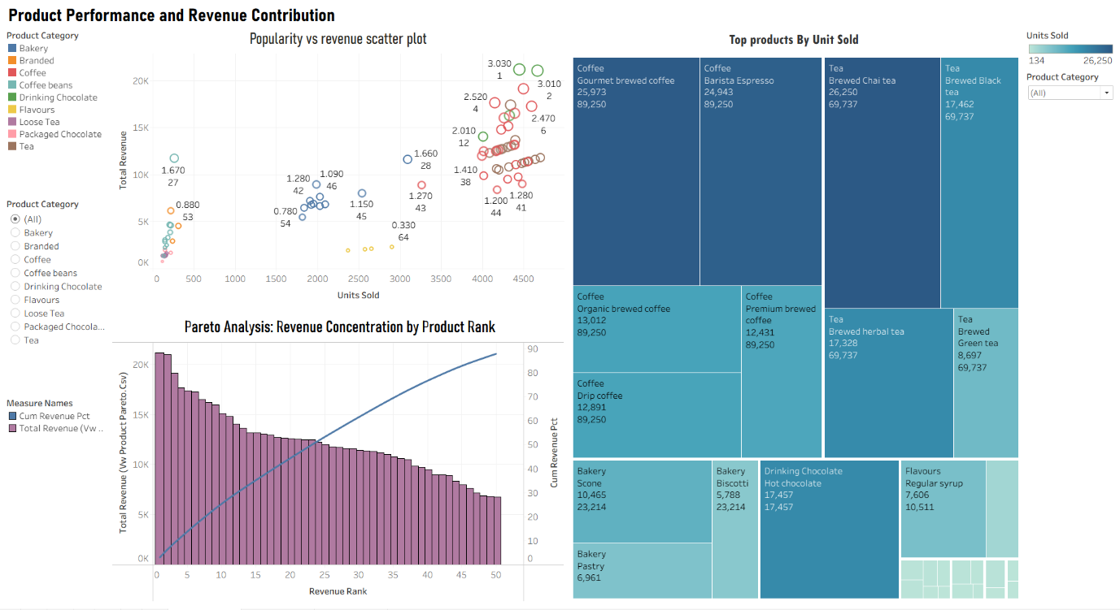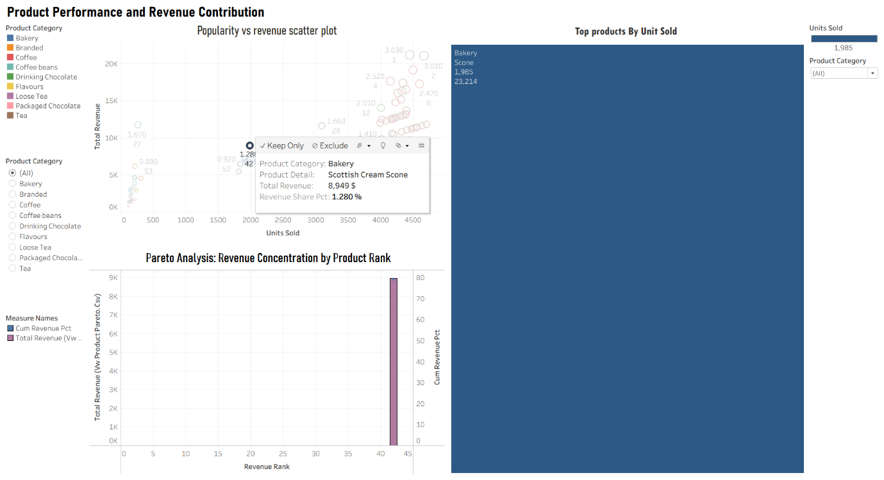
Figure 4. Product performance and revenue contribution

Dashboard 2: Revenue Mix and Category Leaders
This dashboard focuses on understanding how revenue is distributed across categories and identifying category-leading products.
Product Revenue Flow by Category and Product Detail
The Sankey diagram visualizes the relationship between individual products and their corresponding categories.
Key observations:
- Coffee products contribute the largest share of total revenue among all categories.
- Multiple high-performing products flow into the Coffee category, indicating strong category dominance.
- Tea represents the second-largest revenue contributor with several high-performing products.
- Smaller categories such as Flavours, Loose Tea, and Packaged Chocolate contribute comparatively less revenue.
The Sankey visualization provides a clear understanding of how individual products collectively contribute to category-level performance.
Top Products by Revenue and Category
The packed bubble chart displays top products based on revenue contribution.
Key findings:
- Barista Espresso appears as the largest bubble, indicating the highest revenue contribution.
- Other major revenue-generating products include:
  - Gourmet Brewed Coffee
  - Premium Brewed Coffee
  - Organic Brewed Coffee
  - Brewed Chai Tea
  - Brewed Black Tea
- Coffee products dominate the top revenue rankings, demonstrating strong customer demand and profitability.
- Tea products also contribute significantly but remain secondary to coffee products.
Interactive Drill-Down Analysis
The dashboard supports interactive exploration through category selection.
Examples include:
- Selecting the Coffee category filters the bubble chart to show only top-performing coffee products.
- Selecting Flavours highlights flavour-related products and their revenue contribution.
- Users can quickly identify category leaders and compare revenue distribution across categories.
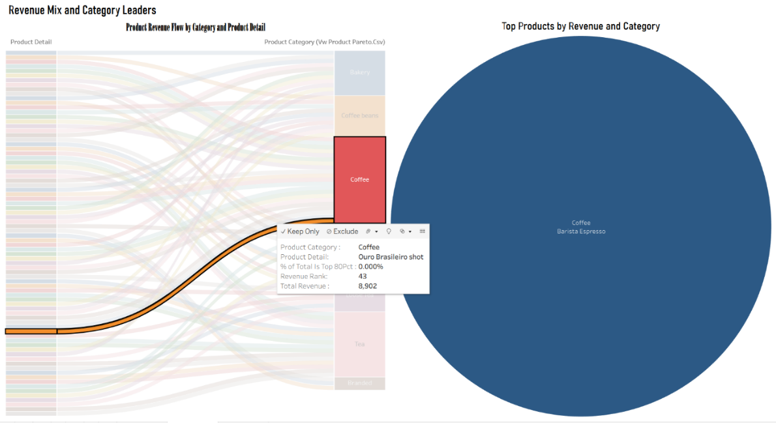
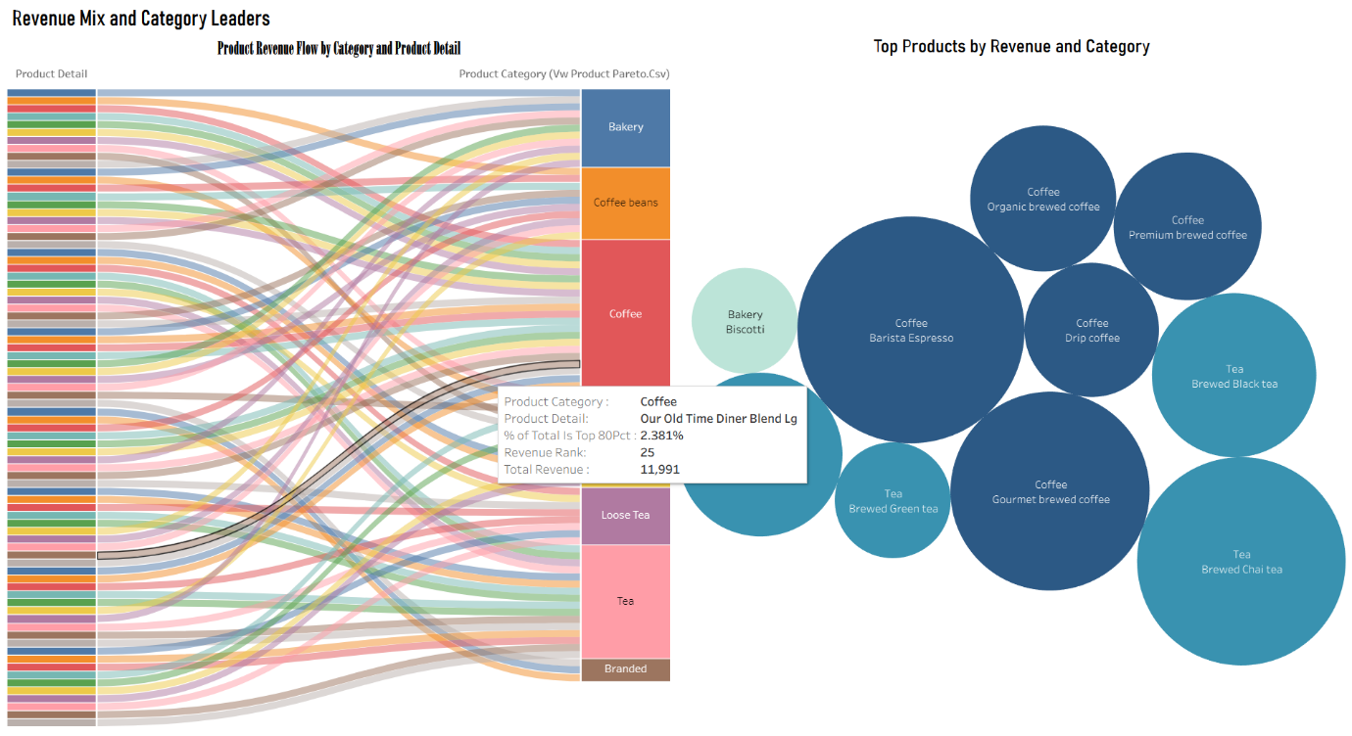
Figure 5. Revenue mix and category leaders

Dashboard 3: Beverage Revenue and Menu Breadth
This dashboard evaluates product assortment breadth and category-level product performance.
Top-80 Products Table
The table displays products that collectively contribute approximately 80% of total business revenue.
Key findings:
- A limited number of products generate the majority of revenue.
- Premium coffee beverages dominate the top-performing product list.
- Revenue percentages help prioritize products for marketing and inventory decisions.
Beverage Menu Breadth and Volume by Category
The heatmap visualizes product variety and sales volume across beverage categories.
Key observations:
- Coffee has the largest number of products and the highest sales volume.
- Tea also maintains a broad product portfolio with strong sales performance.
- Categories such as Coffee Beans and Loose Tea contain fewer products and lower overall sales volumes.
- Drinking Chocolate and Flavours contribute moderate revenue but have smaller product portfolios.
Business Insights
The analysis demonstrates that:
- Coffee is the dominant category in terms of both menu breadth and revenue generation.
- Tea serves as a strong secondary category supporting overall sales.
- Smaller categories provide diversification but contribute less significantly to overall revenue.
- Maintaining a balanced portfolio between high-volume categories and niche products can support sustainable revenue growth.
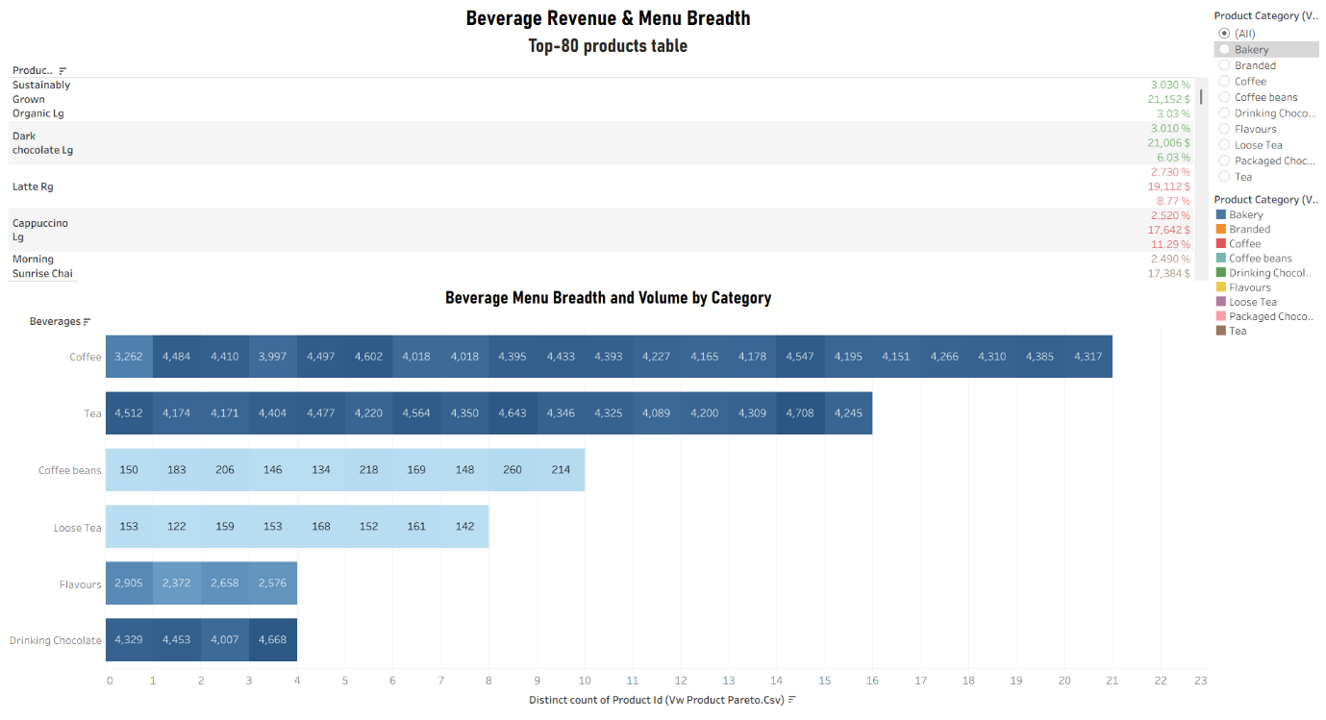
Figure 6. Beverage menu breadth and volume by category

