Construction of morphologically differentiated phosphorus-doped zinc oxide nanostructures and their supercapacitive properties
Xiaohui Huang *, Wenhao Zhou, Jian Wang, Hehui Wang
School of Environment and Chemical Engineering, Heilongjiang University of Science and Technology, China
* Corresponding authors.
E-mail address: 1614401842@qq.com (X. Huang)
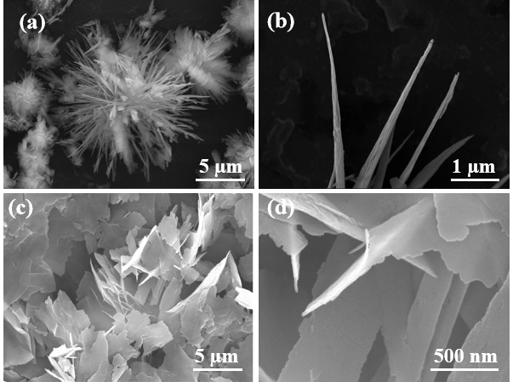
Figure S1. SEM images of ZNP: (a-b) ZNR-C120 and its high-magnification image; (c-d) ZNS-C110 and it shigh-magnification image
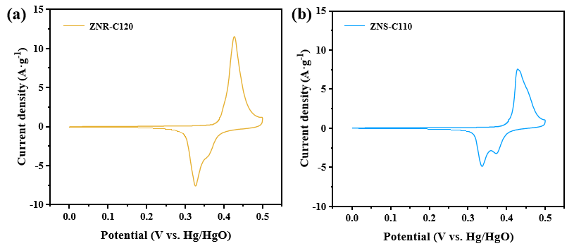
Figure S2. (a-b) CV curves of ZNR-C120 and ZNS-C110
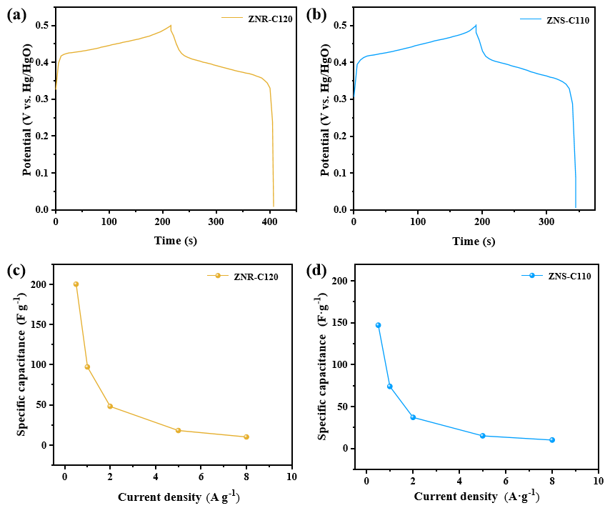
Figure S3. (a-b) GCD curves of ZNR-C120 and ZNS-C110; (c-d) rate performance curves of ZNR-C120 and ZNS-C110
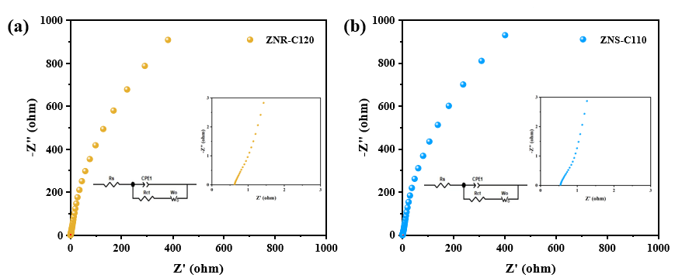
Figure S4. (a-b) Nyquist plots of ZNR-C120 and ZNS-C110

