Figures and Graphs

An Interactive Decision Support Dashboard for Monitoring and Forecasting UAC Care System Operations Using Streamlit and Power BI

Submitted by:
Gunjan Sahoo

System Design and Architecture

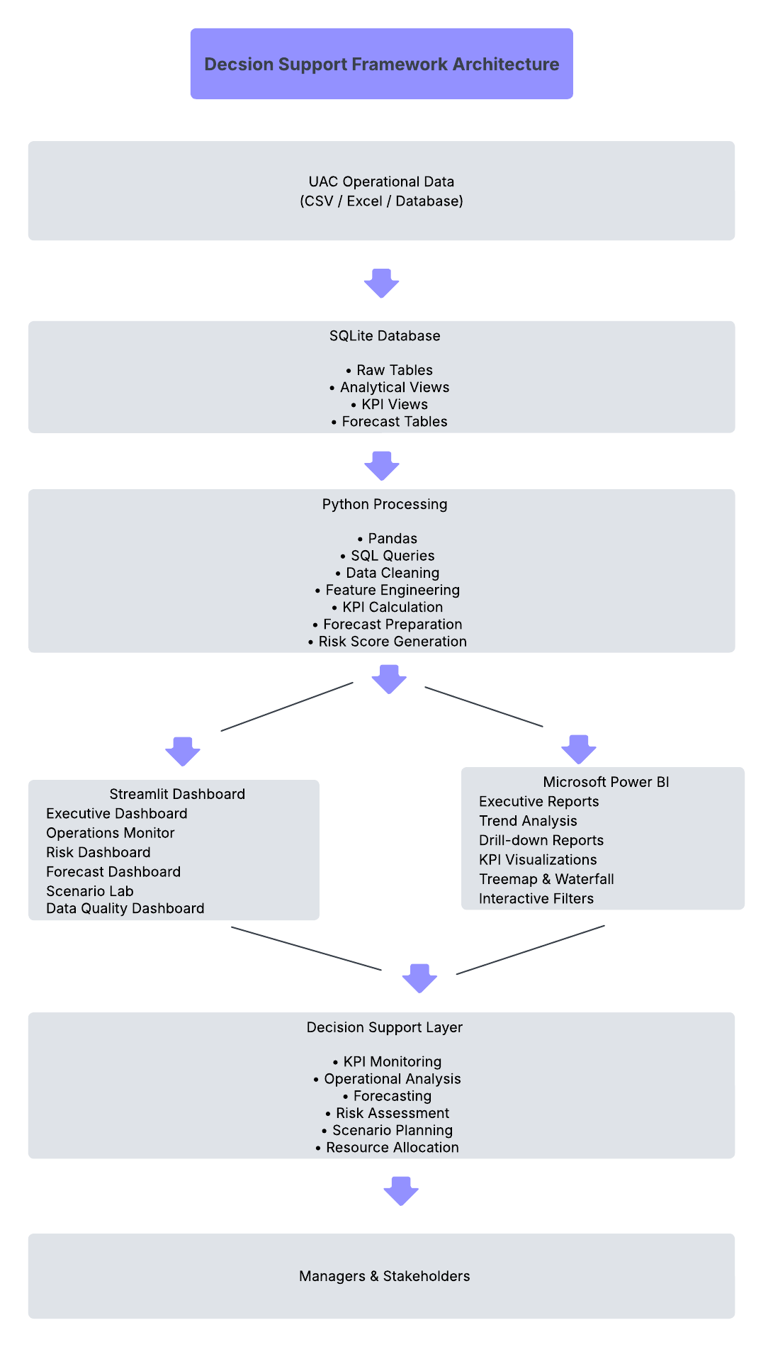
Figure 1. Proposed System Architecture of the UAC Operations Command Center

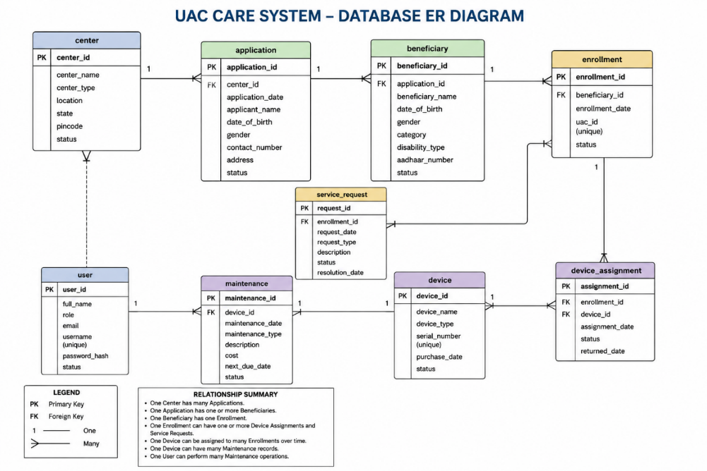
Figure 2. Database Schema

Dashboard Implementation:
The UAC Operations Command Center was implemented as an interactive web-based analytical application using Python and Streamlit. The dashboard was designed to provide operational managers with real-time visibility into system performance while supporting exploratory analysis, forecasting, and scenario-based decision-making. The implementation combines SQLite for data storage, Python for data processing, Plotly Express for visualization, and Power BI for advanced business intelligence reporting.
The dashboard follows a modular design consisting of multiple functional tabs, each addressing a specific operational objective. A common filter panel allows users to select the reporting year, date range, trend frequency, and primary analytical metric. These global filters dynamically update all visualizations, ensuring consistent analysis across different dashboard components.

Executive Summary Dashboard
The Executive Summary provides a consolidated overview of the current operational status of the UAC care system. Key Performance Indicators (KPIs), including Total System Load, Net Intake Pressure, 14-Day Backlog Accumulation, and Discharge Offset Ratio, are presented using metric cards that display both current values and percentage changes from the previous reporting period. A Composite Operational Risk Score summarizes overall system conditions, while the Risk Driver Intensity chart identifies the operational factors contributing most significantly to organizational risk. This dashboard enables senior decision-makers to rapidly assess system performance without examining detailed operational reports.
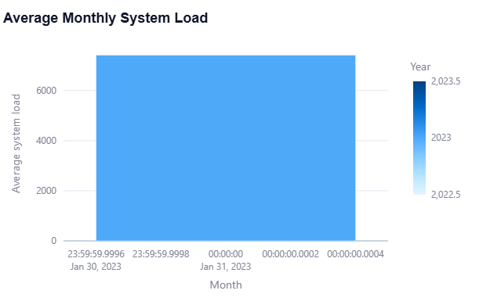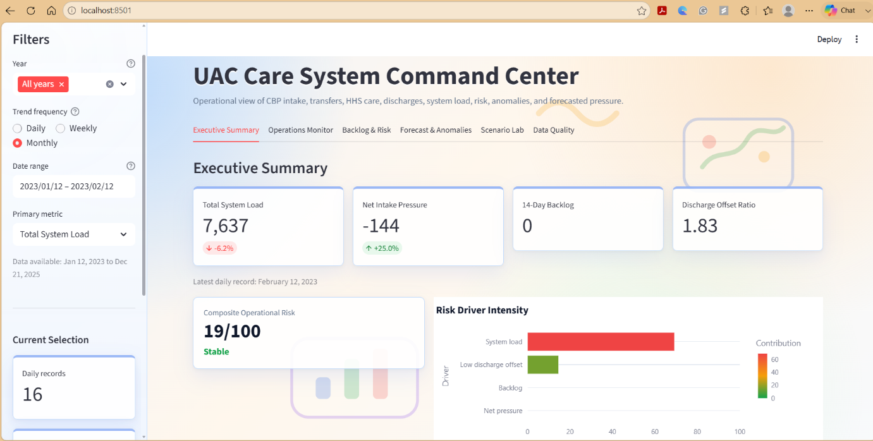
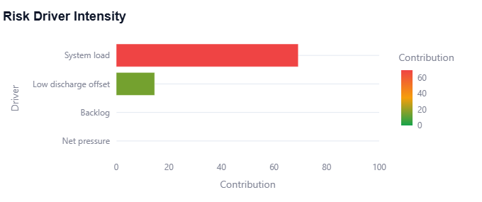
Figure 3. Executive Summary Tab
Operations Monitoring Dashboard
The Operations Monitor provides continuous visibility into daily, weekly, and monthly operational activities. Interactive time-series visualizations present trends in CBP apprehensions, transfers, HHS discharges, and Total System Load, allowing managers to identify changes in operational workload over time. Comparative charts facilitate performance assessment across reporting periods and support the identification of seasonal or recurring operational patterns. By consolidating multiple operational indicators within a single interface, the dashboard improves situational awareness and assists managers in detecting emerging capacity constraints.

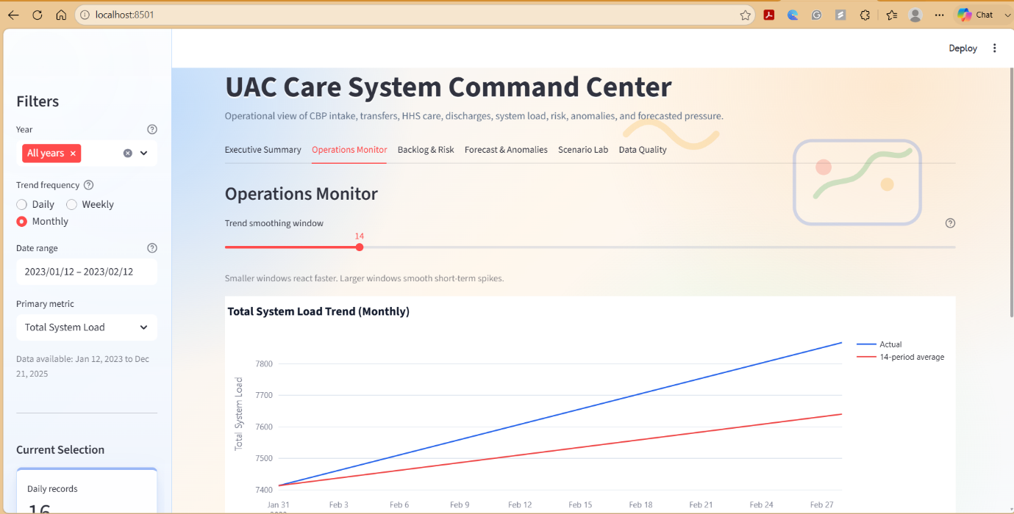
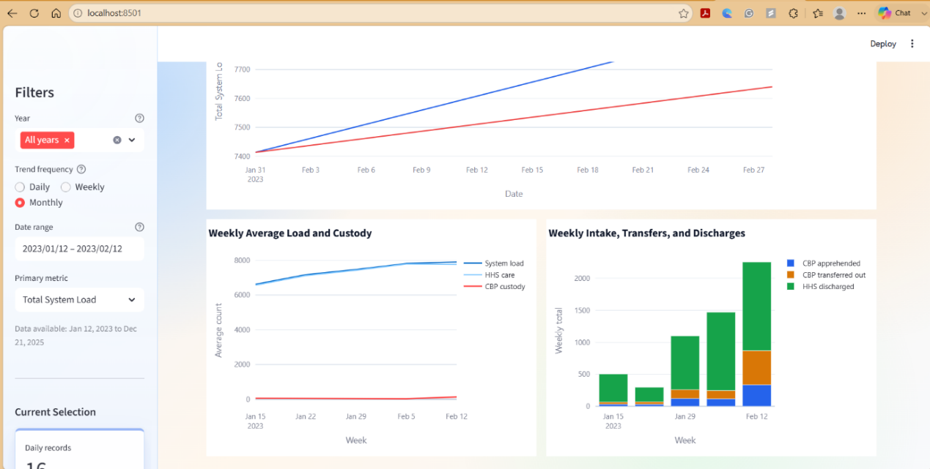
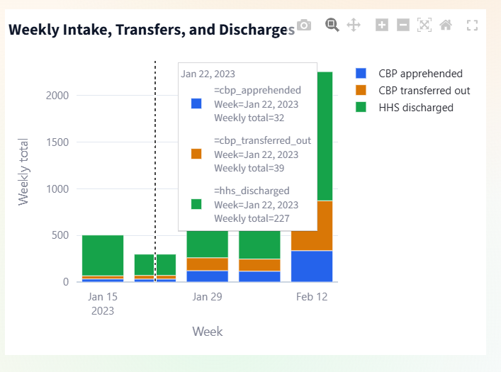
Figure 4. Operation Monitor Tab
Backlog and Risk Dashboard
The Backlog and Risk Dashboard provides a focused assessment of operational stability by monitoring key backlog and risk indicators. Summary cards display the Composite Risk Score, Top Risk Driver, and the number of Selected Daily Rows, offering managers a quick overview of the current operational condition.
The dashboard includes visualizations of the Average Discharge Offset Ratio by Month, Monthly Apprehension-to-Transfer Gap, and 14-Day Backlog Accumulation. These charts help identify imbalances between apprehensions, transfers, and discharges, enabling users to detect periods where operational demand exceeds system capacity. By combining risk indicators with backlog trends, the dashboard supports early identification of potential bottlenecks and facilitates proactive planning and resource allocation.
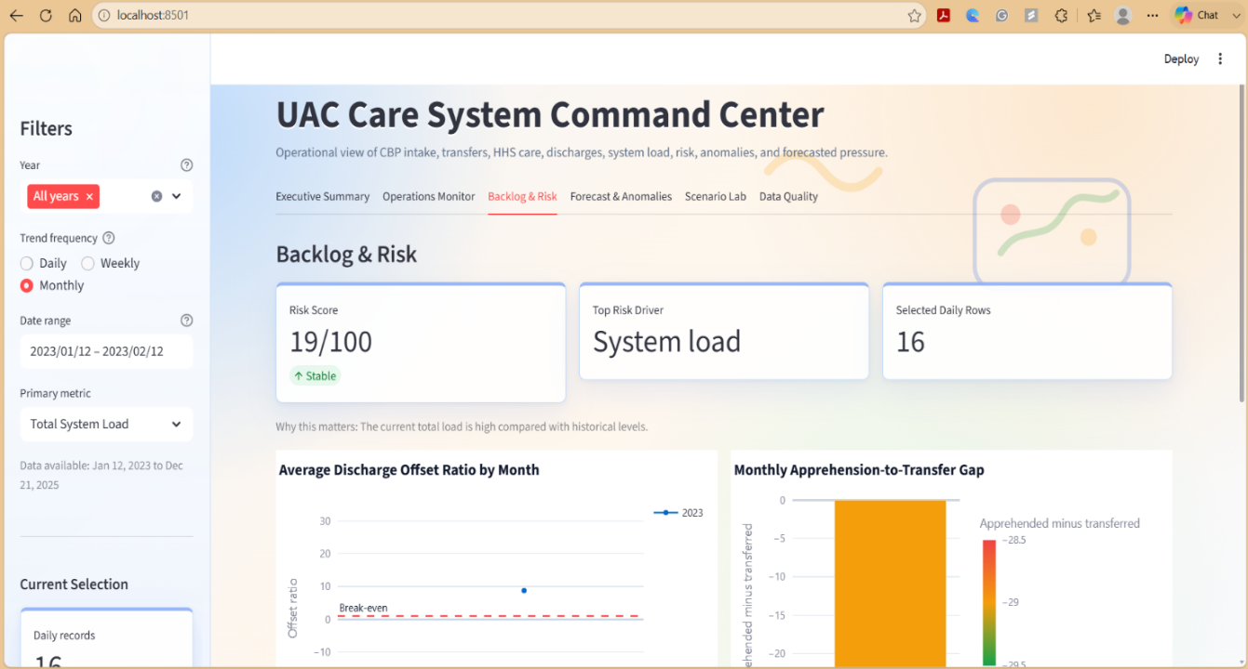
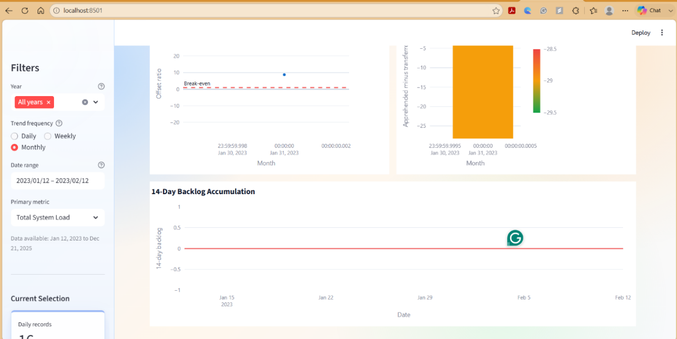
Figure 5. Backlog and risk Tab

Forecast and Anomaly Analysis
To support proactive planning, the dashboard incorporates forecasting and anomaly detection capabilities based on historical operational trends. Users can adjust parameters including anomaly sensitivity, baseline observation window, forecasting horizon, and model training period through interactive controls. Forecasted values of Total System Load are presented together with confidence intervals, while anomaly detection highlights observations that deviate significantly from expected operational behaviour. These analytical features enable managers to anticipate increasing operational pressure and evaluate potential intervention strategies before critical thresholds are reached.

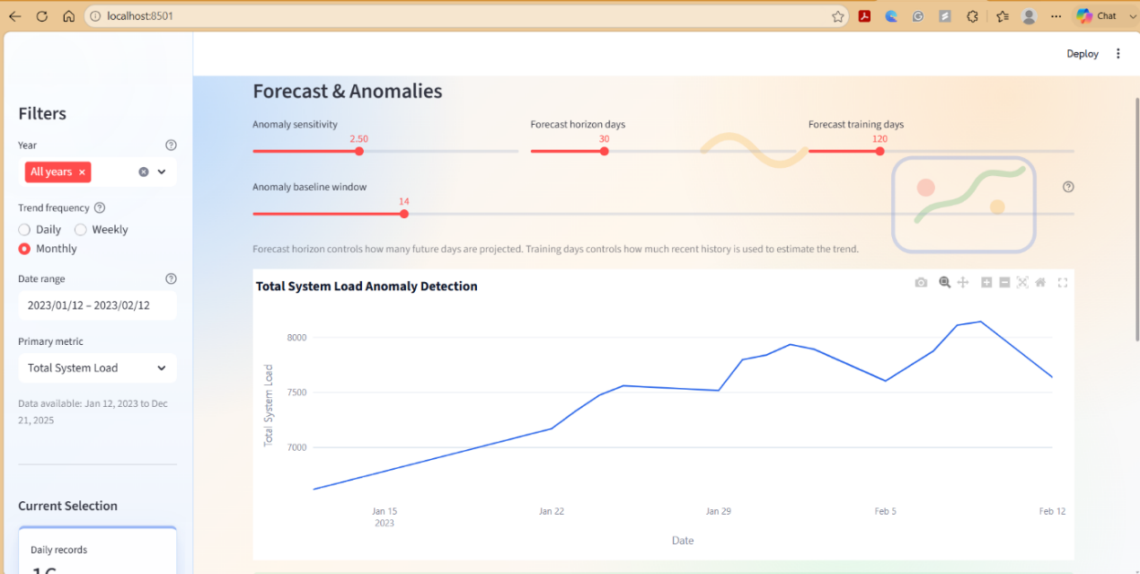

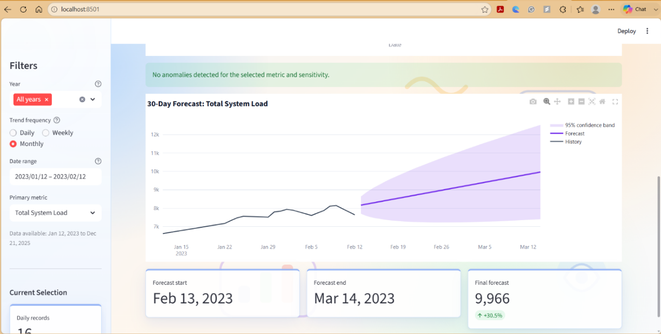
Figure 5. Forecast and anomaly Tab
Data Quality Dashboard
The Data Quality module improves transparency by providing information regarding dataset completeness and reporting coverage. Summary indicators display the number of records available within each analytical view together with reporting date ranges and monthly summary statistics. Additional validation views identify missing dates, duplicate records, and rule violations to ensure that dashboard outputs are generated from complete and reliable data. Providing visibility into data quality increases user confidence in analytical results and supports reliable managerial decision-making.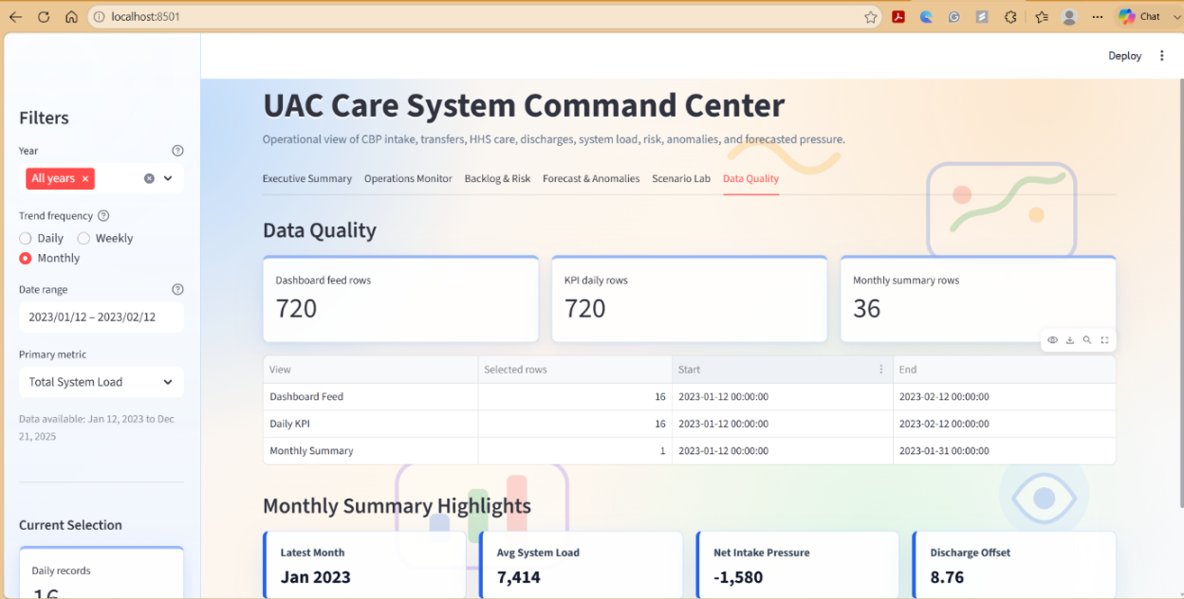
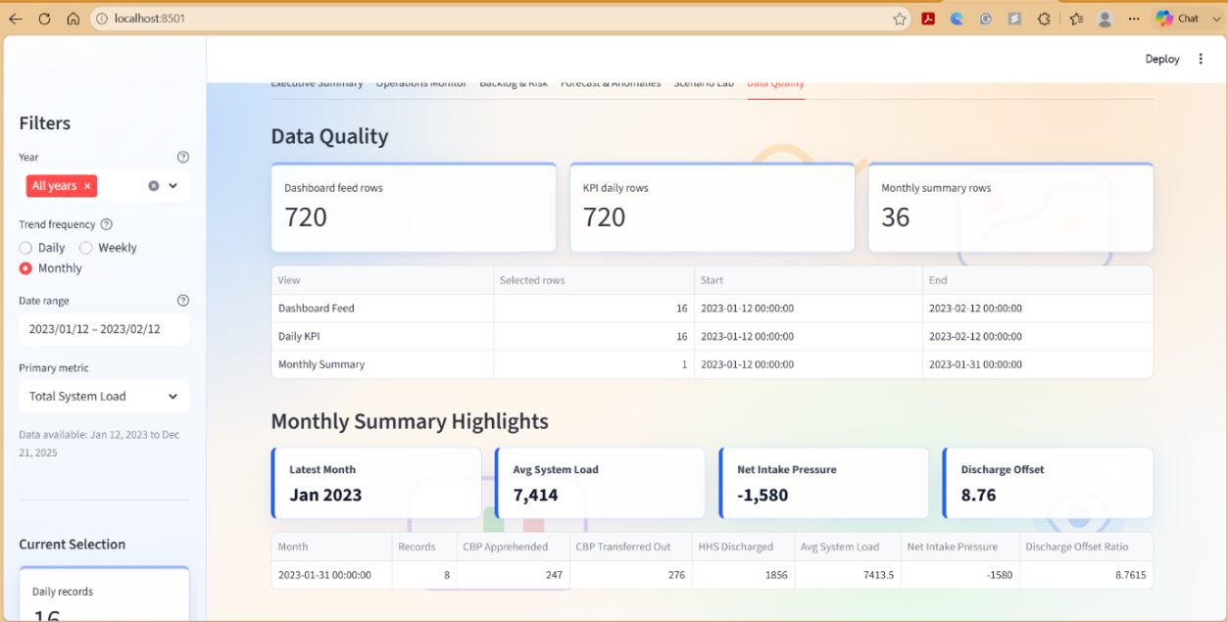
Figure 6. Data Quality Tab
Scenario Analysis Module
The Scenario Lab extends the dashboard beyond descriptive analytics by incorporating interactive simulation capabilities. Users can modify operational assumptions, including the percentage change in CBP transfers and HHS discharges, using configurable slider controls. The application recalculates Net Intake Pressure under simulated conditions and compares projected outcomes against baseline operational performance. This functionality enables decision-makers to evaluate alternative operational strategies and assess their potential impact before implementation, thereby strengthening evidence-based planning and resource allocation.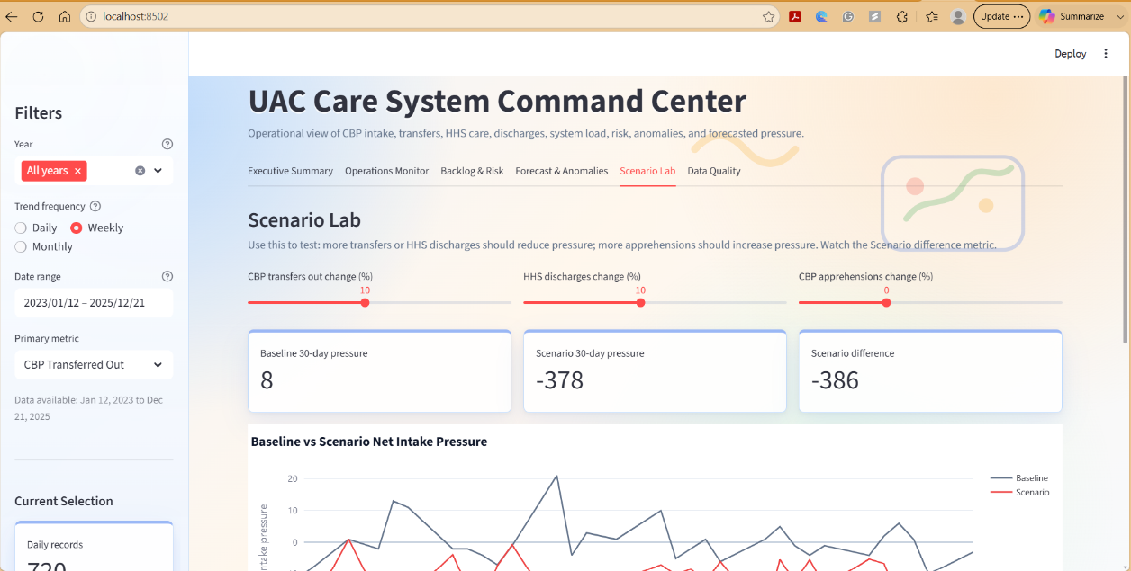
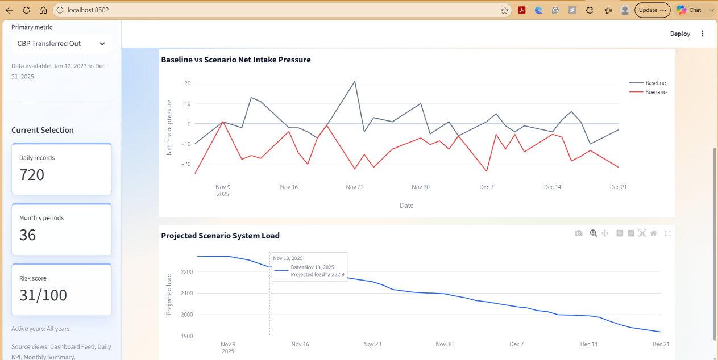
Before changes 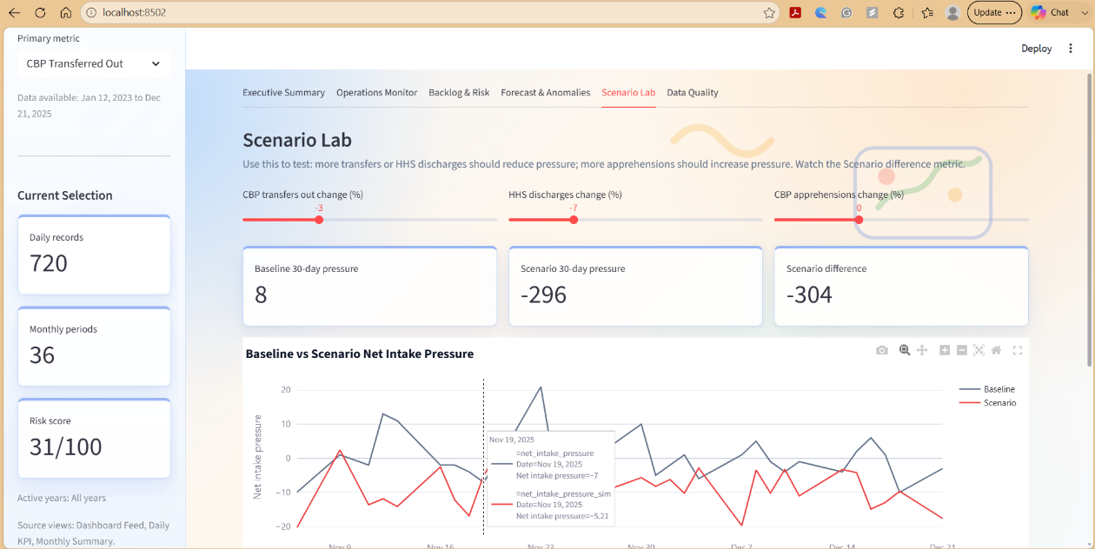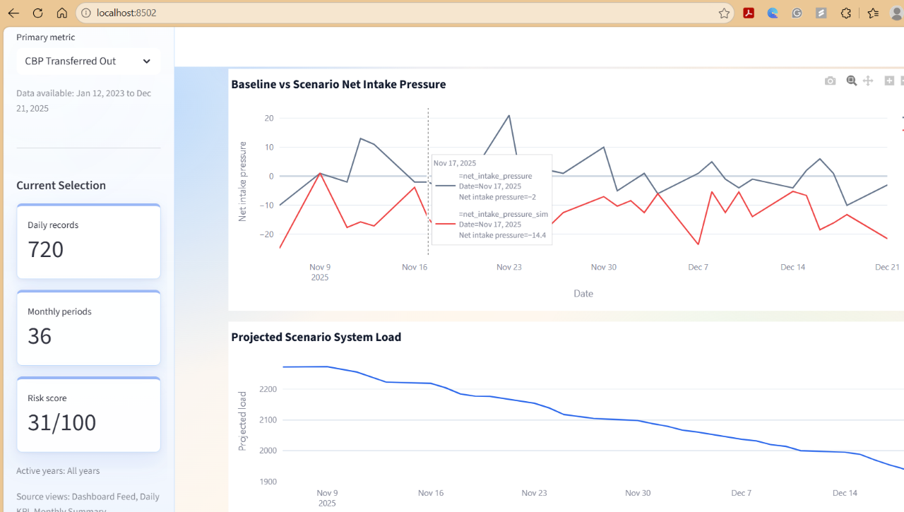
After the changes
Figure 7. Scenario lab Tab

Power BI Analytical Dashboard
In addition to the Streamlit application, a complementary Power BI dashboard was developed to support detailed business intelligence analysis. Connected to the same SQLite database through an ODBC interface, the Power BI report provides multi-year performance comparisons, drill-down analysis, backlog monitoring, throughput assessment, and operational trend visualization. Interactive filtering and hierarchical navigation allow users to move from annual summaries to quarterly, monthly, and weekly operational views without altering the underlying data model. This complementary analytical environment enables both executive monitoring and detailed operational investigation using a shared data source.
Overall, the dashboard implementation demonstrates how lightweight analytical technologies can be integrated into a unified decision-support platform capable of supporting operational monitoring, forecasting, performance evaluation, and strategic planning. The modular architecture ensures flexibility for future extensions, including machine learning models, automated alert mechanisms, and cloud-based deployment.
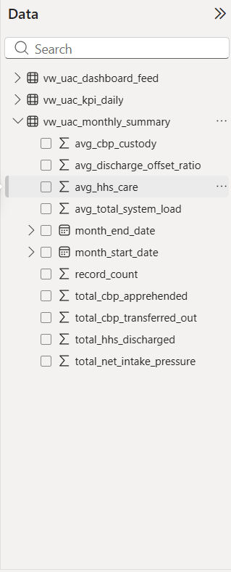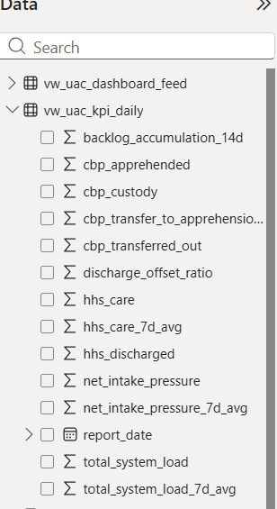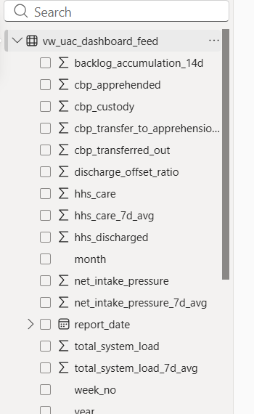
Figure 8. Power BI Data Populated views
The Annual System Load and Net Intake Pressure visualization presents the contribution of each reporting year to the overall operational workload. The chart enables rapid comparison of annual system pressure and helps identify years that experienced relatively higher operational demand, supporting long-term performance assessment.
The Annual 14-Day Backlog Accumulation chart compares backlog levels across reporting years. The results indicate that 2024 recorded the highest backlog accumulation (approximately 114K) compared with 2025 (9K) and 2023 (6K), suggesting that operational demand exceeded processing capacity during this period. This visualization assists managers in identifying periods requiring additional resources and capacity planning.
The Yearly CBP Apprehended vs. CBP Custody chart compares the annual number of apprehended children with those remaining in CBP custody. The visualization demonstrates that custody counts consistently exceeded annual apprehensions, indicating that a considerable proportion of cases remained within the system across reporting periods. Interactive drill-down functionality further enables analysis at quarterly and monthly levels.
Finally, the Weekly System Load, Transfers, and Discharges chart illustrates the relationship between total system load, CBP transfers, and HHS discharges on a weekly basis. By comparing these operational flows, the dashboard highlights weeks where increases in system load coincide with lower discharge activity or higher intake volumes. Combined with the backlog and ratio analyses, this visualization provides valuable insights into operational bottlenecks and supports evidence-based resource planning.

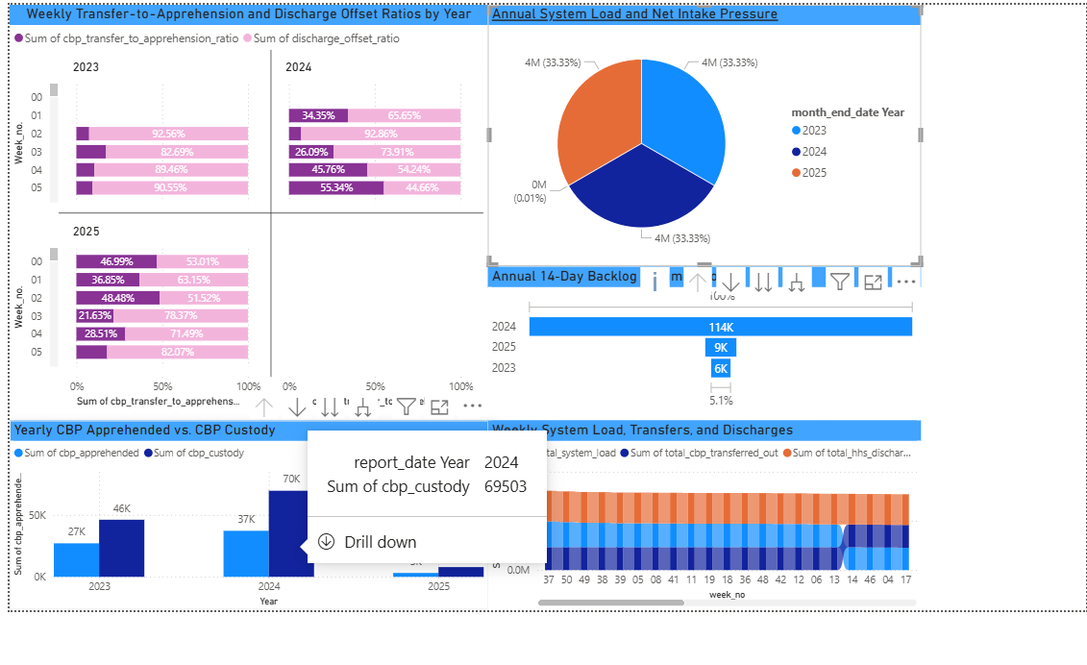
The above figures give a compact multi-year overview of system load, flows, and backlog.
- Top left: Weekly transfer-to-apprehension and discharge-offset ratios, by year, showing how efficiently cases move from CBP to HHS and out of the system.
- Top right: Pie chart of annual system load and net intake pressure, comparing how much pressure each year contributes.
- Middle right: Annual 14-day backlog accumulation, highlighting which year has the highest sustained backlog (2024 is clearly the worst).
- Bottom left: Yearly CBP apprehended vs CBP custody counts, indicating how much of the caseload remains in CBP custody at year-end versus new apprehensions.
- Bottom right: Weekly system load, transfers, and discharges, showing how weekly flows of intakes and discharges drive total system load over time.

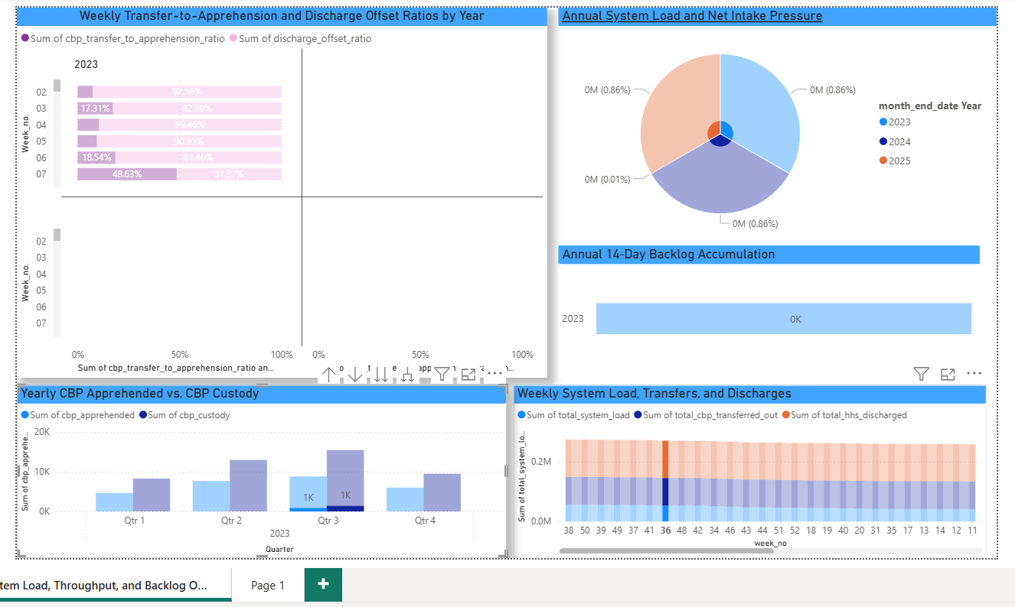

The above screenshot shows the same System Load, Throughput, and Backlog Power BI page as the overview, but with an important interactive feature highlighted — the drill-down mode is active on the Yearly CBP Apprehended vs. CBP Custody chart.
Key points:
- Top left – Weekly Transfer-to-Apprehension and Discharge Offset Ratios by year (2023, 2024, 2025), showing how efficiently CBP transfers children to HHS relative to total apprehensions each week.
- Top right – Pie chart of Annual System Load and Net Intake Pressure, showing each year's share of total system pressure across the full dataset.
- Middle right – Annual 14-Day Backlog Accumulation bar, now showing only 2023's backlog (6K) because the drill-down has filtered the view to that specific year.
- Bottom left – The Yearly CBP Apprehended vs. CBP Custody chart has been drilled down to quarter level for 2023, showing a tooltip that reads report_date.Quarter: 2023 Qtr 1, Sum of cbp_custody: 8,263. This confirms that Power BI's native drill-down capability is working, allowing users to move from yearly to quarterly granularity with a single click.
- Bottom right – Weekly System Load, Transfers, and Discharges stacked bar chart, unchanged from the overview, providing consistent context.

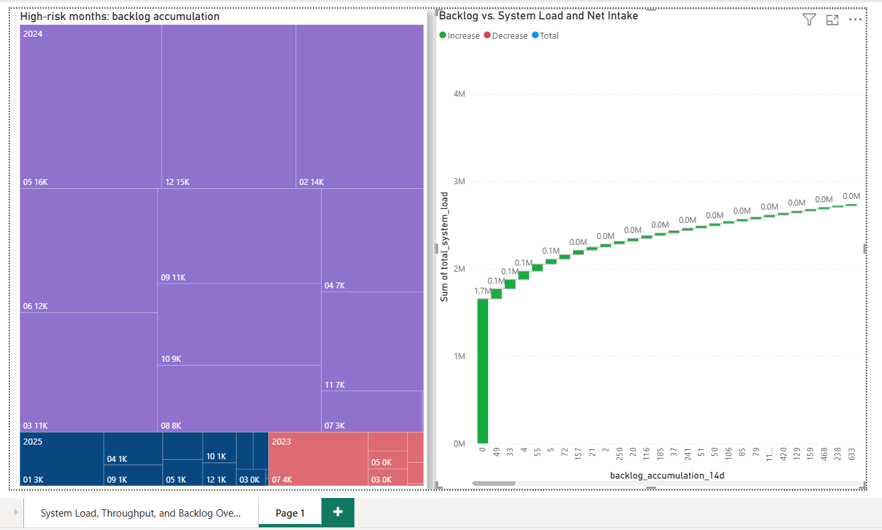

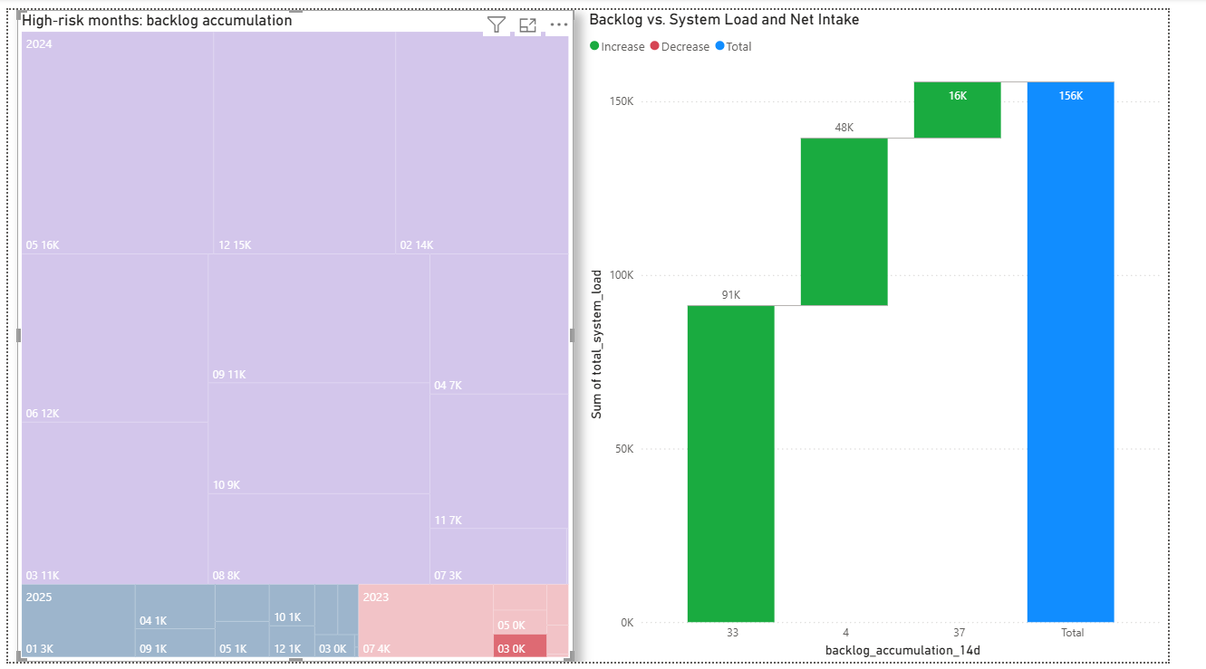

Treemap Analysis: High-Risk Months – Backlog Accumulation
The treemap visual highlights the distribution of backlog accumulation across different months and years. Each rectangle represents a month, with larger and darker purple blocks indicating higher backlog volumes.
Key Findings
- 2024 contributed the highest backlog accumulation, as shown by the dominance of large purple blocks across the treemap.
- Within 2024, months such as February, March, and April recorded the largest backlog volumes, indicating periods where incoming workload significantly exceeded processing capacity.
- 2025 shows comparatively smaller backlog values, suggesting improved workload management and reduced accumulation compared to the previous year.
- The lighter-colored sections represent months with lower backlog accumulation, indicating periods of relatively balanced system load and throughput.

