Supplementary Figure

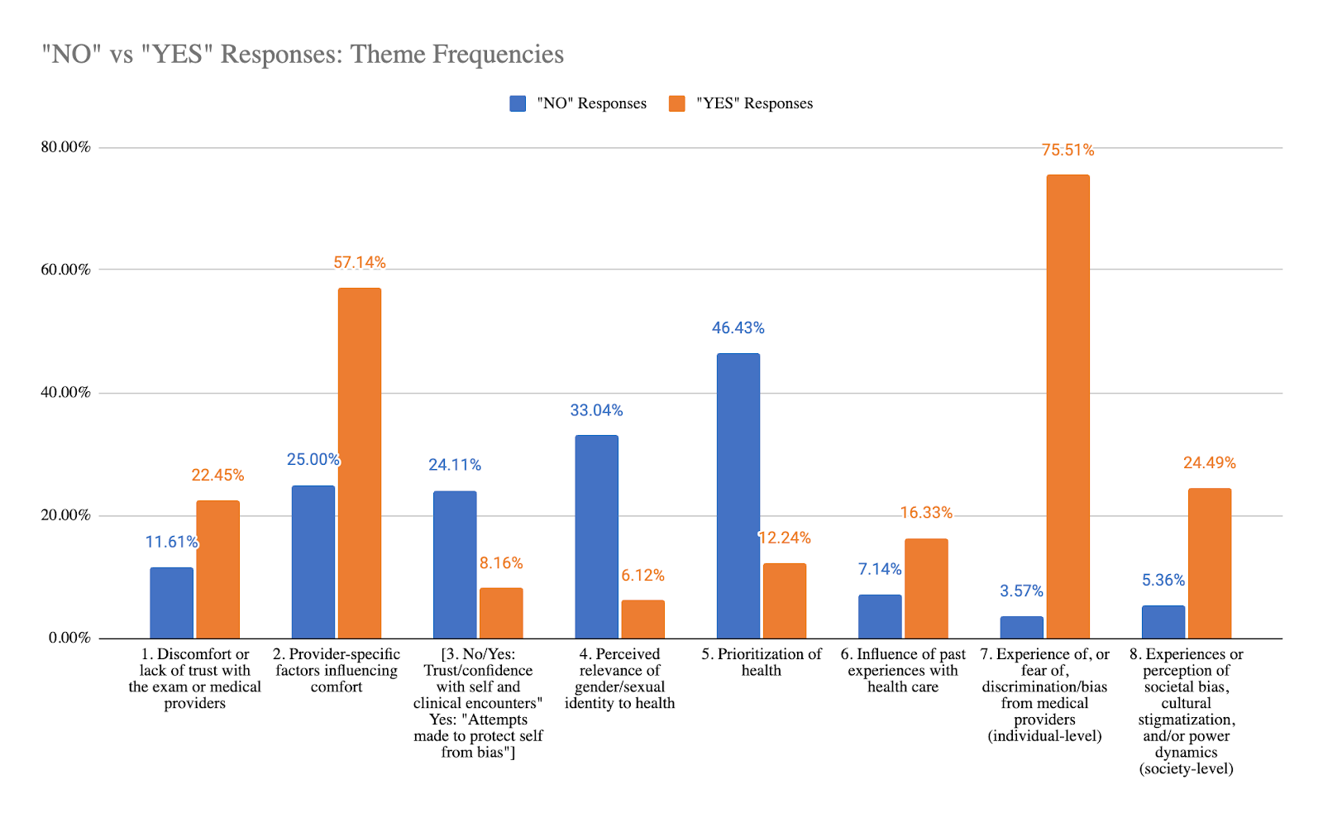
Figure 1. Major Theme Frequencies: “No” vs “Yes” Responses

