Supplementary Information for
Quaternion optical computing chip for parallel high-dimensional data processing
Songyue Liu¹, Qi Lu¹, Yuan Zhong¹, Yuru Li², Meng Xiang³, Zhaohui Li⁴, Chao Lu⁵, Yikai Su^{1*}, and Lu Sun^{1*}
¹State Key Lab of Photonics and Communications, Department of Electronic Engineering, Shanghai Jiao Tong University, Shanghai 200240, China
²School of Microelectronics Science and Technology, Sun Yat-Sen University, Zhuhai 519000, China
³Key Laboratory of Photonic Technology for Integrated Sensing and Communication, Ministry of Education, Guangdong University of Technology, Guangzhou 510006, China
⁴Southern Marine Science and Engineering Guangdong Laboratory (Zhuhai), Zhuhai 519000, China
⁵Photonics Research Institute, Department of Electronic and Information Engineering, The Hong Kong Polytechnic University, Hong Kong SAR, China
*Corresponding author: Yikai Su and Lu Sun and (email: yikaisu@sjtu.edu.cn; sunlu@sjtu.edu.cn)
Supplementary Note 1: Quaternion presentation of 3D space transformation
Quaternions are an extension of complex numbers, introduced by William Rowan Hamilton in 1843. A quaternion is a 4D hypercomplex number represented as
where q₀ is the scalar (real) part, q₁, q₂, q₃ are the vector (imaginary) parts, and i, j, k are the fundamental quaternion units, satisfying
For any point in 3D space, it can be written as a quaternion p = (0, p), where p = (p_{x}, p_{y}, p_{z}) is the position vector. The transformation on such a point can be represented by a quaternion operator q. The transformed point p’ is related to the original point p by p’ = qpq⁻¹, where p’ = (p_{x}’, p_{y}’, p_{z}’) is the vector part of the quaternion p’ = (0, p’) that denotes the spatial coordinates of the point. Expanding the quaternion product in the matrix form, we have
(3)
The vectors p and p’ are connected bywhere the transformation matrix R(q) can be derived by extracting the 3×3 submatrix at the bottom right corner of the resulting matrix of Eq. (3)¹
(4)
Supplementary Note 2: Weight configuration of MRR banks
The thermally tunable MRR bank allows for the individual configuration of weights for input optical signals at different wavelengths. Figure S1 shows the schematic of the MRR bank. It consists of three MRRs coupled to two bus waveguides (the difference in output power between the through and drop ports represents the weight). The three MRRs have radii of 10.00 μm, 10.02 μm, and 10.04 μm, respectively. The gap between the MRR and the bus waveguide is 185 nm, and the waveguide width is 450 nm. The spectral response of the MRR bank can be controlled by the microheater (TiN with a thickness of 200 nm and a width of 2 μm). The resonant wavelength shift Δλ is proportional to the variation in temperature ΔT, which can be described as
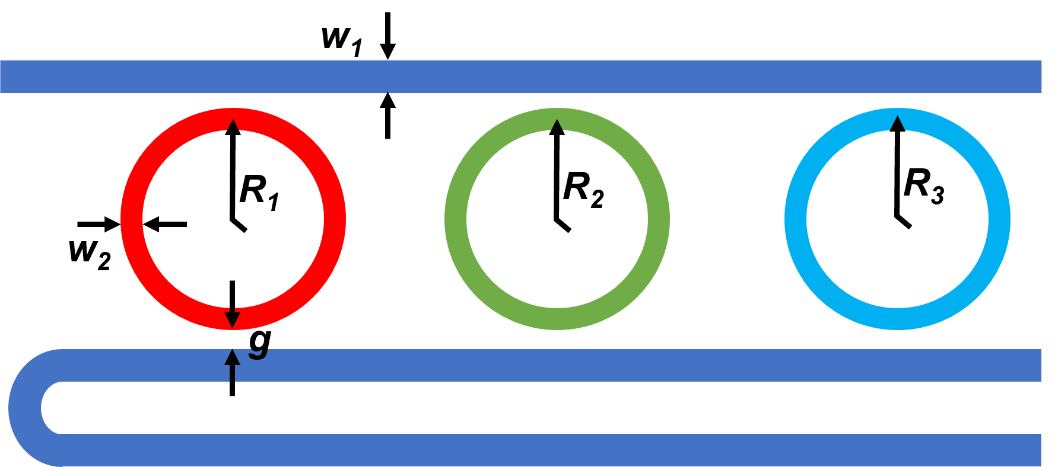
Fig. S1| Design details of the MRR bank.
(5)
where λ₀ is the resonant wavelength of the MRR, n is the effective index, and Δn/ΔT is the thermo-optic coefficient of silicon (1.86 × 10⁻⁴ K⁻¹). In the experiments, the resonant wavelength shifts linearly with the heating power.
The experimental setup employed for MRR bank characterization is shown in Fig. S2. A fiber polarization controller (PC) was used to tune the polarization of light from a tunable continuous wave (CW) laser (Santec TSL-770). The TE-polarized light was coupled into and out of the chip by grating couplers. The coupling losses were ~3 dB/port at the central wavelengths of 1550 nm. The multi-channel voltage source (TIME-TRANSFER) was used to tune multiple MRRs simultaneously. The light output from the chip was evenly split via a 3-dB fiber coupler. One half of the light was guided into a power meter (PM) for optical calibration while the other half was directed into a photodetector (PD, Santec MPM-210) for receiving the transmitted power. The tunable laser and the PD were controlled by a computer to record the transmitted optical power at every wavelength.
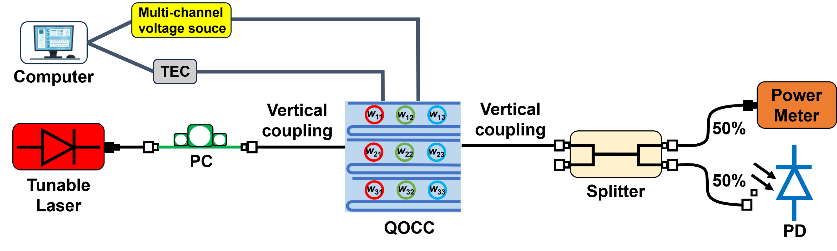
Fig. S2| Schematic of the experimental setup for the transmission measurement of the MRR banks.
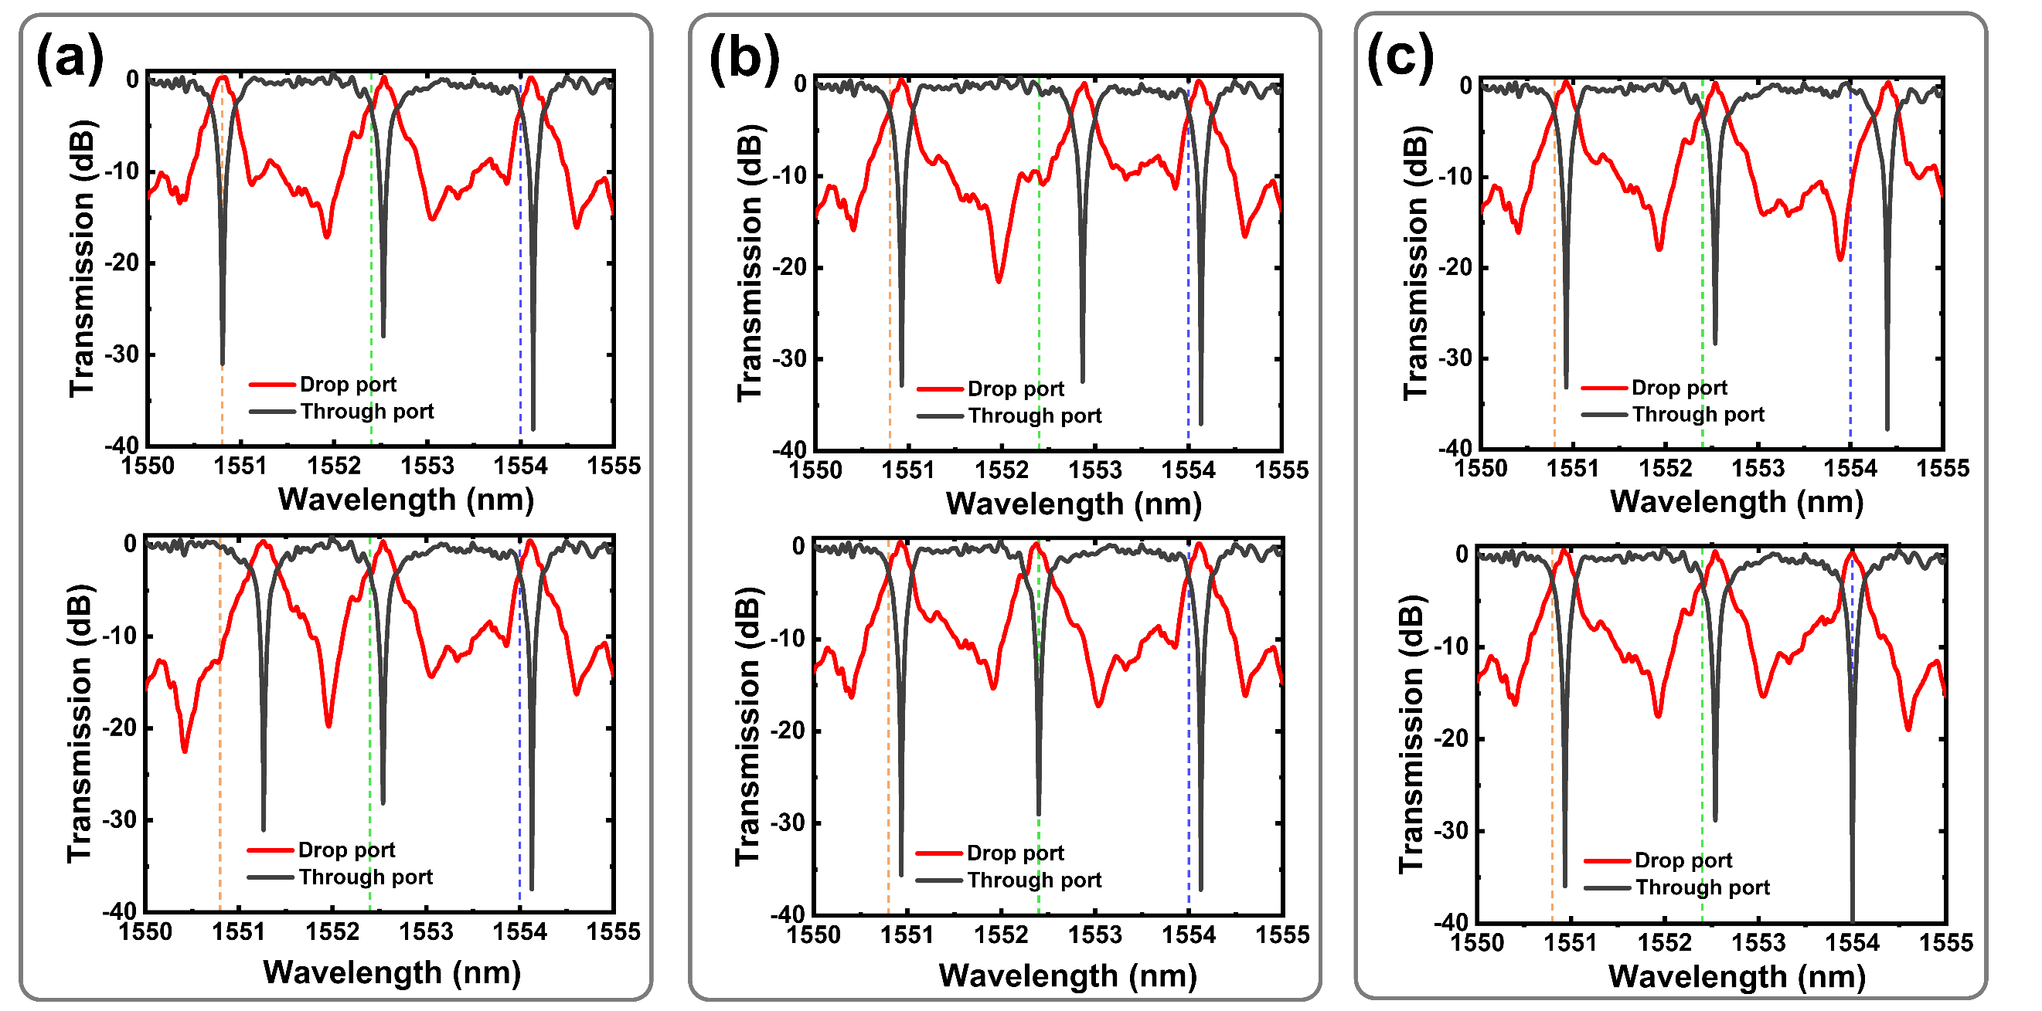
Fig. S3| Weight configuration of a MRR bank. a-c, Transmission spectra of the MRRs configured with weights of -1 (top) and 1(bottom) at 1552.8 nm (a), 1552.4 nm (b) and 1554 nm (c). The weights of the unconfigured MRRs are initialized to 0 by default.
The measured transmission spectra are all normalized to that of the reference grating couplers fabricated on the same chip.
The resonant wavelengths of the three MRRs in a bank are λ₁ = 1550.8 nm, λ₂ = 1552.4 nm and λ₃ = 1554 nm. As shown in Fig. S3, the MRR bank achieves various weights of -1, 0, 1 at all three operating wavelengths (indicated by the orange, green and purple dashed lines). By thermally tuning the MRR resonances, the weights of the MRRs can be continuously adjusted within the range of [-1, 1], fully satisfying the weight configuration requirements of our QOCC.
Supplementary Note 3: Quaternion data preparation, processing and extraction
The simplest computing unit of the QOCC consists of three parallel MRR banks, with each bank capable of performing weighted summation on signals across three wavelengths. The data flow in the quaternion computing process is schematically illustrated in Fig. S4. The coordinates of the points in 3D space are modulated onto the optical carriers of three wavelengths, producing three replicas of encoded signals. The resulting wavelength- and time-domain signal sequences are shown in Fig. S4a. After passing through a dispersive fiber, the data sequences undergo a 1-bit delay between adjacent wavelengths, as shown in Fig. S4b. The dispersive delay Δt can be calculated by
(6)
where β is the dispersion coefficient of the dispersive compensation fiber (DCF), L is the length of the DCF, and Δλ is the wavelength difference between two adjacent optical carriers. On the other hand, the symbol duration of the encoded data can be expressed as
(7)
where f_{b} = 9.2 Gbaud is the symbol rate. To satisfy the 1-bit latency between sequences with adjacent wavelengths, we adjust the DCF length to ensure that the dispersive delay Δt is equal to the symbol duration τ
(8)
As we can see in Fig. S4b, this method generates two sets of redundant data in the process, and only the yellow columns of data in Fig. S4b contribute to the final computational results. After transmitting the QOCC for quaternion operations, the optical signals are detected by the BPDs, generating three output sequences (Fig. S4c). The computational results are obtained by extracting the data in every third columns of the sequences (yellow columns in Fig. S4c). Compared with conventional parallel computation schemes employing multiple discrete modulators, the time-domain-wavelength-stretching method can reduce the number of high-speed modulators while maintaining ideal computational performance. As a result, the effective quaternion computing speed of the basic computing unit of the QOCC becomes 9.2 (data rate) ×3 (number of parallel branches) ×3 (number of wavelengths) ÷ 3 (redundancy) = 27.6 GOPS.
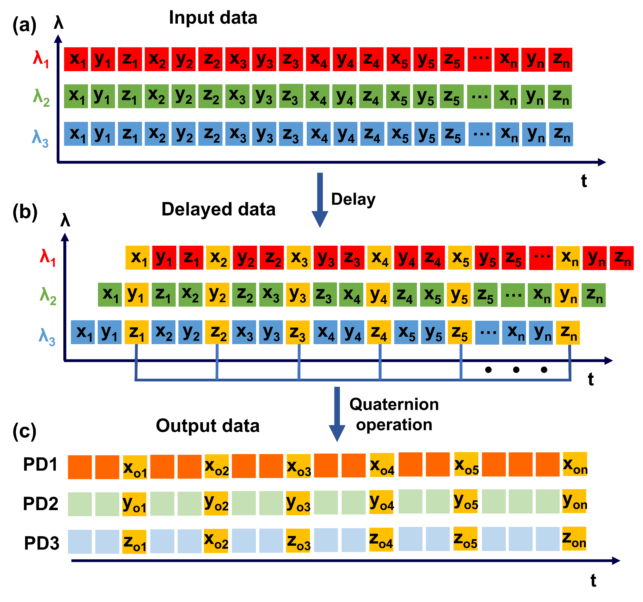
Fig. S4| Schematic of the data flow in the quaternion computing process.
Supplementary Note 4: Experimental details for 3D point cloud processing
The experimental setup for the 3D point cloud processing can be found in Fig. 2a of the main text. The baseband sampling rate of the AWG (Keysight M9502A) is 27.6 GSa/s, and each data point is repeated for three times (to achieve a flat-top waveform). Therefore, the equivalent data rate f_{b} is 27.6 ÷ 3 = 9.2 Gbaud and the average time interval for each data point is 108 ps. The light containing three wavelengths (1550.8, 1552.4 and 1554 nm) with 1.6-nm spacing are generated by the DFB laser and then multiplexed via a DWDM. The spatial coordinates of the 3D point cloud are sequentially formatted as S = [x₁, y₁, z₁, x₂, y₁, z₁… x_{n}, y_{n}, z_{n}] and subsequently input into the MZM. After completing the electro-optical signal conversion, the modulated signal is launched into the QOCC for quaternion processing. The output signal is detected by the BPDs to produce the coordinates of the transformed 3D point cloud, which is finally used to reconstruct the 3D point cloud images.
To validate the high-throughput processing capability of the QOCC, we perform continuous rotation and scaling transformations on two 3D point cloud models—the “SJTU” letter model and the “Dog” model. For the “SJTU” model, the quaternion representing the transformation evolves as follows (Fig. S5a)
  - During frames 1 - 25, the quaternion gradually evolves from q = 1 + 0i + 0j + 0k to q = 1 - 0.4i + 0j + 0k,
  - During frames 26 - 32, the quaternion gradually evolves from q = 1 - 0.4i + 0j + 0k to q = 1 - 0.4i - 0.1j + 0k,
  - During frames 33 - 50, the quaternion gradually evolves from q = 1 - 0.4i – 0.1j + 0k to q = 1 - 0.4i - 0.1j + 0.3k.
For the “dog” model, the transformation progresses as follows (Fig. S5b)
  - During frames 1 - 25, the quaternion gradually evolves from q = 1 + 0i + 0j + 0k to q = 1 + 0i + 0j – 0.5k,
  - During frames 26 - 32, the quaternion gradually evolves from q = 1 + 0i + 0j – 0.5k to q = 1 + 0i + 0j – 0.64k,
  - During frames 33 - 50, the quaternion gradually evolves from q = 1 + 0i + 0j – 0.64k to q = 1 + 0i + 0j – 1k.
The 3D point cloud images of the “SJTU” letter model and the “Dog” model during the transformations are presented in Fig. S6. During the first 25 frames of the “SJTU” point cloud images, only the i-component of the quaternion changes, resulting in rotation orthogonal to the YOZ-plane. Since the quaternion is non-unitary, a scaling effect is introduced to the 3D point cloud
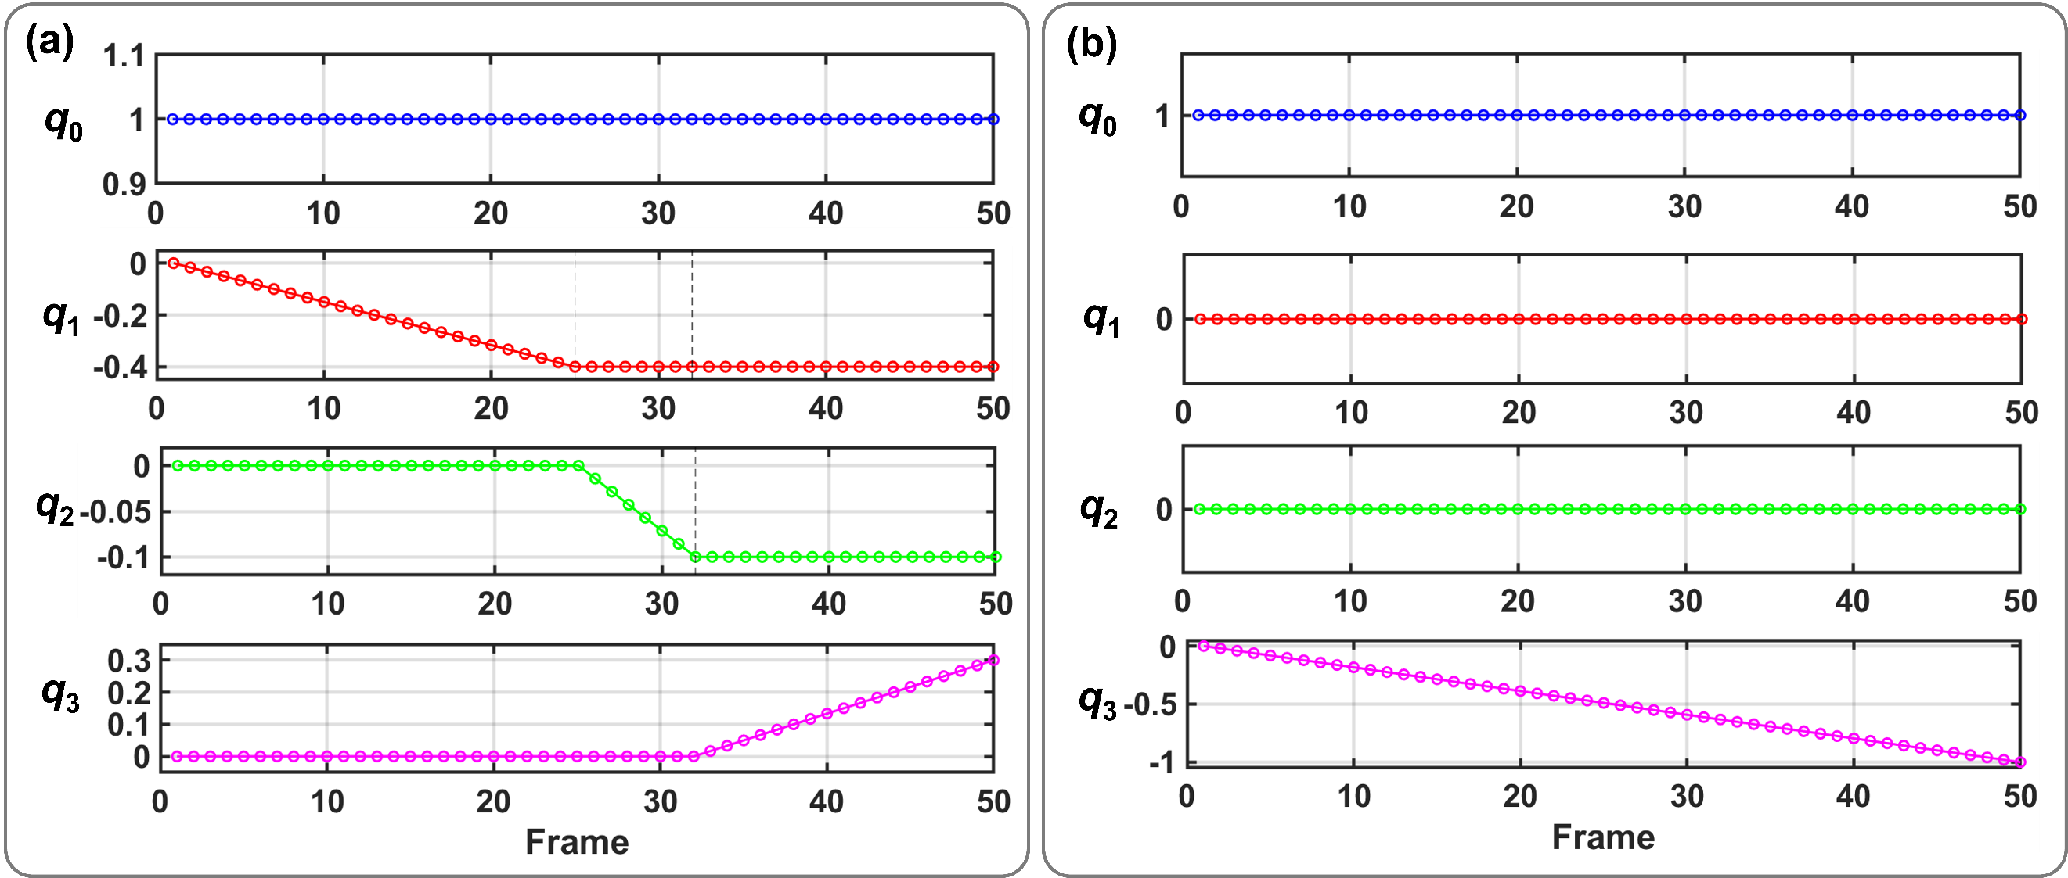
Fig. S5| Quaternion representation of continuous transformations. a,b, Evolution of q₀, q₁, q₂, q₃ for the “SJTU” letter model (a) and the “Dog” model (b).
in this phase. From the 26th to the 50th frame, both the j- and k-components of the quaternion are varied, enabling more complicated rotation and scaling operations. For the “Dog” point cloud images, only the k-component of the quaternion varies during the transformation, leading to rotation orthogonal to the XOY-plane. Also, a scaling effect is observed simultaneously because the transformation quaternion is non-unitary.
The ideal (red curve) and experimental (blue curve) waveforms of the coordinate data of the point cloud are compared in Fig. S7. The experimental results show good agreement with the ideal ones for all 50 frames, indicating that the proposed QOCC exhibits high stability and accuracy in
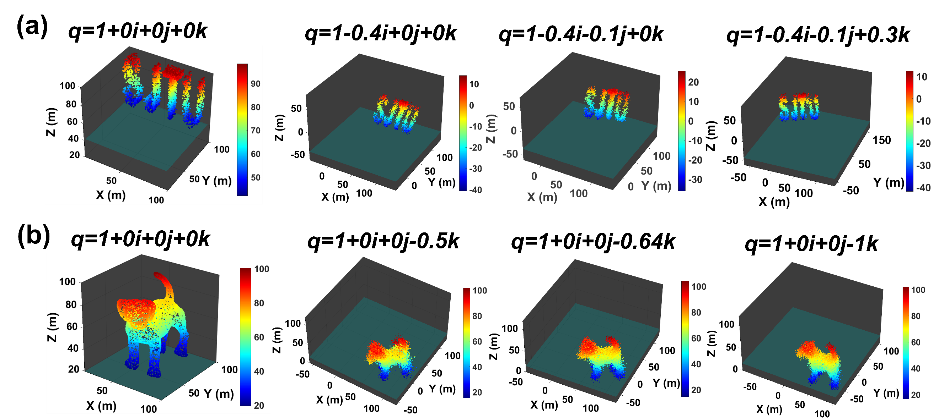
Fig. S6| 3D point cloud reconstruction. a,b, Transformed 3D point cloud images for the “SJTU” letter model (a) and the “Dog” model (b).
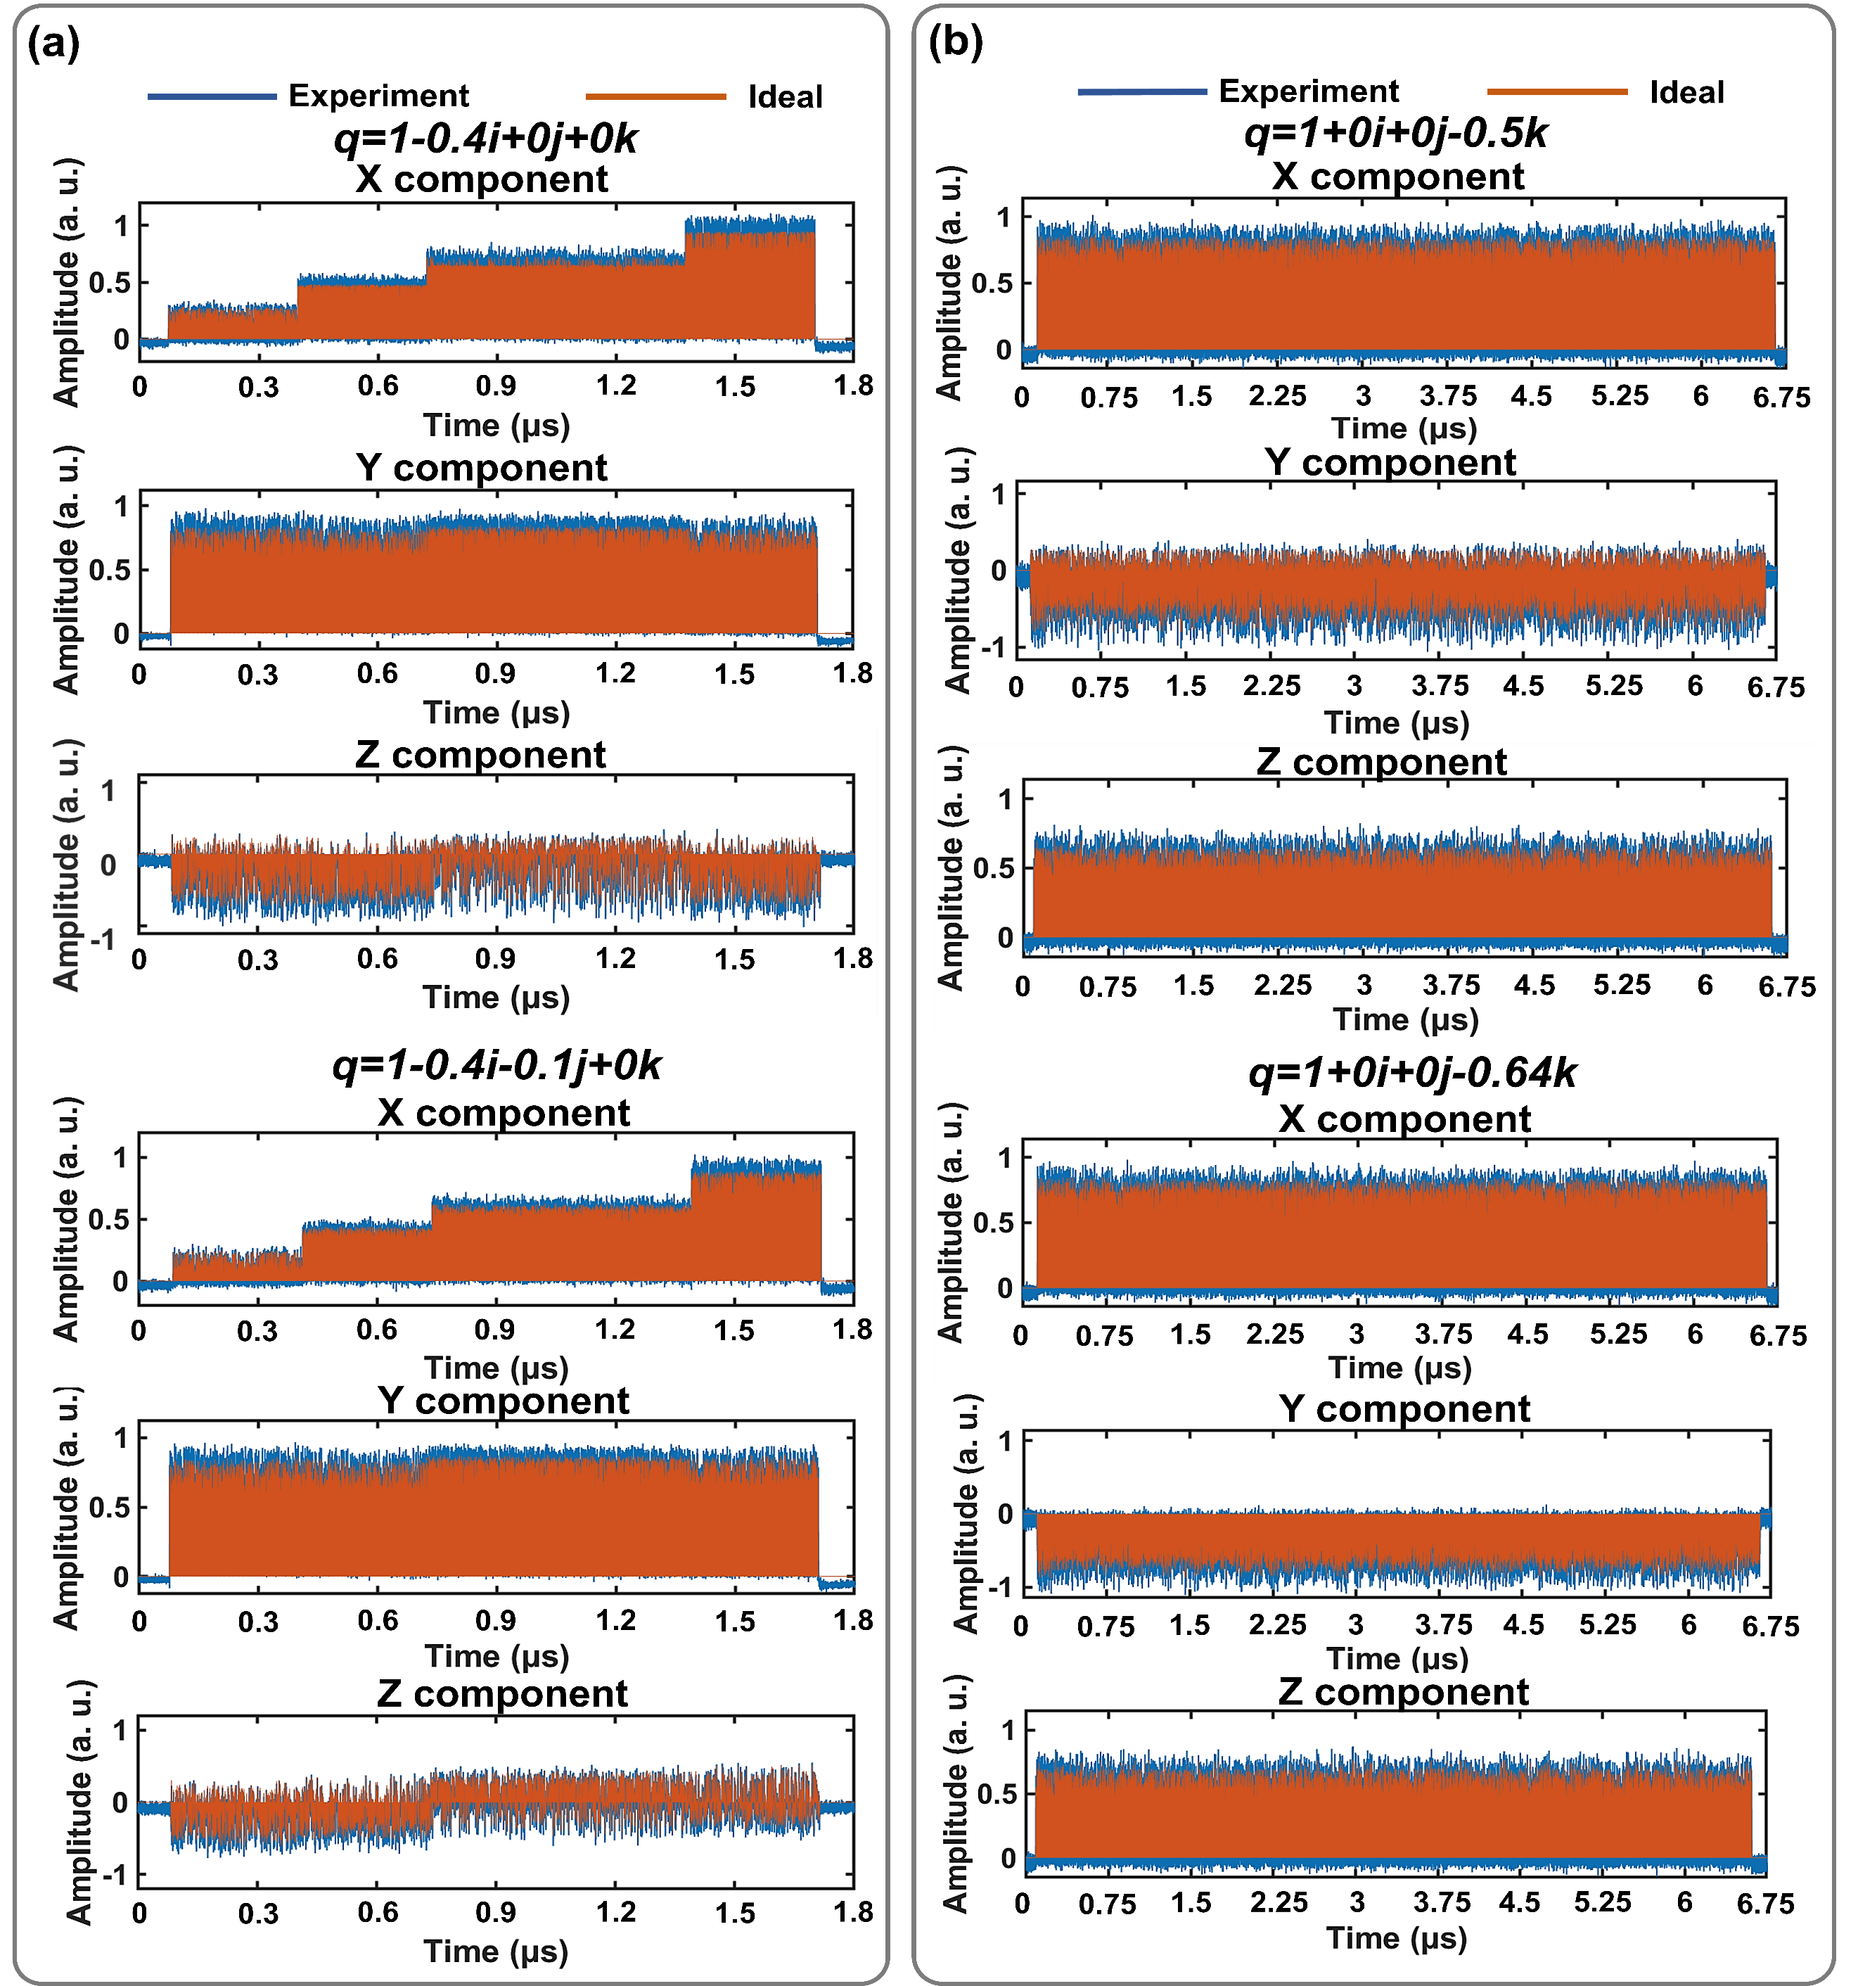
Fig. S7| Transformed coordinates of the 3D point clouds in the 26th and 32nd frames. a,b, Waveform comparison between the ideal (red line) and experimental (blue line) results for the “SJTU” letter model (a) and the “Dog” model (b). The quaternions corresponding to the 26th and 32nd frames are shown on top of the figures.
quaternion computation. For both models, the RMSEs between the theoretical and measured results remain below 0.035 throughout the transformations.
Supplementary Note 5: Performance characterization and error analysis of the QOCC
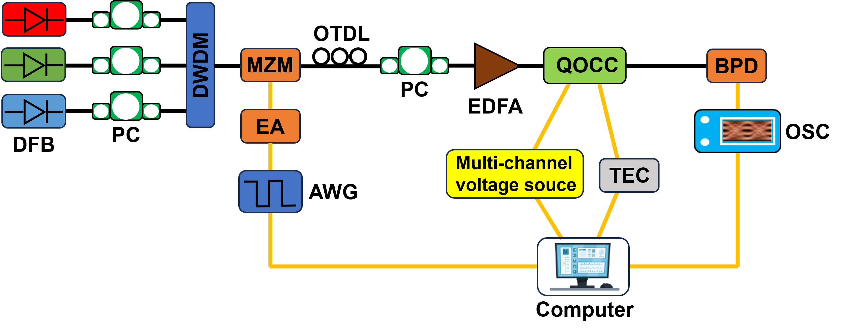
Fig. S8| Experimental setup for the quaternion computation tasks based on the QOCC. DWDM: Dense wavelength division multiplexer, MZM: Mach-Zehnder modulator, EA: Electrical amplifier, AWG: Arbitrary waveform generator, OTDL: Optical tunable delay line, PC: Polarization controller, EDFA: Erbium-doped fiber amplifier, TEC: Thermo-electric cooler, OSC: Oscilloscope, BPD: Balanced photodetector.
Figure S8 illustrates the experimental setup for the quaternion computation tasks carried out in this work. The system is built up using commercially available optoelectronic devices and the QOCC. A tunable polarization-maintaining DFB laser array generates the light of three wavelengths (1550.8 nm, 1552.4 nm and 1554 nm) through separate output ports, with adjustable output power ranging from 10 to 20 dBm. The polarization states of light at distinct wavelengths are first adjusted by three PCs. The multi-wavelength light is then multiplexed using a DWDM, serving as the WDM optical carriers for the computing system. The encoded electrical signal, generated by an AWG and amplified by an EA, is fed into a MZM to perform high-speed electro-optic modulation on the triple-wavelength-multiplexed light. Figure S9 shows the off-chip calibration result of the MZM, where the output power from the MZM is measured as a function of the applied voltage (0 - 10 V). The modulated optical signal passes through an OTDL for time-domain wavelength stretching, followed by optical amplification using an erbium-doped fiber amplifier (EDFA) before being coupled into the QOCC. After propagating through the OTDL, a 1-bit time delay (Δt = 108 ps) is introduced
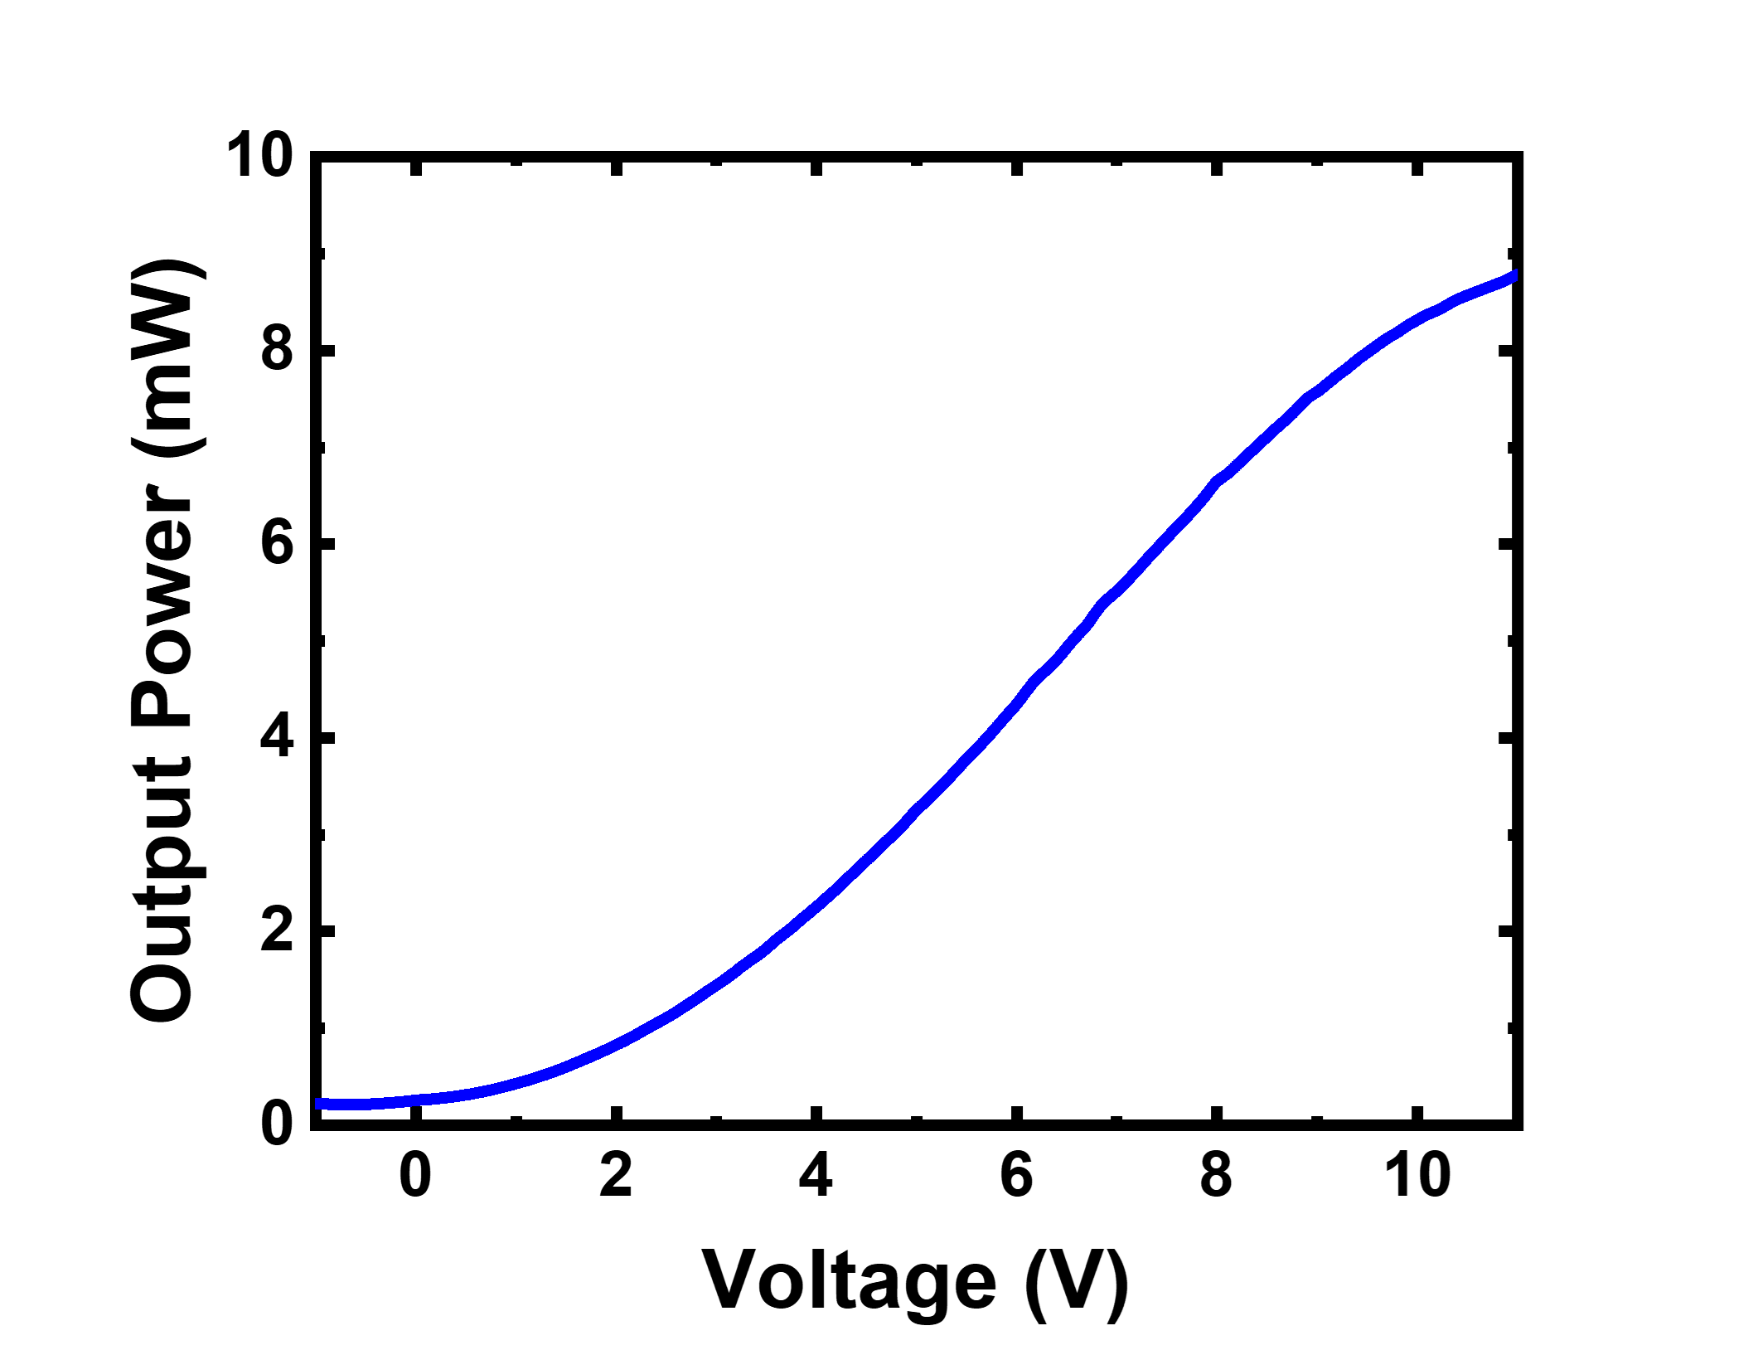
Fig. S9| Calibration of the output power of the MZM as a function of applied voltage.
between signals with adjacent wavelengths, as shown in Fig. S10. By applying computer-controlled voltages to individual microheaters, the weights of the MRRs within the QOCC can be dynamically configured. Furthermore, the QOCC incorporates a thermos-electric cooler (TEC) at the packaging stage, enabling real-time temperature stabilization to ensure thermal stability and therefore computational accuracy. Finally, the optical signals processed by the QOCC is converted back to electrical outputs through BPDs.
The performance of the QOCC is primarily affected by two sources of errors. The first one is the system itself. For instance, an EA is employed in our setup to amplify the encoded electrical waveforms generated by the AWG. This process simultaneously amplifies the baseline noise present
in the AWG output, thereby introducing additional errors. The MZMs used for intensity modulation have voltage resolution limits, and the optical signal intensity itself exhibits intrinsic fluctuations. These factors will cause the alignment errors in the calibration process of the MZMs. Moreover, an EDFA is also used to amplify the optical signals, which inherently introduces ASE noises. To reduce these systematic errors, we perform a number of off-chip calibrations and compensations including optimizing the output powers from different ports of the DBF laser array and minimizing the number
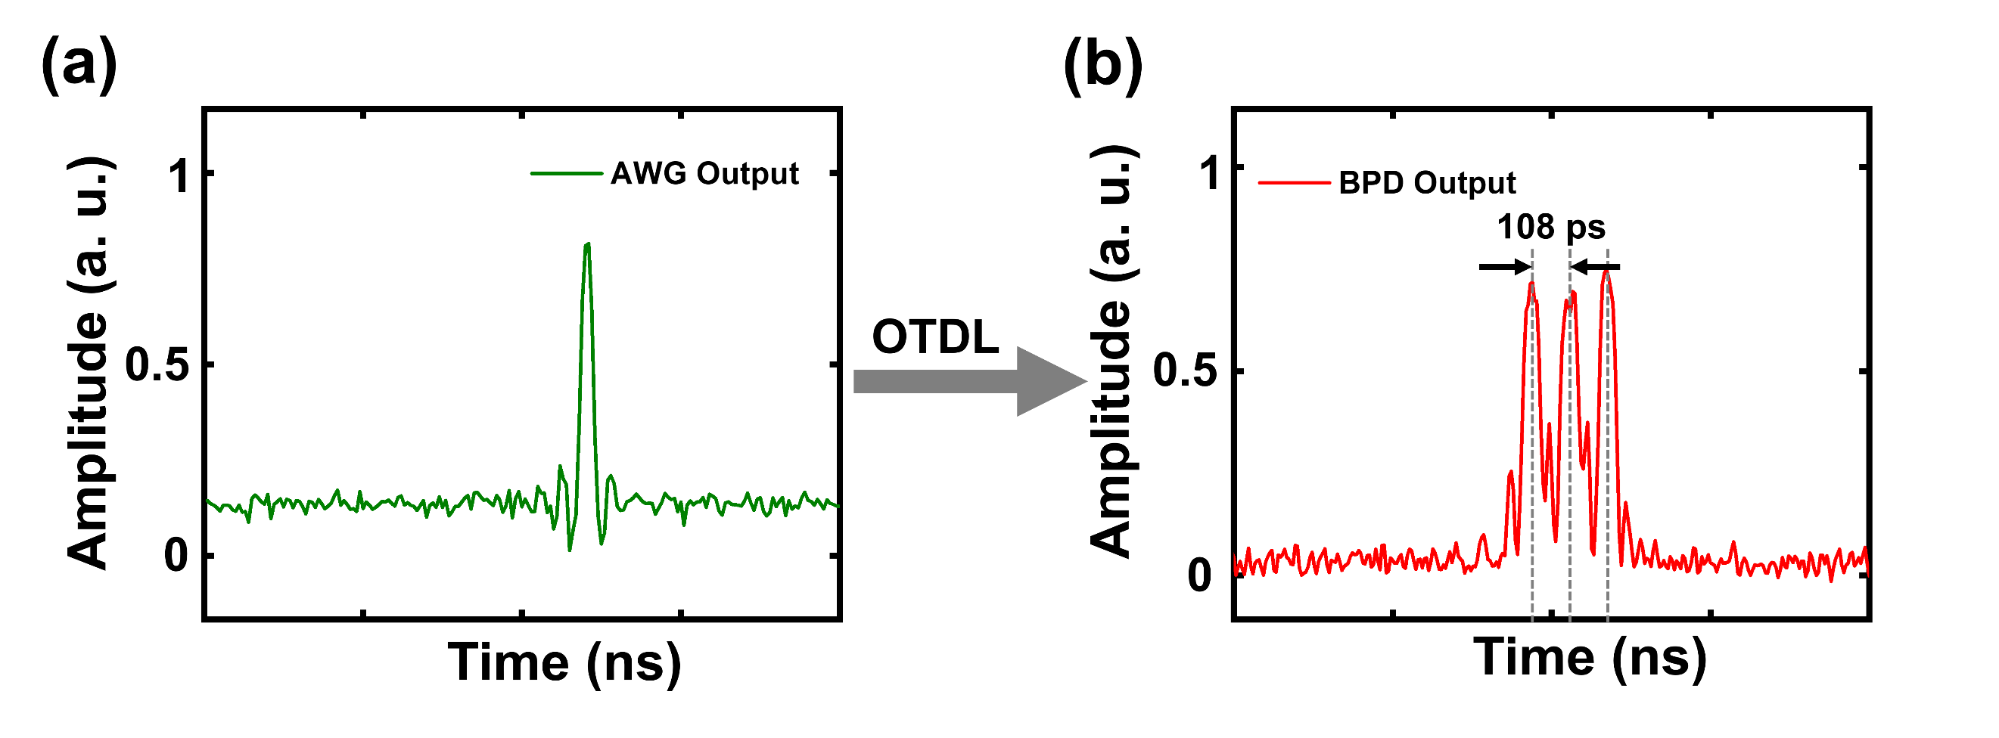
Fig. S10| Delay of the WDM signal using the OTDL. a,b, Pulsed signals before (a) and after (b) propagating through the OTDL.
of EDFAs used in the system. Another source of errors is the surrounding environment and the working condition of the chip. As we all know, the resonant wavelengths of the MRRs drift with ambient temperature. To address this issue, a TEC is placed underneath the chip to stabilize the working temperature. Thermal crosstalk within a chip is also an important factor that degrades its performance. In our design, thermal isolation trenches are adopted to suppress the thermal crosstalk between neighboring MRRs.
To analyze the computational error of the proposed QOCC, we calculate the RMSEs between the results obtained from the electronic computer and those from the QOCC. The RMSE serves as a key metric for assessing the computational error. The calculation formula is as follows²
(9)
where N is the total number of data points, and and represent the ideal and measured values of the i-th point (e. g., the pixel of RGB images or the coordinates of 3D point clouds), respectively. A small RMSE value implies high computational fidelity of the QOCC. Another important metric is the standard deviation σ which is commonly used to characterize the system stability³
(10)
where M represents the total number of measurements carried out in the experiment, andandare the measured results and the mean value of these results. It can also be characterized by the bit precision N_{b} as follows⁴
(11)
where μ_{max} and μ_{min} are the maximum and minimum values attained during the measurements, respectively. The bit precision of the optical computing system is primarily determined by the noise levels and the stability of the experimental setup. Assuming that the noise levels remain invariant during the computation, the accuracy of the output results depends mainly on the stability of the system itself and is largely independent of the specific weight configuration. The QOCC exhibits RMSEs lower than 0.035, a standard deviation of 0.0212 and bit precision of 5 bits, proving that the QOCC can achieve high-precision computation in the quaternion-based signal processing.
Finally, we discuss the potential energy efficiency of a fully integrated QOCC, accounting for all essential system-level overheads. In a realistic deployment, the system must encompass the energy consumption of DAC/drivers, integrated MZMs, optical amplification (EDFA), and the detection-control suite including PD/TIA/ADC and data movement.
Operating at an input data rate of 9.2 Gbaud, the QOCC achieves a total computing speed of 331.2 GOPS (9.2 Gbaud × 3 branches × 4 modules × 3 wavelengths). The power consumption of the integrated laser source (e.g., a micro-DFB array) is optimized to 80 mW⁵. The core computational layers consume 108 mW, dominated by the thermal tuning of 36 MRRs (3 mW each). For the peripheral active components, replacing discrete MZMs with integrated silicon photonic modulators and high-efficiency drivers reduces the modulation power to 40 mW⁶. Furthermore, we allocate 150 mW for the complete detection and electrical suite—comprising PD/TIA/ADC arrays^{7,8}, control/calibration logic, and internal data movement—consistent with state-of-the-art ASIC implementation protocols⁹.
Consequently, the total system-level energy per operation of the fully integrated QOCC is estimated as (80 (Laser) + 108 (Core) + 40 (Modulation) + 150 (Electrical/ADC/Data)) mW / 331.2 GOPS ≈ 1.14 pJ/operation. This efficiency remains highly competitive with modern electronics (typically ∼0.5 pJ/op for digital counterparts)¹⁰. Most importantly, the inherent algorithmic advantage of our architecture—reducing the required operations for high-dimensional tasks by 2/3—ensures a superior “energy-per-task” performance, as it avoids the redundant MAC operations and frequent memory access required by traditional real-valued processors.

Supplementary Note 6: Experimental details for RGB chromatic transformation
The experimental setup for the RGB chromatic transformation can be found in the Fig. 3a of the main text. To achieve a 1-bit shift between data sequences with adjacent wavelengths, the time delay Δt = 108 ps is chosen to align with the symbol rate f_{b} = 1/Δt = 9.2 Gbaud. In this case, the computing ability of the QOCC accelerator is 2nf_{b} = 2 × 9 × 9.2 × 10⁹ = 165.6 GOPS, where n is the number of MRRs in the basic computing unit of the QOCC.
In color image processing, RGB chromatic transformation (e.g., mapping red to green, green to blue, and blue to red) is a common operation. Quaternions provide an elegant and unified mathematical framework for this kind of transformations between three channels. The central concept is to represent each pixel by a quaternion
(12)
The first chromatic transformation can be described by
(13)
which rotates the pixel vector by θ = 120° around the rotation axis u in color space¹¹. Vectors along this axis remain invariant under the rotation transformation, so it can be defined as
(14)
After simple algebraic manipulation, we find that the RGB color space rotation can be represented by the following unit quaternion¹²
(15)
Substituting the parameters θ = 120° and Eq. (14) into Eq. (15), one can derive the quaternion corresponding to the specific cyclic permutation (R→G→B→R)
(16)
The second chromatic transformation is the reverse operation of the first one (i. e., R→B→G→R), equivalently expressed as follows
(17)
It equals to rotating the pixel vector around the same axis u by θ = -120°. Thus, the unit quaternion achieving this operation is
(18)
Traditional real- and complex-valued computational methods process the RGB channels independently, which may induce color distortion or unintended brightness variation. In contrast, quaternion-based rotation treats the RGB channels as a unified entity, thereby avoiding incoherent transformations between three channels. More importantly, quaternion-based rotation is a reversible operation, allowing the original image to be restored through inverse transformation. Therefore, it is more suitable for applications requiring invertible color processing.
We use color images with a resolution of 512 × 512 pixels for experimental demonstration. Due to the limited memory depth of the oscilloscope, a partitioning scheme is employed to divide the color images into four sub-images. The ideal (red line) and experimental (blue line) waveforms for the RGB channels of the second, third and fourth sub-images are compared in Figs. S11, S12 and S13, respectively.
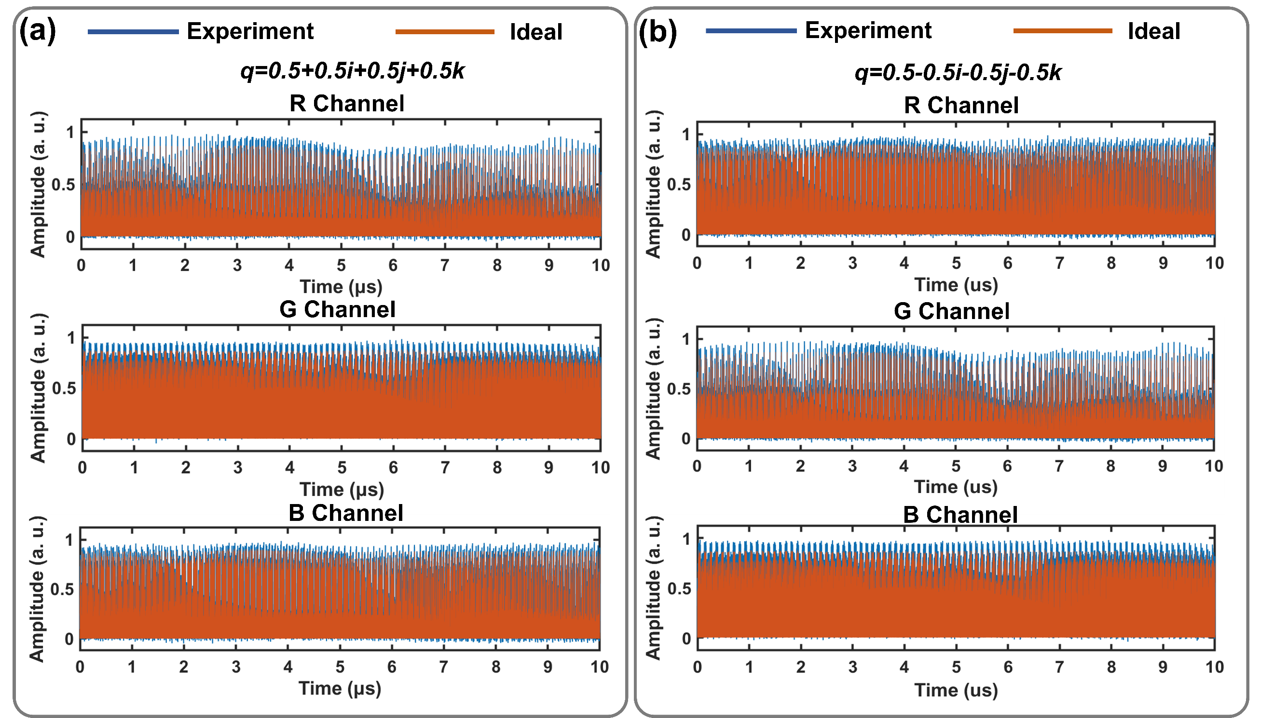
Fig. S11| Experimental results of the second sub-image. a,b, Comparison between the ideal (red line) and the experimental (blue line) waveforms of the RGB channels after the chromatic transformation represented by q = 0.5 + 0.5i + 0.5j + 0.5k (a) and q = 0.5 - 0.5i - 0.5j - 0.5k (b).

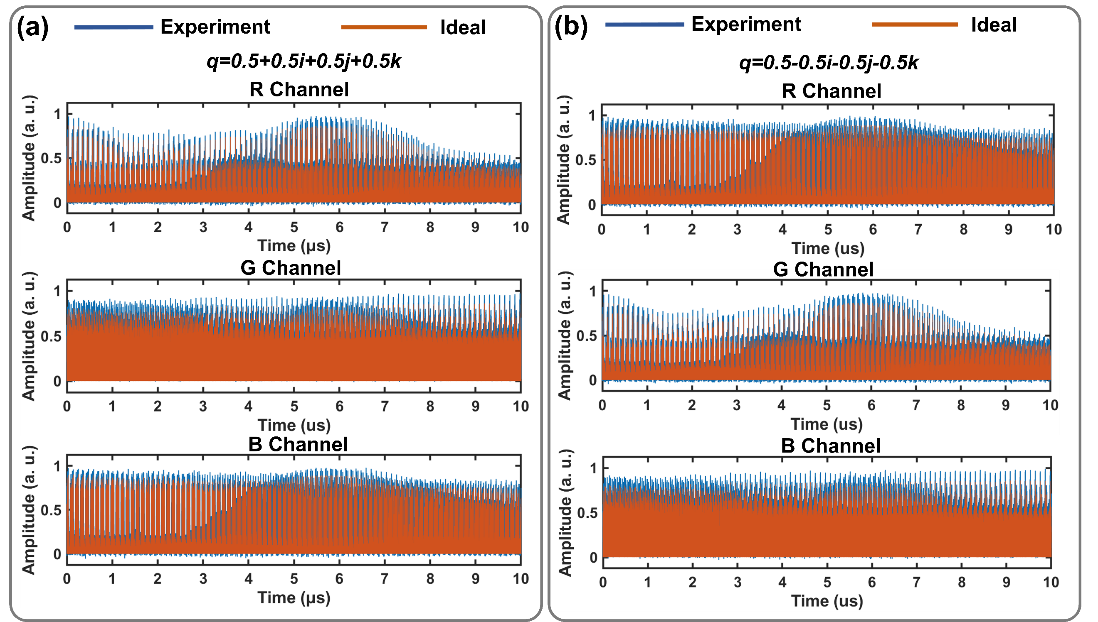
Fig. S12| Experimental results of the third sub-image. a,b, Comparison between the ideal (red line) and the experimental (blue line) waveforms of the RGB channels after the chromatic transformation represented by q = 0.5 + 0.5i + 0.5j + 0.5k (a) and q = 0.5 - 0.5i - 0.5j - 0.5k (b).

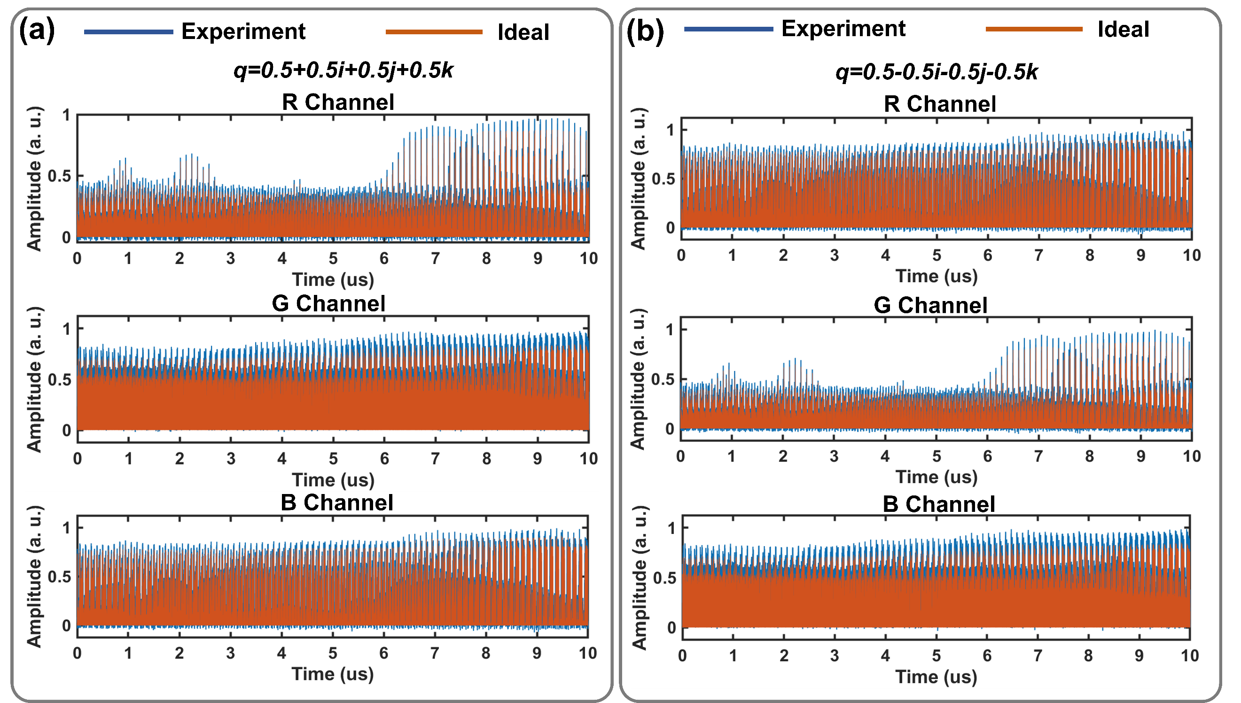
Fig. S13| Experimental results of the fourth sub-image. a,b, Comparison between the ideal (red line) and the experimental (blue line) waveforms of the RGB channels after the chromatic transformation represented by q = 0.5 + 0.5i + 0.5j + 0.5k (a) and q = 0.5 - 0.5i - 0.5j - 0.5k (b).
Supplementary Note 7: Quaternion-valued convolution for color images
In conventional real- and complex-valued convolutions, a L×L convolution kernel performs the sliding-window operation on a N×N-pixel image with unitary stride (stride = 1). The receptive field of the input image maintains strict spatial correspondence with the convolution kernel, generating feature responses through the MAC operations. After performing global convolution operations on the input tensor, the feature matrix is generated. The principle of quaternion-valued convolution is analogous to that of ordinary real- and complex-valued convolutions. In the QC, each element of the convolution kernel is a quaternion which can be expressed as¹³
(19)
where θ_{ll’} ∈ [-π, π] and s_{ll’} ∈ ℝ represent the rotation angle and the scaling factor, respectively, and u = ($\frac{\sqrt{3}}{3},\frac{\sqrt{3}}{3},\frac{\sqrt{3}}{3}$) represents the unit vector along the rotation axis. Therefore, QC can be formally defined as¹⁴
(20)
where X, W and Y are all quaternion-valued matrices, and
(21)
Here, we represent each pixel of the color image as a quaternion x_{nn’} =0 + R_{nn’}i + G_{nn’}j + B_{nn’}k. Then Eq. (21) can be equivalently written as
(22)
where¹³
(23)
QCs fundamentally differ from real- and complex-valued convolutions by processing multi-channel color information as a unified hypercomplex entity through Hamilton products. As shown in Fig. S14a, this approach intrinsically preserves inter-channel correlations by treating the pixels and the kernel elements as quaternions, where their Hamilton product¹⁴ naturally models cross-channel interactions through non-commutative multiplication rules (e.g., ij = -ji = k). The computational results feature elegance in describing color space while showing superior computational efficiency than traditional methods based on real and complex values.
The experimental setup for QC is detailed in Fig. 4 of the main text. The baseband sampling rate of the AWG is 27.6 GSa/s, and each data point is repeated for three times to form the flat-top waveforms. Thus, the equivalent data rate is 27.6 ÷ 3 = 9.2 Gbaud. The incoherent light containing three wavelengths (λ₁ ~ λ₃) is generated by the DFB lasers, and then multiplexed using a DWDM. After that, it is equally divided into three paths through a beam splitter. Four groups of data generated by the AWG are applied to MZMs to accomplish electro-optic conversion, producing modulated optical signals. These four optical signals are then fed into the QOCC composed of four convolution modules, with each module representing one quaternion element of the kernel. After passing through the QOCC, the optical signals are converted to electrical signals using BPDs. These signals then undergo weighted summation, ultimately producing the convolved feature map. The size of the output feature map is^{15,16}
(24)
where N denotes the size of the square matrix, pad is the padding of the input matrix, L is the convolution kernel size, and slide is the convolution window’s sliding step. In our color image recognition experiments based on the CIFAR-5 dataset (5-class subset of CIFAR-10 dataset¹⁷). The pixel dimensions of the feature map after QC are 31×31. Compared with traditional real- and complex-valued convolution, QC exploits the parallelism of WDM and reduces the computational load by 2/3 during feature extraction. Unlike traditional CNNs that generate separate grayscale feature maps for the RGB color channels, the QCNN yields one color image as the feature map of all three channels (Fig. S14b). This inherent characteristic preserves inter-channel correlations through successive QCs, ensuring both color fidelity in the output images and enhanced accuracy in color image recognition tasks.
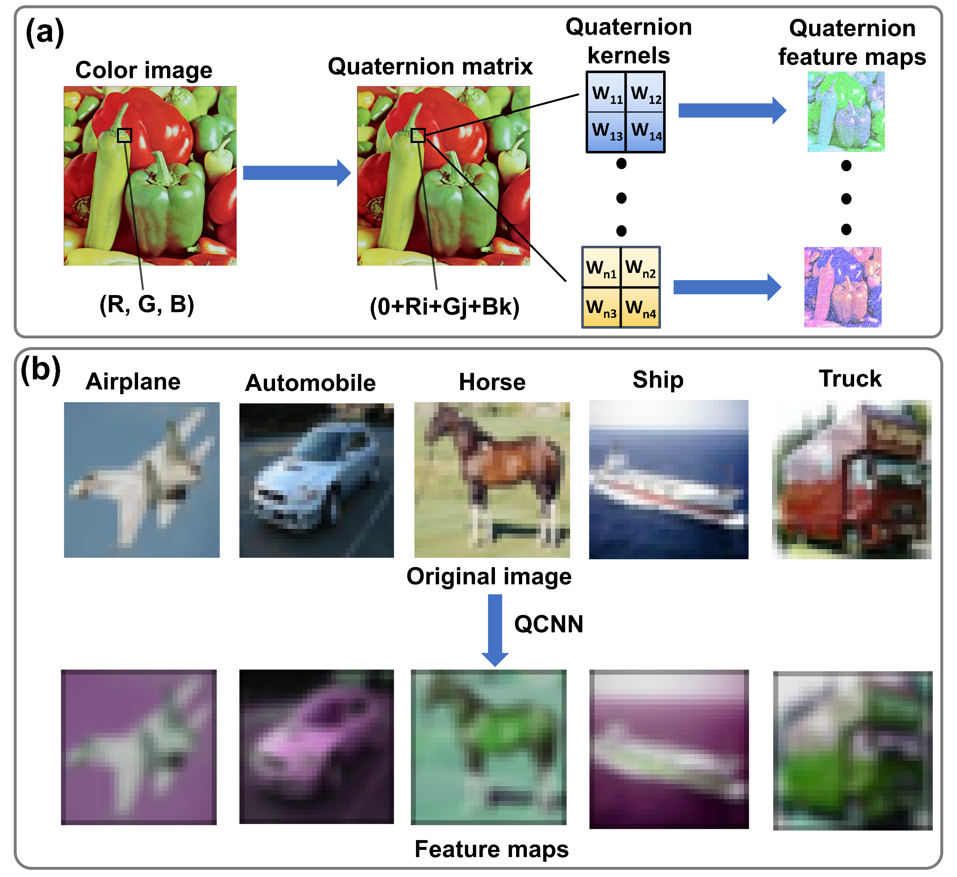
Fig. S14| Quaternion convolution for color images. a, Schematic illustration of color image processing in the quaternion domain. b, Feature extraction from the color images in the CIFAR-5 dataset through the QCNN.
Supplementary Note 8: Training process of the quaternion convolutional neural network
Our QCNN is trained on a 5-class subset of the CIFAR-10 dataset comprising the classes of airplane, automobile, horse, ship and truck. During training, data augmentation techniques including random cropping (with padding = 4) and random horizontal flipping are applied to the training images to mitigate overfitting. The color intensity of all images is normalized, and the training set (5000 images) and test set (500 images) are divided into batches of 128 samples each.
The QCNN model is initialized and moved to a CUDA-enabled GPU (NVIDIA GeForce RTX 5090) for accelerated computation. We train this model using Python and PyTorch (version 1.10.1+ NVIDIA CUDA) on a 64-bit computer. The first QC layer of the QCNN employs a fixed kernel with predefined weights while the subsequent QC layers undergo multiple training iterations with randomized weight initialization. The kernel of the first QC layer takes the same quaternion as its elements (w₁ = w₂ = w₃ = w₄) whose weight matrix is shown below
(25)
The model is trained with the Adam optimizer (initial learning rate = 0.001) using cross-entropy loss as the target function. A step learning rate scheduler is employed, reducing the learning rate by a factor of 0.5 every 30 epochs. The training proceeds for 100 epochs. In each epoch, the model is set to the training mode, and for every mini-batch (batch size = 1)¹⁸ a forward pass is performed to compute the cross-entropy loss. The gradients are then computed via backpropagation, and the model parameters (except those in the first QC layer) are updated using the Adam optimizer. The learning rate is dynamically adjusted according to the predefined decay strategy. The model performance is evaluated on the test set every two training epochs, with parameters achieving the highest classification accuracy being preserved for subsequent analysis.
All QC layers (except the final layer) employ a cascaded structure of ReLU activation followed by 2×2 max-pooling while the output of the final layer is directly fed into the classifier. The classifier consists of two fully connected layers, with a dropout layer (p = 0.5)¹⁹ applied after the first fully connected layer to mitigate overfitting. The computations for the fully connected layers are executed on a conventional computer. After passing through these two fully connected layers, the color image recognition task is completed.
Supplementary Note 9: Implementation of the quaternion convolutional neural network
Our QCNN comprises four QC layers and two fully connected layers, as illustrated in Fig. 5a of the main text. The QC layers are implemented using the QOCC while the fully connected layers and nonlinear activation functions are realized on conventional electronic computers. The QCNN takes 32×32-pixel RGB images as the input layer. It is processed by the first QC layer with a fixed 2 × 2 quaternion kernel, resulting in a feature map with dimensions of 31 ×31 × 3. After being flattened, the output sequence consists of a 1 × 961 × 3 feature map, which is fed into the second QC layer. The kernels of the subsequent QC layers (QC 2 - QC 4) have a dimension of 2 × 2, with their elements iteratively optimized via backpropagation-based training to adaptively extract hierarchical features. Following the second QC operation, the spatial features are reshaped into a 1 × 225 × 12 feature map, where 225 denotes the flattened spatial dimension, and 12 is the channel depth of quaternion-based features. After passing through the third QC layer, the generated feature maps are processed by a pooling²⁰ procedure to achieve spatial dimensionality reduction. This process (convolutional operation and pooling) is repeated in the fourth QC layer, yielding a 1 × 9 × 192 feature map (192 denotes the final channel depth of the quaternion-based features). The feature map is nonlinearly activated using ReLU²¹ and passed to the first fully connected layer, which has a size of 256. The output from this layer is then fed into a second fully connected layer to perform the five-class classification.
Supplementary Note 10: Automated weight configuration
To improve the accuracy and reduce the time consumption during the MRRs configuration process, we develop an automated weight configuration method. This automated system employs a
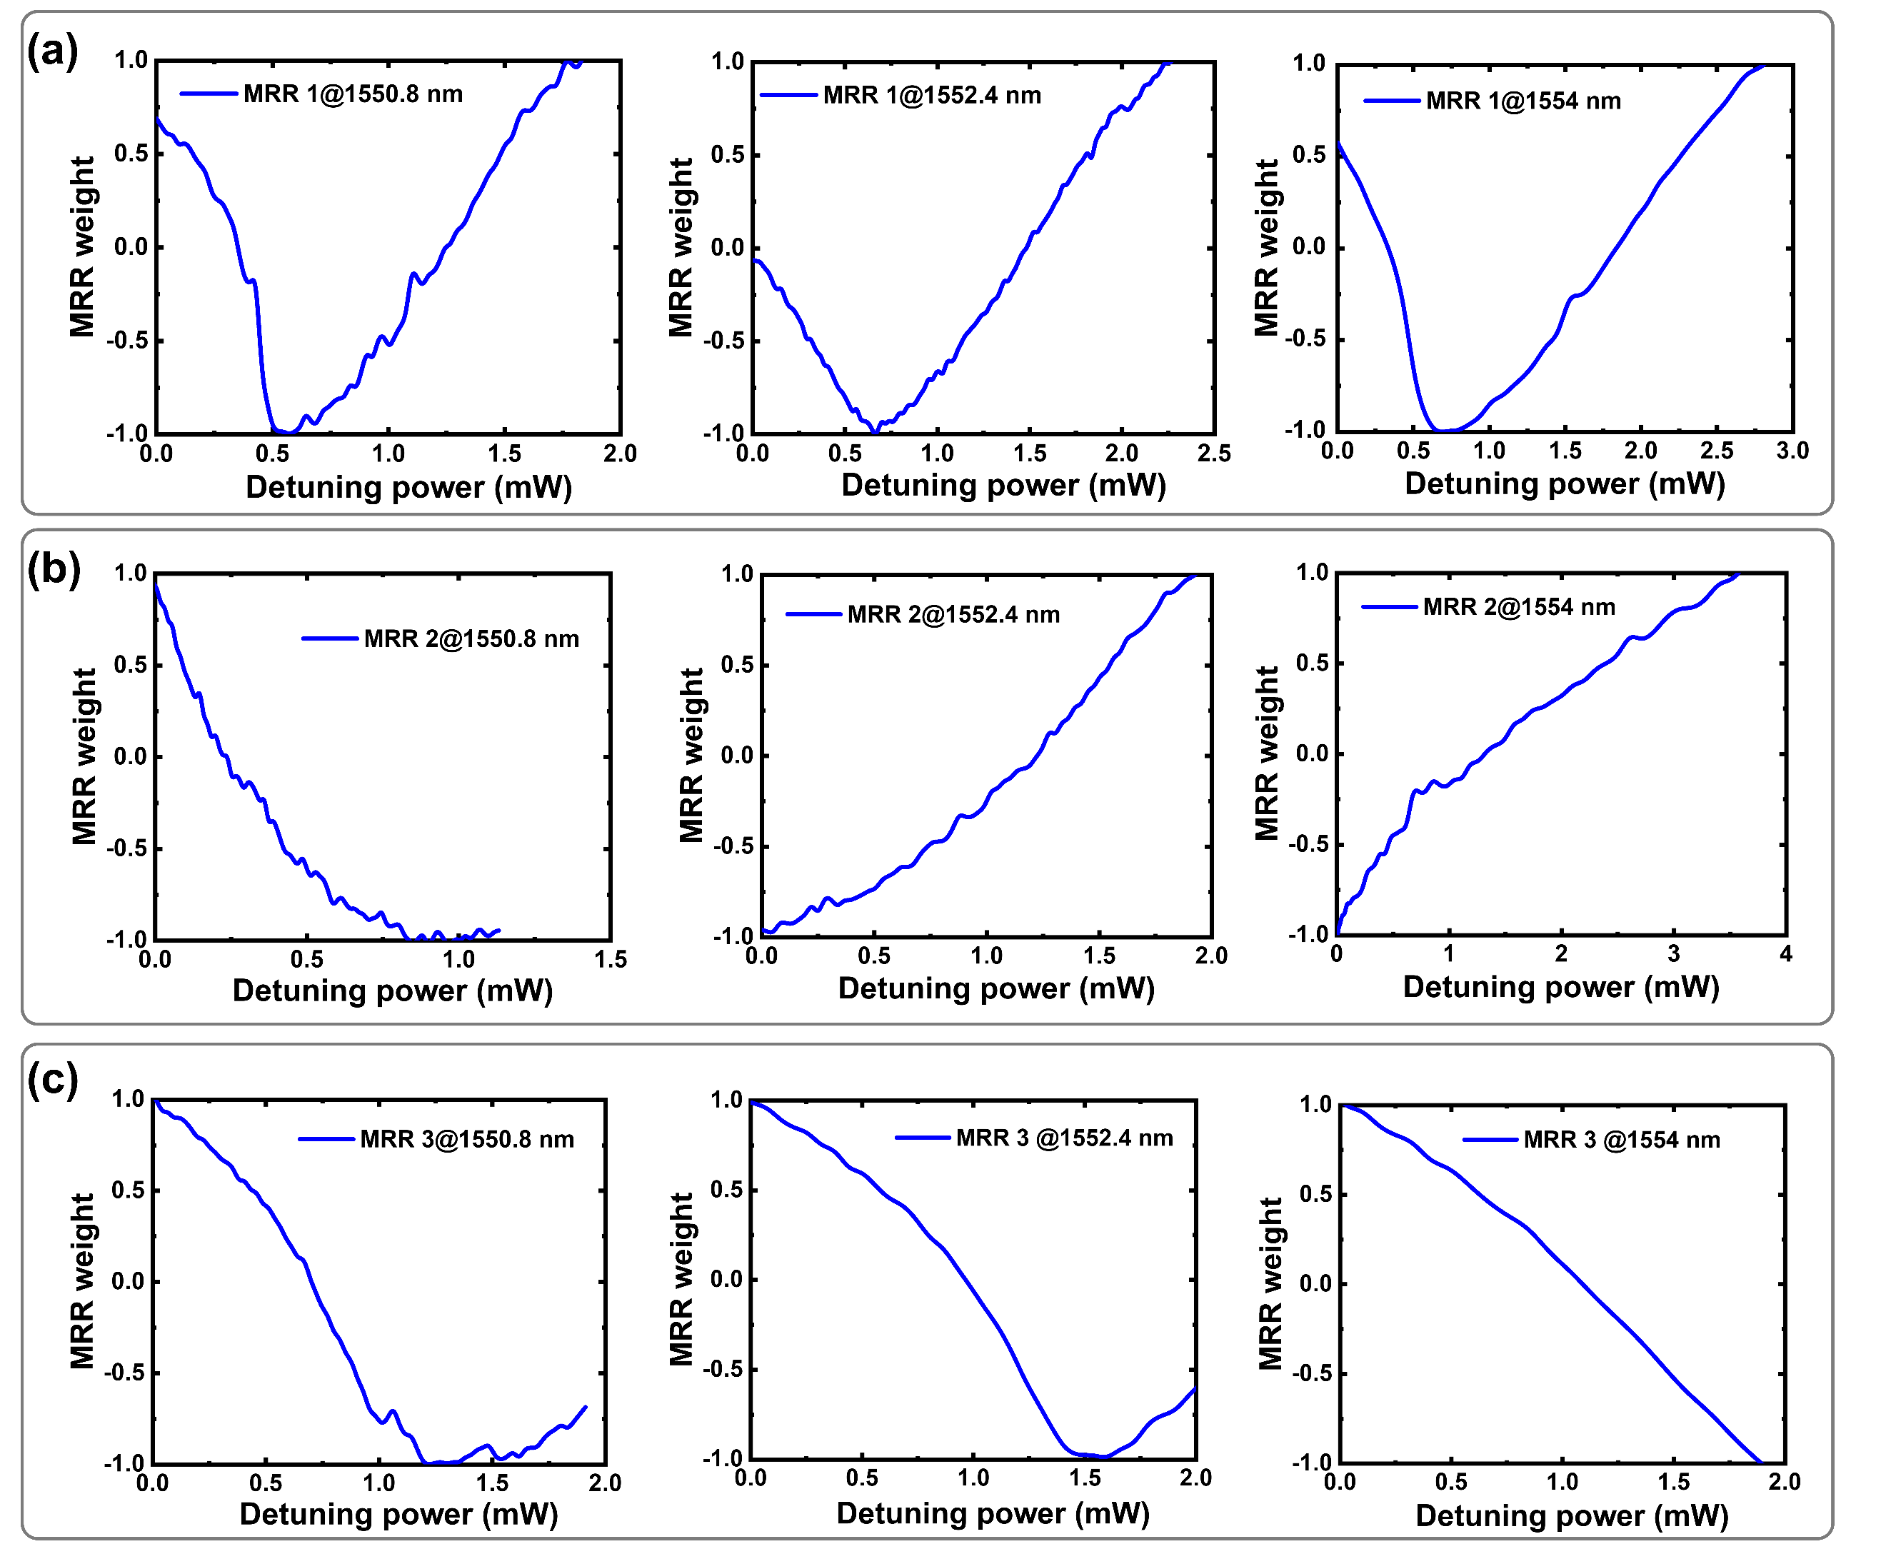
Fig. S15| Relationships between the MRR weight and the detuning power. a-c, Normalized MRR weights as functions of detuning power for distinct MRRs (resonant wavelengths at λ = 1550.8, 1552.4 and 1554 nm) in MRR bank 1 (a), MRR bank 2 (b) and MRR bank 3 (c).
Python script to integrate a programmable voltage source (UDP protocol) and a Lecroy HDO4000 oscilloscope (SCPI protocol) for finding the voltage-power response of the MRR-based devices. It controls a multi-channel voltage source using a custom hexadecimal protocol, enabling linear voltage sweeps (0 - 10 V with a step size of 0.01 V) with checksum verification (sum-inversion algorithm) to ensure command reliability. At every step, a 3-second stabilization delay is included for the chip to reach thermal equilibration, followed by performing oscilloscope SCPI commands to record the detected signals from the BPDs.
Figure S15 illustrates the automatically scanned curves of MRR weight versus detuning power for nine MRRs across three MRR banks in a QOCC. By pre-defining the target weights, the system is capable of automated optimization of arbitrary weight configurations in the range of [-1,1], significantly enhancing both the configuration precision and speed of the QCNN.
Supplementary Note 11: Quantitative scalability analysis and link budget toward peta-scale computing
To evaluate the feasibility of scaling the QOCC architecture toward the 1000 TOPS (PetaOPS) regime, we provide a rigorous link budget analysis based on experimental parameters and state-of-the-art optoelectronic specifications.
I. Analytical framework
The total computing throughput (TCT) is defined by the multi-dimensional multiplexing capacity:
(26)
where λ = 3 (fixed wavelength channels), B is the baud rate, N is the number of parallel modules, and Ops = 9 (3 MRRs × 3 Branches).
II. Power budget for spatial scaling
The scalability of N is primarily governed by the optical power margin (ΔP) and the cascaded splitting loss (L_{split}).
- Binary splitting logic:
Each doubling of the computational cores (N) requires an additional stage of 1×2 (3 dB) splitting. The total splitting loss follows the logarithmic scaling: L_{split} = 3 dB × log₂(N) ≈ 10log₁₀(N). For a configuration with N = 512 modules (i.e., 2⁹ doubling stages), the total splitting loss is approximately 27 dB.
- Available power margin and system losses:
Assuming a high-power on-chip laser source providing P_{in} = 25 dBm and a high-speed photodetector with a sensitivity P_{sens} = -30 dBm, the total available margin is 55 dB. The fixed system losses are rigorously derived from our experimental characterization of the integrated components. Specifically, the total fixed insertion loss, L_{fixed}, is estimated to be approximately 12 dB. This budget accounts for the integrated silicon photonic modulators (L_{mod}≈5 dB) and the high-efficiency computational core (L_{core} < 2dB), which benefits from low-loss components including MMI splitters and MRR banks (each contributing less than 0.5 dB per device). Furthermore, a conservative system margin of 5 dB (M) is reserved to ensure operational stability against environmental fluctuations and polarization tracking errors.
- Scaling capability:
The remaining power budget for 1:N spatial splitting is ΔP - L_{fixed} = 55 - 12 = 43 dB. Given that each doubling stage adds 3 dB of loss, the system can theoretically support up to 14 doublings (43 / 3 ≈ 14), corresponding to over 16,000 modules. Our target of N = 512 consumes only 27 dB of the available budget, leaving a robust 16 dB safety margin to account for additional waveguide crossings and routing losses in large-scale integration. In addition to the linear power budget, we evaluated the impact of TPA, a common nonlinear constraint in SOI waveguides at high power levels. Given our peak input power of 27 dBm, the evolution of the optical intensity I along the propagation direction z is governed by the nonlinear equation:
(27)
where is the TPA coefficient of silicon (≈0.7 cm/GW at = 1550 nm). For our 9-stage cascaded MMI network with a total device length of 108 μm, the calculated power attenuation specifically attributed to TPA is approximately 0.003 dB.
III. Power budget for spatial scaling
By leveraging state-of-the-art 100 GHz baud rate interfaces (B) and N = 512 parallel modules, the theoretical peak throughput is:
(28)
A single QOCC computational core occupies roughly 120 μm×150 μm. Parallel integration of 512 cores alongside on-chip multi-turn delay lines yields a total active core area of ~14.5 mm², which perfectly matches standard 5 mm × 5 mm MPW foundry footprint constraints. To control the micro-ring resonances against ambient fluctuations, a hierarchical control Application-specific integrated circuit (ASIC) executing parallel Matrix-Locking and automated Dither-Locking algorithms can track the array concurrently. Utilizing localized thermal trenches or non-volatile phase-change materials (PCM), the static tuning power is bounded to ~5 W. In addition, through a multi-dimensional co-optimization strategy, the single-channel electrical interface rate is constrained to a mature, high-yield 25 Gbaud rate (thereby drastically lowering the cost threshold of peripheral transceiver chiplets), while expanding the architectural parameters to 512 spatial modules and 32 wavelengths can be seamlessly accommodated within the standard telecom C-band with an inter-channel crosstalk suppression ratio exceeding 25 dB.
This scaling analysis confirms that the QOCC architecture substantially exceeding the 1000 TOPS threshold within the physical power constraints of a monolithic silicon photonic platform.

Reference
1. Katsuki, S. & Sebe, N. Rotation matrix optimization with quaternion. In: 2015 10th Asian Control Conference (ASCC). 1-6 (IEEE, 2015).
2. Eskicioglu, A.M. & Fisher, P.S. Image quality measures and their performance. IEEE Trans. Commun. 43, 2959-2965 (1995).
3. Shi, J.H., Zuo, D.C. & Zhang, Z. Transition activity recognition system based on standard deviation trend analysis. Sensors 20, 3117 (2020).
4. Tait, A.N., et al. Feedback control for microring weight banks. Opt. Express 26, 26422-26443 (2018).
5. Stern, B., Ji, X.C., Okawachi, Y., Gaeta, A.L. & Lipson, M. Battery-operated integrated frequency comb generator. Nature 562, 401-405 (2018).
6. Reed & G., T. Silicon optical modulators. Nat. Photonics 4, 518-526 (2010).
7. Chen, Y.T., et al. All-analog photoelectronic chip for high-speed vision tasks. Nature 623, 48-57 (2023).
8. Jouppi, N.P., Young, C., Patil, N., Patterson, D. & Al, G.A.E. In-Datacenter Performance Analysis of a Tensor Processing Unit. Comput. Archit. News 45, 1-12 (2017).
9. Shen, Y.C., et al. Deep learning with coherent nanophotonic circuits. Nat. Photonics 11, 441-446 (2017).
10. https://gweb-coral-full.uc.r.appspot.com/docs/edgetpu/benchmarks/.
11. Jin, L.H., Liu, H., Xu, X.Y. & Song, E.M. Quaternion-based impulse noise removal from color video sequences. IEEE Trans. Circuits Syst. Video Technol. 23, 741-755 (2013).
12. Kim, S. & Kim, M. Rotation representations and their conversions. IEEE Access 11, 6682-6699 (2023).
13. Zhu, X.Y., Xu, Y., Xu, H.T. & Chen, C.J. Quaternion convolutional neural networks. In: Proceedings of the European conference on computer vision (ECCV). 631-647 (2018).
14. Yin, Q.L., et al. Quaternion convolutional neural network for color image classification and forensics. IEEE Access 7, 20293-20301 (2019).
15. Xu, X.Y., et al. 11 TOPS photonic convolutional accelerator for optical neural networks. Nature 589, 44-51 (2021).
16. Feldmann, J., et al. Parallel convolutional processing using an integrated photonic tensor core (vol 589, pg 52, 2021). Nature 589, 52-58 (2021).
17. Carvalho, E.F. & Engel, P.M. Convolutional sparse feature descriptor for object recognition in CIFAR-10. In: 2013 Brazilian Conference on Intelligent Systems. 131-135 (IEEE, 2013).
18. Yang, Z., Wang, C., Zang, Y. & Li, J. Mini-batch algorithms with Barzilai-Borwein update step. Neurocomputing 314, 177-185 (2018).
19. Omar, A. & Abd El-Hafeez, T. Optimizing epileptic seizure recognition performance with feature scaling and dropout layers. Neural. Comput. Appl. 36, 2835-2852 (2024).
20. Masci, J., Meier, U., Ciresan, D., Schmidhuber, J. & Fricout, G. Steel defect classification with max-pooling convolutional neural networks. Ieee Ijcnn, 1-6 (2012).
21. Glorot, X., Bordes, A. & Bengio, Y. Deep sparse rectifier neural networks. In: Proceedings of the fourteenth international conference on artificial intelligence and statistics. 315-323 (JMLR Workshop and Conference Proceedings, 2011).

