Safety and Efficacy of a Cardiovascular Polypill in People at Very High Risk without a Previous Cardiovascular Event
The International VULCANO Randomised Clinical Trial

Supplementary Information

The authors have provided these supplemental materials to give the readers additional information

TABLE OF CONTENTS
List of Vulcano investigators 2
Table S1. Available versions of the CNIC-polypill given to patients. 4
Table S2. Dose equivalence between ACEi and ARB and the available ramipril options of the polypill. 5
Table S3. Dose equivalence of statins and the available atorvastatin options of the CNIC-polypill. 6
Table S4. Summary results of the change in primary outcomes (LDL-c and SBP) and superiority tests in the per-protocol population. 7
Table S5. Summary results of the change in secondary outcomes from baseline to Week 16 after treatment with the CNIC-polypill or usual care (mITT population). 8
Table S6. Listing of treatment-related adverse events by system organ class (SOC) and preferred term. 9
Fig. S1. CONSORT diagram of the flow of participants through the trial. 11
Fig. S2. Percentage of patients receiving lipid-lowering (A) or BP-lowering drugs, in particular an ACEI (B) or an ARB (C), at baseline by treatment group. 12
Fig. S3. Percentage of subjects who had their LDL-c levels (A), BP values (B), and both LDL-c levels and BP values (C) controlled at baseline and were still at target after 16 weeks of treatment with the CNIC-polypill or usual care. 13

List of Vulcano investigators

Investigator | Centre | Country
Pablo Pérez | Hospital Universitario Reina Sofía, Córdoba | Spain
Jacinto Espinosa | CS Villanueva de la Serena, Badajoz | Spain
Javier Sobrino | Fundació Hospital de l'Esperit Sant, Barcelona | Spain
Antonio Posé | Hospital Clínico Universitario de Santiago de Compostela, A Coruña | Spain
Juan Antonio Arroyo Díaz | Hospital de la Santa Creu i Sant Pau, Barcelona | Spain
Olga García Vallejo | CS Comillas, Madrid | Spain
María Pilar Cubo Romano | Hospital Universitario Infanta Cristina, Madrid | Spain
Carlos Brotons | EAP Sardenya, Barcelona | Spain
Sergio Jansen Chaparro | Hospital Regional Universitario de Málaga, Málaga | Spain
Jesús Cabezón Mariscal | Hospital Fátima, Sevilla | Spain
Miguel Ángel Rico Corral | Hospital Universitario Virgen Macarena, Sevilla | Spain
José Abellán Alemán | CS San Andrés, Murcia | Spain
Domingo Orozco Beltrán | Hospital Universitari Sant Joan de Reus, Tarragona | Spain
Luis Escobar Jimenez | Consulta Luis Escobar, Cádiz | Spain
Pedro Valdivielso Felices | Hospital Universitario Virgen de la Victoria, Málaga | Spain
Joan Carles Pedro-Botet Montoya | Hospital del Mar, Barcelona | Spain
Luis Masana Marín | Hospital Universitari Sant Joan de Reus, Tarragona | Spain
Carlos Guijarro | Hospital Fundación Alcorcón, Madrid | Spain
Ángel Díaz Rodríguez | CS Bembibre, León | Spain
José Luis Díaz Díaz | Hospital Universitario A Coruña, A Coruña | Spain
Andrés De la Peña Fernández | Hospital Son Llàtzer, Palma de Mallorca | Spain
Emmanuel Coloma Bazán | Hospital Universitari Clínic de Barcelona, Barcelona | Spain
Rafael Cuenca Acevedo | Hospital Alto Guadalquivir, Andújar-Jaén | Spain
Carmen Suárez Fernández | Hospital Universitario de La Princesa, Madrid | Spain
Fernando Civeira | Hospital Universitario Miguel Servet, Zaragoza | Spain
José María Castellano Vázquez | Hospital Universitario HM Montepríncipe, Madrid | Spain
José María Mostaza Prieto | Hospital Carlos III, Madrid | Spain
Manuel Suárez Tembra | Hospital San Rafael de A Coruña, A Coruña | Spain
Joaquín Alfonso Megido | Hospital Valle del Nalón, Langreo-Asturias | Spain
Jesús Castiella Herrero | Fundación Hospital Calahorra, La Rioja | Spain
Juan José Tamarit | Hospital General de Valencia, Valencia | Spain
Miguel Angel Martínez-Hervás Alonso | Consulta Martínez-Hervás, Granada | Spain
Francisco Javier Carrasco Franco | H. Juan Ramón Jiménez, Huelva | Spain
Luis Álvarez Sala | H. Gregorio Marañón, Madrid | Spain
Enrique Calderón Sandubete | H. Virgen del Rocío, Sevilla | Spain
Eduardo Rovira Daudi | H. de La Ribera, Alzira-Valencia | Spain
Fernando Bonilla Rovira | H.G.U Elche, Elche-Alicante | Spain
José Manuel Murcia Zaragoza | H. Vega Baja, Alicante | Spain
Lluis Cuixart Costa | EAP Roger de Flor, Barcelona | Spain
José Luis Bianchi Llave | H. Punta de Europa, Algeciras-Cádiz | Spain
Carmen Álvarez Sánchez | CAP El Remei, Barcelona | Spain
Pedro Marqués Da Silva | H. Lisboa, Lisboa | Portugal
Vitória Cunha | H. Garcia de Orta, Almada | Portugal
Catarina Santos | H. Amato Lusitano, Castelo Branco | Portugal
Francisco Araujo | H. Beatriz Angelo, Loures | Portugal
José Moura | Hospital de Coimbra, Coimbra | Portugal
Martín Rosas Peralta | UMF-1, Ciudad de México | México

Table S1. Available versions of the CNIC-polypill given to patients.
Polypill | Aspirin (mg) | Atorvastatin (mg) | Ramipril (mg)
Trinomia 20 | 100 | 20 | 2.5
 | 100 | 20 | 5.0
 | 100 | 20 | 10.0
Trinomia 40 | 100 | 40 | 2.5
 | 100 | 40 | 5.0
 | 100 | 40 | 10.0

Table S2. Dose equivalence between ACEi and ARB and the available ramipril options of the polypill.
 | Ramipril 2.5 mg | Ramipril 5.0 mg | Ramipril 10 mg
ACEi
Enalapril | 5 mg | 10 mg | 20 mg
Captopril | 75 mg | 150 mg | 300 mg
Lisinopril | 5 mg | 10 mg | 20 mg
Fosinopril | - | 20 mg | 40 mg
Perindopril | - | 4 mg | 7/8 mg
ARB
Candesartan | 4 mg | 8 mg | 16 mg
Irbesartan | 75 mg | 150 mg | 300 mg
Losartan | 25 mg | 50 mg | 100 mg
Olmesartan | - | 10 mg | 20 mg
Valsartan | 40 mg | 80 mg | 160 mg
Telmisartan | 20 mg | 40 mg | 80 mg
Eprosartan | - | - | 600 mg
ACEi, angiotensin-converting-enzyme inhibitor; ARB, angiotensin II receptor blocker

Table S3. Dose equivalence of statins and the available atorvastatin options of the CNIC-polypill.
Polypill | Fluvastatin | Lovastatin | Pitavastatin | Pravastatin | Simvastatin | Atorvastatin | Rosuvastatin
Atorvastatin 20 mg | 40 mg | 20 mg | 1 mg | 20 mg | 10 mg
 | 80 mg | 40 mg | 2 mg | 40 mg | 20 mg | 10 mg
 | ….. | 80 mg | 4 mg | 80 mg | 40 mg | 20 mg | 5 mg
 |  |  |  |  |  | 30 mg
Atorvastatin 40 mg | ….. | ….. | ….. | ….. | …… | 40 mg | 10 mg
 |  |  |  |  |  | 60 mg
 |  |  |  |  |  | 80 mg | 20/40 mg

Table S4. Summary results of the change in primary outcomes (LDL-c and SBP) and superiority tests in the per-protocol population.
 | CNIC-polypill  (N=218) |  |  | Usual care  (N=221)
Outcome | Baseline  mean (SD) | Week 16  Mean (95% CI) | LS Mean change  (95% CI) | Baseline  mean (SD) | Week 16  Mean (95% CI) | LS Mean change  (95% CI) | Adjusted mean treatment difference  (95% CI)  p value
LDL-c (mg/dL) | 96.42 (30.03) | 85.12  (81.83; 88.41) | -11.03  (-14.33; -7.74) | 95.93 (30.94) | 93.08  (90.05; 96.12) | -3.07  (-12.44; -3.48) | -7.96 (-12.44; -3.483  p = 0.0005
SBP (mm Hg) | 133.98 (12.72) | 134.82  (133.2; 136.5) | 1.26 (-0.41; 2.94) | 133.20 (12.32) | 132.96  (131.4; 134.5) | -0.60 (-2.14; 0.95) | 1.85 (-0.42; 4.14)  p = 0.1097
LDL-c, low-density lipoprotein cholesterol; SBP, systolic blood pressure; SD, standard deviation

Table S5. Summary results of the change in secondary outcomes from baseline to Week 16 after treatment with the CNIC-polypill or usual care (mITT population).
 | CNIC-polypill  (N=218) |  |  | Usual care  (N=221)
Outcome | Baseline  mean (SD) | Week 16  Mean (95% CI) | LS Mean change between baseline and week 16  (95% CI) | Baseline  mean (SD) | Week 16  Mean (95% CI) | LS Mean change between baseline and week 16  (95% CI) | Adjusted mean difference  between treatments  (95% CI)  p value
TC (mg/dL) | 170.95 (34.21) | 158.41  (154.78; 162.05) | -10.37  (-14.00; - 6.73) | 166.64 (32.06) | 167.80  (164.19; 171.41) | 0.98  (-4.59; 2.63) | -9.386 (-14.52; -4.256)  p = 0.0004
HDL-c (mg/dL) | 49.06 (14.50) | 48.09  (46.59; 49.58) | -0.47  (-1.97; 1.03) | 48.06 (15.40) | 47.80  (46.31; 49.29) | -0.76  (-2.25; 0.73) | 0.287 (-1.83; 2.40)  p = 0.7897
Non-HDL-c (mg/dL) | 119.95 (33.46) | 109.25  (105.55; 112.94) | -10.88  (-14.58; -7.19) | 119.63 (33.18) | 117.52  (113.93; 121.10) | -2.61  (-6.20; 0.97) | -8.269 (-13.42; -3.12)  p = 0.0017
TG (mg/dL) | 143.97 (66.26) | 138.99  (131.01; 146.97) | -3.97  (-11.39; 4.58) | 140.85 (67.55) | 142.96  (135.03; 150.89) | 0.56  (-7.37; 8.49) | -3.966 (-15.22; 7.29)  p = 0.4888
DBP (mm Hg) | 79.18 (9.40) | 79.42  (78.43; 80.42) | 0.12  (-0.88; 1.11) | 79.43 (9.32) | 79.76  (77.78; 79.75) | -0.54  (-1.53; 0.45) | 0.660 (-0.74; 2.06)  p = 0.3559
DBP, diastolic blood pressure; HDL, high-density lipoprotein cholesterol; LDL-c, low-density lipoprotein cholesterol; SBP, systolic blood pressure; SD, standard deviation; TC, total cholesterol; TG, triglycerides

Table S6. Listing of treatment-related adverse events by system organ class (SOC) and preferred term.
SOC | Preferred term | Serious | CNIC-polypill  (n=21) | Usual care  (n=2)
Respiratory, thoracic and mediastinal disorders | Cough | No | 3 (14.3%) | 0 (0.0%)
Nervous system disorders | Dizziness | No | 1 (4.8%) | 0 (0.0%)
Skin and subcutaneous tissue disorders | Exanthema | No | 1 (4.8%) | 0 (0.0%)
 | Rash | No | 1 (4.8%) | 0 (0.0%)
 | Hyperhidrosis | No | 1 (4.8%) | 0 (0.0%)
Vascular disorders | Hypertension not adequately controlled | No | 3 (14.3%) | 0 (0.0%)
 | Orthostatic hypotension | No | 1 (4.8%) | 0 (0.0%)
 | Ecchymosis | No | 1 (4.8%) | 0 (0.0%)
Gastrointestinal disorders | Melena | No | 1 (4.8%) | 0 (0.0%)
 | Epigastralgia | No | 2 (9.5%) | 0 (0.0%)
 | Abdominal pain | No | 1 (4.8%) | 0 (0.0%)
 | Abdominal bloating | No | 1 (4.8%) | 0 (0.0%)
Musculoskeletal and connective tissue disorders | Myalgia | No | 1 (4.8%) | 0 (0.0%)
 | Cervicalgia | No | 1 (4.8%) | 0 (0.0%)
Investigations | Elevated liver enzymes | Yes | 1 (4.8%) | 0 (0.0%)
 | Asymptomatic creatine phosphokinase increase | No | 1 (4.8%) | 0 (0.0%)
Metabolism and nutrition disorders | Hypoglycaemia | No | 0 (0.0%) | 1 (50%)

Fig. S1. CONSORT diagram of the flow of participants through the trial.

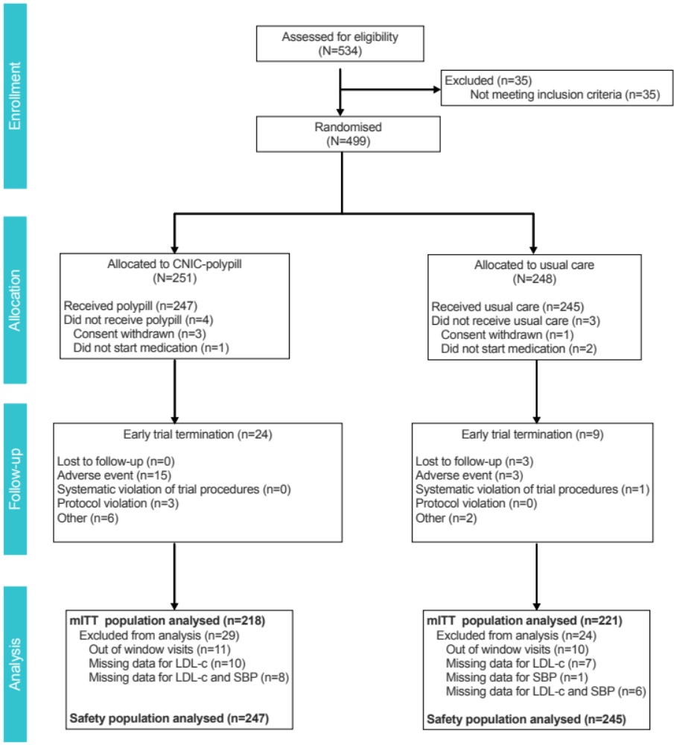

LDL-c, low-density lipoprotein cholesterol; mITT, modified intent-to-treat population; SBP, systolic blood pressure

Fig. S2. Percentage of patients receiving lipid-lowering (A) or BP-lowering drugs, in particular an ACEI (B) or an ARB (C), at baseline by treatment group.
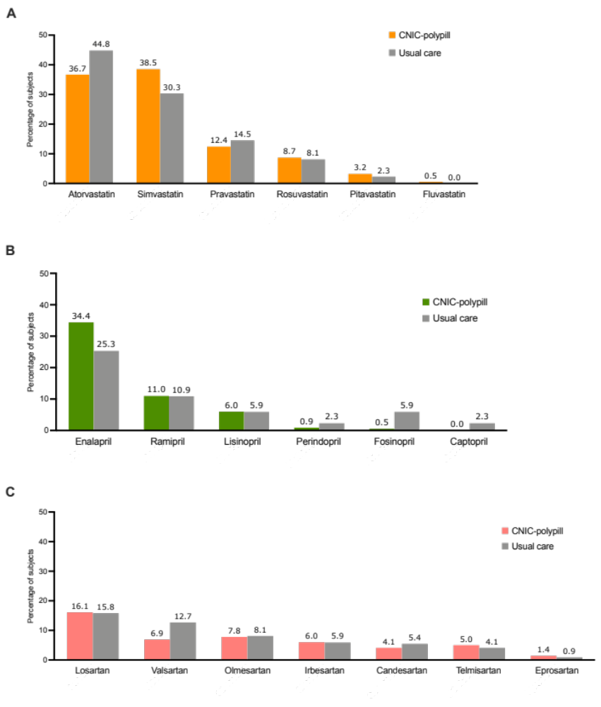
ACEi, angiotensin-converting-enzyme inhibitor; ARB, angiotensin II receptor blocker

Fig. S3. Percentage of subjects who had their LDL-c levels (A), BP values (B), and both LDL-c levels and BP values (C) controlled at baseline and were still at target after 16 weeks of treatment with the CNIC-polypill or usual care.
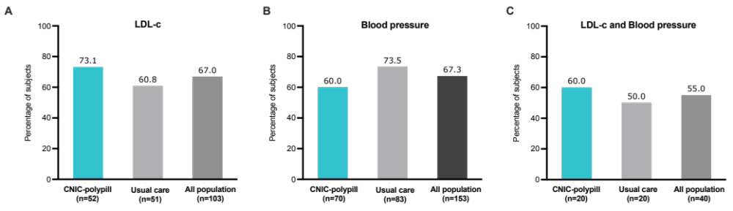
BP, blood pressure; LDL-c, low-density lipoprotein cholesterol

