Supplementary Materials for

A native-state chemical atlas of the aging osteochondral interface
Jie Chen^{1#}, Baikun Liu^{1#}, Jiawei Chen², Ke Yang², Huitong Ruan¹, Yuchen Liu¹, Lu Luo¹, Xiaoyu Zhao³*, Wenguo Cui¹*
¹Department of Orthopaedics, Shanghai Key Laboratory for Prevention and Treatment of Bone and Joint Diseases, Shanghai Institute of Traumatology and Orthopaedics, Ruijin Hospital, Shanghai Jiao Tong University School of Medicine, 197 Ruijin 2nd Road, Shanghai, 200025, PR China.
²Department of Cardiovascular Medicine, Ruijin Hospital, Shanghai Jiaotong University School of Medicine, No. 197 Ruijin Second Rd, Shanghai 200025, China.
³Supervision Medicine Co., Ltd, Xiang Hu Lab, Hangzhou, Zhejiang, 311215, China.
*Corresponding authors: Xiaoyu Zhao (xiaoyuzhao@supervisionmedicine.tech), Wenguo Cui (wgcui@sjtu.edu.cn)
# Contributed equally to this work: J.C., B. L.

This file includes:
Methods
Supplementary legends 1 to 7
Supplementary Figures 1 to 7
Supplementary data 1
Supplementary Table 1

Methods
1. Instruments and reagents
Histological processing and imaging were performed using standard laboratory equipment, including a tissue dehydrator (ATD-405), paraffin embedding system (SWE-JBL5/SWE-JBL5T), and microtome (PM-24) (Servicebio, China), as well as a cryostat (Leica 819) and rotary microtome (RM2016) (Leica, Germany). Bright-field imaging was conducted on an Eclipse E100 microscope (Nikon, Japan). The in situ Raman imaging platform was built on an upright BX53 microscope (Olympus, Japan) and equipped with a deep-cooled EMCCD detector (iXon Ultra 888, Andor, UK). Untargeted metabolomics was performed using a Nexera UHPLC LC-30A system (Shimadzu, Japan) coupled to a Q Exactive HF-X mass spectrometer (Thermo Fisher Scientific, USA) with an ACQUITY UPLC BEH Amide column (Waters, USA).
Reagents included analytical-grade solvents (ethanol, xylene), embedding media (OCT), and standard histological staining kits (H&E, Safranin O/Fast Green, Sirius Red, Masson; Servicebio). All reagents were used according to manufacturer instructions or validated laboratory protocols.
2. Collection of native samples
Male C57BL/6J mice were used to minimize variability associated with hormonal fluctuations in bone metabolism. Animals were grouped by age: 4 weeks (young), 18 weeks (adult), and 21 months (aged) (n = 6 per group). All procedures were approved by the Institutional Animal Care and Use Committee (approval no. 2026-01-RJYY-CJ-134). At each time point, mice were euthanized following deep anesthesia. Knee joints were rapidly dissected with surrounding structures preserved. Each sample was divided into two parts: one for native cryosectioning and Raman imaging, the other for metabolomics and biochemical assays. This parallel design enabled direct cross-validation between spatial imaging and bulk molecular measurements.
3. Preparation of native cryosections from hard tissue
To preserve native biochemical states, fixation, decalcification, and paraffin embedding were omitted. These steps are known to alter protein structure, remove metabolites, and disrupt mineral phases¹⁰. Immediately after dissection, fresh joint tissues were embedded in OCT and rapidly frozen. Samples were oriented to expose a sagittal plane spanning cartilage, calcified cartilage, and subchondral bone. Sections (typically 40 μm thick) were cut using a cryostat and immediately transferred to pre-cooled slides. All sections were stored briefly at −20 °C and imaged within a short time window. This workflow minimizes chemical perturbation and preserves the full molecular spectrum, including water, metabolites, and mineral components, enabling direct in situ analysis.
4. Volumetric confocal Raman hyperspectral imaging
To resolve spatially coupled biochemical processes under native conditions, we developed a label-free confocal Raman imaging framework (PBI-PS). This system enables simultaneous detection of ~70 molecular components within a shared spatial coordinate system, without fixation, decalcification, or labeling.
4.1 Raman instrumentation and 3D imaging
A confocal Raman system was constructed on an Olympus BX53 platform integrated with a custom-built system by SuperVision Medicine Co., Ltd. Excitation was provided by a 532-nm continuous-wave laser. The beam was expanded, collimated, and spatially filtered to generate a high-quality near-Gaussian profile. Laser power at the sample plane was precisely controlled using a variable attenuator composed of neutral density filters and a half-wave plate-polarizer pair, and exposure time was regulated by a fast mechanical shutter. The excitation beam was directed through a dielectric turning mirror and a 532-nm dichroic beamsplitter into the microscope in an epi-illumination configuration and focused onto the sample through a 40× water-immersion objective. Backscattered Raman signals were collected by the same objective and directed into the detection path through the dichroic beamsplitter. An additional notch filter was inserted in the detection path to suppress Rayleigh scattering and improve the signal-to-noise ratio. The system enabled three-dimensional spectral imaging at ~800 nm lateral spatial resolution, suitable for in situ, label-free chemical analysis of complex gradient tissues such as osteochondral units. Colour schemes were assigned to maintain consistency within biochemical classes while preserving distinguishability between individual components.
4.2 Removal of excipient interference in standards
Commercially sourced biomolecular standards were cleaned before Raman analysis to eliminate spectral contributions from trehalose-containing formulation excipients. Lyophilized materials were reconstituted in ultrapure water and subjected to buffer exchange by 7 kDa spin desalting or centrifugal ultrafiltration, depending on sample volume and recovery requirements. For spin-column cleanup, columns were equilibrated three times with ultrapure water, after which samples were loaded onto the resin bed and centrifuged to recover the exchanged eluate. For ultrafiltration-based cleanup, samples were concentrated, diluted back to the initial volume with ultrapure water, and reconcentrated in repeated discontinuous diafiltration cycles until low-molecular-weight excipients were depleted. Fragile samples were alternatively dialyzed against a large excess of ultrapure water at 4 °C. Trehalose removal was confirmed spectroscopically by loss of the characteristic trehalose Raman band near 529 cm. Because this workflow relies on size-based separation, it was applied only to macromolecular standards; low-molecular-weight metabolites were instead obtained as excipient-free standards or excluded from this cleanup procedure.
4.3 Confocal detection and spectral acquisition
Confocal spatial filtering was implemented using a pinhole (100 μm diameter; Newport Corporation) positioned at the plane conjugate to the objective image. For the 40× objective and the Raman wavelength range used here, this size corresponded to approximately one Airy unit and provided a balance between optical sectioning and photon throughput. Collected signals were relayed to the spectrograph through achromatic relay optics. In fiber-coupled mode, a 50-μm-core multimode fiber (Thorlabs, Inc.) served as an additional spatial filter. Spectral dispersion was achieved using a Horiba iHR 320 spectrograph fitted with a 600 lines mm⁻¹ grating, with the entrance slit set to 100 μm to balance spectral resolution and signal throughput. Raman spectra were recorded using a deep-cooled EMCCD (iXon Ultra 888, Andor Technology), and the electron multiplication gain was optimized according to signal intensity to enable sensitive detection under low-signal conditions.
4.4 Reference spectral library construction
A chemometric calibration framework based on tissue phantoms was first established. Guided by the major biochemical constituents of osteochondral tissue, a series of single-component and multicomponent phantoms containing proteins, lipids, nucleic acids, carbohydrates, and key amino acid small-molecule metabolites were prepared in physiologically compatible aqueous buffer across concentration ranges relevant to physiological and pathological states. Raman spectra from all phantoms were preprocessed by cosmic-ray removal, fluorescence background subtraction using an adaptive min–max algorithm, and intensity normalization to the O–H stretching band of water at ~3400 cm⁻¹ to correct for spectral variation arising from laser fluctuations, collection efficiency, and sample geometry. Three-dimensional spectral measurements at different phantom depths were then used to assess signal attenuation and depth-dependent changes in signal-to-noise ratio. Finally, univariate linear calibration curves were generated for each component from normalized spectral intensity versus known concentration, yielding a unit-scaled reference spectral library.
4.5 Volumetric imaging
After calibration, fresh, undecalcified bulk osteochondral cryosections were subjected to three-dimensional confocal Raman imaging. Samples were positioned using a motorized XYZ translation stage with closed-loop feedback. Imaging was performed in a three-dimensional raster-scanning mode, with point-by-point XY scanning at each Z plane and sequential acquisition along the Z axis at defined step intervals. Voxel dimensions were set to 0.8 μm × 1.0 μm in XY and 3.0 μm in Z. For each sample, 210 × 205 × 11 voxels were acquired, corresponding to a physical volume of 168 μm × 205 μm × 33 μm. To minimize system drift during prolonged acquisition, the microscope was mounted on a vibration-isolated optical table and operated within an enclosed environment to reduce airflow and stray-light interference.
4.6 Chemometric spectral unmixing and quantitative analysis
After preprocessing using the same pipeline applied to phantom data, spectra from individual sample voxels were decomposed using a linear mixing model, in which each spectrum was represented as a linear combination of components in the reference spectral library ²⁰. Component coefficients were estimated using non-negative least squares and Bayesian inversion, and then converted to absolute local concentrations using the corresponding calibration curves. Model accuracy and specificity within the quantitative range were assessed from fitting residuals and concentration uncertainty. Spectra were acquired at 0.01 s per voxel under low-power excitation (10 mW at the sample plane), enabling rapid volumetric imaging while minimizing photothermal damage. In addition, spectra were calibrated using a Thorlabs PM100D power meter and a Raman shift range of 0–3850 cm⁻¹. This yielded a series of three-dimensional quantitative concentration maps for multicomponent, label-free, voxel-resolved biochemical phenotyping of osteochondral tissue.
4.7 Three-dimensional reconstruction and data integration
Quantitative concentration maps were reconstructed in three dimensions by stacking stage-coordinate-registered sections along the Z axis and visualized using ImageJ for volume rendering and multichannel display. Voxel-level correlation analysis, colocalization statistics, and clustering were further used to define spatial association patterns among biochemical components and to compare compositional differences across age groups or experimental conditions. All Raman volumetric datasets were spatially registered to bright-field images acquired on the same platform with the same objective, enabling multimodal correlation with histological findings. This workflow established a general label-free, quantitative, three-dimensional Raman omics method for fresh, undecalcified bulk osteochondral tissue and other complex specimens, providing an integrated solution for high-content in situ biochemical phenotyping. In addition, to systematically elucidate the significance of Raman spectroscopic indicators across different analytical dimensions, the indicators were categorized according to the specific objectives of each results section. Therefore, some indicators may be repeatedly referenced in different parts of the results.
5. Histology and multimodal morphological validation
To validate structural integrity, adjacent sections were analyzed using standard histological staining ²³.
5.1 H&E staining
To evaluate structural changes during osteochondral aging, including chondrocyte number and morphology, tidemark architecture, and overall tissue integrity, and to provide cellular and tissue-level spatial reference for the molecular changes revealed by Raman imaging, mouse knee joint sections were subjected to standard H&E staining. This method clearly distinguishes nuclei (blue) from cytoplasm and extracellular matrix (pink) and serves as a baseline histopathological assessment. Briefly, knee joints from 4-week, 18-week, and 21-month-old mice were processed as paraffin sections or cryosections. Paraffin sections were dewaxed with an environmentally friendly clearing agent and rehydrated through graded ethanol. Cryosections were rewarmed, fixed, and treated with pretreatment solution for 1 min. Sections were then stained with hematoxylin for 3–5 min, differentiated and blued, rapidly dehydrated in 95% ethanol, and counterstained with eosin for 15–20 s. After dehydration through absolute ethanol, clearing in n-butanol and xylene, and mounting with neutral resin, sections were imaged by light microscopy. Nuclei appeared blue, whereas cytoplasm and collagen-rich matrix appeared pink to red. This procedure enabled direct visualization of cartilage thickness, cell distribution, tidemark integrity, lipid droplets, and structural fissures, providing accurate cellular and tissue context for biochemical changes detected by Raman spectroscopy, including proteoglycan loss and metabolic heterogeneity.
5.2 Safranin O/Fast Green
To validate and complement extracellular matrix (ECM) changes observed in panoramic Raman imaging, classical Safranin O/Fast Green histochemistry was performed on mouse knee joints. This method specifically stains proteoglycan-rich cartilage matrix with Safranin O (red) and collagen-rich bone tissue with Fast Green (green) and is widely used to assess osteochondral structure and degeneration. Because this workflow requires fixation, decalcification, and embedding, it inevitably results in the loss of endogenous chemical information, such as small metabolites, and was therefore used primarily for morphological correlation. Briefly, knee joints from 4-week, 18-week, and 21-month-old mice were fixed in 4% paraformaldehyde and decalcified with EDTA. After dehydration and clearing, samples were paraffin-embedded and sectioned sagittally at 5 μm. Sections were dewaxed with a xylene substitute, rehydrated through graded ethanol, stained first with 0.02% Fast Green for 3 min to label collagen-rich bone matrix, briefly rinsed in water, and then stained with 0.1% Safranin O for 5 min to selectively label proteoglycan-rich cartilage. Sections were rapidly dehydrated through graded ethanol, cleared in xylene, and mounted in neutral resin. Under light microscopy, mature cartilage appeared red to orange-red, whereas bone, calcified cartilage, and fibrous tissue appeared green, enabling visualization of cartilage degeneration and bone-remodeling regions and providing morphological reference for the chemical changes revealed by Raman spectroscopy.
5.3 Sirius Red
To further resolve age-related changes in collagen fiber architecture and subtype composition in osteochondral tissue, Sirius Red staining was performed. This method binds specifically to collagen fibers, which appear red under bright-field microscopy and, more importantly, allows discrimination between type I collagen (orange-red or bright-red coarse fibers) and type III collagen (green fine fibers) under polarized light on the basis of birefringence. It therefore provided fiber-level morphological reference for the collagen chemistry, crosslinking state, and spatial distribution revealed by Raman spectroscopy. Briefly, paraffin sections from 4-week, 18-week, and 21-month-old mouse knee joints were dewaxed with an environmentally friendly clearing agent and rehydrated through graded ethanol, or cryosections were rewarmed and fixed, then immersed in Sirius Red solution for 8 min. Sections were dehydrated carefully through two to three baths of absolute ethanol to remove excess stain while preserving the yellow background contrast, cleared in xylene, and mounted with neutral resin. Images were acquired under both bright-field and polarized-light microscopy. This method directly reflected the density, organization, and subtype composition of collagen in bone and cartilage, and its staining patterns corresponded closely to the intensity and distribution of collagen-associated Raman signals, supporting a multiscale analysis from chemical bond vibrations to fibrillar ultrastructure.
6. Immunofluorescence validation
To orthogonally validate, at the protein level, ECM transitions, osteogenic activity, senescence, and inflammatory microenvironmental events at the interface identified by PBI-PS, multiplex immunofluorescence staining was performed. Briefly, decalcified paraffin sections (5 μm) of knee joints from mice at 4 weeks, 18 weeks, and 21 months of age were dewaxed, rehydrated, subjected to antigen retrieval, and treated with 3% H₂O₂ to quench endogenous peroxidase activity. After blocking for 1 h at room temperature with 5% serum matched to the species of the secondary antibody, sections were incubated with primary antibodies overnight at 4 °C and with the corresponding fluorescent secondary antibodies for 1 h at room temperature. Nuclei were counterstained with DAPI, and sections were mounted with antifade medium. Images were acquired by fluorescence microscopy. Quantification of fluorescence intensity in specific channels was used to validate Raman-inferred changes in ECM composition and cell state at the protein level and to enable spatial integration across modalities. Target networks included ECM markers (COL I), osteogenic markers (BMP2, RUNX2, and SPP1), senescence markers (P16 and P21), and inflammatory cytokines (IL-6, IL-2, and TNF-α). Detailed antibody sources, catalog numbers, and dilution ratios are provided in the Supplementary Table 1.
- Spatially matched metabolomics
To characterize global metabolic reprogramming during osteochondral aging and to validate and quantify the regional metabolic heterogeneity suggested by Raman imaging, untargeted metabolomics was performed on mouse osteoarticular samples ²⁴.
7.1 Metabolite extraction
Osteoarticular samples were rapidly isolated on ice, rinsed with PBS/deionized water, and finely cut. Polar and non-polar metabolites were extracted simultaneously using a methanol/methyl tert-butyl ether (MTBE) biphasic protocol. Briefly, 300 μL of pre-cooled methanol/water (2:1, v/v) was added to each sample, followed by vortexing for 30 s and homogenization. Next, 600 μL MTBE was added, the samples were vortexed again for 30 s, sonicated in an ice bath for 10 min, and centrifuged at 14,000g for 10 min at 4 °C. The lower aqueous phase containing polar metabolites and the upper organic phase containing lipids were collected separately, vacuum-dried at room temperature, and stored at −80 °C until analysis.
7.2 LC–MS/MS analysis
Metabolite separation was performed on a Nexera UHPLC LC-30A system equipped with an autosampler. Chromatographic separation was carried out on an ACQUITY UPLC BEH Amide column (1.7 μm, 2.1 × 100 mm) at 40 °C with a flow rate of 0.3 mL min⁻¹. The mobile phases were as follows: solvent A, acetonitrile/water (95:5) containing 10 mM ammonium acetate, supplemented with 0.1% formic acid in positive ion mode or adjusted to pH 8.0 with ammonia in negative ion mode; and solvent B, acetonitrile/water (50:50) containing 10 mM ammonium acetate, with the same additives for the respective ionization modes. The gradient program was 0–0.5 min, 2% B; 0.5–12.0 min, linear increase from 2% to 98% B; 12.0–16.0 min, hold at 98% B; 16.0–16.1 min, return to 2% B; followed by 1.9 min re-equilibration.
Mass spectrometric detection was performed on a Q Exactive HF-X instrument in polarity-switching mode. Full-scan MS¹ spectra were acquired over m/z 70–1050 at a resolution of 120,000, with an automatic gain control (AGC) target of 3 × 10⁶ and a maximum injection time of 100 ms. Data-dependent MS² acquisition selected the top 10 most intense ions for fragmentation at a resolution of 7,500, with an AGC target of 2 × 10⁵ and a maximum injection time of 50 ms. High-energy collisional dissociation (HCD) was applied using stepped normalized collision energies of 20, 40, and 60 eV, an isolation window of 1.5 m/z, and a product-ion scan range of m/z 200–2000.
7.3 Data processing
Raw mass spectrometry files were processed using Progenesis QI (Waters Corporation). Metabolites were annotated on the basis of MS/MS spectral matching and retention-time comparison against public databases, including HMDB and MassBank. Signal drift was corrected using QC samples, and relative quantification was performed using internal standards and QC-based response normalization. The resulting dataset was used for downstream differential metabolite screening and pathway enrichment analysis and was integrated with the spatial metabolic features identified by Raman imaging.
- Construction of the high-dimensional feature matrix and multivariable integrative modeling
To ensure data quality and analytical accuracy, missing values were imputed, and near-zero-variance variables were removed before modeling. All variables were then transformed using log10 (x+1) and standardized by Z-score normalization. To explore high-dimensional sample distributions, principal component analysis (PCA) was performed for unsupervised dimensionality reduction ²⁵. PCA score plots were generated from the first two principal components, and 95% confidence ellipses were added to visualize group separation using the prcomp function and the factoextra package in R. Heatmaps of median group-level variable values were generated using the pheatmap package, and variables were grouped by hierarchical clustering.
To identify variables with the greatest classification and predictive value, the least absolute shrinkage and selection operator (LASSO) logistic regression was used for feature reduction and selection ²⁶. Models were fitted with the glmnet package in R, and 10-fold cross-validation was used to evaluate binomial deviance and determine the optimal penalty parameter. The λ value corresponding to λ_min was selected, and variables with non-zero coefficients were retained for downstream analysis.
Spearman's rank correlation analysis was used to evaluate associations between key indicators and conventional components within each group. Correlation coefficients (r) and associated P values were visualized as network diagrams using the vegan and linkET packages in R. Inner heatmaps displayed pairwise correlations among conventional components, whereas outer connecting lines represented the strength and direction of associations between key indicators and conventional components, with red indicating positive correlations, blue indicating negative correlations, and line thickness proportional to the absolute value of r. Associations with P < 0.05 were considered statistically significant, whereas non-significant associations were shown in gray.
- Statistical analysis
All continuous variables are presented as mean ± s.d. Violin plots were used to visualize the distribution of Raman measurements at each sampling point within each group, with the outer contour indicating probability density and the internal marker indicating the median. Normality was first assessed using the Kolmogorov–Smirnov test. For comparisons among multiple groups with normally distributed data and homogeneous variance, one-way ANOVA followed by Tukey’s post hoc multiple-comparison test was used. For non-normally distributed data, the Kruskal–Wallis test followed by Dunn’s post hoc test with appropriate correction was applied. Bivariate association analyses were performed using Spearman correlation according to data characteristics. A two-sided P value < 0.05 was considered statistically significant.

Extended Data Fig. 1 | Expanded technical validation and high-content profiling of PBI-PS
a, Schematic illustration of the osteochondral interface as a chemically heterogeneous gradient-like tissue, highlighting the major molecular classes resolved by PBI-PS, including proteins, proteoglycans, hydroxyapatite, lipids, collagen-rich matrix, and cell-associated components.
b, Spectral regression and unmixing workflow used to decompose raw Raman spectra into linear combinations of reference components, enabling shared spatial coordinate system biochemical quantification across the osteochondral unit.
c, Examples of super-multiplexed imaging and profiling, showing that multiple biochemical layers can be reconstructed from the same acquisition and visualized in either section-wise or volumetric form.
Extended Data Fig. 2 | Additional osteochondral matrix remodelling during aging
a, Collagen-sensitive histological overview of osteochondral tissues across ages, providing an orthogonal structural readout of age-dependent matrix reorganization. Sirius Red staining of osteochondral tissues from 4-week, 18-week, and 21-month-old mice, illustrating progressive age-associated changes in collagen-rich matrix organization and interface morphology.
b, Representative Raman maps of additional matrix-remodelling-associated molecules, including Fibronectin, Laminin, Vitronectin, RANKL, Vimentin, Syndecan, and Tenascin C, showing that age-dependent matrix reorganization extends beyond the core ECM components displayed in Fig. 2.
c, Quantification of selected features across ages, demonstrating coordinated shifts in matrix-remodelling-associated signals with advancing age.
Extended Data Fig. 3 | Expanded lipid and redox-associated metabolic remodelling during osteochondral aging
a, Box plots of selected lipid-related metabolites measured by external metabolomics, including Docosahexaenoic acid, Oleic acid, Arachidonic acid, 13-L-hydroperoxylinoleic acid, Myristoleic acid, 9-Hydroxylinoleic acid, Cholesterol sulfate, and Palmitoleic acid, showing broad age-associated remodelling of lipid metabolism.
b, Representative Raman maps and quantification of redox- and energy-related molecules, including Glycogen, Coenzyme A-related signals (including Acetyl-CoA), NAD+, NADP, NADPH, IDH-1, and Arachidonic Acid illustrating that aging-associated metabolic changes extend to cofactor and oxidative pathways.
Extended Data Fig. 4 | Additional pyruvate-linked metabolic changes during osteochondral aging
a, Representative Raman maps and quantification of phosphatidyl-L-serine (PLS), DHA omega-3, and alpha-keto glutaric acid (AKG)-related features across ages.
b, Box plots of pyruvate-linked metabolites measured by external metabolomics, including 4-Hydroxy-2-oxoglutaric acid, 3-Fumaryl pyruvate, 3-(3,5-Diiodo-4-hydroxyphenyl) pyruvate, Glutamine pyruvate, Glucose pyruvate acetate, Ethyl pyruvate, Glucose lactate pyruvate, Methyl pyruvate, and 12-Hydroxy arachidonic acid.
Extended Data Fig. 5 | Expanded amino-acid metabolic remodelling during osteochondral aging
a, Representative Raman maps and quantification of amino-acid-associated features, including DL-Glutamine, L-Asparagine, L-Glutamic acid, L-Leucine, L-Methionine, and L-Threonine, showing age-dependent spatial redistribution at the osteochondral interface.
b, Heatmap of amino-acid metabolism-related metabolites across age groups.
c, Box plot of L-Valine measured by external metabolomics.
d, Additional box plots of representative amino-acid-associated metabolites, including L-Proline, DL-Glutamine, L-Alanine, L-Arginine, L-Serine, L-Asparagine, L-Citrulline, L-Leucine, L-Methionine, and L-Threonine.
Extended Data Fig. 6 | Expanded inflammatory, oxidative-stress, and damage-associated niche remodelling
a, Representative Raman maps of additional niche-remodelling-associated molecules, including IL-3, M-CSF, CD68, IFN-γ, CD98, C3, and A20, showing age-dependent expansion of inflammatory and immune-associated signals around the osteochondral interface.
b, Representative Raman maps of B7H3, Three-Nitro-L-tyros (3-NT), 4-Hydroxynonenal (4-HNE), Disodium-D-3-phosphoglycerate (D-3-PG), 8-OH-dG, and Superoxide Dismutase (SOD) illustrating progressive remodelling of oxidative, nitrosative, and damage-associated pathways.
c, Quantification of selected expanded niche-remodelling features across ages.
Extended Data Fig. 7 | Additional remodelling of damage sensing, carbonyl stress, and niche regulatory pathways
a, Representative Raman maps of STING, CEL, IL-12, and Propanedial, and IL-2 across ages.
b, Quantification of the corresponding Raman features shown in a, demonstrating age-associated changes in damage sensing, carbonyl stress, inflammatory regulation, and niche-related signalling.

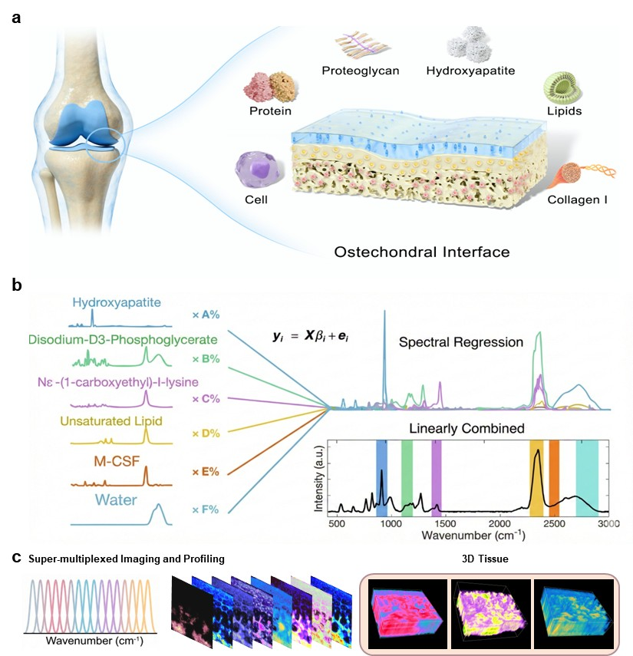
Extended Data Fig. 1

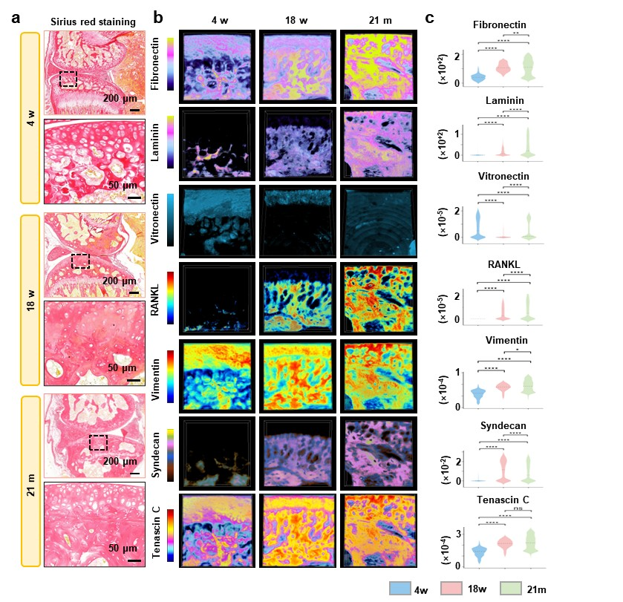
Extended Data Fig. 2

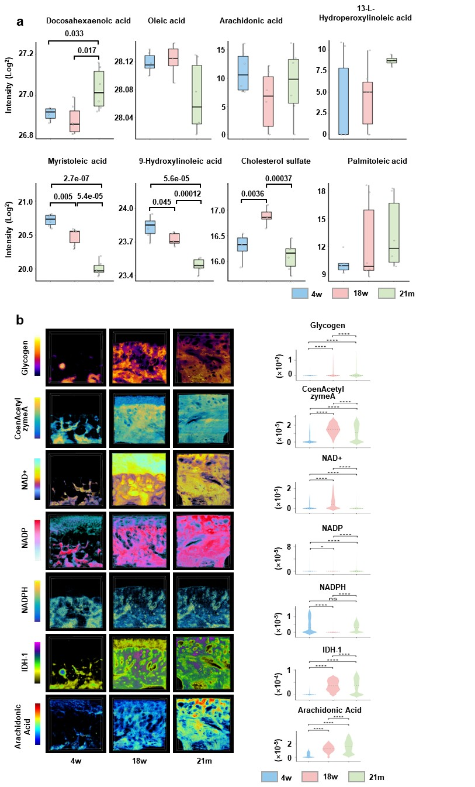
Extended Data Fig. 3

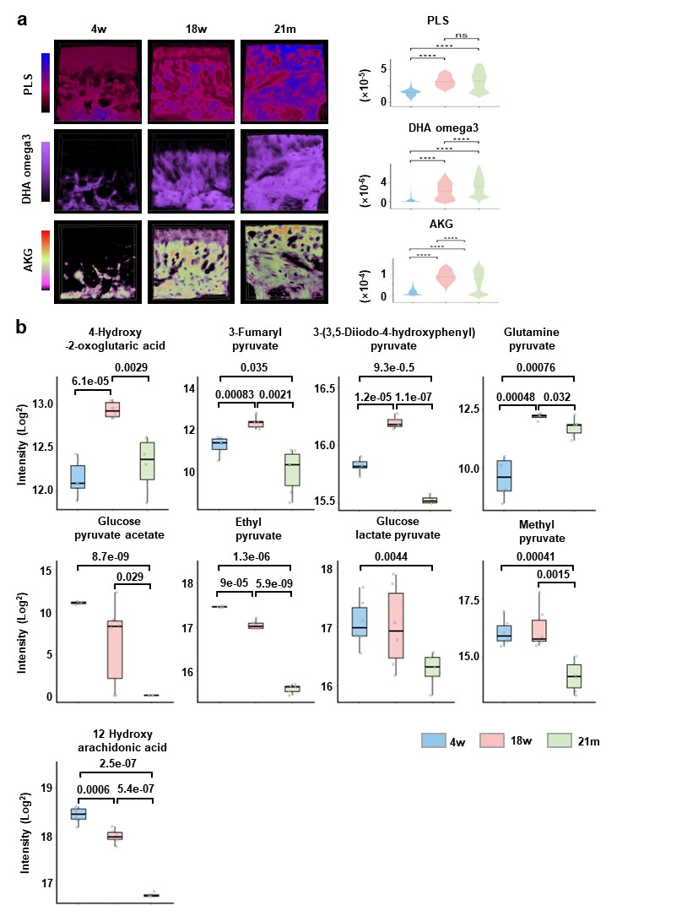
Extended Data Fig. 4

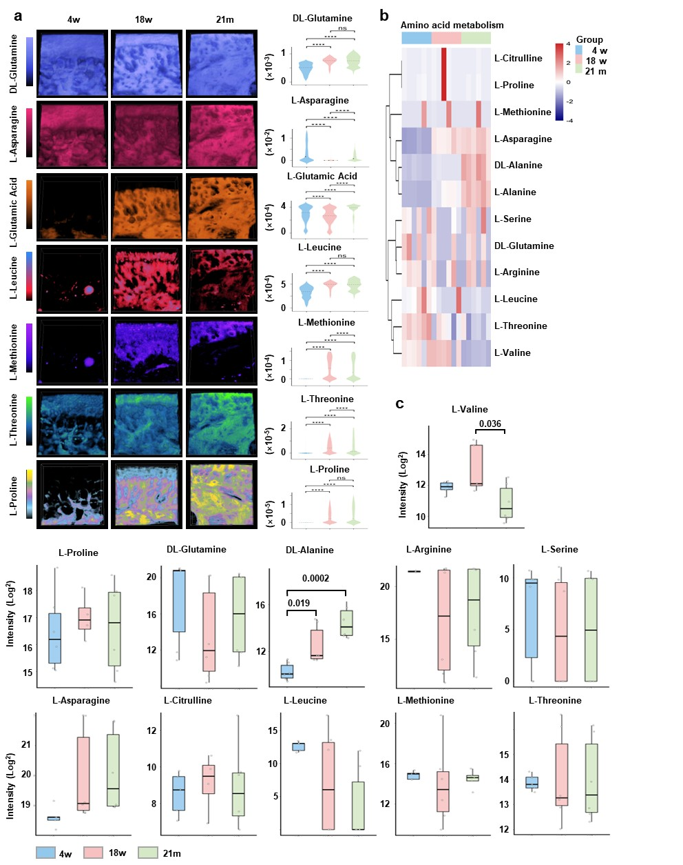
Extended Data Fig. 5

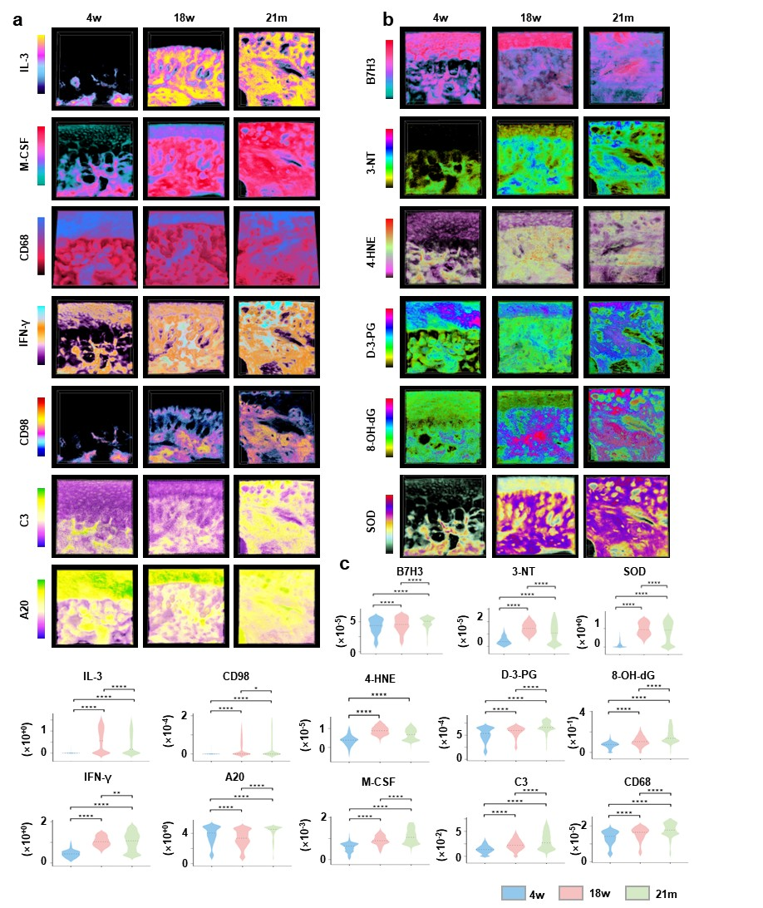
Extended Data Fig. 6

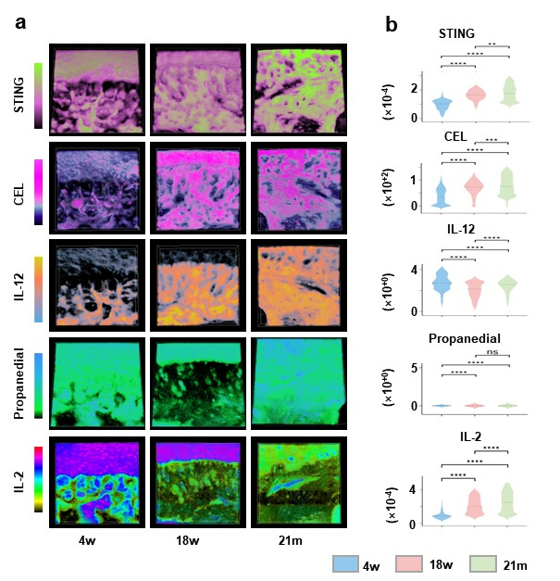
Extended Data Fig. 7

Supplementary data 1
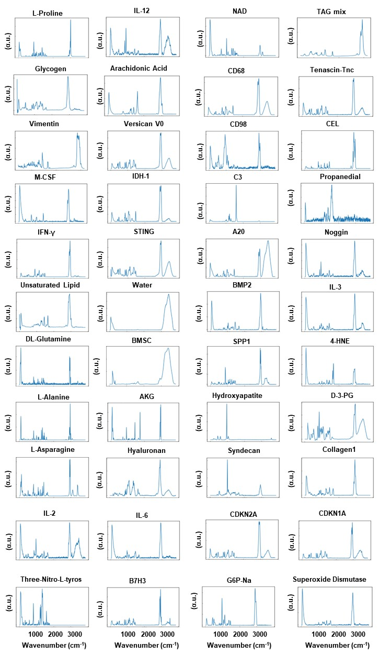

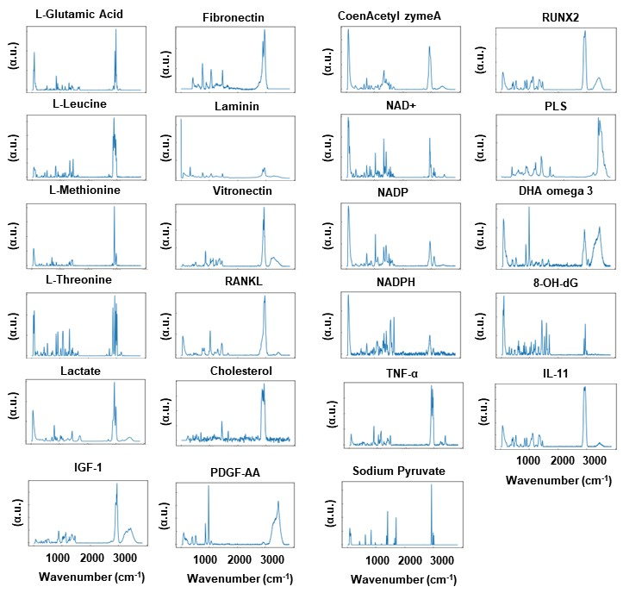

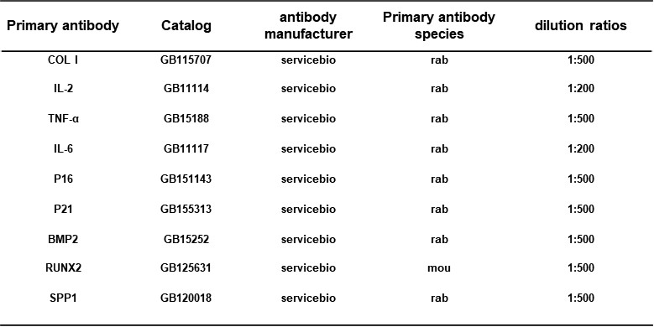
Supplementary Table 1

