Supporting Information

Interpretable Multi-modal Deep Learning Radiomics for Preoperative Mapping of Tertiary Lymphoid Structure Associated B-Cell Tumor Immune Microenvironment and Immunotherapy Response in Clear Cell Renal Cell Carcinoma

Catalogue
Appendix file 1 Participating hospitals of this study
Appendix file 2 The four-step feature selection process for radiomics features
Appendix file 3 Pre-fusion Features’ selection process
Figure S1 Univariate AUCs’ analysis examining the stability of the selected radiomics features via the Mann-Whitney U test
Figure S2 The Elastic_net coefficients bar-plot for the selected radiomics features
Figure S3 Spearman correlation analysis of the selected radiomics features
Figure S4 Univariate AUCs’ analysis examining the stability of the selected pre-fusion features via the Mann-Whitney U test
Figure S5 The Elastic_net coefficients bar-plot for the selected pre-fusion features
Figure S6 Spearman correlation analysis of the selected pre-fusion features
Figure S7 Calibration for PFMs in the primary set
Figure S8 DCA for PFMs in the primary set
Figure S9 Calibration for LFMs in the primary set
Figure S10 DCA for LFMs in the primary set
Figure S11 The SHAP analysis of LFM in the primary set
Table S1 CT scanners and parameters used in this study
Table S2 Clinic-pathological characteristics of patients in the prospective set
Table S3 Clinic-pathological characteristics of patients in the ICI therapy set
Table S4 Clinic-pathological characteristics of patients in the multi-omics set
Table S5 Predictive performances of 2D deep learning models in the primary and test 1 sets
Table S6 Predictive performances of 2.5D deep learning models in the primary and test 1 sets
Table S7 Predictive performances of 3D deep learning models in the primary and test 1 sets
Table S8 Predictive performances of radiomics models in the primary and test 1 sets
Appendix file 1 Participating hospitals of this study
Number | Name | Antonomasia
1 | the First Affiliated Hospital of Chongqing Medical University | Center 1
2 | the Second Affiliated Hospital of Chongqing Medical University | Center 2
3 | the Yongchuan Affiliated Hospital of Chongqing Medical University | Center 3
4 | the Dazu Affiliated Hospital of Chongqing Medical University | Center 4
5 | the Three Gorges Central Hospital Affiliated to Chongqing University | Center 5
6 | the Fuling Affiliated Hospital of Chongqing University | Center 6
7 | Suining Central Hospital | Center 7
8 | Yibin Second People’s Hospital | Center 8

Appendix file 2 The four-step feature selection process for radiomics features
To mitigate the risk of overfitting inherent in high-dimensional datasets and to enhance model generalizability, a four-step dimensionality reduction pipeline was implemented.
Step 1. Stability Screening
Initial tumor volumes were automatically segmented using the 3D nnU-Net framework. To evaluate the stability of radiomic features against observer-induced variability during the refinement process, a subset of 50 cases was randomly selected for a reproducibility study. Two abdominal radiologists (Reader A with 19 years of experience and Reader B with 10 years of experience), who were blinded to the clinical data, independently reviewed and adjusted the 3D nnU-Net-generated masks using ITK-SNAP software (version 3.8.0). Inter- and intra-observer reproducibility was evaluated via intraclass correlation coefficients (ICCs). Features with an ICC > 0.80 were considered highly stable and retained for further analysis.
Step 2. Univariate Robustness Filtering
The distribution of the remaining stable features was compared between TLS-positive and TLS-negative groups. As radiomics features often exhibit non-normal distributions, the Mann-Whitney U test was employed for inter-group comparisons. To control for multiple comparisons, P-values were adjusted using the Benjamini-Hochberg method to maintain a false discovery rate (FDR) below 0.05. Additionally, the univariate area under the receiver operating characteristic curve (AUC) and effect size were calculated for each feature. Only features meeting the FDR-adjusted P-value and AUC thresholds were considered candidates for the next phase.
Step 3. Redundancy Control and mRMR Selection
Redundancy was managed through Spearman correlation analysis and hierarchical clustering. For feature clusters exhibiting high collinearity (absolute correlation coefficient > 0.9), a representative feature was selected based on its stability (ICC) and univariate P-value. Subsequently, the Minimum Redundancy Maximum Relevance (mRMR) algorithm was applied to rank the remaining features according to their relevance to the TLS status and their mutual redundancy.
Step 4. Elastic Net Stability Selection
Final feature selection was performed using Elastic Net regularization combined with bootstrap resampling. This approach utilizes both L1 (LASSO) and L2 (Ridge) penalties, making it more effective than LASSO alone for handling the highly correlated structures common in imaging data. In each of the 100 bootstrap iterations, an Elastic Net model was fitted on the training set. Features were ranked by their selection frequency, and only those consistently selected above a predefined frequency threshold were included in the final predictive signature.

Appendix file 3 Pre-fusion Features’ selection process
For the optimized architectures identified in the single-modality phase (2D-ResNet50, 2.5D-DenseNet161, and 3D-ResNet101), deep features were extracted from the final global average pooling layer. This yielded feature vectors of 2,048 dimensions for ResNet50, 2,208 for DenseNet161, and 2,048 for ResNet101. In the construction of the early-fusion (pre-fusion) model, a block-wise feature selection strategy was adopted. Radiomics and DL features from each modality underwent the four-step dimensionality reduction independently. The selected candidate features from all four modules were then concatenated. A second-level Spearman correlation analysis and Elastic Net stability selection were performed on the concatenated set to identify the optimal cross-module feature subset.

Figure S1 Univariate AUCs’ analysis examining the stability of the selected radiomics features via the Mann-Whitney U test
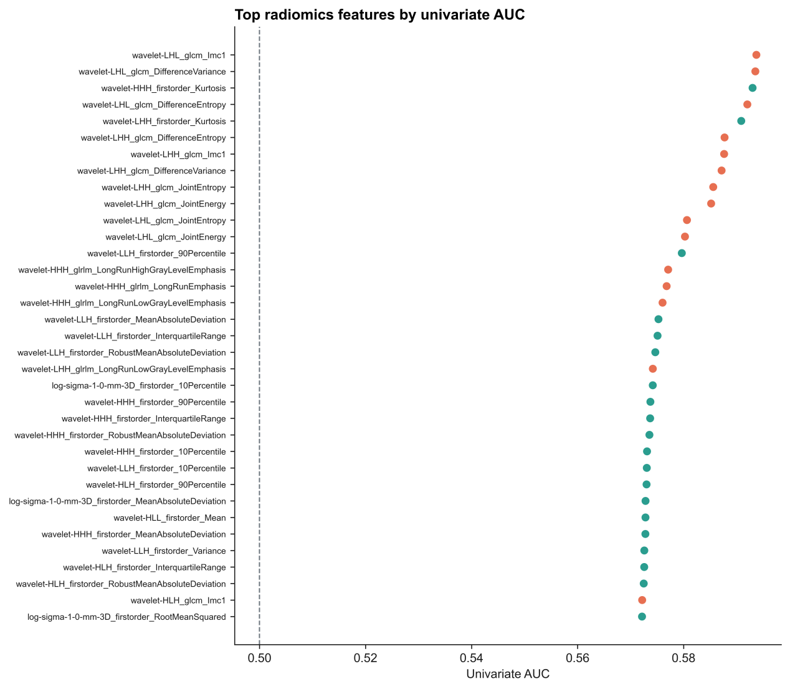
Figure S2 The Elastic_net coefficients bar-plot for the selected radiomics features
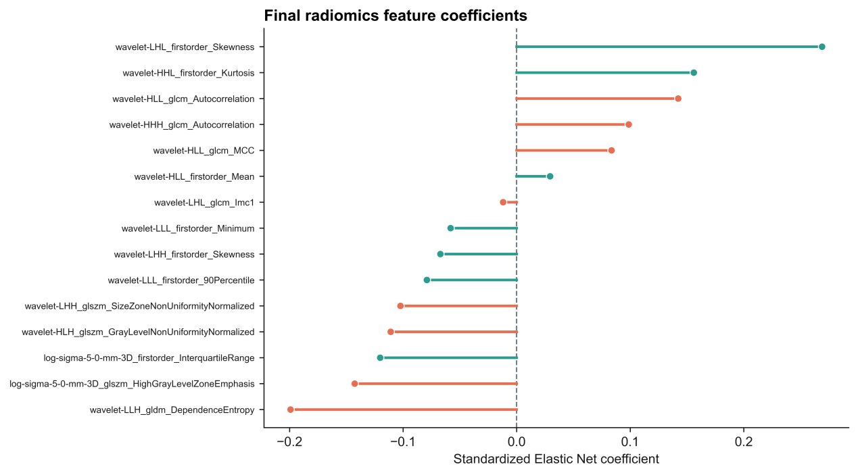

Figure S3 Spearman correlation analysis of the selected radiomics features
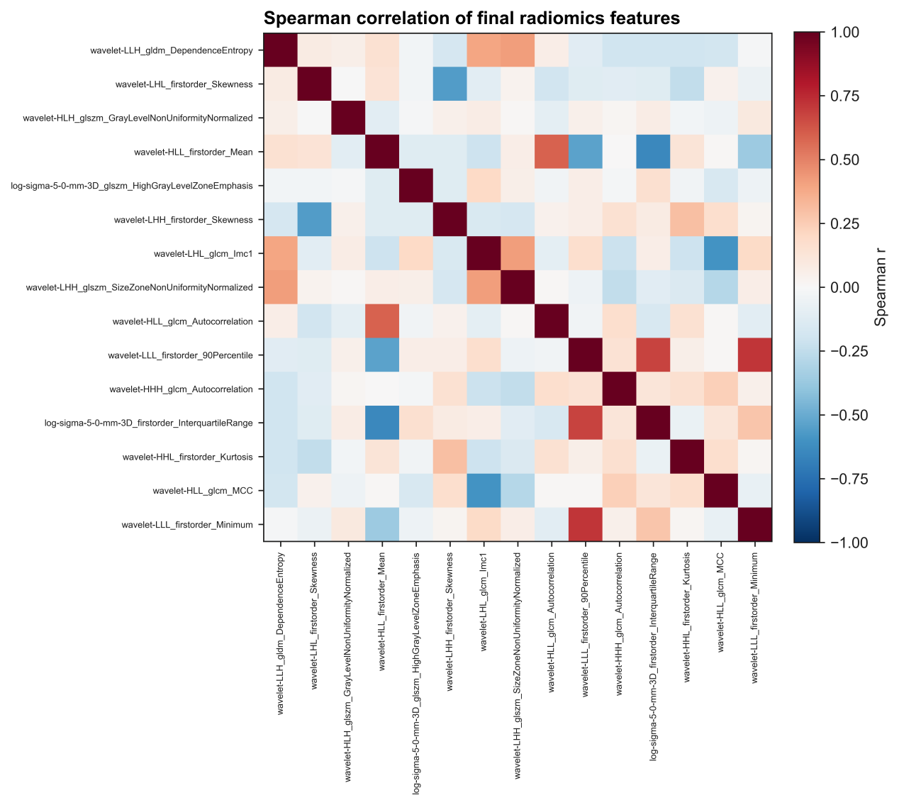

Figure S4 Univariate AUCs’ analysis examining the stability of the selected pre-fusion features via the Mann-Whitney U test
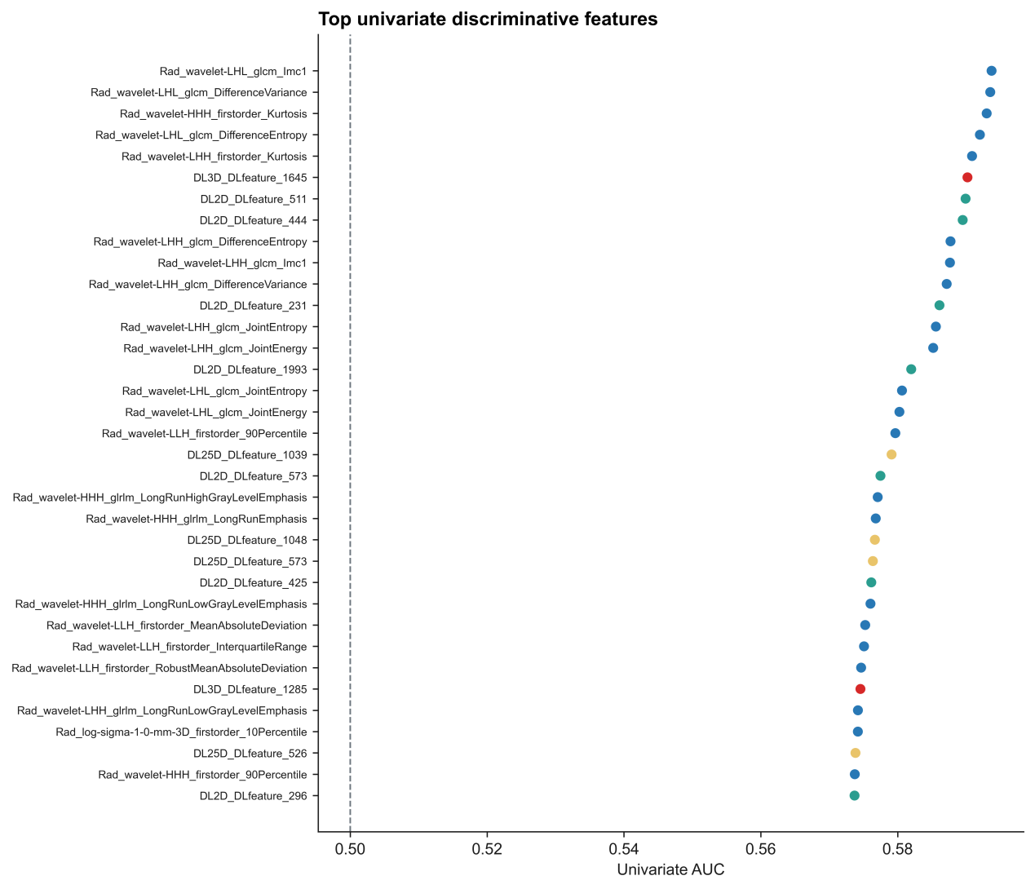
Figure S5 The Elastic_net coefficients bar-plot for the selected pre-fusion features
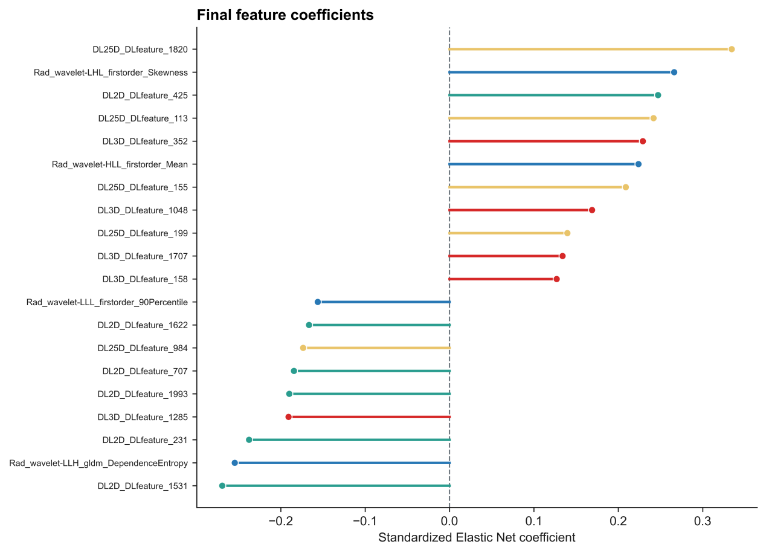
Figure S6 Spearman correlation analysis of the selected radiomics features
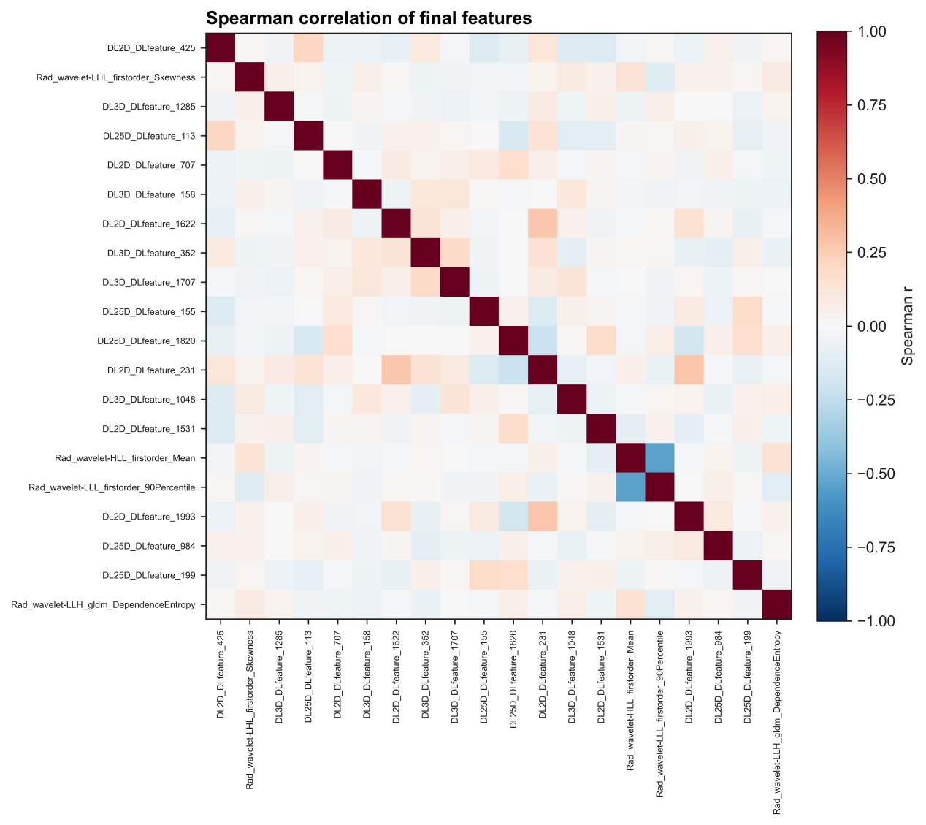

Figure S7 Calibration for PFMs in the primary set
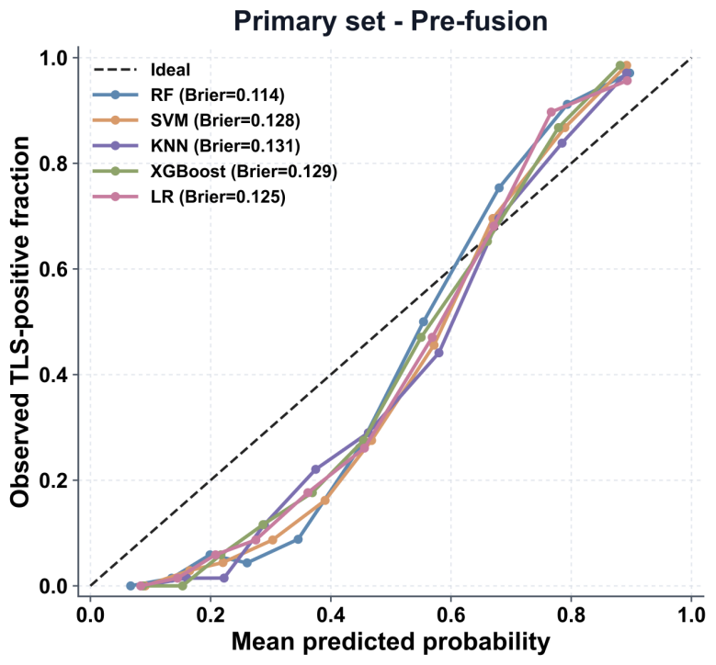
Figure S8 DCA for PFMs in the primary set
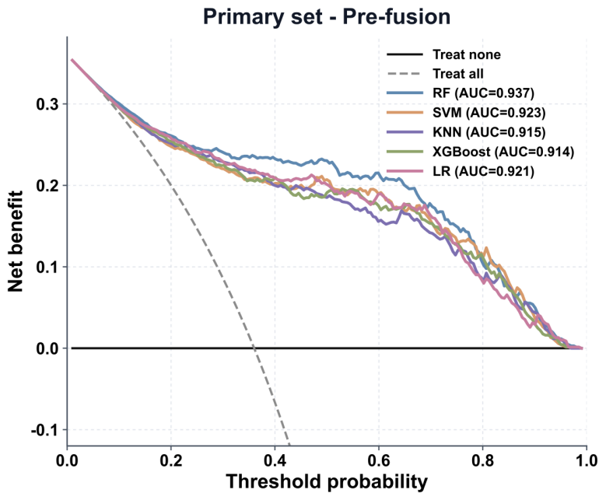

Figure S9 Calibration for LFMs in the primary set
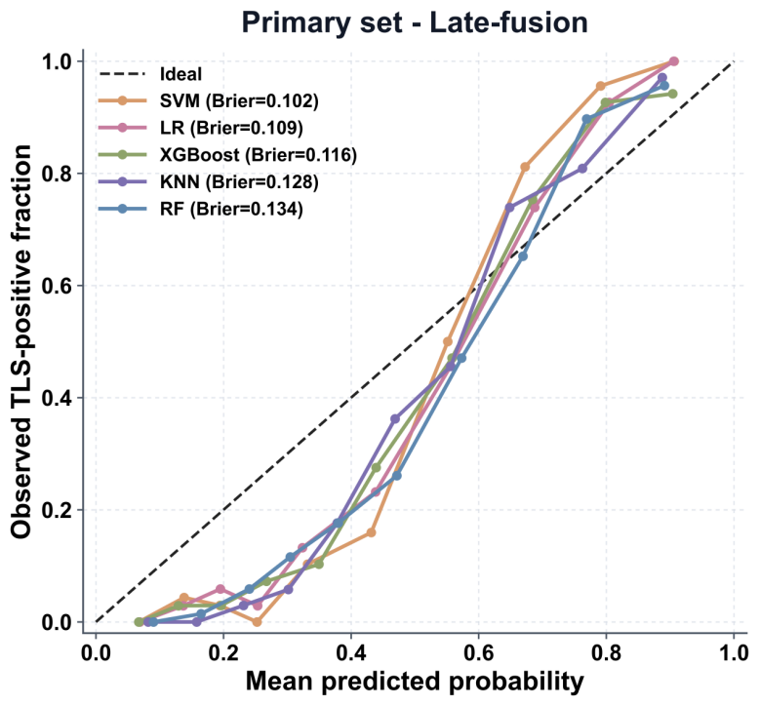
Figure S10 DCA for LFMs in the primary set
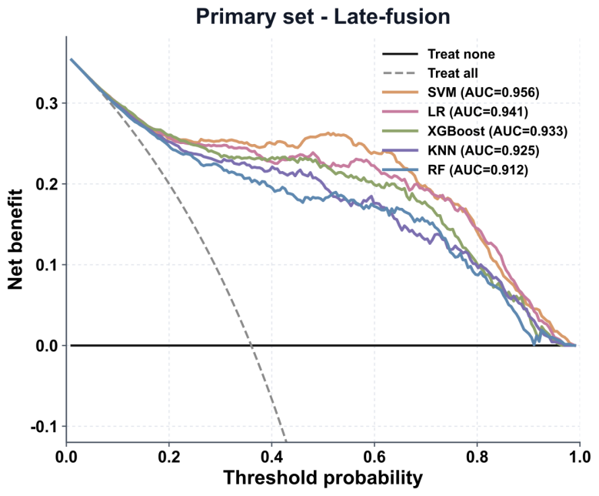
Figure S11 The SHAP analysis of LFM in the primary set
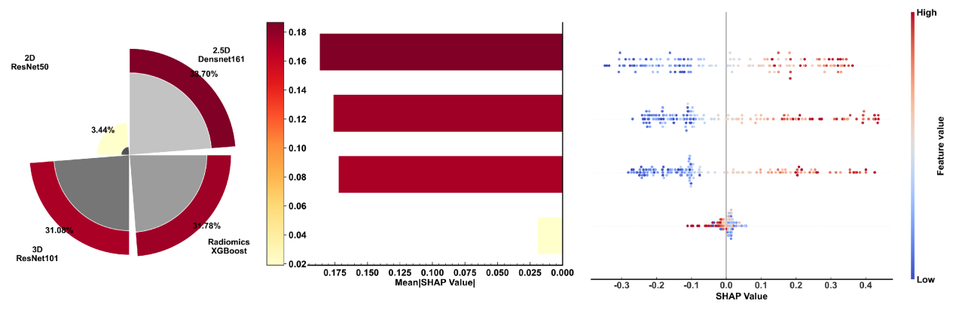

Manufacturer | System Model | Tube Voltage  (kV) | Tube Current  (mA) | Rotation Time  (s) | Collimation  (mm) | Matrix | Slice Thickness  (mm)
GE | Revolution APEX | 100-120 | 200-400 | 0.28 | 256 × 0.625 | 512 | 0.625
GE | Discovery CT750 HD | 80-140 | 200 | 0.35 | 64 × 0.625 | 512 | 0.625
GE | LightSpeed VCT | 100-120 | 200 | 0.35 | 64 × 0.625 | 512 | 0.625
Siemens | SOMATOM Force | 100-120 | 200 | 0.25 | 2 × 96 × 0.6 | 1024 | 0.6
Siemens | Definition Flash | 70-140 | 200 | 0.28 | 2 × 64 × 0.6 | 512 | 0.6
Siemens | Definition | 100-120 | 300 | 0.33 | 2 × 32 × 0.6 | 512 | 0.6
Siemens | Sensation 64 | 100-120 | 300 | 0.33 | 64 × 0.6 | 512 | 0.6
Philips | IQon Spectral CT | 100-120 | 150-300 | 0.27 | 64 × 0.625 | 512 | 0.625
Philips | Brilliance iCT 256 | 80-140 | 200 | 0.27 | 128 × 0.625 | 512 | 0.625
Canon | Aquilion ONE PRISM | 80-135 | 200 | 0.275 | 320 × 0.5 | 512 | 0.5
Table S1 CT scanners and parameters used in this study
kV (kilovolt); mA (milliampere); s (second); mm (milimetre)

Table S2 Clinic-pathological characteristics of patients in the prospective set
Variables | Prospective set (n=67)
Age, years | 56.00 (48.00-68.00)
Tumor size, cm | 3.90 (3.00-5.00)
Sex, n (%)
Female | 20 (29.9)
Male | 47 (70.1)
Tumor laterality, n (%)
Left | 30 (44.8)
Right | 37 (55.2)
Surgical procedure, n (%)
PN | 40 (59.7)
RN | 27 (40.3)
WHO/IUSP grade, n (%)
I | 23 (34.3)
II | 34 (50.7)
III | 8 (11.9)
IV | 2 (3.0)
Presence of necrosis, n (%)
No | 51 (76.1)
Yes | 16 (23.9)
pT stage, n (%)
1 | 56 (83.6)
2 | 5 (7.5)
3 | 6 (9.0)
pN status, n (%)
0 | 67 (100.0)
1 | 0 (0.0)
Presence of TLS, n (%)
No | 45 (67.2)
Yes | 22 (32.8)

Table S3 Clinic-pathological characteristics of patients in the ICI therapy set
Variables | ICI therapy set (n=152)
Age, years | 56.50 (49.25-56.50)
Tumor size, cm | 5.75 (3.43-7.60)
Sex, n (%)
Female | 62 (40.8)
Male | 90 (59.2)
Tumor laterality, n (%)
Left | 78 (51.3)
Right | 74 (48.7)
WHO/IUSP grade, n (%)
I | 21 (13.8)
II | 69 (45.4)
III | 42 (27.6)
IV | 20 (13.2)
Presence of necrosis, n (%)
No | 111 (73.0)
Yes | 41 (27.0)
pT stage, n (%)
1 | 8 (5.3)
2 | 49 (32.2)
3 | 86 (56.6)
4 | 9 (5.9)
pN status, n (%)
0 | 134 (88.2)
1 | 18 (11.8)
pM status, n (%)
0 | 141 (92.8)
1 | 11 (7.2)
TNM stage, n (%)
I | 4 (2.6)
II | 36 (23.7)
III | 96 (63.2)
IV | 16 (10.5)
Presence of TLS, n (%)
No | 92 (60.5)
Yes | 60 (39.5)
ICI+TKI therapy, n (%)
Response | 51 (33.6)
Non-response | 101 (66.4)

Table S4 Clinic-pathological characteristics of patients in the multi-omics set
Variables | Multi-omics set (n=65)
Age, years
Tumor size, cm
Sex, n (%)
Female | 27 (41.5)
Male | 38 (58.5)
Tumor laterality, n (%)
Left | 30 (46.2)
Right | 35 (53.8)
Surgical procedure, n (%)
PN | 41 (63.1)
RN | 24 (36.9)
WHO/IUSP grade, n (%)
I | 14 (21.5)
II | 37 (56.9)
III | 13 (20.0)
IV | 1 (1.5)
Presence of necrosis, n (%)
No | 48 (73.8)
Yes | 17 (26.2)
pT stage, n (%)
1 | 53 (81.5)
2 | 6 (9.2)
3 | 6 (9.2)
pN status, n (%)
0 | 64 (98.5)
1 | 1 (1.5)
Presence of TLS, n (%)
No | 41 (63.1)
Yes | 24 (36.9)

Table S5 Predictive performances of 2D deep learning models in the primary and test 1 sets
 | Model | Dataset | AUC | 95%_CI
2D-DL | Densnet161 | Primary set | 0.879 | 0.821-0.907
2D-DL | Densnet161 | Test set 1 | 0.832 | 0.795-0.884
2D-DL | Densnet201 | Primary set | 0.849 | 0.789-0.867
2D-DL | Densnet201 | Test set 1 | 0.821 | 0.756-0.879
2D-DL | ResNet101 | Primary set | 0.794 | 0.741-0.864
2D-DL | ResNet101 | Test set 1 | 0.694 | 0.600-0.766
2D-DL | ResNet50 | Primary set | 0.897 | 0.841-0.945
2D-DL | ResNet50 | Test set 1 | 0.888 | 0.834-0.946
2D-DL | vgg16_bn | Primary set | 0.771 | 0.701-0.856
2D-DL | vgg16_bn | Test set 1 | 0.761 | 0.703-0.839
2D-DL | vgg19 | Test set 1 | 0.824 | 0.782-0.869
2D-DL | vgg19 | Primary set | 0.814 | 0.756-0.889

Table S6 Predictive performances of 2.5D deep learning models in the primary and test 1 sets
 | Model | Dataset | AUC | 95%_CI
2.5D-DL | Densnet161 | Test set 1 | 0.899 | 0.858-0.939
2.5D-DL | Densnet161 | Primary set | 0.923 | 0.887-0.956
2.5D-DL | Densnet201 | Test set 1 | 0.799 | 0.751-0.843
2.5D-DL | Densnet201 | Primary set | 0.825 | 0.747-0.890
2.5D-DL | ResNet101 | Test set 1 | 0.744 | 0.715-0.789
2.5D-DL | ResNet101 | Primary set | 0.761 | 0.700-0.875
2.5D-DL | ResNet50 | Test set 1 | 0.854 | 0.800-0.912
2.5D-DL | ResNet50 | Primary set | 0.902 | 0.874-0.951
2.5D-DL | vgg16_bn | Test set 1 | 0.729 | 0.689-0.784
2.5D-DL | vgg16_bn | Primary set | 0.759 | 0.699-0.832
2.5D-DL | vgg19 | Test set 1 | 0.783 | 0.733-0.825
2.5D-DL | vgg19 | Primary set | 0.807 | 0.769-0.844

Table S7 Predictive performances of 3D deep learning models in the primary and test 1 sets

 | Model | Dataset | AUC | 95%_CI
3D-DL | ResNet10 | Primary set | 0.669 | 0.623-0.707
3D-DL | ResNet10 | Test set 1 | 0.667 | 0.619-0.696
3D-DL | ResNet101 | Primary set | 0.777 | 0.725-0.841
3D-DL | ResNet101 | Test set 1 | 0.756 | 0.719-0.817
3D-DL | ResNet18 | Primary set | 0.701 | 0.648-0.765
3D-DL | ResNet18 | Test set 1 | 0.724 | 0.699-0.757
3D-DL | ResNet34 | Primary set | 0.694 | 0.659-0.735
3D-DL | ResNet34 | Test set 1 | 0.621 | 0.599-0.680
3D-DL | ResNet50 | Primary set | 0.721 | 0.666-0.779
3D-DL | ResNet50 | Test set 1 | 0.700 | 0.668-0.744

Table S8 Predictive performances of radiomics models in the primary and test 1 sets
 | Model | Dataset | AUC | 95%_CI
Radiomics | KNN | Primary set | 0.712 | 0.674-0.754
Radiomics | KNN | Test set 1 | 0.664 | 0.609-0.700
Radiomics | LR | Primary set | 0.775 | 0.729-0.811
Radiomics | LR | Test set 1 | 0.674 | 0.619-0.730
Radiomics | RF | Primary set | 0.884 | 0.648-0.765
Radiomics | RF | Test set 1 | 0.847 | 0.806-0.889
Radiomics | SVM | Primary set | 0.795 | 0.744-0.839
Radiomics | SVM | Test set 1 | 0.739 | 0.695-0.792
Radiomics | XGBoost | Primary set | 0.907 | 0.725-0.841
Radiomics | XGBoost | Test set 1 | 0.878 | 0.839-0.900

