Supplement
Supplementary Table S1 Distribution of NAT2 diplotype among patients with tuberculosis Included in the study
Variables | Total (n, %),  n = 423 (100) | ATDILI (n, %),  n=109 (25.77) | Non ATDILI (n, %),  n= 314 (74.23) |  | P-value
 |  |  |  | <0.001
Slow acetylator
*5B/*5B | 7 (1.67) | 4 (3.67) | 4 (1.28)
*5B/*6A | 26 (6.21) | 13 (11.93) | 15 (4.79)
*5B/*7B | 13 (3.10) | 6 (5.50) | 7 (2.24)
*6A/*6A | 43 (10.26) | 18 (16.51) | 27 (8.63)7
*6A/*7B | 56 (13.37) | 28 (25.69) | 27 (8.63)
*7B/*7B | 16 (3.82) | 9 (8.26) | 6 (1.92)
Intermediate acetylator
*4/*6A | 93 (22.20) | 12 (11.01) | 83 (26.52)
*4/*7B | 62 (14.80) | 11 (10.09) | 52 (16.61)
*4/*5B | 27 (6.44) | 2 (1.83) | 25 (7.99)
*5B/*13A | 1 (0.24) | 0 (0) | 1 (0.32)
*6A/*12A | 6 (1.43) | 0 (0) | 6 (1.92)
*6A/*13A | 0 (0) | 0 (0) | 0 (0)
*7B/*12A | 3 (0.72) | 0 (0) | 3 (0.96)
*7B/*13A | 0 (0) | 0 (0) | 0 (0)
Rapid acetylator
*4/*4 | 58 (13.84) | 5 (4.59) | 51 (16.29)
*4/*12A | 2 (0.48) | 0 (0) | 3 (0.96)
*4/*13A | 2 (0.48) | 0 (0) | 2 (0.64)
*5C/*7B | 1 (0.24) | 1 (0.92) | 0 (0)
*5B/*12A | 1 (0.48) | 0 (0) | 1 (0.32)

Supplementary Table S2 Liver function test abnormalities among patients who developed ATDILI
Variables | ATDILI group (n=111/426) (26.06%)
 | Median | IQR
Onset (day) (Median, IQR) | 14 | 8.5, 20.5
AST (IU/ml) (Median, IQR) | 168 | 114, 280
ALT (IU/ml) (Median, IQR) | 149.5 | 88.5, 275
ALP (IU/ml) (Median, IQR) | 127 | 95, 165
Total bilirubin (mg/dl) | 1.3 | 0.8, 2.8
Direct bilirubin (mg/dl) | 0.36 | 0.75, 2.2
DILI pattern (n, %)  Transaminitis  Cholestasis  Mixed | 32 (32.32)  37 (37.37)  30 (30.30)
Supplementary Table S3 Multicollinearity Assessment of Predictors
Predictors | VIF | Tolerance
Age ≥ 60 years | 1.38 | 0.72
Female gender | 1.16 | 0.86
BMI < 18.5 kg/m² | 1.06 | 0.94
Current alcohol consumption | 1.18 | 0.84
Comorbid conditions | 1.47 | 0.68
HIV infection | 1.10 | 0.91
Co-administration of hepatotoxic drugs | 1.24 | 0.81
Hypoalbuminemia (< 3.5 mg/dl) | 1.26 | 0.80
AST 25-50 IU/ml | 1.57 | 0.63
AST > 50 IU/ml | 1.86 | 0.54
ALT 20 – 40 IU/ml | 1.46 | 0.68
ALT > 40 IU/ml | 1.90 | 0.53
Abnormal total bilirubin | 1.34 | 0.75
Abnormal direct bilirubin | 1.45 | 0.69
NAT2 gene slow acetylator | 1.05 | 0.95
Hct < 30 mg % | 1.17 | 0.85
Mean VIF | 1.35

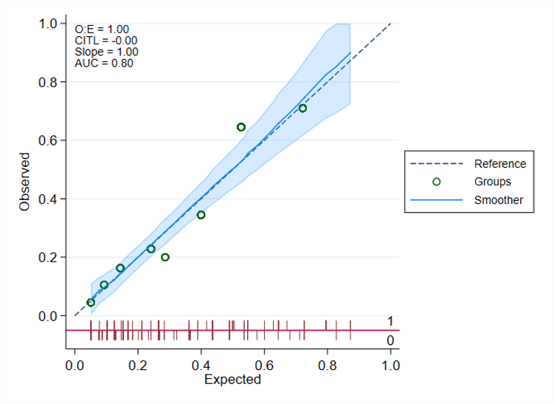
Supplementary Figure S1 Calibration Plot of the Prediction Model for ATDILI Showing Agreement Between Predicted and Observed Risk

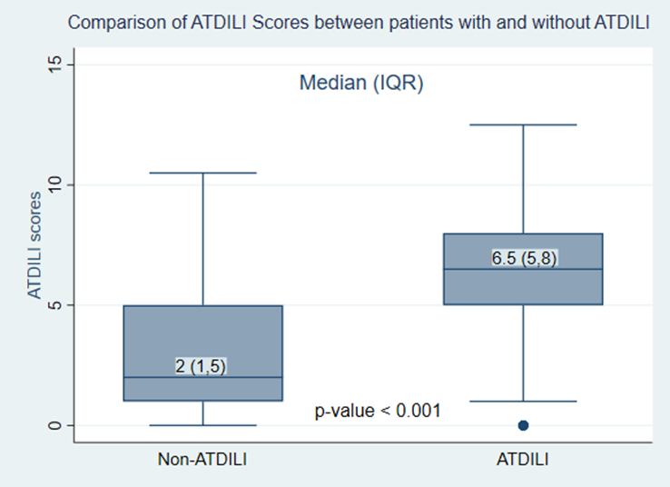
Supplementary Figure S2 Box plot comparing ATDILI scores between patients with and without ATDILI. Discriminatory performance was evaluated using ROC curve analysis (non-parametric and parametric methods). Supplement

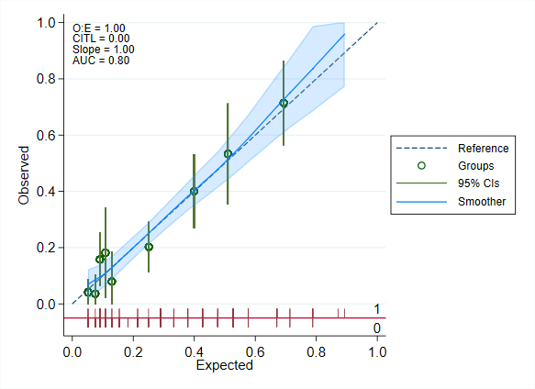
Supplementary Figure S3 Calibration plot showing the agreement between the predicted risk from the ATDILI score and the observed occurrence of ATDILI.

Supplementary Figure S4 Decision curve analysis showing the net benefit of the ATDILI score across a range of threshold probabilities.

