Supplementary information
for

Mapping Mediterranean marginal lands as opportunity spaces for climate-resilient agrifood diversification
  - Luigi Tosi¹*, Cristina Da Lio¹*, Marta Cosma¹, Taoufik Hermassi², Mohamed Lassaad Kotti², Fathia Jarray², Vassilis Aschonitis³, Sandra Donnici¹
¹National Research Council of Italy, Institute of Geosciences, Padova, Italy
²National Research Institute of Rural Engineering, Water and Forests, Laboratory of Rural Engineering, Ariana, Tunisia
³Hellenic Agricultural Organization-DIMITRA, Soil and Water Resources Institute, Thessaloniki, Greece

Supplementary Notes
Note S 1. Contribution of selected parameters to plant growth.
Soil acidity/alkalinity and salinity, as measured by pH and electrical conductivity (EC), emerge as key abiotic stressors shaping soil function and plant productivity across Mediterranean environments. Acidic conditions reduce nutrient availability, suppress beneficial microbial activity, and increase the solubility of potentially toxic elements (e.g., Al and Mn), thereby constraining plant growth and yields ¹. Salinity affects soil structure and infiltration, and limits crop productivity by restricting plant water uptake ², and induces osmotic stress and ion toxicity, disrupting water relations and physiological processes ³. These effects are particularly relevant in arid and semi-arid settings, where irrigation and natural processes promote salt accumulation ⁴.
Soil organic carbon (SOC) underpins plant growth by improving aggregate stability, water retention, and nutrient availability, in part by enhancing cation exchange capacity, while also sustaining microbial activity and nutrient cycling ^{1,5}. Conversely, compaction (bdod) is a key constraint on root penetration and, by reducing permeability, can promote soil sealing and increase the risk of erosion.
Intrinsic texture-based productivity indicators refer to the Retention Curve Index (RCI) following ⁶, and cation exchange capacity (CEC), as well as a climate-based indicator of intrinsic fertility/productivity, i.e., Aridity Index (AI). RCI and CEC quantify the soil’s capacity, as a physical growth medium, to sustain plant development through texture-controlled properties, whereas AI captures the climatic contribution to productivity under conditions where other limiting factors are negligible. Baselines and thresholds for intrinsic texture-based productivity considered both physical/hydraulic and chemical properties linked to soil texture, ensuring a comprehensive representation of soil functionality in supporting plant productivity.
Soil texture (USDA, cfvo) delineates areas where particle-size distribution exerts primary control over soil hydraulic and physicochemical behavior. Specifically, texture regulates water retention capacity, pore-size distribution, drainage dynamics, soil aeration status, nutrient availability, and root penetrability, thereby modulating a broad spectrum of paedogenetic, biochemical, and ecological processes. Although coarse fragments (>2 mm) are excluded from the fine-earth fraction used in standard texture classification systems, their abundance significantly modifies soil functional properties. Coarse fragments reduce the effective water- and nutrient-holding capacity per unit volume of soil, alter mechanical impedance and rooting depth, and constrain tillage operations. At the same time, by promoting soil macroporosity and the development of preferential flow pathways, they may enhance infiltration rates and saturated hydraulic conductivity ⁷.
Topographic variables (DEM and slope) further modulate soil and plant conditions by shaping microclimate, soil development, and water redistribution ⁸. Slope influences drainage, erosion, and effective soil depth.
NDVI captures vegetation conditions and delineates marginal or degraded areas with sparse cover or bare land.
Land cover (lc_2014, lc_2022) modulates soil condition and productivity by influencing erosion protection, organic matter inputs, infiltration, and compaction.
Precipitation (pr) pattern together with reference/potential evapotranspiration (eto_hs) capture the primary climatic controls on soil-moisture dynamics ⁹. By governing the water balance, these variables modulate soil physical and chemical conditions and ultimately constrain plant growth. In arid and semi-arid settings, reduced precipitation and/or increased evapotranspiration can intensify soil desiccation, suppress microbial activity, enhance compaction, and lower nutrient availability ^{10,11}.

Note S 2. Sensitivity and validation analysis of the operational thresholds used for marginal-land identification.
The identification of marginal lands was based on an operational threshold of five aggregated unhealthy parameters. Because no universally accepted threshold exists for defining land marginality at continental scales, we evaluated the robustness of the framework by testing alternative thresholds corresponding to ±1 unhealthy parameter around the selected threshold (i.e., 4 and 6 unhealthy parameters).
A less restrictive threshold of four unhealthy parameters substantially increased the extent of marginal lands, incorporating many areas characterized by only moderate environmental limitations. This resulted in a broader classification that reduced the framework's discriminatory capacity and included several intensively managed agricultural regions across the Mediterranean Basin.
Conversely, a more restrictive threshold of six unhealthy parameters substantially reduced the extent of marginal lands and limited the classification to areas affected by very severe environmental constraints. Under this scenario, several well-documented environmentally constrained regions commonly recognized as marginal or degradation-prone in Mediterranean assessments were excluded from the marginal-land category.
Thresholds lower than four or higher than six unhealthy parameters were not considered further because they progressively reduced the conceptual meaning of marginality within the framework, either by over-classifying moderately constrained environments or by restricting the classification to only the most extreme conditions.
The robustness of the selected threshold was evaluated using independent evidence from published regional assessments of land degradation, salinity hotspots, drought-prone environments, and environmentally constrained agricultural systems across the Mediterranean Basin. The threshold of five unhealthy parameters showed the highest consistency with the spatial distribution of well-known degraded and environmentally constrained regions, including the Atlas and Maghreb regions, the Chott el Jerid basin, southern Italy, and the Iberian Peninsula ^{12–15}.
Sensitivity analysis indicated that marginal-land extent varied from 2.23 million km² under the threshold of four unhealthy parameters to 1.46 million km² under the threshold of six unhealthy parameters, compared with 1.82 million km² under the selected threshold of five unhealthy parameters (Supplementary Table S 2.1). This corresponds to an increase of approximately 22% and a decrease of approximately 20%, respectively, relative to the reference threshold. Similar proportional differences were observed under SSP2–4.5 and SSP5–8.5, indicating that the overall spatial patterns are robust to reasonable variations in threshold definition.

Table S 2.1. Sensitivity analysis of the operational threshold used for marginal-land identification. The table compares the extent of marginal lands obtained using alternative thresholds (4 and 6 unhealthy parameters) relative to the selected threshold of 5 unhealthy parameters under recent-past (2000–2019) and future climate scenarios (SSP2–4.5 and SSP5–8.5). Differences are reported both as total marginal area and as gains/losses relative to the reference threshold.
Threshold | recent past scenario | future scenario SSP2-4.5 | future scenario SSP5-8.5 | recent past scenario | future scenario SSP2-4.5 | future scenario SSP5-8.5 | loss/gain of marginal lands (km2) | loss/gain of marginal lands (km2) | loss/gain of marginal lands (km2)
Threshold | marginal area  (km2) | marginal area  (km2) | marginal area  (km2) | marginal area (%) | marginal area (%) | marginal area (%) | (SSP2-4.5-recent past) | (SSP585-SSP2-4.5) | (SSP5-8.5-recent past)
4 | 2227340.4 | 2211515.4 | 2215669.8 | 50.82% | 50.46% | 50.55% | -15825 | 4154.4 | -11670.6
5 | 1820974.8 | 1837049.4 | 1843032.6 | 41.55% | 41.92% | 42.05% | 16074.6 | 5983.2 | 22057.8
6 | 1458027.6 | 1472218.8 | 1473588 | 33.27% | 33.59% | 33.62% | 14191.2 | 1369.2 | 15560.4

Supplementary Figures
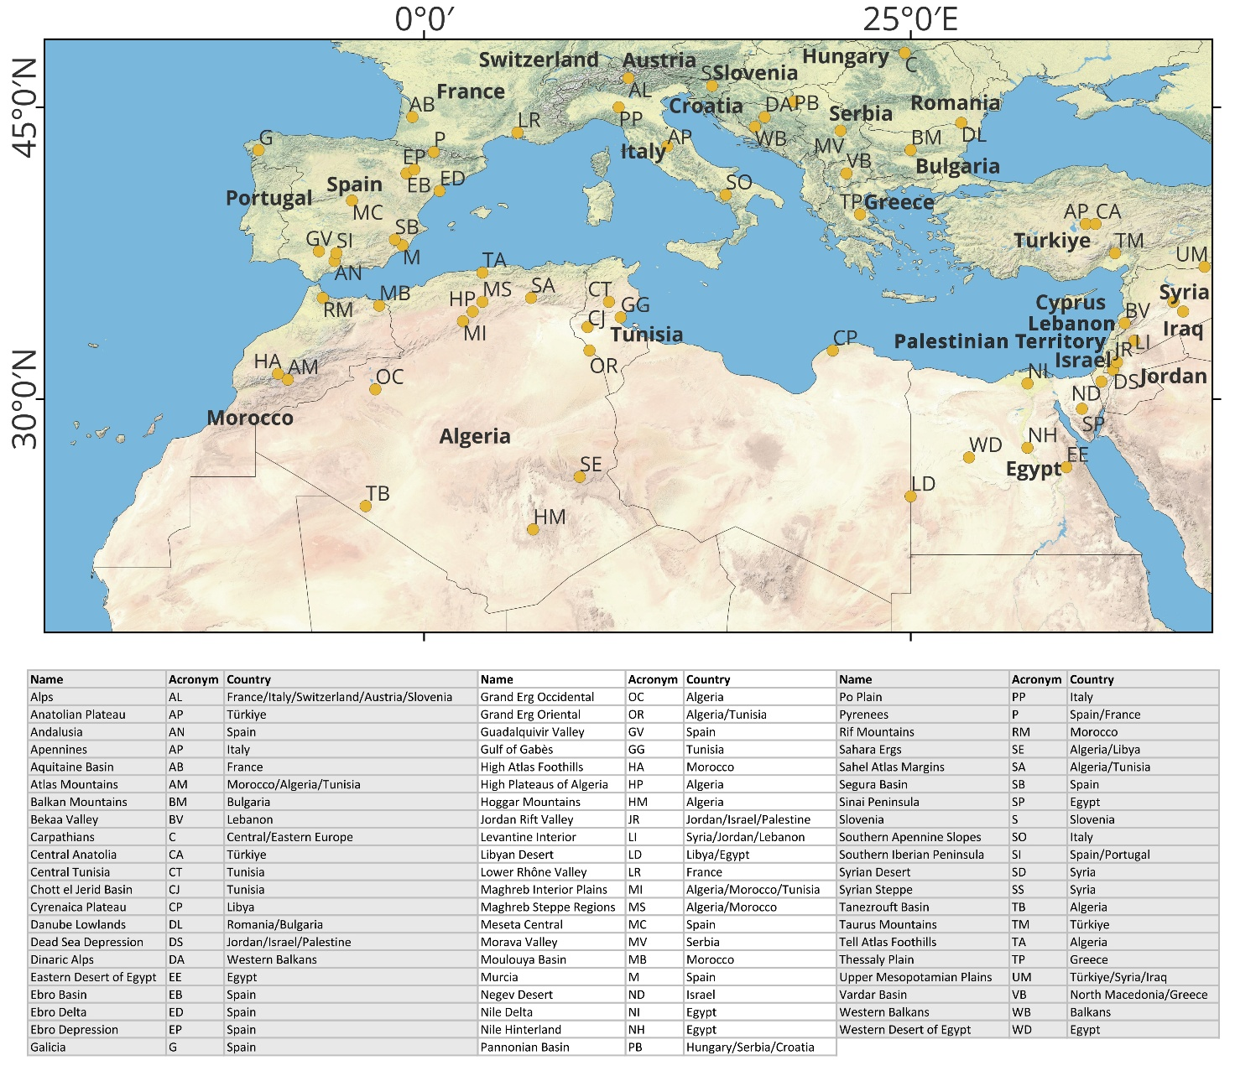
Fig. S 1. Geographical site nomenclature within the Mediterranean basin. Basemap is from ESRI (https://hub.arcgis.com/datasets/esri::world-countries-generalized/about).
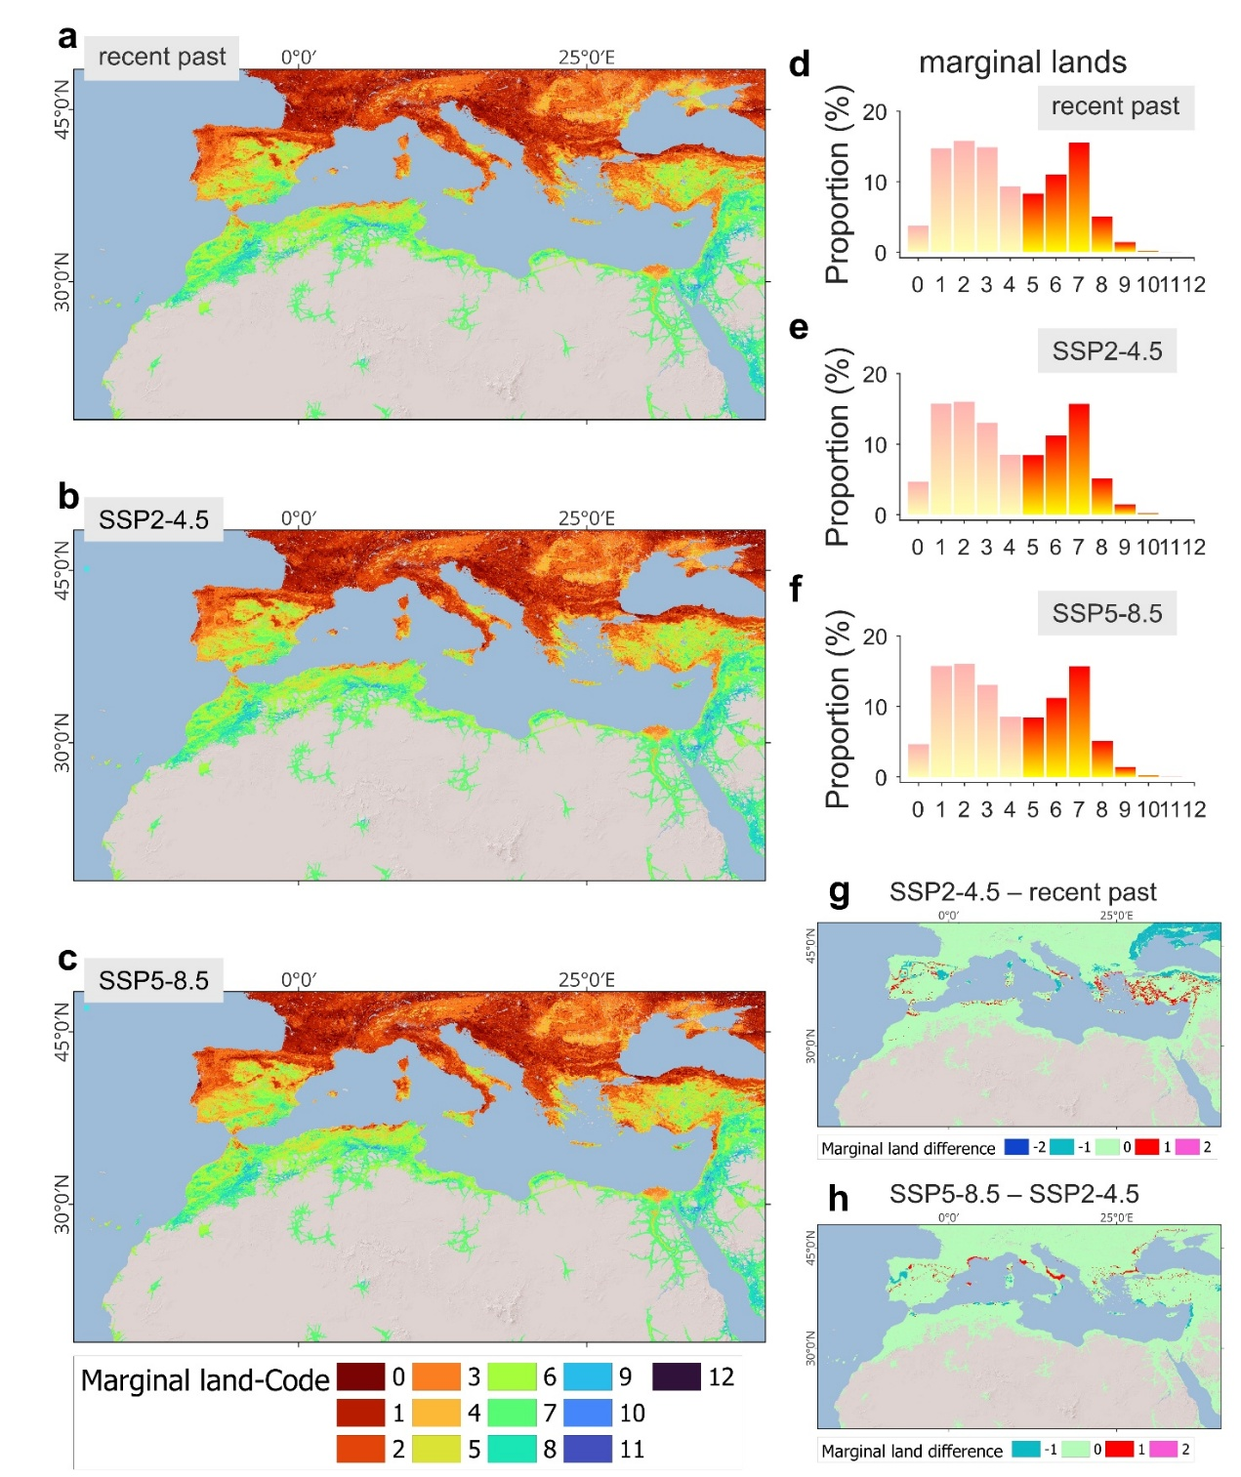
Fig. S 2. Classification of marginal lands mapped within areas reachable from an urban center within a 3-hour travel-time cutoff for a) recent past (2000–2019), b) SSP2–4.5 (2041–2060), c) SSP5–8.5 (2041–2060). Values represent the cumulative number of “unhealthy” parameters. The bar charts show the proportion of areas by marginal classes for d) recent past (2000–2019), e) SSP2–4.5 (2041–2060), f) SSP5–8.5 (2041–2060); full color indicates classes above the critical threshold, thus considered as marginal, and color shading indicates classes below the critical threshold not considered as marginal. g-h, display the difference in the marginality classification of marginal lands between g) future scenario SSP2–4.5 (2041–2060) and recent past (2000–2019), h) future scenario SSP5-8.5 and SSP2–4.5 (2041–2060). The positive values indicate an increase in the number of marginality classes. Basemaps in a, b, c, g, h are from ESRI.
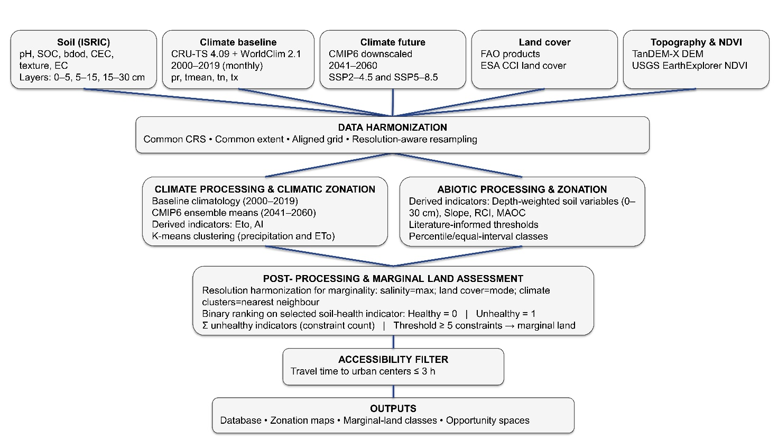
Fig. S 3. Overview of geospatial databases analysis, harmonization, and processing workflow for zonation and marginal land assessment.
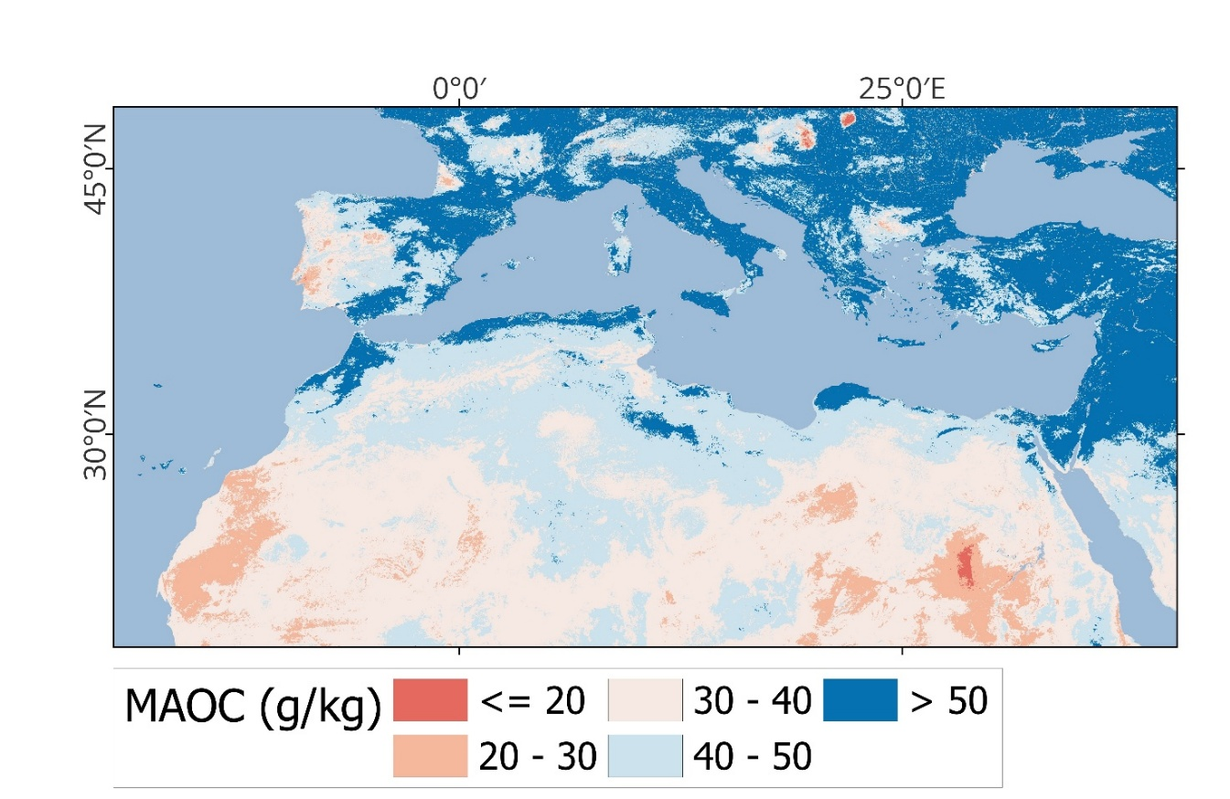
Fig. S 4. Mineral-associated organic carbon (MAOC) parameter.
Supplementary Tables
Table S 1. Classification of soil pH (pH), soil salinity (EC), soil organic carbon (SOC), soil bulk density (bdod) parameters. pH classification is adapted from NRCS, 2017, considering also nutrient availabilities from USDA-NRCS, 1997; EC classification is from ¹⁶, and Table 2.4 of ¹⁷, adapted from Table 42 ¹⁸; bdod classification is adapted from Table 3.3.1.4.1 of ¹⁹.
Code | pH | EC (dS/m) | SOC (g/kg) | bdod (g/cm3)
1 | <4.5  Very Strongly Acidic | <2  Non-saline | <0.25 MAOC | <R1  ideal conditions usually after tillage, harrowing etc.
2 | 4.5-5.3  Strongly Acidic | 2-4  Slightly saline | 0.25 MAOC-0.50 MOAC | R1-R2  adequate conditions
3 | 5.3-6.0  Moderately Acidic | 4-8  Moderate saline | 0.5 MAOC-0.75 MAOC | R2-R3  conditions that may affect plant/root growth
4 | 6.0-6.5  Slightly Acidic | 8-16  Highly saline | 0.75 MAOC-MAOC | >R3  conditions that restrict plant/root growth and may initiate soil sealing by compaction
5 | 6.5 - 7.3  Neutral | >16  Extremely saline | >MAOC
6 | 7.3 - 7.8  Slightly Alkaline
7 | 7.8 - 8.5  Moderately Alkaline
8 | 8.5 - 9.0  Strongly Alkaline
9 | >9.0  Very Strongly Alkaline
Table S 2. Classification of soil retention curve index (RCI), cation exchange capacity (CEC), and aridity index (AI) parameters. CEC classification is from Table 5.5. of ⁷; AI classification is from ^{20,21}.
Code | RCI | CEC (cmol+/kg) | AI
1 | <0.88 | <6 | <0.05 Hyper arid
2 | 0.88-0.91 | 6-12 | 0.05-0.20 Arid
3 | 0.91-0.945 | 12-25 | 0.20-0.50 Semi-arid
4 | 0.945-0.975 | 25-40 | 0.50-0.65 Dry Sub-humid
5 | >0.975 | >40 | ≥0.65 Humid
Table S 3. Classification of soil texture USDA (sand, silt, clay), soil coarse fragments content (cfvo), topography elevation (DEM), surface slope (slope), vegetation cover seasonality (NDVI), land cover (lc_2014) parameters. cfvo classification is from table on p. 2–37 of ²² and on p. 133 of ²³; slope classification is from table 7 of ¹⁸; lc_2014 classification is from https://www.fao.org/land-water/land/land-governance/land-resources-planning-toolbox/category/details/en/c/1036355/; https://data.apps.fao.org/catalog//iso/7f4f5ce4-9a3e-406f-bae6-efe63867329a.
Code | USDA | cfvo (%) | dem (m above msl) | slope (%) | NDVI | lc_2014
1 | SAND | <15  No texture class modifier (noun only; e.g., loam) | <-20 | 0-0.2  Flat | <0  No vegetation | Artificial Surfaces
2 | LOAM _SAND | 15-35  Use fragment-size adjective with texture class (e.g.,  gravelly loam) | -20-0 | 0.2-0.5  Level | 0-0.3  Sparse vegetation (primary priority) | Cropland
3 | SANDY_LOAM | 35-60  Use “very” with a fragment-size adjective with texture  class (e.g., very gravelly loam) | 0-100 | 0.5-1.0  Nearly level | 0.3-0.4  Sparse vegetation (less priority) | Grassland
4 | LOAM | 60-90  Use “extremely” with a fragment-size adjective with texture class (e.g., extremely gravelly loam) | 100-500 | 1.0-2.0  Very gently sloping | >0.4  Dense vegetation | Tree Covered Areas
5 | SILT_LOAM | ≥ 90  No adjective or modifier. If ≤ 10% fine earth, use the  appropriate fragment-size class name for the dominant  size class (e.g., gravel) | 500-1000 | 2-5  Gently sloping |  | Shrubs Covered Areas
6 | SILT |  | >1000 | 5-10  Sloping |  | Herbaceous vegetation, aquatic or regularly flooded
7 | SANDY_CLAY_LOAM |  |  | 10-15  Strongly sloping |  | Mangroves
8 | CLAY_LOAM |  |  | 15-30  Moderately steep |  | Sparse vegetation
9 | SILTY_CLAY_LOAM |  |  | 30-60  Steep |  | Baresoil
10 | SILTY_CLAY |  |  | >60  Very steep |  | Snow and glaciers
11 | CLAY |  |  |  |  | Waterbodies

Table S 4. Classification of lc_2022 parameter made available by Land Cover ESA Land Cover Climate Change Initiative. lc_2022 classification is from https://maps.elie.ucl.ac.be/CCI/viewer/index.php
Code | lc_2022
10 | Cropland, rainfed
11 | Herbaceous cover
12 | Tree or shrub cover
20 | Cropland, irrigated or post-flooding
30 | Mosaic cropland (>50%) / natural vegetation (tree, shrub, herbaceous cover) (<50%)
40 | Mosaic natural vegetation (tree, shrub, herbaceous cover) (>50%) / cropland (<50%)
50 | Tree cover, broadleaved, evergreen, closed to open (>15%)
60 | Tree cover, broadleaved, deciduous, closed to open (>15%)
61 | Tree cover, broadleaved, deciduous, closed (>40%)
62 | Tree cover, broadleaved, deciduous, open (15-40%)
70 | Tree cover, needle-leaved, evergreen, closed to open (>15%)
71 | Tree cover, needle-leaved, evergreen, closed (>40%)
80 | Tree cover, needle-leaved, deciduous, closed to open (>15%)
90 | Tree cover, mixed leaf type (broadleaved and needle-leaved)
100 | Mosaic tree and shrub (>50%) / herbaceous cover (<50%)
110 | Mosaic herbaceous cover (>50%) / tree and shrub (<50%)
120 | Shrubland
122 | Shrubland deciduous
130 | Grassland
140 | Lichens and mosses
150 | Sparse vegetation (tree, shrub, herbaceous cover) (<15%)
151 | Sparse tree (<15%)
152 | Sparse shrub (<15%)
153 | Sparse herbaceous cover (<15%)
160 | Tree cover, flooded, fresh or brackish water
170 | Tree cover, flooded, saline water
180 | Shrub or herbaceous cover, flooded, fresh/saline/brackish water
190 | Urban areas
200 | Bare areas
201 | Consolidated bare areas
202 | Unconsolidated bare areas
210 | Water bodies
220 | Permanent snow and ice

Table S 5. Classification of recent past precipitation (pr) parameter for the period 2000-2019.
Cluster | No. Elem. | Area % | Recent past precipitation (mm)
Cluster | No. Elem. | Area % | Jan | Feb | Mar | Apr | May | Jun | Jul | Aug | Sep | Oct | Nov | Dec | Annual | Apr-Sep
1 | 94656 | 53.49 | 2 | 1 | 1 | 1 | 1 | 1 | 3 | 7 | 4 | 2 | 2 | 2 | 26 | 17
2 | 16899 | 9.55 | 16 | 12 | 10 | 9 | 6 | 2 | 1 | 2 | 6 | 10 | 15 | 18 | 106 | 25
3 | 8663 | 4.90 | 38 | 32 | 35 | 34 | 28 | 13 | 5 | 8 | 24 | 38 | 44 | 40 | 339 | 112
4 | 6527 | 3.69 | 47 | 36 | 38 | 34 | 47 | 54 | 46 | 30 | 39 | 39 | 40 | 43 | 494 | 251
5 | 5063 | 2.86 | 65 | 49 | 54 | 51 | 57 | 39 | 12 | 11 | 23 | 37 | 42 | 60 | 501 | 193
6 | 6009 | 3.40 | 67 | 60 | 61 | 49 | 33 | 14 | 5 | 8 | 30 | 68 | 82 | 76 | 552 | 138
7 | 5712 | 3.23 | 38 | 35 | 39 | 42 | 65 | 76 | 71 | 54 | 49 | 44 | 40 | 38 | 590 | 356
8 | 4126 | 2.33 | 120 | 86 | 62 | 49 | 39 | 22 | 7 | 8 | 24 | 48 | 64 | 110 | 638 | 149
9 | 5723 | 3.23 | 60 | 51 | 56 | 53 | 60 | 53 | 40 | 39 | 51 | 67 | 70 | 61 | 660 | 296
10 | 3759 | 2.12 | 48 | 45 | 52 | 54 | 81 | 89 | 78 | 69 | 62 | 58 | 54 | 50 | 740 | 434
11 | 4153 | 2.35 | 87 | 70 | 72 | 65 | 66 | 53 | 41 | 45 | 64 | 89 | 109 | 89 | 852 | 335
12 | 1525 | 0.86 | 189 | 129 | 77 | 52 | 37 | 14 | 5 | 7 | 24 | 62 | 90 | 170 | 856 | 139
13 | 2725 | 1.54 | 120 | 98 | 93 | 67 | 48 | 25 | 10 | 12 | 46 | 98 | 123 | 119 | 858 | 208
14 | 3036 | 1.72 | 66 | 58 | 65 | 69 | 87 | 76 | 71 | 72 | 68 | 83 | 90 | 69 | 875 | 443
15 | 1661 | 0.94 | 62 | 55 | 68 | 66 | 110 | 114 | 118 | 118 | 89 | 78 | 73 | 63 | 1016 | 616
16 | 1891 | 1.07 | 94 | 88 | 91 | 90 | 108 | 96 | 90 | 86 | 95 | 106 | 123 | 101 | 1168 | 564
17 | 2080 | 1.18 | 126 | 104 | 106 | 92 | 88 | 68 | 56 | 57 | 84 | 121 | 159 | 124 | 1184 | 445
18 | 1245 | 0.70 | 87 | 73 | 91 | 92 | 146 | 150 | 164 | 169 | 128 | 111 | 102 | 88 | 1402 | 850
19 | 1080 | 0.61 | 189 | 152 | 159 | 120 | 84 | 53 | 28 | 32 | 72 | 179 | 191 | 174 | 1432 | 388
20 | 430 | 0.24 | 130 | 116 | 126 | 130 | 149 | 132 | 121 | 131 | 164 | 173 | 195 | 148 | 1716 | 828
Total | 176963 | 100 | 1654 | 1349 | 1356 | 1218 | 1341 | 1143 | 972 | 967 | 1145 | 1511 | 1708 | 1642 | 16007 | 6786

Table S 6. Classification of recent past reference/potential evapotranspiration (eto_hs) parameter for the period 2000-2019.
Cluster | No. Elem. | Area % | Recent past reference/potential evapotranspiration (mm)
Cluster | No. Elem. | Area % | Jan | Feb | Mar | Apr | May | Jun | Jul | Aug | Sep | Oct | Nov | Dec | Annual
1 | 23342 | 13.19 | 13 | 19 | 41 | 67 | 96 | 112 | 120 | 105 | 69 | 40 | 19 | 12 | 714
2 | 21274 | 12.02 | 21 | 29 | 56 | 87 | 124 | 146 | 161 | 144 | 96 | 58 | 30 | 20 | 972
3 | 14237 | 8.05 | 38 | 48 | 82 | 111 | 151 | 180 | 199 | 179 | 127 | 84 | 49 | 36 | 1285
4 | 12782 | 7.22 | 58 | 70 | 111 | 144 | 187 | 210 | 225 | 206 | 155 | 114 | 73 | 56 | 1610
5 | 16233 | 9.17 | 76 | 90 | 140 | 177 | 220 | 239 | 249 | 231 | 183 | 140 | 94 | 75 | 1912
6 | 20079 | 11.35 | 94 | 110 | 166 | 208 | 250 | 269 | 277 | 259 | 212 | 166 | 114 | 92 | 2218
7 | 16769 | 9.48 | 101 | 120 | 183 | 230 | 280 | 304 | 321 | 295 | 236 | 181 | 123 | 98 | 2470
8 | 22505 | 12.72 | 131 | 148 | 210 | 248 | 281 | 279 | 277 | 260 | 235 | 202 | 152 | 128 | 2551
9 | 14003 | 7.91 | 124 | 145 | 214 | 260 | 306 | 320 | 335 | 309 | 258 | 208 | 147 | 121 | 2747
10 | 15739 | 8.89 | 151 | 171 | 240 | 280 | 312 | 306 | 301 | 282 | 258 | 229 | 175 | 149 | 2854
Total | 176963 | 100 | 806 | 949 | 1444 | 1812 | 2207 | 2367 | 2465 | 2271 | 1828 | 1421 | 975 | 787 | 19332

Table S 7. Classification of future precipitation parameter under SSP2-4.5 (pr_245) projections for the period 2041-2060.
Cluster | No. Elem. | Area % | Future precipitation SSP2-4.5 (mm)
Cluster | No. Elem. | Area % | Jan | Feb | Mar | Apr | May | Jun | Jul | Aug | Sep | Oct | Nov | Dec | Annual | Apr-Sep
1 | 90205 | 52.03 | 1 | 1 | 2 | 1 | 1 | 1 | 3 | 6 | 4 | 2 | 2 | 1 | 26 | 17
2 | 18679 | 10.77 | 13 | 10 | 12 | 8 | 5 | 2 | 1 | 1 | 4 | 9 | 13 | 14 | 93 | 22
3 | 6937 | 4.00 | 35 | 30 | 30 | 24 | 19 | 9 | 3 | 5 | 14 | 24 | 31 | 36 | 260 | 72
4 | 7981 | 4.60 | 45 | 40 | 40 | 47 | 48 | 32 | 12 | 12 | 23 | 39 | 45 | 50 | 434 | 175
5 | 7819 | 4.51 | 37 | 35 | 34 | 42 | 54 | 60 | 50 | 41 | 39 | 35 | 44 | 45 | 516 | 286
6 | 6820 | 3.93 | 73 | 62 | 55 | 48 | 37 | 18 | 6 | 7 | 19 | 48 | 66 | 81 | 521 | 136
7 | 2800 | 1.62 | 30 | 31 | 34 | 54 | 73 | 91 | 80 | 61 | 48 | 39 | 37 | 36 | 614 | 408
8 | 5065 | 2.92 | 61 | 55 | 52 | 60 | 64 | 50 | 33 | 35 | 44 | 62 | 67 | 68 | 652 | 287
9 | 4299 | 2.48 | 43 | 42 | 46 | 60 | 74 | 82 | 63 | 57 | 52 | 53 | 56 | 52 | 680 | 387
10 | 4537 | 2.62 | 109 | 90 | 73 | 58 | 43 | 20 | 8 | 9 | 21 | 56 | 87 | 117 | 690 | 159
11 | 3687 | 2.13 | 87 | 75 | 68 | 72 | 67 | 50 | 37 | 44 | 61 | 90 | 98 | 94 | 844 | 331
12 | 3644 | 2.10 | 66 | 61 | 63 | 73 | 84 | 79 | 59 | 65 | 72 | 86 | 82 | 72 | 863 | 432
13 | 1108 | 0.64 | 164 | 137 | 101 | 67 | 47 | 21 | 6 | 7 | 24 | 69 | 110 | 159 | 914 | 174
14 | 1813 | 1.05 | 55 | 54 | 66 | 81 | 100 | 120 | 112 | 97 | 80 | 76 | 74 | 65 | 980 | 590
15 | 1605 | 0.93 | 122 | 107 | 89 | 82 | 69 | 44 | 31 | 37 | 61 | 109 | 136 | 134 | 1022 | 324
16 | 2810 | 1.62 | 96 | 89 | 88 | 98 | 99 | 89 | 67 | 72 | 87 | 111 | 121 | 107 | 1126 | 514
17 | 1385 | 0.80 | 78 | 75 | 96 | 112 | 128 | 157 | 158 | 140 | 113 | 106 | 106 | 91 | 1359 | 807
18 | 814 | 0.47 | 209 | 185 | 128 | 113 | 99 | 55 | 26 | 31 | 71 | 140 | 174 | 209 | 1441 | 396
19 | 1017 | 0.59 | 136 | 119 | 118 | 124 | 114 | 104 | 76 | 87 | 109 | 148 | 169 | 154 | 1458 | 614
20 | 334 | 0.19 | 114 | 100 | 132 | 164 | 161 | 186 | 168 | 153 | 157 | 176 | 173 | 142 | 1824 | 988
Total | 173359 | 100 | 1575 | 1398 | 1326 | 1387 | 1389 | 1269 | 1001 | 967 | 1104 | 1478 | 1692 | 1728 | 16315 | 7116
Table S 8. Classification of future precipitation parameter under SSP5-8.5 (pr_585) projections for the period 2041-2060.
Cluster | No. Elem. | Area % | Future precipitation SSP5-8.5 (mm)
Cluster | No. Elem. | Area % | Jan | Feb | Mar | Apr | May | Jun | Jul | Aug | Sep | Oct | Nov | Dec | Annual | Apr-Sep
1 | 89892 | 51.85 | 1 | 1 | 2 | 1 | 1 | 1 | 3 | 7 | 4 | 2 | 2 | 1 | 26 | 17
2 | 18898 | 10.90 | 13 | 10 | 12 | 8 | 5 | 2 | 1 | 1 | 4 | 9 | 13 | 14 | 91 | 21
3 | 7018 | 4.05 | 34 | 29 | 29 | 23 | 18 | 9 | 3 | 5 | 14 | 24 | 30 | 35 | 254 | 71
4 | 8211 | 4.74 | 45 | 39 | 40 | 46 | 47 | 31 | 12 | 12 | 23 | 39 | 44 | 50 | 427 | 170
5 | 5760 | 3.32 | 76 | 63 | 56 | 48 | 37 | 17 | 5 | 5 | 15 | 43 | 62 | 81 | 509 | 128
6 | 8288 | 4.78 | 37 | 35 | 35 | 43 | 52 | 59 | 48 | 40 | 37 | 35 | 44 | 46 | 512 | 280
7 | 2250 | 1.30 | 65 | 56 | 52 | 46 | 35 | 24 | 14 | 19 | 38 | 71 | 75 | 75 | 571 | 176
8 | 2711 | 1.56 | 31 | 31 | 34 | 54 | 72 | 90 | 76 | 58 | 46 | 38 | 37 | 36 | 602 | 396
9 | 4702 | 2.71 | 63 | 56 | 55 | 61 | 65 | 51 | 35 | 36 | 45 | 63 | 67 | 70 | 666 | 293
10 | 4106 | 2.37 | 44 | 42 | 48 | 61 | 73 | 81 | 61 | 55 | 52 | 53 | 57 | 54 | 681 | 383
11 | 4139 | 2.39 | 115 | 91 | 75 | 55 | 40 | 19 | 7 | 8 | 19 | 53 | 84 | 119 | 685 | 148
12 | 3789 | 2.19 | 94 | 81 | 72 | 72 | 62 | 45 | 33 | 40 | 59 | 94 | 105 | 103 | 860 | 311
13 | 3781 | 2.18 | 69 | 63 | 65 | 74 | 82 | 75 | 54 | 61 | 72 | 91 | 84 | 75 | 864 | 418
14 | 1823 | 1.05 | 56 | 55 | 67 | 80 | 99 | 118 | 105 | 92 | 78 | 76 | 76 | 68 | 973 | 573
15 | 1529 | 0.88 | 155 | 129 | 97 | 74 | 57 | 30 | 15 | 17 | 40 | 88 | 124 | 156 | 983 | 234
16 | 2899 | 1.67 | 101 | 91 | 90 | 99 | 95 | 84 | 62 | 67 | 84 | 112 | 123 | 113 | 1122 | 492
17 | 1382 | 0.80 | 79 | 76 | 97 | 111 | 125 | 155 | 149 | 134 | 112 | 106 | 107 | 94 | 1345 | 786
18 | 771 | 0.44 | 209 | 183 | 129 | 109 | 93 | 52 | 25 | 30 | 70 | 137 | 173 | 214 | 1424 | 380
19 | 1069 | 0.62 | 138 | 120 | 117 | 122 | 108 | 97 | 69 | 80 | 105 | 151 | 169 | 156 | 1432 | 581
20 | 341 | 0.20 | 116 | 101 | 133 | 161 | 157 | 181 | 157 | 144 | 154 | 176 | 176 | 145 | 1803 | 954
Total | 173359 | 100 | 1541 | 1355 | 1304 | 1348 | 1326 | 1220 | 934 | 912 | 1071 | 1460 | 1653 | 1705 | 15829 | 6812

Table S 9. Classification of future reference/potential evapotranspiration parameter under SSP2-4.5 projections (eto_hs_245) for the period 2041-2060.
Cluster | No. Elem. | Area % | Future reference/potential evapotranspiration SSP2-4.5 (mm)
Cluster | No. Elem. | Area % | Jan | Feb | Mar | Apr | May | Jun | Jul | Aug | Sep | Oct | Nov | Dec | Annual
1 | 22149 | 12.78 | 14 | 21 | 43 | 67 | 99 | 116 | 128 | 113 | 74 | 42 | 20 | 13 | 751
2 | 19678 | 11.35 | 22 | 30 | 58 | 89 | 128 | 152 | 170 | 151 | 102 | 61 | 30 | 20 | 1012
3 | 13606 | 7.85 | 39 | 49 | 84 | 114 | 155 | 184 | 208 | 187 | 134 | 87 | 50 | 36 | 1328
4 | 12251 | 7.07 | 60 | 72 | 114 | 148 | 193 | 216 | 235 | 216 | 163 | 117 | 74 | 57 | 1666
5 | 16248 | 9.37 | 80 | 94 | 144 | 183 | 227 | 246 | 258 | 240 | 190 | 144 | 97 | 77 | 1978
6 | 20344 | 11.74 | 98 | 115 | 171 | 214 | 258 | 277 | 287 | 269 | 219 | 172 | 117 | 96 | 2294
7 | 18879 | 10.89 | 107 | 127 | 190 | 237 | 287 | 311 | 328 | 304 | 243 | 187 | 128 | 104 | 2552
8 | 19875 | 11.47 | 138 | 156 | 220 | 259 | 289 | 286 | 281 | 263 | 238 | 212 | 159 | 136 | 2636
9 | 15915 | 9.18 | 130 | 152 | 221 | 268 | 311 | 327 | 340 | 315 | 262 | 214 | 153 | 126 | 2820
10 | 14394 | 8.30 | 157 | 178 | 250 | 292 | 323 | 319 | 314 | 292 | 265 | 238 | 181 | 154 | 2964
Total | 173339 | 100 | 844 | 994 | 1494 | 1871 | 2271 | 2434 | 2550 | 2350 | 1891 | 1473 | 1009 | 820 | 20001

Table S 10. Classification of future reference/potential evapotranspiration parameter under SSP5-8.5 projections (eto_hs_585) for the period 2041-2060.
Cluster | No. Elem. | Area % | Future reference/potential evapotranspiration SSP5-8.5 (mm)
Cluster | No. Elem. | Area % | Jan | Feb | Mar | Apr | May | Jun | Jul | Aug | Sep | Oct | Nov | Dec | Annual
1 | 21938 | 12.66 | 14 | 22 | 44 | 68 | 101 | 118 | 132 | 96 | 76 | 43 | 20 | 13 | 748
2 | 19883 | 11.47 | 22 | 31 | 58 | 90 | 130 | 156 | 174 | 126 | 104 | 61 | 31 | 21 | 1004
3 | 13651 | 7.88 | 39 | 50 | 85 | 116 | 159 | 189 | 213 | 155 | 137 | 88 | 51 | 37 | 1319
4 | 12226 | 7.05 | 61 | 74 | 116 | 151 | 196 | 220 | 239 | 185 | 165 | 118 | 75 | 58 | 1659
5 | 16172 | 9.33 | 80 | 96 | 145 | 185 | 229 | 250 | 262 | 214 | 192 | 146 | 98 | 78 | 1974
6 | 19984 | 11.53 | 99 | 116 | 172 | 216 | 261 | 281 | 292 | 245 | 221 | 173 | 118 | 96 | 2288
7 | 18987 | 10.95 | 108 | 129 | 191 | 240 | 290 | 314 | 330 | 275 | 244 | 189 | 129 | 105 | 2542
8 | 17028 | 9.82 | 142 | 159 | 222 | 261 | 290 | 285 | 280 | 256 | 238 | 214 | 163 | 139 | 2649
9 | 18434 | 10.63 | 129 | 151 | 220 | 268 | 312 | 326 | 337 | 287 | 261 | 213 | 154 | 127 | 2785
10 | 15036 | 8.67 | 158 | 179 | 251 | 294 | 327 | 324 | 322 | 288 | 268 | 239 | 183 | 155 | 2988
Total | 173339 | 100 | 853 | 1006 | 1504 | 1890 | 2295 | 2463 | 2579 | 2126 | 1907 | 1484 | 1022 | 829 | 19956

Table S 11. Parameters used as soil health indicators grouped on the basis of their similar influence on the soil.
No | Group of parameters | Used parameters and codes
1 | Soil acidity and salinity | •Soil pH (pH)  •Soil salinity classification (EC)
2 | Soil organic carbon | •Soil organic carbon content (SOC)
3 | Compaction | •Soil bulk density (bdod)
4 | Intrinsic soil-textured-based and climate-based productivity | •Retention curve index (RCI)  •Soil cation exchange capacity (CEC)  •Recent past aridity index (AI)  •Aridity index_SSP245_SSP585 (AI_245, AI_585)
5 | Soil texture | •Coarse fragment content (cfvo)
6 | Vegetation cover | •Vegetation cover seasonality (NDVI)
7 | Topography | •Topography elevation (dem)  •Surface slope (slope)
8 | Land cover | •Land cover – database 2022 (lc_2022)
9 | Climate | •Recent past precipitation (pr)  •Future precipitation_SSP245_SSP585 (pr_245, pr_585)  •Future reference/potential evapotranspiration_SSP245_SSP585 (eto_hs_245, eto_hs_585)

Table S 12. Ranking of soil pH (pH) and salinity (EC) parameters. pH classification is adapted from ²³, considering also nutrient availabilities from ²⁴; EC classification is from ¹⁶, and Table 2.4 of ¹⁷, adapted from Table 42, ¹⁸.
Code | pH | pH_Rank | EC (dS/m) | EC_Rank
1 | <4.5  Very Strongly Acidic | 1 | <2  Non-saline | 0
2 | 4.5-5.3  Strongly Acidic | 1 | 2-4  Slightly saline | 1
3 | 5.3-6.0  Moderately Acidic | 1 | 4-8  Moderate saline | 1
4 | 6.0-6.5  Slightly Acidic | 0 | 8-16  Highly saline | 1
5 | 6.5 - 7.3  Neutral | 0 | >16  Extremely saline | 1
6 | 7.3 - 7.8  Slightly Alkaline | 0
7 | 7.8 - 8.5  Moderately Alkaline | 1
8 | 8.5 - 9.0  Strongly Alkaline | 1
9 | >9.0  Very Strongly Alkaline | 1

Table S 13. Ranking of soil organic carbon (SOC) and bulk density (bdod) parameters. bdod classification is adapted from Table 3.3.1.4.1 of ¹⁹.
Code | SOC (g/kg) | SOC_Rank | bdod (g/cm3) | bdod_Rank
1 | <0.25 MAOC | 1 | <R1  ideal conditions usually after tillage, harrowing, etc. | 0
2 | 0.25 MAOC-0.50 MOAC | 1 | R1-R2  adequate conditions | 0
3 | 0.5 MAOC-0.75 MAOC | 0 | R2-R3  conditions that may affect plant/root growth | 1
4 | 0.75 MAOC-MAOC | 0 | >R3  conditions that restrict plant/root growth and may initiate soil sealing by compaction | 1
5 | >MAOC | 0

Table S 14. Ranking of retention curve index (RCI), soil cation exchange capacity (CEC), and aridity index (AI) parameters. CEC classification is from Table 5.5 of ⁷; AI classification is from ^{20,21}.
Code | RCI | RCI_Rank | CEC (cmol+/kg) | CEC_Rank | AI | AI_Rank
1 | <0.88 | 1 | <6 | 1 | <0.05  Hyper arid | 1
2 | 0.88-0.91 | 1 | 6-12 | 1 | 0.05-0.20  Arid | 1
3 | 0.91-0.945 | 1 | 12-25 | 0 | 0.20-0.50  Semi-arid | 1
4 | 0.945-0.975 | 0 | 25-40 | 0 | 0.50-0.65  Dry Sub-humid | 0
5 | >0.975 | 0 | >40 | 0 | ≥0.65  Humid | 0

Table S 15. Ranking of coarse fragment content (cfvo), vegetation cover seasonality (NDVI) parameters. cfvo classification is from the table on p. 2–37 of ²², and on p. 133 of ²³.
Code | cfvo (%) | cfvo_Rank | NDVI | NDVI_Rank
1 | <15  No texture class modifier (noun only; e.g., loam) | 0 | <0  No vegetation | 0
2 | 15-35  Use a fragment-size adjective with texture class (e.g.,  gravelly loam) | 1 | 0-0.3  Sparse vegetation (primary priority) | 1
3 | 35-60  Use “very” with a fragment-size adjective with texture  class (e.g., very gravelly loam) | 1 | 0.3-0.4  Sparse vegetation (less priority) | 1
4 | 60-90  Use “extremely” with a fragment-size adjective with texture class (e.g., extremely gravelly loam) | 1 | >0.4  Dense vegetation | 0
5 | ≥ 90  No adjective or modifier. If ≤ 10% fine earth, use the  appropriate fragment-size class name for the dominant  size class (e.g., gravel) | 1

Table S 16. Ranking of topography elevation (dem), surface slope (slope) parameters. slope classification is from table 7 of ¹⁸.
Code | dem (m above msl) | dem_Rank | slope (%) | slope_Rank
1 | <-20 | 1 | 0-0.2 Flat | 0
2 | -20-0 | 1 | 0.2-0.5 Level | 0
3 | 0-100 | 0 | 0.5-1.0 Nearly level | 0
4 | 100-500 | 0 | 1.0-2.0 Very gently sloping | 0
5 | 500-1000 | 0 | 2-5 Gently sloping | 0
6 | >1000 | 0 | 5-10 Sloping | 1
7 |  |  | 10-15 Strongly sloping | 1
8 |  |  | 15-30 Moderately steep | 1
9 |  |  | 30-60 Steep | 1
10 |  |  | >60 Very steep | 1

Table S 17. Ranking of land cover (2022) parameter made available by Land Cover ESA Land Cover Climate Change Initiative. lc_2022 classification is from https://maps.elie.ucl.ac.be/CCI/viewer/index.php
Code | lc_2022 | lc_2022_Rank
10 | Cropland, rainfed | 0
11 | Herbaceous cover | 0
12 | Tree or shrub cover | 0
20 | Cropland, irrigated or post-flooding | 0
30 | Mosaic cropland (>50%) / natural vegetation (tree, shrub, herbaceous cover) (<50%) | 0
40 | Mosaic natural vegetation (tree, shrub, herbaceous cover) (>50%) / cropland (<50%) | 0
50 | Tree cover, broadleaved, evergreen, closed to open (>15%) | 0
60 | Tree cover, broadleaved, deciduous, closed to open (>15%) | 0
61 | Tree cover, broadleaved, deciduous, closed (>40%) | 0
62 | Tree cover, broadleaved, deciduous, open (15-40%) | 0
70 | Tree cover, needle-leaved, evergreen, closed to open (>15%) | 0
71 | Tree cover, needle-leaved, evergreen, closed (>40%) | 0
80 | Tree cover, needle-leaved, deciduous, closed to open (>15%) | 0
90 | Tree cover, mixed leaf type (broadleaved and needle-leaved) | 0
100 | Mosaic tree and shrub (>50%) / herbaceous cover (<50%) | 0
110 | Mosaic herbaceous cover (>50%) / tree and shrub (<50%) | 0
120 | Shrubland | 1
122 | Shrubland deciduous | 1
130 | Grassland | 0
140 | Lichens and mosses | 0
150 | Sparse vegetation (tree, shrub, herbaceous cover) (<15%) | 1
151 | Sparse tree (<15%) | 1
152 | Sparse shrub (<15%) | 1
153 | Sparse herbaceous cover (<15%) | 1
160 | Tree cover, flooded, fresh or brackish water | 0
170 | Tree cover, flooded, saline water | 0
180 | Shrub or herbaceous cover, flooded, fresh/saline/brackish water | 1
190 | Urban areas | 0
200 | Bare areas | 1
201 | Consolidated bare areas | 1
202 | Unconsolidated bare areas | 1
210 | Water bodies | 0
220 | Permanent snow and ice | 0

Table S 18. Ranking of recent past precipitation (pr) parameter for the period 2000-2019.
Cluster | Recent past precipitation (mm) |  |  |  |  |  |  |  |  |  |  |  |  |  | pr_Rank
Cluster | Jan | Feb | Mar | Apr | May | Jun | Jul | Aug | Sep | Oct | Nov | Dec | Annual | Apr-Sep | pr_Rank
1 | 2 | 1 | 1 | 1 | 1 | 1 | 3 | 7 | 4 | 2 | 2 | 2 | 26 | 17 | 1
2 | 16 | 12 | 10 | 9 | 6 | 2 | 1 | 2 | 6 | 10 | 15 | 18 | 106 | 25 | 1
3 | 38 | 32 | 35 | 34 | 28 | 13 | 5 | 8 | 24 | 38 | 44 | 40 | 339 | 112 | 1
4 | 47 | 36 | 38 | 34 | 47 | 54 | 46 | 30 | 39 | 39 | 40 | 43 | 494 | 251 | 1
5 | 65 | 49 | 54 | 51 | 57 | 39 | 12 | 11 | 23 | 37 | 42 | 60 | 501 | 193 | 1
6 | 67 | 60 | 61 | 49 | 33 | 14 | 5 | 8 | 30 | 68 | 82 | 76 | 552 | 138 | 1
7 | 38 | 35 | 39 | 42 | 65 | 76 | 71 | 54 | 49 | 44 | 40 | 38 | 590 | 356 | 0
8 | 120 | 86 | 62 | 49 | 39 | 22 | 7 | 8 | 24 | 48 | 64 | 110 | 638 | 149 | 1
9 | 60 | 51 | 56 | 53 | 60 | 53 | 40 | 39 | 51 | 67 | 70 | 61 | 660 | 296 | 0
10 | 48 | 45 | 52 | 54 | 81 | 89 | 78 | 69 | 62 | 58 | 54 | 50 | 740 | 434 | 0
11 | 87 | 70 | 72 | 65 | 66 | 53 | 41 | 45 | 64 | 89 | 109 | 89 | 852 | 335 | 0
12 | 189 | 129 | 77 | 52 | 37 | 14 | 5 | 7 | 24 | 62 | 90 | 170 | 856 | 139 | 1
13 | 120 | 98 | 93 | 67 | 48 | 25 | 10 | 12 | 46 | 98 | 123 | 119 | 858 | 208 | 0
14 | 66 | 58 | 65 | 69 | 87 | 76 | 71 | 72 | 68 | 83 | 90 | 69 | 875 | 443 | 0
15 | 62 | 55 | 68 | 66 | 110 | 114 | 118 | 118 | 89 | 78 | 73 | 63 | 1016 | 616 | 0
16 | 94 | 88 | 91 | 90 | 108 | 96 | 90 | 86 | 95 | 106 | 123 | 101 | 1168 | 564 | 0
17 | 126 | 104 | 106 | 92 | 88 | 68 | 56 | 57 | 84 | 121 | 159 | 124 | 1184 | 445 | 0
18 | 87 | 73 | 91 | 92 | 146 | 150 | 164 | 169 | 128 | 111 | 102 | 88 | 1402 | 850 | 0
19 | 189 | 152 | 159 | 120 | 84 | 53 | 28 | 32 | 72 | 179 | 191 | 174 | 1432 | 388 | 0
20 | 130 | 116 | 126 | 130 | 149 | 132 | 121 | 131 | 164 | 173 | 195 | 148 | 1716 | 828 | 0
Total | 1654 | 1349 | 1356 | 1218 | 1341 | 1143 | 972 | 967 | 1145 | 1511 | 1708 | 1642 | 16007 | 6786 | -

Table S 19. Ranking of future precipitation SSP2-4.5 parameter (pr_245) for the period 2041-2060.
Cluster | Future precipitation SSP2-4.5 (mm) |  |  |  |  |  |  |  |  |  |  |  |  |  | pr_Rank
Cluster | Jan | Feb | Mar | Apr | May | Jun | Jul | Aug | Sep | Oct | Nov | Dec | Annual | Apr-Sep | pr_Rank
1 | 1 | 1 | 2 | 1 | 1 | 1 | 3 | 6 | 4 | 2 | 2 | 1 | 26 | 17 | 1
2 | 13 | 10 | 12 | 8 | 5 | 2 | 1 | 1 | 4 | 9 | 13 | 14 | 93 | 22 | 1
3 | 35 | 30 | 30 | 24 | 19 | 9 | 3 | 5 | 14 | 24 | 31 | 36 | 260 | 72 | 1
4 | 45 | 40 | 40 | 47 | 48 | 32 | 12 | 12 | 23 | 39 | 45 | 50 | 434 | 175 | 1
5 | 37 | 35 | 34 | 42 | 54 | 60 | 50 | 41 | 39 | 35 | 44 | 45 | 516 | 286 | 0
6 | 73 | 62 | 55 | 48 | 37 | 18 | 6 | 7 | 19 | 48 | 66 | 81 | 521 | 136 | 1
7 | 30 | 31 | 34 | 54 | 73 | 91 | 80 | 61 | 48 | 39 | 37 | 36 | 614 | 408 | 0
8 | 61 | 55 | 52 | 60 | 64 | 50 | 33 | 35 | 44 | 62 | 67 | 68 | 652 | 287 | 0
9 | 43 | 42 | 46 | 60 | 74 | 82 | 63 | 57 | 52 | 53 | 56 | 52 | 680 | 387 | 0
10 | 109 | 90 | 73 | 58 | 43 | 20 | 8 | 9 | 21 | 56 | 87 | 117 | 690 | 159 | 1
11 | 87 | 75 | 68 | 72 | 67 | 50 | 37 | 44 | 61 | 90 | 98 | 94 | 844 | 331 | 0
12 | 66 | 61 | 63 | 73 | 84 | 79 | 59 | 65 | 72 | 86 | 82 | 72 | 863 | 432 | 0
13 | 164 | 137 | 101 | 67 | 47 | 21 | 6 | 7 | 24 | 69 | 110 | 159 | 914 | 174 | 1
14 | 55 | 54 | 66 | 81 | 100 | 120 | 112 | 97 | 80 | 76 | 74 | 65 | 980 | 590 | 0
15 | 122 | 107 | 89 | 82 | 69 | 44 | 31 | 37 | 61 | 109 | 136 | 134 | 1022 | 324 | 0
16 | 96 | 89 | 88 | 98 | 99 | 89 | 67 | 72 | 87 | 111 | 121 | 107 | 1126 | 514 | 0
17 | 78 | 75 | 96 | 112 | 128 | 157 | 158 | 140 | 113 | 106 | 106 | 91 | 1359 | 807 | 0
18 | 209 | 185 | 128 | 113 | 99 | 55 | 26 | 31 | 71 | 140 | 174 | 209 | 1441 | 396 | 0
19 | 136 | 119 | 118 | 124 | 114 | 104 | 76 | 87 | 109 | 148 | 169 | 154 | 1458 | 614 | 0
20 | 114 | 100 | 132 | 164 | 161 | 186 | 168 | 153 | 157 | 176 | 173 | 142 | 1824 | 988 | 0
Total | 1575 | 1398 | 1326 | 1387 | 1389 | 1269 | 1001 | 967 | 1104 | 1478 | 1692 | 1728 | 16315 | 7116 | -

Table S 20. Ranking of recent future precipitation SSP5-8.5 parameter (pr_585) for the period 2041-2060.
Cluster | Future precipitation SSP5-8.5 (mm) |  |  |  |  |  |  |  |  |  |  |  |  |  | pr_Rank
Cluster | Jan | Feb | Mar | Apr | May | Jun | Jul | Aug | Sep | Oct | Nov | Dec | Annual | Apr-Sep | pr_Rank
1 | 1 | 1 | 2 | 1 | 1 | 1 | 3 | 7 | 4 | 2 | 2 | 1 | 26 | 17 | 1
2 | 13 | 10 | 12 | 8 | 5 | 2 | 1 | 1 | 4 | 9 | 13 | 14 | 91 | 21 | 1
3 | 34 | 29 | 29 | 23 | 18 | 9 | 3 | 5 | 14 | 24 | 30 | 35 | 254 | 71 | 1
4 | 45 | 39 | 40 | 46 | 47 | 31 | 12 | 12 | 23 | 39 | 44 | 50 | 427 | 170 | 1
5 | 76 | 63 | 56 | 48 | 37 | 17 | 5 | 5 | 15 | 43 | 62 | 81 | 509 | 128 | 1
6 | 37 | 35 | 35 | 43 | 52 | 59 | 48 | 40 | 37 | 35 | 44 | 46 | 512 | 280 | 0
7 | 65 | 56 | 52 | 46 | 35 | 24 | 14 | 19 | 38 | 71 | 75 | 75 | 571 | 176 | 1
8 | 31 | 31 | 34 | 54 | 72 | 90 | 76 | 58 | 46 | 38 | 37 | 36 | 602 | 396 | 0
9 | 63 | 56 | 55 | 61 | 65 | 51 | 35 | 36 | 45 | 63 | 67 | 70 | 666 | 293 | 0
10 | 44 | 42 | 48 | 61 | 73 | 81 | 61 | 55 | 52 | 53 | 57 | 54 | 681 | 383 | 0
11 | 115 | 91 | 75 | 55 | 40 | 19 | 7 | 8 | 19 | 53 | 84 | 119 | 685 | 148 | 1
12 | 94 | 81 | 72 | 72 | 62 | 45 | 33 | 40 | 59 | 94 | 105 | 103 | 860 | 311 | 0
13 | 69 | 63 | 65 | 74 | 82 | 75 | 54 | 61 | 72 | 91 | 84 | 75 | 864 | 418 | 0
14 | 56 | 55 | 67 | 80 | 99 | 118 | 105 | 92 | 78 | 76 | 76 | 68 | 973 | 573 | 0
15 | 155 | 129 | 97 | 74 | 57 | 30 | 15 | 17 | 40 | 88 | 124 | 156 | 983 | 234 | 0
16 | 101 | 91 | 90 | 99 | 95 | 84 | 62 | 67 | 84 | 112 | 123 | 113 | 1122 | 492 | 0
17 | 79 | 76 | 97 | 111 | 125 | 155 | 149 | 134 | 112 | 106 | 107 | 94 | 1345 | 786 | 0
18 | 209 | 183 | 129 | 109 | 93 | 52 | 25 | 30 | 70 | 137 | 173 | 214 | 1424 | 380 | 0
19 | 138 | 120 | 117 | 122 | 108 | 97 | 69 | 80 | 105 | 151 | 169 | 156 | 1432 | 581 | 0
20 | 116 | 101 | 133 | 161 | 157 | 181 | 157 | 144 | 154 | 176 | 176 | 145 | 1803 | 954 | 0
Total | 1541 | 1355 | 1304 | 1348 | 1326 | 1220 | 934 | 912 | 1071 | 1460 | 1653 | 1705 | 15829 | 6812 | -

Table S 21. Freely available databases evaluated at the Mediterranean scale.
ISRIC SoilGrids (https://www.isric.org)
JRC-ESDAC (https://esdac.jrc.ec.europa.eu)
FAO (https://data.apps.fao.org; https://www.fao.org/soils-portal)
Tandem-X (https://download.geoservice.dlr.de)
Copernicus (https://esdac.jrc.ec.europa.eu)
USGS Earth Explorer (https://earthexplorer.usgs.gov)
NASA Earth data (https://search.earthdata.nasa.gov/search)
Corinne land cover (https://land.copernicus.eu/en/products/corine-land-cover)
ESA world cover (https://esa-worldcover.org/en)
ESA CCI land cover (https://climate.esa.int/en/projects/land-cover)
WorldClim (https://www.worldclim.org)
Cordex (https://cordex.org; https://www.medcordex.eu/)
PCMDI - Earth System Model Evaluation Project (https://pcmdi.llnl.gov)

Table S 22. Selected parameters, their acronyms, and related characteristics of the raster files.
Parameter | Acronym | Description | Database  Provided by | Native Resolution | Harmonised Resolution | Year
soil pH | pH | Soil pH | ISRIC SoilGrids | 1 km | 30 arc-seconds | 2020-2021
soil organic carbon | SOC | Soil organic carbon content in the fine earth fraction (i.e. < 2mm) | ISRIC SoilGrids | 1 km | 30 arc-seconds | 2020-2022
soil bulk density | bdod | Bulk density of the fine earth fraction (i.e. < 2mm) | ISRIC SoilGrids | 1 km | 30 arc-seconds | 2020-2022
soil cation exchange capacity | CEC | Cation Exchange Capacity of the soil | ISRIC SoilGrids | 1 km | 30 arc-seconds | 2020-2022
soil texture (clay, silt, sand %) | clay, silt, sand, | proportion of clay particles (< 0.002 mm; ≥ 0.002 mm and ≤ 0.05/0.063 mm; >0.05-0.063 mm) in the fine earth fraction (i.e. < 2mm)) | ISRIC SoilGrids | 1 km | 30 arc-seconds | 2020-2022
soil texture (gravel %) | cfvo | Volumetric fraction of coarse fragments (> 2 mm) | ISRIC SoilGrids | 1 km | 30 arc-seconds | 2020-2022
retention curve index | RCI | quality indicator for intrinsic soil-texture-based productivity and workability | derived from ISRIC SoilGrids | 1 km | 30 arc-seconds | 2020-2022
mineral-associated organic carbon | MAOC | capacity of soils to preserve organic carbon | derived from ISRIC SoilGrids | 1 km | 30 arc-seconds | 2020-2022
soil salinity classification | EC | Classification of soil salinity | ISRIC SoilGrids | 1 km | 30 arc-seconds | 2020-2022
vegetation cover seasonality | NDVI | Normalized Difference Vegetation Index for the period 2023-2024 (10-Day, from day 11 to day 20 of each month) | USGS archive using EarthExplorer | 1 km | 30 arc-seconds | 2023-2024
topography elevation | DEM | digital elevation model | TanDEM-X mission | 90 m | 30 arc-seconds | 2010-2015
surface slope | slope | slope of surface; maximum slope of surface | derived from TanDEM-X data | 30 arc-seconds | 30 arc-seconds | 2010-2015
land cover | lc_2014, lc_2022 | classification of land cover | FAO; ESA Climate Change Initiative | 30 arc-seconds; 300 m | 30 arc-seconds | 2014; 2022
recent past precipitation | pr | mean monthly precipitation for the period 2000-2019; mean annual precipitation for the period 2000-2019 | WorldClim | 5 arc-minutes | 5 arc-minutes | 2000-2019
recent past air temperature | tmean, tn, tx | mean monthly of mean, minimum and maximum temperature for the period 2000-2019 | WorldClim | 5 arc-minutes | 5 arc-minutes | 2000-2019
reference/potential evapotranspiration | eto_hs | mean monthly reference/potential evapotranspiration for the period 2000-2019; mean annual reference/potential evapotranspiration for the period 2000-2019 | derived from WorldClim data | 5 arc-minutes | 5 arc-minutes | 2000-2019
aridity index | AI | aridity index for the period 2000-2019 | derived from WorldClim data | 5 arc-minutes | 5 arc-minutes | 2000-2019
future precipitation_SSP245_SSP585 | pr_245, pr_585 | mean monthly precipitation for the period 2041-2060, SSP2-45; mean annual precipitation for the period 2041-2060, SSP2-45, SSP5-85 | WorldClim | 5 arc-minutes | 5 arc-minutes | 2041-2060
future air temperature_SSP245_SSP585 | tmean_245, tn_245, tx_245, tmean_585, tn_585, tx_585 | mean monthly of mean, minimum and maximum temperature for the period 2041-2060, SSP2-45, SSP5-85 | WorldClim | 5 arc-minutes | 5 arc-minutes | 2041-2060
future reference/potential evapotranspiration_SSP245_SSP585 | eto_hs_245, eto_hs_585 | mean monthly reference/potential evapotranspiration for the period 2041-2060, SSP2-45; mean annual reference/potential evapotranspiration for the period 2041-2060, SSP2-45, SSP5-85 | derived from WorldClim data | 5 arc-minutes | 5 arc-minutes | 2041-2060
future aridity index_SSP245_SSP585 | AI_245, AI_585 | aridity index for the period 2041-2060, SSP2-45, SSP5-85 | derived from WorldClim data | 5 arc-minutes | 5 arc-minutes | 2041-2060

Table S 23. Soil abiotic and climate classified database grouped into thematic classes.
No | Group of parameters | Parameters and codes
1 | Soil acidity and salinity | •Soil acidity (pH)  •Soil salinity (EC)
2 | Soil organic carbon | •Soil organic carbon content (SOC)
3 | Compaction | •Soil bulk density (bdod)
4 | Intrinsic soil-textured-based and climate-based productivity | •Retention curve index (RCI)  •Soil cation exchange capacity (CEC)  •Recent past aridity index (AI)  •Aridity index_SSP245_SSP585 (AI_245, AI_585)
5 | Soil texture | •Clay content (clay)  •Silt content (silt)  •Sand content (sand)  •Coarse fragment content (cfvo)
6 | Vegetation cover | •Vegetation cover seasonality (NDVI)
7 | Topography | •Topography elevation (dem)  •Surface slope (slope)
8 | Land cover | •Land cover – database 2014 (lc_2014)  •Land cover – database 2022 (lc_2022)
9 | Climate | •Recent past precipitation (pr)  •Recent past reference-potential evapotranspiration (eto_hs)  •Future precipitation_SSP245_SSP585 (pr_245, pr_585)  •Future reference/potential evapotranspiration_SSP245_SSP585 (eto_hs_245, eto_hs_585)

Table S 24. Critical bulk density thresholds from the literature, based on the R approach of ¹⁹. Rearrangement of the values in the Table 3.3.1.4.1.(p.99) provided by ¹⁹. Some classes appear to have two thresholds in the SSS(2014) table, and for this reason, the average value was used (https://www.nrcs.usda.gov/sites/default/files/2023-01/SSIR51.pdf)
 |  |  |  | Soil Survey Staff (2014)
FAO/USDA Class | Clay % | Silt % | Sand % | Ideal bulk densities below these values (R1) (g/cm3) | Bulk densities that may affect rot growth (R2) (g/cm3) | Bulk densities that restrict root growth (R3) (g/cm3)
Clay | 60 | 20 | 20 | 1.10 | 1.39 | 1.47
Sandy Clay | 42 | 7 | 49 | 1.10 | 1.49 | 1.58
Silty Clay | 47 | 47 | 6 | 1.10 | 1.49 | 1.58
Clay Loam | 34 | 34 | 32 | 1.25 | 1.55 | 1.67
Silty Clay Loam | 34 | 56 | 10 | 1.40 | 1.55 | 1.65
Sandy Clay Loam | 27 | 13 | 60 | 1.40 | 1.60 | 1.75
Loam | 17 | 41 | 42 | 1.40 | 1.62 | 1.78
Silty Loam | 14 | 66 | 20 | 1.35 | 1.58 | 1.70
Silt | 5 | 87 | 8 | 1.30 | 1.60 | 1.75
Sandy Loam | 10 | 28 | 62 | 1.40 | 1.63 | 1.80
Loamy Sand | 4 | 13 | 83 | 1.60 | 1.69 | 1.80
Sand | 3 | 3 | 94 | 1.60 | 1.69 | 1.80

References
1. Brady, N. C. & Weil, R. R. The Nature and Properties of Soils (15th Ed.). (Prentice-Hall Inc., Upper Saddle River, USA, 2016).
2. Stavi, I., Thevs, N. & Priori, S. Soil Salinity and Sodicity in Drylands: A Review of Causes, Effects, Monitoring, and Restoration Measures. Front. Environ. Sci. 9, 712831 (2021).
3. Munns, R. & Gilliham, M. Salinity tolerance of crops - what is the cost? New Phytologist 208, 668–673 (2015).
4. Thaker, P. N., Brahmbhatt, N. & Shah, K. A review: impact of soil salinity on ecological, agricultural and socioeconomic concerns. Int. J. Adv. Res. (Indore). 9, 979–986 (2020).
5. Lal, R. Soil Carbon Sequestration Impacts on Global Climate Change and Food Security. Science (1979). 304, 1623–1627 (2004).
6. Aschonitis, V., Bilias, F. & Marques, K. MS20. Soil Quality Classification Thresholds/Baselines". Report of the GOV4ALL Project ‘Governance and Business Models for Living Labs: Rural Regeneration Hubs for Tackling Soil Health Challenges in the Mediterranean Region’. (2025).
7. Hazelton, P. & Murphy, B. Interpreting Soil Test Results: What Do All The Numbers Mean? (CSIRO Publishing, Melbourne, 2007).
8. Rabia, A. H. et al. Chapter Four - Principles and applications of topography in precision agriculture. in Advances in Agronomy (ed. Sparks, D. L.) 143–189 (Academic Press, 2022). doi:https://doi.org/10.1016/bs.agron.2021.08.005.
9. Xi, X., Zhuang, Q., Kim, S. & Gentine, P. Evaluating the Effects of Precipitation and Evapotranspiration on Soil Moisture Variability Within CMIP5 Using SMAP and ERA5 Data. Water Resour. Res. 59, 1–19 (2023).
10. Tramblay, Y., Llasat, M. C., Randin, C. & Coppola, E. Climate change impacts on water resources in the Mediterranean. Reg. Environ. Change 20, 4–6 (2020).
11. Ferreira, C. S. S., Seifollahi-Aghmiuni, S., Destouni, G., Ghajarnia, N. & Kalantari, Z. Soil degradation in the European Mediterranean region: Processes, status and consequences. Science of the Total Environment 805, 150106 (2022).
12. Toreti, A. et al. Drought in the western Mediterranean May 2023 GDO Analytical Report. in (2023). doi:10.2760/883951.
13. Cherif, I., Kolintziki, E. & Alexandridis, T. K. Monitoring of Land Degradation in Greece and Tunisia Using Trends.Earth with a Focus on Cereal Croplands. Remote Sens. (Basel). 15, (2023).
14. Laamouri, A. & Khattabi, A. Estimating the Economic Cost of Land Degradation and Desertification in Morocco. Land (Basel). 14, (2025).
15. Toreti, A. et al. GDO Analytical Report. in doi:10.2760/384093.
16. Ivushkin, K. et al. Remote Sensing of Environment Global mapping of soil salinity change. Remote Sens. Environ. 231, 111260 (2019).
17. Omuto, C. et al. Mapping of Salt-Affected Soils: Technical Manual. (2020) doi:https://doi.org/10.4060/ca9215en The.
18. FAO. Guidelines for Soil Description. (FOOD AND AGRICULTURE ORGANIZATION OF THE UNITED NATIONS, Rome, 2006).
19. Soil Survey Staff. Soil Survey Field and Laboratory Methods Manual. Soil Survey Investigations Report No. 51, Version 2.0. (U.S. Department of Agriculture, Natural Resources Conservation Service, 2014).
20. UNEP. World Atlas of Desertification. (United nations environment programme, London, 1997).
21. Cherlet, M. et al. World Atlas of Desertification Rethinking Land Degradation and Sustainable Land Management. (Publication Office of the European Union, Luxembourg, 2018). doi:https://doi.org/10.2760/9205.
22. Soil Survey Staff. Field Book for Describing and Sampling Soils, Version 4.0. (USDA, Natural Resources Conservation Service. U.S. Government Printing Office, 2024).
23. USDA-NRCS. Soil Survey Manual: Agriculture Handbook No. 18. (2017).
24. USDA-NRCS. National Engineering Handbook 210-VI: Irrigation Guide. Part 652. (United States Department of Agriculture, 1997).

