Supplementary material

Supplementary Figure 1. Distribution of perfusion index values in the overall study population.
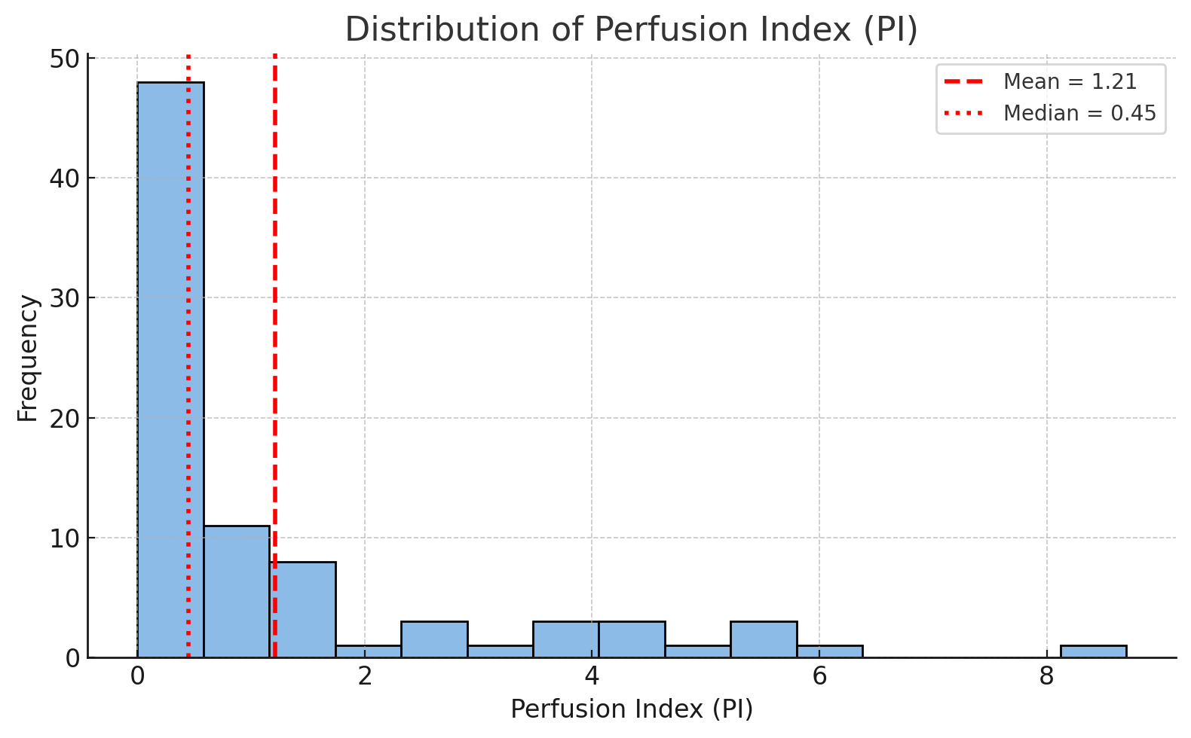
Legend: PI, perfusion index. The dashed vertical line represents the mean, and the dotted vertical line represents the median. The Shapiro–Wilk test confirmed that PI values were not normally distributed (W = 0.705, p = 1.05 × 10⁻¹¹).

Supplementary Figure 2. Distribution of perfusion index (PI) according to nailfold capillaroscopic pattern.
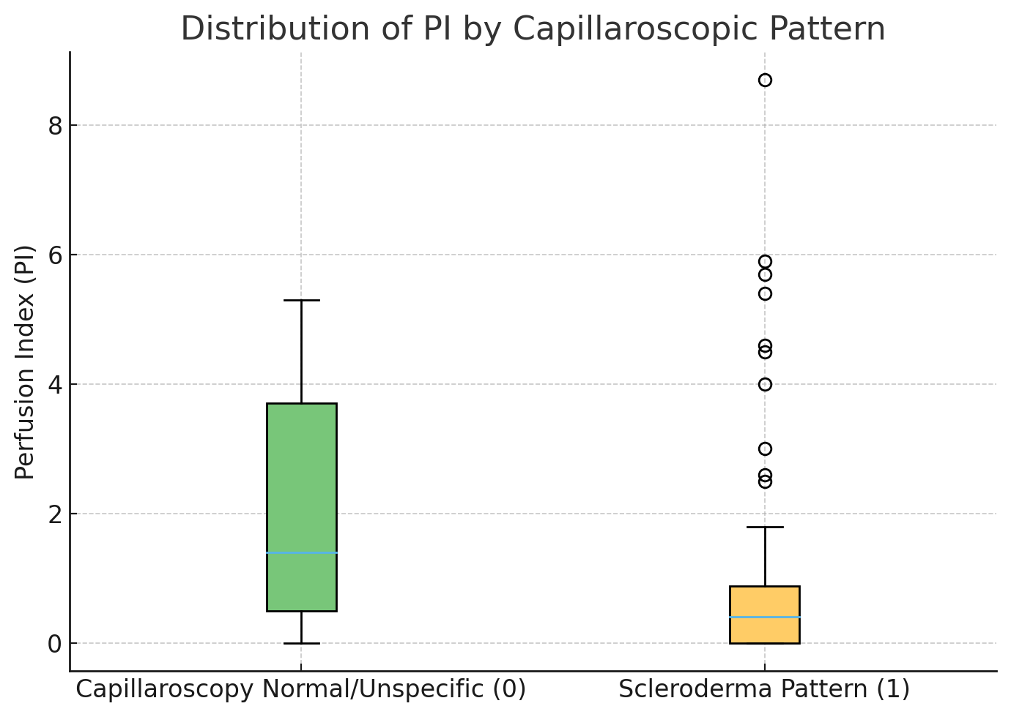

Legend: PI, perfusion index. Boxplots show the distribution of PI values in patients with normal/nonspecific microangiopathy (0) and scleroderma pattern (1). The central line represents the median, the box indicates the interquartile range (IQR), whiskers extend to 1.5 × IQR, and circles represent outliers. PI values were significantly lower in patients with the scleroderma pattern than in those with normal or nonspecific capillaroscopic findings (Mann–Whitney U test: U = 761.5, p = 0.0115).

