Supplementary Information

Contents

A. Methodology 2
A1. Derivation of the basic reproduction number from SIR model 2
A2. Calculation of the instantaneous basic reproduction number 3
A3. Calculation of the practical vaccination rate 4
B. Additional results 7
B1. MCMC convergence 7
B2. Meta-analysis 8
B3. Collinearity 14
B4. Herd immunity threshold 14
B5. Sensitivity analysis 15
C. Additional discussions 18
C1. limitations of the reproduction number 18
C2. Using stringency index of NPIs 19
Reference 20

A. Methodology

A1. Derivation of the basic reproduction number from SIR model
The basic reproduction number, denoted $R_{0}$, is an important epidemiological parameter, representing the expected number of infections caused by an imported infection during the corresponding infection period when everyone else is susceptible. When $R_{0}<1$, the average number of the second-generation infections will be less than 1, where the epidemic will gradually vanish. Though incubation period does exist for Covid-19, we used the Susceptible-Infectious-Recovered (SIR) model to derive the basic reproduction number because cases identified by mass screening include both the infectious and the exposed population. Assuming there is no significant natural births and deaths, the standard SIR model without any intervention can be described as
$$dS=-βIS$$
$$dI=βIS-γI$$
$$dR=γI$$
where $β$ is the transmission rate and $γ$ is the recovery rate. Here, we use the disease-free equilibrium of the above epidemiological model to derive $R_{0}$ from the regeneration matrix. In specific, assuming
$$dx/dt=f(x)=r(x)-h(x)$$
where $r(x)$ is the ratio of new infection, $h(x)$ is the transfer rate that infections moved to the recovered population. The regeneration matrix is defined as
$$FV^{-1}=dr/dx*(dh/dx)^{-1}$$
Now, the basic reproduction number, $R_{0}$, is the spectral radius of the regeneration matrix, i.e., the eigenvalue with the maximum norm. With respect to the above standard SIR model, the regeneration matrix is
$FV^{-1}$=$d(βIS)/dI*(d(γI)/dI)^{-1}=βS/γ$
and the disease-free equilibrium is (1,0,0). Thus, the basic reproduction number is
$$R_{0}=β/γ$$
The effective reproduction number, denoted $R_{t}$, is defined as
${R_{t}=R}_{0}*(S/S+I+R)$
which is equals to the average number of individuals infected by a single infection when a fraction ($S/S+I+R$) of the population is susceptible. Finally, the daily growth rate ($g_{t}$) of the number of infections is
$$g_{t}=(I_{t}-I_{t-1})/I_{t-1}=γ(R_{t}-1)$$

A2. Calculation of the instantaneous basic reproduction number
The basic reproduction number of an infection is the expected number of cases directly generated by one case in a population where all individuals are susceptible to infection¹. The basic reproduction number is affected by several factors, including the duration of infectivity of affected people, the infectiousness of the microorganism, and the number of susceptible people in the population that the infected people contact. Within the same local context, because of the different infectiousness between SARS-CoV-2, the original virus caused Covid-19, and its variants, different coronavirus implies different $R_{0}$. There were many studies ²⁻¹¹ about the transmissibility of SARS-CoV-2 as well as its variants, reported by the corresponding estimated $R_{0}$. For each country, we estimated the instantaneous basic reproduction number, denoted $R_{0,t}$, to account for the different structures of variants that produced the identified Covid-19 cases over time. We used the weighted average of the basic reproduction number of each coronavirus as the instantaneous basic reproduction number,
$$R_{0,t}=\sum_{i=1}^{7}{w_{i,t}R_{0,i}}$$
where $w_{i,t}$ is the weight of the basic reproduction number of the coronavirus i, $R_{0,i}$, at day $t$, calculated by the proportion of infections caused by that virus. The basic reproduction number of SARS-CoV-2 and its variants can be found in Table A1. Of note, the transmissibility of variants was mainly reported by the expansion of the basic reproduction number of SARS-CoV-2. However, the basic reproduction numbers estimated across countries worldwide were different. Thus, we place a normal distribution with a mean of 3.25 over $R_{0}$¹², $R_{0}\sim normal(3.25, k)$, $k\sim half_normal(0, 0.5)$, reflecting the heterogeneity of regional estimates. Moverover, the uncertainty of the coefficient of expansion regarding $R_{0}$ of SARS-CoV-2 was integrated into our model during data preprocessing. We assumed that the coefficient of expansion following normal distribution where the parameter of variation was determined by the consequent 95% credible interval listed in Table A1. Then, we performed the estimation described in the main text 30 times, and for each time, the coefficient of expansion for variants was independently sampled from their distributions.

Table A1. Transmissibility of SARS-CoV-2 variants. The estimates are shown by its medians and IQR. These parameters were used in the calculation of synthetic basic reproduction numbers.
Variants | Coefficient of expansion regarding R0 of SARS-CoV-2 (Q1-Q3) | Source
Alpha | 1.29 (1.24-1.33) | Curran, J., et al.¹³
Beta | 1.25 (1.20-1.30) | CDC¹⁴
Gamma | 1.38 (1.29-1.48) | Campbell, et al.¹⁵
Delta | 1.97 (1.76-2.17) | Campbell, et al.¹⁵
Eta | 1.29 (1.23-1.35) | ¹⁶
Kappa | 1.48 (1.28-1.69) | ¹⁶

A3. Calculation of the practical vaccination rate
The reported vaccination rates ($V_{t}$) across countries were only the statistics of the population who have received at least two doses of the Covid-19 vaccine. While the de facto population that is immune is lower than the fully vaccinated population due to the effectiveness of the used vaccine products, especially facing various SARS-CoV-2 variants. It indicated the importance of using the immune population in the estimation of the effectiveness of vaccination. For example, assuming that the basic reproduction number of Delta is about 5, we need 80 percent of the population to be immune to stop the Covid-19. Under the circumstances, even if we vaccinated 100 percent of the residents, we still need to assure the effect of vaccines against Delta has 80%. Without any ambiguity, we termed the fraction of the de facto population that is immune to vaccination as a practical vaccination rate. However, the practical vaccination rate cannot be statistics.

Here, we evaluated the biweekly practical vaccination rate (${EV}_{t}$) according to the used vaccine products as well as the active coronavirus across countries. We estimated the fraction of the population vaccinated by the specific vaccine product $i$ by multiplying the documented vaccination rate with the proportion of the vaccine product $i$, denoted $P_{i,t}$. Then, the fraction of the population that is immune by the vaccine product $i$ was evaluated by further multiplying the context-based effectiveness of the vaccine $i$. The context-based effectiveness was estimated by the average effect of vaccine $i$ against the active variants, wherein the weights were determined by the proportion of infection caused by various coronaviruses. That is,
$${EV}_{t}=\sum_{i=1}^{6}{V_{t}*P_{i,t}*e_{i,t}}$$
$$e_{i,t}=\sum_{j=1}^{7}{vaccine_{i,j}*virus_{j,t}}$$
The effective vaccination rate (${EV}_{t}$) was variants-adjusted vaccination rate in terms of the used 6 vaccine products and their effectiveness against the original SARS-CoV-2 virus and its 6 popular variants over time. Due to the changing situation of structure of vaccines and variants, the practical effect ($e_{i,t}$) of each vaccine $i$ was the weighted average of its effectiveness against each coronavirus $j$ ($vaccine_{i,j}$), where the weight ($virus_{j,t}$) is the proportion of corresponding positive testing caused by the virus $j$ at time period $t$.

The effectiveness of different vaccines against various variants and SARS-CoV-2 was listed in Table A2. By 20 September 2021, there was still some particular effectiveness absent in the existing literature. Thus, we made assumptions on the missing effect in Table A2 as the default setting (i.e., the absent effect was the same as that of the same vaccine against SARS-CoV-2). We also conceived another two scenarios of the absent effect, as shown in B5. Sensitivity analysis, to examine the impact of our assumptions on the main results documented in this article.

Table A2. Effectiveness of various vaccines against SARS-CoV-2 as well as its 6 variants. The estimates are shown by its medians and IQR. *: these estimates are absent in the literature which were assumed to be the same as the vaccine product against SARS-CoV-2.
 | Sinopharm.Beijing | Sputnik.V | Pfizer | AstraZeneca | Moderna | Johnson & Johnson
SARS-CoV-2 | 78.10  (IQR: 64.90,86.30) | 91.60  (IQR: 85.60,95.20) | 95.00  (IQR: 90.30,97.60) | 66.70  (IQR: 57.40,74.00) | 94.10  (IQR: 89.30,96.80) | 66.90  (IQR: 59.10,73.40)
Alpha | 65.00  (IQR: 54.01,71.82) | 81.00  (IQR: 75.69,84.18) | 93.70  (IQR: 91.60,95.30) | 74.50  (IQR: 68.40,79.40) | 100.00  (IQR: 91.80,100.00) | 72.00  (IQR: 63.61,79.00)
Beta | 56.00  (IQR: 46.54,61.88) | 70.00  (IQR: 65.41,72.75) | 84.00  (IQR: 69.00,92.00) | 21.90  (IQR: -49.90,72.80) | 96.40  (IQR: 91.90,98.70) | 52.00  (IQR: 30.30,67.40)
Gamma | 56.00  (IQR: 46.54,61.88) | 70.00  (IQR: 65.41,72.75) | 84.00  (IQR: 69.00,92.00) | 51.00  (IQR: 43.89,56.58) | 80.00  (IQR: 75.92,82.30) | 66.20  (IQR: 51.00,77.10)
Delta | 56.00  (IQR: 46.54,61.88) | 70.00  (IQR: 65.41,72.75) | 88.00  (IQR: 85.30,90.10) | 60.00  (IQR: 53.00,66.00) | 80.00  (IQR: 75.92,82.30) | 56.00  (IQR: 49.47,61.44)
Eta | 78.10*  (IQR: 64.90,86.30) | 91.60*  (IQR: 85.60,95.20) | 95.00*  (IQR: 90.30,97.60) | 66.70*  (IQR: 57.40,74.00) | 94.10*  (IQR: 89.30,96.80) | 66.90*  (IQR: 59.10,73.40)
Kappa | 78.10*  (IQR: 64.90,96.30) | 91.60*  (IQR: 85.60,95.20) | 87.90  (IQR: 78.20,93.20) | 59.80  (IQR: 28.90,77.30) | 94.10*  (IQR: 89.30,96.80) | 66.90*  (IQR: 59.10,73.40)

B. Additional results

B1. MCMC convergence
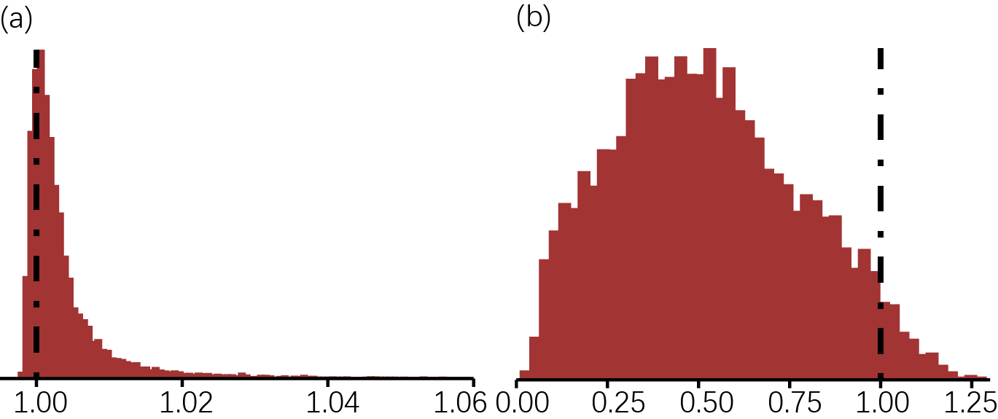
Fig. B1 The convergence of MCMC in our estimation. (a)R-hat statistic taken from a run using the default model with default settings and values for all parameters. Values are close to 1, indicating convergence; (b)Relative effective sample size taken from a run using the default model with default settings and values for all parameters. Value 1 indicates perfect decorrelation between samples. Values above (below) 1 indicate that the effective number of samples is higher (lower) than the actual number of samples due to negative (positive) correlation, respectively.

B2. Meta-analysis
Due to the heterogeneous context across the 27 countries, we estimated the national effectiveness of NPIs and national effectiveness of vaccination for each of the 27 countries. Then, we meta-analyse the data to generate the general effects of NPIs and vaccination, respectively, through the bottom-up approach.

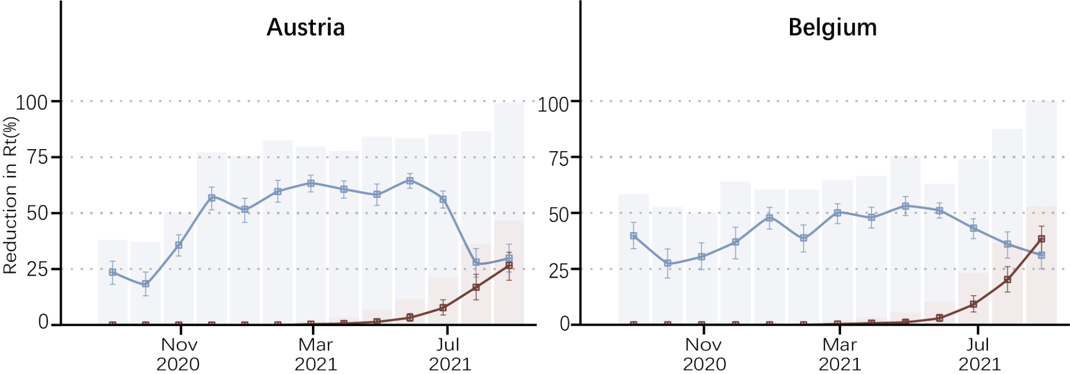
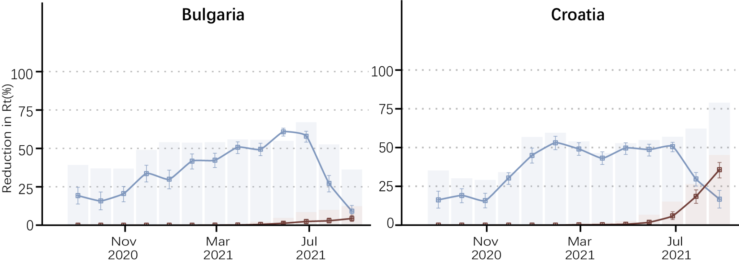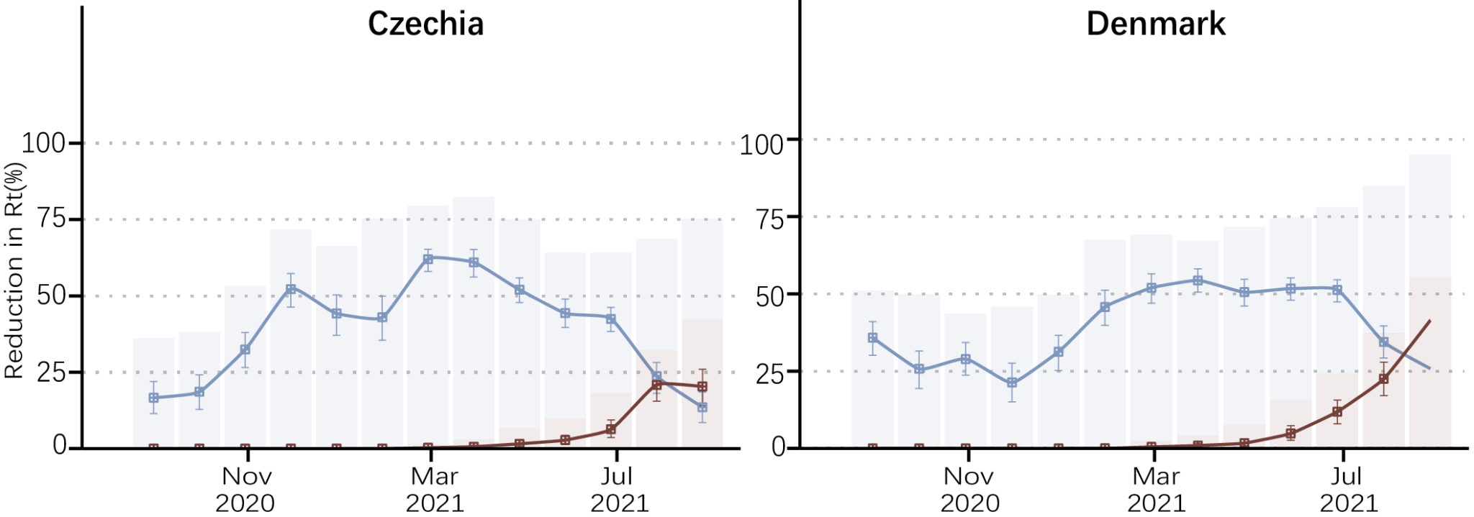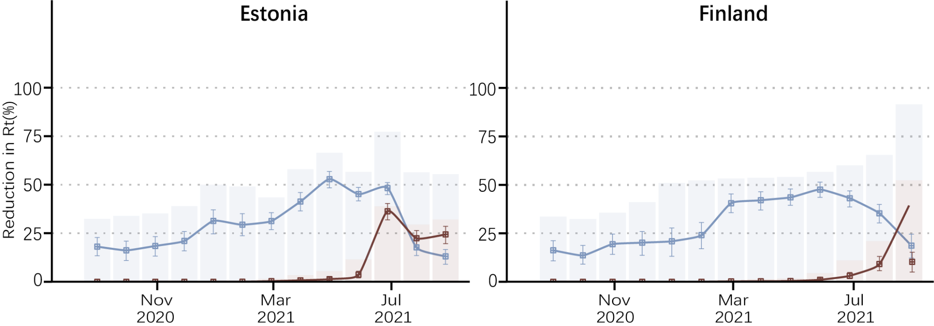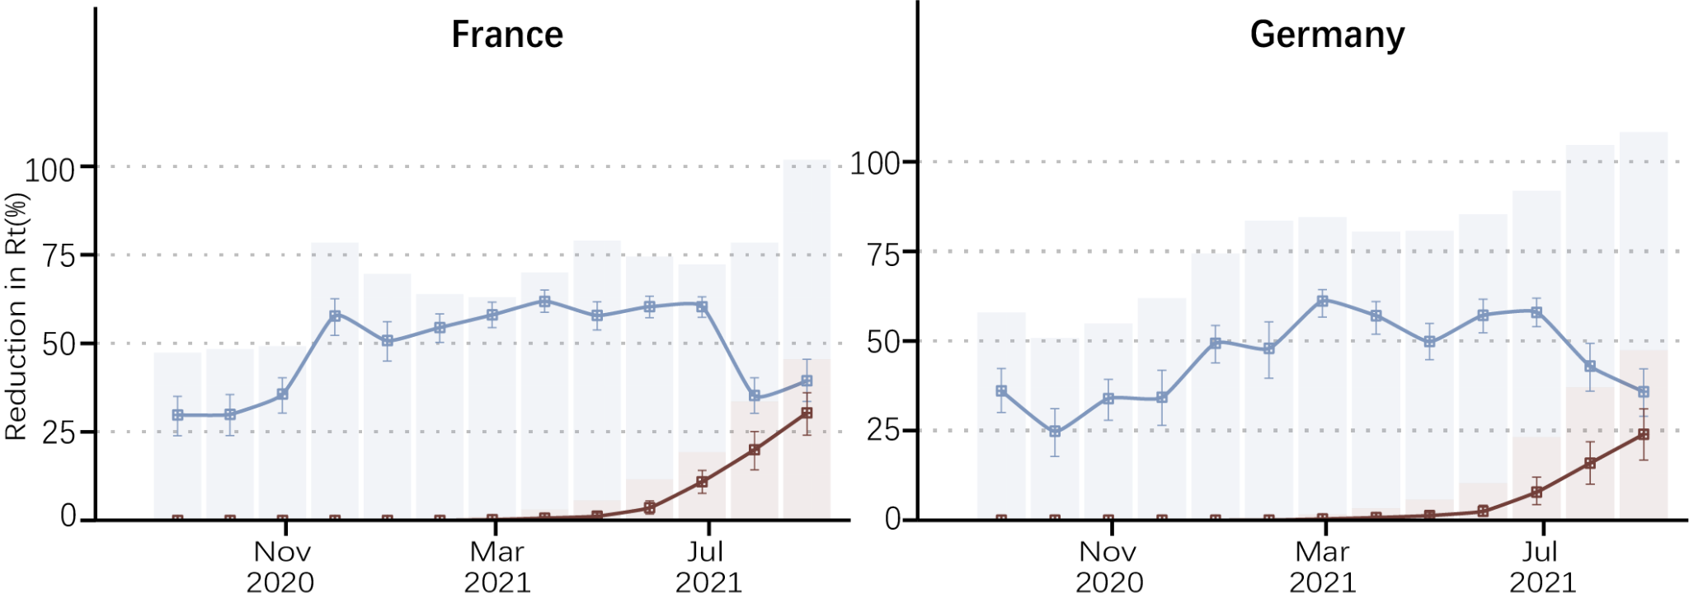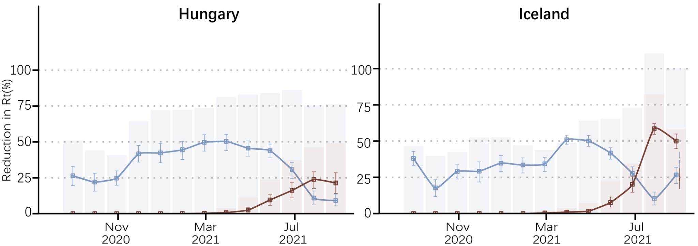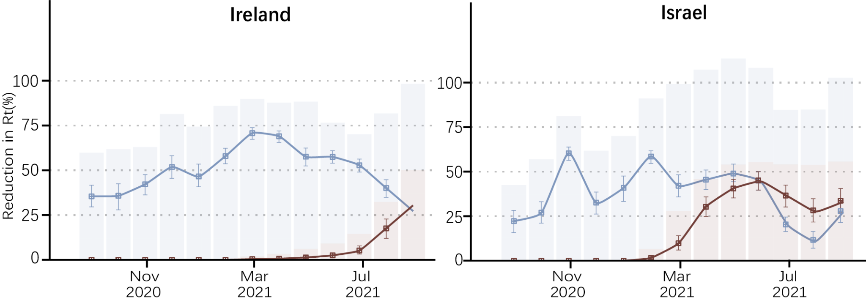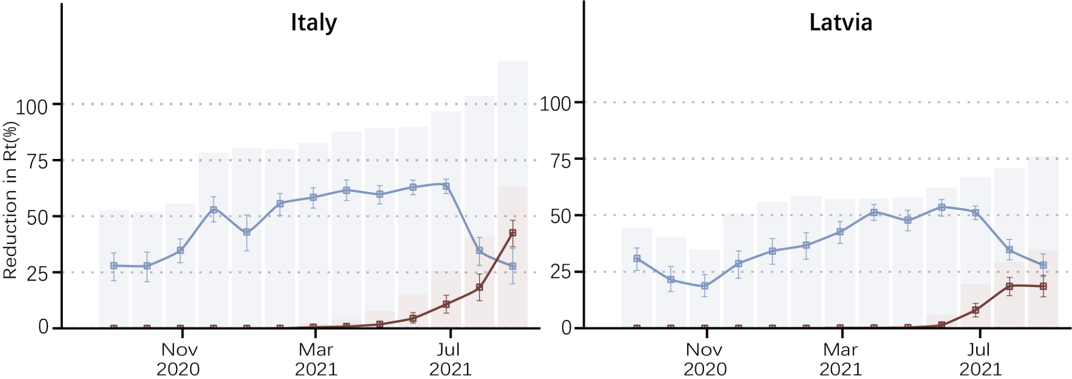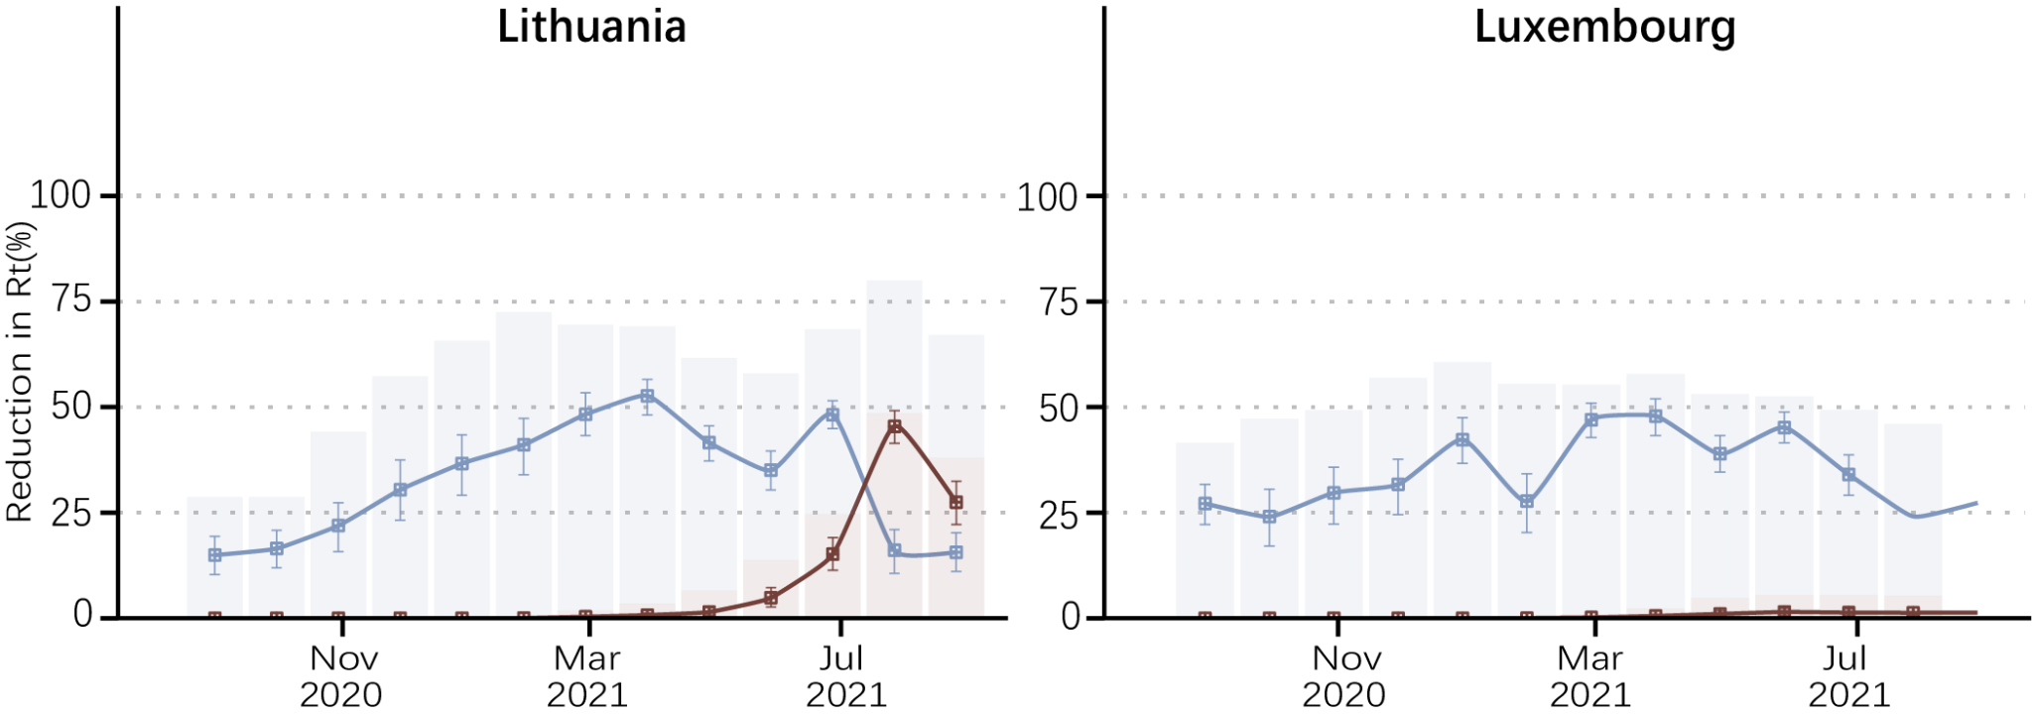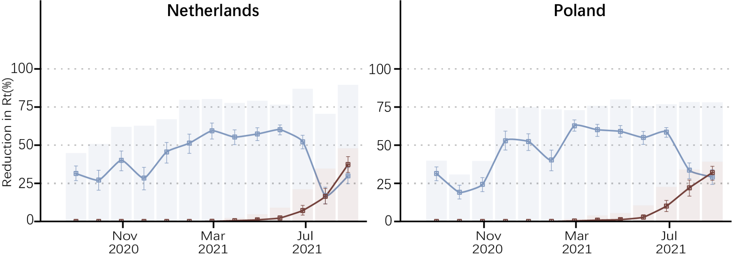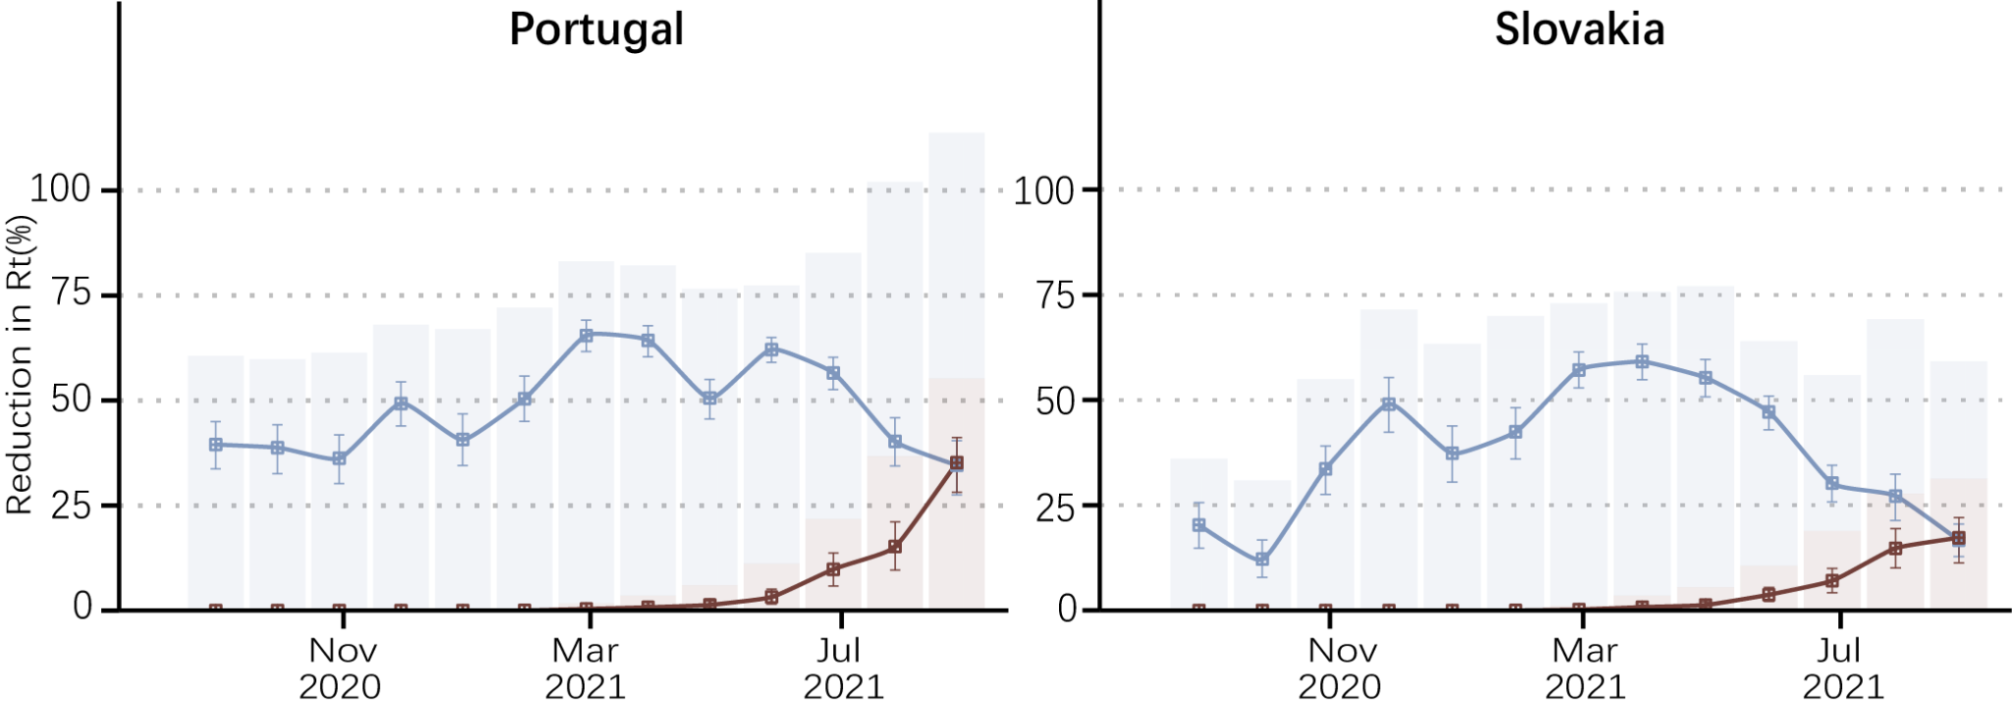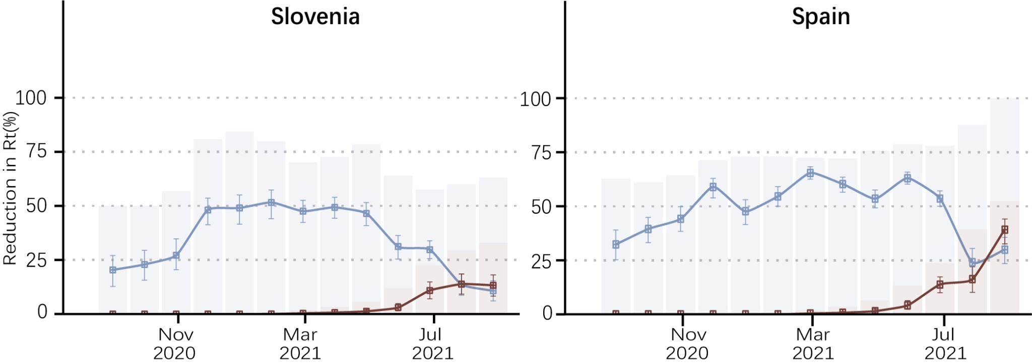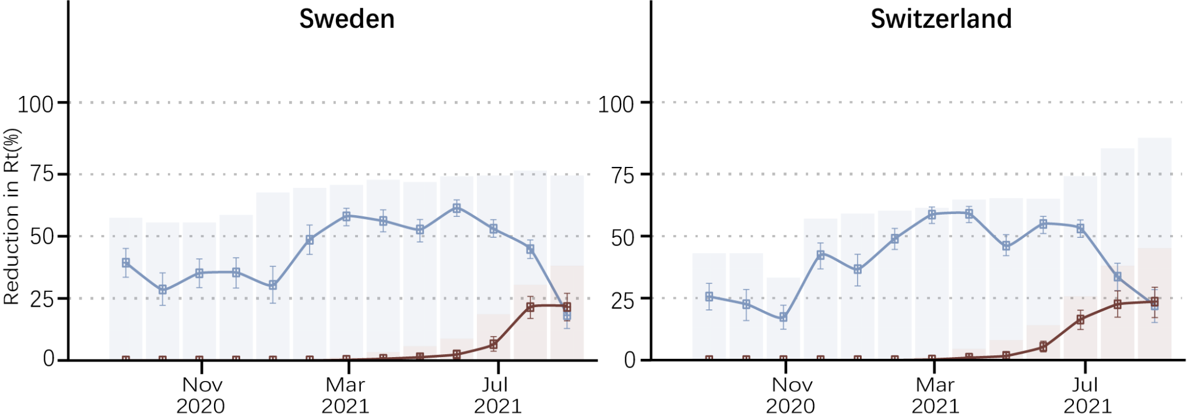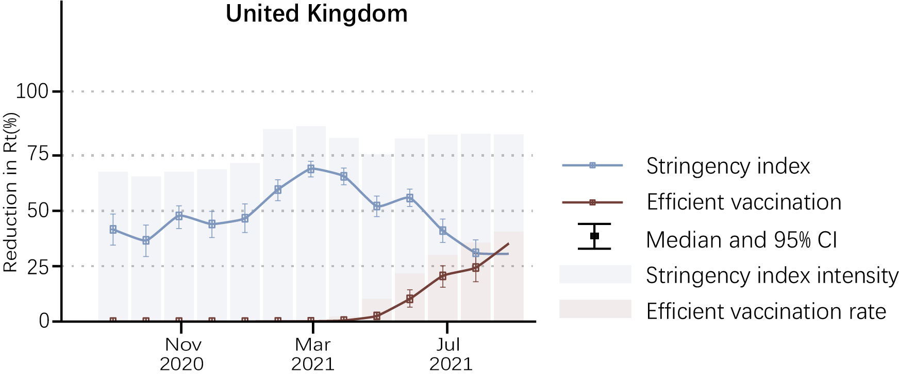

Fig. B2 The effectiveness of NPIs and vaccination for each of 27 countries over time. The effects of NPIs (in blue lines) and vaccination (in red lines) were estimated over each month for each country. The corresponding stringency index of NPIs implementation and the practical vaccination rates over time were represented by the heights of the bars in the background. Noting that the bars of NPIs were stacked on that of vaccination, instead of overlapping.

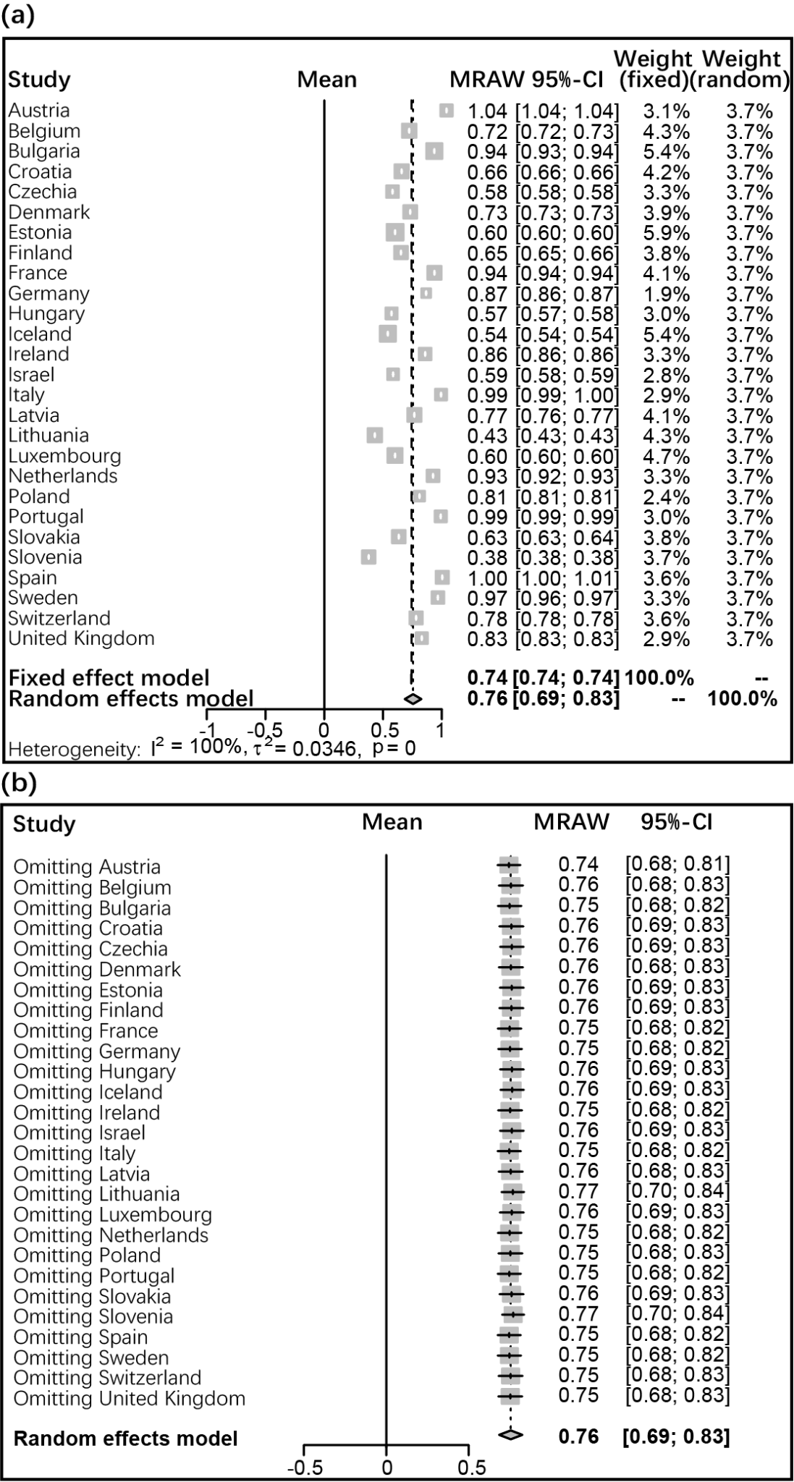
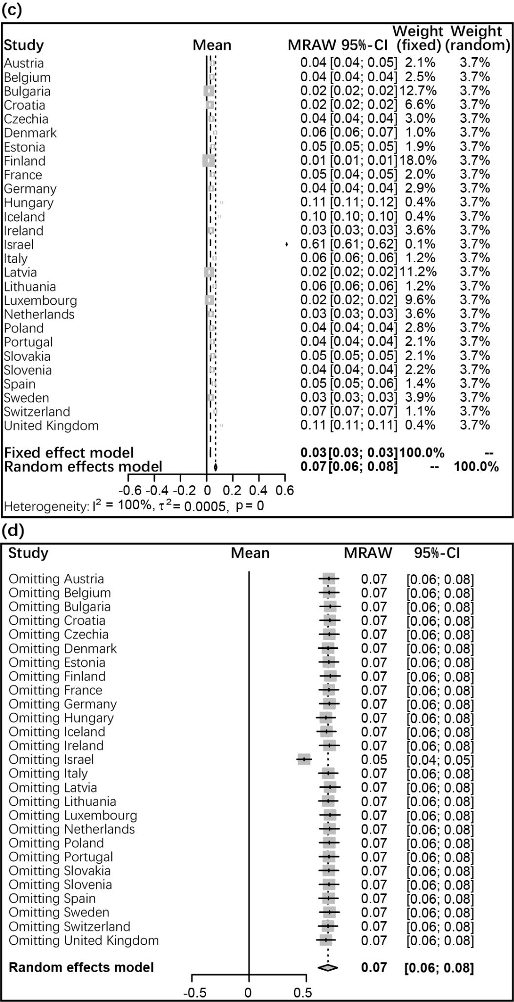
Fig. B3 Forest plot comparing effects of NPIs and vaccination across 27 countries, respectively. (a) Forest plot depicting the meta-analytical results for NPIs among 27 countries. (b) Forest plot depicting an influence analysis for NPIs omitting each country. (c) Forest plot depicting the meta-analytical results for vaccination among 27 countries. (d) Forest plot depicting an influence analysis for vaccination omitting each country. And it’s shown that the existence of Israel may affect the vaccination effectiveness result. Noting the high heterogeneity among 27 countries, a random effects method was used to meta-analyse the data.

B3. Collinearity
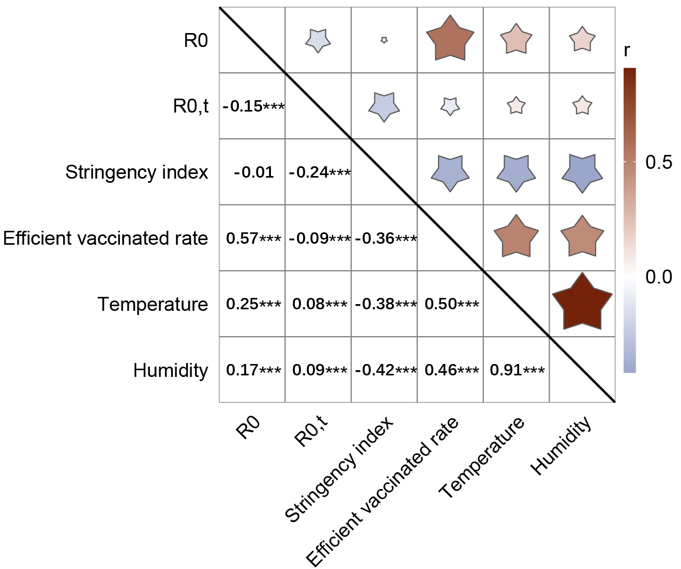
Fig. B4 The collinearity between the involved variables in this study. The correlation coefficients were calculated by Pearson method. Noting that the temperature is highly associated with humidity, we only take temperature as the control variable to account for the seasonal and calendar effect.

B4. Herd immunity threshold
The most important uses of $R_{0}$ are determining if an emerging infectious disease can spread in a population and determining what proportion of the population should be immunized through vaccination to eradicate a disease. In commonly used infection models, when $R_{0}>1$ the infection will be able to start spreading in a population, but not if $R_{0}<1$. Generally, the larger the value of $R_{0}$, the harder it is to control the epidemic. For simple models, the proportion of the population that needs to be effectively immunized (meaning not susceptible to infection) to prevent sustained spread of the infection must be larger than $1-1/R_{0}$¹⁷. Conversely, the proportion of the population that remains susceptible to infection in the endemic equilibrium is $1/R_{0}$.
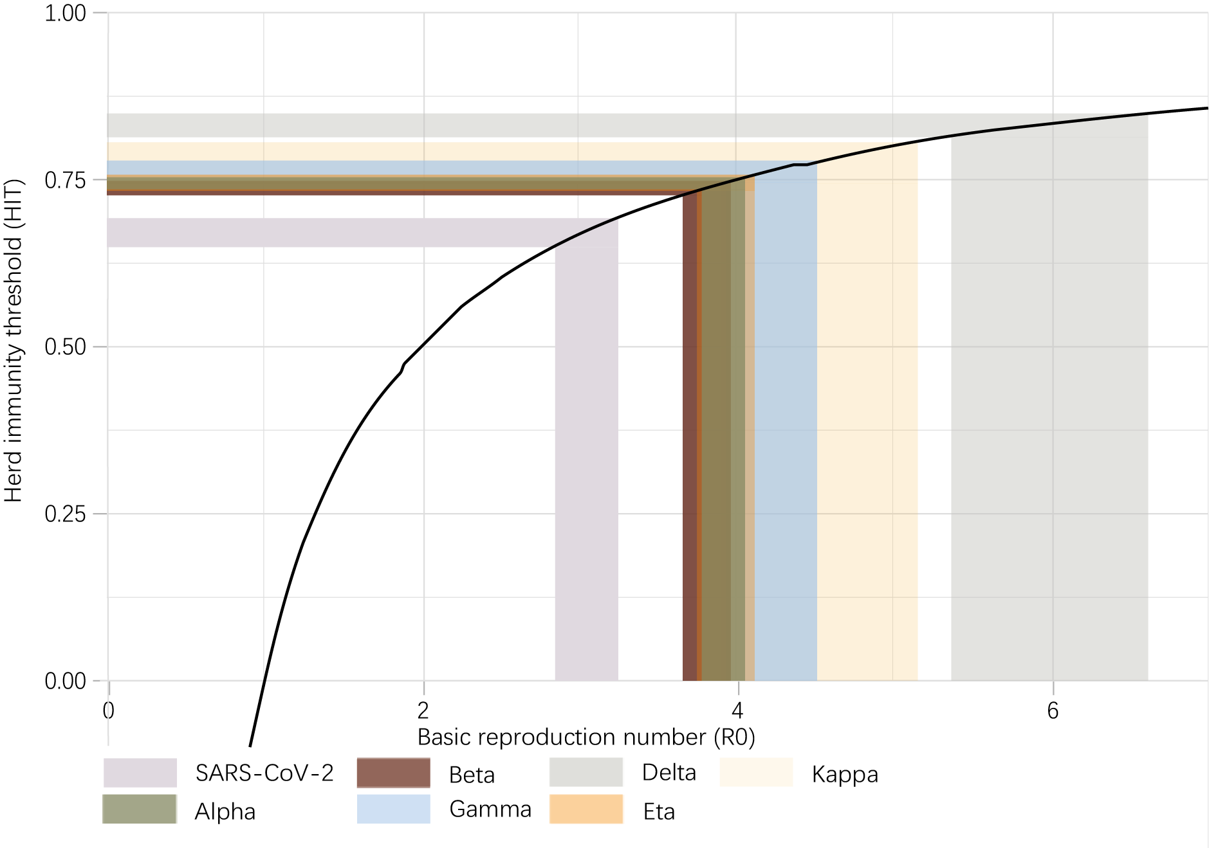
Fig. B5 The thresholds of herd immunity in terms of SARS-CoV-2 and its variants. Of note, the threshold here refers to the fraction of the population that should be immune instead of the population that has been vaccinated

B5. Sensitivity analysis
In contrast to the default setting of the assumed absent effect of vaccines against variants, we also designed another two scenarios to assess the impact of our assumptions on the main results documented in the main text. Because the variants Alpha and Delta are two major coronavirus transmissions in Europe, one scenario was that the absent effects of vaccines were the same as that against Alpha (Table B1); and another was assumed to be the same as the Delta (Table B2). Fig. B6 showed that the effectiveness of NPIs and vaccination estimated from the default setting (Table A2) did not significantly differ from the two additional scenarios.

Table B1. Effectiveness of various vaccines against SARS-CoV-2 as well as its 6 variants. The estimates are shown by its medians and IQR. *: these estimates are absent in the literature which were assumed to be the same as the vaccine product against Alpha.
 | Sinopharm.Beijing | Sputnik.V | Pfizer | AstraZeneca | Moderna | Johnson & Johnson
SARS-CoV-2 | 78.10  (IQR: 64.90,86.30) | 91.60  (IQR: 85.60,95.20) | 95.00  (IQR: 90.30,97.60) | 66.70  (IQR: 57.40,74.00) | 94.10  (IQR: 89.30,96.80) | 66.90  (IQR: 59.10,73.40)
Alpha | 65.00  (IQR: 54.01,71.82) | 81.00  (IQR: 75.69,84.18) | 93.70  (IQR: 91.60,95.30) | 74.50  (IQR: 68.40,79.40) | 100.00  (IQR: 91.80,100.00) | 72.00  (IQR: 63.61,79.00)
Beta | 56.00  (IQR: 46.54,61.88) | 70.00  (IQR: 65.41,72.75) | 84.00  (IQR: 69.00,92.00) | 21.90  (IQR: -49.90,72.80) | 96.40  (IQR: 91.90,98.70) | 52.00  (IQR: 30.30,67.40)
Gamma | 56.00  (IQR: 46.54,61.88) | 70.00  (IQR: 65.41,72.75) | 84.00  (IQR: 69.00,92.00) | 51.00  (IQR: 43.89,56.58) | 80.00  (IQR: 75.92,82.30) | 66.20  (IQR: 51.00,77.10)
Delta | 56.00  (IQR: 46.54,61.88) | 70.00  (IQR: 65.41,72.75) | 88.00  (IQR: 85.30,90.10) | 60.00  (IQR: 53.00,66.00) | 80.00  (IQR: 75.92,82.30) | 56.00  (IQR: 49.47,61.44)
Eta | 65.00*  (IQR: 54.01,71.82) | 81.00*  (IQR: 75.69,84.18) | 93.70*  (IQR: 91.60,95.30) | 74.50*  (IQR: 68.40,79.40) | 100.00*  (IQR: 91.80,100.00) | 72.00*  (IQR: 63.61,79.00)
Kappa | 65.00*  (IQR: 54.01,71.82) | 81.00*  (IQR: 75.69,84.18) | 87.90  (IQR: 78.20,93.20) | 59.80  (IQR: 28.90,77.30) | 100.00*  (IQR: 91.80,100.00) | 72.00*  (IQR: 63.61,79.00)

Table B2. Effectiveness of various vaccines against SARS-CoV-2 as well as its 6 variants. The estimates are shown by its medians and IQR. *: these estimates are absent in the literature which were assumed to be the same as the vaccine product against Delta.
 | Sinopharm.Beijing | Sputnik.V | Pfizer | AstraZeneca | Moderna | Johnson & Johnson
SARS-CoV-2 | 78.10  (IQR: 64.90,86.30) | 91.60  (IQR: 85.60,95.20) | 95.00  (IQR: 90.30,97.60) | 66.70  (IQR: 57.40,74.00) | 94.10  (IQR: 89.30,96.80) | 66.90  (IQR: 59.10,73.40)
Alpha | 65.00  (IQR: 54.01,71.82) | 81.00  (IQR: 75.69,84.18) | 93.70  (IQR: 91.60,95.30) | 74.50  (IQR: 68.40,79.40) | 100.00  (IQR: 91.80,100.00) | 72.00  (IQR: 63.61,79.00)
Beta | 56.00  (IQR: 46.54,61.88) | 70.00  (IQR: 65.41,72.75) | 84.00  (IQR: 69.00,92.00) | 21.90  (IQR: -49.90,72.80) | 96.40  (IQR: 91.90,98.70) | 52.00  (IQR: 30.30,67.40)
Gamma | 56.00  (IQR: 46.54,61.88) | 70.00  (IQR: 65.41,72.75) | 84.00  (IQR: 69.00,92.00) | 51.00  (IQR: 43.89,56.58) | 80.00  (IQR: 75.92,82.30) | 66.20  (IQR: 51.00,77.10)
Delta | 56.00  (IQR: 46.54,61.88) | 70.00  (IQR: 65.41,72.75) | 88.00  (IQR: 85.30,90.10) | 60.00  (IQR: 53.00,66.00) | 80.00  (IQR: 75.92,82.30) | 56.00  (IQR: 49.47,61.44)
Eta | 56.00*  (IQR: 46.54,61.88) | 70.00*  (IQR: 65.41,72.75) | 88.00*  (IQR: 85.30,90.10) | 60.00*  (IQR: 53.00,66.00) | 80.00*  (IQR: 75.92,82.30) | 56.00*  (IQR: 49.47,61.44)
Kappa | 56.00*  (IQR: 46.54,61.88) | 70.00*  (IQR: 65.41,72.75) | 87.90  (IQR: 78.20,93.20) | 59.80  (IQR: 28.90,77.30) | 80.00*  (IQR: 75.92,82.30) | 56.00*  (IQR: 49.47,61.44)

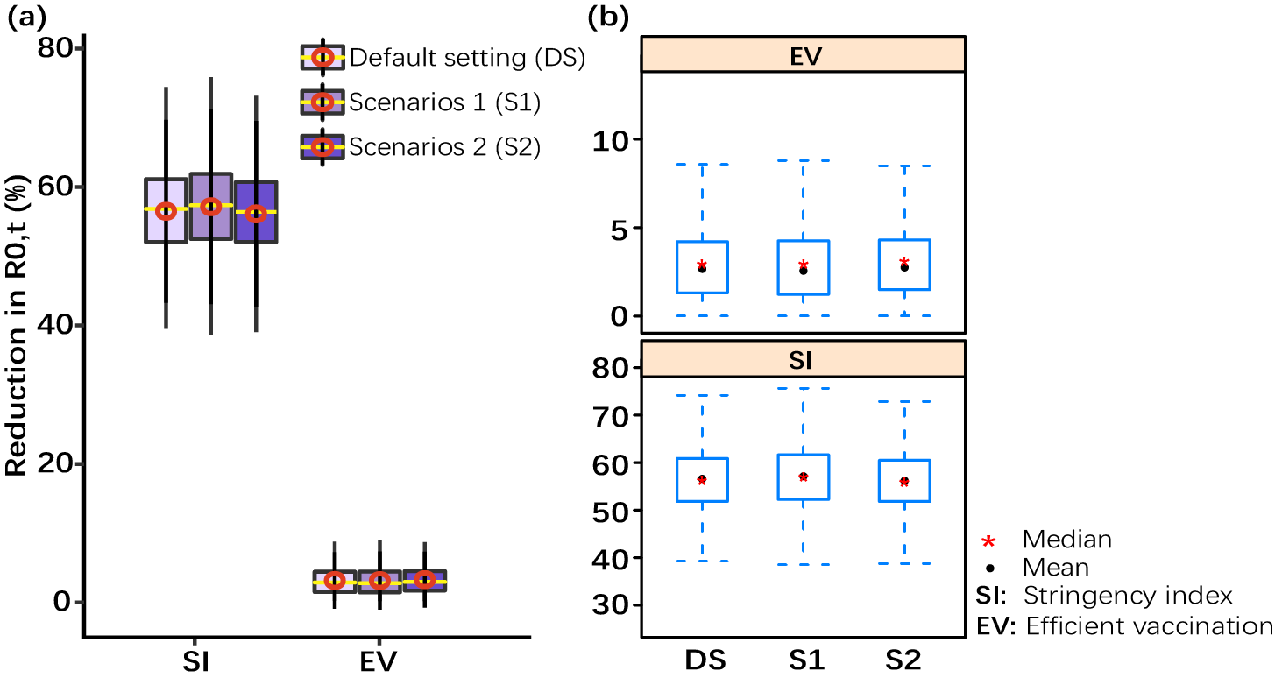
Fig. B6 The comparison between the default settings and the two scenarios described in this section regarding the effect of NPIs and vaccination.

C. Additional discussions

C1. limitations of the reproduction number
We used production number as an outcome variable to characterize the transmission trend of Covid-19. Here, we give an additional discussion on the limitation of using the production number. $R_{0}$ can be calculated from many different mathematical models. Methods used to calculate $R_{0}$ include the survival function, rearranging the largest eigenvalue of the Jacobian matrix, the next-generation method, calculations from the intrinsic growth rate¹⁸, existence of the endemic equilibrium, the number of susceptible at the endemic equilibrium, the average age of infection¹⁹ and the final size equation. Few of these methods agree with one another, even when starting with the same system of differential equations. Even fewer calculate the average number of secondary infections. Since $R_{0}$ is rarely observed in the field and is usually calculated via a mathematical model, this severely limits its usefulness²⁰. Each of these methods can give a different estimate of $R_{0}$, which needs to be interpreted in the context of that model. Therefore, the contagiousness of different infectious agents cannot be compared without recalculating $R_{0}$ with invariant assumptions. That is the similar results cannot be compared if the involved $R_{0}$ was calculated by different models. In addition, $R_{0}$ values for past outbreaks might not be valid for current outbreaks of the same disease. Nonetheless, we estimated the instantaneous basic production number to represent the transmission variation over time, against variants and various settings. $R_{0}$ can be used as a threshold, even if calculated with different methods: if $R_{0}<1$, the outbreak will die out, and if $R_{0}>1$, the outbreak will expand. In some cases, for some models, values of $R_{0}<1$ can still lead to self-perpetuating outbreaks. This is particularly problematic if there are intermediate vectors between hosts, such as malaria²¹. Therefore, the findings built upon $R_{0}=1$ should be cautiously interpreted.
Although $R_{0}$ cannot be modified through vaccination or other changes in population susceptibility, it can vary based on several biological, socio-behavioural, and environmental factors²². It can also be modified by physical distancing and other public policy or social interventions, although some historical definitions exclude any deliberate intervention in reducing disease transmission, including non-pharmacological interventions. And indeed, whether non-pharmacological interventions are included in $R_{0}$ often depends on the paper, disease, and what if any intervention is being studied. This creates some confusion, because $R_{0}$ is not a constant, whereas most mathematical parameters with "nought" subscripts are constants. In our study, we used the $R_{0}$ estimated in the initial outbreak to represent the approximate transmissibility without interventions.

C2. Using stringency index of NPIs
Of note, we used the stringency index to represent the government response level in terms of ordinal containment, closure policy and public information campaigns, which is calculated by the strictness of ‘lockdown style’ policies that primarily restrict people’s behaviour including school closures, workplace closures, and travel bans. As heterogeneous countries may enact different packages of NPIs and the same intervention may also be implemented in different ways across neighbouring countries²³, it is hard to find out the standard effect of NPIs applicable in all countries. In contrast, we used the relative common concept of the response level against Covid-19 transmission. For the same strength of the response, different countries are allowed to deploy NPIs with different combinations. Haug et al.²⁴ documented that less disruptive and costly NPIs can be as effective as more intrusive, drastic ones (for example, a national lockdown) in March–April 2020, thus a suitable combination of NPIs is necessary to curb the spread of the virus. In fact, strong associations between OxCGRT stringency index and measures of mobility behaviour have been evidenced²⁵. Despite the effectiveness of individual NPIs cannot be estimated in this way, our study still provided insights on the response level that each country should have, to stop Covid-19 under different vaccination progress.

Reference
- Fraser, C., Donnelly, C.A., Cauchemez, S., Hanage, W.P., Van Kerkhove, M.D., Hollingsworth, T.D., Griffin, J., Baggaley, R.F., Jenkins, H.E., Lyons, E.J. and Jombart, T., 2009. Pandemic potential of a strain of influenza A (H1N1): early findings. science, 324(5934), pp.1557-1561.
- Bernal, J.L., Andrews, N., Gower, C., Gallagher, E., Simmons, R., Thelwall, S., Stowe, J., Tessier, E., Groves, N., Dabrera, G. and Myers, R., 2021. Effectiveness of Covid-19 vaccines against the B. 1.617. 2 (delta) variant. New England Journal of Medicine.
- Shinde, V., Bhikha, S., Hoosain, Z., Archary, M., Bhorat, Q., Fairlie, L., Lalloo, U., Masilela, M.S., Moodley, D., Hanley, S. and Fouche, L., 2021. Efficacy of NVX-CoV2373 Covid-19 Vaccine against the B. 1.351 Variant. New England Journal of Medicine, 384(20), pp.1899-1909.
- Dagan, N., Barda, N., Kepten, E., Miron, O., Perchik, S., Katz, M.A., Hernán, M.A., Lipsitch, M., Reis, B. and Balicer, R.D., 2021. BNT162b2 mRNA Covid-19 vaccine in a nationwide mass vaccination setting. New England Journal of Medicine, 384(15), pp.1412-1423.
- Haas, E.J., Angulo, F.J., McLaughlin, J.M., Anis, E., Singer, S.R., Khan, F., Brooks, N., Smaja, M., Mircus, G., Pan, K. and Southern, J., 2021. Impact and effectiveness of mRNA BNT162b2 vaccine against SARS-CoV-2 infections and COVID-19 cases, hospitalisations, and deaths following a nationwide vaccination campaign in Israel: an observational study using national surveillance data. The Lancet, 397(10287), pp.1819-1829.
- Sadoff, J., Gray, G., Vandebosch, A., Cárdenas, V., Shukarev, G., Grinsztejn, B., Goepfert, P.A., Truyers, C., Fennema, H., Spiessens, B. and Offergeld, K., 2021. Safety and efficacy of single-dose Ad26. COV2. S vaccine against Covid-19. New England Journal of Medicine, 384(23), pp.2187-2201.
- Chemaitelly, H., Yassine, H.M., Benslimane, F.M., Al Khatib, H.A., Tang, P., Hasan, M.R., Malek, J.A., Coyle, P., Ayoub, H.H., Al Kanaani, Z. and Al Kuwari, E., 2021. mRNA-1273 COVID-19 vaccine effectiveness against the B. 1.1. 7 and B. 1.351 variants and severe COVID-19 disease in Qatar. Nature medicine, pp.1-8.
- Thomas, S.J., Moreira Jr, E.D., Kitchin, N., Absalon, J., Gurtman, A., Lockhart, S., Perez, J.L., Pérez Marc, G., Polack, F.P., Zerbini, C. and Bailey, R., 2021. Safety and efficacy of the BNT162b2 mRNA covid-19 vaccine through 6 months. New England Journal of Medicine.
- Emary, K.R., Golubchik, T., Aley, P.K., Ariani, C.V., Angus, B., Bibi, S., Blane, B., Bonsall, D., Cicconi, P., Charlton, S. and Clutterbuck, E.A., 2021. Efficacy of ChAdOx1 nCoV-19 (AZD1222) vaccine against SARS-CoV-2 variant of concern 202012/01 (B. 1.1. 7): an exploratory analysis of a randomised controlled trial. The Lancet, 397(10282), pp.1351-1362.
- Heath, P.T., Galiza, E.P., Baxter, D.N., Boffito, M., Browne, D., Burns, F., Chadwick, D.R., Clark, R., Cosgrove, C., Galloway, J. and Goodman, A.L., 2021. Safety and efficacy of NVX-CoV2373 Covid-19 vaccine. New England Journal of Medicine.
- Madhi, S.A., Baillie, V., Cutland, C.L., Voysey, M., Koen, A.L., Fairlie, L., Padayachee, S.D., Dheda, K., Barnabas, S.L., Bhorat, Q.E. and Briner, C., 2021. Efficacy of the ChAdOx1 nCoV-19 Covid-19 vaccine against the B. 1.351 variant. New England Journal of Medicine, 384(20), pp.1885-1898.
- Brauner, J.M., Mindermann, S., Sharma, M., Johnston, D., Salvatier, J., Gavenčiak, T., Stephenson, A.B., Leech, G., Altman, G., Mikulik, V. and Norman, A.J., 2021. Inferring the effectiveness of government interventions against COVID-19. Science, 371(6531).
- Curran, J., Dol, J., Boulos, L., Somerville, M., & McCulloch, H. Public Health and Health Systems Impacts of SARS-CoV-2 Variants of Concern.
- US Centers for Disease Control and Prevention. SARS-CoV-2 variant classifications and definitions. Updated Aug 2021. https://www.cdc.gov/coronavirus/2019-ncov/variants/variant-info.html
- Campbell, F., Archer, B., Laurenson-Schafer, H., Jinnai, Y., Konings, F., Batra, N., Pavlin, B., Vandemaele, K., Van Kerkhove, M.D., Jombart, T. and Morgan, O., 2021. Increased transmissibility and global spread of SARS-CoV-2 variants of concern as at June 2021. Eurosurveillance, 26(24), p.2100509.
- https://www.hindustantimes.com/india-news/study-delta-variant-more-transmissible-than-others-101624300116730.html
- Fine, P., Eames, K. and Heymann, D.L., 2011. “Herd immunity”: a rough guide. Clinical infectious diseases, 52(7), pp.911-916.
- Chowell, G., Hengartner, N.W., Castillo-Chavez, C., Fenimore, P.W. and Hyman, J.M., 2004. The basic reproductive number of Ebola and the effects of public health measures: the cases of Congo and Uganda. Journal of theoretical biology, 229(1), pp.119-126.
- Ajelli, M., Iannelli, M., Manfredi, P. and degli Atti, M.L.C., 2008. Basic mathematical models for the temporal dynamics of HAV in medium-endemicity Italian areas. Vaccine, 26(13), pp.1697-1707.
- Heffernan, J.M., Smith, R.J. and Wahl, L.M., 2005. Perspectives on the basic reproductive ratio. Journal of the Royal Society Interface, 2(4), pp.281-293.
- Li, J. and Blakeley, D., The failure of 𝑅0. Computational and Mathematical Methods in Medicine, 2011.
- Delamater, P.L., Street, E.J., Leslie, T.F., Yang, Y.T. and Jacobsen, K.H., 2019. Complexity of the basic reproduction number (R0). Emerging infectious diseases, 25(1), p.1.
- Ruktanonchai, N.W., Floyd, J.R., Lai, S., Ruktanonchai, C.W., Sadilek, A., Rente-Lourenco, P., Ben, X., Carioli, A., Gwinn, J., Steele, J.E. and Prosper, O., 2020. Assessing the impact of coordinated COVID-19 exit strategies across Europe. Science, 369(6510), pp.1465-1470.
- Haug, N., Geyrhofer, L., Londei, A. et al. Ranking the effectiveness of worldwide COVID-19 government interventions. Nat Hum Behav 4, 1303–1312 (2020). https://doi.org/10.1038/s41562-020-01009-0
- Hale, T., Angrist, N., Goldszmidt, R. et al. A global panel database of pandemic policies (Oxford COVID-19 Government Response Tracker). Nat Hum Behav 5, 529–538 (2021). https://doi.org/10.1038/s41562-021-01079-8

