Supplementary Information File

ZIF-Derived Fe/Co/Zn Ternary Metal Oxide Embedded N-Doped Carbon for Supercapacitor and Hydrogen Evolution Reaction (HER)

Zeinab M. Hassan^{a‡*}, Fatma M. Elantabli^{a‡}, Mohamed A.sultan^{b}, Hani Nasser Abdelhamid^{c}*
ª Chemistry Department, Faculty of Science, Fayoum University, P.O. Box 63514, Fayoum 63514, Egypt
^{b}Department of Chemistry, Faculty of Science, Cairo University, Egypt
^{c}Department of Chemistry, College of Science, Imam Mohammad Ibn Saud Islamic University (IMSIU), 11623, Riyadh, Saudi Arabia
‡ These authors contributed equally
*Corresponding: hnabdelhamid@imamu.edu.sa (Abdelhamid); zma00@fayoum.edu.eg (Hassan)"
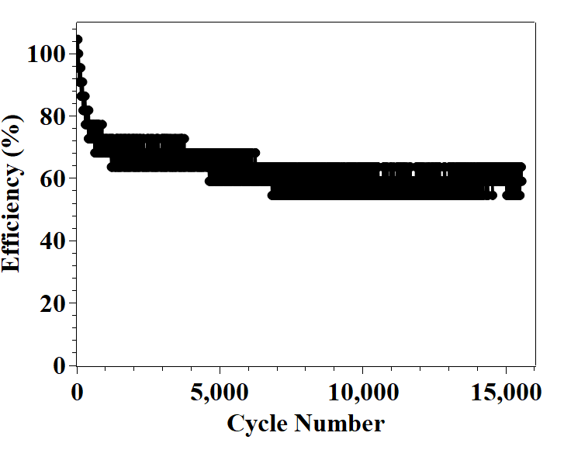
Figure S1: recycling efficiency for the three-electrode system at 10 A/g.

