Supplementary Materials
Carboxylated magnetic polymer microspheres with tunable poly(acrylic acid) shells for charge-selective adsorption of cationic dyes
Linlin Du, Shangfang Zhao, Bing Niu*, Sisi Ma*
College of Textile Engineering, Henan University of Engineering, Zhengzhou 451191, China
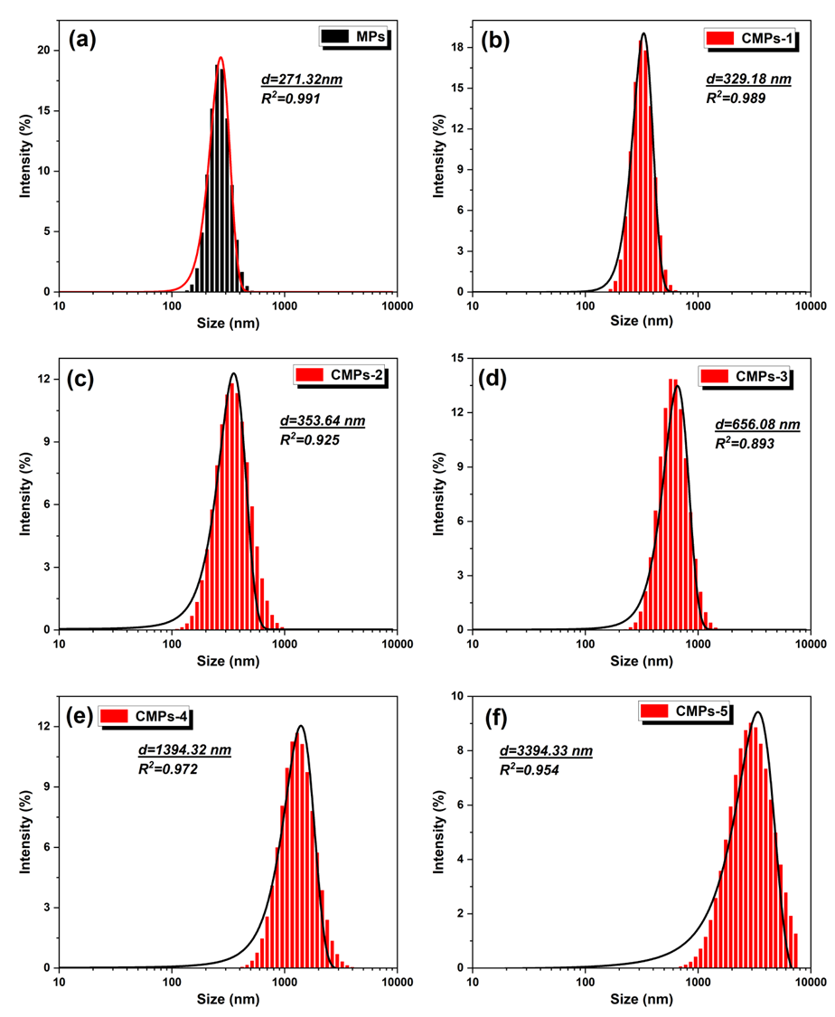
Fig. S1 Dynamic light scattering size distributions of magnetic particles (MPs) and carboxylated magnetic polymer microspheres prepared with different polymer-shell contents: (a) MPs, (b) CMPs-1, (c) CMPs-2, (d) CMPs-3, (e) CMPs-4, and (f) CMPs-5.

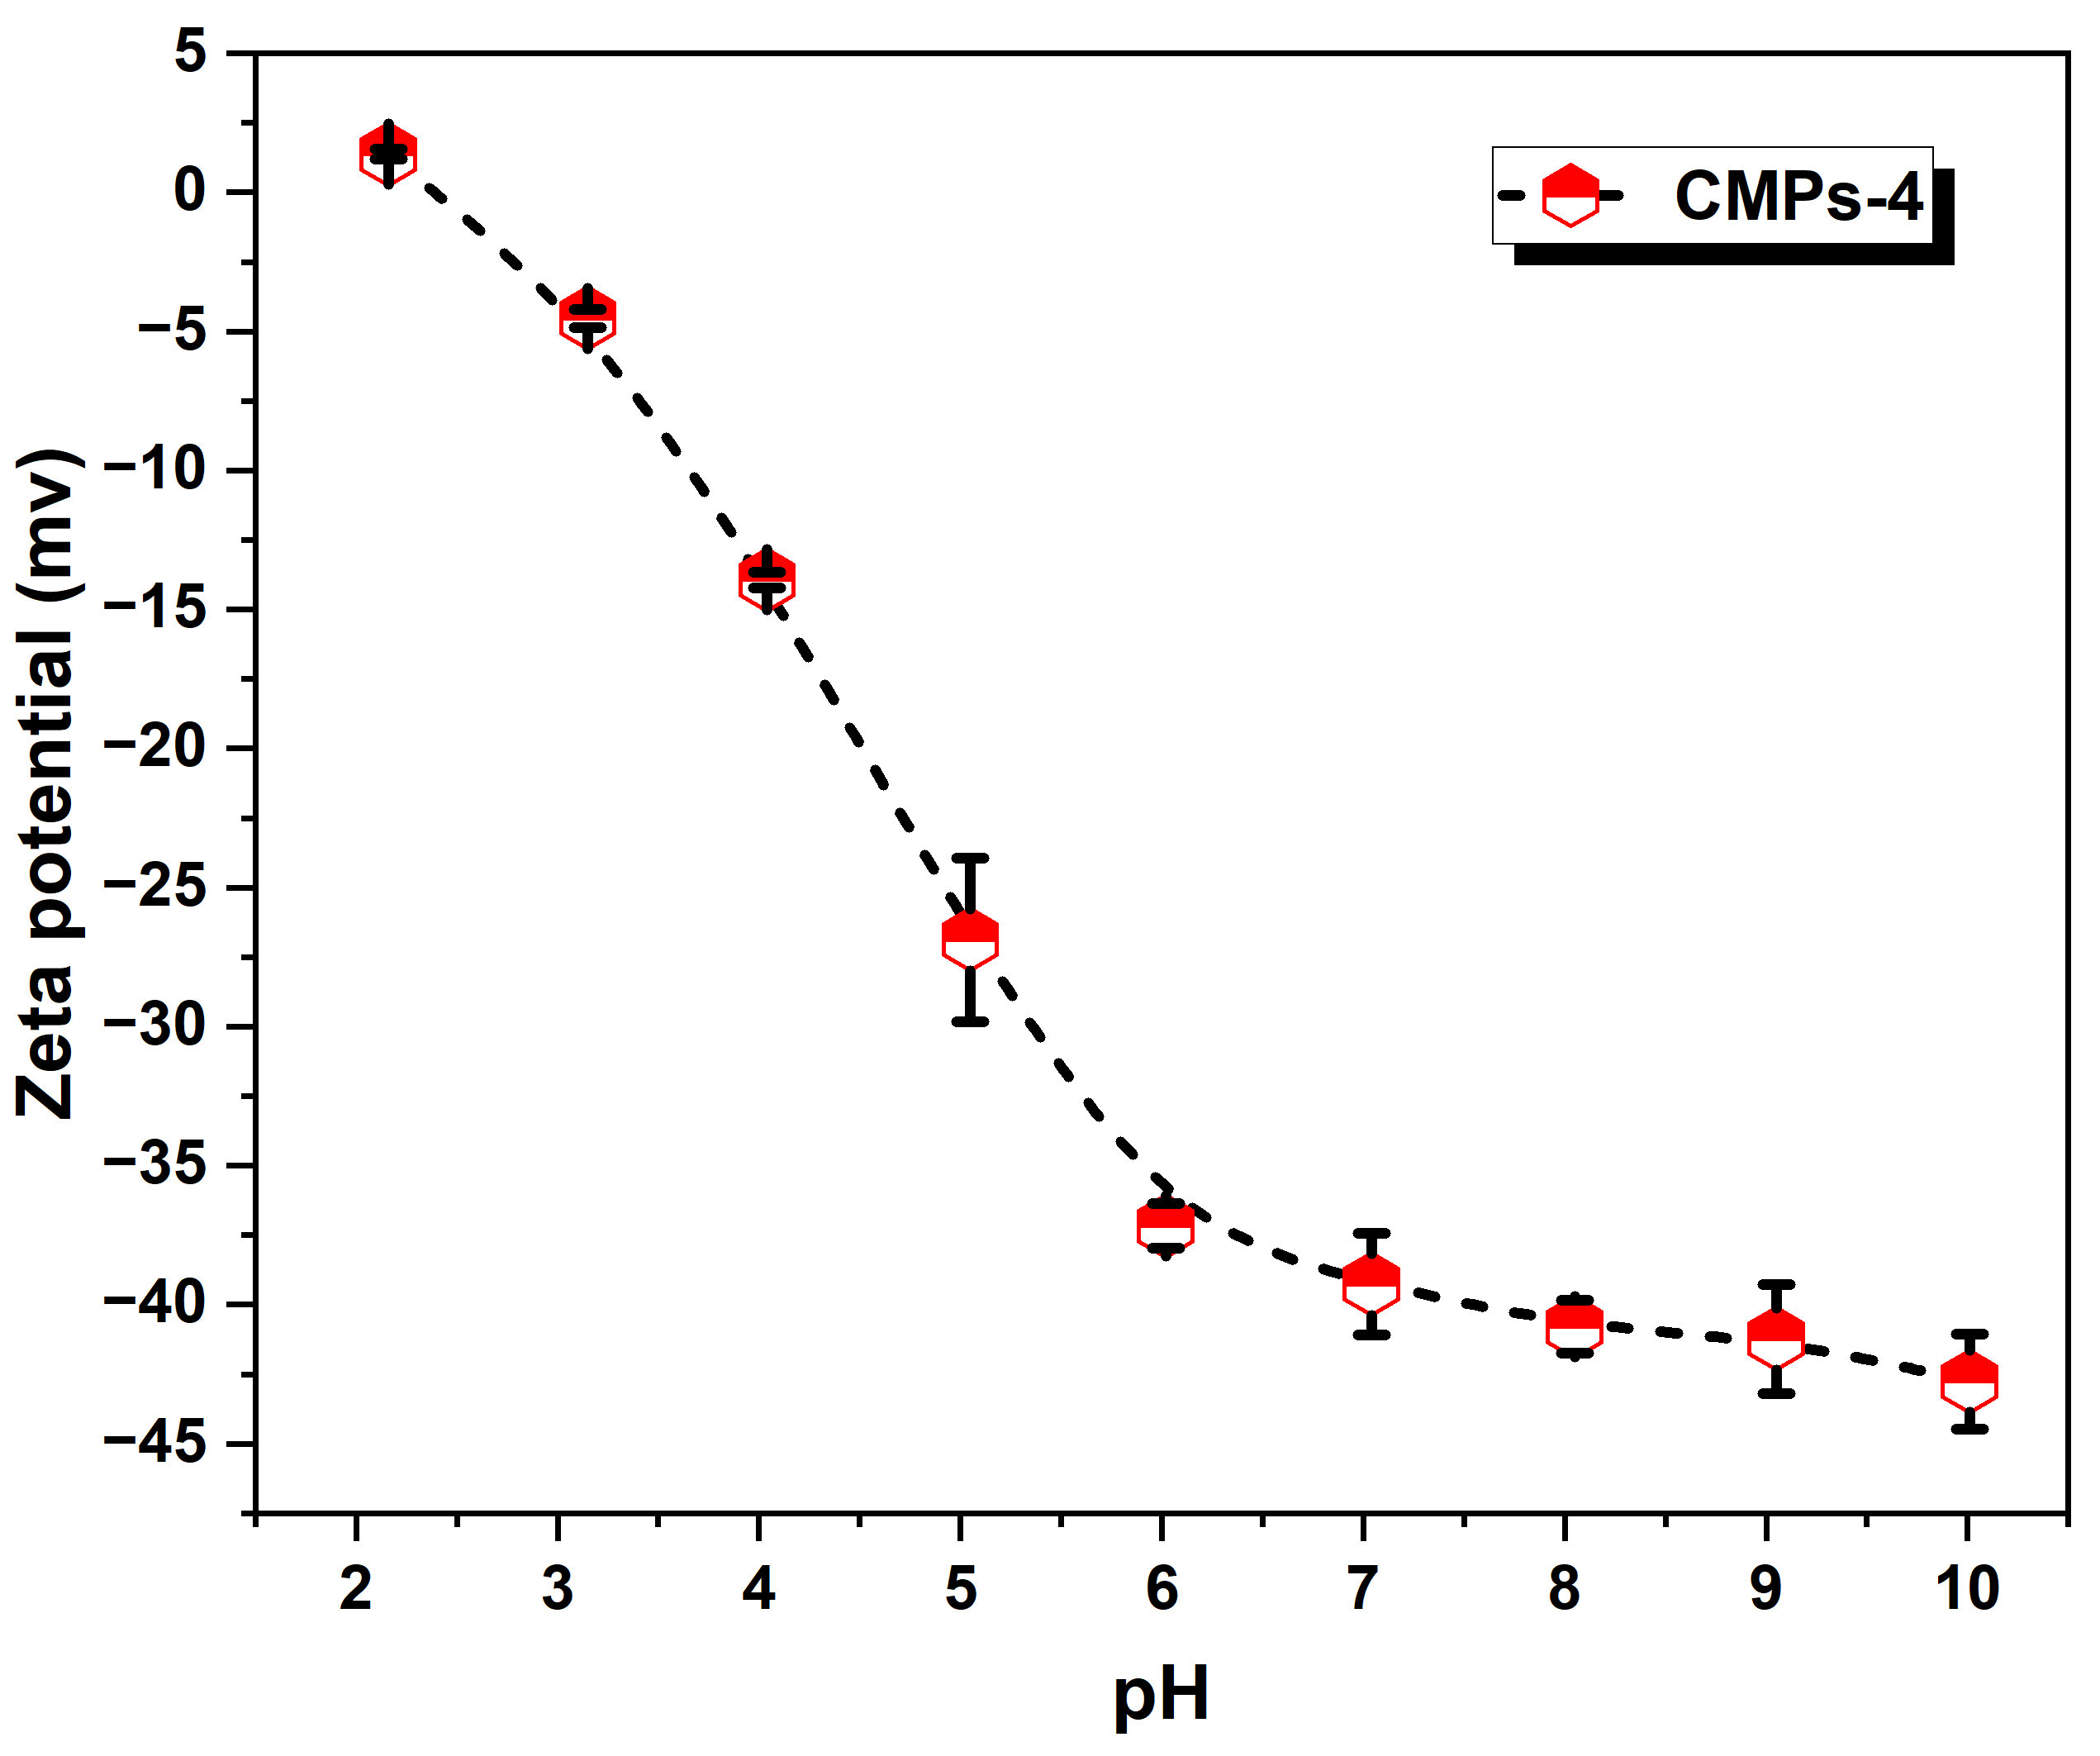
Fig. S2 Zeta potential of CMPs-4 as a function of solution pH.
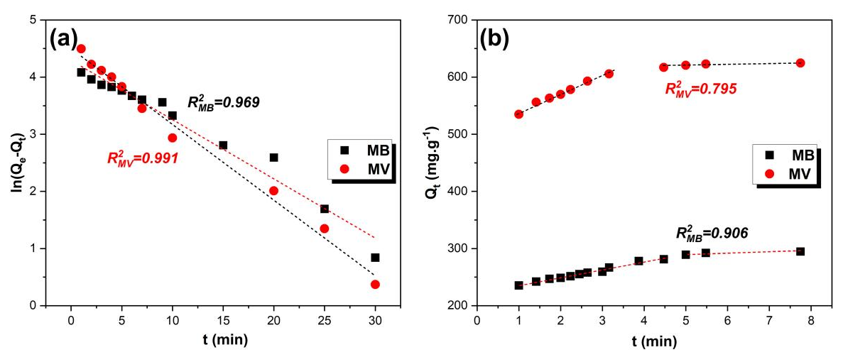
Fig. S3 Kinetic fitting for adsorption of methylene blue (MB) and methyl violet (MV) onto CMPs: (a) pseudo-first-order kinetic model and (b) intraparticle diffusion model.
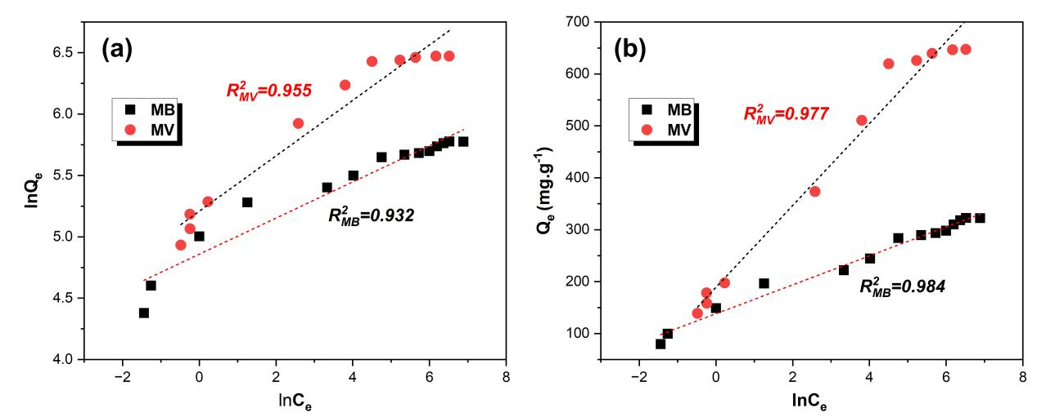
Fig. S4 Isotherm fitting for adsorption of MB and MV onto CMPs: (a) Freundlich model and (b) Temkin model.
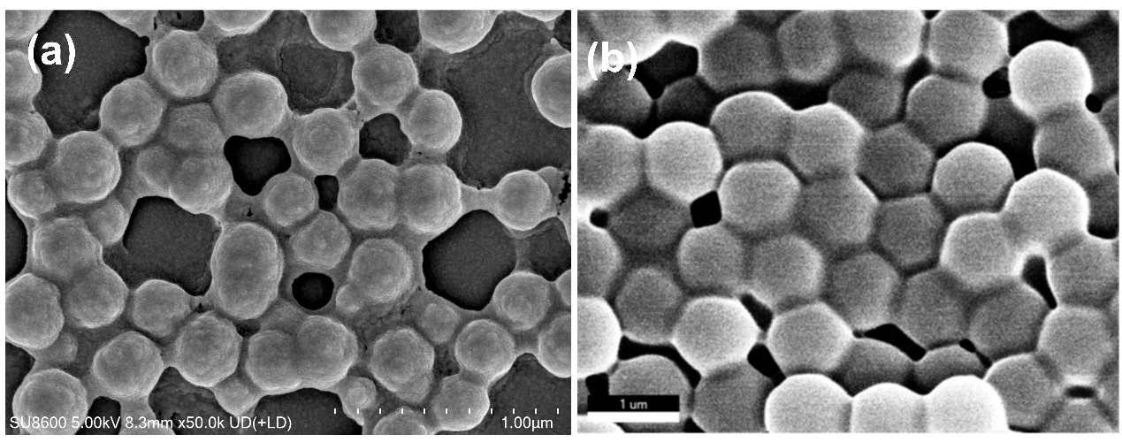
Fig. S5 SEM images of CMPs (a) before and (b) after five adsorption-desorption cycles.

Table S1. Comparison of the adsorption capacities of CMPs with those of reported biosorbents.
Adsorbents | Dye types | Q_{max} (mg·g⁻¹) | References
Magnetic chitosan-Fe₃O₄/activated carbon composite | MB | 11.02 | [1]
gum/Fe₃O₄ nano-bioadsorbent | MB | 85.7 | [2]
Fe₃O₄/Polypyrrole/Phytic Acid Magnetic Nanocomposite | MB | 153.84 | [3]
EDTA modified Fe₃O₄/sawdust carbon nanocomposites | MB | 227.3 | [4]
CMPs | MB | 322.58 | Present study
gum xanthan/Fe₃O₄ based nanocomposite hydrogel | MV | 642 | [5]
gum/Fe₃O₄ nano-bioadsorbent | MV | 113 | [2]
Clay/starch/Fe₃O₄ nanocomposite | MV | 29.67 | [6]
montmorillonite/graphene oxide/CoFe₂O₄ nanocomposite | MV | 97.26 | [7]
CMPs | MV | 653.59 | Present study

References
[1] Tsauria Q D, Gareso P L, Abdullah B, et al. Magnetic chitosan-Fe₃O₄/activated carbon composite for efficient simultaneous removal of methylene blue and congo red from water[J]. Advanced Powder Technology, 2026, 37(7): 105315.
- Kumar A, Sur D, Algethami N, et al. Synthesis and characterization of gum/Fe₃O₄ nano-bioadsorbent for removing methylene blue and methyl violet in batch and continuous systems[J]. Journal of Sol-Gel Science and Technology, 2025, 116(2): 1188-1204.
- Mohanty N, Behera S, Patra B N. Fabrication of Fe₃O₄/polypyrrole/phytic acid magnetic nanocomposite for preferential adsorption of cationic dye: Adsorption properties, kinetics, and mechanism[J]. Industrial and Engineering Chemistry Research, 2025, 64 (4), 2274-2282.
- Kataria N, Garg V K. Application of EDTA modified Fe₃O₄/sawdust carbon nanocomposites to ameliorate methylene blue and brilliant green dye laden water[J]. Environmental research, 2019, 172: 43-54.
- Mittal H, Kumar V, Saruchi, et al. Adsorption of methyl violet from aqueous solution using gum xanthan/Fe₃O₄ based nanocomposite hydrogel[J]. International Journal of Biological Macromolecules, 2016, 89: 1-11.
- Ansari Mojarad A, Tamjidi S, Esmaeili H. Clay/starch/Fe₃O₄ nanocomposite as an efficient adsorbent for the removal of methyl violet dye from aqueous media[J]. International Journal of Environmental Analytical Chemistry, 2022, 102(19): 8159-8180.
- Foroutan R, Mohammadi R, Mousa Khanloo F, et al. Performance of montmorillonite/graphene oxide/CoFe₂O₄ as a magnetic and recyclable nanocomposite for cleaning methyl violet dye-laden wastewater[J]. Advanced Powder Technology, 2020, 31(9): 3993-4004.

