Supplementary Material

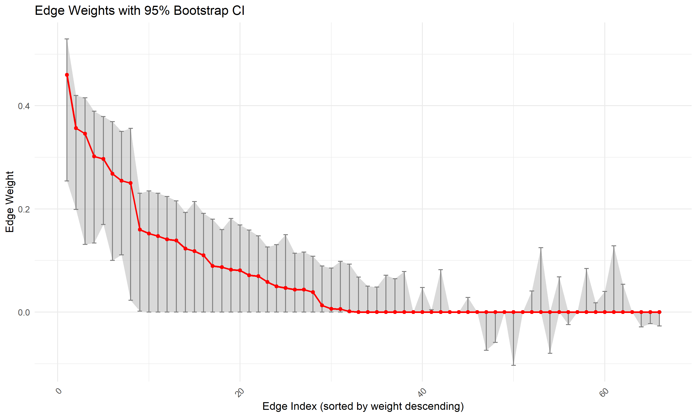
Figure S1 Bootstrap 95% confidence intervals for the edge weights in the network. The red line shows the sample edge weight values and the grey areas show the respective bootstrapped confidence intervals.

Supplementary Table 1. Standardized centrality estimates and predictability for each node (N = 280)
 | Strength | Closeness | R² | Bridge strength
SCHFI1 | 0.14 | -0.07 | 0.54 | 0.15
SCHFI2 | 0.59 | -0.40 | 0.59 | 0.26
SCHFI3 | 0.71 | 0.20 | 0.63 | 0.39
MS | -1.27 | -1.14 | 0.18 | 0.35
SSRS1 | -0.25 | -0.75 | 0.46 | 0.20
SSRS2 | 1.18 | 0.07 | 0.59 | 0.29
SSRS3 | -0.05 | 0.33 | 0.41 | 0.37
SCQ1 | 0.25 | 0.86 | 0.43 | 0.81
SCQ2 | -2.03 | -2.13 | 0.10 | 0.12
HFSHLS1 | -0.53 | 0.69 | 0.34 | 0.16
HFSHLS2 | 1.57 | 1.56 | 0.64 | 0.75
HFSHLS3 | -0.31 | 0.79 | 0.43 | 0.10
Note: Values are standardized z-scores. Strength = strength centrality; Closeness = closeness centrality; R² = node predictability. SCHFI1: self-care maintenance; SCHFI2: symptom perception; SCHFI3: self-care management; MS: mutuality; HF-SHLS1: functional health literacy; HF-SHLS2: communicative health literacy; HF-SHLS3: critical health literacy; SSRS1: objective support; SSRS2: subjective support; SSRS3: support utilization; SCQ1: positive spiritual coping; SCQ2: negative spiritual coping.

Supplementary Table 2. Edge weights in the network model of health literacy, social support, spiritual coping, mutuality, and self-care among patients with CHF (N = 280)
 | SCHFI1 | SCHFI2 | SCHFI3 | MS | SSRS1 | SSRS2 | SSRS3 | SCQ1 | SCQ2 | HFSHLS1 | HFSHLS2 | HFSHLS3
SCHFI1 | 0.00
SCHFI2 | 0.36 | 0.00
SCHFI3 | 0.27 | 0.30 | 0.00
MS | 0.00 | 0.01 | 0.05 | 0.00
SSRS1 | 0.00 | 0.00 | 0.00 | 0.01 | 0.00
SSRS2 | 0.00 | 0.00 | 0.00 | 0.01 | 0.46 | 0.00
SSRS3 | 0.07 | 0.00 | 0.00 | 0.04 | 0.00 | 0.35 | 0.00
SCQ1 | 0.08 | 0.07 | 0.08 | 0.09 | 0.09 | 0.11 | 0.14 | 0.00
SCQ2 | 0.00 | 0.00 | 0.00 | 0.00 | 0.00 | 0.00 | 0.12 | 0.00 | 0.00
HFSHLS1 | 0.00 | 0.04 | 0.00 | 0.00 | 0.00 | 0.12 | 0.00 | 0.00 | 0.00 | 0.00
HFSHLS2 | 0.00 | 0.15 | 0.26 | 0.14 | 0.06 | 0.00 | 0.00 | 0.15 | 0.00 | 0.16 | 0.00
HFSHLS3 | 0.00 | 0.00 | 0.00 | 0.00 | 0.05 | 0.04 | 0.00 | 0.00 | 0.00 | 0.25 | 0.30 | 0.00
Note：SCHFI1: self-care maintenance; SCHFI2: symptom perception; SCHFI3: self-care management; MS: mutuality; HF-SHLS1: functional health literacy; HF-SHLS2: communicative health literacy; HF-SHLS3: critical health literacy; SSRS1: objective support; SSRS2: subjective support; SSRS3: support utilization; SCQ1: positive spiritual coping; SCQ2: negative spiritual coping.

