Supplementary Information for: Reddin et al. Climate change will displace habitats prioritised for marine protected areas in the high seas
Authors: Carl J. Reddin, Adam T. Kocsis, Sina Berends, Bernd Blasius, Jan-Claas Dajka, Jan Freund, Helmut Hillebrand, Taranjot Kaur, Wolfgang Kiessling, Michal Kucera, Lukas Meysick, Bernd Siebenhüner, Isaiah Smith, Tonke Strack, Torsten Grothmann, Marina Rillo, Lukas Jonkers

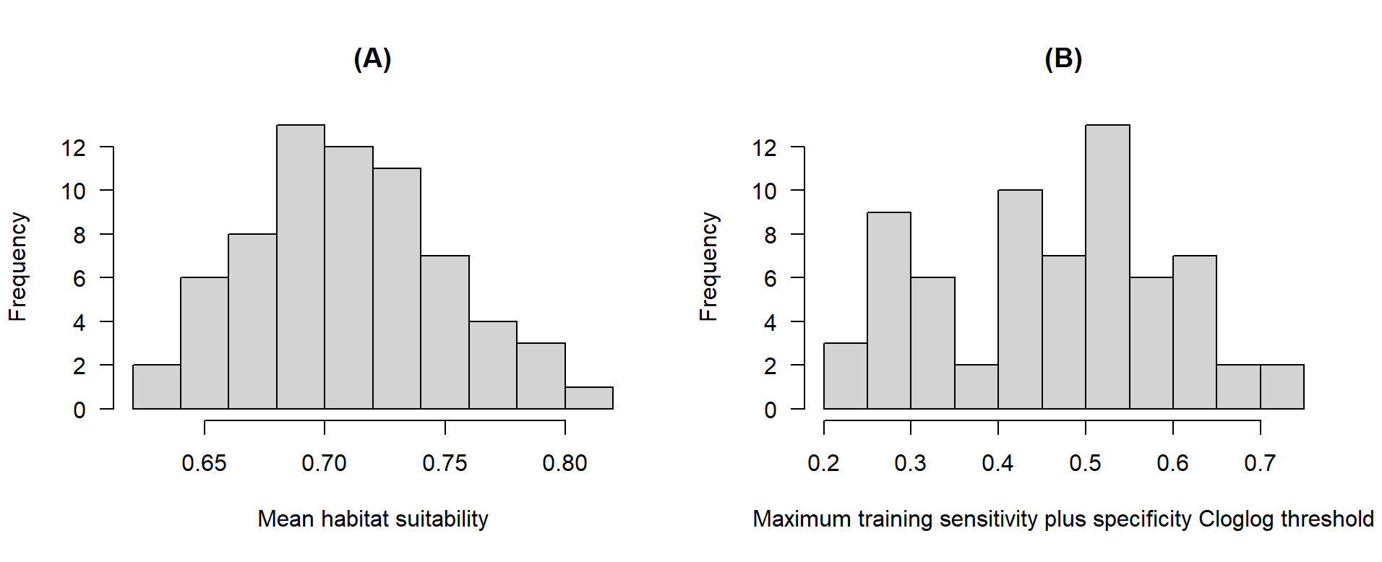
Figure S2. Individual EBSAs variation in (A) the mean habitat suitability within the EBSA boundary at the 2010-2020 baseline, and (B) the EBSA-specific habitat suitability threshold. Mean habitat suitability min = 0.62, 1st quartile = 0.68, median = 0.70, 3rd quartile = 0.74, max = 0.81. Maximum TSS threshold min = 0.22, 1st quartile = 0.33, median = 0.46, 3rd quartile = 0.55, max = 0.70.

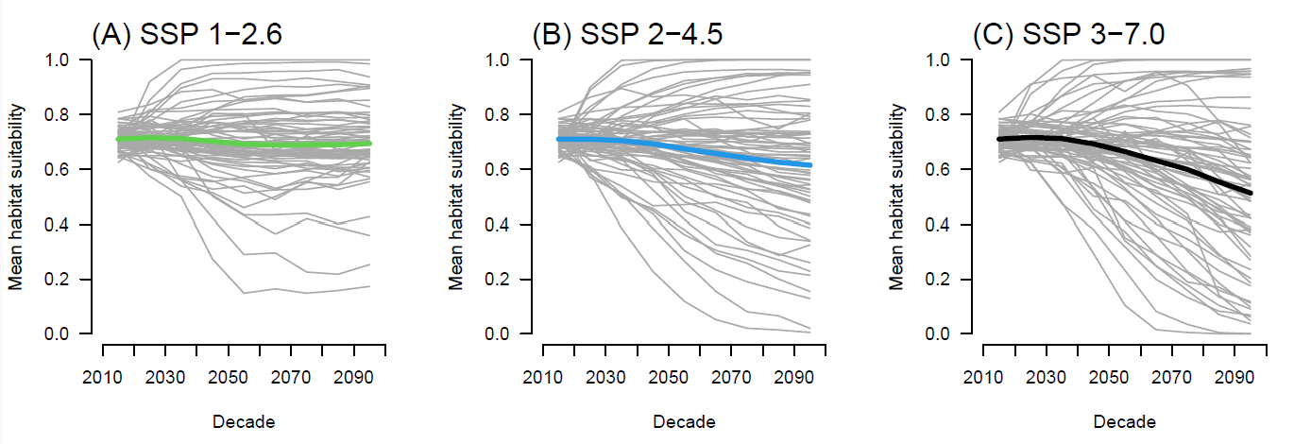
Figure S3. Temporal change in mean habitat suitability within high seas EBSA boundaries into the future relative to 2010-2020 baseline at three different carbon emissions scenarios, supporting Fig. 2A. Bold lines are the median among EBSAs for each SSP, with each grey line being the trajectory of an individual EBSA. For regression statistics, see Table S1.

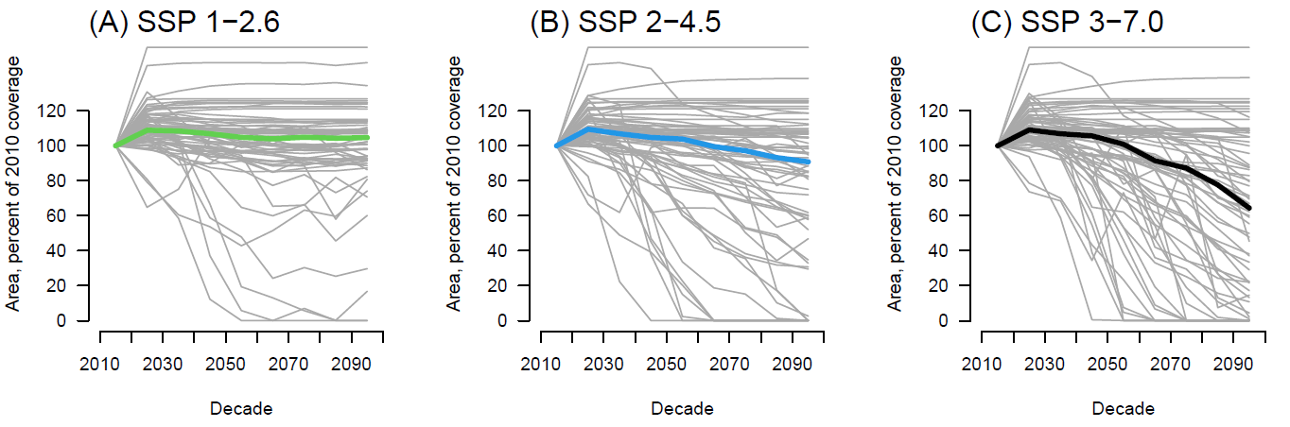
Figure S5. Temporal change in % suitable habitat area within high seas EBSA boundaries into the future relative to 2010-2020 baseline (100%) at three different carbon emissions scenarios. Bold lines are the median among EBSAs for each SSP, with each grey line being the trajectory of an individual EBSA. For regression statistics, see Table S2.

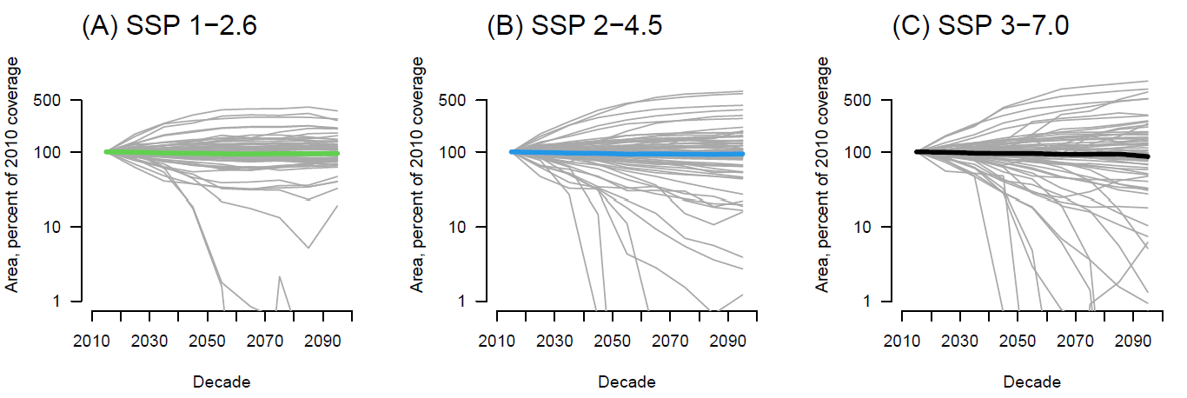
Figure S6. Temporal change in % suitable habitat area in the wider region around and including the EBSA boundaries, relative to 2010-2020 baseline, at three different carbon emissions scenarios. Bold lines are the median among EBSAs for each SSP, with each grey line being the trajectory of an individual EBSA. For regression statistics, see Table S3.
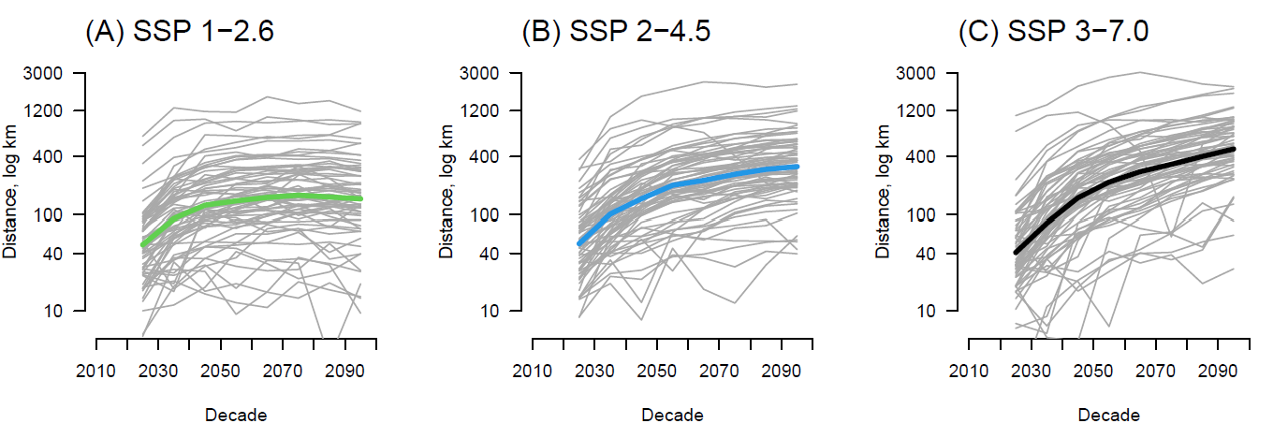
Figure S7. Temporal change in distance from the centre of gravity of baseline habitat to their centre of gravity for each decade thereafter at three different carbon emissions scenarios, supporting Fig. 2B. Bold lines are the median among EBSAs for each SSP, with each grey line being the trajectory of an individual EBSA. For regression statistics, see Table S4.

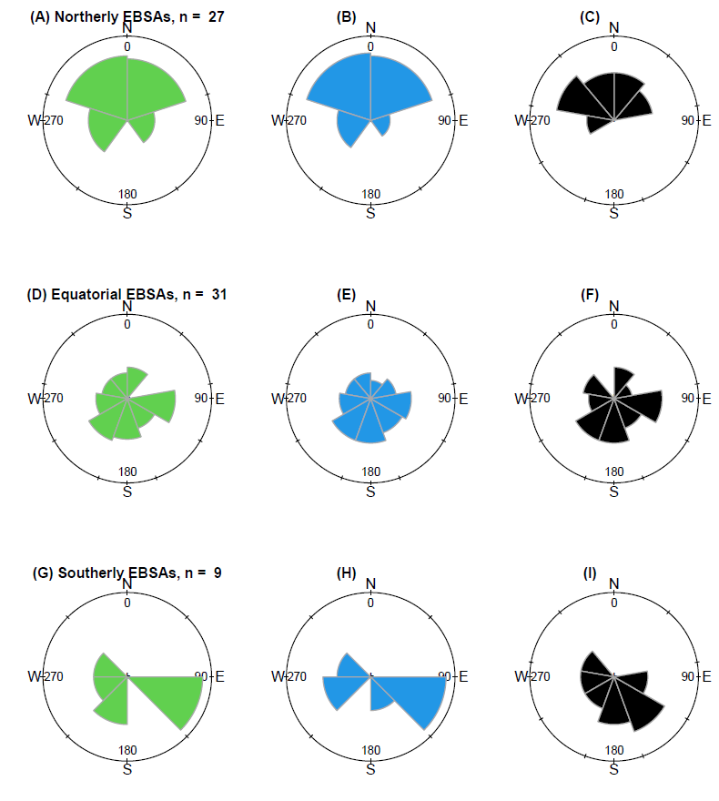
Figure S8. Directional tendencies for movement of the habitat centre of gravity across EBSAs from northerly (>30 degrees latitude, top row), equatorial (<30 degrees latitude and > -30 degrees latitude, middle row), and southerly (< -30 degrees latitude, bottom row) for SSP 1-2.6 (left column, green), SSP 2-4.5 (centre column, blue), and 3-7.0 (right column, black). For regression statistics, see Table S5.

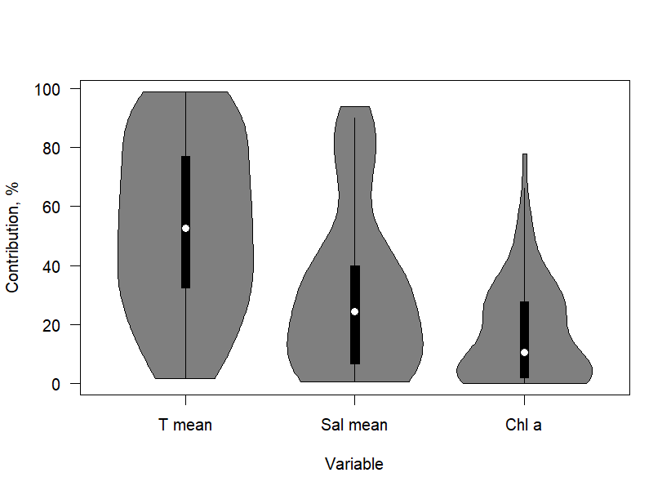
Figure S9. The distribution of environmental variable contributions to habitat uniqueness across all EBSA habitat suitability models (n = 67). Maxent model formula: Habitat suitability ~ T_mean + S_mean + Chl_a_mean. Box plots show the median (central point), interquartile range (box; IQR), and whiskers cover observations within 1.5 IQR, while dark grey shading shows the distribution density.

Tables
Table S1. Mixed effect regression statistics describing the effect of time and SSP on: (A) EBSA mean habitat suitability; (B) EBSA suitable area relative to baseline; (C) EBSA suitable area in the wider region around and including the EBSA boundaries, relative to baseline; (D) distance from the centre of gravity of baseline habitat to their centre of gravity for each decade thereafter. DF = 1605. (A) supports Fig. 2A; (B) supports Fig. S5; (C) supports Fig. 6; (D) supports Fig. S7. EBSA ID was a random effect.
(A) | β | S.E. | t | P
(Intercept) | -0.84938 | 0.367893 | -2.31 | 0.0211 | *
Decade | 0.00077 | 0.00018 | 4.28 | <0.00001 | ***
SSP | 0.019939 | 0.001464 | 13.62 | <0.00001 | ***
Decade:SSP | -9.8E-06 | 7E-07 | -13.75 | <0.00001 | ***
(B)
(Intercept) | -10.4259 | 4.575244 | -2.28 | 0.0228 | *
Decade | 0.005163 | 0.002237 | 2.31 | 0.0211 | *
SSP | 0.186525 | 0.018226 | 10.23 | <0.00001 | ***
Decade:SSP | -9.2E-05 | 0.000009 | -10.33 | <0.00001 | ***
(C)
(Intercept) | -1.60438 | 5.258236 | -0.31 | 0.7603
Decade | 0.000779 | 0.00257 | 0.30 | 0.7618
SSP | 0.096299 | 0.020946 | 4.60 | <0.00001 | ***
Decade:SSP | -4.8E-05 | 0.00001 | -4.64 | <0.00001 | ***
(D)
(Intercept) | 8.126945 | 1.043559 | 7.79 | <0.00001 | ***
Decade | -0.0007 | 0.000506 | -1.37 | 0.1697
SSP | -0.0104 | 0.004123 | -2.52 | 0.0118 | *
Decade:SSP | 0.000005 | 0.000002 | 2.56 | 0.0106 | *

Table S2. Share of EBSAs falling beneath 50% coverage of suitable habitat.
SSP | n EBSAs | Total EBSAs | %
126 | 63 | 67 | 94.03
245 | 52 | 67 | 77.61
370 | 38 | 67 | 56.72

Table S3. Mixed effect regression statistics of the effect of changing environmental conditions from each EBSA’s baseline and SSP on (A) EBSA mean habitat suitability and (B) on the logged distance shifted by habitat centroids. DF = 1536. EBSA ID was a random effect. A lag = 1 autoregressive term is integrated.
 | β | S.E. |  | t |  | P
(A)
(Intercept) | 0.721184 | 0.029533 |  | 24.42 |  | <0.0001
SSP | 3.75E-05 | 8.51E-05 |  | 0.44 |  | 0.6596
Mean_T.delta | -0.02286 | 0.031469 |  | -0.73 |  | 0.4676
Mean_S.delta | -0.02637 | 0.061791 |  | -0.43 |  | 0.6696
Mean_Chl.delta | 0.389496 | 0.647815 |  | 0.60 |  | 0.5478
SSP:Mean_T.delta | -0.00019 | 0.000093 |  | -2.05 |  | 0.0402
(B)
(Intercept) | 3.463516 |  | 0.141552 |  | 24.47 |  | <0.0001
SSP | 0.001349 |  | 0.00035 |  | 3.85 |  | 0.0001
Mean_T.delta | 3.140045 |  | 0.175928 |  | 17.85 |  | <0.0001
Mean_S.delta | -1.37295 |  | 0.443172 |  | -3.10 |  | 0.002
Mean_Chl.delta | 4.956371 |  | 4.75241 |  | 1.04 |  | 0.2972
SSP:Mean_T.delta | -0.00511 |  | 0.000457 |  | -11.18 |  | <0.0001

Table S4. Mixed effect regression statistics of the effect of SSP (dependent on latitude) on direction from the centre of gravity of baseline habitat to their centre of gravity for each decade thereafter, supporting Fig. S8. DF = 1538. EBSA ID was a random effect.
 | β | S.E. | t | P
(Intercept) | 64.74644 | 40.17822 | 1.61 | 0.1073
EBSA_latitude | -0.81206 | 0.12812 | -6.34 | <0.0001 | ***
SSP | 0.00149 | 0.00475 | 0.31 | 0.7529 | *
Decade | 0.01696 | 0.01943 | 0.87 | 0.3829
EBSA_latitude:SSP | -0.0006 | 0.00013 | -4.42 | <0.0001 | ***

Table S5. Spearman’s Rank correlation matrix for habitat conditions over all EBSA areas together for the 2010-2020 decade. Highest correlations between salinity (S) range and mean, the two ranges, and S and temperature (T) means.
 | chl_mean | S_mean | S_range | T_mean | T_range
chl_mean |  | 0.24 | -0.48 | 0.18 | 0.62
S_mean | 0.24 |  | -0.68 | 0.66 | 0.58
S_range | -0.48 | -0.68 |  | -0.40 | -0.67
T_mean | 0.18 | 0.66 | -0.40 |  | 0.40
T_range | 0.62 | 0.58 | -0.67 | 0.40
TOTAL of absolute values | 1.51 | 2.15 | 2.22 | 1.64 | 2.26

Table S6. Full list of SIRUS stable rules based on random forests to predict EBSA habitat suitability by 2100. [Separate Excel sheet]
Table S7. Full output of EBSA response variables per decade per SSP. [Separate Excel sheet]

