SPR measurements and data analysis for mutated EGFR
SPR was performed using the same running buffer and temperature as previously described. EGFR^{L858R/T790M/C797S} triple mutant (MedChemExpress, HY-P702831) protein was immobilized on flow cell 2 (FC2) of a CM5 sensor chip via amine coupling: the surface was activated with a 1:1 mixture of 1-ethyl-3-(3-dimethylaminopropyl)carbodiimide and N-hydroxysuccinimide (EDC/NHS) for 9 min, followed by injection of protein (30 μg/mL in 10 mM sodium acetate, pH 4.5) for 400 s, and residual reactive groups were quenched with ethanolamine for 9 min. The level of ligand immobilization was 13,000 RU. Flow cell 1 (FC1) was left blank-immobilized to serve as the reference surface. Analytes were prepared in 1.05X PBS-P+ to give a stock concentration of 500 μM in 5% DMSO–1X PBS-P+, and this stock was serially diluted in running buffer to yield final concentrations of 1, 10, 25, 50, 75, 125, and 250 μM. Each analyte was injected over the reference and active surfaces with an association time of 120 s and a dissociation time of 120 s. Binding responses were double-referenced against FC1 and buffer-only injections, and the resulting sensorgrams were analyzed by steady-state affinity fitting to determine the equilibrium dissociation constant (K_{D}) for each interaction using Biacore X100 Evaluation Software (v2.0.x).

Results
To evaluate the binding of the compounds to mutant EGFR, the triple-mutant EGFR (L858R /T790M/ C797S), which confers resistance to the third-generation EGFR inhibitor osimertinib (1), was analyzed. Compounds 1, MUC-853, and MUC-858 showed markedly enhanced binding to the mutant relative to wild-type EGFR (Figure 7), with KD values of 0.04 μM, 6.6 μM, and 0.2 μM, respectively (Figure S3). Osimertinib was also evaluated against the mutant EGFR under identical experimental conditions. It exhibited relatively weak binding, with a K_{D} of 73.3 M (Figure S3). This finding is consistent with previous reports demonstrating that the C797S mutation confers resistance to third-generation EGFR inhibitors.

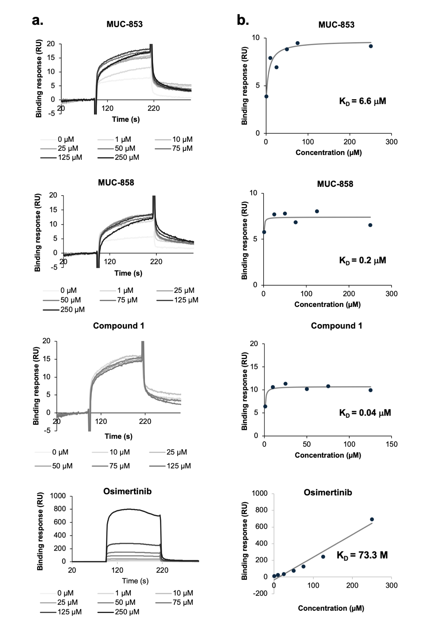
Figure S3. Steady state affinity analysis of compounds against triple mutant EGFR. a. Sensorgrams show the binding responses following the injection of analytes over a range of concentrations. b. Steady-state analyses.
Reference
1. Wang S, Tsui ST, Liu C, Song Y, Liu D. EGFR C797S mutation mediates resistance to third-generation inhibitors in T790M-positive non-small cell lung cancer. Journal of Hematology & Oncology. 2016;9(1):59.

