Supplementary Data 1

Figure S1. Docking scores of CTA and its derivatives against standard inhibitors A) ALK, B) BRAF, C) c-MET, D) RET, E) ROS1, F) Topoisomerase Iiα, G) Mutant EGFR^{L858R}, H) Mutant EGFR^{L858R/T790M}, I) Mutant EGFR^{L858R/T790M/C797S}

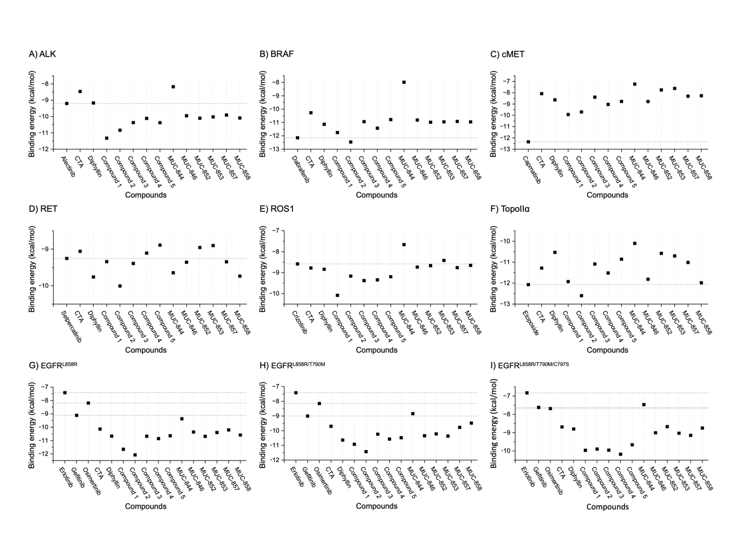

Figure S2. Sensorgram of Compound 2 and CTA. The compounds were injected over the immobilized EGFR at the indicated concentrations.

Table S1: PDB IDs and molecular docking grid centers of targeted proteins.
Targeted protein | PDB ID | Grid center | Reference compound | Note | Ref
WT EGFR | 1M17 | 21.86 × 0.26 × 52.76 | Erlotinib | - | (1)
EGFR^{L858R} | 4I22 | 9.88 × -15.60 × 11.45 | Gefitinib | Mutated V948R | (2)
EGFR^{L858R/T790M} | 4I22 | 9.88 × -15.60 × 11.45 | Gefitinib | Mutated V948R | (2)
EGFR^{L858R/T790M/C797S} | 6LUD | -49.77 × -0.02 × -18.19 | Osimertinib | - | (3)
ALK | 3AOX | –23.62 × 9.05 × –7.23 | Alectinib | - | (4)
BRAF | 4XV2 | –0.51 × –3.28 × –20.73 | Dabrafenib | - | (5)
c-MET | 9SXJ | –18.45 × 1.76 × –13.28 | Capmatinib | - | (6)
RET | 7JU6 | 8.05 × 2.48 × –5.25 | Selpercatinib | - | (7)
ROS1 | 3ZBF | 42.40 × 19.66 × 4.31 | Crizotinib | - | (8)
Topoisomerase IIα | 5GWK | 23.28 × –38.57 × –59.55 | Etoposide | - | (9)

Table S2: Structures of CTA and its derivatives
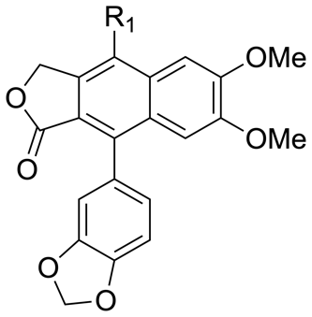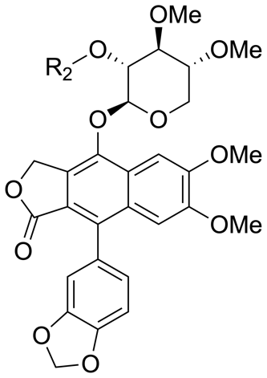

Name | R1 | R2
Diphyllin | OH | -
Cleistanthin A | - | H
MUC 844 | -
MUC 846 | -
MUC 852 | -
MUC 853 | -
MUC 857 | -
MUC 858 | -
Compound 1 |  | -
Compound 2 |  | -
Compound 3 |  | -
Compound 4 |  | -
Compound 5 |  | -

Table S3: SMILES strings of CTA and its derivatives.
Name | SMILES format
Cleistanthin A | COC1COC(C(C1OC)O)OC2=C3COC(=O)C3=C(C4=CC(=C(C=C42)OC)OC)C5=CC6=C(C=C5)OCO6
Diphyllin | COC1=C(C=C2C(=C1)C(=C3C(=C2O)COC3=O)C4=CC5=C(C=C4)OCO5)OC
MUC 844 | O=C(OC1)C2=C1C(O[C@H]3OC[C@H](OC)[C@@H](OC)[C@@H]3O[C@H]4O[C@@H](COC(C)=O)[C@H](OC(C)=O)[C@@H](OC(C)=O)  [C@@H]4OC(C)=O)=C(C=C(OC)C(OC)=C5)C5=C2C6=CC=C(OCO7)C7=C6
MUC 846 | O=C(OC1)C2=C1C(O[C@H]3[C@H](OC(C4=CC=C(F)C=C4)=O)[C@@H](OC)[C@H](OC)CO3)=C(C=C(OC)C(OC)=C5)C5=C2C6=CC=C(OCO7)C7=C6
MUC 852 | O=C(OC1)C2=C1C(O[C@H]3[C@H](OC(C4=CC(Cl)=CC=C4)=O)[C@@H](OC)[C@H](OC)CO3)=C(C=C(OC)C(OC)=C5)C5=C2C6=CC=C(OCO7)C7=C6
MUC 853 | O=C(OC1)C2=C1C(O[C@H]3[C@H](OC(C4=CC(F)=CC=C4)=O)[C@@H](OC)[C@H](OC)CO3)=C(C=C(OC)C(OC)=C5)C5=C2C6=CC=C(OCO7)C7=C6
MUC 857 | O=C(OC1)C2=C1C(O[C@H]3[C@H](OC(C4=CC=C(Cl)C=C4)=O)[C@@H](OC)[C@H](OC)CO3)=C(C=C(OC)C(OC)=C5)C5=C2C6=CC=C(OCO7)C7=C6
MUC 858 | O=C(OC1)C2=C1C(O[C@H]3[C@H](OC(C4=CC(Br)=CC=C4)=O)[C@@H](OC)[C@H](OC)CO3)=C(C=C(OC)C(OC)=C5)C5=C2C6=CC=C(OCO7)C7=C6
Compound 1 | O=C(OC1)C2=C1C(OCC3=CC(C(F)(F)F)=CC=C3)=C4C(C=C(OC)C(OC)=C4)=C2C5=CC=C6OCOC6=C5
Compound 2 | O=C(OC1)C2=C1C(OC(C3=CC(C(F)(F)F)=CC=C3)=O)=C4C(C=C(OC)C(OC)=C4)=C2C5=CC=C6OCOC6=C5
Compound 3 | O=C(OC1)C2=C1C(OCC3=CN=CC=C3)=C4C(C=C(OC)C(OC)=C4)=C2C5=CC=C6OCOC6=C5
Compound 4 | O=C(OC1)C2=C1C(OCC3=CC=C(F)C=C3)=C4C(C=C(OC)C(OC)=C4)=C2C5=CC=C6OCOC6=C5
Compound 5 | O=C(OC1)C2=C1C(OCC3=CC=CC=C3)=C4C(C=C(OC)C(OC)=C4)=C2C5=CC=C6OCOC6=C5

Table S4: Predicted binding target of CTA by SwissTargetPrediction.

Target | Common name | Uniprot ID | ChEMBL ID | Target Class | Probability
Tyrosine-protein kinase SYK | SYK | P43405 | CHEMBL2599 | Kinase | 0.09562379 | Tyrosine kinase
Vascular endothelial growth factor receptor 2 | KDR | P35968 | CHEMBL279 | Kinase | 0.09562379 | Tyrosine kinase
Fibroblast growth factor receptor 1 | FGFR1 | P11362 | CHEMBL3650 | Kinase | 0.09562379 | Tyrosine kinase
Galectin-1 | LGALS1 | P09382 | CHEMBL4915 | Other cytosolic protein | 0.09562379
Vascular endothelial growth factor receptor 3 | FLT4 | P35916 | CHEMBL1955 | Kinase | 0.09562379 | Tyrosine kinase
Adenosine A2a receptor (by homology) | ADORA2A | P29274 | CHEMBL251 | Family A G protein-coupled receptor | 0.09562379
Sodium/nucleoside cotransporter 2 | SLC28A2 | O43868 | CHEMBL5780 | Electrochemical transporter | 0.09562379
Epidermal growth factor receptor erbB1 | EGFR | P00533 | CHEMBL203 | Kinase | 0.09562379 | Tyrosine kinase
Transforming protein p21/H-Ras-1 | HRAS | P01112 | CHEMBL2167 | Other cytosolic protein | 0.09562379
Adenosine A2b receptor | ADORA2B | P29275 | CHEMBL255 | Family A G protein-coupled receptor | 0.09562379
Adenosine A3 receptor | ADORA3 | P0DMS8 | CHEMBL256 | Family A G protein-coupled receptor | 0.09562379
Leucine-rich repeat serine/threonine-protein kinase 2 | LRRK2 | Q5S007 | CHEMBL1075104 | Kinase | 0.09562379 | Tyrosine kinase-like
Matrix metalloproteinase 13 | MMP13 | P45452 | CHEMBL280 | Protease | 0.09562379
Matrix metalloproteinase 14 | MMP14 | P50281 | CHEMBL3869 | Protease | 0.09562379
Vascular endothelial growth factor receptor 1 | FLT1 | P17948 | CHEMBL1868 | Kinase | 0.09562379 | Tyrosine kinase
Serine/threonine-protein kinase mTOR | MTOR | P42345 | CHEMBL2842 | Kinase | 0.09562379 | Atypical
Hypoxia-inducible factor 1 alpha | HIF1A | Q16665 | CHEMBL4261 | Transcription factor | 0.09562379
Kinesin-1 heavy chain/ Tyrosine-protein kinase receptor RET | RET | P07949 | CHEMBL2041 | Kinase | 0.09562379 | Tyrosine kinase
Biotin--protein ligase | HLCS | P50747 | CHEMBL2062354 | Enzyme | 0.09562379
Adenosine kinase | ADK | P55263 | CHEMBL3589 | Enzyme | 0.09562379 | unknown
Interleukin-1 receptor-associated kinase 4 | IRAK4 | Q9NWZ3 | CHEMBL3778 | Kinase | 0 | Tyrosine kinase-like
Serine/threonine-protein phosphatase | PPP5C | Q9BPW0 | CHEMBL1293265 | Phosphatase | 0
Neurokinin 2 receptor | TACR2 | P21452 | CHEMBL2327 | Family A G protein-coupled receptor | 0
Poly [ADP-ribose] polymerase-1 | PARP1 | P09874 | CHEMBL3105 | Enzyme | 0
Serine/threonine-protein kinase Chk1 | CHEK1 | O14757 | CHEMBL4630 | Kinase | 0 | CAMK
Tankyrase-2 | TNKS2 | Q9H2K2 | CHEMBL6154 | Enzyme | 0
Tankyrase-1 | TNKS | O95271 | CHEMBL6164 | Enzyme | 0
Mitogen-activated protein kinase kinase kinase 14 | MAP3K14 | Q99558 | CHEMBL5888 | Kinase | 0 | STE
Serine/threonine-protein kinase PAK 4 | PAK4 | O96013 | CHEMBL4482 | Kinase | 0 | STE
Puromycin-sensitive aminopeptidase | NPEPPS | P55786 | CHEMBL2264 | Protease | 0
Nerve growth factor receptor Trk-A | NTRK1 | P04629 | CHEMBL2815 | Kinase | 0 | Tyrosine kinase
Matrix metalloproteinase 3 | MMP3 | P08254 | CHEMBL283 | Protease | 0
Matrix metalloproteinase 9 | MMP9 | P14780 | CHEMBL321 | Protease | 0
ADAM17 | ADAM17 | P78536 | CHEMBL3706 | Protease | 0
Coagulation factor XI | F11 | P03951 | CHEMBL2820 | Protease | 0
Matrix metalloproteinase 2 | MMP2 | P08253 | CHEMBL333 | Protease | 0
Dual specificity mitogen-activated protein kinase kinase 1 | MAP2K1 | Q02750 | CHEMBL3587 | Kinase | 0 | STE
Matrix metalloproteinase 12 | MMP12 | P39900 | CHEMBL4393 | Protease | 0
Matrix metalloproteinase 8 | MMP8 | P22894 | CHEMBL4588 | Protease | 0
Estrogen receptor beta | ESR2 | Q92731 | CHEMBL242 | Nuclear receptor | 0
PI3-kinase p110-gamma subunit | PIK3CG | P48736 | CHEMBL3267 | Enzyme | 0 | unknown
PI3-kinase p110-alpha subunit | PIK3CA | P42336 | CHEMBL4005 | Enzyme | 0 | unknown
Tyrosine-protein kinase BTK | BTK | Q06187 | CHEMBL5251 | Kinase | 0 | Tyrosine kinase
Purinergic receptor P2Y12 (by homology) | P2RY12 | Q9H244 | CHEMBL2001 | Family A G protein-coupled receptor | 0
Kappa Opioid receptor | OPRK1 | P41145 | CHEMBL237 | Family A G protein-coupled receptor | 0
Beta amyloid A4 protein | APP | P05067 | CHEMBL2487 | Membrane receptor | 0
Apoptosis regulator Bcl-X | BCL2L1 | Q07817 | CHEMBL4625 | Other ion channel | 0
Apoptosis regulator Bcl-2 | BCL2 | P10415 | CHEMBL4860 | Other ion channel | 0
Serine/threonine-protein kinase B-raf | BRAF | P15056 | CHEMBL5145 | Kinase | 0 | Tyrosine kinase-like
Cyclin-dependent kinase 2/cyclin E | CCNE2 CDK2 CCNE1 | O96020 P24941 P24864 | CHEMBL2094126 | Other cytosolic protein | 0 | CMGC
Platelet activating factor receptor (by homology) | PTAFR | P25105 | CHEMBL250 | Family A G protein-coupled receptor | 0
Tyrosine-protein kinase JAK2 | JAK2 | O60674 | CHEMBL2971 | Kinase | 0 | Tyrosine kinase
P2X purinoceptor 3 | P2RX3 | P56373 | CHEMBL2998 | Ligand-gated ion channel | 0
Threonyl-tRNA synthetase | TARS | P26639 | CHEMBL3391 | Enzyme | 0
Serine/threonine-protein kinase GAK | GAK | O14976 | CHEMBL4355 | Kinase | 0 | CMGC
Phosphodiesterase 10A | PDE10A | Q9Y233 | CHEMBL4409 | Phosphodiesterase | 0
Somatostatin receptor 5 | SSTR5 | P35346 | CHEMBL1792 | Family A G protein-coupled receptor | 0
Serine/threonine-protein kinase Aurora-B | AURKB | Q96GD4 | CHEMBL2185 | Kinase | 0 | AGC
Mannose-6-phosphate isomerase | MPI | P34949 | CHEMBL2758 | Isomerase | 0
Serine/threonine-protein kinase Aurora-A | AURKA | O14965 | CHEMBL4722 | Kinase | 0 | AGC
Mitogen-activated protein kinase kinase kinase 5 | MAP3K5 | Q99683 | CHEMBL5285 | Kinase | 0 | STE
Tyrosyl-tRNA synthetase | YARS | P54577 | CHEMBL3179 | Enzyme | 0
Corticotropin releasing factor receptor 1 | CRHR1 | P34998 | CHEMBL1800 | Family B G protein-coupled receptor | 0
Inosine-5'-monophosphate dehydrogenase 1 | IMPDH1 | P20839 | CHEMBL1822 | Oxidoreductase | 0
Thrombin | F2 | P00734 | CHEMBL204 | Protease | 0
Serine/threonine-protein kinase receptor R3 | ACVRL1 | P37023 | CHEMBL5311 | Kinase | 0 | Tyrosine kinase-like
Squalene monooxygenase (by homology) | SQLE | Q14534 | CHEMBL3592 | Enzyme | 0
Cyclin-dependent kinase 2 | CDK2 | P24941 | CHEMBL301 | Kinase | 0 | CMGC
Cyclin-dependent kinase 1 | CDK1 | P06493 | CHEMBL308 | Kinase | 0 | CMGC
Transmembrane domain-containing protein TMIGD3 | TMIGD3 | P0DMS9 | CHEMBL3712907 | Unclassified protein | 0
Sigma opioid receptor | SIGMAR1 | Q99720 | CHEMBL287 | Membrane receptor | 0
PI3-kinase p110-beta subunit | PIK3CB | P42338 | CHEMBL3145 | Enzyme | 0 | unknown
c-Jun N-terminal kinase 1 | MAPK8 | P45983 | CHEMBL2276 | Kinase | 0 | CMGC
Carbonic anhydrase I | CA1 | P00915 | CHEMBL261 | Lyase | 0
Isoleucyl-tRNA synthetase | IARS | P41252 | CHEMBL3235 | Enzyme | 0
Serotonin 2b (5-HT2b) receptor | HTR2B | P41595 | CHEMBL1833 | Family A G protein-coupled receptor | 0
Macrophage colony stimulating factor receptor | CSF1R | P07333 | CHEMBL1844 | Kinase | 0 | Tyrosine kinase
Calpain 1 | CAPN1 CAPNS1 | P07384 P04632 | CHEMBL2111357 | Protease | 0
Carbonic anhydrase III | CA3 | P07451 | CHEMBL2885 | Lyase | 0
Carbonic anhydrase VI | CA6 | P23280 | CHEMBL3025 | Lyase | 0
Carbonic anhydrase XIII | CA13 | Q8N1Q1 | CHEMBL3912 | Lyase | 0
Carbonic anhydrase VB | CA5B | Q9Y2D0 | CHEMBL3969 | Lyase | 0
Insulin-like growth factor binding protein 3 | IGFBP3 | P17936 | CHEMBL3997 | Secreted protein | 0
Carbonic anhydrase VA | CA5A | P35218 | CHEMBL4789 | Lyase | 0
Endothelin receptor ET-B | EDNRB | P24530 | CHEMBL1785 | Family A G protein-coupled receptor | 0
Cyclin-dependent kinase 5/CDK5 activator 1 | CDK5R1 CDK5 | Q15078 Q00535 | CHEMBL1907600 | Kinase | 0 | CMGC
Dual-specificity tyrosine-phosphorylation regulated kinase 1A | DYRK1A | Q13627 | CHEMBL2292 | Kinase | 0 | CMGC
Endothelin receptor ET-A | EDNRA | P25101 | CHEMBL252 | Family A G protein-coupled receptor | 0
MAP kinase p38 alpha | MAPK14 | Q16539 | CHEMBL260 | Kinase | 0 | CMGC
Rho-associated protein kinase 2 | ROCK2 | O75116 | CHEMBL2973 | Kinase | 0 | AGC
Protein arginine N-methyltransferase 7 | PRMT7 | Q9NVM4 | CHEMBL3562175 | Writer | 0
Carbonic anhydrase IX | CA9 | Q16790 | CHEMBL3594 | Lyase | 0
Quinone reductase 1 | NQO1 | P15559 | CHEMBL3623 | Enzyme | 0
Induced myeloid leukemia cell differentiation protein Mcl-1 | MCL1 | Q07820 | CHEMBL4361 | Other cytosolic protein | 0
Butyrylcholinesterase | BCHE | P06276 | CHEMBL1914 | Hydrolase | 0
Thymidylate synthase (by homology) | TYMS | P04818 | CHEMBL1952 | Transferase | 0
Glutamate receptor ionotropic, AMPA 1 | GRIA1 | P42261 | CHEMBL2009 | Ligand-gated ion channel | 0
Coagulation factor IX | F9 | P00740 | CHEMBL2016 | Protease | 0
Serine/threonine-protein kinase ILK-1 | ILK | Q13418 | CHEMBL5247 | Kinase | 0 | TKL
SUMO-activating enzyme subunit 1 | SAE1 | Q9UBE0 | CHEMBL1615388 | Unclassified protein | 0

Reference:
1. Stamos J, Sliwkowski MX, Eigenbrot C. Structure of the Epidermal Growth Factor Receptor Kinase Domain Alone and in Complex with a 4-Anilinoquinazoline Inhibitor. Journal of Biological Chemistry. 2002;277(48):46265-72.
2. Ketan, Feng J, Ferre R, Ryan K, Brodsky O, Weinrich S, et al. Insights into the Aberrant Activity of Mutant EGFR Kinase Domain and Drug Recognition. Structure. 2013;21(2):209-19.
3. Kashima K, Kawauchi H, Tanimura H, Tachibana Y, Chiba T, Torizawa T, et al. CH7233163 Overcomes Osimertinib-Resistant EGFR-Del19/T790M/C797S Mutation. Molecular Cancer Therapeutics. 2020;19(11):2288-97.
4. Sakamoto H, Tsukaguchi T, Hiroshima S, Kodama T, Kobayashi T, Takaaki, et al. CH5424802, a Selective ALK Inhibitor Capable of Blocking the Resistant Gatekeeper Mutant. Cancer Cell. 2011;19(5):679-90.
5. Zhang C, Spevak W, Zhang Y, Burton EA, Ma Y, Habets G, et al. RAF inhibitors that evade paradoxical MAPK pathway activation. Nature. 2015;526(7574):583-6.
6. Russell IC, Bachurska-Szpala P, Van Beek L, Michaelides IN, Phillips C, Snijder A, et al. Molecular Basis of c-MET Inhibition by Approved Small Molecule Drugs: A Structural Perspective. ACS Medicinal Chemistry Letters. 2026;17(3):590-7.
7. Subbiah V, Shen T, Terzyan SS, Liu X, Hu X, Patel KP, et al. Structural basis of acquired resistance to selpercatinib and pralsetinib mediated by non-gatekeeper RET mutations. Annals of Oncology. 2021;32(2):261-8.
8. Awad MM, Katayama R, McTigue M, Liu W, Deng Y-L, Brooun A, et al. Acquired Resistance to Crizotinib from a Mutation in <i>CD74</i>–<i>ROS1</i>. New England Journal of Medicine. 2013;368(25):2395-401.
9. Wang Y-R, Chen S-F, Wu C-C, Liao Y-W, Lin T-S, Liu K-T, et al. Producing irreversible topoisomerase II-mediated DNA breaks by site-specific Pt(II)-methionine coordination chemistry. Nucleic Acids Research. 2017;45(18):10861-71.

