Supplementary Information
Effects of Seed Crystal Size and Shoulder Angle on CdZnTe Crystal Growth by Traveling Heater Method

Jijun Zhang,^{abc} Chaohui Gu,^{b} Bin Zhai,^{b} Yifan Wu,^{b} Bo Zhang,^{b} Kexin Zhang,^{b} Xiangkun Zhang,^{b} and Xiaoyan Liang^{*abc}
a.State Key·Laboratory·of Materials for Advanced Nuclear Energy, Shanghai, 200444, China
b.School of Materials Science and Engineering, Shanghai University, Shanghai 200444, China.
c. Zhejiang Institute of Advanced Materials, SHU, Jiashan 314113, China
*Corresponding author.
E-mail: zhangjijun222@shu.edu.cn; xxlyy@shu.edu.cn

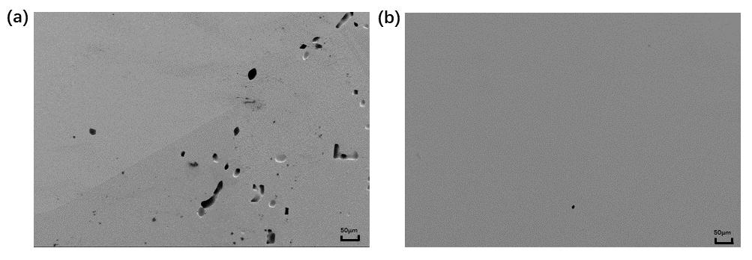
Supplementary Fig 1 SEM images of the bonding region for crystal I: (a) SEM image at the edge of the bonding region; (b) SEM image at the center of the bonding region.

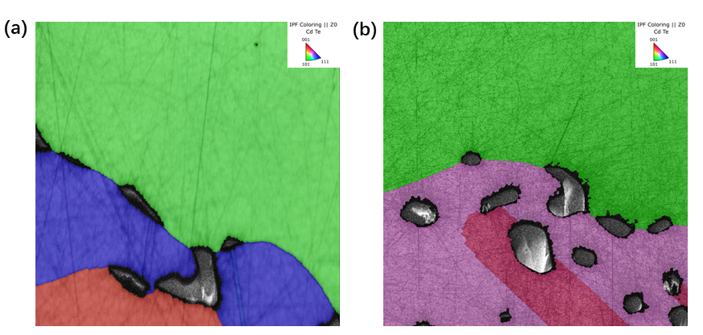
Supplementary Fig 2 Inverse pole figure (IPF) maps at the main-grain boundary in the bonding region: (a) results for crystal II; (b) results for crystal III.

