2. Supplementary Materials and methods

2.1 Cell transfection
MIF-overexpressing (OE-MIF), MIF-knockdown (sh-MIF-1/2/3), SERPIND1-overexpressing (OE-SERPIND1), SERPIND1-knockdown (sh-SERPIND1-1/2/3), SERPINE1-overexpressing (OE-SERPINE1), SERPINE1-knockdown (sh-SERPINE1-1/2/3), SERPINF2-overexpressing (OE-SERPINF2), and SERPINF2-knockdown (sh-SERPINF2-1) lentiviral vectors, as well as their corresponding negative controls (OE-NC, sh-NC), were purchased from GeneChem (Shanghai, China). Primary rat NPCs were seeded in 6-well plates at a density of 5 × 10⁵ cells/well and cultured until 70–80% confluence. Lentiviral vectors were added to the culture medium at a multiplicity of infection (MOI) of 10, and polybrene (5 μg/mL) was added to enhance transfection efficiency. After 48 h of transfection, the medium was replaced with fresh medium. The transfection efficiency was verified by quantitative real-time polymerase chain reaction (qRT-PCR) and Western blotting (WB) analysis 72 h post-transfection. The most effective knockdown sequences were selected for subsequent experiments.

2.2 qRT-PCR Analysis
Total RNA was extracted from cells and tissues using Trizol reagent (Invitrogen, USA) according to the manufacturer’s instructions. The concentration and purity of RNA were determined using a NanoDrop 2000 spectrophotometer (Thermo Fisher Scientific, USA). Complementary DNA (cDNA) was synthesized from 1 μg of total RNA using a PrimeScript RT Reagent Kit (TaKaRa, Japan). qRT-PCR was performed using a SYBR Premix Ex Taq II Kit (TaKaRa, Japan) on a StepOnePlus Real-Time PCR System (Thermo Fisher Scientific, USA). The reaction conditions were as follows: pre-denaturation at 95 °C for 30 s, followed by 40 cycles of denaturation at 95 °C for 5 s and annealing/extension at 60 °C for 30 s. GAPDH was used as an internal reference gene. The relative expression levels of target genes were calculated using the 2⁻ΔΔCt method.

2.3 Western Blot Analysis
Total protein was extracted from cells and tissues using RIPA lysis buffer (Beyotime, China) supplemented with protease inhibitor cocktail (Roche, Switzerland) and phosphatase inhibitor cocktail (Roche, Switzerland). The protein concentration was determined using a BCA Protein Assay Kit (Beyotime, China). Equal amounts of protein (30 μg per lane) were separated by 10% sodium dodecyl sulfate-polyacrylamide gel electrophoresis (SDS-PAGE) and transferred to polyvinylidene fluoride (PVDF) membranes (Millipore, USA). Membranes were blocked with 5% non-fat milk in Tris-buffered saline with Tween 20 (TBST) for 1 h at room temperature, then incubated with primary antibodies overnight at 4 °C. The primary antibodies used were: anti-MIF (Abcam, UK, ab215685), anti-SERPIND1 (Abcam, UK, ab180857), anti-SERPINE1 (Abcam, UK, ab27970), anti-SERPINF2 (Abcam, UK, ab180771), anti-RELA (Cell Signaling Technology, USA, 8242), anti-NFKB1 (Cell Signaling Technology, USA, 12546), anti-MCL1 (Cell Signaling Technology, USA, 5453), anti-LAMB3 (Cell Signaling Technology, USA, 14693), anti-FLT1 (Cell Signaling Technology, USA, 3718), anti-KRAS (Cell Signaling Technology, USA, 3965), anti-EREG (Cell Signaling Technology, USA, 14374), and anti-GAPDH (Cell Signaling Technology, USA, 5174). After washing with TBST three times, membranes were incubated with horseradish peroxidase (HRP)-conjugated secondary antibodies (Cell Signaling Technology, USA) for 1 h at room temperature. Protein bands were visualized using an Enhanced Chemiluminescence (ECL) Detection Kit (Millipore, USA), and the band intensity was quantified using ImageJ software (National Institutes of Health, USA). GAPDH was used as an internal reference.

2.4 Immunofluorescence Staining
Cells were seeded on coverslips in 24-well plates and cultured until 70–80% confluence. After transfection or treatment, cells were fixed with 4% paraformaldehyde for 15 min at room temperature, permeabilized with 0.1% Triton X-100 for 10 min, and blocked with 5% bovine serum albumin (BSA) for 30 min. Cells were then incubated with primary antibodies (anti-MIF, anti-SERPIND1, anti-SERPINE1, anti-SERPINF2, anti-Col-2, anti-MMP-13) overnight at 4 °C, followed by incubation with fluorescein isothiocyanate (FITC)- or cyanine 3 (Cy3)-conjugated secondary antibodies (Invitrogen, USA) for 1 h at room temperature. Nuclei were stained with 4’,6-diamidino-2-phenylindole (DAPI) for 5 min. Coverslips were mounted with anti-fluorescence quenching medium (Beyotime, China), and images were captured using a fluorescence microscope (Olympus, Japan). For tissue immunofluorescence staining, paraffin-embedded disc tissue sections (5 μm) were deparaffinized, rehydrated, and subjected to antigen retrieval with sodium citrate buffer (pH 6.0) for 15 min. The subsequent steps were the same as those for cell immunofluorescence staining.

2.5 Co-Immunoprecipitation (Co-IP) Assay
Wild-type MIF overexpression plasmid (MIF-WT) and site-specific mutant MIF overexpression plasmid (MIF-Mut, deletion of amino acids 105–111) were constructed in our laboratory, with full-length sequence verified by Sanger sequencing. Briefly, NP cells were seeded into 10 cm culture dishes, and transfected with Lipofectamine 3000 Transfection Reagent (Invitrogen, USA) according to the manufacturer’s instructions when cell confluence reached 70%–80%. Cells were harvested 48 h after transfection for subsequent experiments. Co-IP assay was performed using a Co-Immunoprecipitation Kit (Beyotime, China) according to the manufacturer’s instructions. Briefly, cells were lysed with IP lysis buffer supplemented with protease inhibitor cocktail. The cell lysate was centrifuged at 12,000 rpm for 15 min at 4 °C, and the supernatant was collected. A portion of the supernatant was saved as input. The remaining supernatant was incubated with 5 μg of anti-MIF (AB176565, Abcam, USA) , anti-SERPIND1 (AB289971, Abcam, USA), anti-SERPINE1 (AB222754, Abcam, USA), or anti-SERPINF2 (MA5-41054, Invitrogen, USA), or IgG control (as a negative control), overnight at 4 °C with gentle rotation. Then, 50 μL of protein A/G agarose beads were added to the mixture and incubated for 4 h at 4 °C. The beads were washed with IP washing buffer five times, and the bound proteins were eluted with elution buffer. The eluted proteins and input were analyzed by WB.

2.6 Molecular Docking
The 3D structures of MIF (PDB ID: 1MIF), SERPIND1 (PDB ID: 4ZJD), SERPINE1 (PDB ID: 1C5J), and SERPINF2 (PDB ID: 1R02) were downloaded from the Protein Data Bank (PDB). The structures of alphitolic acid and 3-indoleacrylic acid were obtained from the PubChem database. Molecular docking was performed using AutoDock Vina software. The protein structures were prepared using PyMOL software (removal of water molecules and ligands, addition of hydrogen atoms), and the ligand structures were optimized using Gaussian 09 software. The docking results were visualized using PyMOL software, and the binding energy and key binding sites were analyzed (Table S2).

2.7 ELISA and Flow Cytometry Analysis
The levels of IL-1β and TNF-α in the culture supernatant were measured using ELISA kits (R&D Systems, USA) according to the manufacturer’s instructions. Briefly, the culture supernatant was collected and centrifuged at 1000 rpm for 5 min. The supernatant was added to the wells of a 96-well plate coated with specific antibodies, and incubated for 2 h at room temperature. After washing, the detection antibody was added and incubated for 1 h. Then, the substrate solution was added, and the reaction was stopped with stop solution. The absorbance was measured at 450 nm using a microplate reader (Thermo Fisher Scientific, USA).
Flow cytometry analysis was performed to detect intracellular TNF-α expression. Cells were seeded in 6-well plates and treated as indicated. After treatment, cells were collected, fixed with 4% paraformaldehyde for 15 min, permeabilized with 0.1% Triton X-100 for 10 min, and blocked with 5% BSA for 30 min. Cells were incubated with anti-TNF-α antibody (BD Biosciences, USA) for 1 h at room temperature, followed by incubation with FITC-conjugated secondary antibody for 30 min. Cells were analyzed using a flow cytometer (BD FACSCalibur, USA), and the percentage of TNF-α-positive cells was calculated using FlowJo software (Tree Star, USA).

2.8 MRI and Histological Staining
Rats were anesthetized with 10% chloral hydrate (3 mL/kg, intraperitoneal injection) and subjected to MRI scanning using a 3.0 T MRI scanner (Siemens, Germany) at 4 and 8 weeks post-treatment. T2-weighted images were acquired, and the disc signal intensity was evaluated using ImageJ software. After MRI scanning, rats were sacrificed, and the L5-L6 intervertebral discs were collected. The discs were fixed with 4% paraformaldehyde, decalcified with 10% EDTA (pH 7.4) for 2 weeks, embedded in paraffin, and cut into 5 μm sections. Hematoxylin and eosin (H&E) staining was used to observe the morphological structure of the disc. Safranin O (SO) staining was used to evaluate the proteoglycan content. Immunohistochemistry staining was used to detect MIF expression in disc tissues, following the same procedure as immunofluorescence staining except that HRP-conjugated secondary antibody and DAB substrate were used for visualization.

2.9 Single-Cell RNA Sequencing (scRNA-seq) Analysis
scRNA-seq data of NPCs from different IVDD grades were downloaded from the Gene Expression Omnibus (GEO) database (GSE165722). The data were processed using Seurat software (v4.0.5). Briefly, the raw data were filtered to remove cells with fewer than 200 genes or more than 2000 genes, and cells with mitochondrial gene content >5% were excluded. The data were normalized using the NormalizeData function, and variable genes were identified using the FindVariableFeatures function. Principal component analysis (PCA) was performed, and t-distributed stochastic neighbor embedding (tSNE) was used for dimensionality reduction and clustering. The FindClusters function was used to identify cell clusters, and the FindAllMarkers function was used to identify differentially expressed genes in each cluster. Functional enrichment analysis of differentially expressed genes was performed using the clusterProfiler package in R software.

2.10 Preparation and Characterization of Liposomes and Hydrogel
Alphitolic acid-loaded liposomes were prepared using the thin-film hydration method. Briefly, soybean lecithin and cholesterol (molar ratio 5:1) were dissolved in chloroform, and alphitolic acid was added to the solution. The chloroform was evaporated under reduced pressure to form a thin film. PBS (pH 7.4) was added to the flask, and the mixture was hydrated at 60 °C for 30 min with stirring. The liposomes were sonicated for 10 min to obtain a uniform suspension and filtered through a 0.22 μm filter membrane. The morphology of liposomes was observed by transmission electron microscopy (TEM, Hitachi, Japan). The UV-Vis absorption spectra of liposomes were measured using a UV-Vis spectrophotometer (Shimadzu, Japan). The in vitro release profile of alphitolic acid from liposomes was determined by dialysis method. Briefly, liposomes were placed in a dialysis bag (MWCO 10 kDa) and immersed in PBS (pH 7.4) at 37 °C with shaking (100 rpm). At different time points, 1 mL of the release medium was collected, and an equal volume of fresh PBS was added. The concentration of alphitolic acid was measured by HPLC.
The composite hydrogel (HDgel) was prepared using hyaluronic acid (HA) and dopamine (DA). HA was dissolved in PBS (pH 7.4) to a concentration of 2% (w/v), and DA was added to the solution to a concentration of 1% (w/v). The mixture was stirred at room temperature for 24 h to form a uniform hydrogel. Alphitolic acid-loaded liposomes were added to the hydrogel to prepare Alp@HDgel. The morphology of the hydrogel was observed by scanning electron microscopy (SEM, Hitachi, Japan). The in vitro degradation behavior of the hydrogel was determined by weighing method. Briefly, the hydrogel was immersed in PBS (pH 7.4) at 37 °C with shaking (100 rpm). At different time points, the hydrogel was taken out, dried, and weighed. The degradation rate was calculated as (initial weight - remaining weight)/initial weight × 100%. The mechanical properties of the hydrogel were measured using a universal testing machine (Instron, USA) with a tensile speed of 1 mm/min and a compressive speed of 0.5 mm/min.

Supplementary figure legend
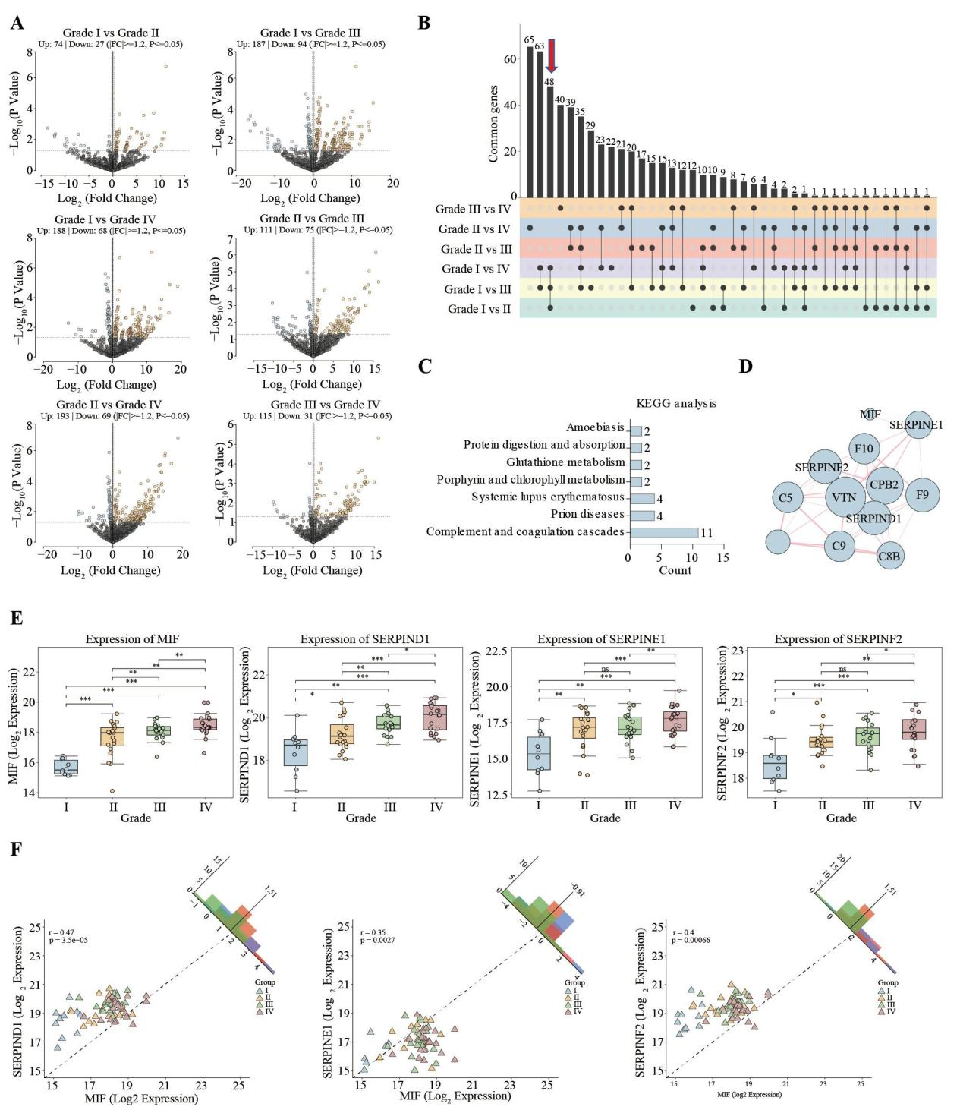

Figure S1. MIF is positively correlated with SERPIND1, SERPINE1, and SERPINF2 in IVDD
(A) Volcano plots showing differentially expressed genes (DEGs) between different IVDD grades (Grade I vs Grade II, Grade I vs Grade III, Grade I vs Grade IV, Grade II vs Grade III, Grade II vs Grade IV, Grade III vs Grade IV); red dots represent upregulated DEGs, blue dots represent downregulated DEGs, and black dots represent non-differentially expressed genes. (B) Upset plot showing the intersection of 48 differentially expressed proteins between Grade I vs Grade II, Grade I vs Grade III, and Grade I vs Grade IV; the number of overlapping proteins in different comparison groups is indicated. (C) Functional enrichment analysis of the 48 intersection proteins, showing significant enrichment in the Complement and coagulation cascades pathway. (D) Protein-protein interaction (PPI) network of MIF and SERPIN family members (SERPIND1, SERPINE1, SERPINF2, SERPINA4) predicted by the STRING database, indicating potential interaction relationships. (E) Proteomics results showing the protein expression levels of MIF, SERPIND1, SERPINE1, and SERPINF2 in different IVDD grades (Grade I to Grade IV). (F) Correlation analysis between MIF and SERPIND1, SERPINE1, SERPINF2; the correlation coefficient (r) and P value are indicated, confirming a positive correlation between MIF and the three SERPIN family proteins. Notes: *P < 0.05, **P < 0.01, ***P < 0.001.
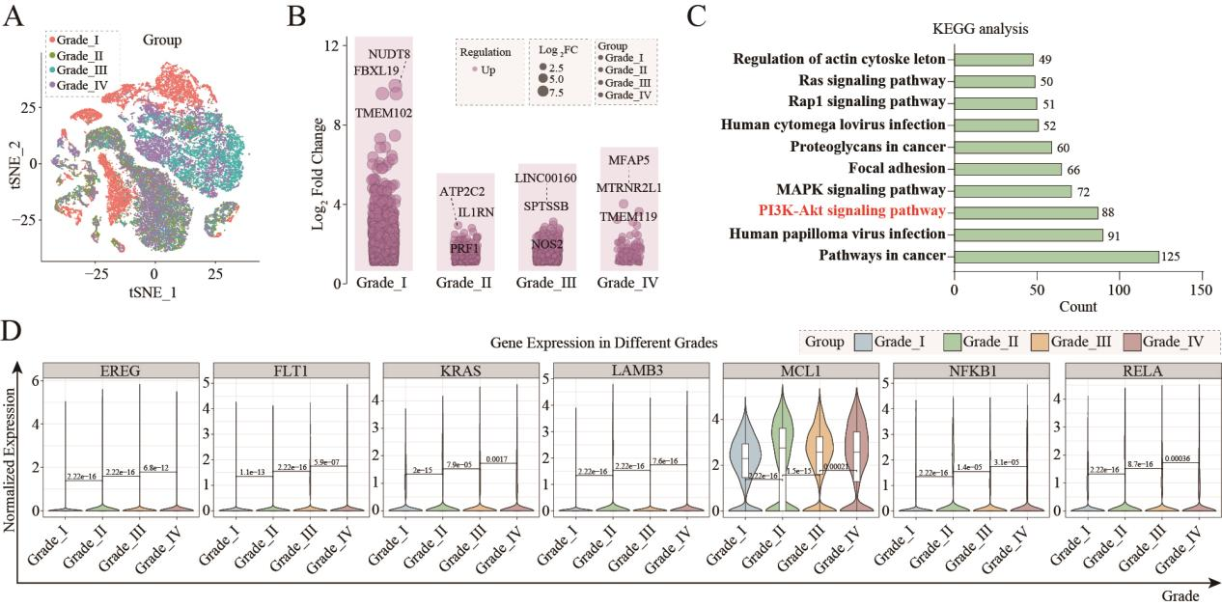

Figure S2. Single-cell transcriptomic profiling reveals gene expression changes and pathway activation during IVDD
(A) tSNE clustering plot of NPCs from different IVDD grades based on single-cell RNA sequencing (scRNA-seq) data from the GSE165722 dataset, showing 29 independent cell clusters (0-28). (B) Volcano plots showing significantly upregulated genes in each IVDD grade, with the top 3 most upregulated genes labeled in each plot. (C) Functional enrichment analysis of specific genes in Grade IV NPCs, showing significant enrichment in the PI3K-Akt signaling pathway. (D) scRNA-seq results showing the expression levels of RELA, NFKB1, MCL1, LAMB3, FLT1, KRAS, and EREG (NF-κB pathway-related genes) in different IVDD grades, indicating that these genes are upregulated with the progression of IVDD.
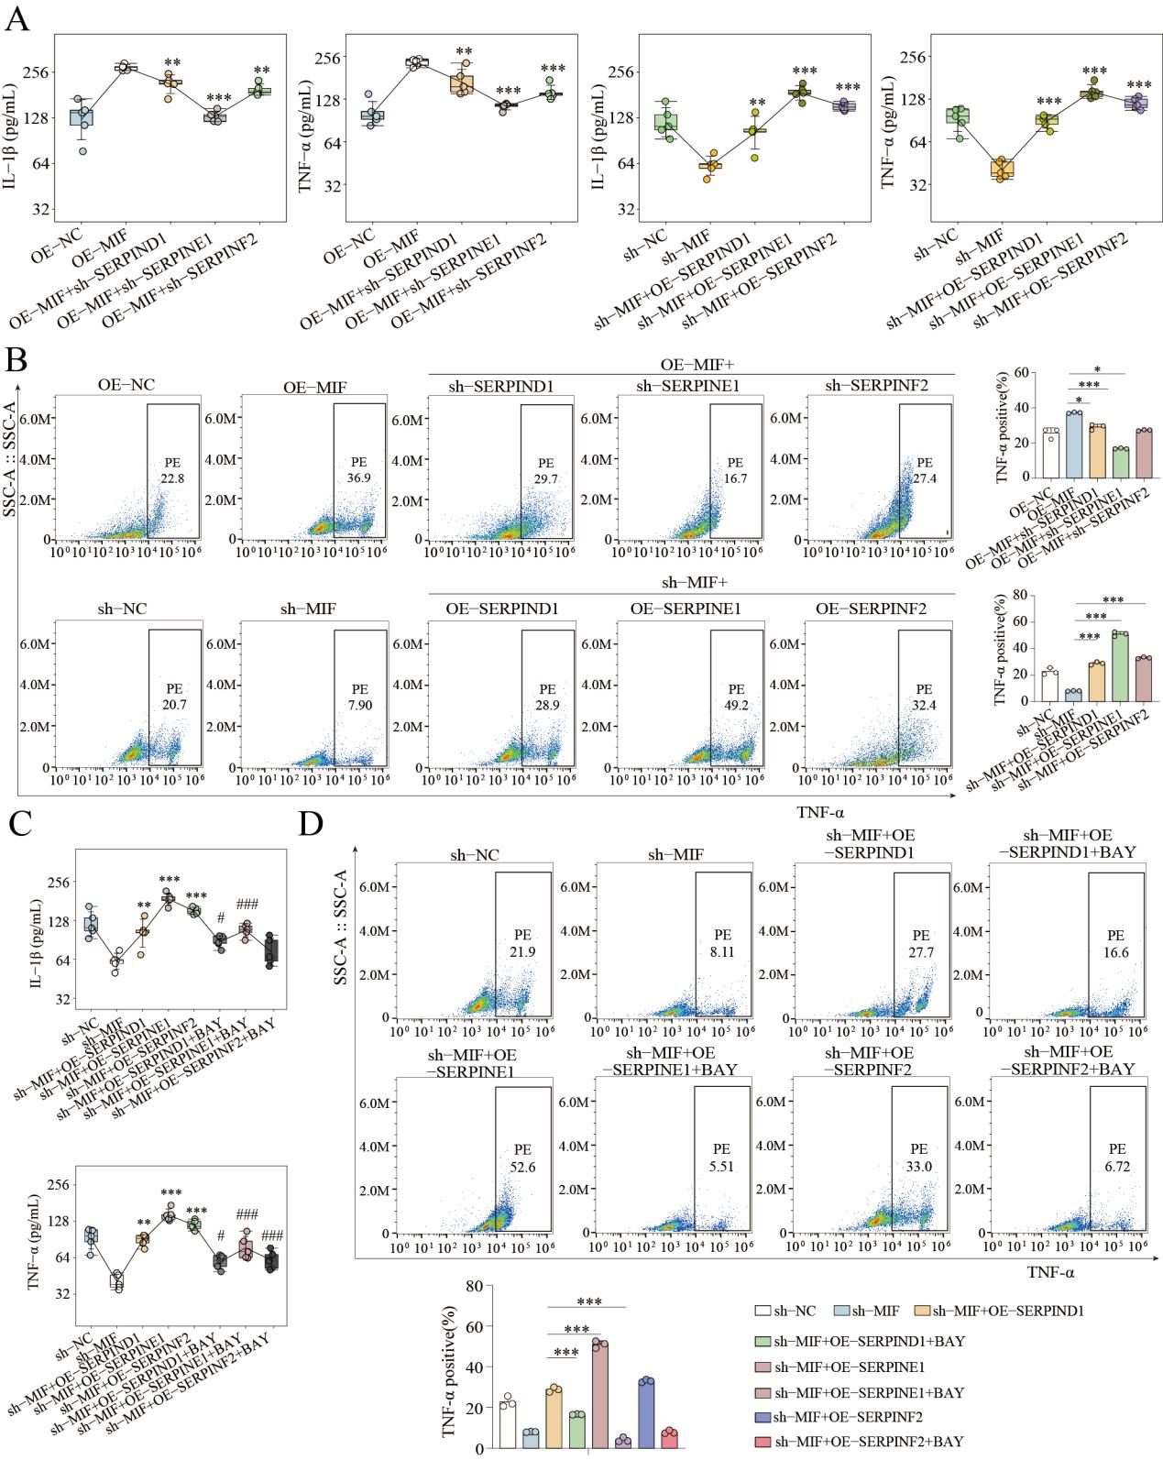

Figure S3. Rescue experiments verify the regulatory axis of MIF/SERPINs via PI3K-Akt/NF-κB pathway on inflammatory response
(A) ELISA quantification of IL-1β and TNF-α protein levels in culture supernatants following rescue assays. Cells were subjected to the following treatments: OE-NC, OE-MIF, OE-MIF combined with sh-SERPIND1, sh-SERPINE1, or sh-SERPINF2; sh-NC, sh-MIF, sh-MIF combined with OE-SERPIND1, OE-SERPINE1, or OE-SERPINF2. (B) Flow cytometry analysis of intracellular TNF-α expression in the indicated rescue groups. (C) ELISA quantification of IL-1β and TNF-α protein levels in culture supernatants following NF-κB inhibition with BAY 11-7082 (BAY). Cells were treated with sh-NC, sh-MIF, sh-MIF combined with OE-SERPIND1/OE-SERPINE1/OE-SERPINF2, or the same combinations with additional BAY treatment. (D) Flow cytometry analysis of intracellular TNF-α expression in the indicated groups; representative dot plots are shown on the left, and the corresponding quantification of TNF-α-positive cell percentages is presented on the right. Notes: All data are presented as mean ± SD. *p < 0.05, **p < 0.01, ***p < 0.001.
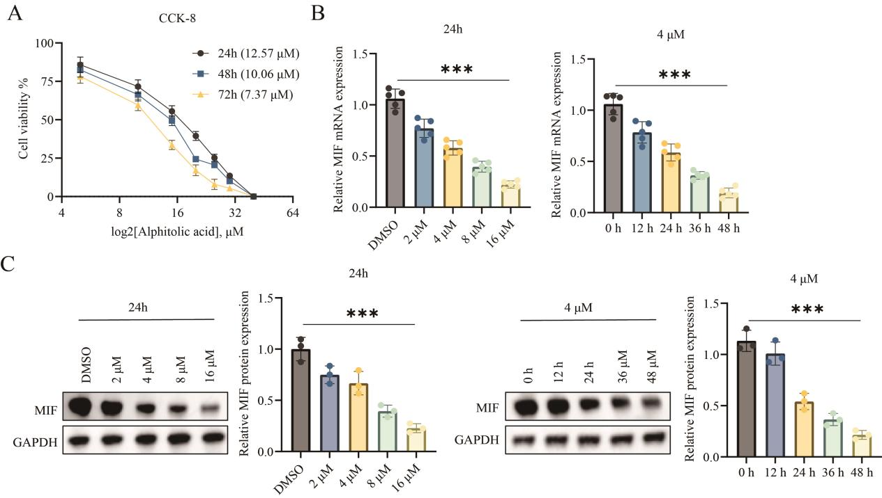

Figure S4. Alphitolic acid inhibits MIF expression in a dose- and time-dependent manner
NPCs were isolated from rat IVDD models and treated with alphitolic acid at indicated concentrations or time points. (A) Cell viability was measured by CCK-8 assay after treatment with alphitolic acid (2, 4, 8, 16 μM) for 24, 48 and 72 h. The half-maximal inhibitory concentration (IC₅₀) values are indicated in parentheses. (B) qRT-PCR analysis of MIF mRNA expression. Left: NPCs were treated with DMSO, 2, 4, 8 or 16 μM alphitolic acid for 24 h. Right: NPCs were treated with 4 μM alphitolic acid for 0, 12, 24, 36 or 48 h. (C) Western blot analysis of MIF protein expression with GAPDH as the internal reference. Left: NPCs were treated with DMSO, 2, 4, 8 or 16 μM alphitolic acid for 24 h. Right: NPCs were treated with 4 μM alphitolic acid for 0, 12, 24, 36 or 48 h. Notes: All data are presented as mean ± SD. *p < 0.05, **p < 0.01, ***p < 0.001.

Table S1. Specific amino acid binding sites between MIF and SERPIND1, SERPINF2, and SERPINE1 via molecular docking
SERPIND1 | SERPINF2 | SERPINE1
10 PRO | 8 ASN | 16 ASP
11 ARG | 9 VAL | 17 GLY
12 ALA | 10 PRO | 18 PHE
24 GLN | 11 ARG | 19 LEU
35 GLN | 12 ALA | 20 SER
36 TYR | 24 GLN | 23 THR
38 ALA | 35 GLN | 24 GLN
39 VAL | 36 TYR | 34 PRO
40 HIS | 38 ALA | 35 GLN
41 VAL | 39 VAL | 36 TYR
46 LEU | 40 HIS | 38 ALA
47 MET | 41 VAL | 39 VAL
48 ALA | 44 ASP | 40 HIS
49 PHE | 45 GLN | 41 VAL
50 GLY | 46 LEU | 46 LEU
51 GLY | 47 MET | 47 MET
69 GLY | 48 ALA | 48 ALA
72 ASN | 49 PHE | 49 PHE
73 ARG | 50 GLY | 50 GLY
77 LYS | 51 GLY | 51 GLY
80 CYS | 55 PRO | 69 GLY
91 PRO | 69 GLY | 72 ASN
92 ASP | 72 ASN | 73 ARG
95 TYR | 73 ARG | 77 LYS
96 ILE | 77 LYS | 80 CYS
97 ASN | 80 CYS | 91 PRO
98 TYR | 91 PRO | 92 ASP
105 ASN | 92 ASP | 95 TYR
106 VAL | 95 TYR | 96 ILE
107 GLY | 96 ILE | 97 ASN
108 TRP | 97 ASN | 98 TYR
109 ASN | 98 TYR | 105 ASN
110 ASN | 105 ASN | 106 VAL
111 SER | 106 VAL | 107 GLY
 | 107 GLY | 108 TRP
 | 108 TRP | 109 ASN
 | 109 ASN | 110 ASN
 | 110 ASN | 111 SER
 | 111 SER

