Supplementary Material

Synthesis of the cobalt-based CoLAm2 complex

The metal complex CoLAm2 as the PF₆⁻ salt was synthesized as previously reported (Chan et al., 2021). Following this, to improve water solubility, the PF₆⁻ counterion was exchanged for bromide. This was done by dissolving the complex in acetone followed by addition of a saturated acetone solution of tetrabutylammonium bromide. This led to the formation of a precipitate which was filtered and washed with further acetone, and dried under reduced pressure to yield the final product. Figure S1 below shows the NMR results: ¹H NMR (400 MHz, DMSO- d₆) δ 8.99 (s, 2H), 8.85 (s, 2H), 8.00 (dd, J = 6.4, 3.4 Hz, 2H), 7.61 (dd, J = 9.2, 4.9 Hz, 4H), 6.77 (d, J = 2.4 Hz, 2H), 6.43 (dd, J = 8.8, 2.4 Hz, 2H), 4.55 (d, J = 5.9 Hz, 4H), 3.83 (t, J = 4.6 Hz, 4H), 3.69 (q, J = 6.3 Hz, 4H), 3.21 (s, 18H), 1.41 (t, J = 6.4 Hz, 6H). Elemental analysis: theoretical, C 40.73, H 5.13, N 8.91 (C₃₂H₄₈Br₂CoN₆O₄·1.4NaBr); obtained C 41.12, H 5.19, N 9.02.

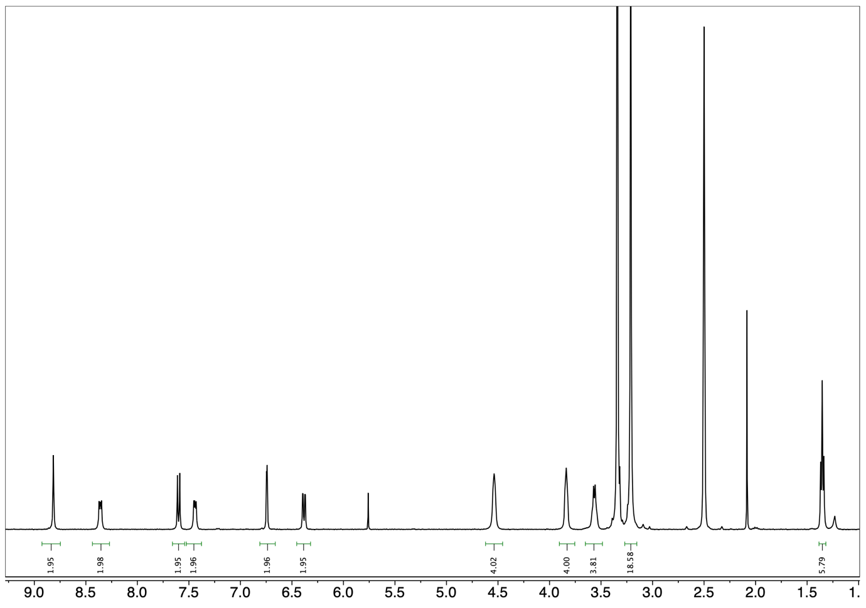

Figure S1. ¹H NMR spectrum of CoLAm2 in DMSO-d6.

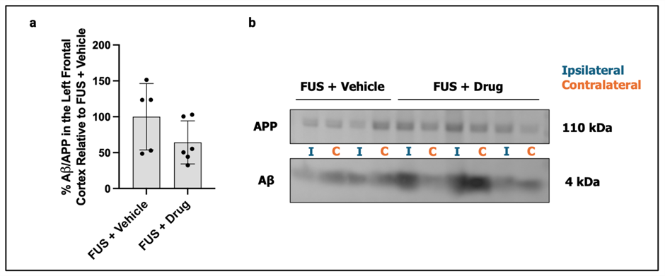

Figure S1. No significant differences in the expression of Aβ detected in mice treated with focused ultrasound and CoLAm2 drug in cortex samples. No significant differences were observed in the percentage of the guanidine fraction of Aβ to amyloid precursor protein (APP) in FUS + Drug relative to FUS + Vehicle treated mice (a). These results were expected given that the cortex area was not treated with ultrasound. Example of cropped Western Blot images (b) used to quantify APP and Aβ levels in ipsilateral and contralateral cortex samples of FUS + Vehicle and FUS + Drug treated 5xFAD animals (left ipsilateral hippocampus targeted with FUS) with entire Western Blot shown below.

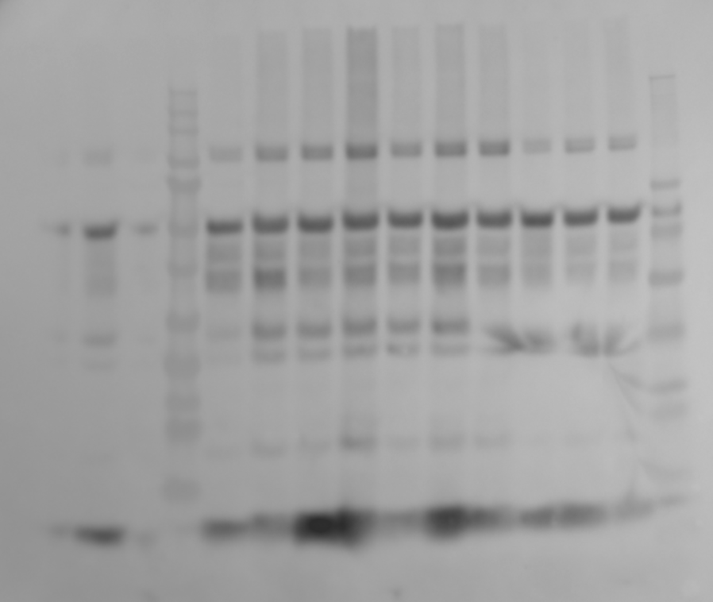
Figure S1.2. Full Western Blot shown for Figure S1 above.

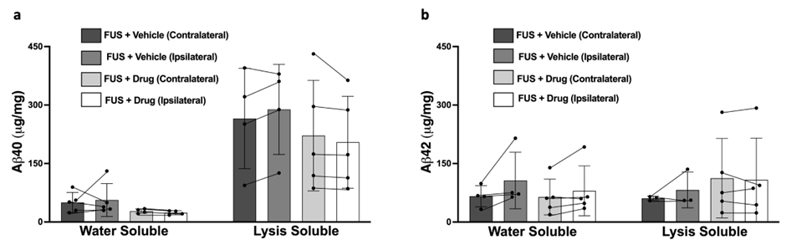Figure S2. No significant differences were observed in the expression of Aβ40 and Aβ42 in mice treated with FUS + Vehicle vs FUS + Drug in cortex samples. Quantification of data acquired from ELISAs of water soluble and lysis detergent soluble components of cortical homogenates from 5XFAD mice treated with FUS + Vehicle and FUS + Drug. As expected, given that the cortex was not treated with ultrasound, no significant differences were observed between hemispheres (contralateral and ipsilateral) in the amount of Aβ40 (a) and Aβ42 (b) protein detected. Columns represent mean±SD.
Supplementary 1. Behavioral Tests: Open Field Test and Novel Object Recognition Test
The Open Field Test (OFT) and the Novel Object Recognition Test (NORT) are widely recognized and convenient tools in rodent behavioral testing. They offer valuable insights into cognitive outcomes, including exploratory behavior, anxiety levels, and hippocampal-dependent spatial memory performance. Thigmotaxis, a measure obtained from the OFT, reflects the tendency of animals to stick to the periphery of the testing arena, indicating anxiety. Usually, this tendency decreases after some exploration time. A higher thigmotaxis index indicates higher anxiety levels. The discrimination index D2, a metric from NORT, quantifies an animal’s preference to explore novel objects over familiar ones, providing an indicator of their memory performance. The utilization of these behavioral measures yields preliminary indications of potential adverse effects, such as heightened anxiety levels or impaired hippocampal-dependent spatial memory. This approach offers a valuable starting point for identifying potential neurobehavioral alterations resulting from experimental manipulations or interventions.
Open Field and Novel Object Recognition Testing Protocols
Open Field Test (OFT):
- Ensure the arena is devoid of objects
- Place mouse in an open field arena with sawdust on the bottom
- Allow mice to explore the arena for 5 minutes
- Record video footage for subsequent analysis using EthoVision XT Software
Novel Object Recognition Training (Day 1)
- Place mouse in an arena with two identical objects (constructions made with large lego blocks)
- Allow mouse to freely explore the objects for 10 minutes
- Record video footage during the testing session
Novel Object Recognition Testing (Day 2)
- Replace one of the objects used in training with a new object (larger in size, different in shape and lighter colors)
- Place mouse into the arena with one of the old objects and the new one (placed equidistant from the sides of the arena)
- Allow mouse to freely explore the objects for 10 minutes
- Record video footage during this testing session
Note:
- Maintain consistent testing conditions across all mice during behavioural testing
- Document specific object colours, shapes, and sizes used
- Ensure accurate labelling and proper storage of video recordings for subsequent analysis

Supplementary 2. Protocol: Fractioning Procedure for Western Blotting
Subcellular fractionation
Frontal cortices were homogenized in PBS using a Dounce homogenizer, centrifuged for 45 min at 12000 RPM at 4°C and the supernatant containing water-soluble proteins of the cytoplasm and interstitial fluid (PBS fraction) was stored at −80°C. The pellet was resuspended in lysis buffer (PBS/Triton X-100 supplemented with protease and phosphatase inhibitors) and incubated for 20 min prior centrifugation for 10 min at 9000 RPM at 4°C. The supernatant containing all membrane-associated proteins (lysis fraction) was stored at −80°C. The remaining pellet was resuspended in Guanidine-HCl (5 M, pH 8) overnight at 4°C under constant agitation. Following centrifugation for 10 min at 9000 RPM, the supernatant containing all plaque-associated proteins (guanidine fraction) was stored at −80°C.
Western blotting
Guanidine fraction samples were immunoprecipitated with 4G8 antibody (Covance) to concentrate the Aβ. Immunoprecipitated samples were denatured by heating at 95 °C for 5 minutes in NuPAGE sample buffer and 10% β-mercaptoethanol. Samples were run in 4–12% Bis-Tris NuPAGE gels (Invitrogen) in MES running buffer followed by transfer to nitrocellulose membranes (Katsouri et al., 2015). Membranes were blocked with 5% non-fat semi-skimmed milk diluted in Tris buffered saline with Tween (TBST) for 1 hour. Membranes were then incubated with a primary antibody against Aβ (clone 6E10, Covance, 1:1000), diluted in 1% BSA in TBST, for 48 hours at 4 °C. Membranes were washed in TBST and incubated with a horse-radish peroxidase-conjugated secondary antibody diluted in 5% non-fat semi-skimmed milk for 1 hour at room temperature. Bands were visualised using enhanced chemiluminescence (ECL) and imaged using the GenGnome XRQ system. Band intensities were quantified by densitometry in FIJI and normalised to full-length APP.
Supplementary 3. ELISAs
ELISAs were performed following the manufacturer’s detailed protocol present in the ELISA kits used (EZHS-SET; https://www.merckmillipore.com/DE/de/product/High-Sensitivity-Human-Amyloid-42-ELISA,MM_NF-EZHS42#anchor_PR).

