Supplementary Figure and Legends
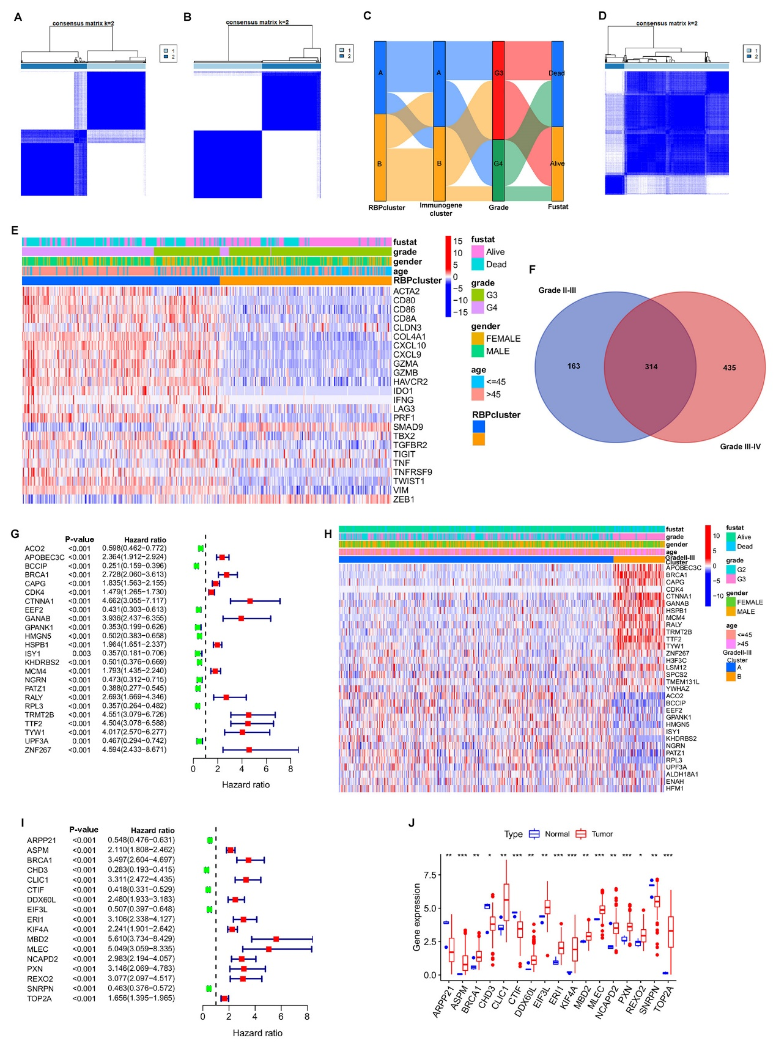
Fig. S1 (A) Clustering of 749 prognosis-related RBPs. (B) Cluster plot of 244 immune genes. (C) Alluvial diagram of the possible relationship between expression clusters of RBPs and those of immune genes. (D) The cluster plot of 477 prognostically significant RBPs in grade II-III glioma samples. (E) Distribution of inflammatory pathway-related genes in RBPs gene cluster pattern. (F) Venn diagram of prognosis-related RBPs in grade II-III gliomas and prognosis-related RBPs in grade III-IV gliomas from the TCGA database. (G) Forest plot of the prognostic impact of 24 factors in grade II-III glioma samples. (H) Enrichment of 24 different factors in the RBP clusters of grade II-III gliomas in TCGA database. (I, J) Forest plot of the prognostic impact of 17 RBPs in the CGGA database and their expressions in the tumors.

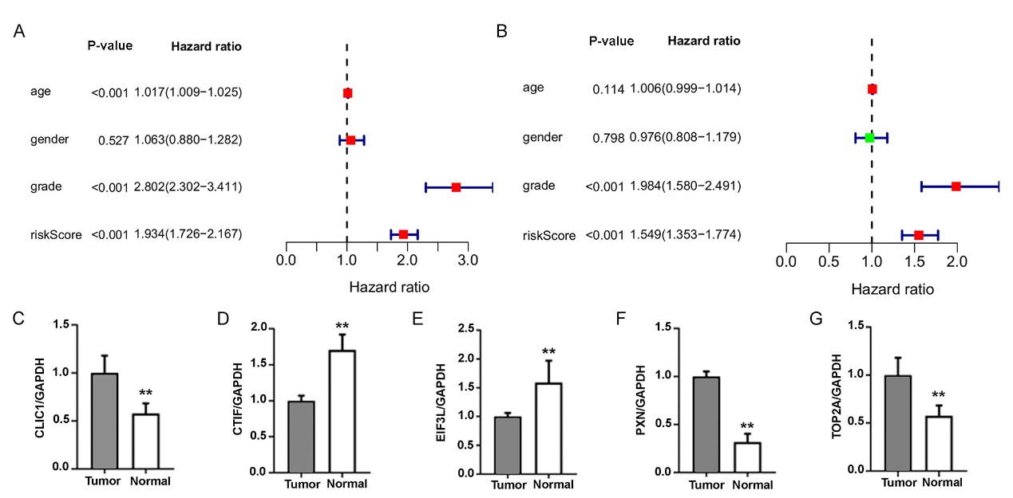
Fig. S2 (A, B) Univariate and multivariate Cox analysis in the CGGA database. (C-G) Rt-PCR results showed that compared with cancer tissue, the mRNA expression levels of CTIF (D) and EIF3L (E) were significantly increased in adjacent tissues, while the mRNA expression levels of CLIC1(C), PXN (F) and TOP2A (G) were significantly decreased.

